Supporting Information

Synergistic d−Band Center Modulation and Interfacial Charge Distribution on ZrO₂/CdS Catalyst for Solar−Driven CO₂ Conversion

1. Photoelectrochemical measurements
The transient photocurrent, electrochemical impedance spectroscopy (EIS), linear sweep voltammograms (LSV) and open circuit potential (OCP) were carried out by Chenhua CHI 660E in the installation of a standard three-electrode system, comprising silver-silver chloride electrode (Ag/AgCl) as reference electrode, Pt foil as counter electrode, the prepared catalyst on ITO as working electrode. Besides, the measurements were carried out in an aqueous solution of 0.1 M Na₂SO₄.
2. The formula for converting VB−XPS to NHE was as follows
The conduction band (CB) and valence band (VB) potentials are calculated as follows: [1]
E_{VB−NHE} = φ + E_{VB−XPS} − 4.44 | (1)
E_{g} = E_{VB} − E_{CB} | (2)
where φ is the work function of the instrument (4.5 eV).
3. The formula for solar−to−chemical (STC)conversion efficiency was as follows
The solar−to−chemical (STC) conversion efficiency could be expressed by the input vs. output energy, which can be calculated by the following formula: [2, 3]
$$η_{STC}= \frac{qm}{IAt} ×1000‰ (\frac{J∙{mol}^{−1}∙mol}{W∙{cm}^{2}∙{cm}^{−2}∙s}= \frac{J}{W∙s}=1)$$
where q is the combustion heat value of CO (q_{CO} = 283.5 kJ·mol⁻¹), m denotes the mole of products (mol), I denotes the light intensity (W·cm⁻²), A is the irradiation area (cm²), and t denotes the reaction time (s).

Table S1. BET of ZrO₂, CdS and ZOCS−20.
Thermophysical Properties | ZrO₂ | CdS | ZOCS−20
BET Surface Area (m²·g⁻¹) | 91.656 | 4.470 | 19.293
Pore Volume (cm³·g⁻¹) | 0.314 | 0.016 | 0.061
Average Pore Size (nm) | 19.032 | 16.383 | 8.869

Table S2. CO yield for different samples.
Catalysts | CO Yield  (μmol·g⁻¹·h⁻¹)
CdS | 39.009
ZOCS−10 | 98.516
ZOCS−15 | 203.632
ZOCS−20 | 330.232
ZOCS−25 | 226.473
ZOCS−30 | 140.061
ZrO₂ | Trace

Table S3. Comparison of CO yield and STC conversion efficiency among ZrO₂, CdS, and ZOCS−20.
Catalysts | CO Yield  (μmol·g⁻¹·h⁻¹) | STC  (‰)
ZrO₂ | 0 | 0
CdS | 39.01 | 0.070
ZOCS−20 | 330.23 | 0.591

Table S4. Performance comparison of reported photocatalytic CO₂ reduction
Catalysts | Reaction  medium | CO Yield  (μmol·g⁻¹·h⁻¹) | Ref.
ZOCS−20 | CO₂ and H₂O | 330.23 | This work
CTU/TiO₂ | CO₂ and H₂O | 31.32 | [4]
Cs₃Bi₂I₉/CeO₂ | CO₂ and H₂O | 58.67 | [5]
BiOBr/CdS | CO₂ and H₂O | 19.40 | [6]
Cu₂O/Fe₂O₃ | CO₂ and H₂O | 4.92 | [7]
(Ni, Fe)−N−C | CO₂ and H₂O | 86.16 | [8]
Pt SA/ZrO₂ | CO₂ and H₂O | 16.61 | [9]
g−C₃N₄@CeO₂ | CO₂ and H₂O | 16.80 | [10]
CdS/TiO₂ | CO₂ and H₂O | 3.62 | [11]
Co₂N/BiOBr−1 | CO₂ and H₂O | 67.80 | [12]

Table S5. Comparison of STC conversion efficienciy of common photocatalysts.
Catalysts | Light  source | Reaction  medium | Reduction  products | Dosage  (mg) | Yield (μmol·g⁻¹·h⁻¹) | η_{STC}  (‰) | Ref.
ZOCS−20 | 300 W Xe  lamp | CO₂ and H₂O | CO | 25 | 330.23 | 0.591 | This work
CuPt/WO₃ | 300 W Xe  lamp | CO₂ and H₂O | HCOOH and CH₃COOH | 40 | 2.62 and 19.41 | 0.043 | [13]
Pt/ZnO | 300 W Xe  lamp | CO₂ and H₂O | CO and CH₄ | 50 | 115.32 and 9.61 | 0.264 | [14]
Ni−Co/ZrO₂−V_{O} | 300 W Xe  lamp | CO₂ and H₂O | CO and CH₄ | 30 | 663.84 and 3.17 | 0.372 | [15]
Au@Cr₂O₃ | 300 W Xe  lamp | CO₂ and H₂O | CO and H₂ | 30 | 0.074 and 0.013 | 0.267 | [16]
CoRu HCNp | 300 W Xe  lamp | CO₂ and H₂O | CO and CH₄ | 50 | 31.87 and 0.7 | 0.182 | [17]
Cu:CsPbBr₃ | 300 W Xe  lamp | CO₂ and H₂O | CO and CH₄ | 150 | 0.53 and 14.72 | 0.165 | [18]
CeO₂/WO₃ | 300 W Xe  lamp | CO₂ and H₂O | CO and C₂H₄ | 50 | 64.17 and 124.21 | 0.356 | [19]
FS@TC | 300 W Xe  lamp | CO₂ and H₂O | CO and CH₄ | 25 | 361.39 and 70.84 | 0.358 | [20]
Ni−SA−5/ZrO₂ | 300 W Xe  lamp | CO₂ and H₂O | CO and CH₄ | 10 | 11.8 and 0.96 | 0.001 | [21]

Table S6. TRPL fitting parameters of ZrO₂, CdS, and ZOCS−20.
Catalysts | τ₁ (ns) | A₁ | τ₂ (ns) | A₂ | τ_{ave} (ns)
ZrO₂ | 0.5685 | 0.6882 | 8.6227 | 0.34263 | 7.6809
CdS | 0.5530 | 0.7014 | 8.6649 | 0.3439 | 7.7306
ZOCS−20 | 0.5882 | 0.6872 | 9.3966 | 0.3261 | 8.3702

Table S7. Gibbs free energy of ZrO₂, CdS and ZOCS−20 for photocatalytic CO₂ reduction.
Reaction Coordinate | ZrO₂ | CdS | ZOCS−20
CO₂ | 0 | 0 | 0
ΔG₁ | −0.19 eV | −0.79 eV | −0.95 eV
*CO₂ | −0.19 eV | −0.79 eV | −0.95 eV
ΔG₂ | 0.94 eV | 0.63 eV | 0.56 eV
*COOH | 0.75 eV | −0.16 eV | −0.39 eV
ΔG₃ | −0.16 eV | −0.56 eV | −0.16 eV
*CO | 0.59 eV | −0.72 eV | −0.55 eV
ΔG₄ | −0.44 eV | 0.87 eV | 0.70 eV
CO | 0.15 eV | 0.15 eV | 0.15 eV

Fig. S1. Raman spectra of ZrO₂, CdS, and ZOCS−20

Fig. S2. High−resolution X−ray photoelectron spectroscopy (HR−XPS) spectra of O 1s for ZrO₂ and ZOCS−20.

Fig. S3. High−resolution X−ray photoelectron spectroscopy (HR−XPS) spectra of S 2p for CdS and ZOCS−20.

Fig. S4. CO temperature−programmed desorption (CO−TPD) spectra of ZrO₂, CdS, and ZOCS−20.

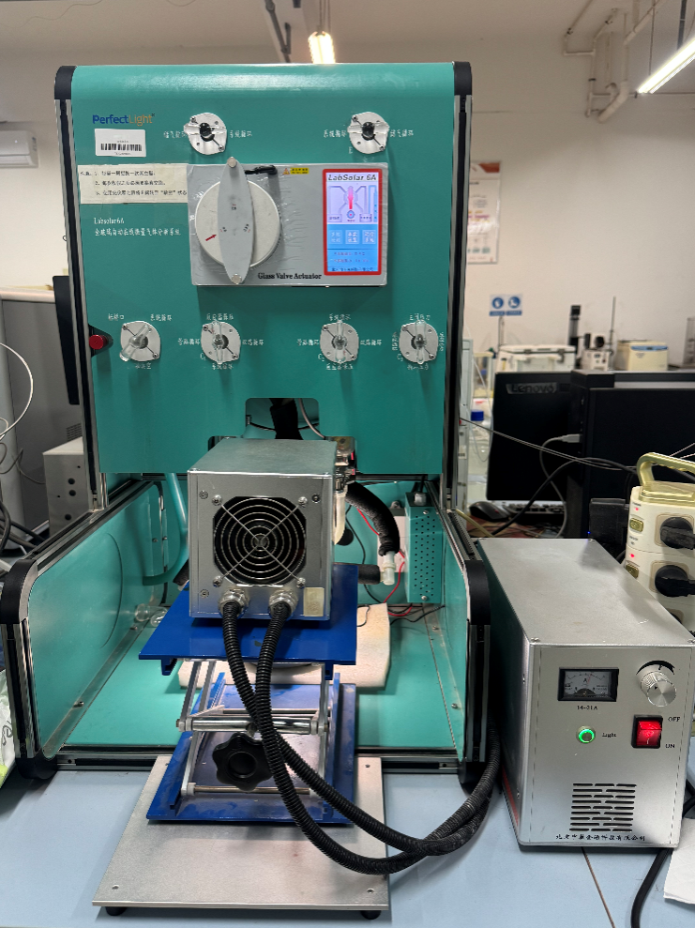
Fig. S5. CO₂ reduction reaction system.

Fig. S6. CO₂ reduction performance of ZOCS−20 at different temperatures under dark conditions.

Fig. S7. H₂ production rate of ZrO₂, CdS, and ZOCS−20.

Fig. S8. Infrared thermographic images of different samples.

Fig. S9. Temperature of different samples.

Fig. S10. TEM image of ZOCS−20 after reaction.

Fig. S11. DSC of ZrO2, CdS, and ZOCS−20.

Fig. S12. OCP curves of ZrO₂, CdS, and ZOCS−20.

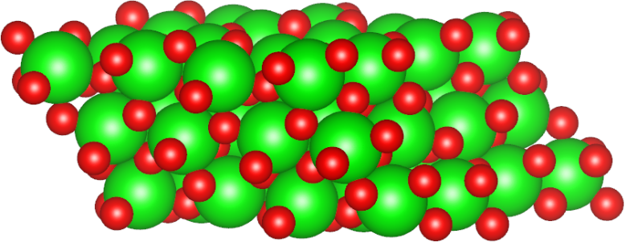
Fig. S13. Catalyst model of ZrO₂.

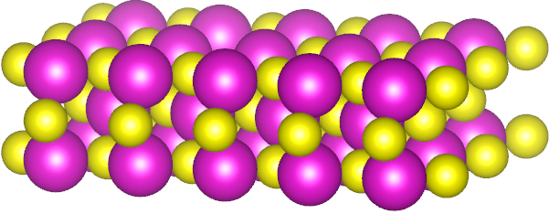
Fig. S14. Catalyst model of CdS.

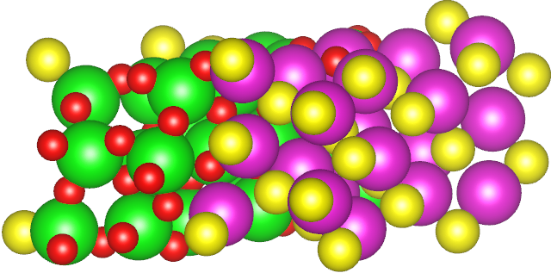
Fig. S15. Catalyst model of ZOCS−20.

Fig. S16. Adsorption model of CO₂ at the ZrO₂/CdS interface.

Fig. S17. High−resolution O 1s XPS spectra of ZOCS−20 under dark and light conditions.

Fig. S18. High−resolution S 2p XPS spectra of ZOCS−20 under dark and light conditions.

Fig. S19. DOS of ZrO₂ and PDOS for Zr and O.

Fig. S20. DOS of CdS and PDOS for Cd and S.

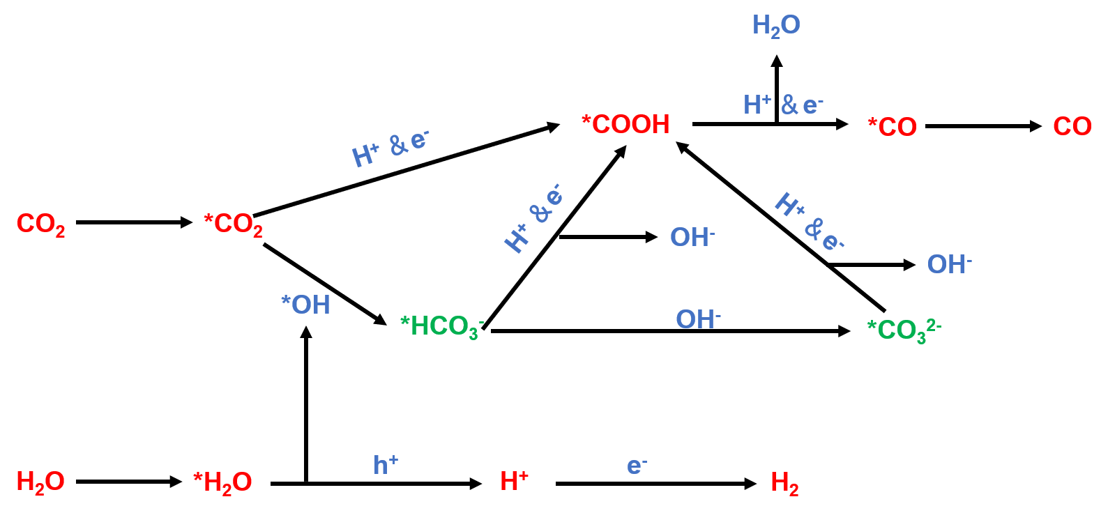
Fig. S21. Catalytic reduction process of CO₂ on ZOCS−20.

Fig. S22. Adsorption configurations of reaction intermediates on the ZrO₂ catalyst surface.

Fig. S23. Adsorption configurations of reaction intermediates on the CdS catalyst surface.

Fig. S24. Adsorption configurations of reaction intermediates on the ZOCS−20 catalyst surface.

References
[1] Xiao Y, Li M, Li H, et al. Multi-channel charge transfer in self-supporting B-g-C₃N_{x}/Bi₂S₃/CdS dual S-scheme heterojunction toward enhanced photothermal-photocatalytic performance. Nano Energy, 2024, 120: 109164.
[2] Xiao S, Li Z, Fu Q, et al. Hybrid microbial photoelectrochemical system reduces CO₂ to CH₄ with 1.28% solar energy conversion efficiency. Chemical Engineering Journal, 2020, 390: 124530.
[3] Xu L, Ren Y, Fu Y, et al. Strong photo-thermal coupling effect boosts CO₂ reduction into CH₄ in a concentrated solar reactor. Chemical Engineering Journal, 2023, 468: 143831.
[4] Wang L, Jin P, Duan S, et al. In-situ incorporation of Copper(II) porphyrin functionalized zirconium MOF and TiO₂ for efficient photocatalytic CO₂ reduction. Science Bulletin, 2019, 64 (13): 926–933.
[5] Feng Y-X, Dong G-X, Su K, et al. Self-template-oriented synthesis of lead-free perovskite Cs₃Bi₂I₉ nanosheets for boosting photocatalysis of CO₂ reduction over Z-scheme heterojunction Cs₃Bi₂I₉/CeO₂. Journal of Energy Chemistry, 2022, 69: 348–355.
[6] Huang Y, Zhang J, Dai K, et al. Efficient solar-driven CO₂ reduction on aminated 2D/2D BiOBr/CdS-diethylenetriamine S-scheme heterojunction. Ceramics International, 2022, 48 (6): 8423–8432.
[7] Wang J-C, Zhang L, Fang W-X, et al. Enhanced Photoreduction CO₂ Activity over Direct Z-Scheme α-Fe₂O₃/Cu₂O Heterostructures under Visible Light Irradiation. ACS Applied Materials & Interfaces, 2015, 7 (16): 8631–8639.
[8] Mo S, Zhao X, Li S, et al. Non-Interacting Ni and Fe Dual-Atom Pair Sites in N-Doped Carbon Catalysts for Efficient Concentrating Solar-Driven Photothermal CO₂ Reduction. Angewandte Chemie International Edition, 2023, 62 (50): e202313868.
[9] Dong S, Liu W, Liu S, et al. Single atomic Pt on amorphous ZrO₂ nanowires for advanced photocatalytic CO₂ reduction. Materials Today Nano, 2022, 17: 100157.
[10] Liang M, Borjigin T, Zhang Y, et al. Controlled assemble of hollow heterostructured g-C₃N₄@CeO₂ with rich oxygen vacancies for enhanced photocatalytic CO₂ reduction. Applied Catalysis B: Environmental, 2019, 243: 566–575.
[11] Pan X, Xu Y-J. Graphene-Templated Bottom-up Fabrication of Ultralarge Binary CdS–TiO₂ Nanosheets for Photocatalytic Selective Reduction. The Journal of Physical Chemistry C, 2015, 119 (13): 7184–7194.
[12] Di J, Chen C, Zhu C, et al. Cobalt nitride as a novel cocatalyst to boost photocatalytic CO₂ reduction. Nano Energy, 2021, 79: 105429.
[13] Ren Y, Lan S, Zhu Y-H, et al. Concentrated Solar-Driven Catalytic CO₂ Reduction: From Fundamental Research to Practical Applications. ChemSusChem, 2025, 18 (10): e202402485.
[14] Wu M, Ren Y, Zhu F, et al. Photothermal Coupling Effect Boosts the Conversion of CO₂ to Solar Fuel Over Pt/ZnO Photocatalyst in a Concentrated Solar Reactor. Industrial & Engineering Chemistry Research, 2023, 62 (24): 9463–9473.
[15] Chen J, Ren Y, Fu Y, et al. Integration of Co Single Atoms and Ni Clusters on Defect-Rich ZrO₂ for Strong Photothermal Coupling Boosts Photocatalytic CO₂ Reduction. ACS Nano, 2024, 18 (20): 13035–13048.
[16] Rashid R T, Chen Y, Liu X, et al. Tunable green syngas generation from CO₂ and H₂O with sunlight as the only energy input. Proceedings of the National Academy of Sciences, 2022, 119 (26): e2121174119.
[17] Cheng L, Yue X, Wang L, et al. Dual-Single-Atom Tailoring with Bifunctional Integration for High-Performance CO₂ Photoreduction. Advanced Materials, 2021, 33 (49): 2105135.
[18] Bian H, Liu T, Li D, et al. Unveiling the effect of interstitial dopants on CO₂ activation over CsPbBr₃ catalyst for efficient photothermal CO₂ reduction. Chemical Engineering Journal, 2022, 435: 135071.
[19] Wang J, Peng R, Zhu Y-H, et al. The photothermal coupling effect boosts the conversion of CO₂ to C₂H₄ over CeO₂/WO₃ heterojunctions under concentrated solar irradiation. New Journal of Chemistry, 2025, 49 (17): 7060–7072.
[20] Wang K, Ren Y, Wang N, et al. Band-division utilization of core-shell photocatalyst under condenser solar-light and enhancement of synergistic catalytic CO₂ reduction. Chemical Engineering Journal, 2024, 479: 147529.
[21] Xiong X, Mao C, Yang Z, et al. Photocatalytic CO₂ Reduction to CO over Ni Single Atoms Supported on Defect-Rich Zirconia. Advanced Energy Materials, 2020, 10 (46): 2002928.

