Electronic Supplementary Material

Bifunctional Pt/TiO₂-O_{v} Catalysts for Enhanced Electron Transfer and CO Tolerance in Acidic HOR and ORR

1 Experimental
1.1 Chemicals and materials

Pt/C (20 wt% Pt, TKK) was commercially acquired from TANAKA. Ethylene glycol, H₂PtCl₆·6H₂O (Pt ≥37.5%), isopropanol, KBr, Hydrofluoric acid (HF) were supplied by Aladdin, Ltd. (Shanghai, China). H₂O₂ (AR), Ammonia solution (AR) and Ti(SO₄)₂ were purchased from SINOPHARM GROUP CO.LTD. A 50 wt.% aqueous suspension of TM-50 was obtained from Sigma-Aldrich. Ultrapure water, having a resistivity of 18.2 MΩ·cm at 25 ℃ was supplied by Merck Millipore (USA). Nafion (D-520) from Dupont (polymer content: 5%) served as the ionomer. High-purity gases (>99.999%), including Ar, H₂, and O₂, were used throughout the experiments. Additionally, gas mixtures of H₂/1000 ppm CO and O₂/1000 ppm CO were also employed. All reagents were employed in their original form without additional refinement.

1.2 Physicochemical characterizations

SEM images were obtained using a JSM-6610LV electron microscope. The morphological features of the Pt/TiO₂-O_{v} were further examined through TEM, as well as EDS, on an FEI TECNAI G2 F20 operating at 200 kV. The specific surface area was measured using a Micromeritics ASAP2460 instrument (USA). To explore the surface chemistry and oxygen vacancies in the TiO₂ supports, X-ray photoelectron spectroscopy (XPS) was conducted using an ESCALAB 250Xi (Thermo Fisher). XRD data were collected on a Rigaku Ultima IV (Japan). Additionally, oxygen vacancy-related properties were further probed using Raman spectroscopy, carried out on a WITec alpha300 R (Germany), and UV–vis–NIR diffuse reflectance spectra were collected on an Agilent Cary 7000 spectrometer.

1.3 Electrochemical measurements

All electrochemical assessments in this research utilized a conventional three-electrode arrangement, integrated with an RDE setup and managed via a CHI-760E potentiostat. The electrochemical cell was composed of a glassy carbon working electrode (S=0.19625 cm^{–2}), an Hg/HgSO₄ reference electrode (saturated with K₂SO₄), and a carbon rod serving as the counter electrode. Preliminary to the electrochemical assays, the glassy carbon (GC) electrode was refined with 0.05 μm alumina particulates and subsequently subjected to ultrasonic purification. For catalyst ink preparation, the electrocatalyst was dispersed in isopropyl alcohol and ultrapure water (9:1) with 5% (mass fraction) Nafion D520 and ketjenblack EC-600JD. After 25 minutes of sonication, a consistent catalyst ink was produced with a ratio of catalyst and EC-600JD of 4:1. Subsequently, the catalyst ink dispersion was affixed onto the surface-prepared GC for electrochemical testing. The total catalyst loading on GC was 143 μg/cm² for Pt/C (20% TKK) and 305.7 μg/cm² for Pt/TiO₂-O_{v} respectively. All measured potentials in this study were referenced to the reversible hydrogen electrode (RHE) scale.
The cyclic voltammograms (CVs) were recorded to ascertain the ECSA, with the working electrode potential being scanned from 0.05 to 1.2 V (vs. RHE) in Ar-saturated 0.1 M HClO₄ solutions at a scan rate of 50 mV/s. The ORR activity of the catalysts was evaluated through linear sweep voltammetry (LSV), wherein the working electrode potential was scanned between 0.05 and 1.0 V (vs. RHE), employing a RDE at a rotational speed of 1600 r/min and a sweeping rate of 10 mV/s. An accelerated durability test (ADT) was performed at 28°C by subjecting the system to cyclic sweeps between 0.6 and 1.1 V (vs. RHE), at a scan rate of 100 mV/s for a total of 5000 cycles. ECSA values of catalysts were calculated via the equation:
$\text{ECSA}\text{=}\frac{S_{\text{H}}\text{/V}}{\text{0.21}∙M_{Pt}},$ (1)
where S_{H} denotes the charge related with H_{upd} processes, M_{Pt} represents the mass of Pt loaded onto the working electrode (g_{Pt}) and V (V/s) is the sweep rate of CV.
For the HOR tests, all CV testing conditions remain the same as for ORR, while the potential settings for LSV are adjusted to –0.1‒0.9 V, with O₂ replaced by H₂. Chronoamperometry measurements were performed at 0.1 V in a H₂-saturated solution.
The CO poisoning experiments were conducted under the same conditions as the previously mentioned HOR and ORR tests, with the exception that the electrolyte solutions were purged with two distinct gas mixtures: O₂/CO and H₂/CO.
Kinetic current density (${\text{j}}_{\text{k}}$) was deduced from the Kotick-Levich equation:
$\frac{\text{1}}{\text{j}}\text{=}\frac{\text{1}}{{\text{j}}_{\text{k}}}\text{+}\frac{\text{1}}{{\text{j}}_{\text{d}}}\text{=}\frac{\text{1}}{{\text{j}}_{\text{k}}}\text{+}\frac{\text{1}}{\text{B}{\text{C}}_{\text{0}}{\text{ω}}^{\frac{\text{1}}{\text{2}}}}$, （2）
where c₀, B and ω are the solubility of H₂ (7.33 × 10⁻⁴ mol/L), Levich constant, and the rotating speed, respectively.
Exchange current density (${\text{j}}_{\text{0}}$) was calculated by Butler-Volmer equation:
${\text{j}}_{\text{k}}={\text{j}}_{\text{0}}\left[e^{\frac{αFη}{RT}}-e^{\frac{-η(1-α)F}{RT}}\right]$ (3)
where ${\text{j}}_{\text{0}}$ is calculated via the Taylor’s formula：
$\text{j}\text{=}{\text{j}}_{\text{0}}\frac{\text{ηF}}{\text{RT}}$. （4）

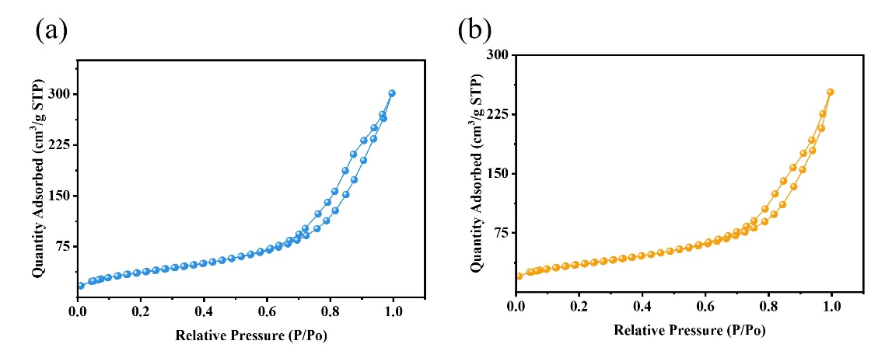
Fig. S1 N₂ adsorption/desorption isotherms of TiO₂ etched in (a) 0.1% and (b) 0.3% HF respectively.

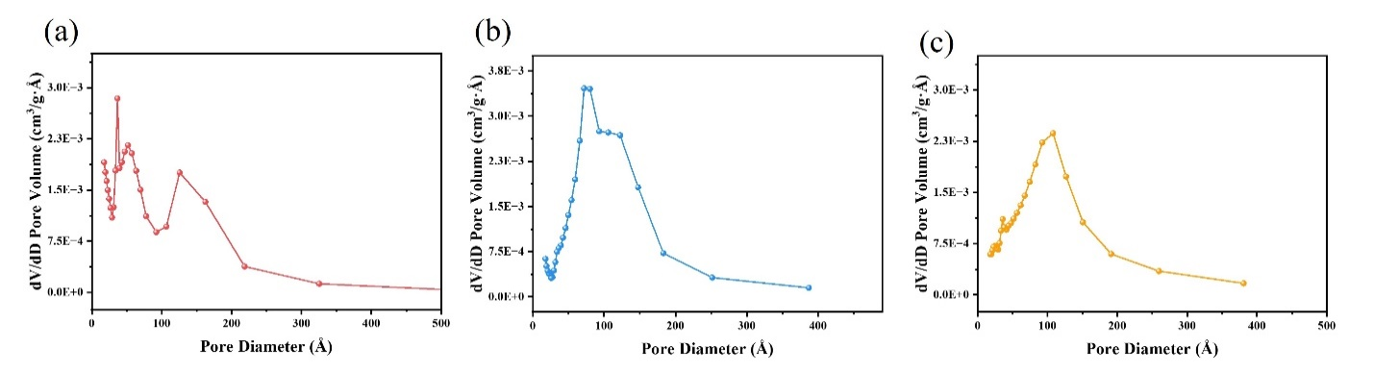
Fig. S2 Pore size distribution of TiO₂ etched in (a) 0.5%, (b) 0.3% and (c) 0.1% HF respectively.

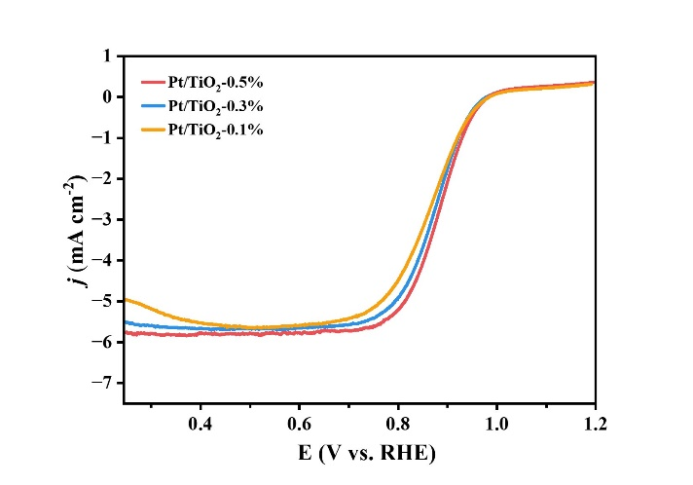
Fig. S3 ORR polarization curves of Pt/TiO₂-0.5%, Pt/TiO₂-0.3% and Pt/TiO₂-0.1%.

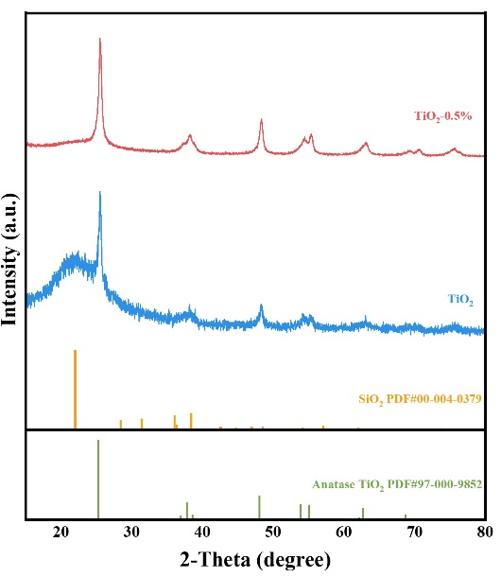
Fig. S4 XRD spectra of TiO₂-0.5% and TiO₂., respectively.

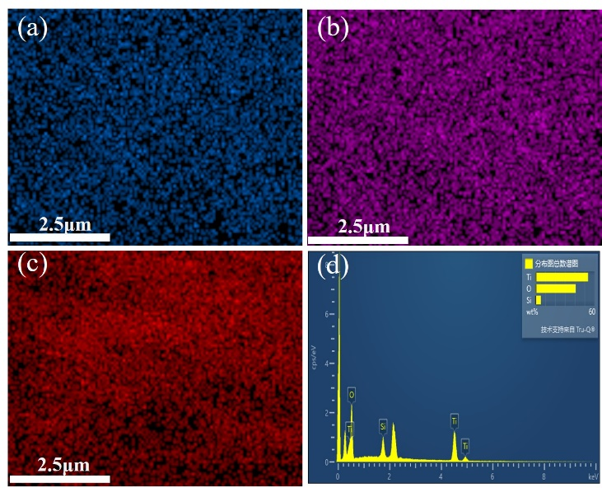
Fig. S5 EDS mapping of TiO₂-0.5%, where (a) blue, (b) pink, and (c) red represent Si, Ti, and O, respectively.

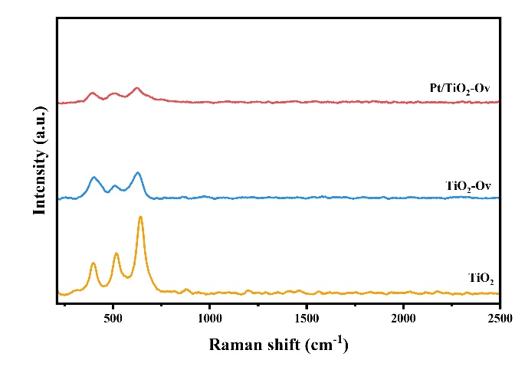
Fig. S6 Raman spectrum of Pt/TiO₂-O_{v}, TiO₂-O_{v} and TiO₂.
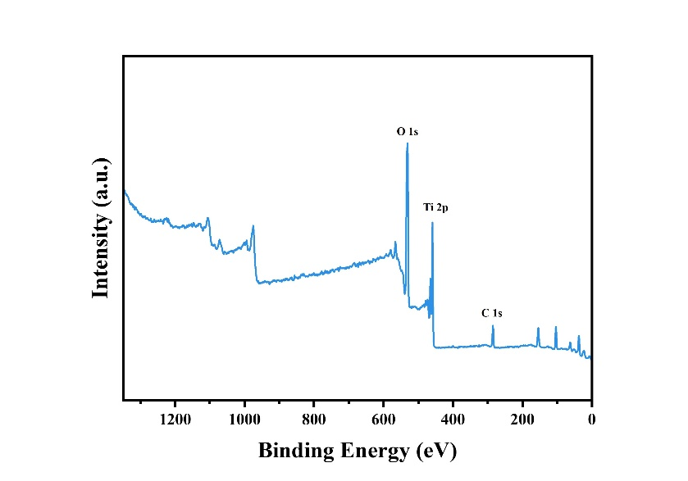
Fig. S7 XPS survey spectrum of TiO₂-O_{v}.
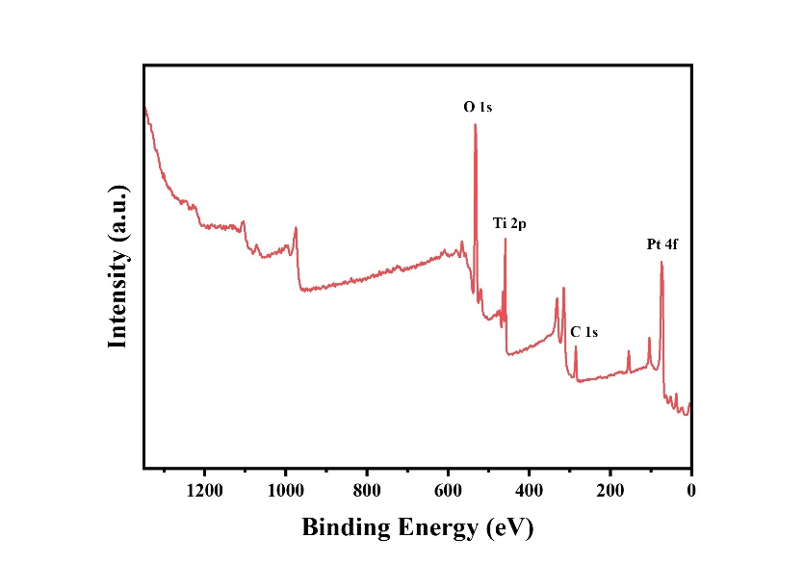
Fig. S8 XPS survey spectrum of Pt/TiO₂-O_{v}.

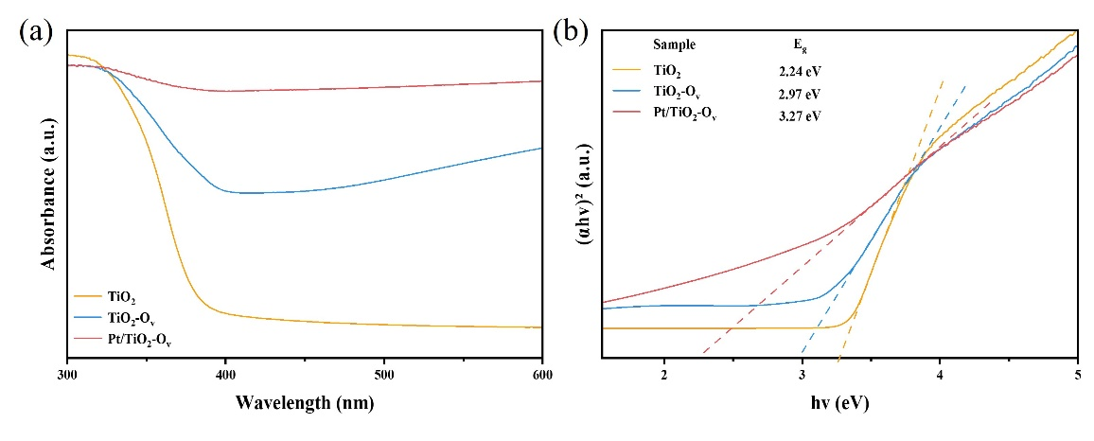
Fig. S9 (a) UV/Vis spectra and (b) The plot of (αhν)² versus photon energy (hν) of TiO₂, TiO₂-O_{v} and Pt/ TiO₂-O_{v}.
The bandgap energy (E_{g}) can be deduced from the relation αhν = C(hν-E_{g})^{1/2}, where α is the absorption coefficient, hν is the photon energy, C is a constant, E_{g} is the band gap energy for direct transition.
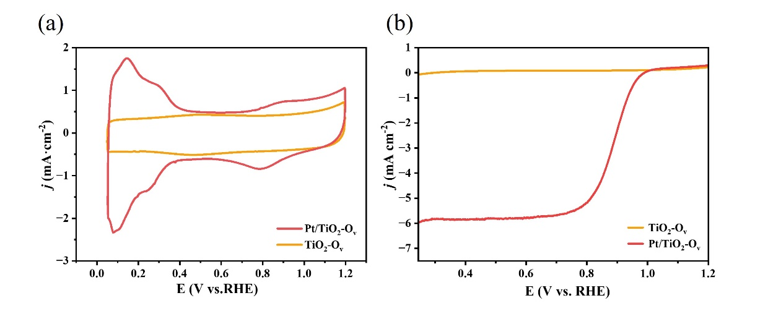
Fig. S10 (a) CV curves of Pt/TiO₂-O_{v} and TiO₂-O_{v} in Ar-saturated 0.1 M HClO₄; (a) LSV curves of Pt/TiO₂-O_{v} and TiO₂-O_{v} in O₂-saturated 0.1 M HClO_{4.}

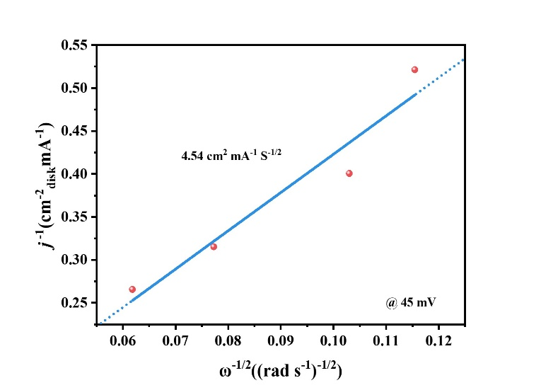
Fig. S11 Koutechy−Levich plot.

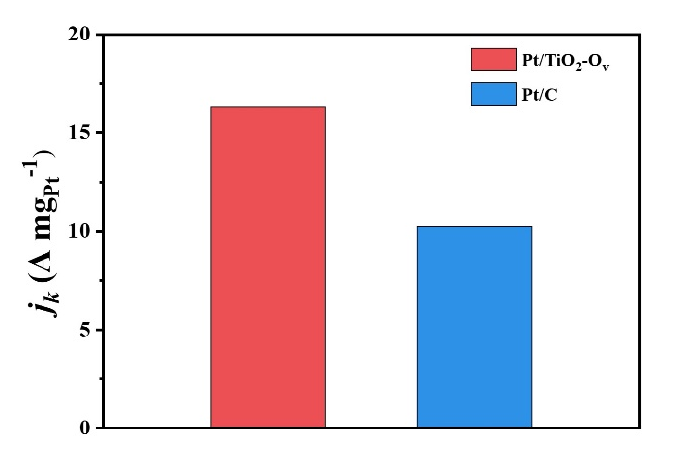
Fig. S12 Comparison of j_{k} of two samples.

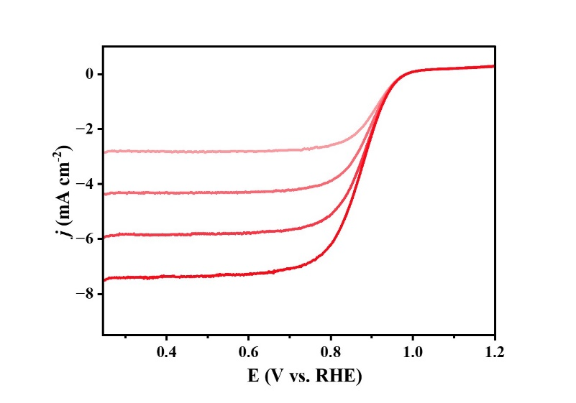
Fig. S13 LSV curves of Pt/TiO₂-O_{v} at different rotating rates (400−2500 r/min).
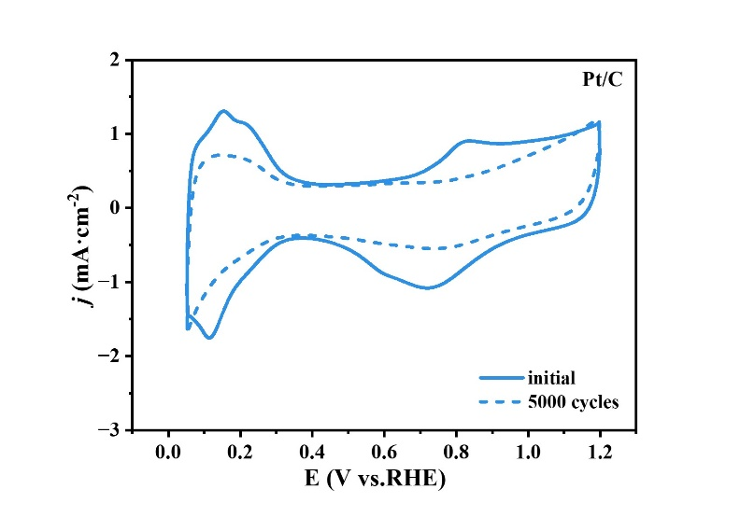
Fig. S14 CV curves of Pt/C before and after ADT.

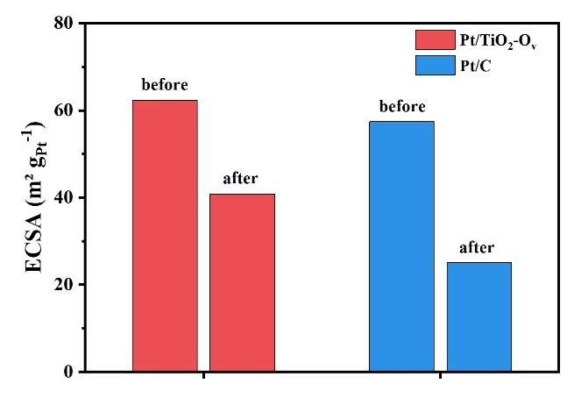
Fig. S15 ECSA of Pt/TiO₂-O_{v} and Pt/C before and after ADT.

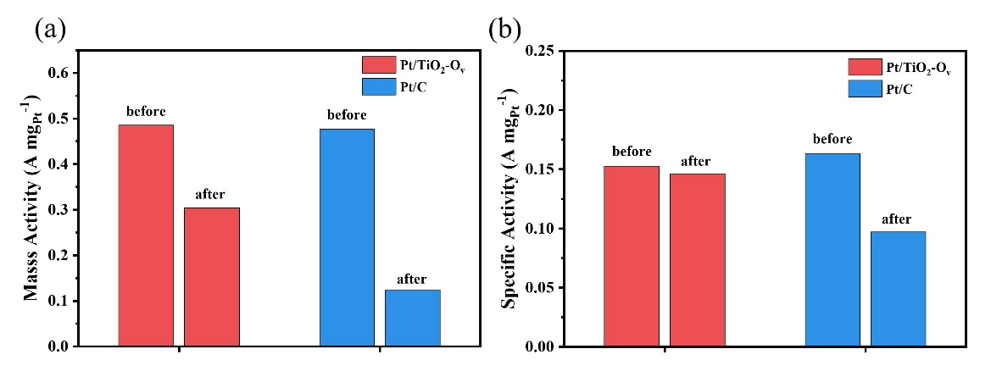
Fig. S16 (a) MA and (b) SA of Pt/TiO₂-O_{v} and Pt/C before and after ADT.

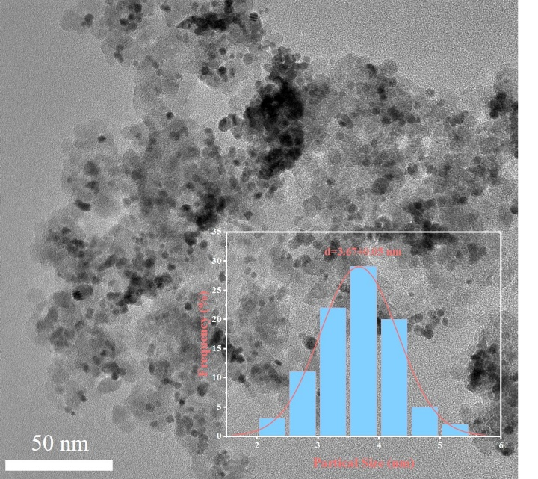
Fig. S17 TEM image of Pt/TiO₂-O_{v} after ADTs.

Table S1 Elemental composition using EDS of TiO₂-0.5%, TiO₂-0.3% and TiO₂-0.1%

Element /At% | TiO₂-0.5% | TiO₂-0.3% | TiO₂-0.1%
O | 66.03 | 66.95 | 67.44
Si | 5.08 | 10.29 | 14.78
Ti | 28.89 | 22.76 | 17.78

Table S2 Elemental contents of as-prepared Pt/TiO₂-O_{v} measured by ICP-OES

Element | wt. %
Si | 14.45
Ti | 28.96
Pt | 15.99

