Supporting Information
Surface electron reconfiguration of artificial interface layer by cationic doping for stable and dendrite-free zinc anode
Linlong Lu^{1, 2}, Zheng Wang^{1, 2}, Jingwen Cai^{1, 2}, Zhengyu Bao^{1, 2}, Yukai Lan^{1, 2}, Yinze Zuo^{1, 2*}, Yidong Jiang^{1, 2}, Wei Yan^{1, 2*}, Jiujun Zhang^{1, 2*}

¹ Institute for New Energy Materials and Engineering, College of Materials Science and Engineering, Fuzhou University, Fuzhou 350108, China
² Fujian Engineering Research Center of High Energy Batteries and New Energy Equipment and Systems, Fuzhou University, Fuzhou, 350108, China
E-mails: yinzezuo@fzu.edu.cn; weiyan@fzu.edu.cn; jiujun.zhang@fzu.edu.cn

Experimental Section
- Preparation of electrolytes
Take 5.75 g of ZnSO₄·7H₂O (ZnSO₄·7H₂O, AR, Aladdin) is dissolved in deionized water to form a 10 mL solution, obtaining a 2 mol/L ZnSO₄ electrolyte.
- Preparation of electrodes
2.1 Synthesis of CeO₂ and Cu₂Ce₇O_{x}
CeO₂ and Cu₂Ce₇O_{x}: First, dissolve 4 g of polyvinylpyrrolidone (PVP, K30, M.W.~40000) in 20 mL of deionized water. Weigh a total mass of 4 g of cerium nitrate hexahydrate (Ce(NO₃)₃·6H₂O, 99.5％metals basis, Aladdin) and copper nitrate trihydrate (Cu(NO₃)₂·3H₂O, AR) with a molar mass ratio of 7:2 and dissolve them in the previous solution so that the mass ratio of PVP to metal salts is 1. After ultrasonic treatment for 30 min, a uniform and transparent solution is obtained. Rapidly condense with liquid nitrogen and freeze-dry for 48 hours to remove water. The dried material is calcined at 400 °C (heating rate is 5 °C/min) for 6 h to obtain Cu₂Ce₇O_{x} powder. For CeO₂ powder, take 4 g of Ce(NO₃)₃·6H₂O and PVP respectively and dissolve them in deionized water.
  - Preparation of Anode
Bare Zn: The Zn foil (100 μm, 99.99％) is punched into a disc with a diameter of 12 mm through a mold. Then, it is ultrasonically treated with anhydrous ethyl alcohol (AR) for 30 min to remove surface oxides and other impurities, and then put into an oven for drying.
CeO₂@Zn and Cu₂Ce₇O_{x}@Zn: The synthesized CeO₂ and Cu₂Ce₇O_{x} were respectively mixed with polyvinylidene fluoride (PVDF) at a molar mass ratio of 9:1 and stirred for 8 h using a magnetic stirrer. After the stirring was completed, the slurry was uniformly coated onto the cleaned Zn foil by the doctor blade coating method. Subsequently, it was placed in a vacuum environment and dried at 60 °C for 12 h to obtain the CeO₂@Zn and Cu₂Ce₇O_{x}@Zn. Finally, cut it into circular pieces with a diameter of 12 mm, and then they can be used as anodes.
2.3 Synthesis and preparation of manganese dioxide cathode
Manganese dioxide (MnO₂) is synthesized by hydrothermal method. 3 mmol of manganese sulfate monohydrate (MnSO₄·H₂O, AR, ≥99％, Aladdin) and 0.15 mmol of potassium permanganate (KMnO₄, ACS, ≥99％, Aladdin) are dissolved in 30 mL of deionized water and stirred for 30 min. Then 2 mL of sulfuric acid with a concentration of 0.5 mol/L is slowly dropped into the stirred solution and stirred vigorously. Transfer to a 50 mL reaction kettle, heat at 120 °C for 12 h, and cool to room temperature in an air atmosphere. The precipitate obtained after the reaction is rinsed several times with deionized water, purified by centrifugation, and dried in a vacuum drying oven at 70 °C overnight to obtain pure α-MnO₂ powder. The cathode is prepared by uniformly mixing α-MnO₂ powder, Super p, and PVDF in a mass ratio of 7:2:1. Using NMP as a solvent to obtain a fluid with a yogurt-like texture. After stirring for 6‒8 h, the fluid is uniformly coated on the stainless steels mesh by the blade method and dried in a vacuum at 60 °C for 12 hours.
- Characterizations
Raman spectroscopy is measured using Witec Alpha 300 with a 532 nm laser. Fourier transform infrared spectroscopy (FTIR) is measured under the condition of wavenumber range of 800–4000 cm^{–1}. The XRD experiment was conducted on a Bruker D8 Advance diffractometer with Cu Ka radiation and generated at 40 kV and 40 mA. The images of scanning electron microscopy (SEM) and transmission electron microscopy (TEM) are also measured by instruments from Bruker. The synthesized materials are studied by X-Ray-photoelectron spectroscopy (XPS, Thermo Scientific K-Alpha). The interfacial wettability of electrode surface in the ZnSO₄ electrolytes is evaluated by the contact angle measurements (SDC 350KS). The surface condition during the battery deposition process is measured by in-situ optical microscopy.
- Electrochemical measurements
All testing CR2032-type coin cells were assembled in air environment by using a glass fiber filter (GF/D, Whatman) as the separator. The electrolyte amount used in cells was 120 μL. Zn/Zn symmetric cells were fabricated by using two identical Zn foils (100 μm, a circular disc with a diameter of 12 mm.). Zn/Cu half-cells were assembled with Cu foil (50 μm) as the working electrode and Zn foil (100 μm) as the reference and counter electrode. The Zn/MnO₂ full cell uses 2 mol/L ZnSO₄ electrolyte, the discharge/charge measurements of cells were conducted using a LAND Cell Test System. CV curves of the Zn plating/stripping were measured using the Zn/Cu half-cell at a scan rate of 0.5 mV/s. The chronoamperometry tests were measured based on the Zn/Zn coin cell at a fixed overpotential of ‒150 mV. LSV curves were measured using a Zn/Ti coin cell at a scan rate of 5 mV/s. Tafel plots were measured based on the three-electrode system, the working electrodes (WE) of bare Zn, CeO₂@Zn, and Cu₂Ce₇O_{x}@Zn, Ag/AgCl electrode as the reference electrode (RE) and the platinum sheet as the counter electrode (CE) by scanning between –1.2 and 0.7 V at 5 mV/s.
Moreover, the theoretical basis for the calculation of activation energy is the Arrhenius equation:
$k=A*e^{\frac{-E_{a}}{RT}}$.
Among them, $k$ is the reaction rate constant, A is the pre-exponential factor (also known as the frequency factor), Ea is the activation energy (with the unit of J/mol), R is the molar gas constant (R = 8.314 J/(mol·K)), and T is the thermodynamic temperature (with the unit of K).
- Theoretical calculations
The DFT calculations with periodic models are performed in this work by Vienna Ab initio Simulation Package (VASP). A generalized gradient approximation (GGA) and projector augmented wave (PAW) method were used to better simulate the electronic structures and the core-electron interaction. The cutoff energy for all the computations was set 450 eV. In addition, the force threshold of optimization convergence was 0.05 eV/Å. The adsorption energies of obtained by following formula:
E_{ads}= E_{slab+molec} – E_{slab} – E_{molec},
where E_{slab+molec} means the total energy of the slab with species adsorbed, E_{slab} indicates the energy of the slab and E_{molec} represents the energy of the molecule in vaccum.

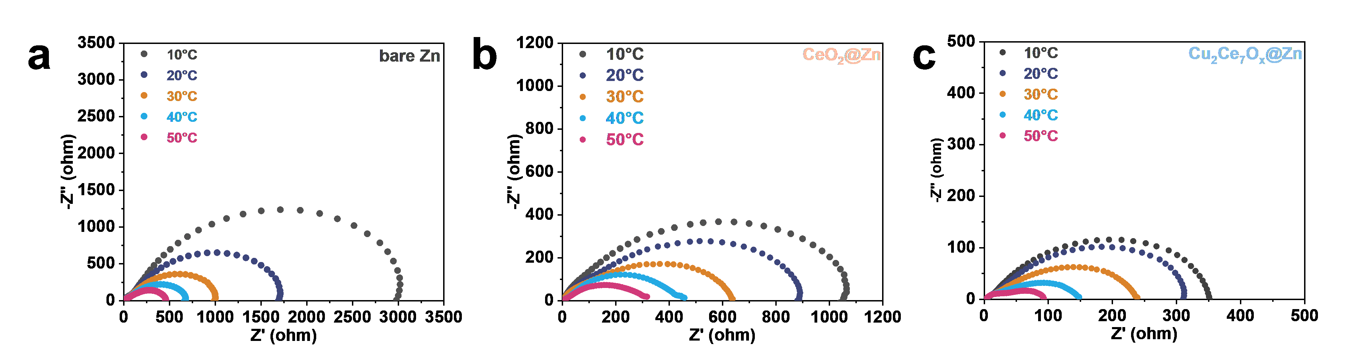Fig. S1 EIS of (a) bare Zn/bare Zn, (b) CeO₂@Zn/CeO₂@Zn, and (c) Cu₂Ce₇O_{x}@Zn/Cu₂Ce₇O_{x}@Zn symmetric cells at different temperatures.

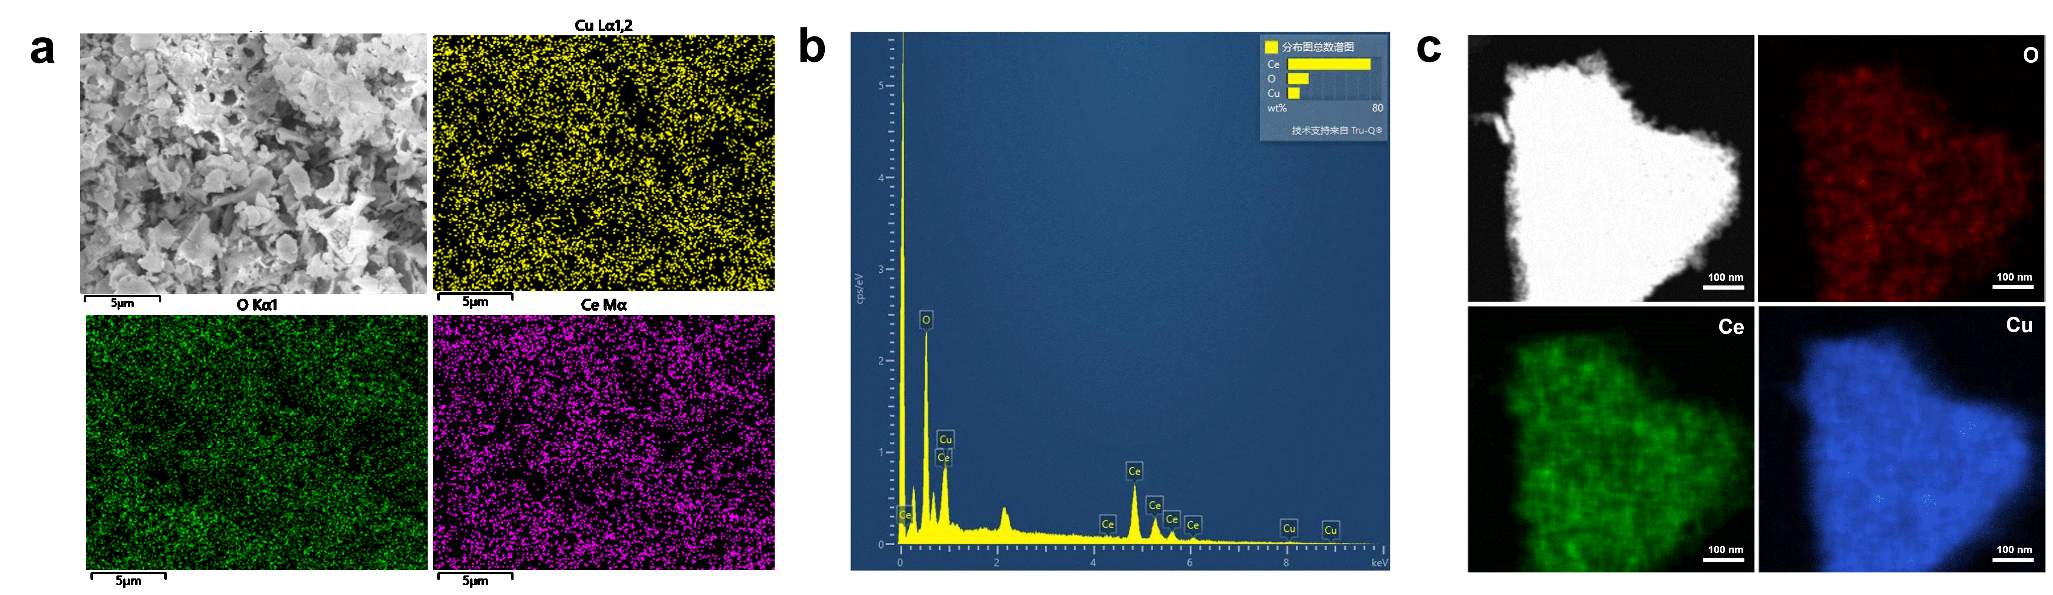
Fig. S2 (a) The SEM image of Cu₂Ce₇O_{x} and elemental distribution mapping. (b) The proportional content of each element in Cu₂Ce₇O_{x}, as measured by the elemental scanning analyzer in SEM. (c) The TEM image of Cu₂Ce₇O_{x} and elemental distribution mapping.

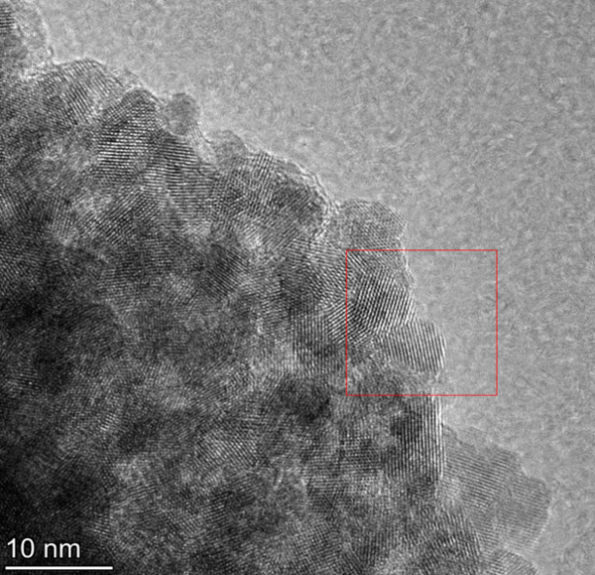
0.309 nm
5 nm
CeO₂ (111))

Fig. S3 The microscopic morphologies of CeO₂ and lattice plane spacing under TEM.

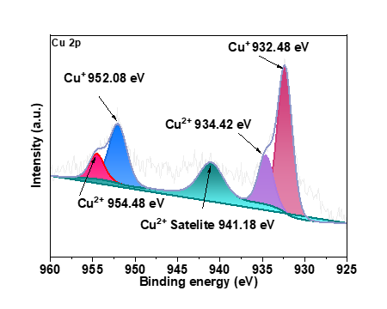
Fig. S4 XPS spectrum of Cu 2p in Cu₂Ce₇O_{x}.

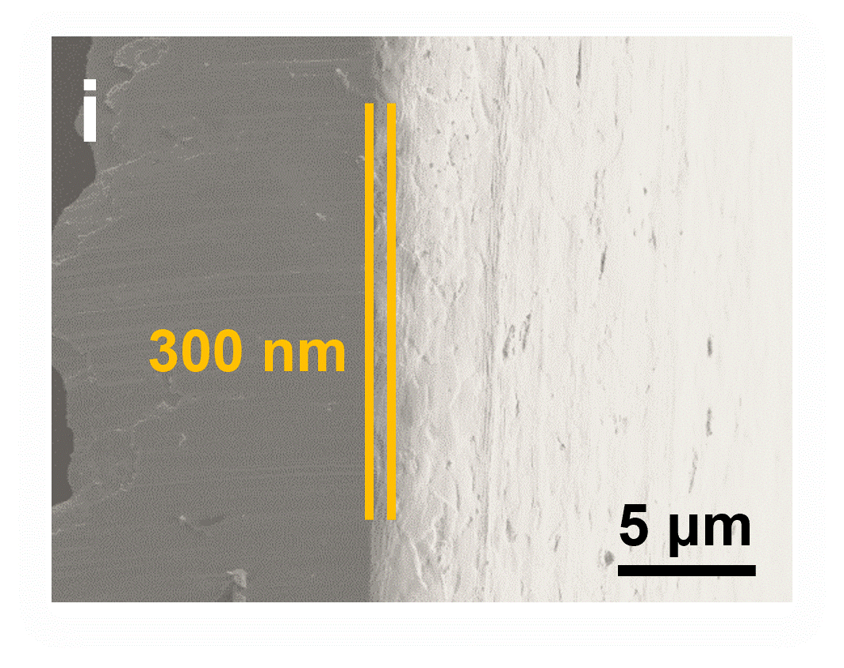
Fig. S5 Cross-sectional SEM image of Cu₂Ce₇O_{x}@Zn.

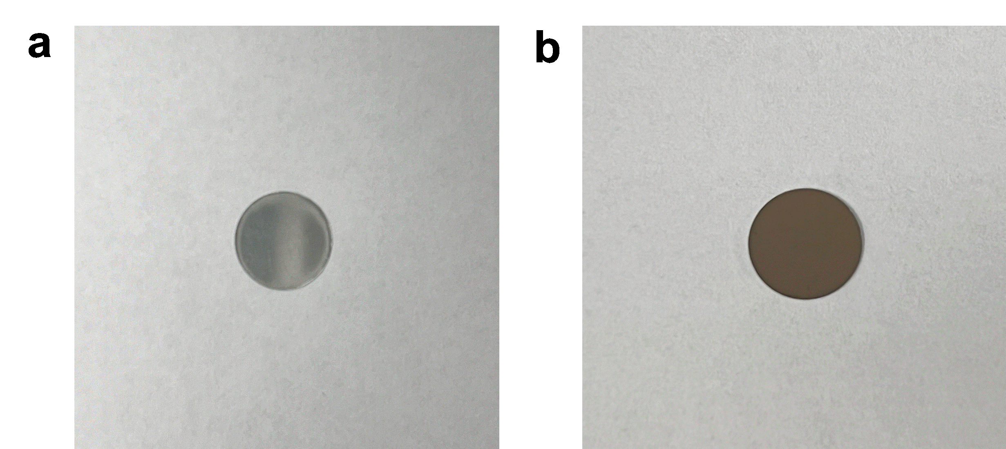
Fig. S6 Surface comparison between (a) bare Zn and (b) Cu₂Ce₇O_{x}@Zn.

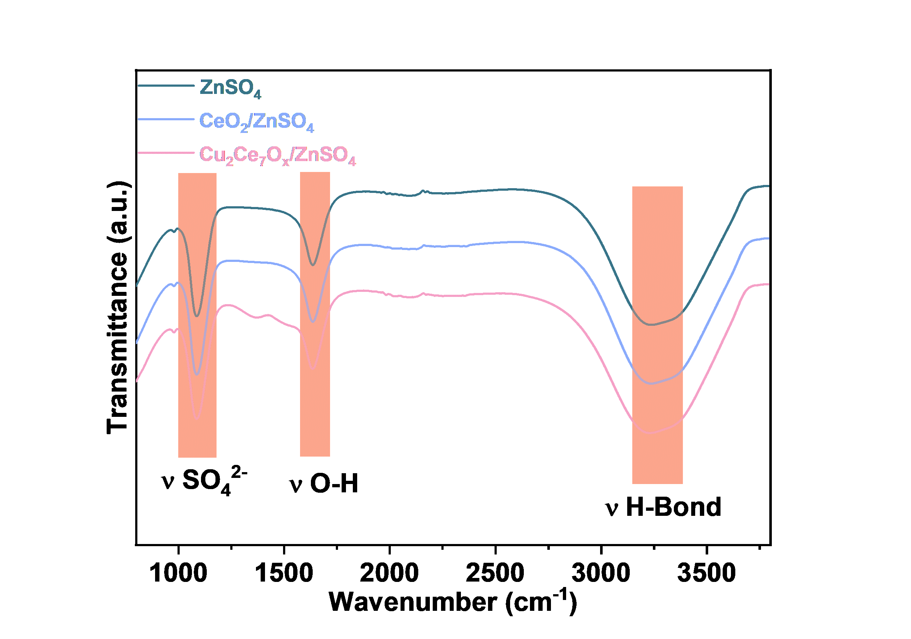
Fig. S7 The infrared spectra of ZnSO₄ electrolyte, as well as those of CeO₂ and Cu₂Ce₇O_{x} in ZnSO₄ electrolyte.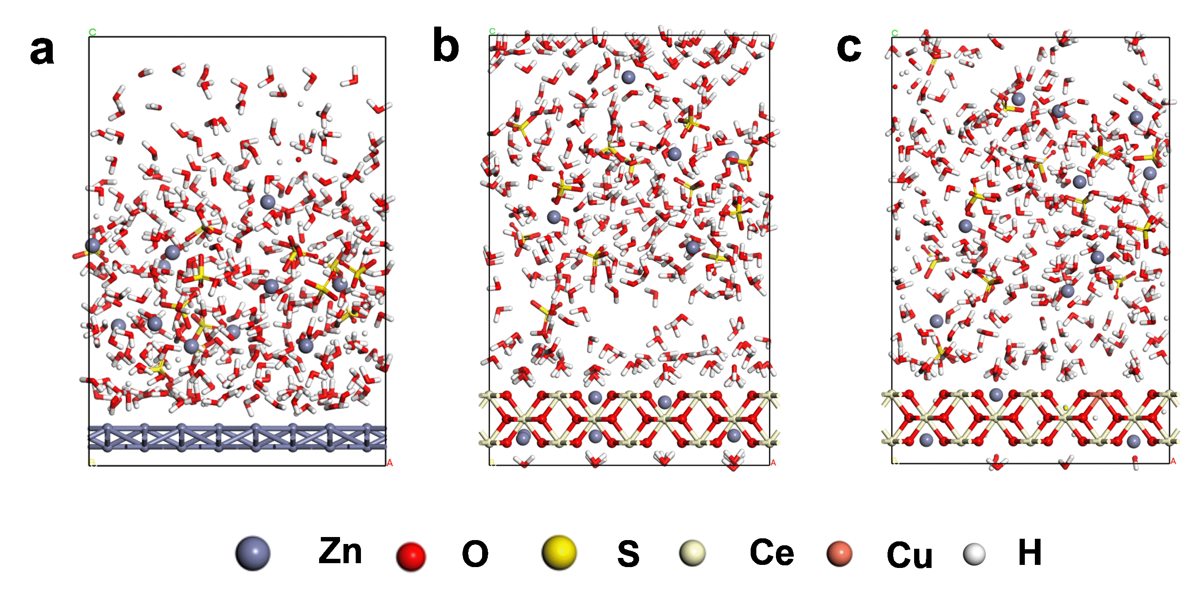

Fig. S8 Molecular dynamics simulation of the solution states of (a) bare Zn, (b) CeO₂@Zn, and (c) Cu₂Ce₇O_{x}@Zn at the electrode/electrolyte interfaces.

Fig. S9 Comparison of the solvation energies of the bare Zn/electrolyte, CeO₂@Zn/electrolyte and Cu₂Ce₇O_{x}@Zn/electrolyte interfaces.

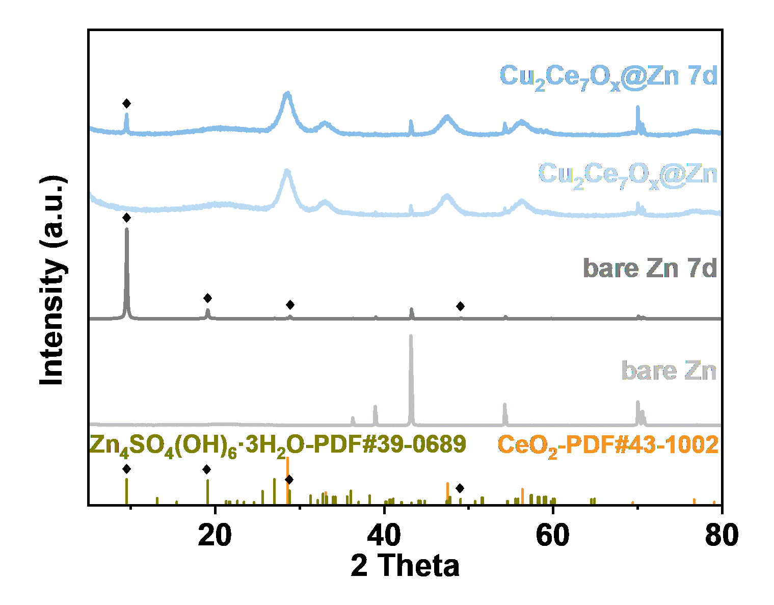
Fig. S10 XRD patterns of bare Zn and Cu₂Ce₇O_{x}@Zn after immersion for seven days.

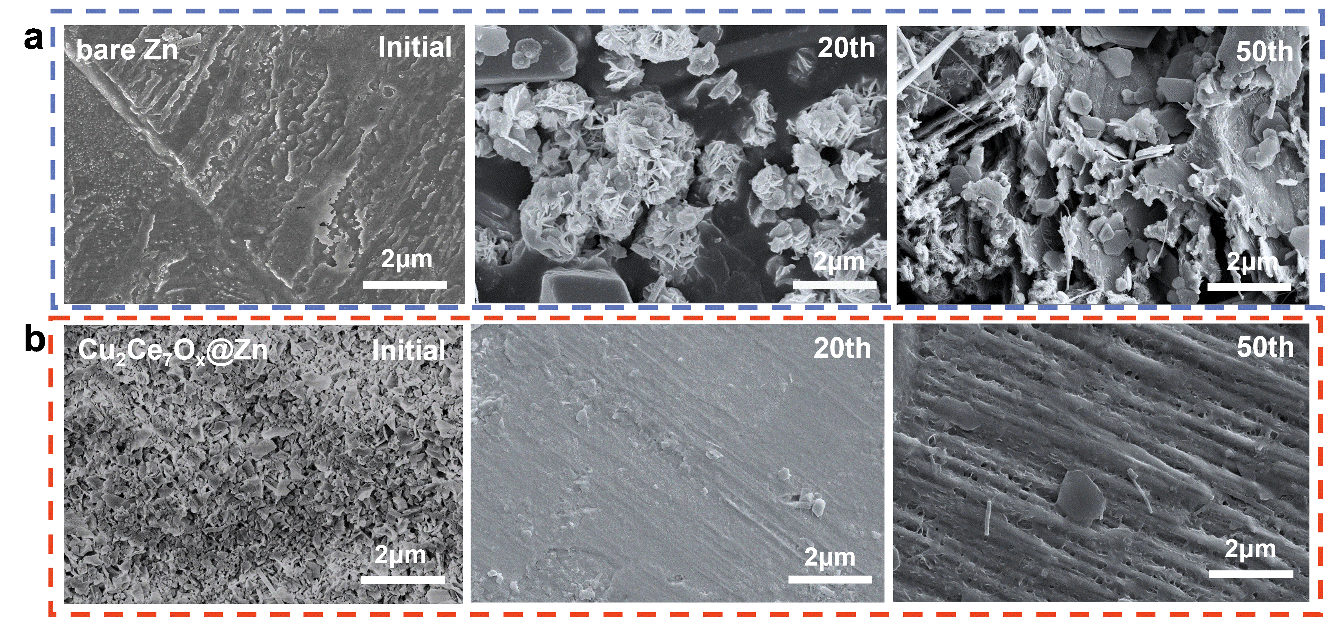
Fig. S11 SEM images of bare Zn and Cu₂Ce₇O_{x}@Zn electrodes before cycling and after 50 cycles.
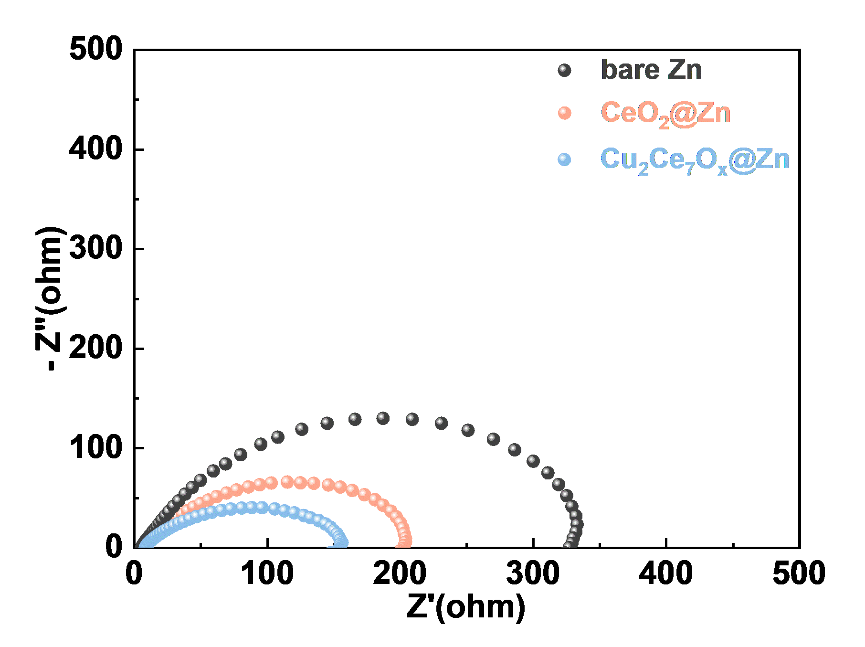
Fig. S12 EIS of Zn/Zn symmetric cells at room temperature (25 °C).

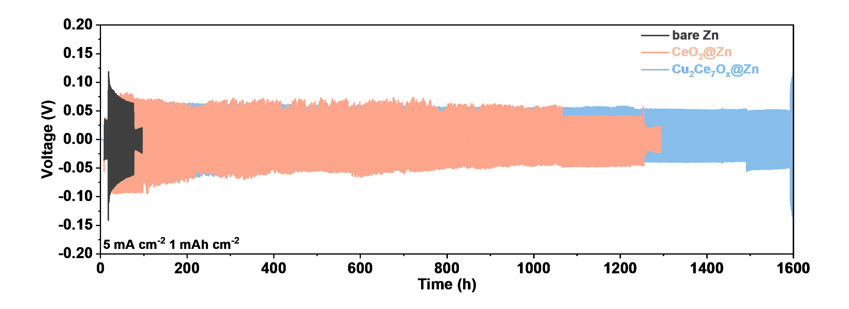
Fig. S13 The time-voltage curves of symmetric cells under the conditions of the current density of 5 mA/cm² and the capacity of 1 mAh/cm².

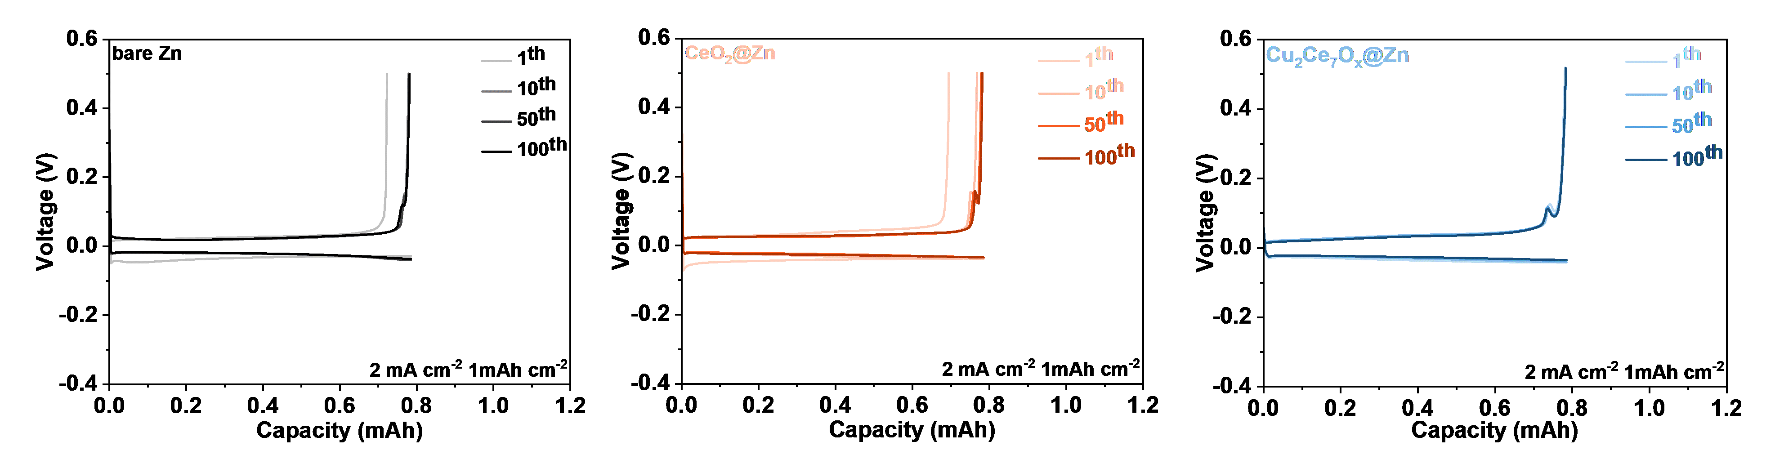

Fig. S14 Potential capacity curves of (a) bare Zn/Cu, (b) CeO₂@Zn/Cu, and (c) Cu₂Ce₇O_{x}@Zn/Cu asymmetric cells.
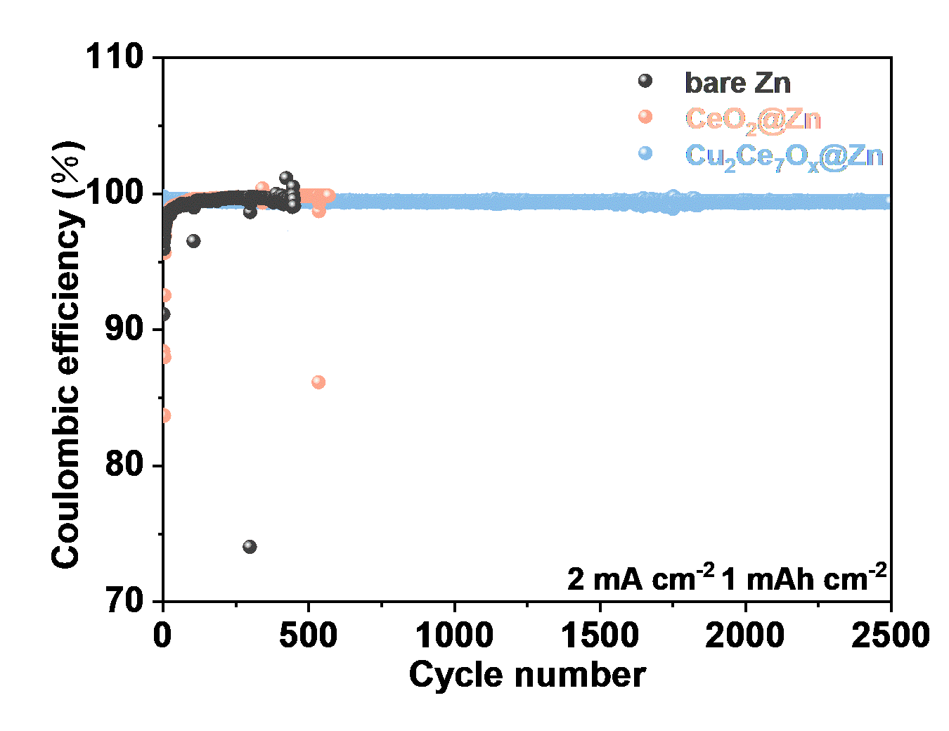

Fig. S15 Long cycle test of bare Zn/Cu, CeO₂@Zn/Cu and Cu₂Ce₇O_{x}@Zn/Cu asymmetric cells.

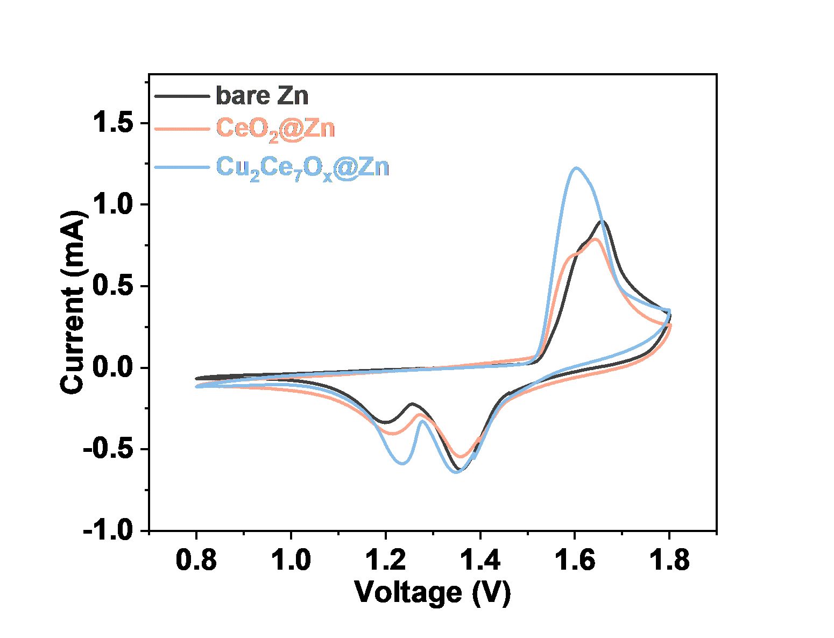
Fig. S16 The CV curves of the bare Zn/MnO₂, CeO₂@Zn/MnO₂, and Cu₂Ce₇O_{x}@Zn/MnO₂ full cells in the third cycle, under the condition of the scan rate of 0.5 mV/s.

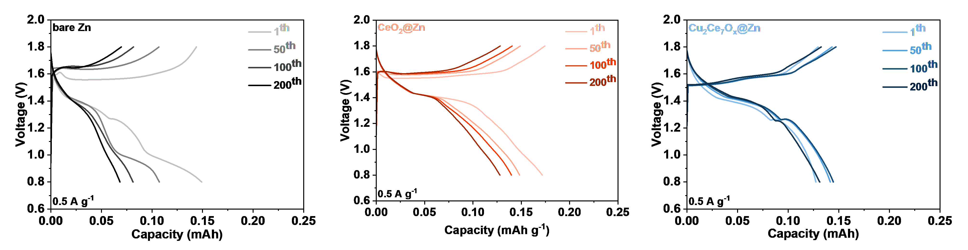

Fig. S17 GCD curves of bare Zn/MnO₂, CeO₂@Zn/MnO₂, and Cu₂Ce₇O_{x}@Zn/MnO₂ full cells at different cycle numbers under a current condition of 0.5 A/g.

