Supporting Information
Boosting Zn²⁺ Storage Performance of MnO₂ Cathode by Engineering Dual-Crystal-Phases Architecture for Reversible Zn-Ion Batteries
Experiment section
Synthesis of MnO₂:
In a typical process, 4 mmol KMnO₄ and 4 mmol NH₄Cl (KMnO₄: NH₄Cl = 1:1) were added into the 35 mL deionized water with the constant stirring for 1 h until their completely dissolved. Then, the hybrid solution was transferred to a 100 mL Teflon autoclave in an oven at 140 ℃ for reaction for 12 h. After cooling down to room temperature, the MnO₂ powders were obtained by centrifugation and washing by DI water and ethanol several times and dried at 80℃ overnight. The addition concentration of NH₄Cl (KMnO₄:NH₄Cl = 1:1, 1:2, 1:4, 1:6, 1:8, 1:10, 1:12) was controlled to optimize the performances. The obtained powders were denoted as the KMO:NH₄⁺@1:1, KMO:NH₄⁺@1:2, KMO:NH₄⁺@1:4, KMO:NH₄⁺@1:6, KMO: NH₄⁺@1:8, KMO: NH₄⁺@1:10 and KMO: NH₄⁺@1:12 respectively.
Material characterization:
The crystalline structures and composition characteristics of MnO₂ powder were measured by X-ray diffraction (XRD, Bruker, D8 DISCOVER). Scanning electron microscope (SEM, Hitachi S-4800) and field emission electron microscopy (FETEM, Talos F200X) were used to investigate the microstructure of the samples. X-ray photoelectron spectroscopy (XPS, PHI5700) was carried out to investigate the surface composition and chemical state of the samples. N₂ adsorption/desorption measurement (ASAP 2460) was conducted to understand the pore structure of the samples. Raman spectroscopy was conducted to investigate the composition evolution of the cathodes.
Electrochemical characterization:
The cathodes were fabricated by blade coating of the active slurry (mixing the cathode materials, Super P, and polyvinyl difluoride binder with a mass ratio of 7:2:1 in NMP solvent) onto the graphite paper followed by drying at 60 °C for 12 h. The electrochemical performance of cathode materials was examined in CR2032 coin cells. The cells were assembled using MnO₂ cathode, zinc metal plate as the anode, glass fiber (GF/D) as the separator, and 2 M ZnSO₄ with 0.1 M MnSO₄ as the electrolyte. The galvanostatic charge/discharge and galvanostatic intermittent titration technique (GITT) measurements were conducted on a multichannel battery test equipment (LAND CT2001A). The voltage setting range is 0.8-1.8 V. GITT was executed under a pulse current time of 10 mins and a rest time of 60 mins. The ionic diffusion coefficient was calculated according to the Fick’s second law:
$D=\frac{4}{πτ}{(\frac{m_{B}V_{M}}{M_{B}S})}^{2}{(\frac{{∆E}_{s}}{{∆E}_{τ}})}^{2}$ (1)
τ (s) is the pulse duration, m_{B} (g) is the electrode’s active mass, V_{M} (cm³ mol⁻¹) is molar volume, S is the contact surface area of the electrode, M_{B} (g mol⁻¹) is the molar mass of carbon, ΔE_{s} refers to the steady-state voltage change, and ΔE_{t} represents the voltage change during current pulse. The cyclic voltammogram (CV) and electrochemical impedance spectroscopy (with 5 mV amplitude in the frequency from 0.01 to 10⁶ Hz) were conducted on a CHI660e electrochemical workstation.

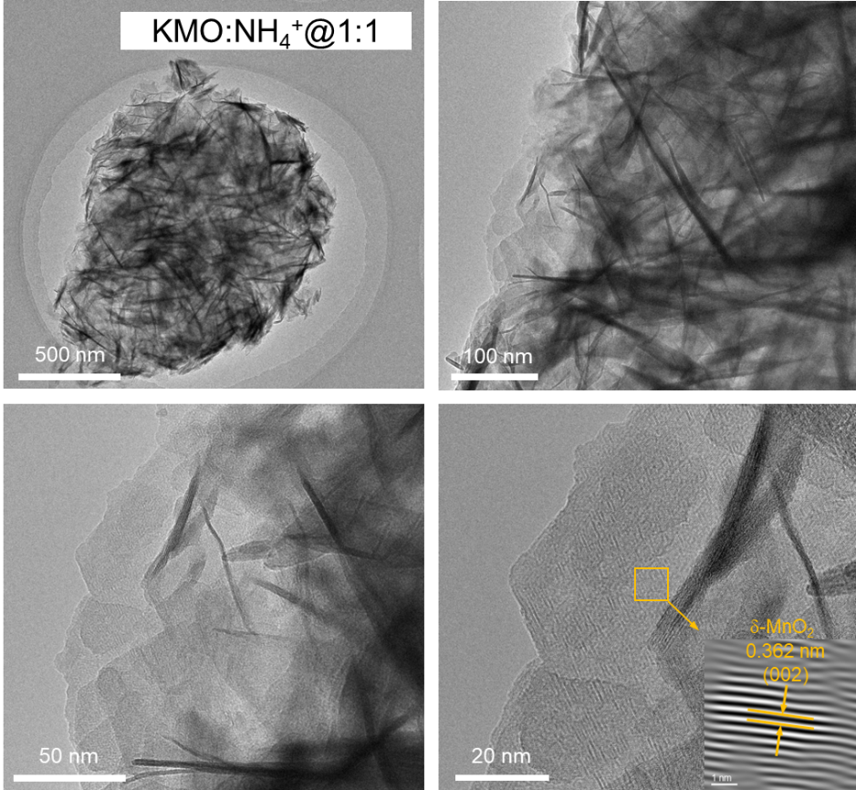
Figure S1. TEM images of the KMO: NH₄⁺@1:1 sample.

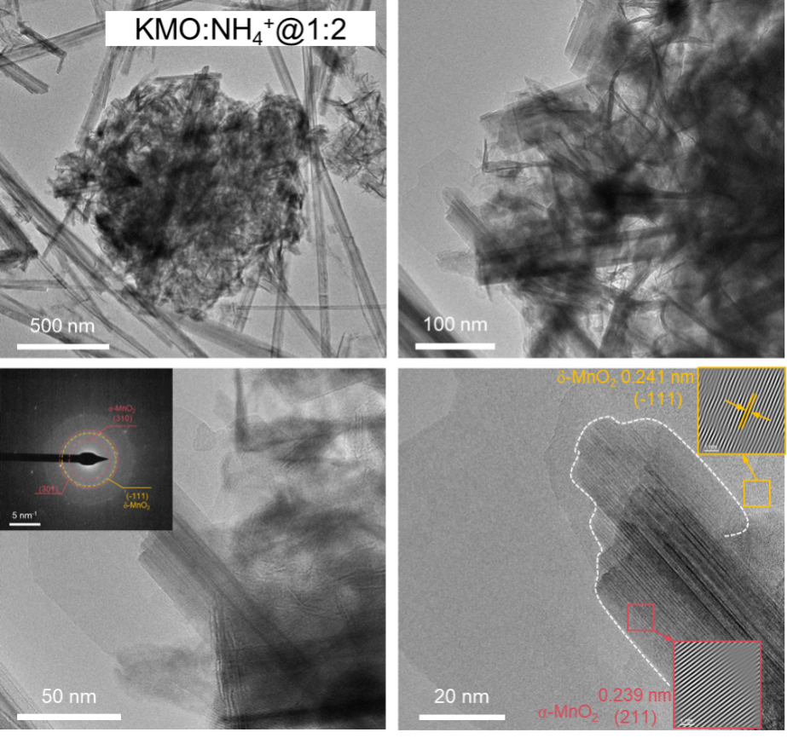
Figure S2. TEM images of the KMO: NH₄⁺@1:2 sample.

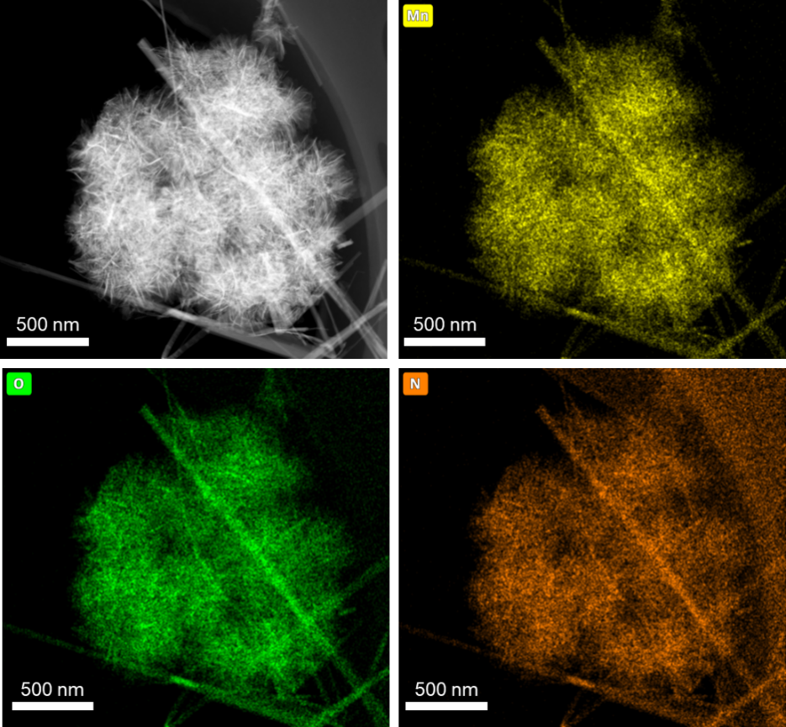
Figure S3. Element distribution maps of the KMO: NH₄⁺@1:4 sample.

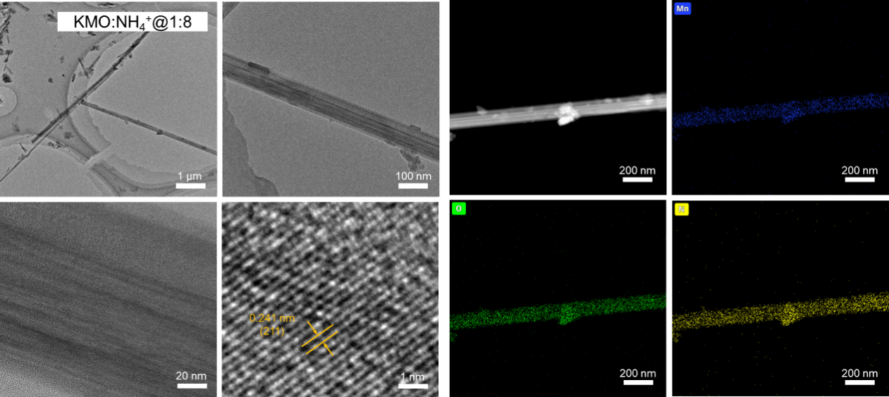
Figure S4. TEM images and the corresponding EDS of the KMO: NH₄⁺@1:8 sample.

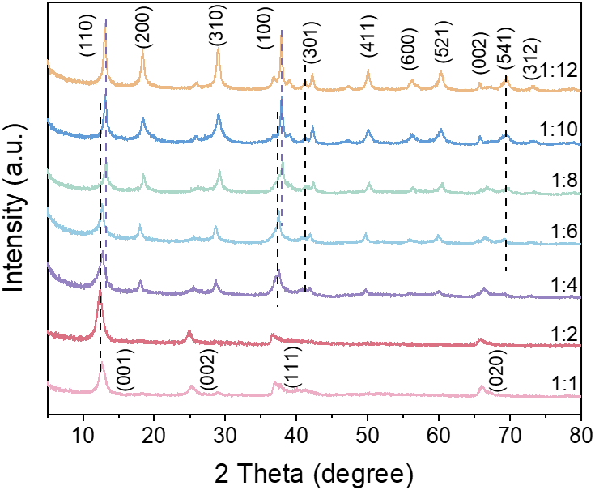
Figure S5. XRD patterns of all the samples.

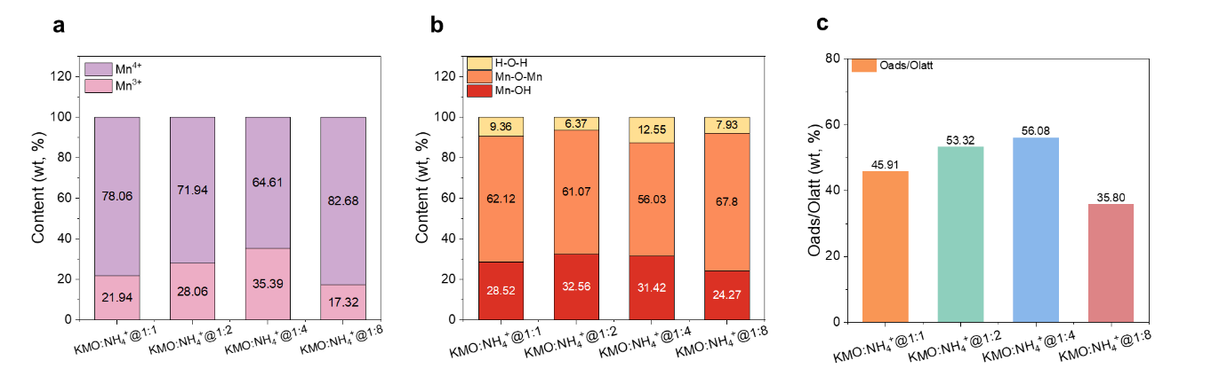
Figure S6. (a) The Mn³⁺/Mn⁴⁺ ratio from XPS data of the samples. (b) The H-O-H, Mn-OH (O_{ads}), and Mn-O-Mn (O_{latt}) ratio from XPS data of the samples. (c) O_{ads}/O_{latt} value of the samples.

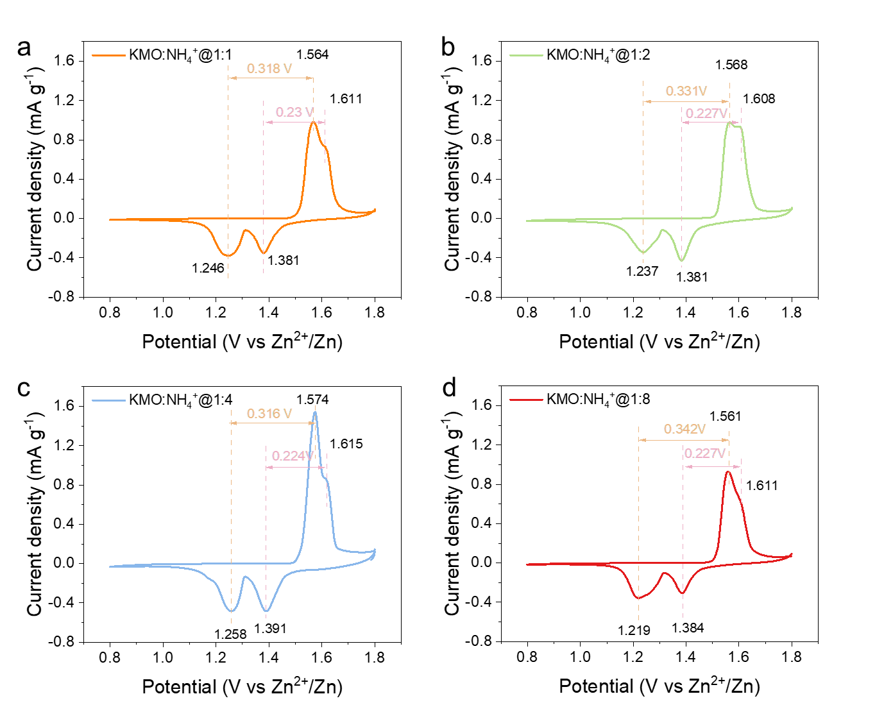
Figure S7. CV curves of the (a) KMO: NH₄⁺@1:1, (b) KMO: NH₄⁺@1:2, (c) KMO: NH₄⁺@1:4, (d) KMO: NH₄⁺@1:8 cathodes.

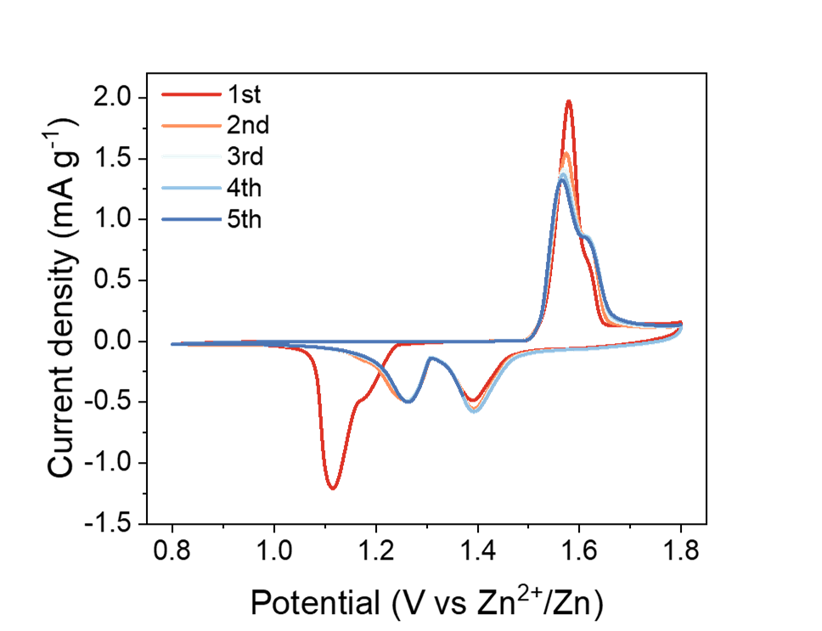
Figure S8. CV curve of the initial five cycles. of the KMO: NH₄⁺@1:4 cathode.

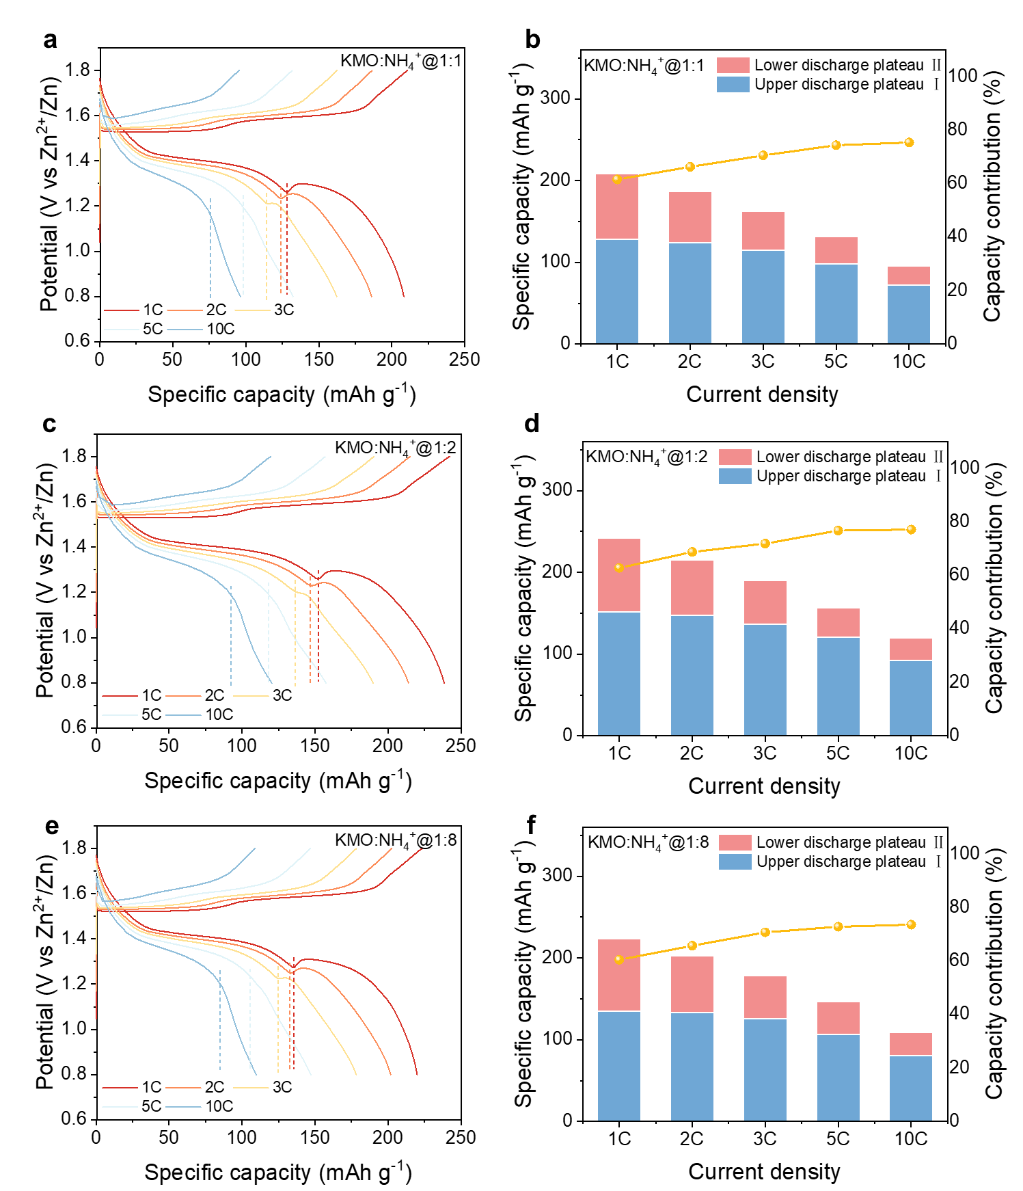
Figure S9. The GCD curves and the plateau capacities of the (a, b) the KMO: NH₄⁺@1:1, (c, d) the KMO: NH₄⁺@1:2, (e, f) the KMO: NH₄⁺@1:8.

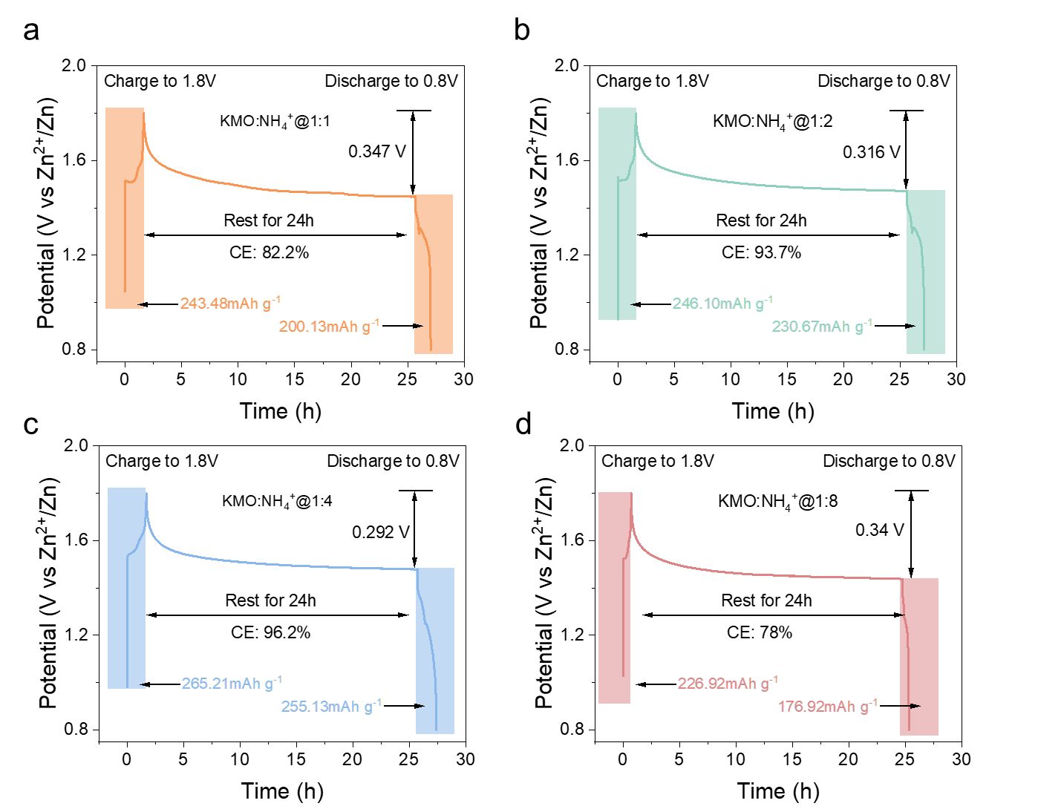
Figure S10. The self-discharge behavior curve of the (a) KMO: NH₄⁺@1:1, (b) KMO: NH₄⁺@1:2, (c) KMO: NH₄⁺@1:4, (d) KMO: NH₄⁺@1:8 cathodes.

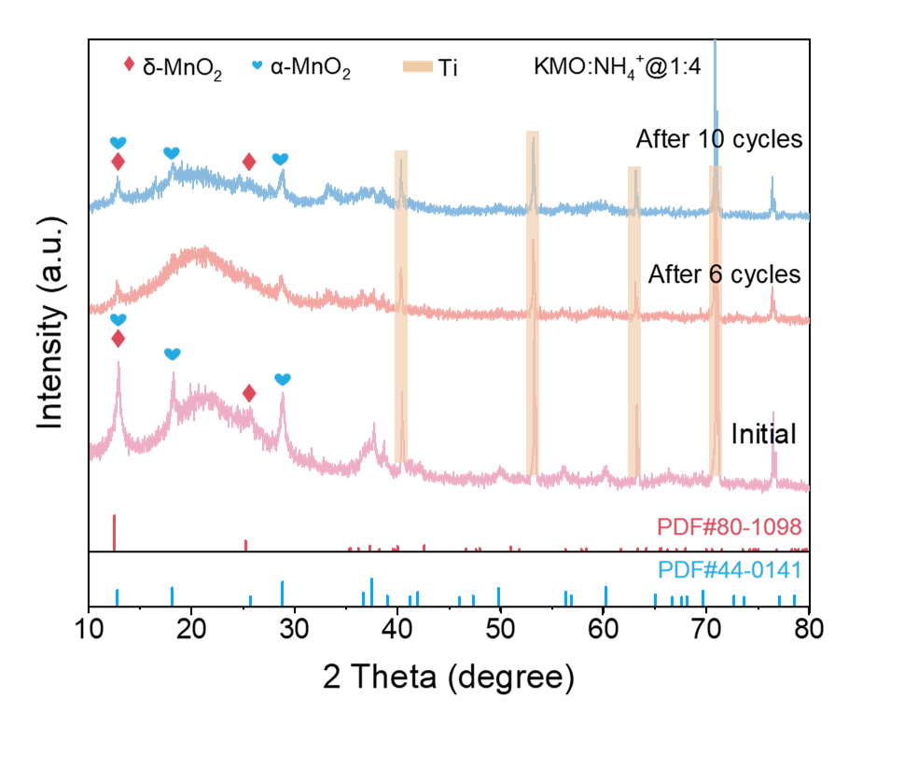
Figure S11. XRD patterns of the KMO: NH₄⁺@1:4 cathodes during cycling at 1C.

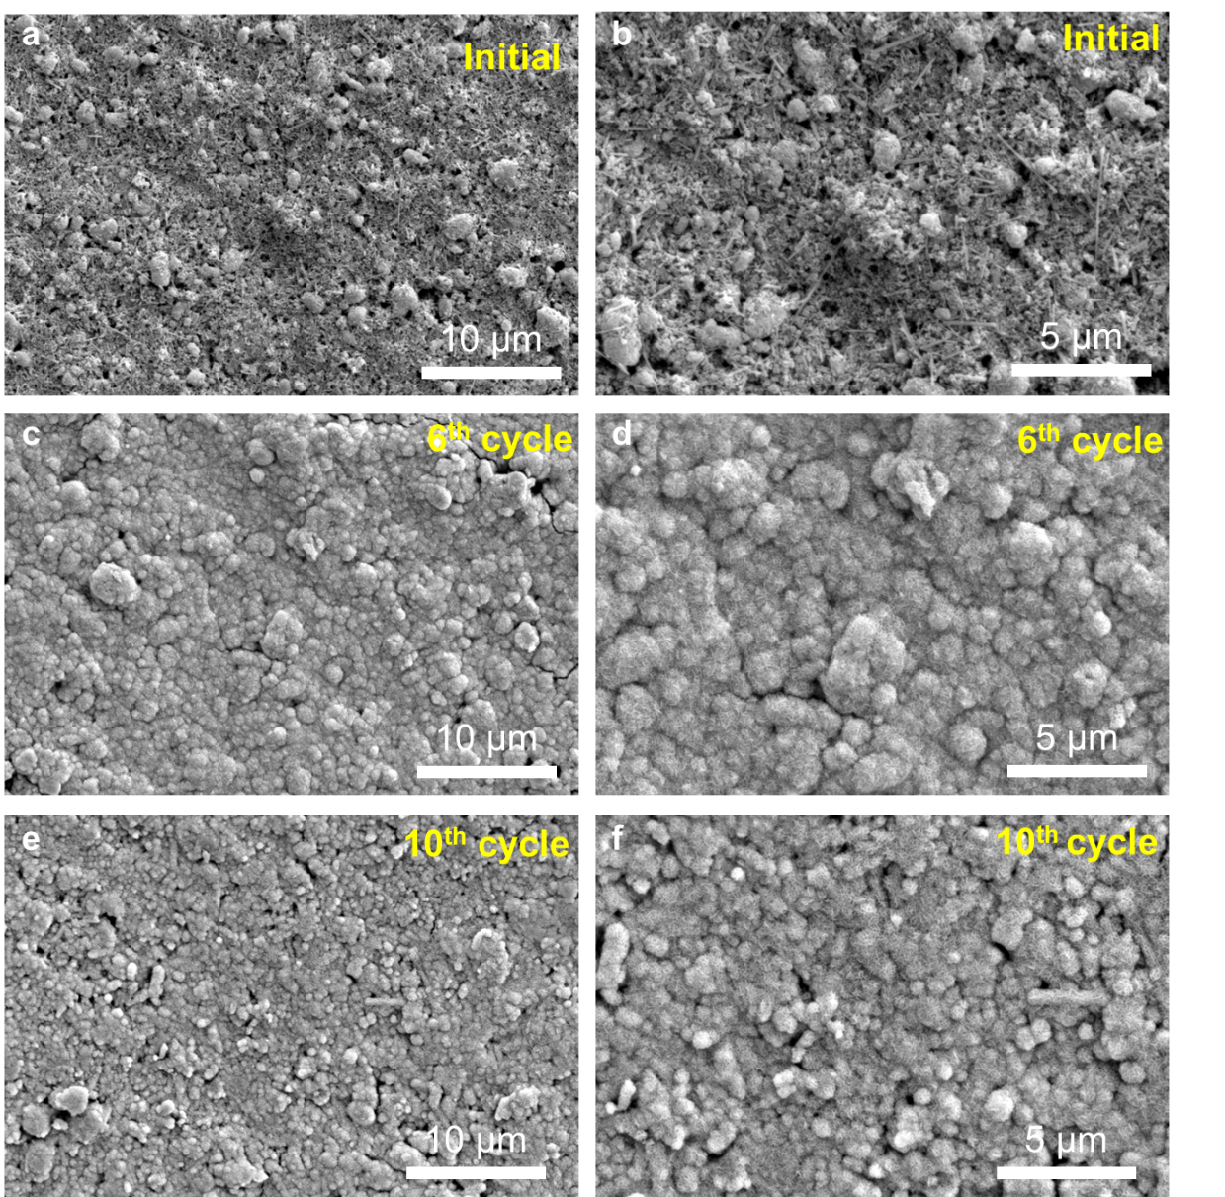
Figure S12. SEM images of the KMO: NH₄⁺@1:4 cathodes during cycling at 1C.

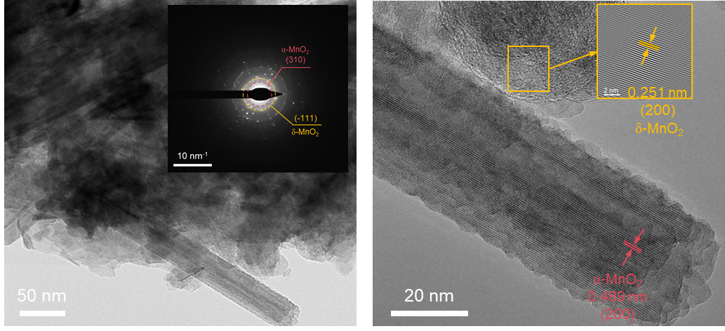
Figure S13. TEM images of the KMO: NH₄⁺@1:4 cathodes after cycling.

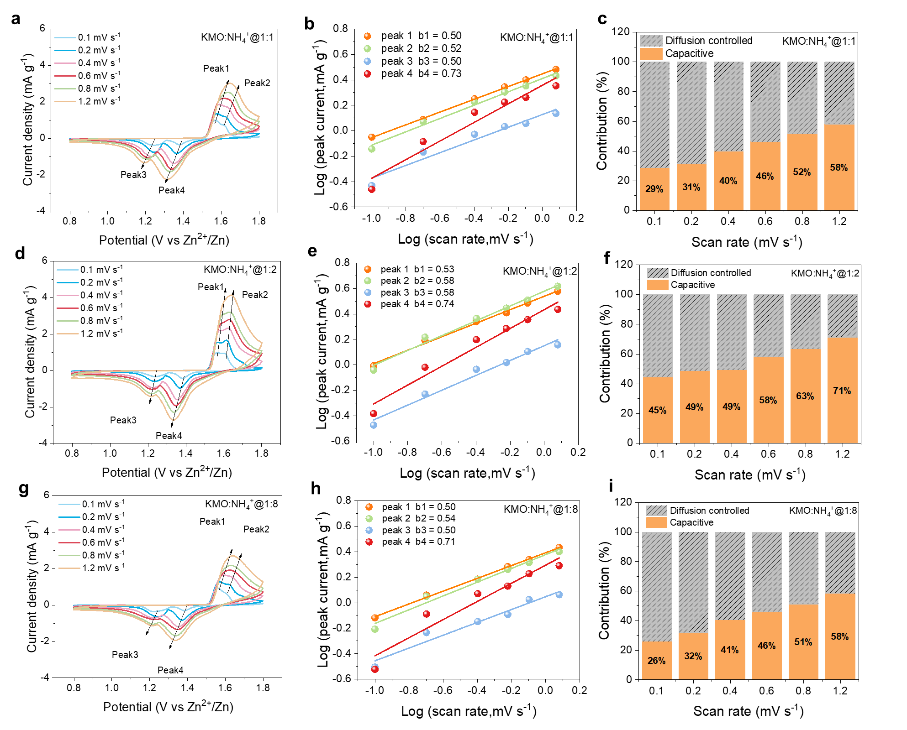
Figure S14. Electrochemical kinetic analyses of the (a-c) the KMO: NH₄⁺@1:1, (d-f) the KMO:NH₄⁺@1:2, (g-i) the KMO: NH₄⁺@1:8 cathodes.

Table S1. Textural properties of the MnO₂ samples derived from N₂ adsorption-desorption measurements.
Sample | Surface area | Pore volume
KMO: NH₄⁺@1:1 | 90.3 m² g⁻¹ | 0.32 cm³ g⁻¹
KMO: NH₄⁺@1:2 | 137.9 m² g⁻¹ | 0.39 cm³ g⁻¹
KMO: NH₄⁺@1:4 | 156.4 m² g⁻¹ | 0.41 cm³ g⁻¹
KMO: NH₄⁺@1:8 | 108.5 m² g⁻¹ | 0.37 cm³ g⁻¹

Table S2. Comparison of the electrochemical performance in this work with ever-reported cathodes for Zn-ion batteries.
Cathode | Rate performance | Cycling performance | Electrolyte | Voltage range | Ref.
(CNF)@MnO₂ | 280 mAh g⁻¹ at 0.2 A g⁻¹  210 mAh g⁻¹ at 1.0 A g⁻¹ | 64.3% Capacity retention  (700cycle at 0.2 A g⁻¹) | 2 M ZnSO₄ +0.1 M MnSO₄ | 0.8-1.8V |  | ^{[1]}
δ-MnO₂ NDs | 327 mAh g⁻¹ at 0.1 A g⁻¹  206 mAh g⁻¹ at 1.0 A g⁻¹  125 mAh g⁻¹ at 2.0 A g⁻¹ | 73.8% Capacity retention  (50cycle at 0.1 A g⁻¹) | 2 M ZnSO₄ +0.1 M MnSO₄ | 1-1.9V | ^{[2]}
N-coordinated MnO₂ | 325 mAh g⁻¹ at 0.2 A g⁻¹  256 mAh g⁻¹ at 0.5 A g⁻¹  210 mAh g⁻¹ at 1.0 A g⁻¹ | 94% Capacity retention  (200cycle at 0.2 A g⁻¹) | 2 M ZnSO₄ +0.1 M MnSO₄ | 1-1.8V | ^{[3]}
PANI-MnO₂ | 280 mAh g⁻¹ at 0.2 A g⁻¹  125 mAh g⁻¹ at 2.0 A g⁻¹ | 90% capacity retention  (200 cycle at 0.2 A g⁻¹) | 2 M ZnSO₄ +0.1 M MnSO₄ | 1-1.8V | ^{[4]}
δ-MnO₂/rGO | 221 mAh g⁻¹ at 0.2 A g⁻¹  122 mAh g⁻¹ at 2.0 A g⁻¹ | 84.3% capacity retention  (300 cycle at 0.2 A g⁻¹) | 2 M ZnSO₄ | 1-1.8V | ^{[5]}
α-MnO₂  nanowires | 240 mAh g⁻¹ at 0.1A g⁻¹ | 58% capacity retention  (300 cycle at 0.1 A g⁻¹) | 2 M ZnSO₄ + 0.2 M MnSO₄ | 0.9-1.8V | ^{[6]}
NH₄-V₂O₅ | 274 mAh g⁻¹ at 0.2A g⁻¹  241mAh g⁻¹ at 0.5A g⁻¹ | 62.2% capacity retention  (1000 cycle at 0.5 A g⁻¹) | 3 M Zn(CF₃SO₃)₂ | 0.2-1.6V | ^{[7]}
K₂V₈O₂₁ | 247 mAh g⁻¹ at 0.3A g⁻¹  226 mAh g⁻¹ at 0.5A g⁻¹  139 mAh g⁻¹ at 2A g⁻¹ | 90% capacity retention  (50 cycle at 0.5 A g⁻¹) | 2 M ZnSO₄ | 0.4-1.4V | ^{[8]}
VS₂ | 190 mAh g⁻¹ at 0.05A g⁻¹  112 mAh g⁻¹ at 0.5A g⁻¹  116 mAh g⁻¹ at 2 A g⁻¹ | 98% capacity retention  (200 cycle at 0.5 A g⁻¹) | 1 M ZnSO₄ | 0.4-1.0V | ^{[9]}
NTNQ | 251 mAh g⁻¹ at 0.1A g⁻¹  203 mAh g⁻¹ at 1A g⁻¹ | 83.2% capacity retention  (100 cycle at 0.1 A g⁻¹) | 1 M Zn(CF₃SO₃)₂ | 0.1-1.5V | ^{[10]}
This work | 297 mAh g⁻¹ at 1 C  223 mAh g⁻¹ at 3 C  182 mAh g⁻¹ at 5 C  136 mAh g⁻¹ at 10 C | 93.7% Capacity retention  (600 cycle at 1C) | 2 M ZnSO₄ +0.1 M MnSO₄ | 0.8-1.8V | —

References

[1] Chen X, Li W, Zeng Z, et al. Engineering stable Zn-MnO₂ batteries by synergistic stabilization between the carbon nanofiber core and birnessite-MnO₂ nanosheets shell [J]. Chemical Engineering Journal, 2021, 405.
[2] Tang H, Chen W, Li N, et al. Layered MnO₂ nanodots as high-rate and stable cathode materials for aqueous zinc-ion storage [J]. Energy Storage Materials, 2022, 48: 335-43.
[3] Wang S, Yao S, Dai N, et al. Spin symmetry breaking‐induced hubbard gap near‐closure in N‐coordinated MnO₂ for enhanced aqueous zinc‐ion battery performance [J]. Angewandte Chemie International Edition, 2024, 63(35).
[4] Huang J, Wang Z, Hou M, et al. Polyaniline-intercalated manganese dioxide nanolayers as a high-performance cathode material for an aqueous zinc-ion battery [J]. Nature communications, 2018, 9(1).
[5] Qiu C, Liu J, Liu H, et al. Suppressed layered‐to‐spinel phase transition in δ‐MnO₂ via van der Waals interaction for highly stable Zn/MnO₂ batteries [J]. Small Methods, 2022, 6(12).
[6] Gao X, Wu H, Li W, et al. H⁺‐insertion boosted α‐MnO₂ for an aqueous Zn‐ion battery [J]. Small, 2020, 16(5).
[7] Lu Y, Wang T, Naresh N, et al. Pre-doped cations in V₂O₅ for high-performance Zn-ion batteries [J]. Nano Research Energy, 2024, 3(4).
[8] Tang B, Fang G, Zhou J, et al. Potassium vanadates with stable structure and fast ion diffusion channel as cathode for rechargeable aqueous zinc-ion batteries [J]. Nano Energy, 2018, 51: 579-87.
[9] He P, Yan M, Zhang G, et al. Layered VS₂ nanosheet‐based aqueous Zn ion battery cathode [J]. Advanced Energy Materials, 2017, 7(11).
[10] Wang J, Gao X, Wang Y, et al. Robust ring insoluble naphthoquinone derivative cathode with high loading and long cycle life for aqueous zinc organic batteries [J]. Nano Research Energy, 2024, 3(4).

