Boosting Oxygen Reduction Reaction Performance of Spinel Lithium Manganese Oxide via Proton Exchange

Experimental section
1 Synthesis of LiMn₂O₄ and protonated LiMn₂O₄
LiMn₂O₄ was synthesized via a solid-state reaction method. Briefly, LiOH and Mn₂CO₃ were mixed in a high-energy planetary ball mill at 400 rpm for 12 hours at a Li to Mn molar ratio of 1:2. Subsequently, the mixture was transferred to a muffle furnace and heated to 450 °C with 5 °C min⁻¹, and annealed at this temperature for 40 h in air to obtain LiMn₂O₄.
The as-prepared LiMn₂O₄ powder was ground and subjected to acid leaching to obtain a series of acid-treated HLMO materials. Specifically, 1 mol L⁻¹ H₂SO₄ solution was prepared, and 100 mg LiMn₂O₄ sample was added, after which it was stirred continuously at 25 °C for 12 h. Finally, to obtain the acid-treated LiMn₂O₄, the sample was rinsed three times with water and allowed to dry overnight denoted as HLMO. The samples treated with different acid concentrations (0.5, 1, 2.5, and 3 mol L⁻¹ H₂SO₄) were labeled as 1-HLMO, 2-HLMO, 3-HLMO, and 4-HLMO, respectively. The original black LiMn₂O₄ sample turned brown after acid treatment.
2 Electrochemical measurements
All ORR tests were performed at room temperature in 1 M KOH solution using an electrochemical workstation (VMP3, Bio-Logic, France) with a rotating disk electrode (RDE) configuration. A three-electrode electrochemical cell was used for the measurements, specifically, a glassy carbon (GC) electrode (0.196 cm²) as working electrode (WE), a graphite electrode as counter electrode (CE), and an Hg|HgO electrode as reference electrode (RE). The electrocatalyst (3 mg), Vulcan XC-72R (7 mg), and Nafion® solution (100 µL, 5.0 wt%, Aldrich) were spread out in 1.9 mL of anhydrous isopropanol, mixing by ultrasonication for 0.5 h. 20 µL of the catalyst ink was drop-cast onto the GC electrode and dried at room temperature. The metal loading of the electrocatalyst was ~ 0.15 mg cm⁻². Subsequently, electrochemical tests were performed. First, cyclic voltammetry (CV) was conducted in the potential range of 0.1 to 1.3 V vs. RHE at 50 mV s⁻¹ for 50 cycles to activate the catalyst. Activation was complete when the CV curves nearly overlapped. Next, polarization curves were determined by linear sweep voltammetry (LSV) across the potential range of 1.3 to 0.1 V vs. RHE at a scan rate of 5 mV s⁻¹ in the negative direction, with the RDE rotating at 1600 rpm. These steps were carried out in both N₂-saturated and O₂-saturated electrolytes to subtract the background current contribution from the oxide itself to the LSV curves. Tafel plots were gained from the LSV curves. For the accelerated durability test (ADT), it was cycled in the range of 0.4 to 1.1 V vs. RHE at 100 mV s⁻¹. After completion of cycling, LSV measurements were again performed to evaluate the ORR stability performance. The chronoamperometry (CA) was done at 0.8 V vs. RHE with the RDE rotating at 1600 rpm. The electrochemical active area (ECSA) was derived from measurements of the double-layer charge (C_{dl}). This was done by scanning the CV, between 1.125 V vs. RHE and 1.325 V vs. RHE, with sweeping speeds at 20, 40m 60, 80, and 100 mV s⁻¹, respectively. The C_{dl} value can be estimate by calculating the slope from the linear relationship between current and scan rates at 1.225 V vs. RHE. The ECSA was obtained by $ECSA= C_{dl}/C_{s}$. Here, $C_{s}$ was taken to be 60 μF cm⁻², representing the specific capacitance of corresponding smooth surface under the same conditions.
3 Physical characterization
Phase purity and structural details of the samples were characterized by X-ray diffraction (XRD, Cu-Kα radiation, λ₁ = 1.5405 Å, λ₂ = 1.5443 Å) on a Bruker D8 Advance diffractometer. XRD patterns were recorded in the 2θ range of 15° to 90° with a scanning step size of 0.02°. Morphology was examined using scanning electron microscopy (SEM, Zeiss Sigma 500, Germany) at an accelerating voltage of 5 kV. Transmission electron microscopy (TEM) and high-resolution transmission electron microscopy (HR-TEM, JEOL 2100F, Japan) were performed at an operating voltage of 200 kV. Nitrogen adsorption and desorption measurements were executed on a TriStar 3020 instrument (Micromeritics, USA) using the Brunauer-Emmett-Teller (BET) method. Metal ratios were measured by inductively coupled plasma optical emission spectroscopy (ICP-OES, Agilent 730, USA). The electronic structure was investigated by X-ray photoelectron spectroscopy (XPS, Thermo Scientific ESCALAB 250Xi, USA). X-ray absorption spectroscopy (XAS) measurements were carried out on the Mn K-edge at the TPS 17C beamline of the National Synchrotron Radiation Research Center (NSRRC) in Taiwan. A metal foil was used as a reference to calibrate the energy scale. Both k-space and R-space data were obtained with k³ weighted and exported from the Athena software. Thermogravimetric analysis (TGA) was performed using a Mettler Toledo instrument, with a heating rate of 20 °C min⁻¹ from room temperature to 700 °C, followed by natural cooling within the furnace.
4 Theoretical calculations
All calculations were carried out with the Vienna Ab initio Simulation Package (VASP). The Perdew–Burke–Ernzerhof (PBE) functional in the generalized gradient approximation (GGA) was used to treat the exchange–correlation energy. To characterize core electrons, projector augmented-wave (PAW) pseudopotentials were used. A four-layer LiMn₂O₄ slab model was constructed, in which several Li atoms were randomly replaced by H atoms based on inductively coupled plasma (ICP) data, resulting in an H-LiMn₂O₄ (HLMO) slab. During the construction optimization process, the bottom two layers of the slab were established. A plane-wave cutoff energy of 450 eV was applied, and convergence was achieved when the forces on the atoms were less than 0.02 eV Å⁻¹. Geometry optimization was performed using a 2×2×1 Monkhorst–Pack k-point mesh. Spin polarization was considered all atoms.
The preferred mechanism for the ORR involves a four-electron pathway, which proceeds through the following elementary steps:
* + O₂ + H⁺ + e⁻ → *OOH
*OOH + H⁺ + e⁻ → *O + H₂O
*O + H⁺ + e⁻ → *OH
*OH + H⁺ + e⁻ → * + H₂O
Here, * denotes an active chemisorption site. The adsorption energies of the *OOH, *O, and *OH intermediates are calculated using the expression:
∆E_{ad} = E_{species+cat.} – E_{cat.} - E_{species}
where E_{species}$E_{species}$, E_{species+cat.}$E_{species+cat.}$, and E_{cat}$E_{cat.}$ are the total energies of the catalyst with and without the adsorbate, respectively. E_{species}$E_{species}$ is the energy of the isolated species (OOH, O, OH), referenced to gas-phase H₂ and H₂O via the RHE model proposed by Nørskov et al.
The Gibbs free energy change for adsorption is calculated as:
∆G = ∆E_{ad} + ∆ZPE - T∆S +∆G_{pH} - ∆G_{U}
Here, ∆ZPE represents the zero-point energy correction, T means temperature (298.15 K), and ∆S represents entropy change. ∆G_{pH} = k_{B}T ln10*pH$ΔG_{pH}=kBT\ln{10*}pH$, with pH assumed to be 0. The effect of electrode potential U is accounted for by ∆G_{U} = -neU$ΔG_{U}=-neU$, where n is the number of electrons transferred. Among the four steps, the one with the largest Gibbs free energy change (i.e., ΔG₁, ΔG₂, ΔG₃, ΔG₄) is considered the rate-determining step (RDS). The corresponding overpotential η is estimated using:
η = 1.23 V + ∆G_{max(∆G1, ∆G2, ∆G3, ∆G4)}
where 1.23 V is the theoretical equilibrium potential for the four-electron ORR. This overpotential is obtained solely from thermodynamic free energies, independent of kinetic barriers, due to the linear Brønsted–Evans–Polanyi (BEP) relationship during activation energy and reaction energy in heterogeneous catalysis, as proposed by Nørskov et al.

Figure S1. XRD patterns with Rietveld method of LiMn₂O₄, 1-HLMO, 2-HLMO, 3-HLMO, and 4-HLMO with standard LiMn₂O₄ (PDF#88-0589).
Figure S2. (a) LSV curves for 2-HLMO at 1600 rpm under O₂-saturated 1 M KOH solution using rotating ring-disk electrode (RRDE). (b) electron transfer numbers and HO₂⁻ yields for 2-HLMO.
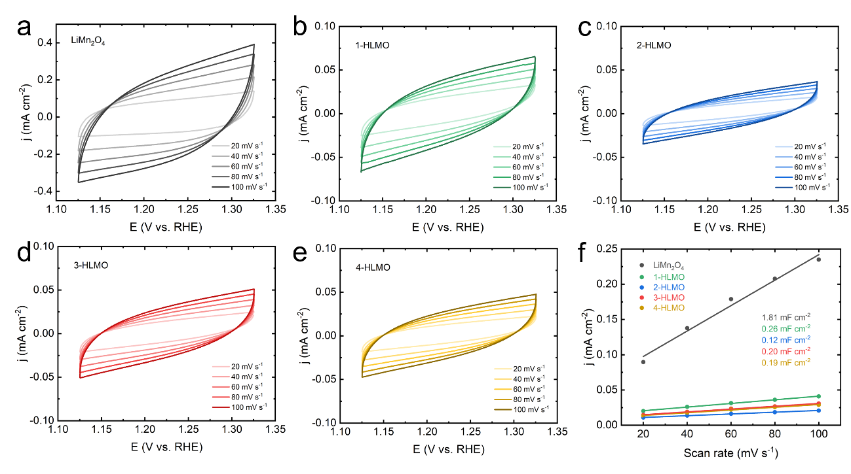
Figure S3. CV scans with non-Faradaic current for (a) LiMn₂O₄, (b) 1-HLMO, (c) 2-HLMO, (d) 3-HLMO, and (e) 4-HLMO, with 20, 40, 60, 80, and 100 mV s⁻¹ scan rates. (f) linear fitting between the capacitive currents and scan rates for these electrocatalysts.

Figure S4. (a) ECSA values from C_{dl} test of LiMn₂O₄, 1-HLMO, 2-HLMO, 3-HLMO, 4-HLMO samples.
Figure S5. CV curves of LiMn₂O₄ and 2-HLMO at 10 mV s⁻¹ between 0.45 V vs. RHE and 1.65 V vs. RHE.
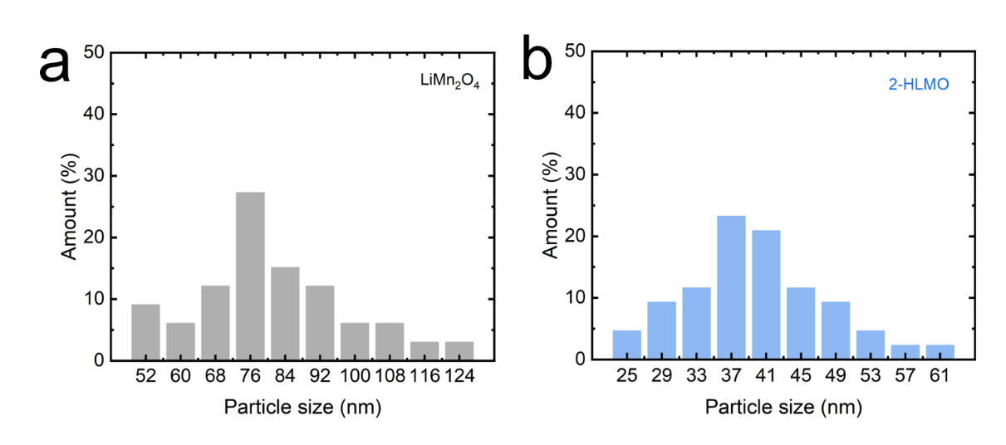
Figure S6. Particle size distribution of LiMn₂O₄ and 2-HLMO from SEM images.

Figure S7. N₂ absorption-desorption isotherm linear plots and BET surface area of LiMn₂O₄.

Figure S8. N₂ absorption-desorption isotherm linear plots and BET surface area of 2-HLMO.

Figure S9. Normalized mass activity and normalized to BET-measured specific surface area current density.

Figure S10. Mn 2p XPS spectrum of LiMn₂O₄, and fitted valence state of Mn^{3.5+} with Mn₂O₃, and MnO₂.

Figure S11. Mn 2p XPS spectrum of 2-HLMO, and fitted valence state of Mn^{3.8+} with Mn₂O₃, and MnO₂.

Figure S12. O 1s XPS spectrum of LiMn₂O₄, and deconvolution into three oxygen related peaks: lattice oxygen (A), surface hydroxyl groups or adsorbed water(B), and adsorbed oxygen species (C).

Figure S13. O 1s XPS spectrum of 2-HLMO, and deconvolution into three oxygen related peaks: lattice oxygen (A), surface hydroxyl groups or adsorbed water(B), and adsorbed oxygen species (C).
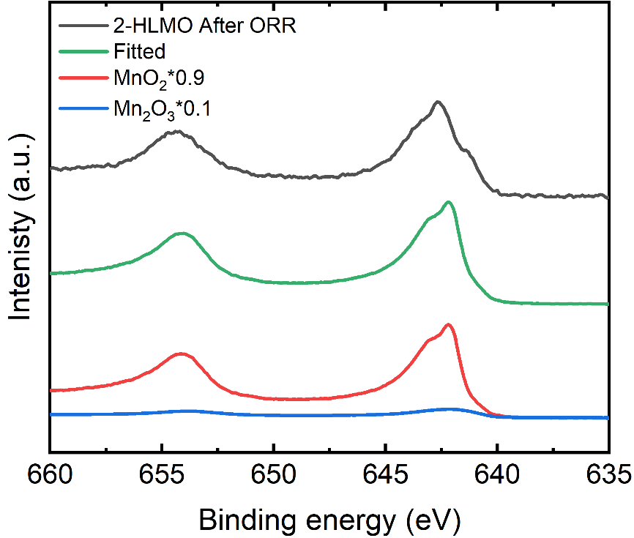
Figure S14. Mn 2p XPS spectrum of 2-HLMO, and fitted valence state of Mn^{3.9+} with Mn₂O₃, and MnO₂.
Figure S15. Content of Li and Mn of 2-HLMO after 10,000 cycles CV measured by ICP-MS.
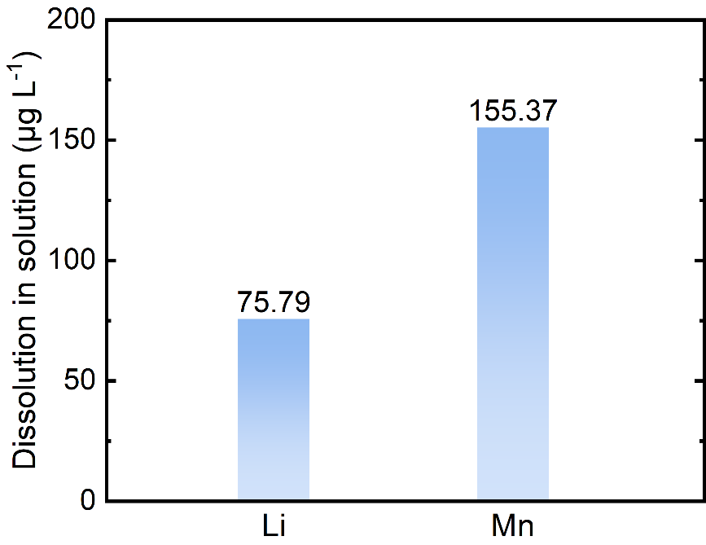
Figure S16. Dissolution of Li and Mn in solutions of 2-HLMO after 10,000 cycles CV measured by ICP-MS.
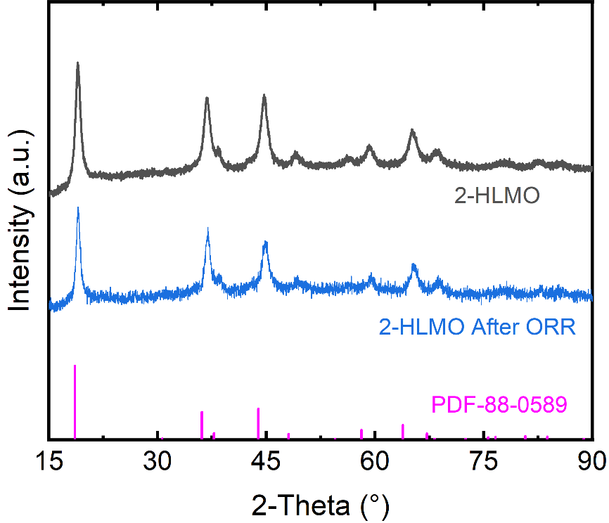
Figure S17. XRD patterns before and after 10,000 cycles CV.

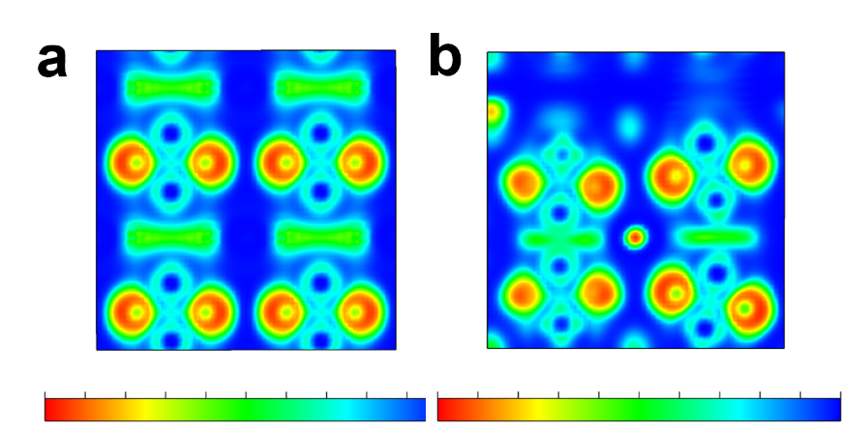
Figure S18. Electron localization function (ELF) of (a) LiMn₂O₄ and (b) HLMO.

Table S1. Fit goodness, R factor, crystal structural data of XRD Rietveld refinements for LiMn₂O₄, 1-HLMO, 2-HLMO, 3-HLMO, and 4-HLMO.

 | LiMn₂O₄ | 1-HLMO | 2-HLMO | 3-HLMO | 4-HLMO
X² | 1.02 | 1.56 | 1.68 | 1.7 | 1.27
R_{exp} | 5.32 | 0.95 | 0.96 | 0.93 | 3.23
R_{wp} | 5.42 | 1.48 | 1.6 | 1.57 | 4.10
R_{p} | 4.31 | 1.18 | 1.27 | 1.21 | 3.19
R_{Bragg} | 0.862 | 0.747 | 0.649 | 0.399 | 0.572
Cell Volume  (Å³) | 546.8(3) | 544.6(3) | 541.2(3) | 534.5(2) | 520.1(2)
a (Å) | 8.1775(17) | 8.1662(16) | 8.1492(14) | 8.1155(12) | 8.0420(10)

