Supplementary Informations For
Enhanced Performance and Flexibility in Perovskite/Silicon Tandem Solar Cells via Uniform Submicron Pyramids
Qi Liu^{1,2†}, Junjun Li^{1†*}, Fei Wang^{1*}, Shuangbiao Xia^{1,2}, Yuhui Ji^{1,3}, Yutao Wang^{1,2}, Yunren Luo^{1,2}, Jian Yu³, Fanying Meng^{1,2}, Liping Zhang^{1,2}, Zhengxin Liu^{1,2}, Wenzhu Liu^{1,2*}
¹Research Center for New Energy Technology (RCNET), National Key Laboratory of Materials for Integrated Circuits, Shanghai Institute of Microsystem and Information Technology (SIMIT), Chinese Academy of Sciences (CAS), Shanghai 200050, China
²College of Materials Science and Opto-Electronic Technology, University of Chinese Academy of Sciences (UCAS), Shijingshan, Beijing 100049, China
³School of New Energy and Materials, Southwest Petroleum University, Chengdu 610500, China

†These authors contributed equally.
*Corresponding Authors. E-Mail address: junjun.li@mail.sim.ac.cn (Junjun Li); wangfei@mail.sim.ac.cn (Fei Wang); wenzhu.liu@mail.sim.ac.cn (Wenzhu Liu).

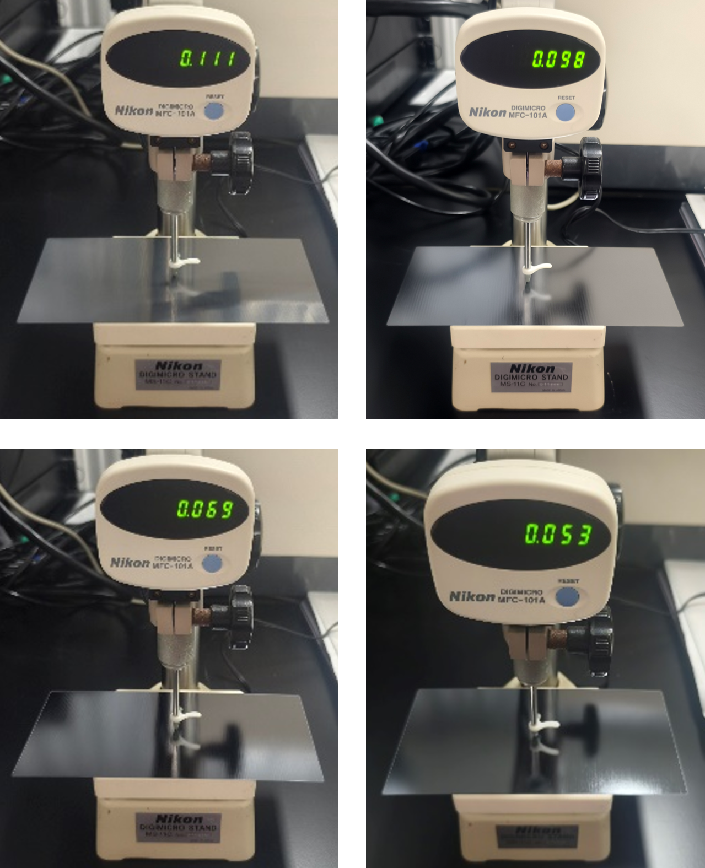
Fig. S1 Thickness measurement of silicon wafers used in actual three-point bending tests, correspond to 110 μm, 100 μm, 75 μm, and 55 μm, respectively, all measured thicknesses fall within the tolerance range.

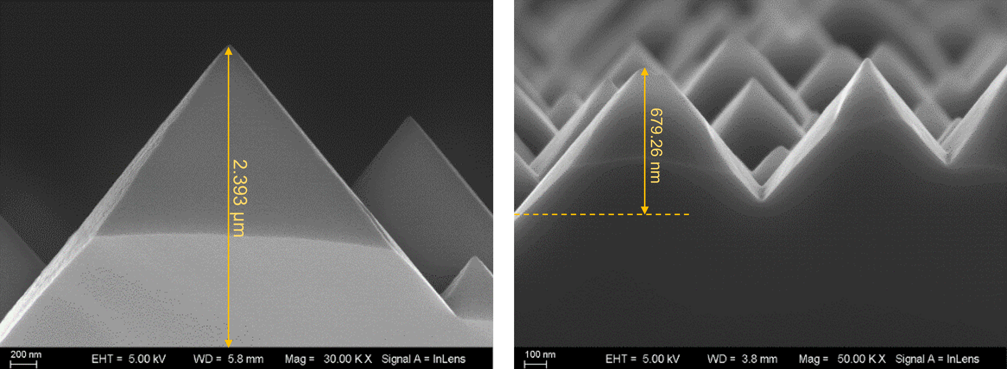
Fig. S2 Cross-sectional SEM morphologies of pyramid on large and small textured silicon surface, the size difference is quite noticeable.

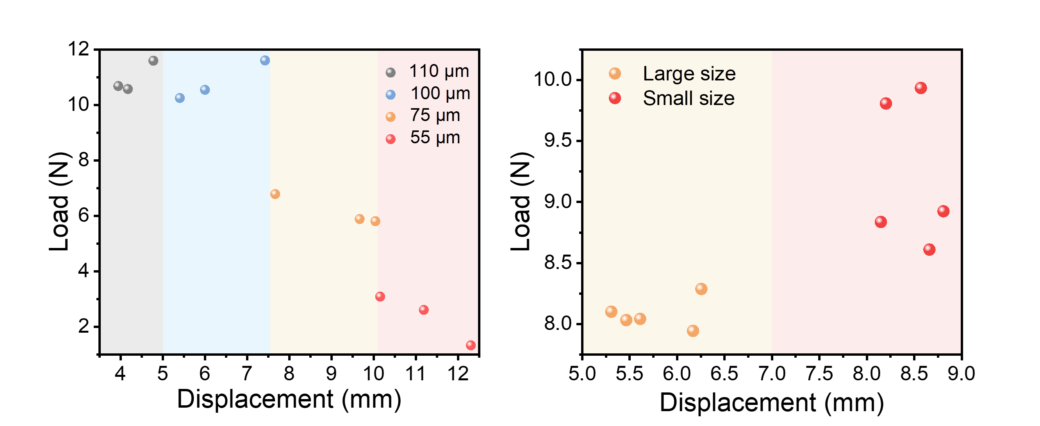
Fig. S3 Load-Displacement Statistical Distribution of Silicon Wafers with Different Thicknesses and Different Texturing Durations.

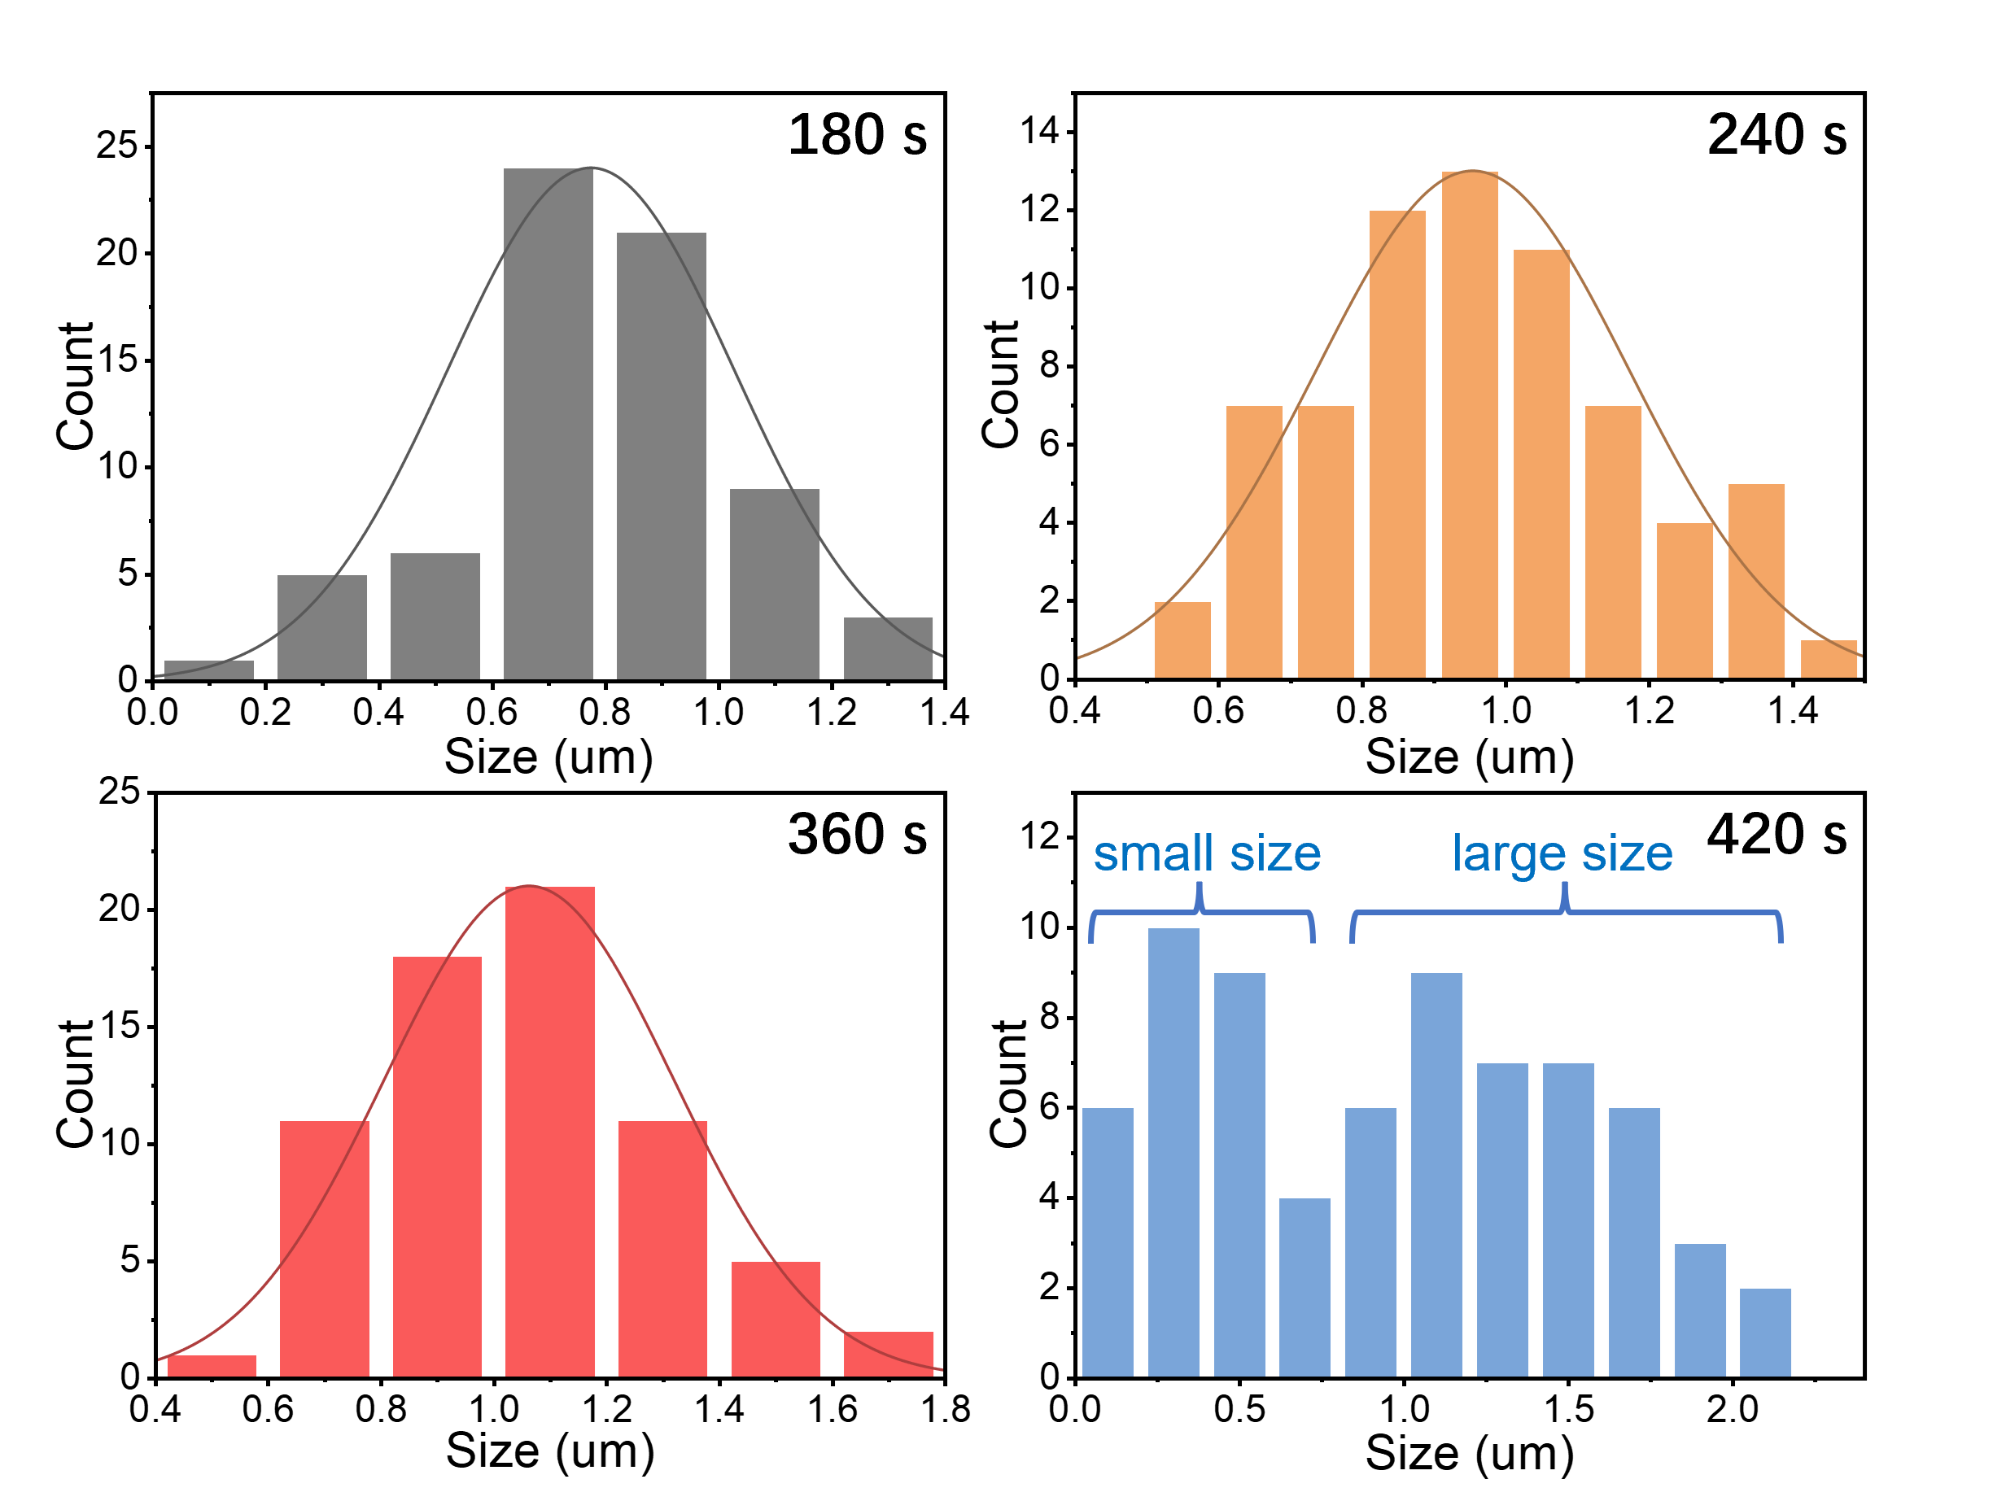
Fig. S4 Statistical distribution of pyramid sizes on textured silicon surfaces at different etching durations.

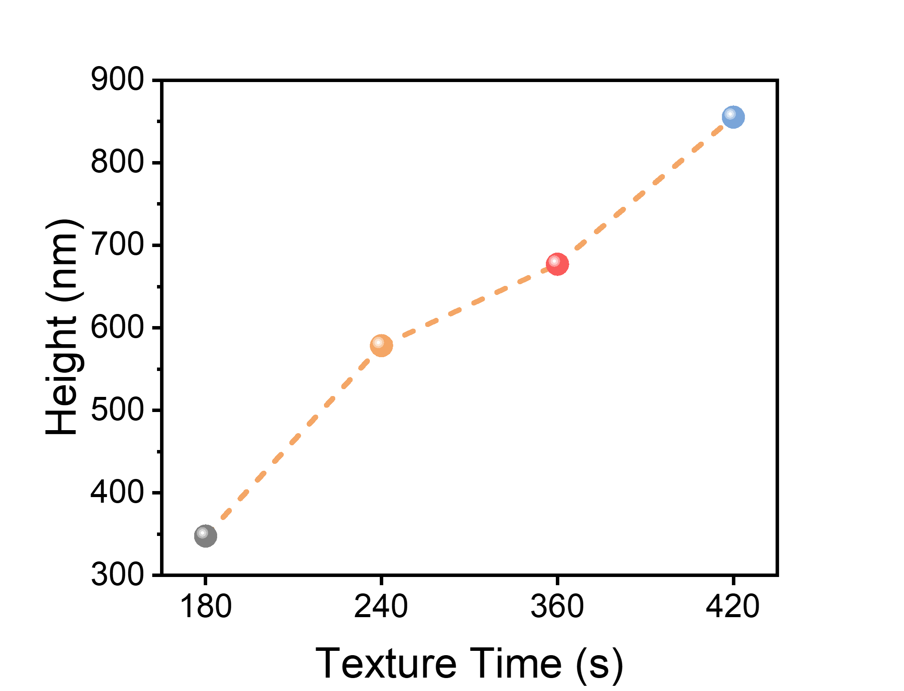
Fig. S5 The statistics of pyramid heights on silicon surfaces at different etching times, showing an upward trend.

Fig. S6 Schematic diagram of etched silicon substrate structure.

Fig. S7 Three-point bending results for SHJ cells with annealing times of 360s and 420s.

Fig. S8 Surface SEM morphologies of perovskite deposited on various textured silicon.

Fig. S9 PLQY (photoluminescence quantum yield) vs. QFLS (quasi-Fermi level splitting) based on substrates with different etching durations.

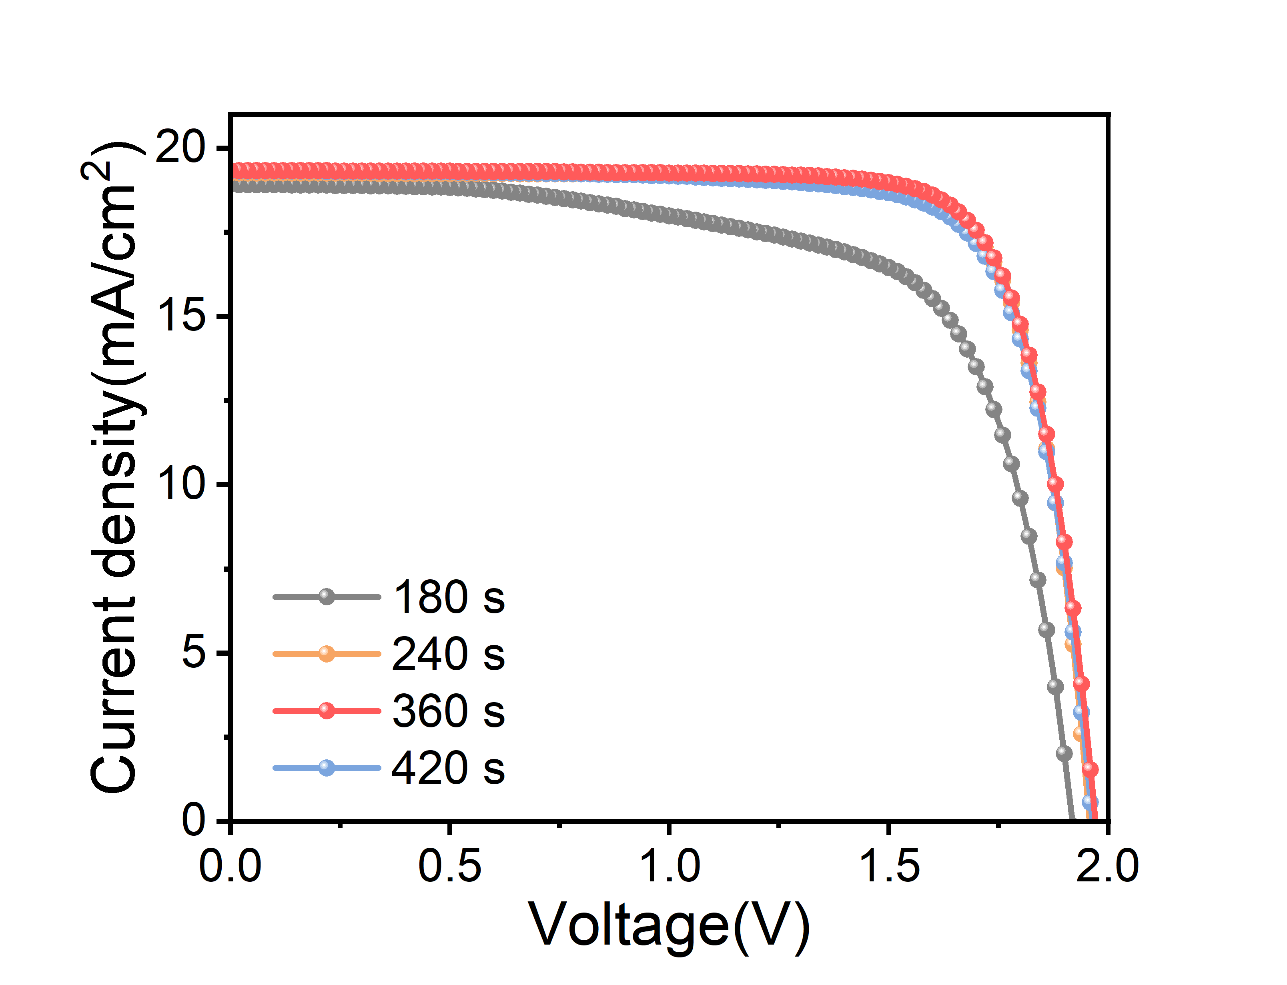
Fig. S10 J-V curves of tandem devices based on substrates with different etching durations.

