Supplementary material
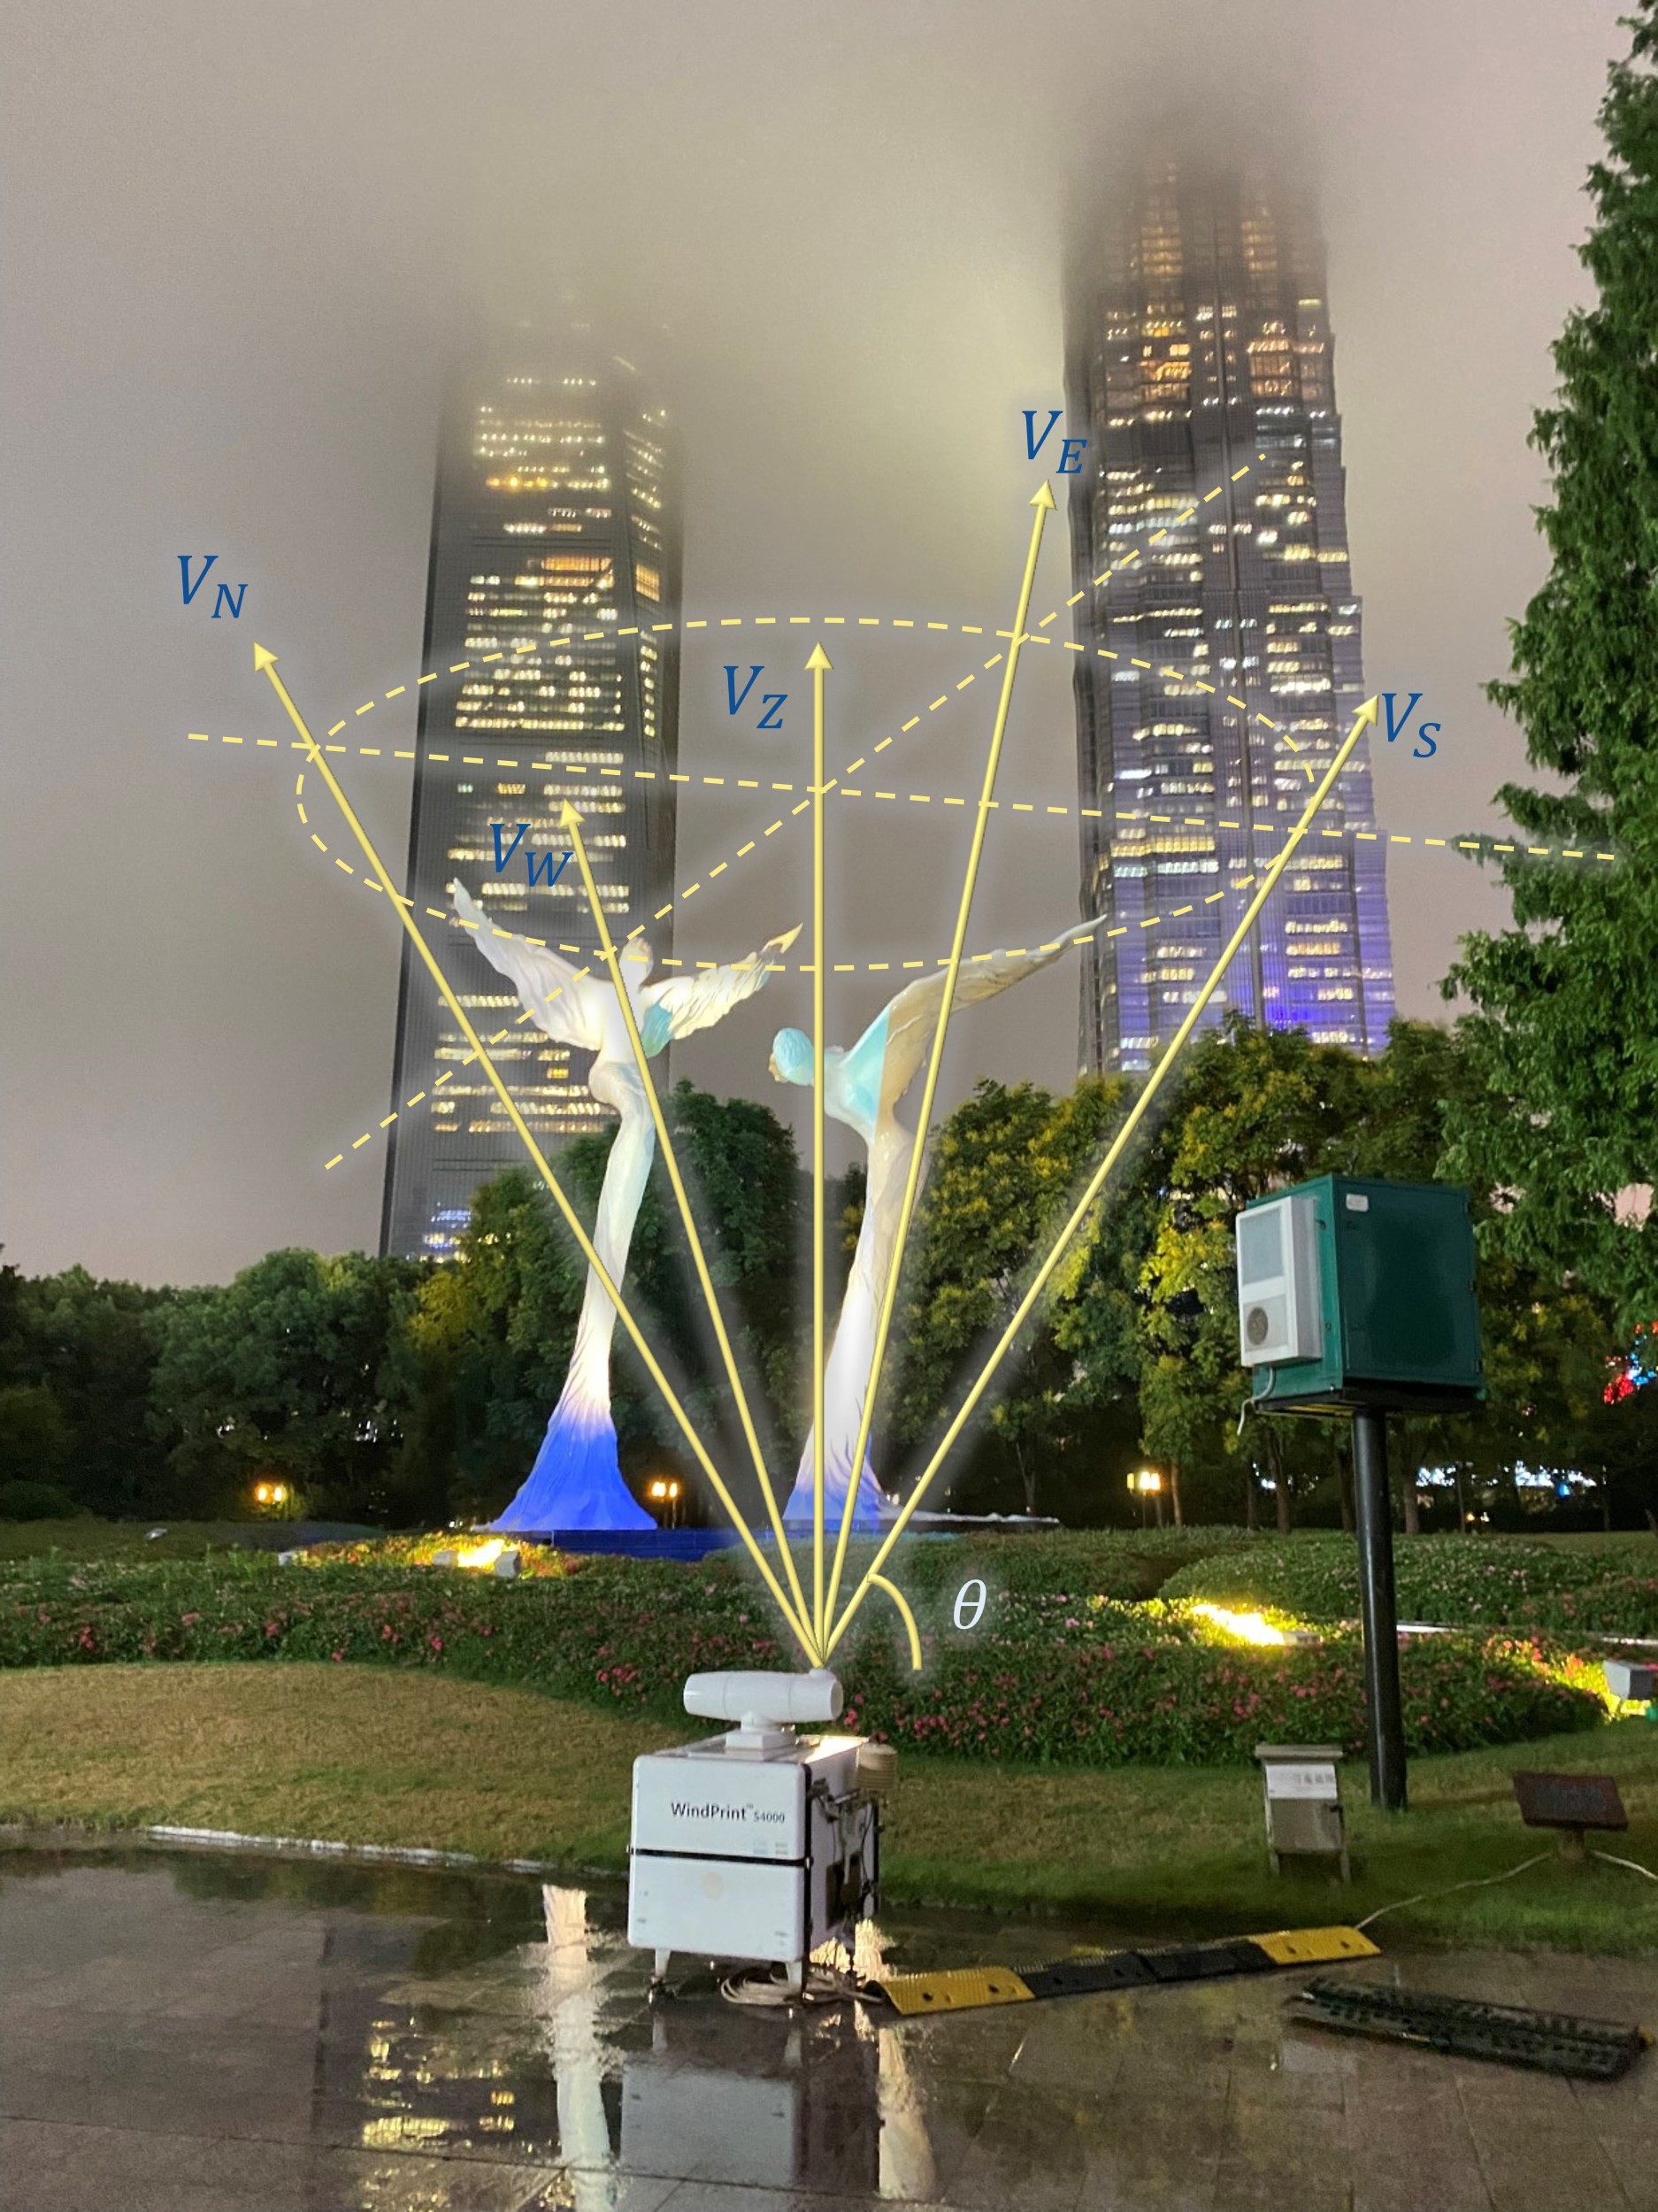

Supplementary Fig. 1 The observation scene of Downtown and the schematic diagram of DBS (Doppler Beam Swinging) scan. V_{E}, V_{W}, V_{S}, V_{N} and V_{Z} are the radial wind speed in the east, west, north, south and vertical directions respectively, and θ is the Angle between the laser beam and the horizontal direction.
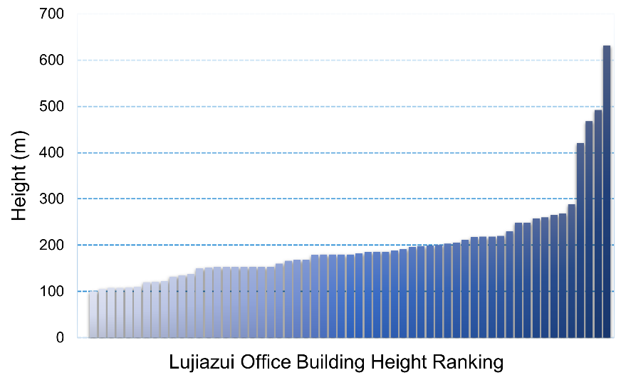

Supplementary Fig. 2 Statistics on buildings taller than 100 m within 1 km of the observation site in the Downtown.

