Building a multidisciplinary database across cultures: lessons from the Mongolian Rangelands and Resilience (MOR2) Project
Khishigbayar JAMIYANSHARAV^{1,} Melinda J. LAITURI^{1,2,3,4,5}, Mara SEDLINS⁶, Tobin MAGLE⁷, Maria FERNANDEZ-GIMENEZ^{1,8} Sophia LINN³, Steven R. FASSNACHT ()^{1,2}, Niah VENABLE^{1,2}, Tungalag ULAMBAYAR⁸, Arren Mendezona ALLEGRETTI⁹, Chantsallkham JAMSRANJAV⁵, Robin REID^{1,4,5}
1 Warner College of Natural Resources, Colorado State University (CSU), USA
2 ESS-Watershed Science, Colorado State University CSU, USA
3 Geospatial Centroid at CSU, USA
4 Ecosystem Science and Sustainability, CSU, USA
5 Natural Resources Ecology Laboratory, CSU, USA
6 Morgan Library, CSU USA
7 Division of Information Technology, University of Wisconsin-Madison, USA
8 Forest, Rangeland, Stewardship, CSU, USA
9 Graduate Degree Program in Ecology, CSU, USA
Received January 19, 2025; accepted February 24, 2025
- mail: Steven.Fassnacht@colostate.edu
- © Higher Education Press 2025

Supplementary Materials
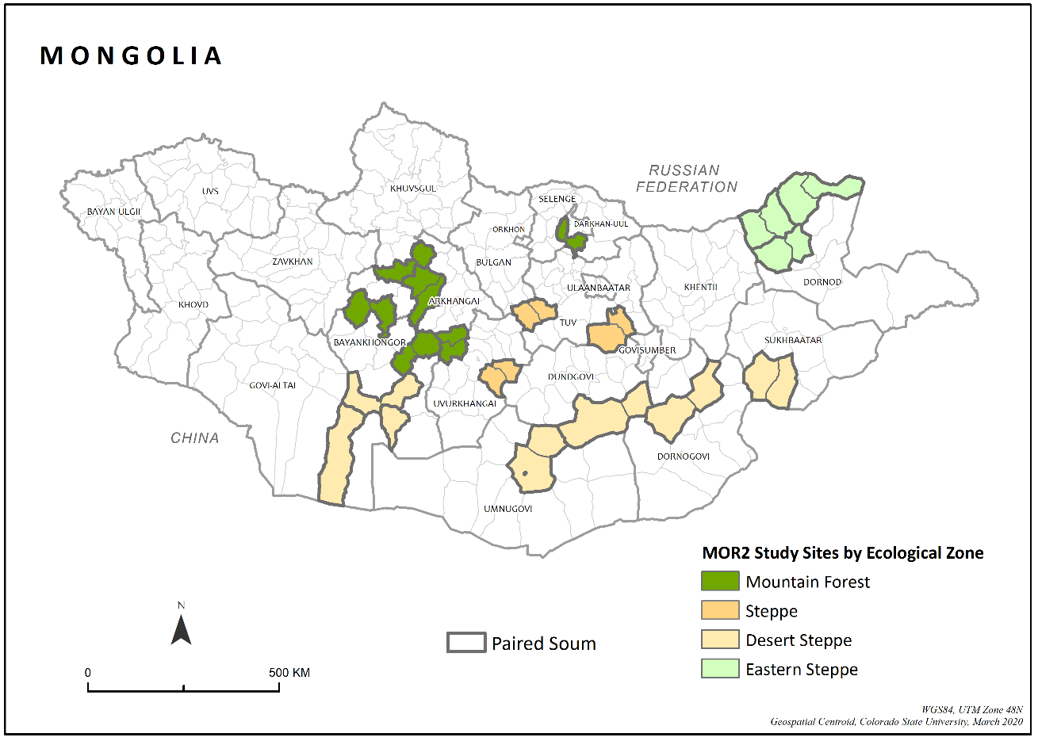

Fig. S1 MOR2 paired soum study sites.

Table S1 Coding system for survey data
AIMAG | SOUM | ORGANIZATION | HOUSEHOLD
Given a TWO DIGIT code, based on alphabetical order. Aimag codes are assigned beginning with the number 10 through 32.¹ | Given a FOUR DIGIT code. The first two digits = aimag code. The second two digits are based on alphabetical order of the soum names.² | Given a SIX DIGIT number. The first two digits = aimag; the second two digits = soum; the third two digits are assigned randomly. Each year new organizations are added.³ | Given an EIGHT-DIGIT code. The first two digits = aimag; second two digits = soum; third two digits = organization. The final two digits will assigned randomly.³
¹Ulaanbaatar is included in this list, even though it is not officially an aimag.
²The districts of Ulaanbaatar are assigned two-digit codes as if they are soums.
³Alphabetical order is difficult to maintain for organizations and households.

Table S2 The data files and handles in Mountain Scholar (https://mountainscholar.org/handle/10217/201550)
Data file name | Handles
hydro meteorological data | https://hdl.handle.net/10217/201554
ecological data (restricted data set) | https://hdl.handle.net/10217/201557
plot climate data | https://hdl.handle.net/10217/201558
hydrology field data | https://hdl.handle.net/10217/201559
hydraulic field data | https://hdl.handle.net/10217/201560
herder households | https://hdl.handle.net/10217/201552
household survey (restricted data set) | https://hdl.handle.net/10217/201553
livestock data | https://hdl.handle.net/10217/201555
org survey (restricted data set) | https://hdl.handle.net/10217/201556

