Training curves and tables
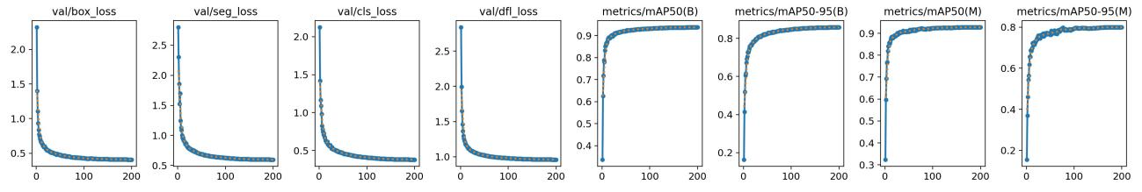
Fig. S1 Training curves of the baseline YOLOv8-seg model. Subplots present losses and evaluation metrics. All curves show smooth and steady trends with minimal oscillation, indicating that the model has been trained sufficiently.
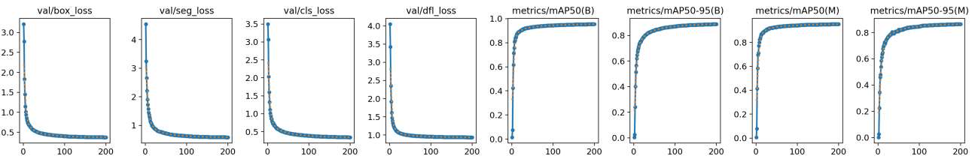
Fig. S2 Training curves of our proposed EMC-YOLO model. Subplots present losses and evaluation metrics. All curves show smooth and steady trends with minimal oscillation, indicating that the model has been trained sufficiently.
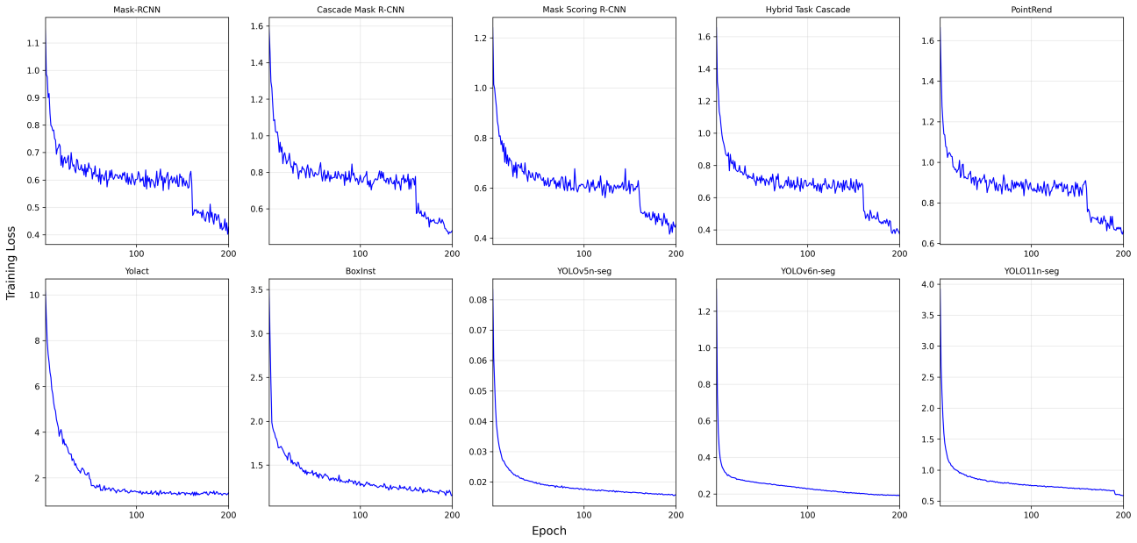
Fig. S3 Training loss curves of compared instance segmentation models over 200 epochs. All models are trained under uniform conditions—utilizing the same stochastic gradient descent (SGD) optimizer to ensure fairness and reproducibility of the comparison. The overall trend indicates that most models reach convergence in later epochs, with significantly reduced fluctuations in loss. The first row illustrates two-stage instance segmentation models (such as the Mask R-CNN series) anchored within the MMDetection framework and employing the default MultiStepLR learning rate scheduler, which decays the learning rate at epochs 160 and 190. A pronounced drop in loss is observed at epoch 160, evidencing that the reduced learning rate enables finer parameter updates, enhancing the convergence speed. In contrast, the second row displays one-stage instance segmentation models (including the YOLO series and other one-stage models). These models typically adopt smoother learning rate scheduling strategies, such as linear decay with warmup, resulting in more gradual and monotonic convergence.
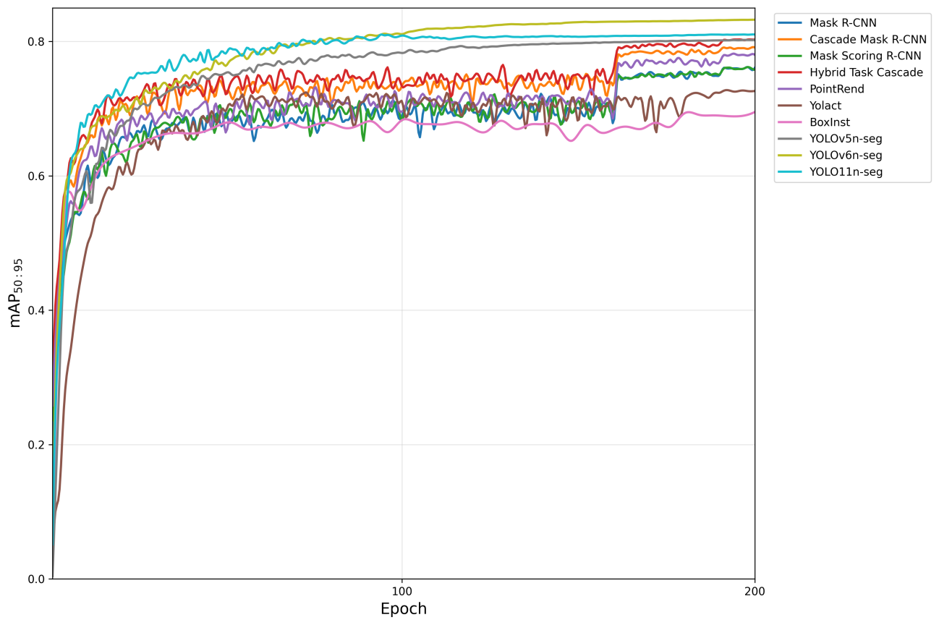
Fig. S4 The mAP_{95:50} curves of compared instance segmentation models over 200 training epochs. As shown, most models experience rapid performance improvements within the first 50 epochs, followed by slower progress in the remaining training period, with the performance stabilizing in the later stages.
Table S1 Training stability metrics for compared semantic segmentation models. Both models exhibit low loss fluctuation and a nearly flat trend in the final training stages, indicating that they have reached a stable optimization state. The metrics Last_30_std (standard deviation of loss over the last 30 epochs) and Last_50_slope (linear regression slope over the last 50 epochs) quantify this training stability and trend flatness, respectively.
Model | Last_30_std | Last_50_slope
UNet | 0.0173 | -0.000993
RAUNet | 0.0116 | -0.000623

