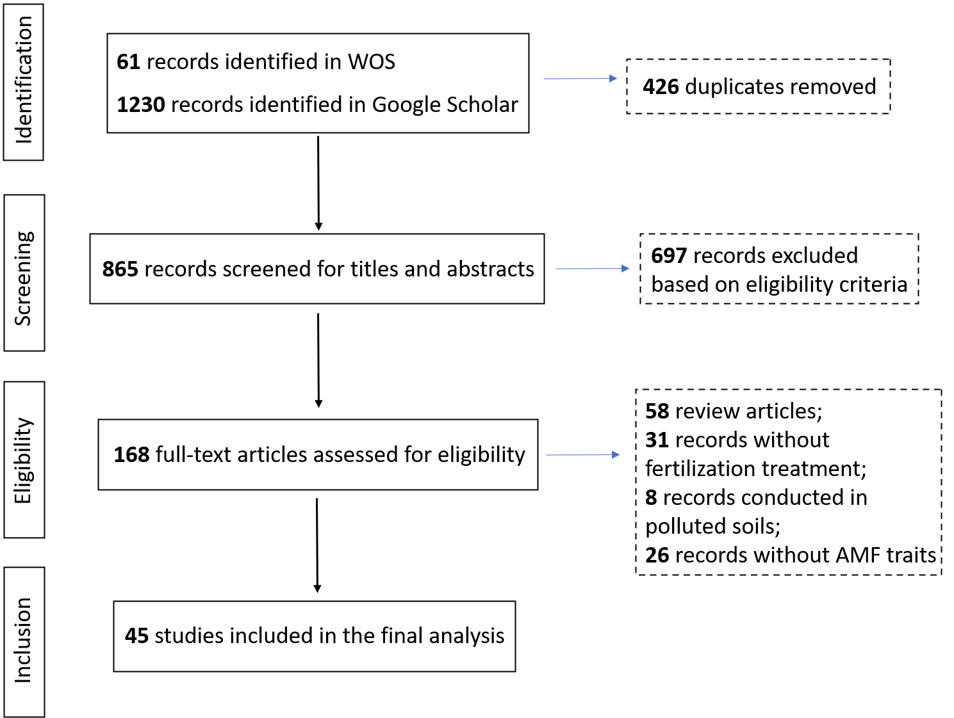
Fig. S1 The PRISMA flow diagram summarizes the various stages of the systematic literature review, including study screening, exclusion details, and the number of studies retained for quantitative analysis.

Table S1 Eggers’ test for publication bias across all interested variables. ▼ indicated the presence of funnel plot asymmetry in the initial test, followed by adjustment using the trim-and-fill method.
Parameter | t value | p value
AMF biomass▼ | -0.46 | 0.65
Chao1▼ | -0.18 | 0.86
Root colonization | -0.96 | 0.34
Hyphal length density | 0.03 | 0.98
Richness | 1.70 | 0.10
Shannon index▼ | -0.45 | 0.65
Spore density | 0.77 | 0.45
AN▼ | 0.65 | 0.52
AP▼ | 0.16 | 0.87
pH▼ | 0.07 | 0.94
SOC | -0.55 | 0.58

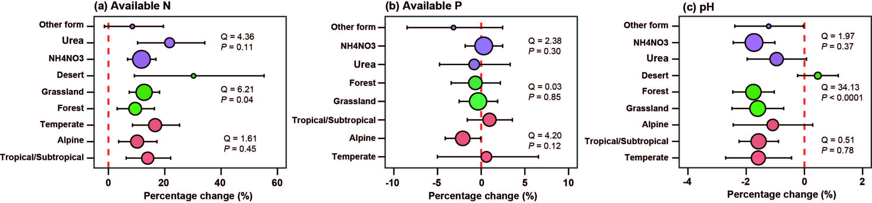
Fig. S2 Effects of nitrogen (N) addition on soil properties across different subgroups (N addition type, ecosystem type, and climate condition). Purple points represent N addition type, green points represent ecosystem type, and orange points represent climate condition. Point size corresponds to the number of pooled studies. Panels (a)-(c) represent soil available N, soil available P, and soil pH, respectively.

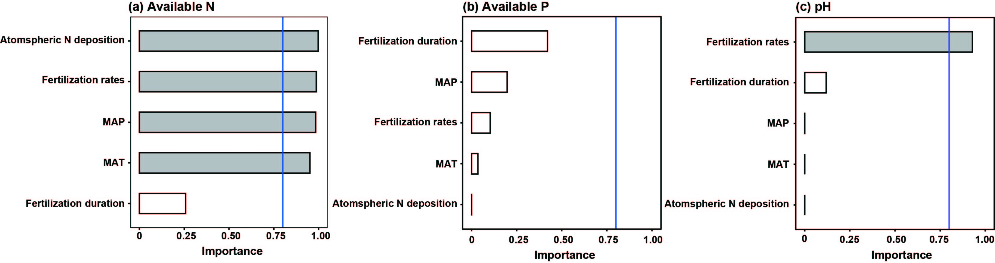
Fig. S3 Predictor importance ranking for soil properties. The vertical blue line at 0.8 distinguishes important predictors from non-important ones. Panels (a)-(c) represent soil available N, soil available P, and soil pH, respectively.

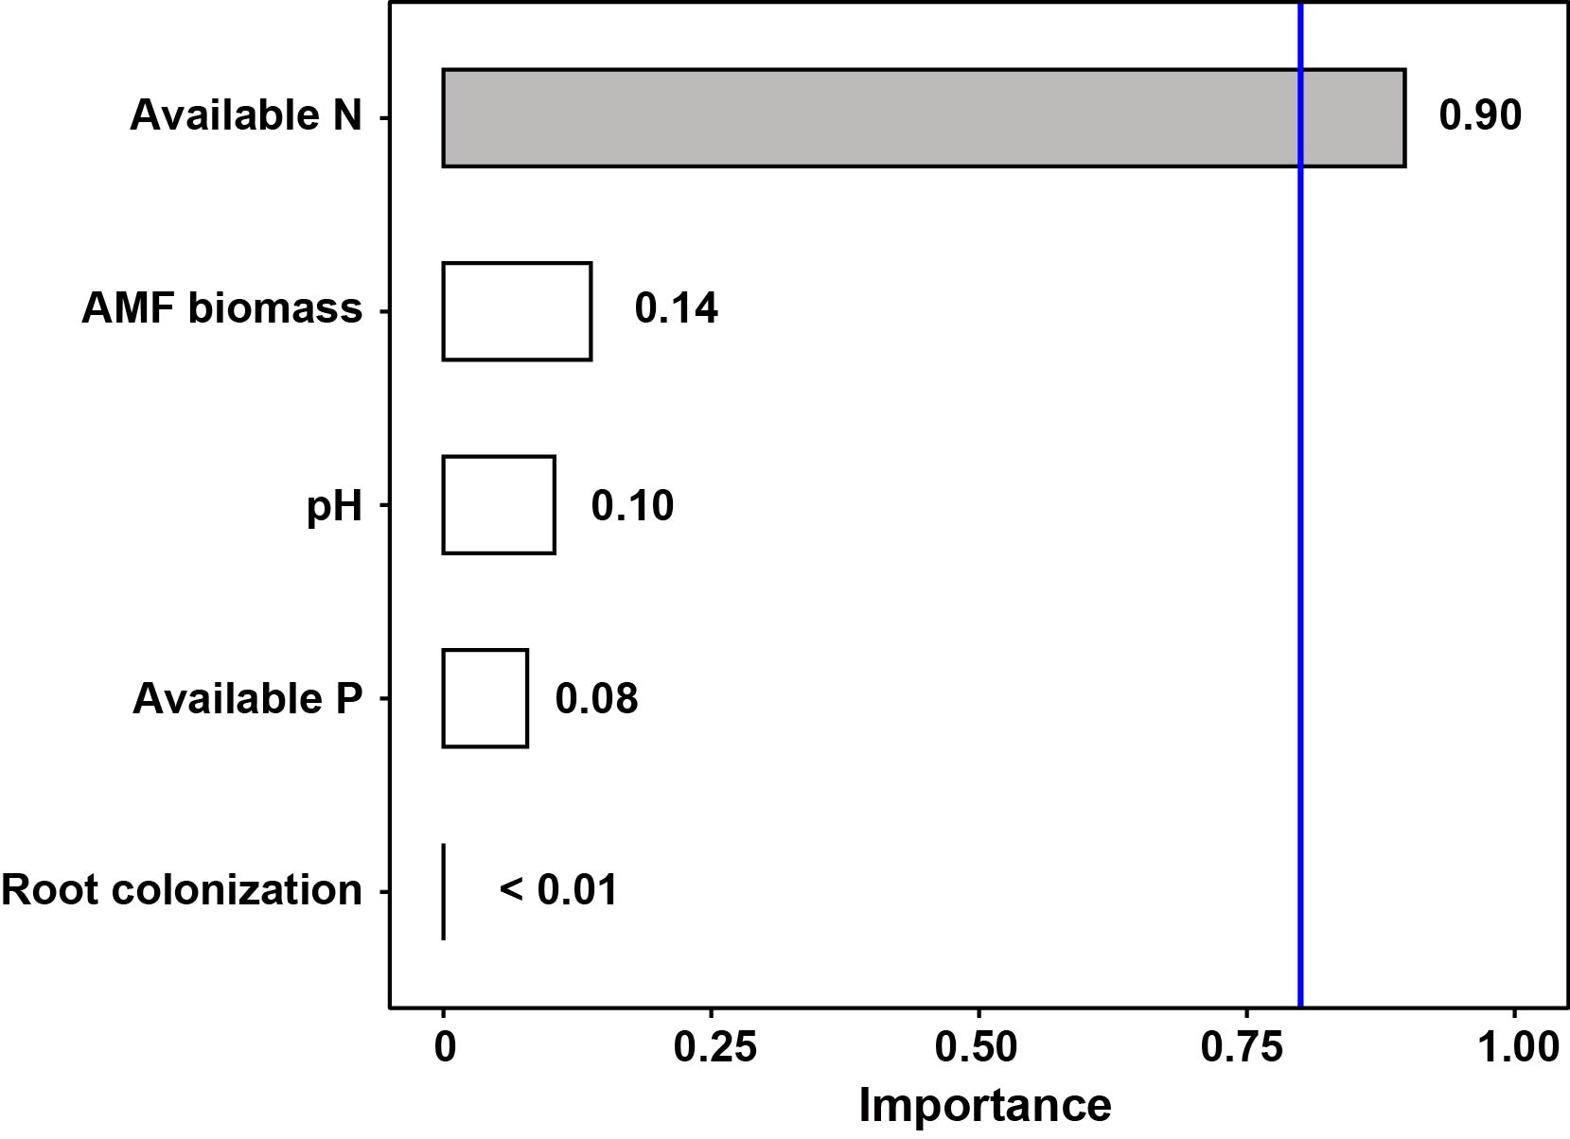
Fig. S4
Fig. S4 Predictor importance ranking for soil organic carbon. The vertical blue line at 0.8 distinguishes important predictors from non-important ones.

Studies in the meta-analysis
- Antoninka, A., P. B. Reich, and N. C. Johnson. 2011. Seven years of carbon dioxide enrichment, nitrogen fertilization and plant diversity influence arbuscular mycorrhizal fungi in a grassland ecosystem. New Phytologist 192:200-214.
- Blanke, V., S. Bassin, M. Volk, and J. Fuhrer. 2012. Nitrogen deposition effects on subalpine grassland: The role of nutrient limitations and changes in mycorrhizal abundance. Acta Oecologica-International Journal of Ecology 45:57-65.
- Camenzind, T., S. Hempel, J. Homeier, S. Horn, A. Velescu, W. Wilcke, and M. C. Rillig. 2014. Nitrogen and phosphorus additions impact arbuscular mycorrhizal abundance and molecular diversity in a tropical montane forest. Global Change Biology 20:3646-3659.
- Camenzind, T., J. Homeier, K. Dietrich, S. Hempel, D. Hertel, A. Krohn, C. Leuschner, Y. Oelmann, P. A. Olsson, J. P. Suarez, and M. C. Rillig. 2016. Opposing effects of nitrogen versus phosphorus additions on mycorrhizal fungal abundance along an elevational gradient in tropical montane forests. Soil Biology & Biochemistry 94:37-47.
- Cao, J. L., T. C. Lin, Z. J. Yang, Y. Zheng, L. Xie, D. C. Xiong, and Y. S. Yang. 2020. Warming exerts a stronger effect than nitrogen addition on the soil arbuscular mycorrhizal fungal community in a young subtropical Cunninghamia lanceolata plantation. Geoderma 367.
- Chen, Y. L., Z. W. Xu, T. L. Xu, S. D. Veresoglou, G. W. Yang, and B. D. Chen. 2017. Nitrogen deposition and precipitation induced phylogenetic clustering of arbuscular mycorrhizal fungal communities. Soil Biology & Biochemistry 115:233-242.
- Chen, Y. L., X. Zhang, J. S. Ye, H. Y. Han, S. Q. Wan, and B. D. Chen. 2014. Six-year fertilization modifies the biodiversity of arbuscular mycorrhizal fungi in a temperate steppe in Inner Mongolia. Soil Biology & Biochemistry 69:371-381.
- Egerton-Warburton, L. M., and E. B. Allen. 2000. Shifts in arbuscular mycorrhizal communities along an anthropogenic nitrogen deposition gradient. Ecological Applications 10:484-496.
- Egerton-Warburton, L. M., N. C. Johnson, and E. B. Allen. 2007. Mycorrhizal community dynamics following nitrogen fertilization: A cross-site test in five grasslands. Ecological Monographs 77:527-544.
- Fan, Y. X. 2020. N addition increased microbial residual carbon by altering soil P availability and microbial composition in a subtropical Castanopsis forest. Geoderma.
- Frater, P. N., E. T. Borer, P. A. Fay, V. Jin, B. Knaeble, E. Seabloom, L. Sullivan, D. A. Wedin, and W. S. Harpole. 2018. Nutrients and environment influence arbuscular mycorrhizal colonization both independently and interactively in Schizachyrium scoparium. Plant and Soil 425:493-506.
- Garcia, M. O., T. Ovasapyan, M. Greas, and K. K. Treseder. 2008. Mycorrhizal dynamics under elevated CO2 and nitrogen fertilization in a warm temperate forest. Plant and Soil 303:301-310.
- Guan, Z.-H., Z. Cao, X. G. Li, T. Scholten, P. Kühn, L. Wang, R.-P. Yu, and J.-S. He. 2024. Soil phosphorus availability mediates the effects of nitrogen addition on community-and species-level phosphorus-acquisition strategies in alpine grasslands. Science of the Total Environment 906:167630.
- Guo, J., Y. Gao, D. M. Eissenstat, C. He, and L. Sheng. 2020. Belowground responses of woody plants to nitrogen addition in a phosphorus-rich region of northeast China. Trees 34:143-154.
- Gutknecht, J. L. M., C. B. Field, and T. C. Balser. 2012. Microbial communities and their responses to simulated global change fluctuate greatly over multiple years. Global Change Biology 18:2256-2269.
- Huang, G., Y. Li, and Y. G. Su. 2015. Divergent responses of soil microbial communities to water and nitrogen addition in a temperate desert. Geoderma 251:55-64.
- Jach-Smith, L. C., and R. D. Jackson. 2018. N addition undermines N supplied by arbuscular mycorrhizal fungi to native perennial grasses. Soil Biology & Biochemistry 116:148-157.
- Jiang, S. J., Y. J. Liu, J. J. Luo, M. S. Qin, N. C. Johnson, M. Opik, M. Vasar, Y. X. Chai, X. L. Zhou, L. Mao, G. Z. Du, L. Z. An, and H. Y. Feng. 2018. Dynamics of arbuscular mycorrhizal fungal community structure and functioning along a nitrogen enrichment gradient in an alpine meadow ecosystem. New Phytologist 220:1222-1235.
- Johnson, N. C., D. L. Rowland, L. Corkidi, L. M. Egerton-Warburton, and E. B. Allen. 2003. Nitrogen enrichment alters mycorrhizal allocation at five mesic to semiarid grasslands. Ecology 84:1895-1908.
- Kang, F., B. Yang, Wujisiguleng, X. Yang, L. Wang, J. Guo, W. Sun, Q. Zhang, and T. Zhang. 2019. Arbuscular mycorrhizal fungi alleviate the negative effect of nitrogen deposition on ecosystem functions in meadow grassland. Land Degradation & Development.
- Kim, Y.-C., C. Gao, Y. Zheng, X.-H. He, W. Yang, L. Chen, S.-Q. Wan, and L.-D. Guo. 2015. Arbuscular mycorrhizal fungal community response to warming and nitrogen addition in a semiarid steppe ecosystem. Mycorrhiza 25:267-276.
- Li, L., M. L. McCormack, F. Chen, H. Wang, Z. Ma, and D. Guo. 2019. Different responses of absorptive roots and arbuscular mycorrhizal fungi to fertilization provide diverse nutrient acquisition strategies in Chinese fir. Forest Ecology and Management 433:64-72.
- Lin, Q.-y., Q.-x. Zeng, X.-c. Yuan, J.-y. Cui, H. Xie, H.-y. Lin, W.-p. Li, Q.-b. Yang, and Y.-m. Chen. 2022. Effects of Nitrogen Addition on the Soil Phoshorus Fractions in Subtropical <i>Pinus taiwanensis</i> Forests. Forest Research 35:170-178.
- Lin, X., Q. Dong, P. Wang, L. Jiang, J. Hu, S. Wang, and B. Ji. 2020. Effects of nitrogen and phosphorus additions on arbuscular mycorrhizal fungi community in the alpine meadow in Qinghai-Tibetan plateau. Journal of South China Agricultural University 41:95-103.
- Liu, L., Y. Ren, S. Sun, C. Liu, K. Ding, R. Li, P. Zhang, B. Shen, M. Ravanbakhsh, and W. Xiong. 2024. Unraveling fertilization effects on the dynamics of arbuscular mycorrhizal fungal community in the Qinghai-Tibet Alpine Meadow. Soil Ecology Letters 6:240248.
- Liu, W., Y. Jiang, G. Wang, Y. Su, J. M. Smoak, M. Liu, and B. Duan. 2021. Effects of N addition and clipping on above and belowground plant biomass, soil microbial community structure, and function in an alpine meadow on the Qinghai-Tibetan Plateau. European Journal of Soil Biology 106:103344.
- Luo, R., Y. Kuzyakov, D. Liu, J. Fan, J. Luo, S. Lindsey, J.-S. He, and W. Ding. 2020a. Nutrient addition reduces carbon sequestration in a Tibetan grassland soil: Disentangling microbial and physical controls. Soil Biology & Biochemistry 144.
- Luo, R., J. Luo, J. Fan, D. Liu, J.-S. He, N. Perveen, and W. Ding. 2020b. Responses of soil microbial communities and functions associated with organic carbon mineralization to nitrogen addition in a Tibetan grassland. Pedosphere 30:214-225.
- Ma, S., G. Chen, D. Tian, E. Du, W. Xiao, L. Jiang, Z. Zhou, J. Zhu, H. He, B. Zhu, and J. Fang. 2020. Effects of seven-year nitrogen and phosphorus additions on soil microbial community structures and residues in a tropical forest in Hainan Island, China. Geoderma 361.
- Mei, L. L., X. Yang, S. Q. Zhang, T. Zhang, and J. X. Guo. 2019. Arbuscular mycorrhizal fungi alleviate phosphorus limitation by reducing plant N:P ratios under warming and nitrogen addition in a temperate meadow ecosystem. Science of the Total Environment 686:1129-1139.
- Mueller, R. C., and B. J. M. Bohannan. 2015. Shifts in the phylogenetic structure of arbuscular mycorrhizal fungi in response to experimental nitrogen and carbon dioxide additions. Oecologia 179:175-185.
- Riggs, C. E., S. E. Hobbie, E. M. Bach, K. S. Hofmockel, and C. E. Kazanski. 2015. Nitrogen addition changes grassland soil organic matter decomposition. Biogeochemistry 125:203-219.
- Treseder, K. K., K. M. Turner, and M. C. Mack. 2007. Mycorrhizal responses to nitrogen fertilization in boreal ecosystems: potential consequences for soil carbon storage. Global Change Biology 13:78-88.
- van Diepen, L. T. A., E. A. Lilleskov, K. S. Pregitzer, and R. M. Miller. 2010. Simulated Nitrogen Deposition Causes a Decline of Intra- and Extraradical Abundance of Arbuscular Mycorrhizal Fungi and Changes in Microbial Community Structure in Northern Hardwood Forests. Ecosystems 13:683-695.
- Wang, C., X. Lu, T. Mori, Q. Mao, K. Zhou, G. Zhou, Y. Nie, and J. Mo. 2018. Responses of soil microbial community to continuous experimental nitrogen additions for 13 years in a nitrogen-rich tropical forest. Soil Biology & Biochemistry 121:103-112.
- Wu, J. P., W. F. Liu, H. B. Fan, G. M. Huang, S. Z. Wan, Y. H. Yuan, and C. F. Ji. 2013. Asynchronous responses of soil microbial community and understory plant community to simulated nitrogen deposition in a subtropical forest. Ecology and Evolution 3:3895-3905.
- Xiao, D., R. X. Che, X. Liu, Y. J. Tan, R. Yang, W. Zhang, X. Y. He, Z. H. Xu, and K. L. Wang. 2019. Arbuscular mycorrhizal fungi abundance was sensitive to nitrogen addition but diversity was sensitive to phosphorus addition in karst ecosystems. Biology and Fertility of Soils 55:457-469.
- Yan, G. Y., M. X. Zhou, M. Wang, S. J. Han, G. C. Liu, X. Zhang, W. J. Sun, B. B. Huang, H. L. Wang, Y. J. Xing, and Q. G. Wang. 2019. Nitrogen deposition and decreased precipitation altered nutrient foraging strategies of three temperate trees by affecting root and mycorrhizal traits. Catena 181.
- Yang, N., J. Zhang, J. Hua, B. Song, T. Wang, W. Xing, G. Wang, L. Mao, and H. Ruan. 2024. Differentiation of fungal trophic guilds to long-term nitrogen addition in a poplar plantation. Forest Ecology and Management 555:121699.
- Yang, S., Z. W. Xu, R. Z. Wang, Y. Y. Zhang, F. Yao, Y. G. Zhang, R. F. Turco, Y. Jiang, H. T. Zou, and H. Li. 2017. Variations in soil microbial community composition and enzymatic activities in response to increased N deposition and precipitation in Inner Mongolian grassland. Applied Soil Ecology 119:275-285.
- Yuan, X., W. Qin, H. Xu, Z. Zhang, H. Zhou, and B. Zhu. 2020. Sensitivity of soil carbon dynamics to nitrogen and phosphorus enrichment in an alpine meadow. Soil Biology and Biochemistry 150:107984.
- Zhang, J., J. Zhou, E. J. Sayer, H. Lambers, Z. Liu, X. Lu, Y. Li, Y. Li, H. Li, and F. Wang. 2023. Nitrogen deposition enhances soil organic carbon and microbial residual carbon in a tropical forest. Plant and Soil 484:217-235.
- Zhao, R., Y. Kuzyakov, H. Zhang, Z. Wang, T. Li, L. Shao, L. Jiang, R. Wang, M. Li, and O. J. Sun. 2024. Labile carbon inputs offset nitrogen-induced soil aggregate destabilization via enhanced growth of saprophytic fungi in a meadow steppe. Geoderma 443:116841.
- Zheng, Y., Y.-C. Kim, X.-F. Tian, L. Chen, W. Yang, C. Gao, M.-H. Song, X.-L. Xu, and L.-D. Guo. 2014. Differential responses of arbuscular mycorrhizal fungi to nitrogen addition in a near pristine Tibetan alpine meadow. Fems Microbiology Ecology 89:594-605.
- Zheng, Z., P. F. Ma, J. Li, L. F. Ren, W. M. Bai, Q. Y. Tian, W. Sun, and W. H. Zhang. 2018. Arbuscular mycorrhizal fungal communities associated with two dominant species differ in their responses to long-term nitrogen addition in temperate grasslands. Functional Ecology 32:1575-1588.

