Supplemental materials

Climate variability and nitrogen legacy effects on corn yield and soil nitrous oxide emissions: a 40-year simulation study

Dafeng Hui^{1,*}, Jaekedah Christian², Faisal Hayat¹, Maazeera Fatima¹, Yujuan Chen², Daniel M. Ricciuto³, and Hanqin Tian^{4,5},

¹ Department of Biological Sciences, Tennessee State University, Nashville, TN, 37209, USA
² Department of Environmental Sciences, Tennessee State University, Nashville, TN 37209, USA
³ Environmental Sciences Division and Climate Change Science Institute, Oak Ridge National Laboratory, Oak Ridge, TN, 37830, USA
⁴ Center for Earth System Science and Global Sustainability, Schiller Institute for Integrated Science and Society, Boston College, Chestnut Hill, MA 02467, USA
⁵ Department of Earth and Environmental Sciences, Boston College, Chestnut Hill, MA 02467, USA

Supplemental materials
Table S1. Mean and coefficient of variance (CV) of simulated corn yield and soil N₂O emissions reflecting nitrogen application legacy effects and interannual climate variability effects.
Figure S1. The variations of simulated corn yield (a) and soil N₂O emissions (b) over 40 years with the same climate data for each year of drought (2007), typical (2010), and wet (1998) years.
Figure S2. The variations of DNDC model simulated leaching NO₃⁻ (a) and soil N₂ flux (b), and soil exchangeable NH₄⁺ over 40 years from 1981 to 2020. soil exchangeable NH₄⁺ increases with year (NH₄⁺=-142.2298 * 0.0777 * Year, r²=0.43, p<0.001).

Table S1. Mean and coefficient of variance (CV) of simulated corn yield and soil N2O emissions reflecting nitrogen application legacy effects and interannual climate variability effects.
Year | Nitrogen application legacy effect |  |  |  | Interannual climate variability effect
Year | Yield  (kg C ha⁻¹) |  | Soil N₂O emissions  (kg N ha⁻¹) |  | Yield  (kg C ha⁻¹) |  | Soil N₂O emissions  (kg N ha⁻¹)
Year | Mean | CV | Mean | CV | Mean | CV | Mean | CV
1981 | 3426.90 | 10.53 | 1.97 | 13.68 | 3974.96 | 4.42 | 3.40 | 28.35
1982 | 3552.53 | 7.02 | 2.04 | 9.29 | 3927.28 | 3.51 | 4.67 | 29.92
1983 | 3580.90 | 6.55 | 2.12 | 10.14 | 3938.50 | 3.23 | 3.79 | 32.06
1984 | 3603.19 | 6.58 | 2.21 | 10.99 | 3994.63 | 4.16 | 3.75 | 29.32
1985 | 3622.87 | 6.60 | 2.29 | 11.95 | 3922.14 | 4.41 | 3.58 | 27.70
1986 | 3642.00 | 6.70 | 2.38 | 12.75 | 3579.81 | 4.07 | 4.78 | 34.24
1987 | 3658.85 | 6.94 | 2.47 | 13.40 | 3770.46 | 3.20 | 3.43 | 24.11
1988 | 3675.97 | 7.10 | 2.57 | 13.91 | 3027.30 | 1.70 | 2.59 | 31.94
1989 | 3692.12 | 7.32 | 2.67 | 14.49 | 4109.60 | 7.51 | 4.00 | 29.11
1990 | 3707.21 | 7.53 | 2.77 | 15.03 | 3780.64 | 3.60 | 3.92 | 28.13
1991 | 3719.70 | 7.75 | 2.87 | 15.47 | 3939.10 | 3.62 | 4.04 | 27.88
1992 | 3731.78 | 7.97 | 2.98 | 15.80 | 4101.86 | 4.84 | 3.78 | 27.29
1993 | 3742.94 | 8.25 | 3.09 | 16.03 | 3503.77 | 3.05 | 3.26 | 29.35
1994 | 3754.40 | 8.49 | 3.20 | 16.28 | 3923.99 | 4.03 | 3.29 | 27.83
1995 | 3767.44 | 8.65 | 3.31 | 16.39 | 3906.41 | 4.66 | 3.54 | 29.91
1996 | 3779.45 | 8.80 | 3.42 | 16.52 | 3968.76 | 3.98 | 4.05 | 29.52
1997 | 3788.64 | 9.01 | 3.54 | 16.45 | 3947.82 | 3.79 | 3.23 | 28.11
1998 | 3797.44 | 9.21 | 3.65 | 16.48 | 3941.62 | 3.46 | 3.58 | 23.74
1999 | 3806.04 | 9.40 | 3.77 | 16.42 | 3534.28 | 2.64 | 3.49 | 25.98
2000 | 3814.02 | 9.56 | 3.88 | 16.41 | 3305.92 | 4.87 | 3.96 | 31.04
2001 | 3823.49 | 9.58 | 4.00 | 16.41 | 3977.32 | 6.60 | 3.83 | 28.93
2002 | 3833.44 | 9.60 | 4.12 | 16.29 | 3499.50 | 2.59 | 3.49 | 30.67
2003 | 3844.88 | 9.63 | 4.25 | 16.06 | 3936.65 | 3.74 | 3.70 | 27.97
2004 | 3855.08 | 9.71 | 4.37 | 15.90 | 3995.35 | 3.73 | 4.11 | 29.56
2005 | 3865.65 | 9.76 | 4.50 | 15.73 | 3627.72 | 3.19 | 3.53 | 24.53
2006 | 3875.83 | 9.92 | 4.62 | 15.43 | 3839.80 | 5.01 | 3.58 | 29.19
2007 | 3885.75 | 9.99 | 4.69 | 15.47 | 2265.50 | 4.60 | 3.25 | 24.59
2008 | 3891.84 | 10.12 | 4.75 | 15.68 | 3619.69 | 2.52 | 3.99 | 30.04
2009 | 3896.27 | 10.18 | 4.80 | 15.84 | 4165.35 | 6.46 | 3.96 | 31.78
2010 | 3903.53 | 10.17 | 4.86 | 16.07 | 3900.91 | 3.96 | 6.15 | 30.53
2011 | 3909.59 | 10.22 | 4.91 | 16.30 | 3844.98 | 3.28 | 4.08 | 29.52
2012 | 3916.53 | 10.29 | 4.96 | 16.39 | 3526.49 | 4.67 | 3.94 | 27.94
2013 | 3925.63 | 10.35 | 5.00 | 16.43 | 4013.46 | 4.35 | 4.03 | 27.09
2014 | 3933.18 | 10.41 | 5.04 | 16.35 | 3969.34 | 4.02 | 3.38 | 25.59
2015 | 3941.85 | 10.50 | 5.08 | 16.26 | 3931.21 | 3.48 | 3.20 | 26.52
2016 | 3950.48 | 10.56 | 5.12 | 16.26 | 3955.62 | 4.95 | 3.91 | 25.94
2017 | 3958.46 | 10.62 | 5.16 | 16.30 | 4020.73 | 4.97 | 4.02 | 28.46
2018 | 3968.60 | 10.70 | 5.20 | 16.35 | 3949.40 | 3.77 | 5.10 | 32.24
2019 | 3979.30 | 10.78 | 5.23 | 16.46 | 3972.75 | 4.09 | 4.07 | 30.02
2020 | 3992.58 | 10.86 | 5.27 | 16.58 | 3905.73 | 3.49 | 3.72 | 28.20

a)
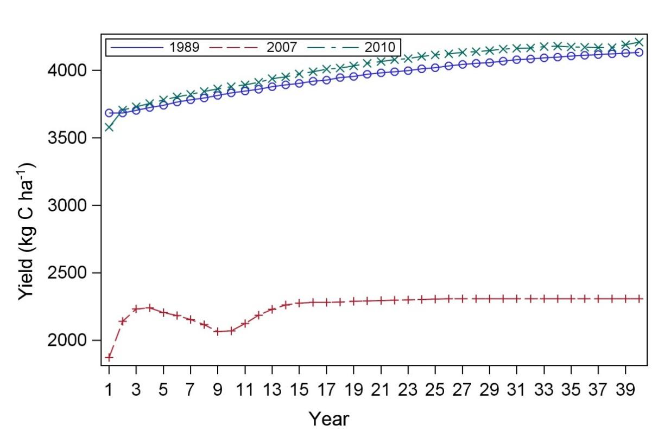
b)
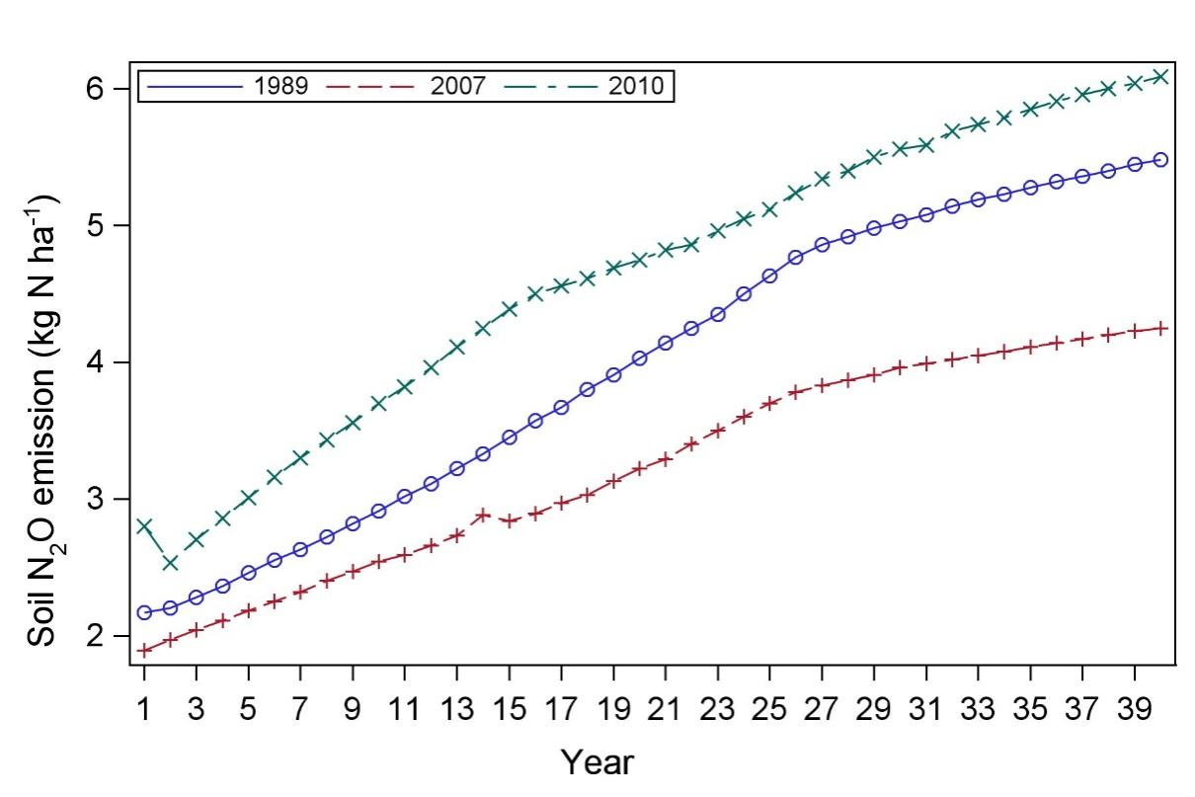
Figure S1. The variations of simulated corn yield (a) and soil N2O emissions (b) over 40 years with the same climate data for each year of drought (2007), typical (2010), and wet (1998) years.

a)

b)
c)
Figure S2. The variations of DNDC model simulated leaching NO₃⁻ (a) and soil N₂ flux (b), and soil exchangeable NH₄⁺ over 40 years from 1981 to 2020. soil exchangeable NH₄⁺ increases with year (NH₄⁺=-142.2298 * 0.0777 * Year, r²=0.43, p<0.001).

