Supplementary materials for
Further geochronological constraints for the Xiuyan impact crater in Northeast China
Zeyang Zhu^{1, 2}, Chang Huang^{3, *}, Jing Wu^{1, 2}, Yawei Li⁴, Zhihao Sun^{1, 2}, Bin Zhang^{1, 2},
Sheng-Hua Li³, Jiaqi Liu^{1, 2}
¹ Key Laboratory of Cenozoic Geology Environment, Institute of Geology and Geophysics, Chinese Academy of Sciences, Beijing 100029, China
² Institution of Earth Science, Chinese Academy of Sciences, Beijing 100029, China
³ Department of Earth Sciences, The University of Hong Kong, Hong Kong, China
⁴ College of Tourism and Planning, Pingdingshan University, Pingdingshan, 467400, China

Contents of this file
Fig. S1 to S4

Introduction
This supporting document contains supplementary materials about the characteristics of luminescence dating.
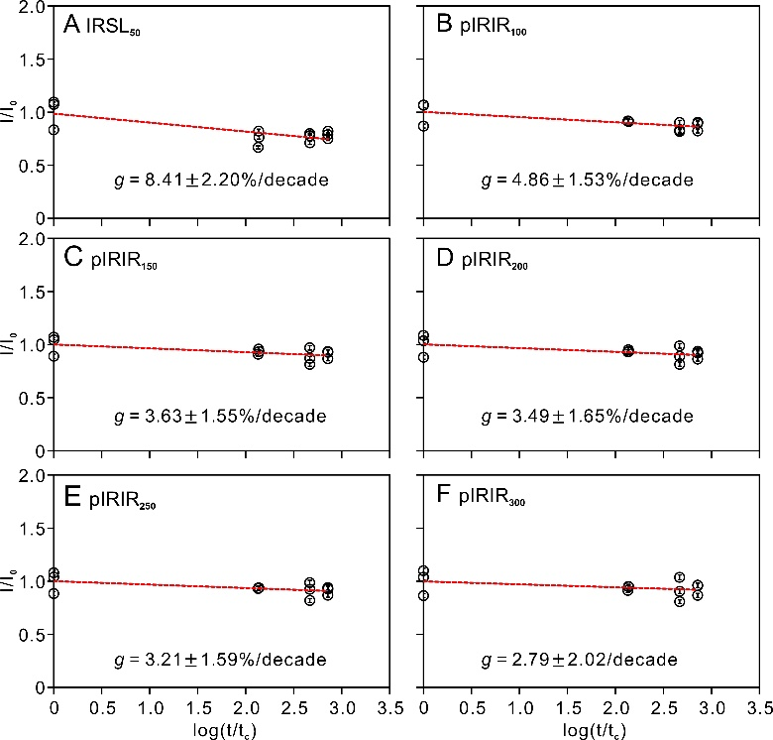
Fig. S1 Fading rate measurements of the IRSL and MET-pIRIR signals of sample A24. The t_{c} is 1.96 h.
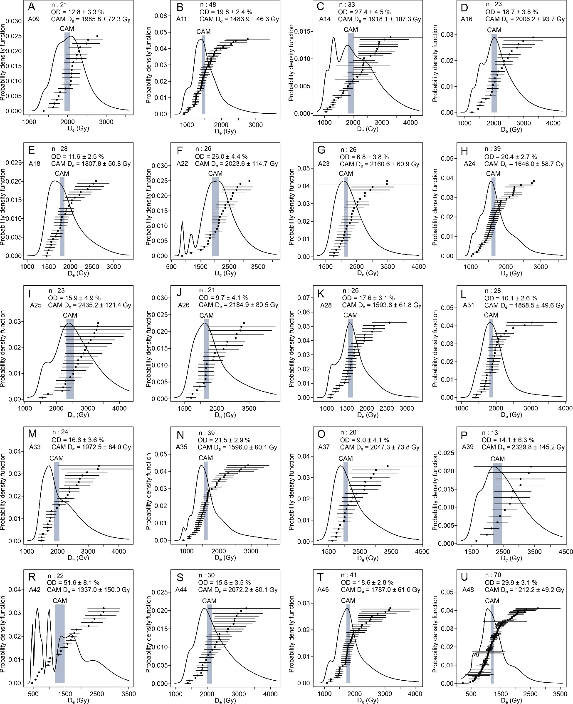Fig. S2 The distribution of pIRIR₃₀₀ D_{e} values for 20 saturated samples. n represents the number of aliquots for the SGC D_{e} calculation.
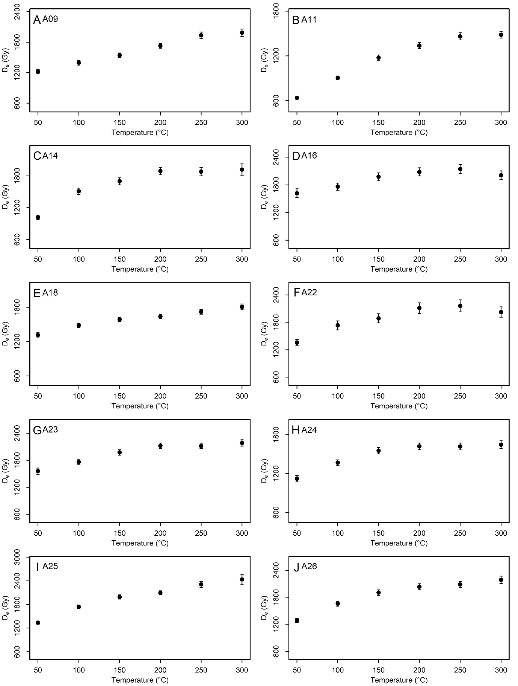Fig. S3 D_{e} values against with different IR stimulation temperatures with the MET-pIRIR protocol for ten saturated samples.
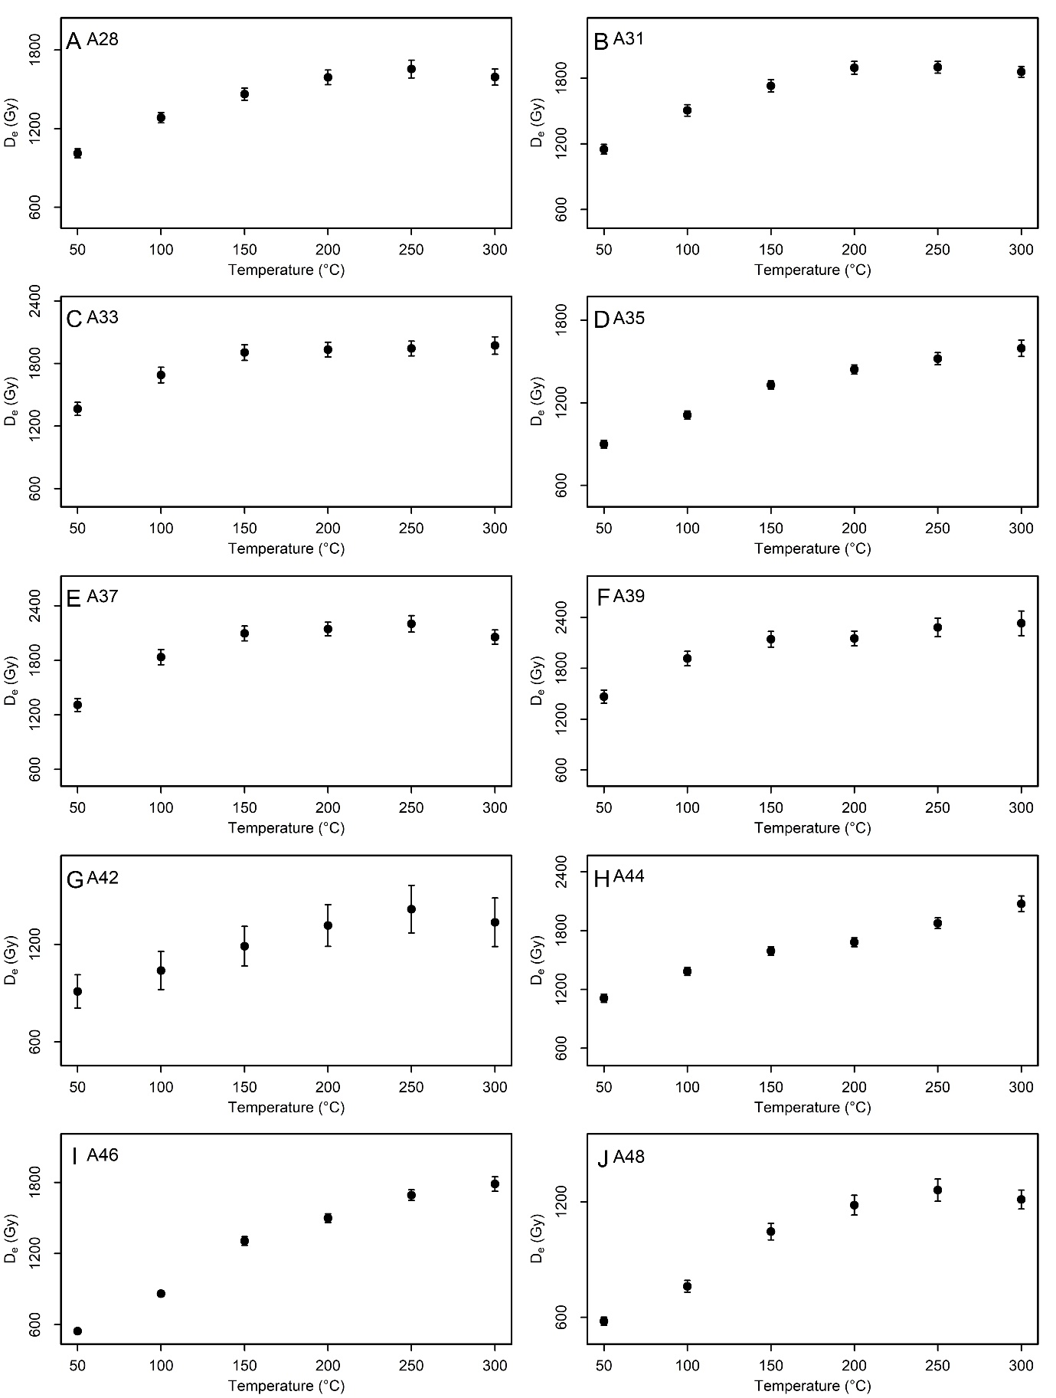
Fig. S4 D_{e} values against with different IR stimulation temperatures with the MET-pIRIR protocol for ten saturated samples.

