Supplementary materials for
Interannual variability and trends of gross primary production and transpiration in savannas and grasslands from 2000 to 2021

Cheng Mengª, Xiangming Xiao^{a, *}, Li Panª, Baihong Panª, Russell L. Scott^{b}, Pradeep Wagle^{c}, Chenchen Zhangª, Yuan Yaoª, Yuanwei Qinª

ª School of Biological Sciences, Center for Earth Observation and Modeling, University of Oklahoma, Norman, OK 73019, USA
^{b} Southwest Watershed Research Center, USDA Agricultural Research Service, Tucson, AZ 85719, USA
^{c} Oklahoma and Central Plains Agricultural Research Center, USDA Agricultural Research Service, EI Reno, OK 73036, USA

*Corresponding author at: School of Biological Sciences, Center for Earth Observation and Modeling, University of Oklahoma, Norman, OK 73019, USA.
E-mail address: xiangming.xiao@ou.edu (X. Xiao).

Table S1. 22-year averages and standard deviation (± std) of annual daytime mean air temperature from the ERA5 dataset (TA_{DT-ERA5}), annual precipitation from the ERA5 dataset (P_{ERA5}), gross primary production (GPP), and transpiration (T) at the five sites.
Site name | US-VAR(GRA) | US-TON(WSA) | US-WKG(GRA) | US-SRG(GRA) | US-SRM(WSA)
TA_{DT-ERA5}  (°C) | 19.1 ± 0.6 | 19.1 ± 0.6 | 19.6 ± 0.6 | 19.9 ± 0.6 | 19.9 ± 0.6
P_{ERA5}  (mm year⁻¹) | 754 ± 237 | 754 ± 237 | 220 ± 59 | 329 ± 76 | 329 ± 77
GPP_{VPM-ERA5}  (gC m⁻² year⁻¹) | 768 ± 127 | 899 ± 51 | 287 ± 139 | 565 ± 223 | 454 ± 165
T_{VTM-ERA5}  (mm year⁻¹) | 207 ± 34 | 243 ± 14 | 43 ± 21 | 92 ± 36 | 86 ± 31

- The method to estimate $1/WUE$
The $1/WUE$ is derived from Physicochemical and Environmental Plant Physiology 5th ed (Nobel, 2020). The relationship between transpiration and photosynthesis is defined as: Specifically, WUE averaged over a day for mature leaves is usually 1g CO₂ (kg H₂O)⁻¹ to 3g CO₂ (kg H₂O)⁻¹ for C3 plants, and 2g CO₂ (kg H₂O)⁻¹ to 5g CO₂ (kg H₂O)⁻¹ for C4 plants:
$$\begin{aligned}\text{C3 plants: }\text{1 }\text{g} {\text{CO}}_{\text{2}} \text{up}\text{take}=\text{1kg} {\text{H}}_{\text{2}}\text{O}\text{ loss }\#\left(S1\right)\end{aligned}$$
$\text{ C4 plants: 2} \text{g} {\text{CO}}_{\text{2}} \text{up}\text{take}=\text{1kg} {\text{H}}_{\text{2}}\text{O}\text{ loss}\text{ (S2)}$
Based on the above conception, the transpiration (T) of C3 (eq. S3) and C4 (eq. S4) plants can be estimated using the subsequent formula:
$$\begin{aligned}{\text{T}}_{\text{VTM}\text{-C3}}=\text{GPP} \left(\text{gC }{\text{m}}^{\text{-2}}\right) ×\frac{\text{1000 g }{\text{H}}_{\text{2}}\text{O}}{\text{1 g C}{\text{O}}_{\text{2}}}\#\left(S3\right) \\ =\text{GPP} \left(\frac{\text{12}}{\text{44}} \text{g C}{\text{O}}_{\text{2}} {\text{m}}^{\text{-2}}\right)× \frac{\text{1000 g }{\text{H}}_{\text{2}}\text{O}}{\text{1 g C}{\text{O}}_{\text{2}}} \\ =\text{GPP} \text{×} \text{0.27mm} \end{aligned}$$
$$\begin{aligned}{\text{T}}_{\text{VTM}\text{-C4}}=\text{GPP} \left(\text{gC }{\text{m}}^{\text{-2}}\right) ×\frac{\text{1000 g }{\text{H}}_{\text{2}}\text{O}}{\text{2}\text{ g C}{\text{O}}_{\text{2}}}\#\left(S4\right) \\ =\text{GPP} \left(\frac{\text{12}}{\text{44}} \text{g C}{\text{O}}_{\text{2}} {\text{m}}^{\text{-2}}\right)× \frac{\text{1000 g }{\text{H}}_{\text{2}}\text{O}}{\text{2}\text{ g C}{\text{O}}_{\text{2}}} \\ =\text{GPP} \text{×} \text{0.}\text{135}\text{mm} \end{aligned}$$

Therefore, the VTM model defines ${\frac{1}{WUE}}_{C3}$ as 0.27 mm / g C m⁻², ${\frac{1}{WUE}}_{C4}$ as 0.135 mm / g C m⁻².

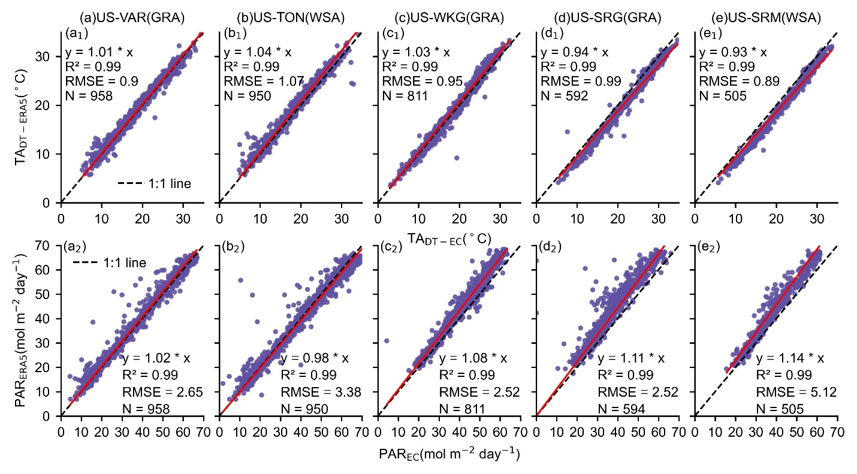
Fig. S1 Comparison between TA_{DT} from EC tower site and ERA5 dataset, PAR from EC tower site and ERA5 dataset.

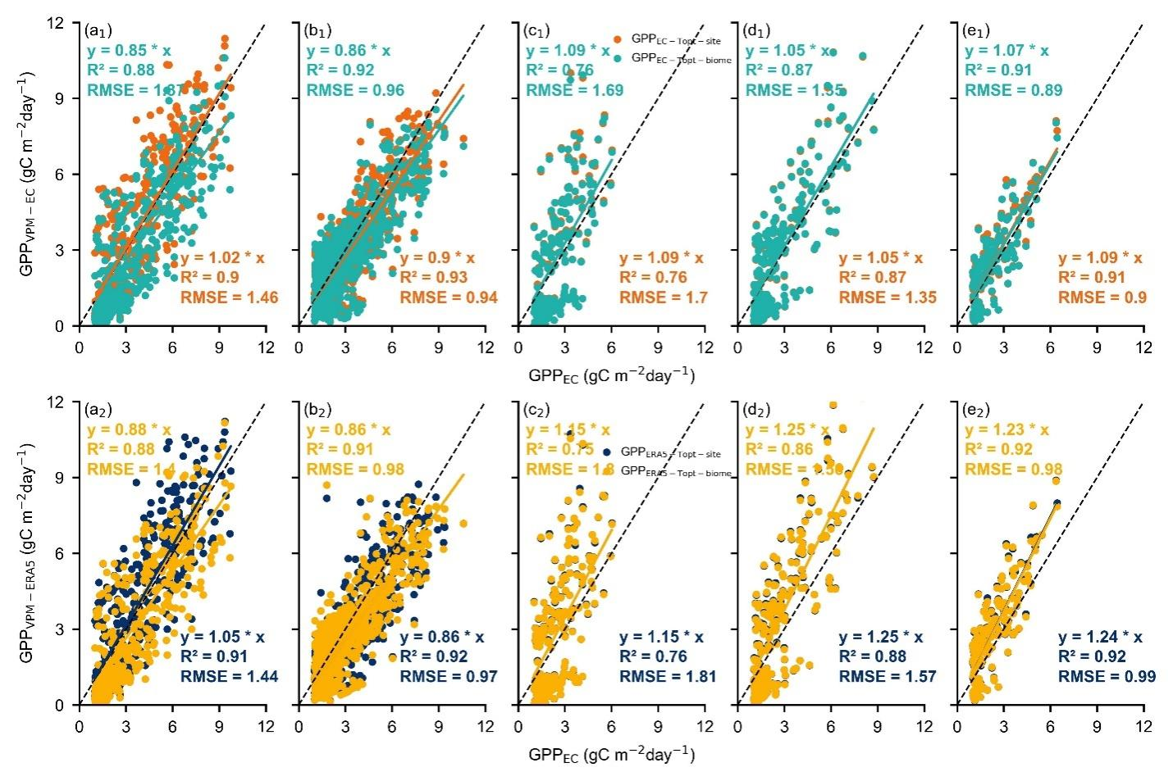
Fig. S2 The comparisons between eddy covariance-derived gross primary production (GPP_{EC}) and vegetation photosynthesis model-based GPP estimates using in-situ eddy covariance measured climate data (first panel) and ERA5 climate data (second panel) at the five flux tower sites. In the first panel, the green point and green text show the GPP simulated using T_{opt-biome} (GPP_{EC-Topt-biome}), and the orange point and orange text show the GPP simulated using T_{opt-site} (GPP_{EC-Topt-site}). In the second panel, the yellow point and yellow text show the GPP simulated using T_{opt-biome} (GPP_{ERA5-Topt-biome}), and the blue point and blue text show the GPP simulated using T_{opt-site} (GPP_{ERA5-Topt-site}).

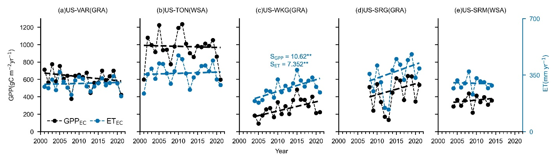
Fig.S3 Interannual variation and trend of GPP_{EC} and ET_{EC}.S means the Sen’s slope** indicates significant at P=0.05 level.

