Supplementary Materials

Inorganic N fertilization reduces soil organic carbon in bamboo forests in China
Wenxu ZHENG¹, Xia XU ()^{2,3}, Chonghua XU², Chenghui JU¹, Qian LI², Wenfang LIU^{3,4}, Yiqi LUO⁵, Huaqing DU², Xiaochou CHEN^{4,6}
1 Co-Innovation Center for Sustainable Forestry in Southern China & Department of Ecology, Nanjing Forestry University, Nanjing 210037, China
2 State Key Laboratory of Subtropical Silviculture & College of Environment and Resources, Zhejiang A&F University, Hangzhou 311300, China
3 National Observation and Research Station of Fujian Wuyishan Forest Ecosystem, Wuyishan 354300, China
4 Wuyishan National Park Research and Monitoring Center, Wuyishan 354300, China
5 School of Integrative Plant Science, Cornell University, Ithaca NY 14583, USA
6 Fuzhou Botanical Garden, Fuzhou 350021, China

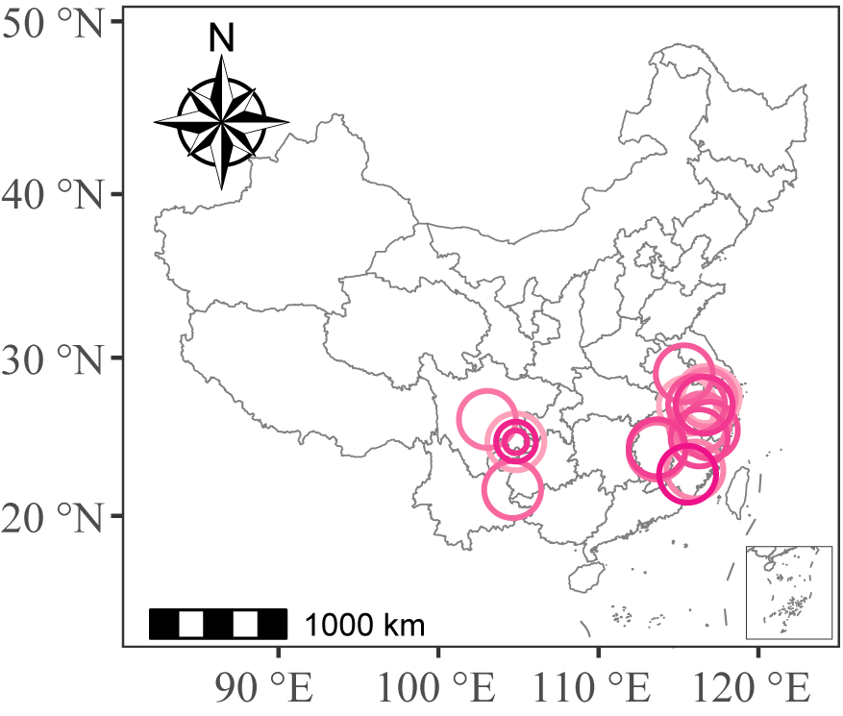

Fig. S1 Geographic distribution of fertilization experiments conducted in bamboo forests across China, derived from published data. The color and shape of the markers are arbitrary and solely used to distinguish experimental sites with identical latitudes and longitudes. These visual elements do not convey any additional information or significance.
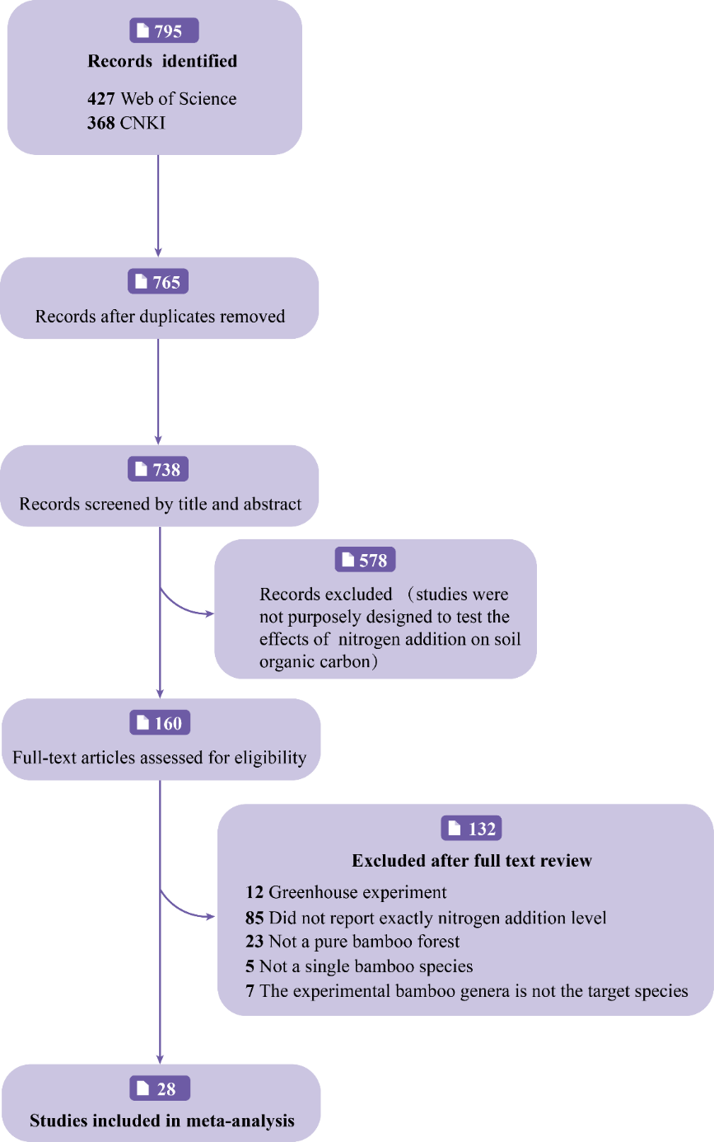

Fig. S2 PRISMA flow diagram illustrating the decision process, including the number of studies identified, rejected, and accepted.
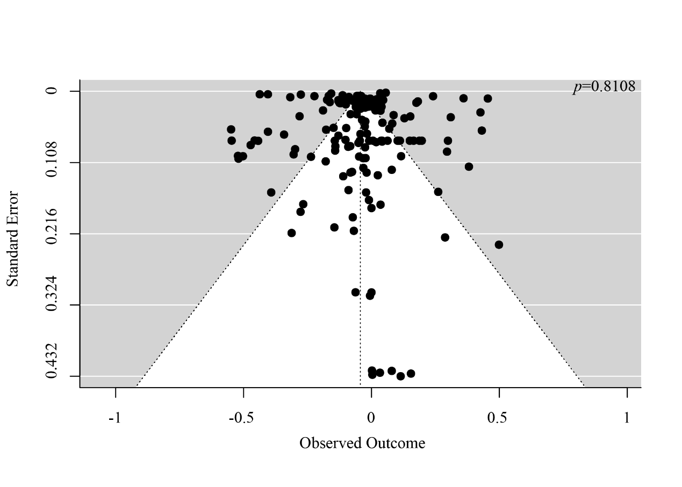

Fig. S3 The funnel plot for SOC. A funnel plot illustrates the relationship between effect sizes and their corresponding standard errors.

