Electronic Supplementary Material
Combined effects of Si-OH content and pore size of SiO₂ carriers on Ni₃P/SiO₂ catalysts for selective dimethyl oxalate hydrogenation to methyl glycolate

Yu-Hui Wang¹, Xiao-Bo Feng ()¹, Ya-Qin Wu¹, Chen-Yan Fu¹, Yu-Xin Duan¹, Zhi-Yang Ren¹, Tian-Long Liu¹, Jing-Pei Cao ()^{1,2,3}
¹Jiangsu Key Laboratory for Clean Utilization of Carbon Resources, China University of Mining and Technology, Xuzhou 221008, China
²Carbon Neutrality Institute, China University of Mining and Technology, Xuzhou 221008, China
³Jiangsu Key Laboratory of Coal-based Greenhouse Gas Control and Utilization, China University of Mining and Technology, Xuzhou 221008, China

E-mails: caojingpei@cumt.edu.cn (Cao J-P); xbfeng@cumt.edu.cn (Feng X-B)

Text 1. Materials
The used chemicals and reagents of Ni(NO₃)₂·6H₂O, cyclohexane, NaOH and ammonia aqueous were purchased from Xilong Scientific. (NH₄)₂HPO₄ was purchased from Kermel. Nitric acid was purchased from Sinopharm Group. Tetraethyl orthosilicate (TEOS), triethanolamine and ethanol were purchased from Shanghai Hushi Reagent. Cetyl trimethyl ammonium bromide (CTAB) was purchased from Macklin Biochemical. All the chemicals are analytical grade and are used without any purification.

Text 2. Catalyst characterization
N₂ adsorption-desorption isotherms were measured on V-Sorb 4800TP multi-functional adsorption instrument. The samples were degassed at 300 ºC for 6 h prior to the measurements. The specific surface area is calculated according to the Brunauer-Emmett-Teller (BET) method. Pore volume and average pore diameter were calculated by the BJH (Barrett-Joyner-Halenda) model.
X-ray diffraction (XRD) was performed on a Bruker AXS D8 ADVANCE X-ray diffractometer with Cu Kα radiation (35 kV and 25 mA). Data points were acquired by step scanning with a rate of 10 º/min from 2θ = 10º to 90º. The diffraction lines were identified by matching them with reference patterns in the JCPDS database. The Scherrer equation was used to calculate crystallite sizes
Scanning electron microscopy (SEM) images were obtained on Gemini SEM 500 microscope. Gold spraying is performed prior to the test, followed by testing at 1 kV. Energy dispersive spectroscopy EDS (Quantax 200 xFlash 660) was used to determine the different elements present in the samples.
Transmission electron microscopy (TEM) and high-resolution TEM (HRTEM) measurements were performed on a JEOL JEM-2100F system electron micro-scope at 100 kV equipped with a field emission gun. The catalyst powders were dispersed in ethanol by ultrasonic at room temperature for 30 minutes. The obtained supernatant was then dropped into copper grids.
H₂-TPR was carried out on Quantachrome ChemStar-TPx to measure the reducibility of the catalysts. About 50 mg catalyst was loaded into a quartz tube and dried in Ar atmosphere at 100 ºC for 1 h. The catalyst was then heated in 5% H₂/Ar at flow rate of 30 mL/min with a heating rate of 10 ºC /min from 100 ºC up to 800 ºC. The amount of hydrogen consumption was continuously monitored by thermal conductivity detector (TCD).
NH₃-TPD was carried out on Quantachrome ChemStar-TPx to measure the surface acidity of the catalysts. The catalyst was reduced in 30 mL/min H₂ at 600 ºC for 2 h prior to evaluation, followed by cooling down to 50 ºC. 10% NH₃//He was passed through the test sample at a flow rate of 30 mL/min for 30 min. Afterward, the TPD experiment was started with a heating rate of 10 ^{O}C/min from 50 ºC to 800 ºC.
CO temperature-programmed desorption (CO-TPD) was carried out on Chembet-3000 analyzer, using a TCD to collect the desorption signal. The catalyst was reduced in 30 mL/min H₂ at 600 ºC for 2 h prior to evaluation then cooled down to 50 ºC. At this temperature, introduced the CO and maintained for 30 minutes. CO-TPD analysis was carried out from 50 ºC to 800 ºC, at a heating rate of 10 ºC min⁻¹.
FTIR spectra were recorded on a Thermo Scientific Nicolet iS5 spectrometer using the KBr method in the range of 4000-400 cm⁻¹.
Thermogravimetric analysis was performed on a Mettler-Toledo TGA/DSC1/1100LF simultaneous thermal analyzer. Approximately 15 mg of the sample was placed in an alumina crucible and heated from 35 ºC to 800 ºC at a heating rate of 10 ºC/min under a high-purity argon (Ar) atmosphere with a flow rate of 50 mL/min.

Text 3. Experimental procedures
The catalytic evaluation was carried out in a fixed bed reaction system, 0.4 g (40-60 mesh) catalyst was loaded into a reaction tube with an inner diameter of 8 mm. Before reaction, the catalyst was reduced in flowing H₂ (30 mL·min⁻¹) with temperature programming (5 ºC/min) to 650 ºC and maintaining for 2 h to remove surface oxide layer. After the temperature was dropped to the desired reaction temperature, H₂ and methanol solution with 13% dimethyl oxalate (DMO) used as feedstock solution was introduced. The molar ratio of H₂ to DMO was set as 60-200, the reaction temperature range was 200-260 ºC and the reaction pressure was 2 MPa, and the weight hourly space velocity (WHSV) was 0.4-1.6 h⁻¹. The products were condensed and off-line analyzed by a gas chromatograph (FULI INSTRUMENTS GC9720Plus) fitted with a 30 m HP-5 capillary column and a flame ionization detector (FID). To ensure reliability, all experiments were performed in triplicate, and the results are reported as the mean values.
The conversion of DMO and selectivity of products for the reactions were calculated based on the following equations:
X_{DMO}(%) =$\frac{nDMO,in-nDMO,out​}{nDMO,in}$ × 100%
S_{i}(%) =$\frac{ni​×vi}{nDMO,in​​-nDMO,out}$ × 100%
where:
X_{DMO} = conversion of DMO (%)；
S_{i} = selectivity of product i (%)；
n_{DMO,in} = molar amount of DMO in the feed (mol)；
n_{DMO,out} = molar amount of DMO in the liquid product (mol)；
ni= molar amount of product i determined by GC (mol)；
νi = stoichiometric coefficient representing the moles of DMO consumed to produce 1 mol of product i.
The “others” fraction was calculated by subtracting the sum of selectivities of all identified products (MG, EG, MA, EtOH) from 100%.
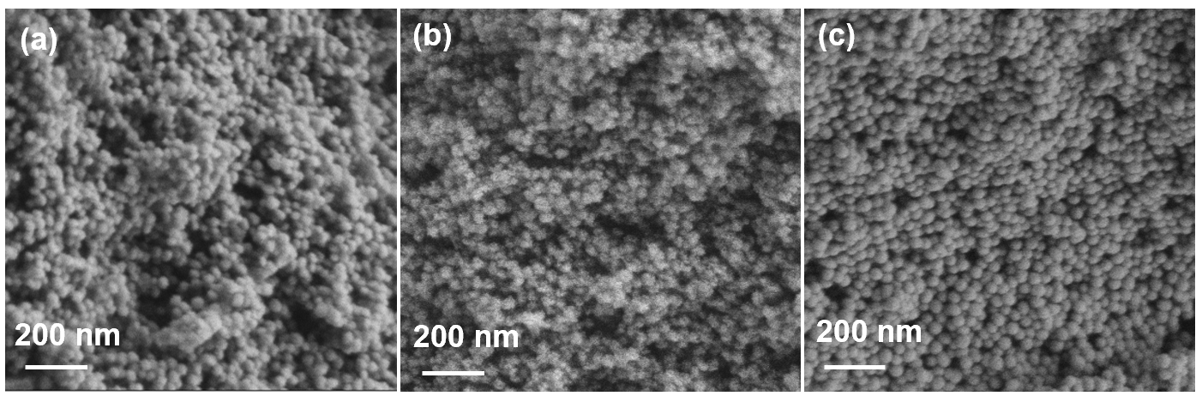
Figure S1. SEM images of different silica carriers: (a) SiO₂-Ⅰ; (b) SiO₂-Ⅱ; (c) SiO₂-Ⅲ.

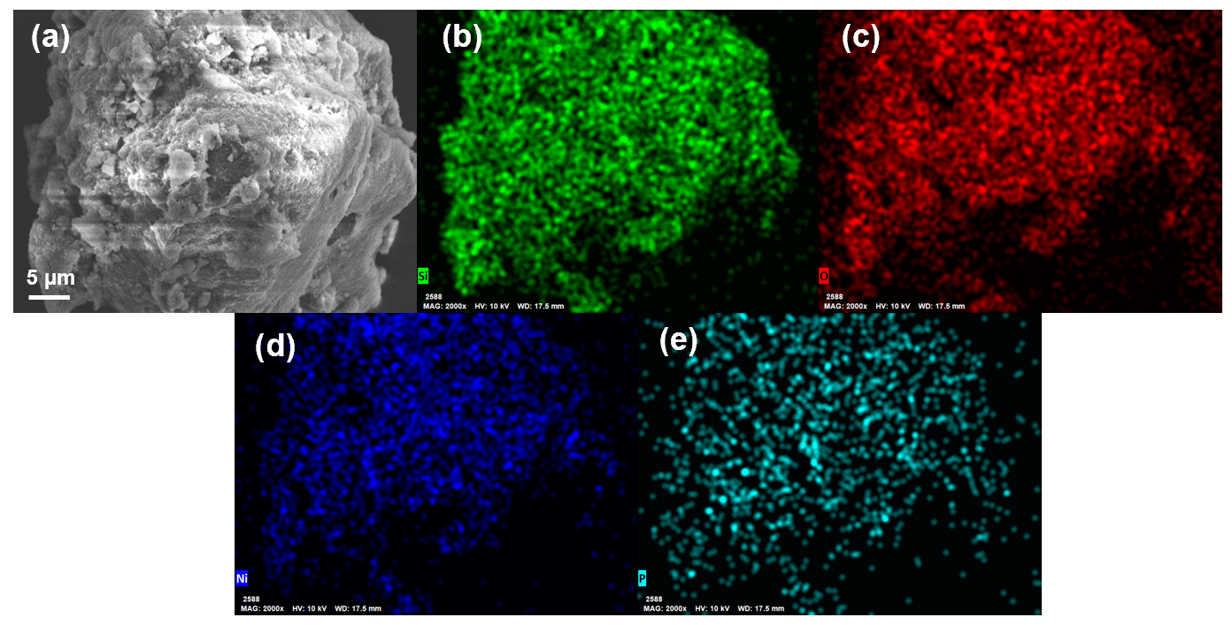
Figure S2. Ni₃P/SiO₂-Ⅰ: (a) SEM image, (b-e) the corresponding EDS elemental mappings of
O (b), Si (c), Ni (d) and P (e).

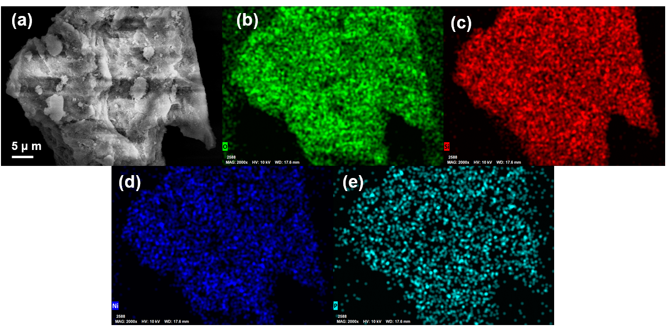
Figure S3. Ni₃P/SiO₂-Ⅱ: (a) SEM image, (b-e) the corresponding EDS elemental mappings of
O (b), Si (c), Ni (d) and P (e).

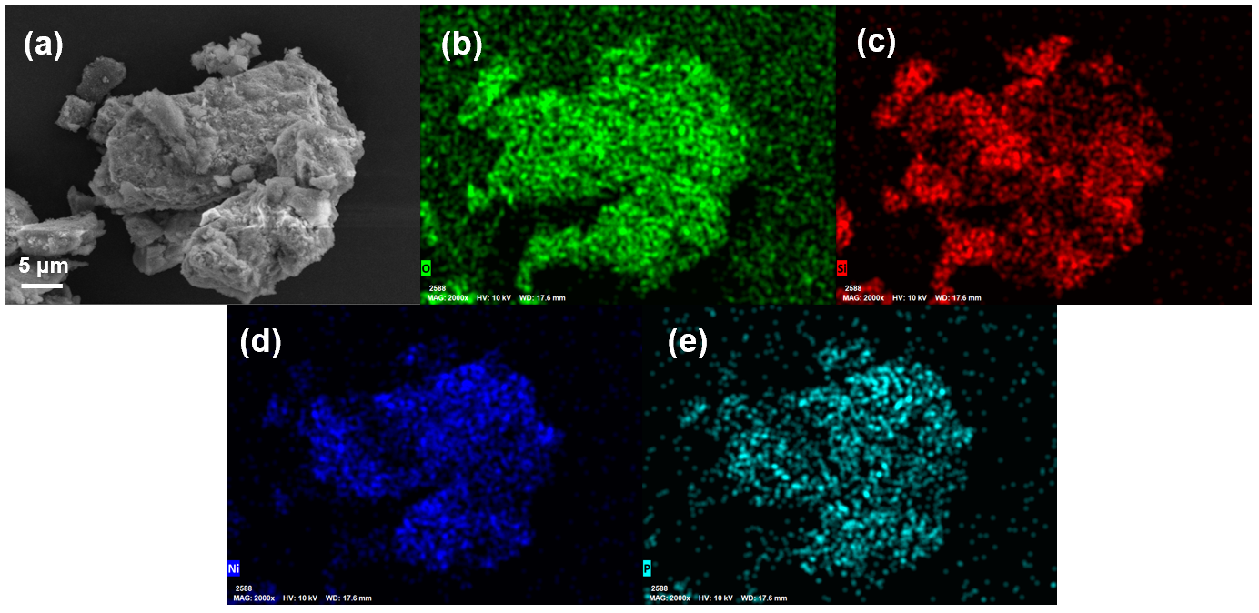
Figure S4. Ni₃P/SiO₂-Ⅲ: (a) SEM image, (b-e) the corresponding EDS elemental mappings of
O (b), Si (c), Ni (d) and P (e).

Figure S5. NH₃​-TPD curves of different silica carriers.

Figure S6. XRD patterns of fresh and reacted Ni₃P/SiO₂-Ⅰ catalysts.

Figure S7. Comparison of STY of MG over Ni₃P/SiO₂-Ⅰ with representative catalysts.

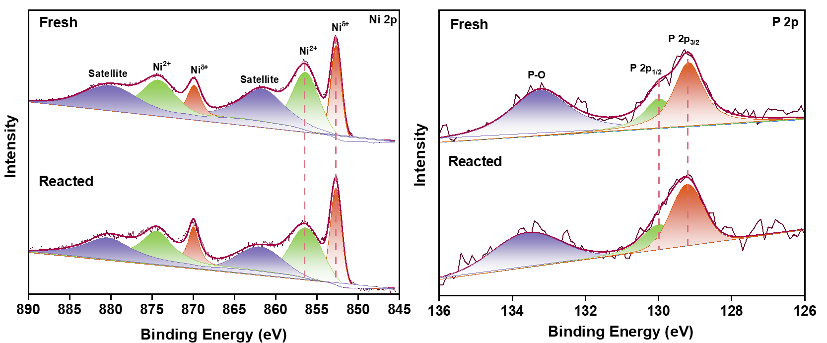
Figure S8. XPS patterns of fresh and reacted Ni₃P/SiO₂-Ⅰ catalysts

Table S1. The calculation results of particle size by Scherrer formula.
Catalysts | 2θ (º) | FWHM (2θº) | Particle size (nm)
Ni₃P/SiO₂-Ⅰ | 41.75 | 0.377 | 22.3
Ni₃P/SiO₂-Ⅱ | 41.76 | 0.455 | 18.5
Ni₃P/SiO₂-Ⅲ | 41.73 | 0.292 | 28.8

Table S2. Comparison of catalytic performance toward DMO selective hydrogenation to MG representative reported catalysts.
Catalysts | P  (MPa) | H₂/DMO  (mol/mol) | WHSV  (h⁻¹) | T  (ºC) | DMO  (%) | MG  (%) | Stability  (h)
Cu/HAP^{[1]} | 2.5 | 150 | 0.4 (LHSV) | 210 | 90 | 70 | 120
Raney Cu^{[2]} | 2.5 | 100 | 2.0 (LHSV) | 210 | 80 | 83 | unstable
Cu/RGO^{[3]} | 2.5 | 200 | 0.257 | 210 | 100 | 98.8 | 300
Cu@C/SiO₂^{[4]} | 1.9 | 150 | 1.25 | 210 | 85 | 74 | 90
Cu/Si₃N₄^{[5]} | 2.5 | 150 | 0.1 | 235 | 89 | 86 | —
Cu/Ti₃C₂ MXene^{[6]} | 2.5 | 100 | 0.1 | 200 | 67.36 | 88 | 120
CuAg@NH₂-MS^{[7]} | 2.5 | 50 | 0.2 | 190 | 98.4 | 97.9 | 300
Cu@HSS-OP^{[8]} | 1.8 | 100 | 4.2 | 210 | 92.7 | 70.7 | 250
His₇-Cu/SiO₂^{[9]} | 2 | 50 | 0.38 | 195 | 100 | 82.9 | —
CuZr₂-1.0K^{[10]} | 2 | 200 | 0.225 (LHSV) | 190 | 93.4 | 85.8 | 120
15%Ag/SiO₂^{[11]} | 2.5 | 100 | 0.2 (LHSV) | 220 | 100 | 92 | 130
Ag/MCM-41^{[12]} | 2.5 | 100 | 0.2 (LHSV) | 220 | 92 | 95 | —
8Au-1.5Ag/SBA-15^{[13]} | 3 | 100 | 0.6 | 145 | 99.5 | 94.2 | —
5Ag-0.2Ni/SBA-15^{[14]} | 3 | 80 | 1 | 200 | 97.6 | 92.8 | 120
Ag/KCC-1^{[15]} | 3 | 100 | 1.75 (LHSV) | 200 | 97.8 | 90.2 | 110
0.4Ag-28CuO_{x}/Ni-foam^{[16]} | 2.5 | 300 | 0.25 | 210 | 96.1 | 96.1 | 200
Ag-in/hCNT^{[17]} | 3 | 80 | 0.6 | 220 | 90 | 97 | 200
10Ag/AC-N-3^{[18]} | 3 | 80 | 0.6 | 220 | 96 | 99 | 150
10Ag-5B₂O₃/SiO₂^{[19]} | 0.5 | 150 | 0.2 | 180 | 98.9 | 97.2 | 264
10Ag/0.02Ti-KCC-1^{[20]} | 3 | 100 | 1.75 | 200 | 97.8 | 95 | 100
10%Ag/SiO₂ (AE)^{[21]} | 1.5 | 150 | 0.28 (LHSV) | 220 | 86.8 | 91.5 | 150
Ag/NH₂-MSNS^{[22]} | 2 | 80 | 1 | 220 | 100 | 96.6 | 100
5Ag₁-Li_{0.05}/SBA-15^{[23]} | 3 | 80 | 0.6 | 200 | 99.45 | 82.2 | 200
1B/Ag/SiO₂^{[24]} | 1.5 | 150 | 0.28 (LHSV) | 220 | 100 | 88.3 | 300
Catalysts | P  (MPa) | H₂/DMO  (mol/mol) | WHSV  (h⁻¹) | T  (ºC) | DMO  (%) | MG  (%) | Stability  (h)
Ag-0.5%Ni/SiO₂^{[25]} | 1.5 | 150 | 0.28 (LHSV) | 220 | 100 | 92.5 | 300
Egg-shell Ag/SiO₂^{[26]} | 1.5 | 80 | 1 (LHSV) | 220 | 80 | 95 | —
Co-Ag0.7/TiO₂^{[27]} | 2.5 | 40 | 0.3 | 240 | 94.4 | 96.9 | 200
Ag-Ni/SiO₂^{[28]} | 2 | 50 | 0.75 (LHSV) | 220 | 99 | 99.7 | 500
Ag/Oh-BN^{[29]} | 2.5 | 100 | 0.6 | 180 | 90 | 98 | 150
Ag-MOF_{der}/MSN^{[30]} | 2 | 35 | 3 (LHSV) | 220 | 98.9 | 92.2 | 50
Ag-3Zr/SiO₂^{[31]} | 2.5 | 100 | 0.4 | 200 | 99.9 | 82 | 200
Ag-Ov-TiO₂^{[32]} | 3 | 80 | 0.6 | 220 | 99.9 | 95 | 240
Ni₂P/TiO₂^{[33]} | 3 | 300 | 0.1 | 210 | 93 | 88 | 3600
Ni₃P/Ni-foam^{[34]} | 2.5 | 180 | 0.44 | 230 | 99.5 | 95 | 1000
Ni₃P/RB-MSN^{[35]} | 2.5 | 90 | 0.44 | 190 | 99.9 | 85 | 500
Ni/PS_450^{[36]} | 2.5 | 300 | 0.3 (LHSV) | 200 | 94 | 90 | 200
2.5Ni0.5Re/TiO₂^{[37]} | 2 | 120 | 0.3 | 240 | 94 | 91 | 200
15Ni-10Co/SiO₂^{[38]} | 2.5 | — | 0.5 (LHSV) | 180 | 51 | 92 | —
Ni₃P/SiO₂-Ⅰ (this work) | 2 | 100 | 0.8 | 220 | 92.2 | 94.8 | —
Ni₃P/SiO₂-Ⅰ(this work) | 2 | 100 | 0.8 | 240 | 95.7 | 91.8 | 250

Reference
[1] Wen C, Cui Y, Chen X, Zong B, Dai W-L. Reaction temperature controlled selective hydrogenation of dimethyl oxalate to methyl glycolate and ethylene glycol over copper-hydroxyapatite catalysts. Applied Catalysis B: Environmental, 2015, 162: 483-493
[2] Kong X, Ma C, Zhang J, Sun J, Chen J, Liu K. Effect of leaching temperature on structure and performance of Raney Cu catalysts for hydrogenation of dimethyl oxalate. Applied Catalysis A: General, 2016, 509: 153-160
[3] Abbas M, Chen Z, Chen J. Shape and size controlled synthesis of Cu nanoparticles wrapped on RGO nanosheet catalyst and their outstanding stability and catalytic performance in the hydrogenation reaction of dimethyl oxalate. Journal of Materials Chemistry A, 2018, 6: 19133-19142
[4] Tian H, En H, Li B, Zhao J. Cu@C/SiO₂ catalyst with tunable Cu⁺ species by sorbitol for the selective hydrogenation of dimethyl oxalate to methyl glycolate. Surfaces and Interfaces, 2025, 56: 105494
[5] Wang L, Xiao T, Ma H, Zeng S, Qiu Z, Li M, Wang Y, Ma X. Silicon nitride supported copper boosting the selective hydrogenation of dimethyl oxalate to methyl glycolate. Chemical Engineering Science, 2025, 316: 121988
[6] Shi X, Ai P, Zhang Y, Zhao J, Huang W. Tuning the interaction between Cu and surface -OH in Cu/Ti₃C₂ MXene derived catalyst for enhanced semi-hydrogenation of dimethyl oxalate. Molecular Catalysis, 2025, 572: 114736
[7] Xie A, Zhang J, Chen C, Zhang Y, Zhang H, Zhao H, Wang G. Enhanced selective hydrogenation of dimethyl oxalate to methyl glycolate through Cu-Ag bimetallic catalysts encapsulated in amino-functionalized mesoporous silica nanospheres. Surfaces and Interfaces, 2025, 67: 106612
[8] Li B, Liu J, Liu Y, Zhao J. Copper nanoparticles confined in hollow silica spheres: Understanding the confinement effect and enhanced catalytic performance for the selective hydrogenation of dimethyl oxalate. Microporous and Mesoporous Materials, 2025, 386: 113490
[9] Liu Z, Li Z, Ma Z, Xie J, Wen X, Chen X, Tan Y, Lei N, Lu W, Ding Y. Histidine-derivate modified Cu/SiO₂ catalyst for selective hydrogenation of dimethyl oxalate to methyl glycolate. Fuel, 2025, 381: 133701
[10] Zheng X, Wang J, Lei P, Xue Q, Kan X, Chen J. A significantly enhanced Cu⁺/Cu⁰ catalytic active structure via the electronic effect of K for methyl glycolate synthesis. Chemical Engineering Journal, 2026, 539: 177222
[11] Yin A, Guo X, Dai W, Fan K. High activity and selectivity of Ag/SiO₂ catalyst for hydrogenation of dimethyl oxalate. Chem Commun (Camb), 2010, 46: 4348-4350
[12] Yin A, Wen C, Dai W-L, Fan K. Ag/MCM-41 as a highly efficient mesostructured catalyst for the chemoselective synthesis of methyl glycolate and ethylene glycol. Applied Catalysis B: Environmental, 2011, 108-109: 90-99
[13] Zheng J, Lin H, Wang Y-N, Zheng X, Duan X, Yuan Y. Efficient low-temperature selective hydrogenation of esters on bimetallic Au-Ag/SBA-15 catalyst. Journal of Catalysis, 2013, 297: 110-118
[14] Li M M, Ye L, Zheng J, Fang H, Kroner A, Yuan Y, Tsang S C. Surfactant-free nickel-silver core@shell nanoparticles in mesoporous SBA-15 for chemoselective hydrogenation of dimethyl oxalate. Chem Commun (Camb), 2016, 52: 2569-2572
[15] Ouyang M, Wang Y, Zhang J, Zhao Y, Wang S, Ma X. Three dimensional Ag/KCC-1 catalyst with a hierarchical fibrous framework for the hydrogenation of dimethyl oxalate. RSC Advances, 2016, 6: 12788-12791
[16] Chen Y, Han L, Zhu J, Chen P, Fan S, Zhao G, Liu Y, Lu Y. High-performance Ag-CuO_{x} nanocomposite catalyst galvanically deposited onto a Ni-foam for gas-phase dimethyl oxalate hydrogenation to methyl glycolate. Catalysis Communications, 2017, 96: 58-62
[17] Zheng J, Duan X, Lin H, Gu Z, Fang H, Li J, Yuan Y. Silver nanoparticles confined in carbon nanotubes: on the understanding of the confinement effect and promotional catalysis for the selective hydrogenation of dimethyl oxalate. Nanoscale, 2016, 8: 5959-5967
[18] Hu M, Yan Y, Duan X, Ye L, Zhou J, Lin H, Yuan Y. Effective anchoring of silver nanoparticles onto N-doped carbon with enhanced catalytic performance for the hydrogenation of dimethyl oxalate to methyl glycolate. Catalysis Communications, 2017, 100: 148-152
[19] Chen H, Tan J, Cui J, Yang X, Zheng H, Zhu Y, Li Y. Promoting effect of boron oxide on Ag/SiO₂ catalyst for the hydrogenation of dimethyl oxalate to methyl glycolate. Molecular Catalysis, 2017, 433: 346-353
[20] Ouyang M, Wang J, Peng B, Zhao Y, Wang S, Ma X. Effect of Ti on Ag catalyst supported on spherical fibrous silica for partial hydrogenation of dimethyl oxalate. Applied Surface Science, 2019, 466: 592-600
[21] Cheng S, Mao D, Guo X, Yu J. Synthesis of methyl glycolate from the hydrogenation of dimethyl oxalate on Ag/SiO₂ catalyst: the effects of Ag contents and promoters. Reaction Kinetics, Mechanisms and Catalysis, 2019, 126: 1067-1079
[22] Dong G, Cao Y, Zheng S, Zhou J, Li W, Zaera F, Zhou X. Catalyst consisting of Ag nanoparticles anchored on amine-derivatized mesoporous silica nanospheres for the selective hydrogenation of dimethyl oxalate to methyl glycolate. Journal of Catalysis, 2020, 391: 155-162
[23] Duan X P, Chen T, Chen T, Huang L, Ye L, Lo B T W, Yuan Y, Edman Tsang S C. Intercalating lithium into the lattice of silver nanoparticles boosts catalytic hydrogenation of carbon-oxygen bonds. Chem Science, 2021, 12: 8791-8802
[24] Cheng S, Meng T, Mao D, Guo X, Yu J. Selective hydrogenation of dimethyloxalate to methyl glycolate over Boron-modified Ag/SiO₂ Catalysts. ACS Omega, 2022, 7: 41224-41235
[25] Cheng S, Meng T, Mao D, Guo X, Yu J, Ma Z. Ni-modified Ag/SiO₂ catalysts for selective hydrogenation of dimethyl oxalate to methyl glycolate. Nanomaterials (Basel), 2022, 12: 407
[26] Xu X, Hu X, Luo Z, Cao Y, Zhu Y-A, Li W, Zhou J, Zhou X. Engineering an egg-shell structure for the Ag/SiO₂ pellet catalyst for selective hydrogenation of dimethyl oxalate to methyl glycolate. New Journal of Chemistry, 2023, 47: 6045-6049
[27] Zheng F, Gong J, Zhang H, Shu W, Wang X, Qin S, Zhang C, Dai B. Cobalt-silver catalyst with low metal content for highly efficient synthesis of methyl glycolate through synergistic effect. Chemical Engineering Journal, 2024, 492: 152350
[28] Luo Z, Ge X, Cao Y, Wang Z, Zhou J, Li W, Duan X, Zhou X. Inverse NiOx-Ag interface to decouple reactant activation for Ag-Ni/SiO₂-catalyzed ester hydrogenation. Angewandte Chemie, International Edition in English, 2026, 65: e19485
[29] Wang J-X, Qiao L-Y, Zong S-S, Cao X-Y, Hu L-Q, Zhou Z-F, Yao Y-G. Effects of boron oxide on Ag/BN catalyst for the hydrogenation of dimethyl oxalate to methyl glycolate. Catalysis Letters, 2025, 155: 245
[30] San X, Zhao Z, Jin Q, Zhang L, Qi J, Meng D. Anchoring ultra small silver particles onto mesoporous silica through MOF derivation to reconstruct catalytic interface for boosting hydrogenation of dimethyl oxalate to methyl glycolate. Colloids and Surfaces A: Physicochemical and Engineering Aspects, 2025, 723: 137376
[31] Shi L, Sun J, Wang X, Cao X, Cheng J, Gao Y, Qiao L, Zhou Z, Yao Y. Synthesis of methyl glycolate via dimethyl oxalate hydrogenation over Zr‑modified Ag/SiO₂ catalysts. Applied Catalysis A: General, 2026, 713: 120765
[32] Duan X, Zhao W, Chen Z C, Zheng J, Lin H, Ye L, Yuan Y. Defective TiO_{x} spontaneously triggers the hydrogenation activity of silver. Chem Commun (Camb), 2026, 62: 3291-3295
[33] Chen H, Tan J, Zhu Y, Li Y. An effective and stable Ni₂P/TiO₂ catalyst for the hydrogenation of dimethyl oxalate to methyl glycolate. Catalysis Communications, 2016, 73: 46-49
[34] Zhu J, Cao L, Li C, Zhao G, Zhu T, Hu W, Sun W, Lu Y. Nanoporous Ni₃P evolutionarily structured onto a Ni Foam for highly selective hydrogenation of dimethyl oxalate to methyl glycolate. ACS Appl Mater Interfaces, 2019, 11: 37635-37643
[35] Zhao G, Li H, Si J, Nie Q, Meng C, Liu Y, Lu Y. High-performance Ni₃P/meso-SiO₂ for gas-phase hydrogenation of dimethyl oxalate to methyl glycolate. ACS Sustainable Chemistry & Engineering, 2021, 9: 16719-16729
[36] Luo Z, Ge X, Fang D, Xu X, Zhang D, Cao Y, Duan X, Li W, Zhou J, Zhou X. In situ exsolution to fabricate interfacial Ni⁰/Ni^{δ+} sites for regulating reaction pathways in hydrogenation. Journal of Catalysis, 2024, 434: 115528
[37] Wang H, Zhang N, Gong J, Zheng F, Li J, Hu Z, Zhang C. Re-doped Ni/TiO₂ catalyst with enhanced active site dispersion and optimized adsorption behavior for high-efficiency hydrogenation of dimethyl oxalate to methyl glycolate. Catalysis Letters, 2025, 155: 366
[38] Xiao D, Xie S, Gao X, Zhang R, Chang C-R. An examination of dimethyl oxalate hydrogenation to methyl glycolate on silica-supported Ni-Co alloy catalysts. Catalysis Science & Technology, 2025, 15: 1041-1054

