Electronic Supplementary Material
State of health estimation for bipolar lead-acid batteries based on grey wolf optimized hybrid regression technique
Sunil K. Pradhan, Basab Chakraborty ()
Rajendra Mishra School of Engineering Entrepreneurship, Indian Institute of Technology, Kharagpur 721302, India
E-mail: basab@see.iitkgp.ac.in

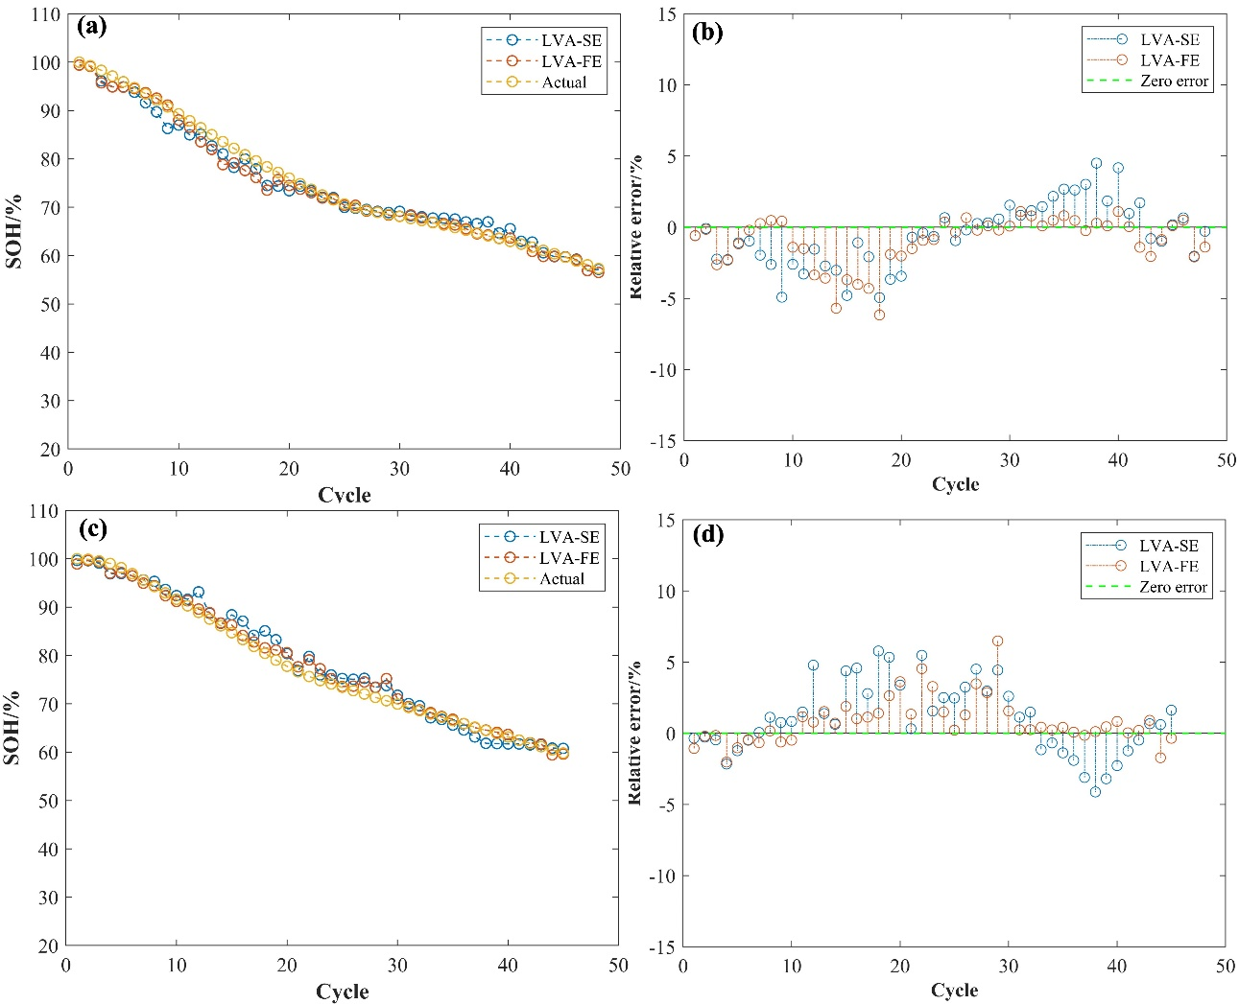
Performance of the GWO integrated hybrid regression model
Fig. S1 SOH estimation results of GWO optimized hybrid model with all features: a) BLAB05, c) BLAB06; corresponding relative error: b), and d) respectively.

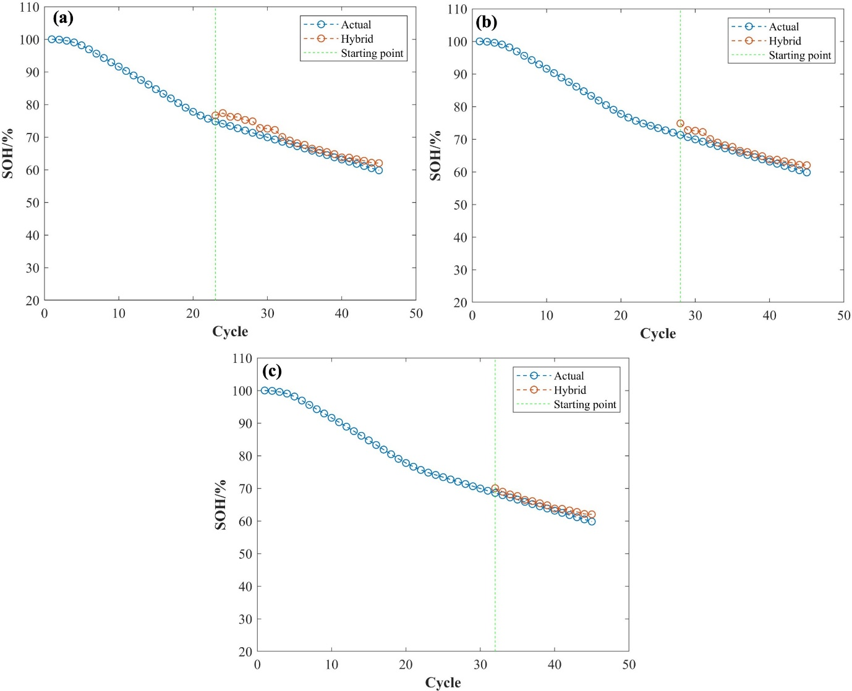
Long-term estimation results of the hybrid RFR model
Fig. S2 SOH estimation results of GWO optimized hybrid model with LVA-FE features for BLAB06 with initial training data of: a) 50%, b) 60%, and c) 70%.

