Electronic Supplementary Material
Dual ion relay storage mechanism in hierarchical porous carbon electrode for aqueous Zinc-ion hybrid capacitors
Bin Yan*, Zhe Zhang*, Ruotong Li, Juan Yang ()
School of Chemical Engineering and Technology, Xi’an Jiaotong University, Xi’an 710049, China

E-mail: juanyang@xjtu.edu.cn
* These authors contributed equally to this work.

1. Experimental Section
1.1 Materials
Pitch was obtained from the by-products of the coal chemical industry. Magnesium oxide (MgO, 99.8% metal basis) and zinc perchlorate hexahydrate (Zn(ClO₄)₂·6H₂O, reagent grade) were purchased from Aladdin. Potassium hydroxide (KOH, AR) was purchased from Sinopharm Group Co., Ltd.
1.2 Materials synthesis
Firstly, the pitch, MgO, and KOH were ground and thoroughly mixed in a ratio of 1:3:2. Subsequently, the mixed materials were transferred to a corundum boat and were heated to the target temperature (600 ℃, 700 ℃, 800 ℃, 900 ℃) under N₂ atmosphere with a heating ramp rate of 5 °C min⁻¹ and maintained for 2 h. After cooling to room temperature, the samples were ground and washed with a 2 M HCl solution to remove the MgO template. After washing with deionized water several times and drying at 80 ℃ for 12 h, the CMK-x samples were obtained.
1.3 Materials characterizations
The morphologies and crystal structures of the samples were characterized by field-emission SEM (TESCAN, MAIA3 LMH), TEM (JEOL, JEM-F200), XRD (Bruker D8 ADVANCE), and Raman (RAMAN DXR2xi). The surface and composition information of CMK-x samples were obtained by employing XPS (Thermo Scientific K-Alpha). Additionally, the N₂ adsorption/desorption isotherms and pore-size distributions were obtained using a Micromeritics ASAP 2460. The BET method was used to calculate the SSA of the samples, while the pore-size distributions and pore parameters were derived from the N₂ adsorption/desorption isotherms using the N₂-DFT slit-pore carbon model.
1.4 Electrochemical measurements
The cathodes for ZIHCs were prepared by ultrasonically dispersing the mixture of the porous carbon material (CMK-x), conductive agent (acetylene black), and PTFE with a mass ratio of 16:3:1 in ethanol to form a uniform slurry. Subsequently, the mixture was compressed and cut into circular electrode sheets with a diameter of 10 mm. For assembled ZIHCs devices, the Zn foil, commercial glass fiber (GF/A), 3 M Zn(ClO₄)_{2,} and the constructed working electrode were used as the anode, separator, electrolyte, and cathode, respectively. The electrochemical performances of assembled ZIHCs with CMK-x samples were investigated using a Biologic VMP3 electrochemical workstation. The cyclic voltammetry (CV) results were obtained with a voltage range of 0-1.9 V from a scan rate of 2-100 mV s⁻¹, while the galvanostatic charge-discharge (GCD) tests were applied with a voltage range of 0-1.9 V from current densities of 0.5-20 A g⁻¹. The charge/ion transport behavior was further investigated by electrochemical impedance spectroscopy (EIS) over a frequency range from 10 mHz to 100 kHz with an AC amplitude of 5 mV. In the fitted equivalent circuit, R_{s}, R_{ct}, CPE, and Z_{w} represent the ohmic/solution resistance, charge-transfer resistance, constant phase element, and Warburg diffusion element, respectively. The cycling performances of CMK-x were tested on the Land battery test system at a current density of 10 A g⁻¹.
1.5 Data calculations
The specific capacity (C, mAh g⁻¹) of the CMK-x cathode for ZIHCs was calculated from the GCD profiles by the following formula:
$$C=\frac{IΔt}{3.6m}$$
where $I$ is the current (mA), $Δt$ is the discharge time, $m$ is the mass of active substance in the cathode.
The specific energy density (E, Wh kg⁻¹) and specific power density (P, W kg⁻¹) were calculated by the following formulas (only the mass of cathode materials considered):
$$E=\frac{I\int_{t_{1}}^{t_{2}}{V(t)dt}}{3.6m}$$
$$P=\frac{3600E}{Δt}$$
where $I$ is current (mA), $m$ is the mass of active substance of the cathode (mg), $V\left(t\right)$ is the instantaneous voltage value (V) at $t$ instant from GCD profiles. $t_{1}{、t}_{2}$ correspond to the initial discharge time and terminal discharge time, respectively. $Δt$ is the discharge time.
The relationship between peak current and scan rate can be described by the following equation:
$$\begin{aligned}i=av^{b}\end{aligned}$$
$$\begin{aligned}\log{i=blog v+\log{a}}\end{aligned}$$
where $i$ is the peak current (mA), $v$ is the scan rate (mV s⁻¹), $a$ and $b$ are constants, and $b$ value can be calculated by the slope of the curve drawn between $\log{i}$ and $\log{v}$, with a value of 0.5 < $i$ < 1.0.
The capacitive/diffusive contributions can be further calculated by the variation formulation of peak current and scan rate mentioned before, as shown below:
$$i=k_{1}v+k_{2}v^{1/2}$$
where $i$ represents each current (mA) value corresponding to various scan rates on the CV curves, $v$ is the scan rate (mV s⁻¹), $k_{1}v$ and $k_{2}v^{1/2}$ are the capacitive and diffusive-controlled contributions of the CMK-x electrode, respectively.
For the electrochemical impedance spectra results, the real capacitance and imaginary capacitance were calculated and fitted by the following formulas:
$$ω=2πf$$
$${|Z\left(ω\right)|}^{2}={Z'\left(ω\right)}^{2}+{Z''\left(ω\right)}^{2}$$
$$C^{'}\left(ω\right)=\frac{-Z''\left(ω\right)}{2πf{|Z\left(ω\right)|}^{2}}$$
$$C^{''}\left(ω\right)=\frac{Z'\left(ω\right)}{2πf{|Z\left(ω\right)|}^{2}}$$
where $ω$ is the angular frequency (rad s⁻¹), $f$ is the testing frequency of EIS, $Z'\left(ω\right)$ and $Z''\left(ω\right)$ are the real part and imaginary part of electrochemical impedance ($Z\left(ω\right)$, Ω). $C^{'}\left(ω\right)$ and $C^{''}\left(ω\right)$ are the real part capacitance (mF) and imaginary part capacitance (mF), respectively.
For the linear relationship between $Z'\left(ω\right)$ and $ω^{-1/2}$ can be described as follows:
$$Z^{'}\left(ω\right)=σω^{-1/2}+R_{s}+R_{ct}$$
where $σ$ is the Warburg impedance coefficient (Ω s^{−1/2}), $R_{s}$ is the equivalent series solution resistance and $R_{ct}$ is the charge transfer resistance.
The Zn²⁺ ions diffusion coefficient can be obtained by using Fick’s second law:
$$D=\frac{R^{2}T^{2}}{2A^{2}n^{4}F^{4}C^{2}σ^{2}}$$
where $R$ is ideal gas constant (J mol⁻¹ K⁻¹), $T$ is the thermodynamic temperature (K), $A$ is the area of electrode (cm²), $n$ is the number of electronic transfers (or valence), $F$ is Faraday constant (C mol⁻¹), $C$ is the concentration of Zn²⁺ in applied electrolyte (mol L⁻¹), $σ$ is the Warburg impedance coefficient (Ω s^{−1/2}).
The time constant τ₀ is calculated by the formula below:
$$τ_{0}=\frac{1}{{2πf}_{0}}$$
where $f_{0}$ is the frequency corresponding to the maximum value in the imaginary capacitance versus frequency graph.

Figure S1. Schematic illustration of the fabrication process for CMK-x.

Figure S2. High resolution C 1s Spectra of (a) CMK-600, (b) CMK-800, and (c) CMK-900. High resolution O 1s spectra of (d) CMK-600, (e) CMK-800, and (f) CMK-900.

Figure S3. The corresponding CV curves of (a) CMK-600, (b) CMK-800, and (c) CMK-900 cathodes at various scan rates from 2-100 mV s⁻¹.

Figure S4. The corresponding GCD profiles of (a) CMK-600, (b) CMK-800, and (c) CMK-900 cathodes at various current densities from 0.5-20 A g⁻¹.

Figure S5. Specific capacity of slope region and plateau-like region of CMK-x cathodes based on GCD profiles.
Figure S6. Cycling performance of (a) CMK-600, (b) CMK-800, and (c) CMK-900 cathodes at the current density of 10 A g⁻¹.
Figure S7. Capacitive contributions of CMK-700 cathode at (a) 5 mV s⁻¹, (b) 10 mV s⁻¹, (c) 30 mV s⁻¹, (d) 50 mV s⁻¹, (e) 70 mV s^{−1,} and (f) 100 mV s⁻¹.
Figure S8. Capacitive contribution analysis of CMK-600, CMK-800, and CMK-900.

Figure S9. The calculated Zn²⁺ diffusion coefficients of CMK-x cathodes.

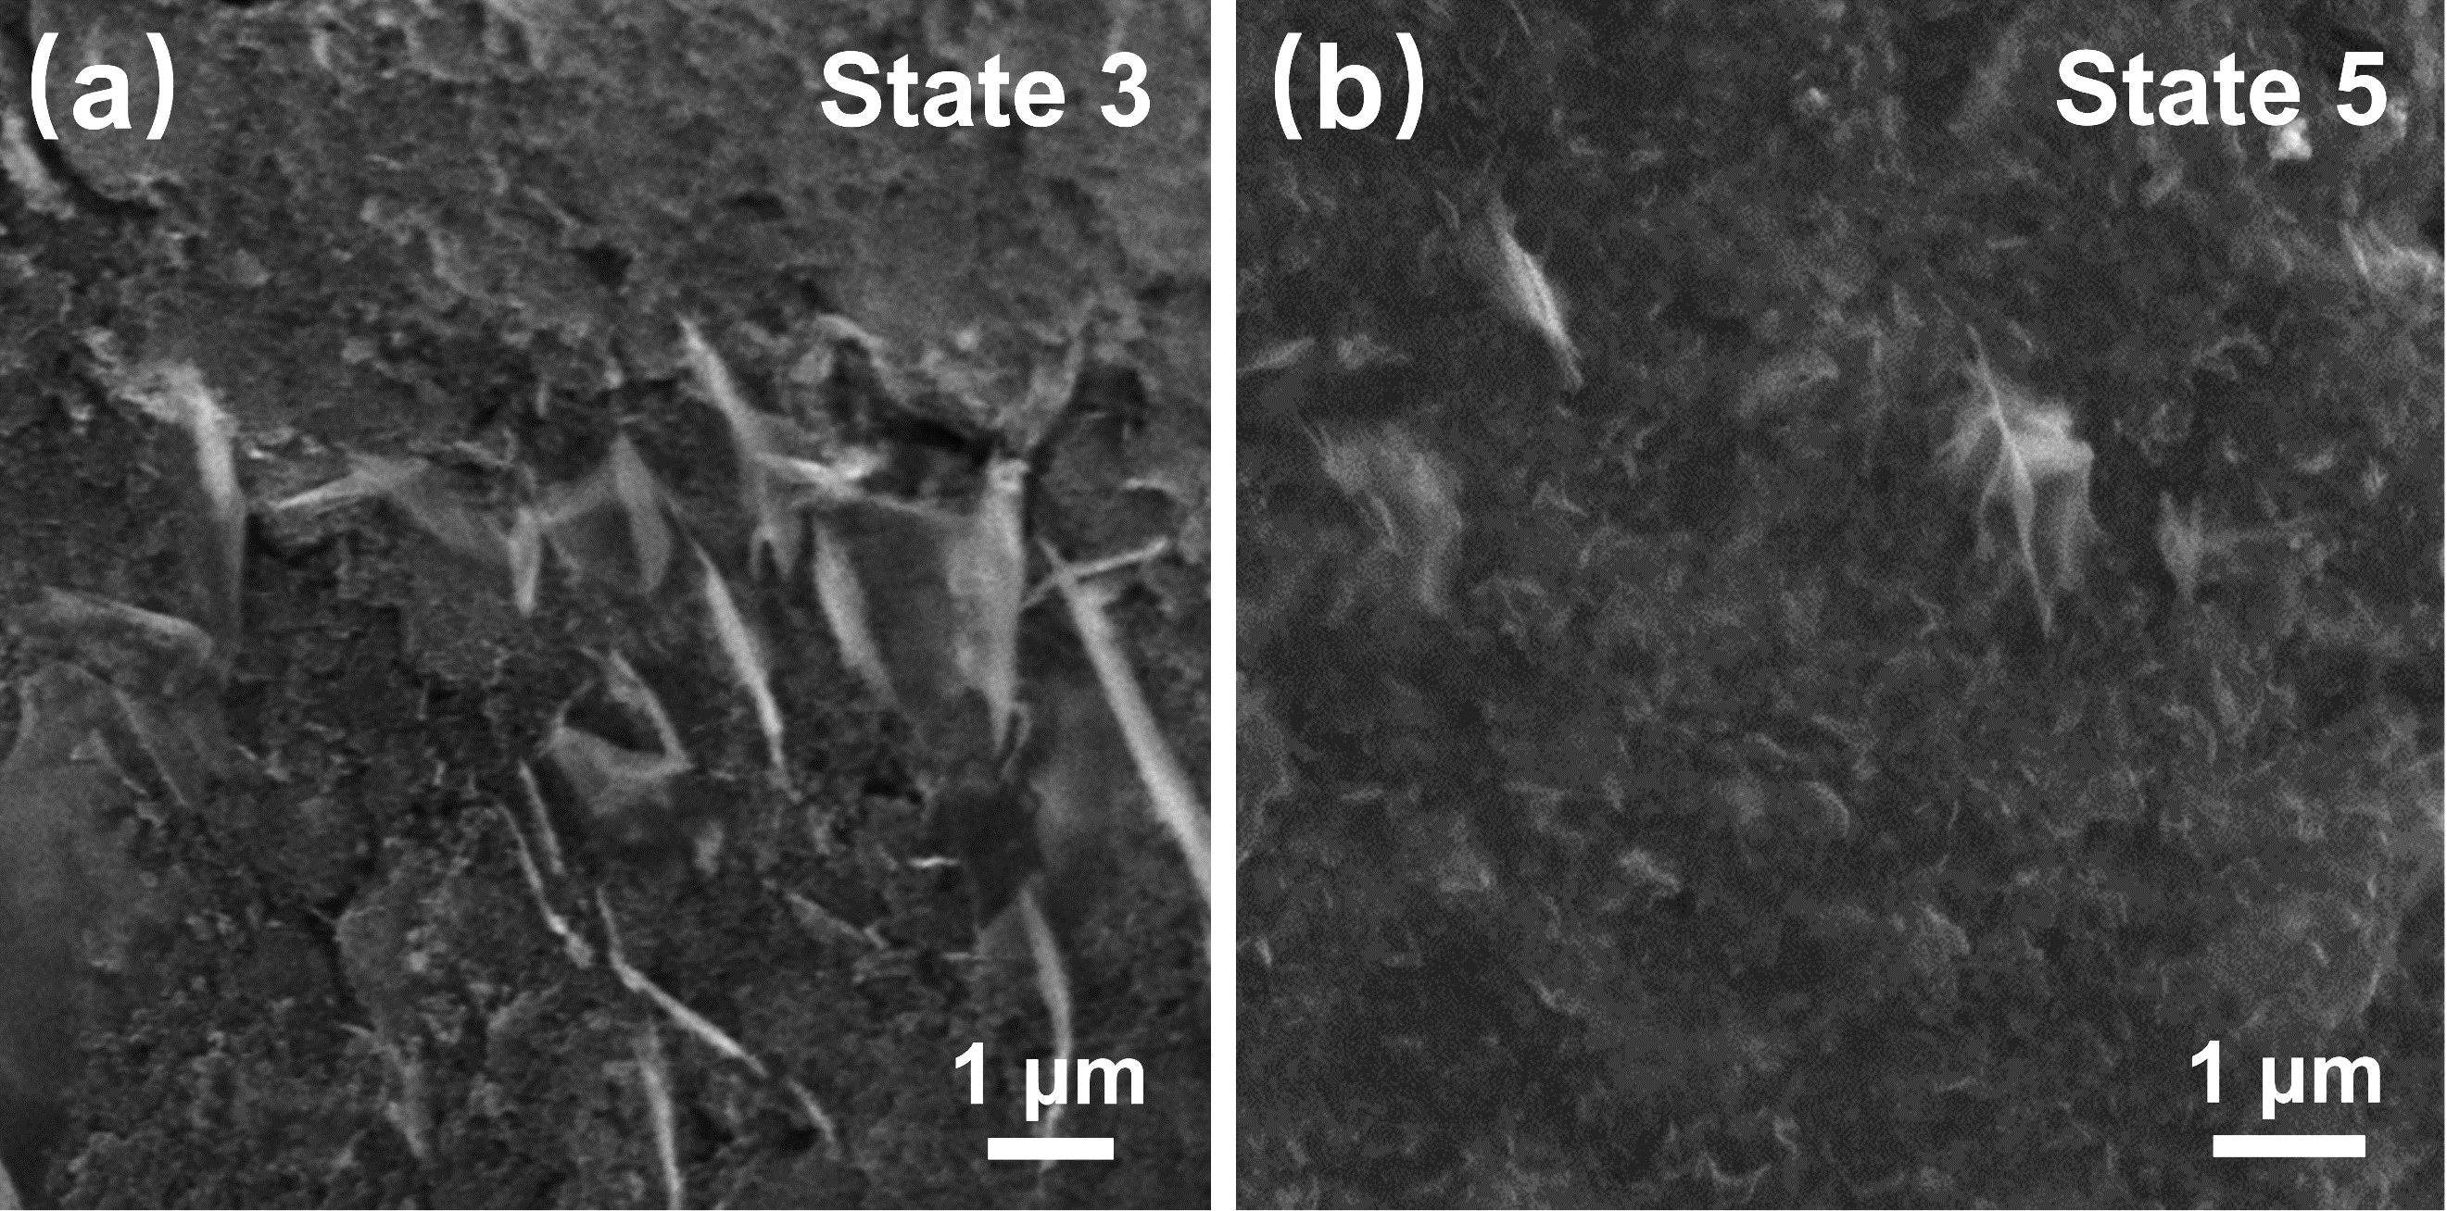
Figure S10. Ex-situ SEM images of CMK-700 electrode surfaces at (a) State 3, (b) State 5.

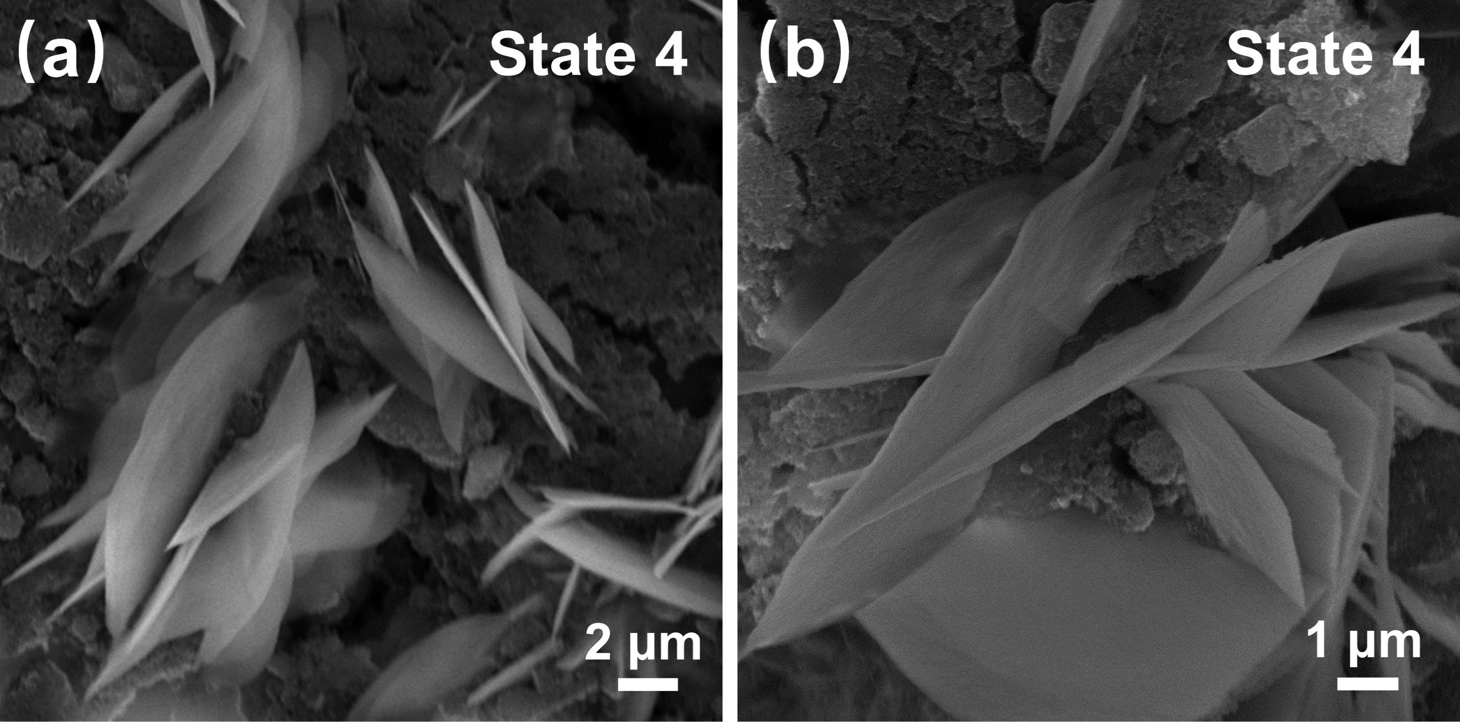
Figure S11. Ex-situ SEM images of CMK-700 electrode surfaces at state 4 at different scales.
Figure S12. MD snapshots for 0.7 nm pore model after a 1.0 ns simulation at (a) 0 V and (b) a bias voltage (-V).
Figure S13. MD snapshots for 1.0 nm pore model after a 1.0 ns simulation at (a) 0 V and (b) a bias voltage (-V).

Table S1. Pore structure parameters of CMK-x.
Samples | S_{BET}  /m² g⁻¹ | S_{micro}  /m² g⁻¹ | V_{micro}  /cm³ g⁻¹ | V_{<1 nm}  /cm³ g⁻¹
CMK-600 | 1882.3 | 1520.8 | 0.5885 | 0.4562
CMK-700 | 2223.9 | 1650.1 | 0.7073 | 0.4836
CMK-800 | 2455.0 | 1822.4 | 0.8004 | 0.4782
CMK-900 | 2741.3 | 1673.1 | 0.8526 | 0.3900

Table S2. Element content analysis of CMK-x samples from XPS results.
Samples | Element content / at.%
Samples | C | O | N
CMK-600 | 85.04 | 13.97 | 0.99
CMK-700 | 88.58 | 10.15 | 1.27
CMK-800 | 91.75 | 6.83 | 1.42
CMK-900 | 93.35 | 5.44 | 1.21

Table S3. EIS fitting results based on the equivalent circuit.
Samples | R_{s} | R_{ct}
CMK-600 | 0.30 | 48.08
CMK-700 | 0.27 | 32.86
CMK-800 | 0.82 | 55.14
CMK-900 | 0.33 | 77.93

Table S4. The calculated specific capacity of CMK-x cathodes in assembled ZIHCs based on GCD profiles
(unit: mAh g⁻¹).
Samples | Current density / A g⁻¹
Samples | 0.5 | 1 | 2 | 4 | 6 | 8 | 10 | 12 | 15 | 20
CMK-600 | 329.6 | 258.8 | 213.0 | 177.8 | 159.8 | 148.2 | 139.8 | 132.7 | 124.3 | 113.0
CMK-700 | 368.1 | 293.2 | 239.3 | 198.4 | 178.4 | 167.0 | 158.8 | 151.8 | 144.0 | 133.7
CMK-800 | 321.2 | 269.0 | 223.7 | 184.5 | 165.3 | 153.2 | 144.0 | 136.4 | 127.2 | 114.7
CMK-900 | 255.0 | 232.5 | 196.8 | 167.8 | 152.7 | 144.1 | 137.8 | 132.6 | 126.3 | 118.4

Table S5. Calculated real and imaginary part capacitance as well as τ₀ values of CMK-x samples.
Samples | C'(ω) / mF | C''(ω) / mF | τ₀ / s
CMK-600 | 106.2 | 143.0 | 15.92
CMK-700 | 150.0 | 105.9 | 10.74
CMK-800 | 105.5 | 133.3 | 14.47
CMK-900 | 67.1 | 119.9 | 13.96

Table S6. Electrochemical performance comparison of CMK-700-based ZIHC cathode and other carbon cathodes in the previously reported literature.
Electrode  Materials | Specific  Capacity | Rate  Performance | Cycling  Performance | Ref.
CMK-700 | 368.1 mAh g⁻¹@0.5 A g⁻¹ | 133.7 mAh g⁻¹@20 A g⁻¹ | 86.39% after 21000  cycles@10 A g⁻¹ | This work
3DPC | 194 mAh g⁻¹@0.5 A g⁻¹ | 102 mAh g⁻¹@30 A g⁻¹ | 88.0% after 15000  cycles@10 A g⁻¹ | [1]
PC-800 | 179.8 mAh g⁻¹@0.1 A g⁻¹ | 78.4 mAh g⁻¹@20 A g⁻¹ | 99.2% after 30000  cycles@20 A g⁻¹ | [2]
PCNF-4 | 177.7 mAh g⁻¹@0.5 A g⁻¹ | 85.5 mAh g⁻¹@20 A g⁻¹ | 90.0% after 10000  cycles@10 A g⁻¹ | [3]
N-HPCS | 180.4 mAh g⁻¹@0.5 A g⁻¹ | 92.2 mAh g⁻¹@40 A g⁻¹ | 98.2% after 50000 cycles@5 A g⁻¹ | [4]
BGC-750 | 257 mAh g⁻¹@0.5 A g⁻¹ | 126 mAh g⁻¹@20 A g⁻¹ | ~150 mAh g⁻¹ after 10000 cycles@5A g⁻¹ | [5]
HPC-700 | 439.2 F g⁻¹/195.2 mAh g⁻¹  @0.5 A g⁻¹ | 39 mAh g⁻¹@20 A g⁻¹ | 90% after 10000  cycles@5 A g⁻¹ | [6]
PCNTs-6 | 289.2 mAh g⁻¹@0.5 A g⁻¹ | 127.2 mAh g⁻¹@20 A g⁻¹ | 90.9% after 10000 cycles@5 A g⁻¹ | [7]
PGC₁-800 | 338.3 mAh g⁻¹@0.2 A g⁻¹ | ~118 mAh g⁻¹@2 A g⁻¹ | 80.7% after 10000 cycles@8 A g⁻¹ | [8]
HPC | 305 mAh g⁻¹@0.1 A g⁻¹ | 101 mAh g⁻¹@5 A g⁻¹ | 94.9% after 20000 cycles@2 A g⁻¹ | [9]
PC-SC-LLMM | 344 mAh g⁻¹@0.1 A g⁻¹ | 152 mAh g⁻¹@5 A g⁻¹ | 98.5% after 10000 cycles@3 A g⁻¹ | [10]
nPC | 303 mAh g⁻¹@1 A g⁻¹ | 204 mAh g⁻¹@5A g⁻¹ | 83.0% over 10000 cycles@5 A g⁻¹ | [11]
HC-0.2 | 245.8 mAh g⁻¹@0.2 A g⁻¹ | 116.7 mAh g⁻¹@10 A g⁻¹ | 82.3% after 10000 cycles@10 A g⁻¹ | [12]
HPAC | 231.1 mAh g⁻¹@0.5 A g⁻¹ | 119.4 mAh g⁻¹@20 A g⁻¹ | 70.0% after 18000 cycles@10 A g⁻¹ | [13]
RbPC | 247.6mAh g⁻¹@1 A g⁻¹ | 130.6 mAh g⁻¹@60 A g⁻¹ | 99.8% after 20000 cycles@10 A g⁻¹ | [14]
OCC-900 | 225 mAh g⁻¹@0.1 A g⁻¹ | 70 mAh g⁻¹@20 A g⁻¹ | 96.5% after 300000 cycles@50 A g⁻¹ | [15]

References
[1] Y. Wang, J. Yang, S. Liu, X. Che, S. He, Z. Liu, M. Wang, X. Wang, J. Qiu, 3D graphene-like oxygen and sulfur-doped porous carbon nanosheets with multilevel ion channels for high-performance aqueous Zn-ion storage, Carbon 201 (2023) 624–632. https://doi.org/10.1016/j.carbon.2022.09.056.
[2] J. Yin, W.L. Zhang, W.X. Wang, N.A. Alhebshi, N. Salah, H.N. Alshareef, Electrochemical zinc ion capacitors enhanced by redox reactions of porous carbon cathodes, Adv. Energy Mater. 10 (2020) 2001705. https://doi.org/10.1002/aenm.202001705.
[3] Z.M. Pan, Z.M. Lu, L. Xu, D.W. Wang, A robust 2D porous carbon nanoflake cathode for high energy-power density zn-ion hybrid supercapacitor applications, Appl. Surf. Sci. 510 (2020) 145384. https://doi.org/10.1016/j.apsusc.2020.145384.
[4] J. Huang, L. Wang, Z. Peng, M. Peng, L. Li, X. Tang, Y. Xu, L. Tan, K. Yuan, Y. Chen, Minimization of ion transport resistance: diblock copolymer micelle derived nitrogen-doped hierarchically porous carbon spheres for superior rate and power Zn-ion capacitors, J. Mater. Chem. A 9 (2021) 8435–8443. https://doi.org/10.1039/D1TA01242H.
[5] W. Fan, J. Ding, J. Ding, Y. Zheng, W. Song, J. Lin, C. Xiao, C. Zhong, H. Wang, W. Hu, Identifying Heteroatomic and Defective Sites in Carbon with Dual-Ion Adsorption Capability for High Energy and Power Zinc Ion Capacitor, Nano-Micro Lett. 13 (2021) 59. https://doi.org/10.1007/s40820-021-00588-5.
[6] J. Ni, J.Y. Chen, C. Sun, C.L. Ding, Y.H. Zhao, X.L. Wu, Double potassium salt self-activation strategy to construct hierarchical porous carbon for zinc ion hybrid capacitor, Adv. Sustainable Syst. 9 (2025) e00247. https://doi.org/10.1002/adsu.202500247.
[7] J. Huo, X. Wang, X. Zhang, L. Zhang, G. Yue, S. Guo, Porous polypyrrole-derived carbon nanotubes as a cathode material for zinc-ion hybrid supercapacitors, J. Energy Storage 73 (2023) 108925. https://doi.org/10.1016/j.est.2023.108925.
[8] F.F. Shi, Q.F. Liu, C. Yang, J.H. Qiu, L.M. Zang, Natural peach gum as porous carbon precursor and gel electrolyte for high-performance zinc-ion hybrid supercapacitors, Adv. Sustainable Syst. 7 (2023) 2200412. https://doi.org/10.1002/adsu.202200412.
[9] P. Yu, Y. Zeng, Y. Zeng, H. Dong, H. Hu, Y. Liu, M. Zheng, Y. Xiao, X. Lu, Y. Liang, Achieving high-energy-density and ultra-stable zinc-ion hybrid supercapacitors by engineering hierarchical porous carbon architecture, Electrochim. Acta 327 (2019) 134999. https://doi.org/10.1016/j.electacta.2019.134999.
[10] P.F. Yu, Y. Zeng, Q.Y. Cao, X.Y. Chen, M.T. Zheng, H. Hu, Y. Xiao, Y.L. Liu, Y.R. Liang, Liquid–liquid micromixing strategy enables low KOH-amount synthesis of ultrahighly porous carbon for zinc-ion storage, SN Appl. Sci. 2 (2020) 829. https://doi.org/10.1007/s42452-020-2666-7.
[11] Y. Li, P. Lu, P. Shang, L. Wu, X. Wang, Y. Dong, R. He, Z.-S. Wu, Pyridinic nitrogen enriched porous carbon derived from bimetal organic frameworks for high capacity zinc ion hybrid capacitors with remarkable rate capability, J. Energy Chem. 56 (2021) 404–411. https://doi.org/10.1016/j.jechem.2020.08.005.
[12] H.-X. Li, W.-J. Shi, L.-Y. Liu, X. Zhang, P.-F. Zhang, Q. Wang, Y. Liu, Z.-Y. Wang, J. Dou, Coupling effect of vacancy defects and multi-adsorption sites in porous carbon cathode for high-performance aqueous zinc-ion hybrid capacitors, Chem. Eng. J. 487 (2024) 150630. https://doi.org/10.1016/j.cej.2024.150630.
[13] Z. Zhou, X. Zhou, M. Zhang, S. Mu, Q. Liu, Y. Tang, In Situ Two‐Step Activation Strategy Boosting Hierarchical Porous Carbon Cathode for an Aqueous Zn‐Based Hybrid Energy Storage Device with High Capacity and Ultra‐Long Cycling Life, Small 16 (2020) 2003174. https://doi.org/10.1002/smll.202003174.
[14] L. Wang, M. Peng, J. Chen, X. Tang, L. Li, T. Hu, K. Yuan, Y. Chen, High Energy and Power Zinc Ion Capacitors: A Dual-Ion Adsorption and Reversible Chemical Adsorption Coupling Mechanism, ACS Nano 16 (2022) 2877–2888. https://doi.org/10.1021/acsnano.1c09936.
[15] C. Hou, Y. Wang, L. Zou, M. Wang, H. Liu, Z. Liu, H. Wang, C. Li, Q. Xu, A Gas‐Steamed MOF Route to P‐Doped Open Carbon Cages with Enhanced Zn‐Ion Energy Storage Capability and Ultrastability, Adv. Mater. 33 (2021) 2101698. https://doi.org/10.1002/adma.202101698.

