Electronic Supplementary Material

NiCo₂O₄/NF nanoneedle array enables low-potential ethylene glycol oxidation and upcycles waste polyethylene terephthalate into commodity chemicals
Bowen Zheng, Yin Wang, Chenkun Zheng, Yihui Song, Guangzhe Li, Chong Peng ()
State Key Laboratory of Fine Chemicals, School of Chemical Engineering, Dalian University of Technology, Dalian 116024, China
E-mail: pengchong@dlut.edu.cn

Table S1. The price of feedstocks and products.
Chemicals | Price ($/ton) | Reference
Feedstocks
Waste PET | 500 | [1]
KOH | 850 | [2]
H₂O | 0.22 | [3]
FA | 400 | [4]
Products
TPA | 1260 | [5]
KDF | 1590 | [3]
H₂ | 1900 | [6]

The calculation of product yield: The yields of TPA and KDF were calculated based on the isolated products obtained after product separation and drying.
The TPA yield is calculated using the following formula:
$$\text{TPA yield = }\frac{\text{Actual output}}{\text{Theoretical output}}\text{ × 100\% = }\frac{\text{3.88}}{\text{4.15}}\text{ = 93.5\%}$$
The KDF yield is calculated using the following formula:
$$\text{KDF yield = }\frac{\text{Actual output}}{\text{Theoretical output}}\text{ × 100\% = }\frac{\text{9.08}}{\text{13.01}}\text{ = 69.8\%}$$
An estimation of the realistic value flow during this electrochemical process: All calculations were normalized to the processing of 1 ton of PET, and the prices of the feedstocks and products used in this calculation are summarized in Table S1.
Input chemicals costs: The input chemicals considered in this calculation include 1 ton of PET, 1.17 tons of KOH, 10.42 tons of water, and 2.97 tons of formic acid. PET was used as the plastic feedstock, KOH was used for alkaline PET hydrolysis and electrolysis, water was used as the solvent, and formic acid was used for pH adjustment during product recovery. The cost of chemicals employed is approximately calculated:
$$\begin{matrix}\text{Product value }\text{= price of PET (500 \$ }{\text{ton}}^{\text{-1}}\text{) × }{\text{m}}_{\text{PET}} \\ \text{+ price of KOH(850}\text{\$ }{\text{ton}}^{\text{-1}}\text{) × }{\text{m}}_{\text{KOH}} \\ \text{+ price of }{\text{H}}_{\text{2}}\text{O (0.22 \$ }{\text{ton}}^{\text{-1}}\text{) × }{\text{m}}_{{\text{H}}_{\text{2}}\text{O}} \\ \text{+ price of FA (400 \$ }{\text{ton}}^{\text{-1}}\text{) × }{\text{m}}_{\text{FA}} \\ \text{= 1 × 500 + 1.17 × 850 + 10.42 × 0.22 + 2.97 × 400 = 2684.79 }\text{\$}\end{matrix}$$
Electricity costs: The total cost per ton of PET electrolysis can be calculated as follows:
$$\text{Q} \text{= }\frac{\text{m} \text{× F × N}}{\text{M × }\text{FE}}\text{ = }\frac{\text{1000000×96485×6}}{\text{192×91\%}}\text{ = 3313358516 C}$$
where Q is the total charge (C), m is the mass of PET (g), F is the Faradaic constant taken as 96485 C/mol, N takes the value 6 since ethylene glycol oxidation to formic acid is a six-electron transfer process, M is the molar mass of PET taken as 192 g/mol, FE is the Faradaic efficiency of formate in PET electrolysis taken as 91% (the obtained lowest value during the electrolysis process).
The current with a capacity factor can be calculated as follows:
$$\text{I = }\frac{\text{Q}}{\text{T × CF}}\text{ = }\frac{\text{3313358516}}{\text{24×3600×0.8}}\text{ = 47936.32 A}$$
where I is the current (A), T is the time of one day taken as 24 h, CF is the capacity factor representing the effective operation time in one day taken as 0.8.
Assuming an electrolysis voltage of 1.4 V (corresponding to the average voltage obtained during galvanostatic electrolysis), the power required to maintain the electrolysis process can be calculated as follows:
$$\text{P} \text{= }\frac{\text{U} \text{×} \text{I}}{\text{1000}}\text{ = }\frac{\text{1.4×47936.32}}{\text{1000}}\text{ = 67.11 kW}$$
Thus, the electricity cost for electrolysis can be calculated by multiplying effective working time during one day and the commercial electricity price.
$$\text{Electricity Cost = P × T × Ct = 67.11 × 24 × 0.098 = 157.84 \$}$$
where P is the power consumption (kW), T is the time of one day taken as 24 h, CF is the capacity factor representing the effective operation time in one day taken as 0.8, and Ct represents the commercial electricity price taken as 0.098 $ per kilowatt-hour in Liaoning Province, China.
Miscellaneous costs: Miscellaneous costs, including capital costs, maintenance costs, installation costs, catalyst depreciation, and operating costs, are estimated at 15% of the total costs incurred thus far:
$\text{Miscellaneous costs = (2684.79 }\text{+ 157.84 ) × 15\% = 426.39 \$}$
$$\text{Total cost of PET upcycling}\text{：}$$
$\text{Total cost = 2684.79 + 157.84 + 426.39 = 3269.02\$}$
Output product income:
During the calculation, at an electrolysis condition of 1.4 V vs. RHE, the Faradaic efficiency of H₂ was assumed to be 100%, while the yields of KDF and TPA were 69.8% and 93.5%, respectively. After electrolysis, 1 ton of PET could produce 0.81 ton of TPA, 1.89 tons of KDF, and 0.012 ton of H₂. Therefore, the profit of the products can be calculated according to the following equation:
$$\begin{matrix}\text{Product value }\text{= price of TPA (1260 \$ }{\text{ton}}^{\text{-1}}\text{) × }{\text{m}}_{\text{TPA}} \\ \text{+ price of KDF(1590}\text{\$ }{\text{ton}}^{\text{-1}}\text{) × }{\text{m}}_{\text{KDF}} \\ \text{+ price of }{\text{H}}_{\text{2}}\text{ (1900 \$ }{\text{ton}}^{\text{-1}}\text{) × }{\text{m}}_{{\text{H}}_{\text{2}}} \\ \text{= 0.81 × 1260 + 1.89 × 1590 + 0.012 × 1900 = 4048.50}\text{\$}\end{matrix}$$
Therefore, the net profit per ton of PET processed by this electrochemical upcycling strategy can be calculated as follows:
$$\begin{matrix}\text{Total profit per ton of PET = Product value - Total cost } \\ \text{= 4048.50 - 3269.02 = 779.48 }\text{\$}\end{matrix}$$

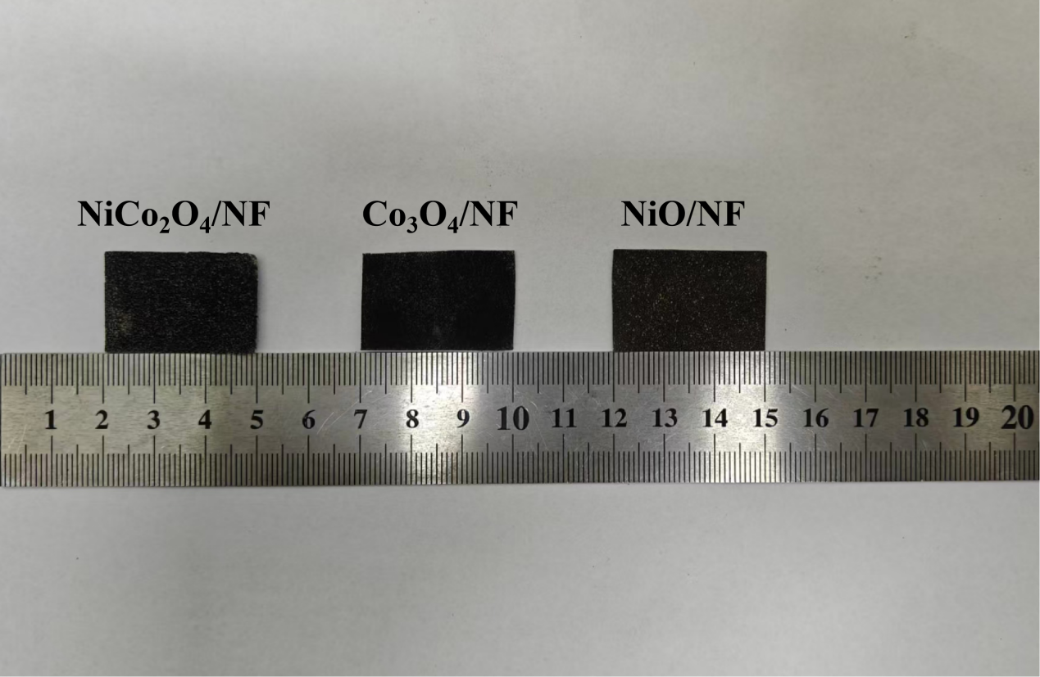
Figure S1. The prepared electrode sheet NiCo₂O₄/NF, Co₃O₄/NF and NiO/NF.

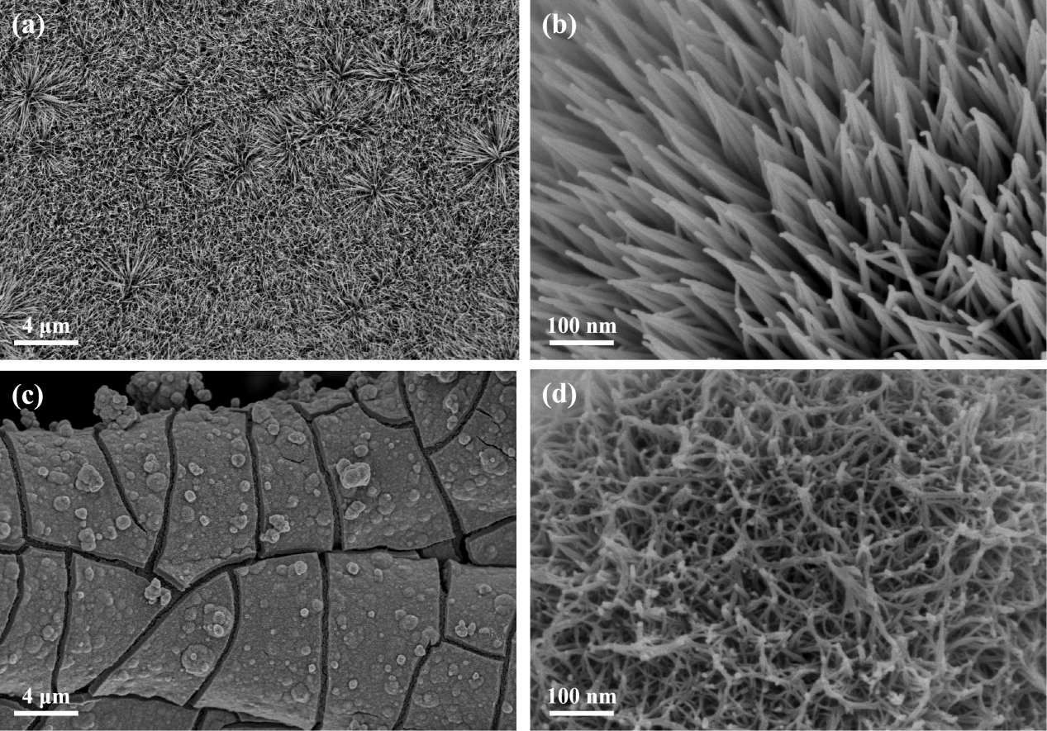
Figure S2. SEM images of (a, b) Co3O4/NF and (c, d) NiO/NF.

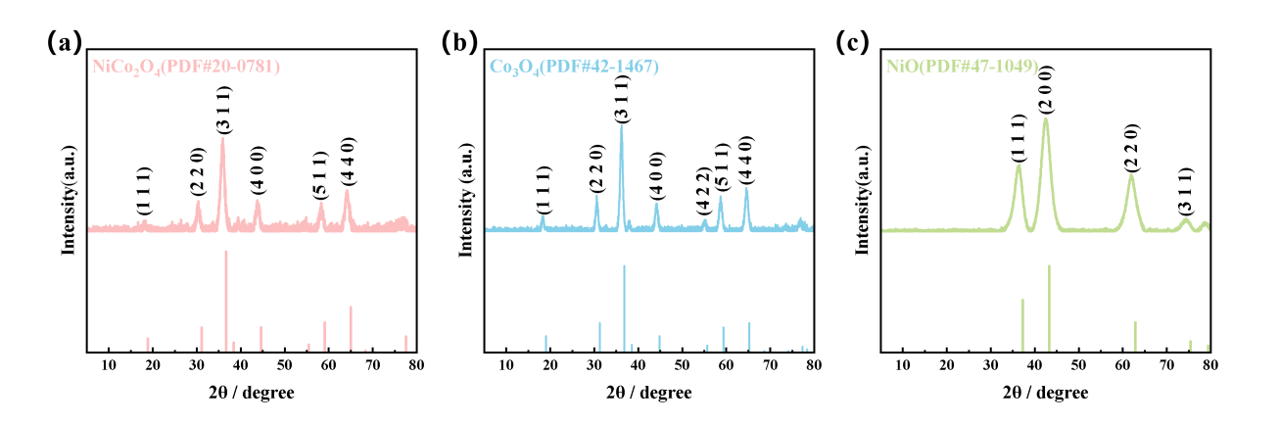
Figure S3. XRD patterns of different catalysts on NF, in a powdery form for (a) NiCo₂O₄, (b) Co₃O₄, (c) NiO.

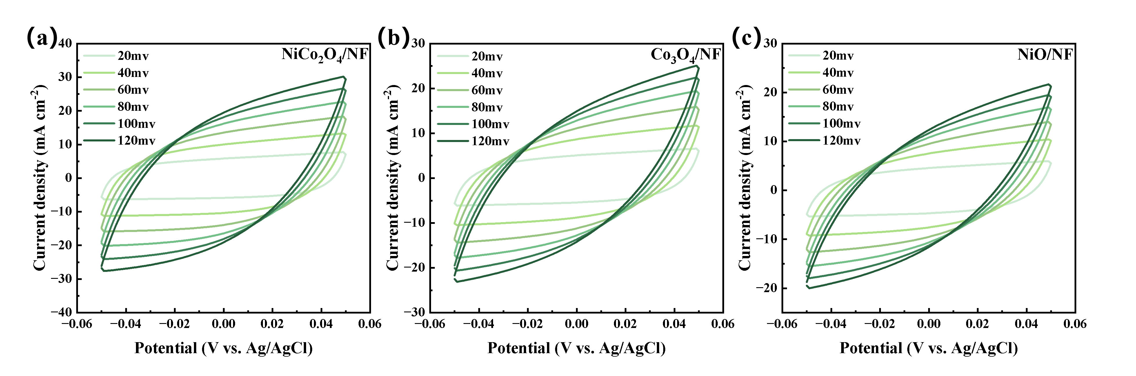
Figure S4. CV curves of (a) NiCo₂O₄/NF, (b) Co₃O₄/NF and (c) NiO/NF at different scanning rates from 20 to 120 mV s⁻¹.

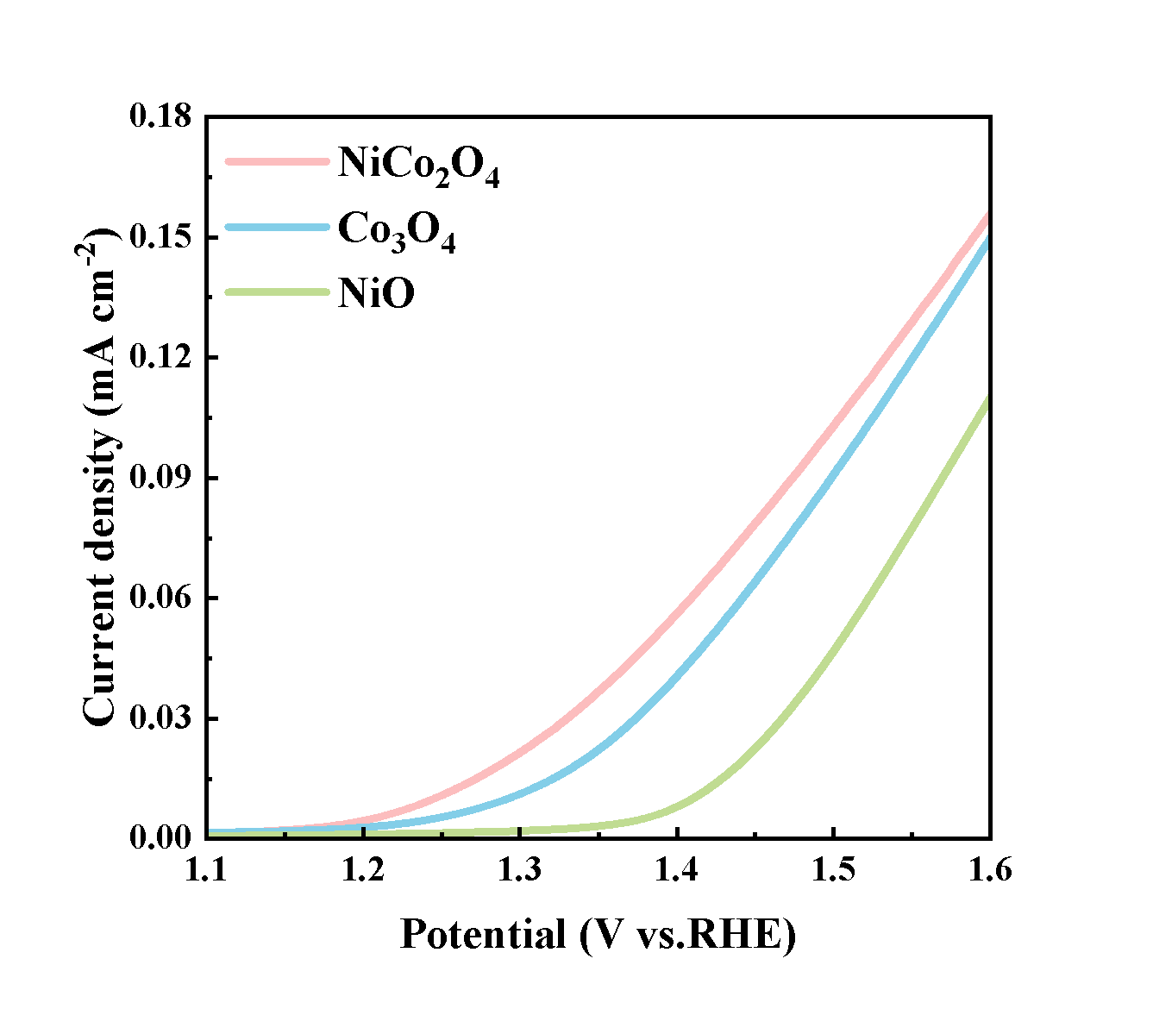
Figure S5. ECSA-normalized LSV curves.

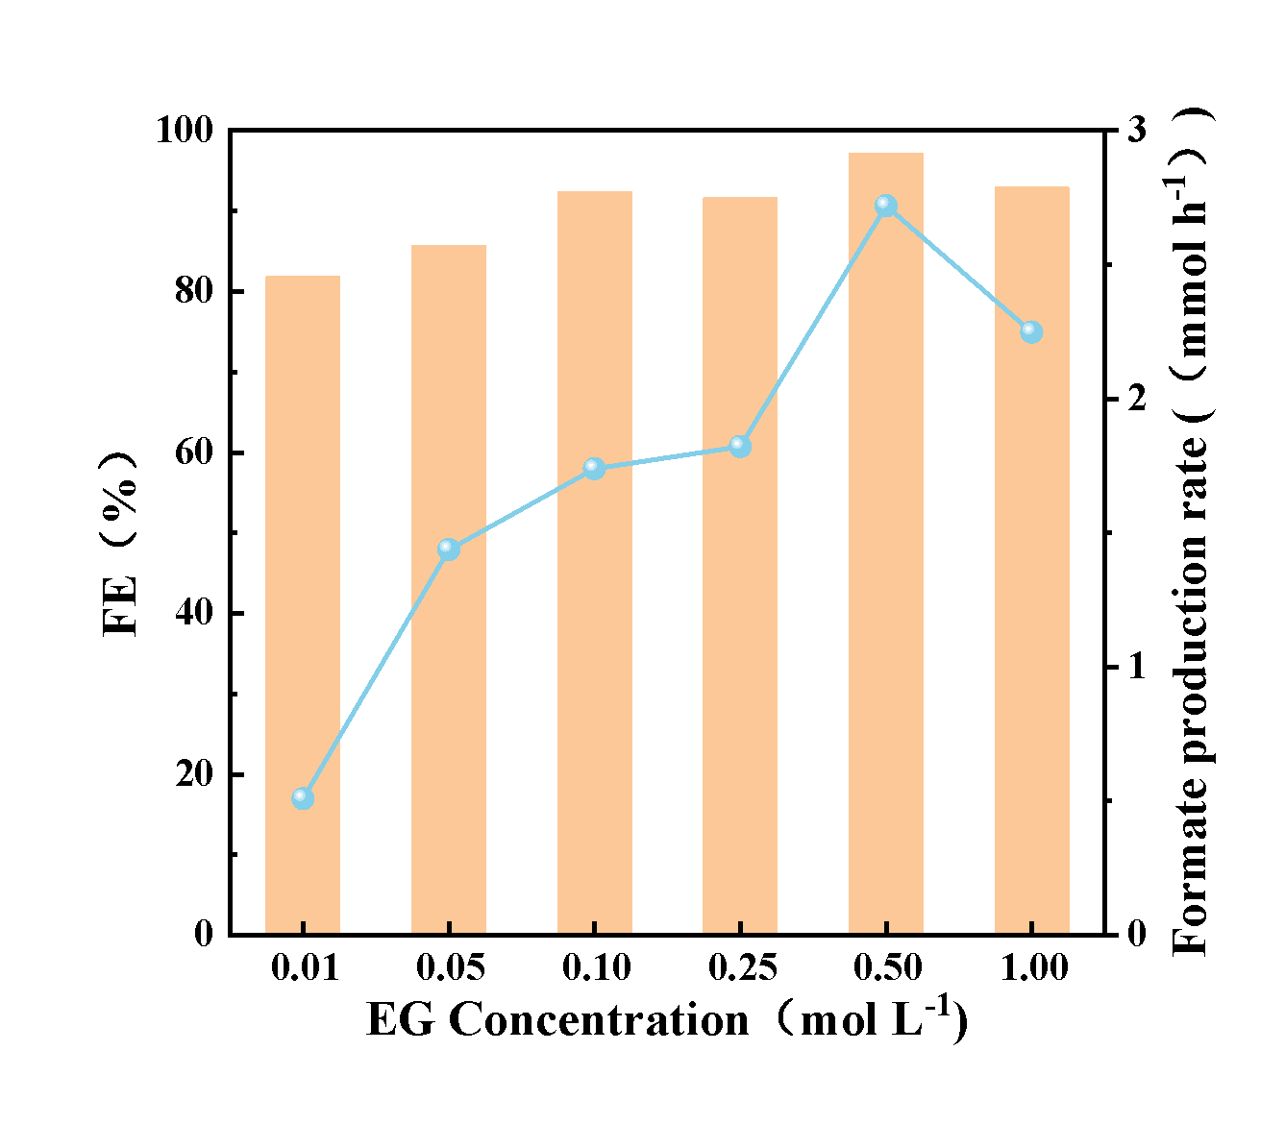
Figure S6. Product FE and FA production rate of NiCo₂O₄/NF in 1 mol·L⁻¹ KOH with different EG concentrations.

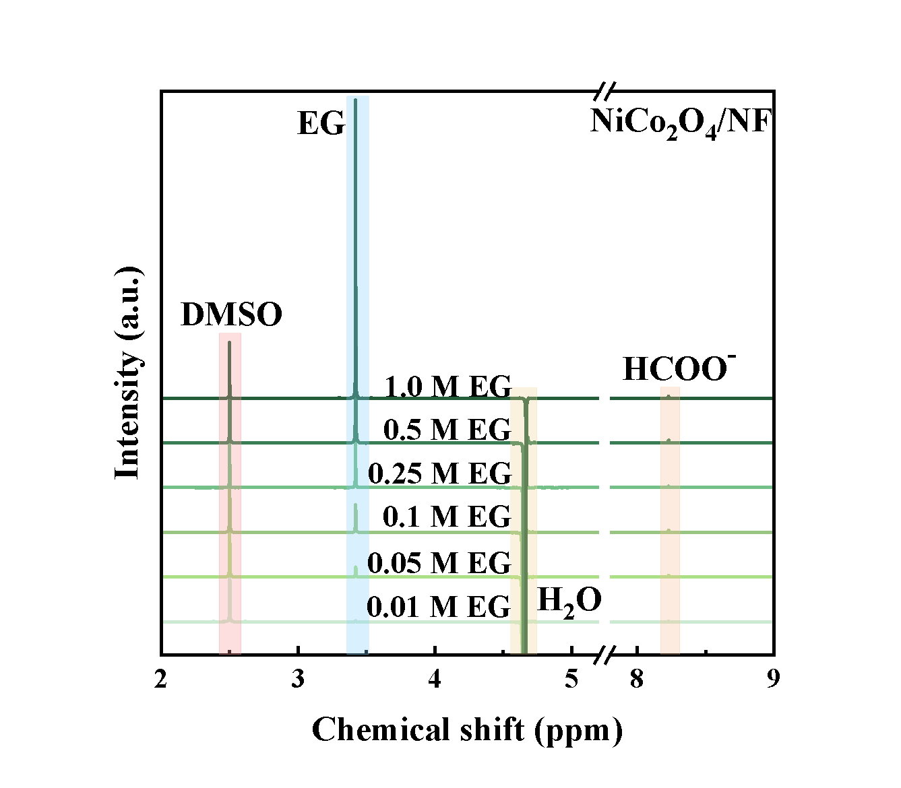
Figure S7. ¹H NMR spectra of the electrolyte collected after electrolysis over NiCo₂O₄/NF in 1 mol·L⁻¹ KOH with different EG concentrations.

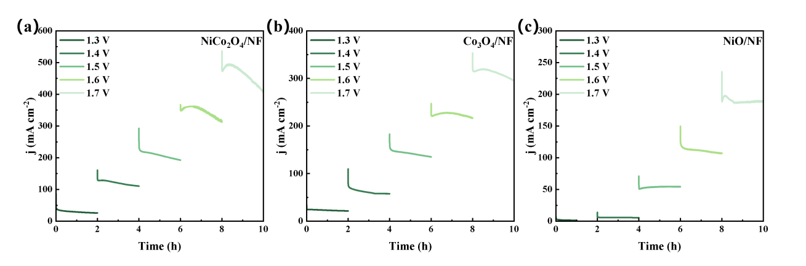
Figure S8. Successive chronoamperometric measurements of the (a) NiCo₂O₄/NF, (b) Co₃O₄/NF and (c) NiO/NF at potentials from 1.3 to 1.7 V for 2 h.

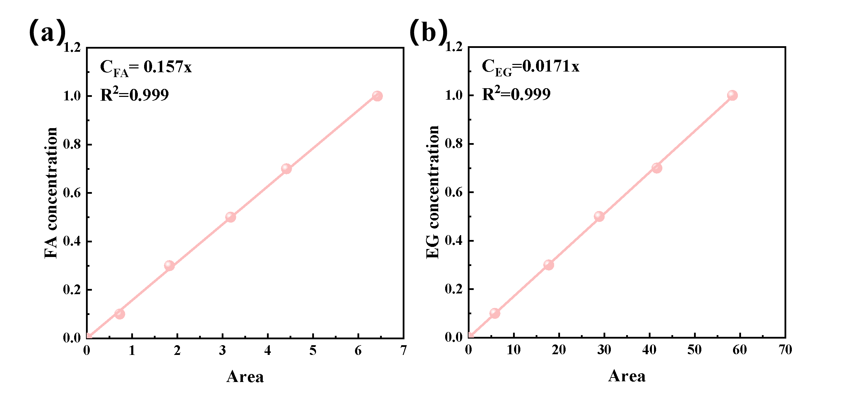
Figure S9. Calibration curves of (a) FA and (b) EG based on ¹H NMR analyses.

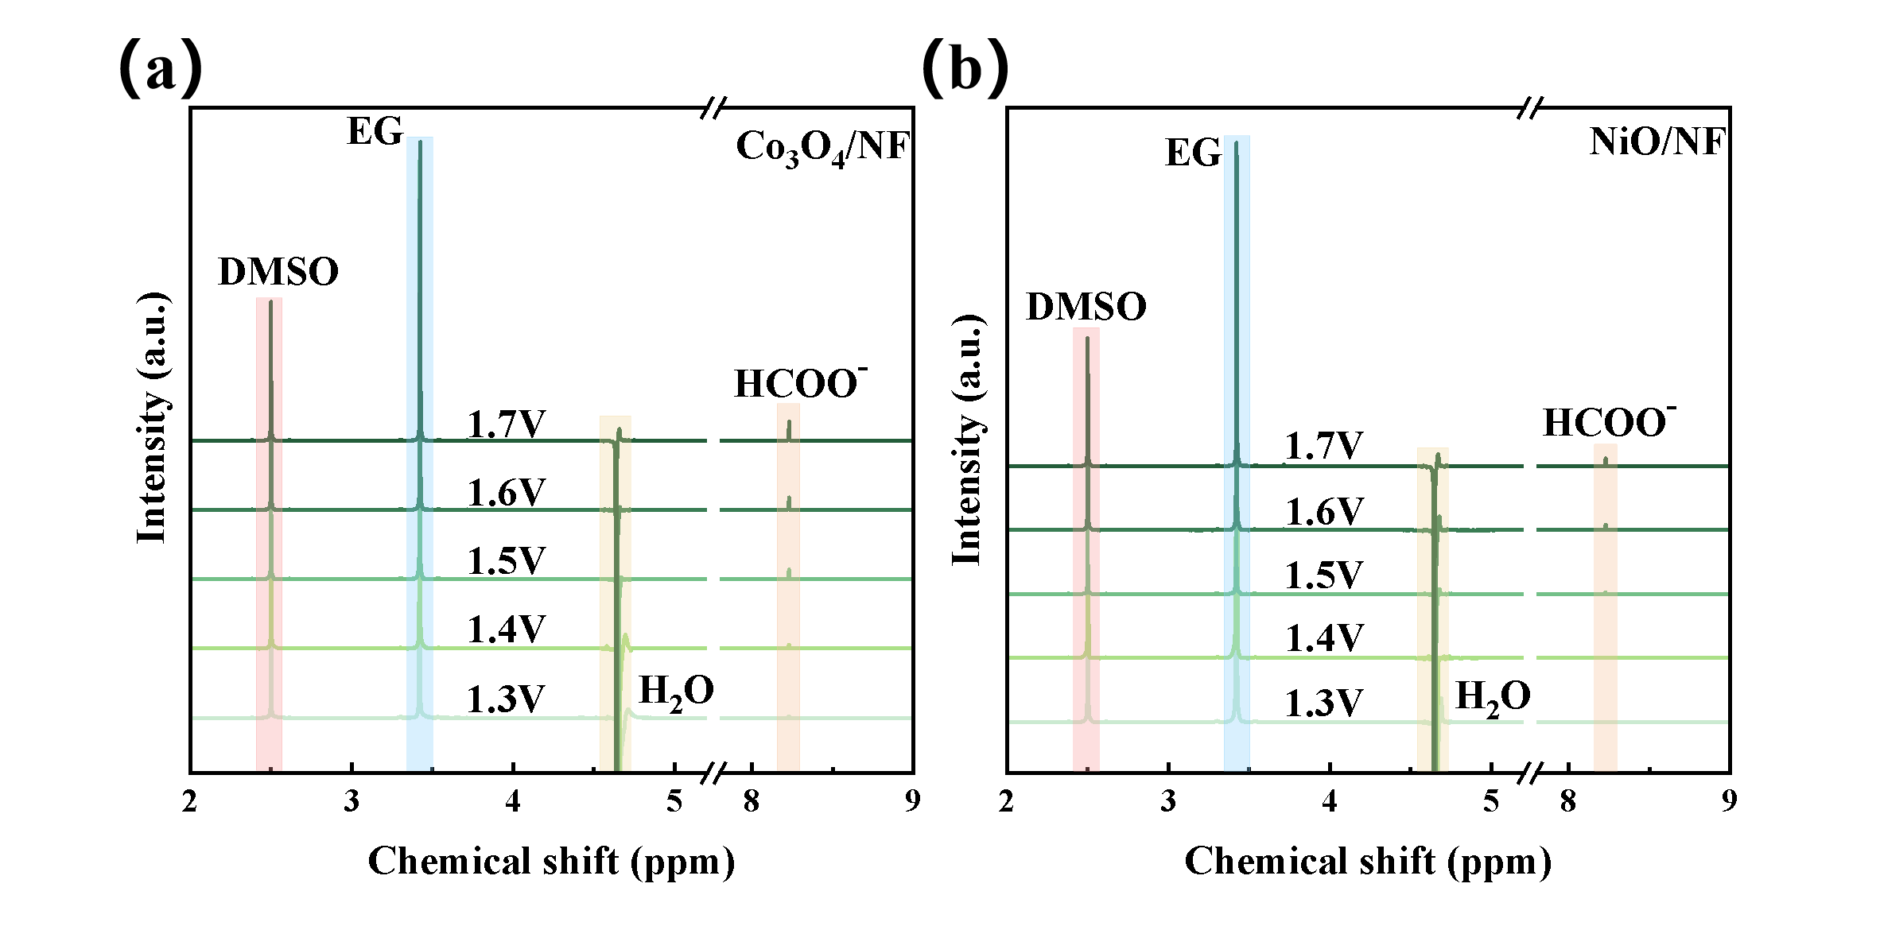
Figure S10. ¹H NMR spectra of the electrolyte collected after 2 h electrolysis over (a) Co₃O₄/NF (b) NiO/NF after electrolysis at potentials from 1.3 to 1.7 V.

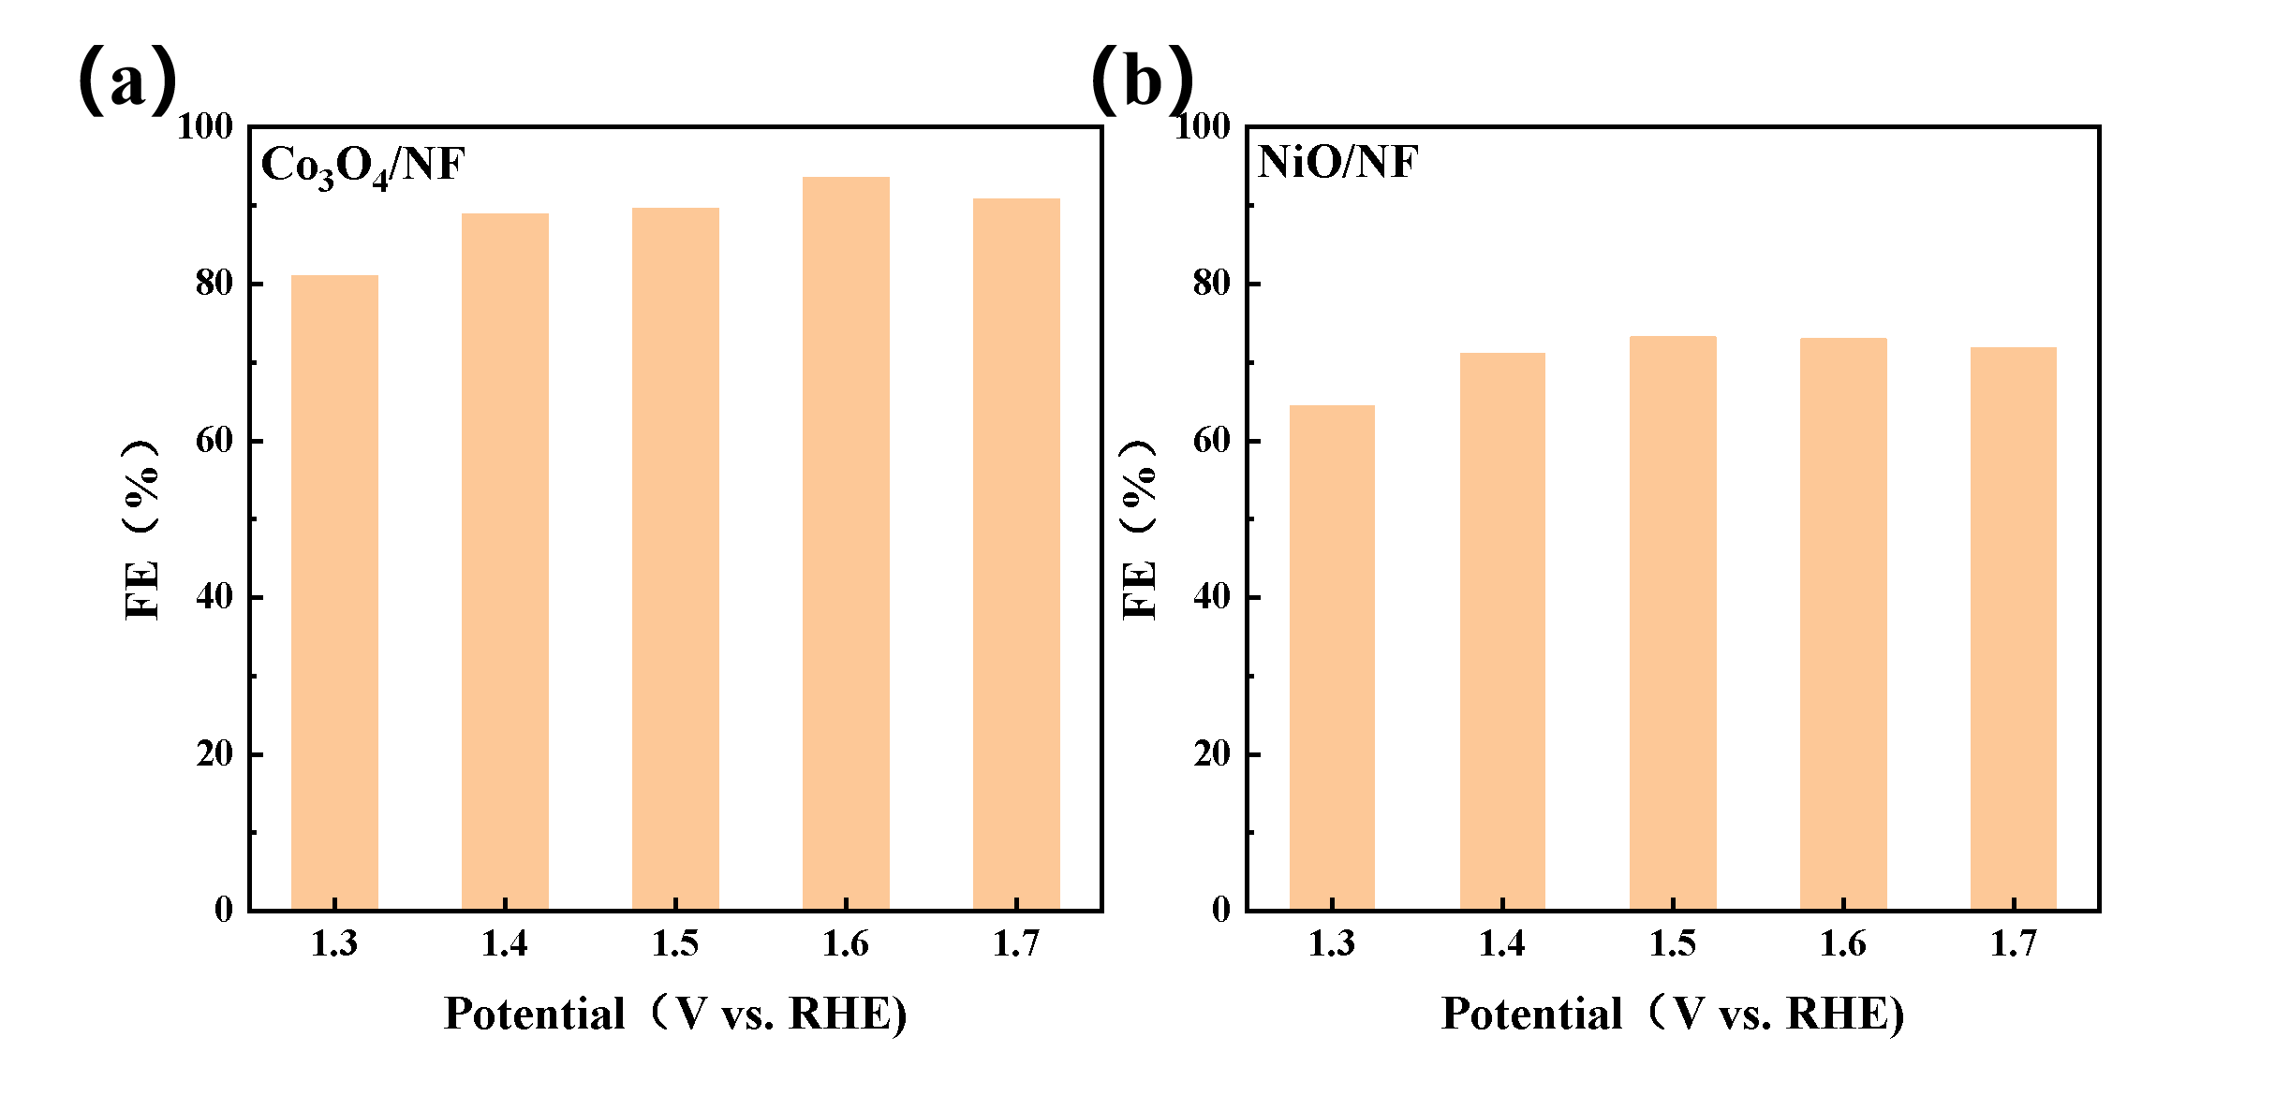
Figure S11. Product FEs at different potentials over (a) Co₃O₄/NF and (b) NiO/NF.
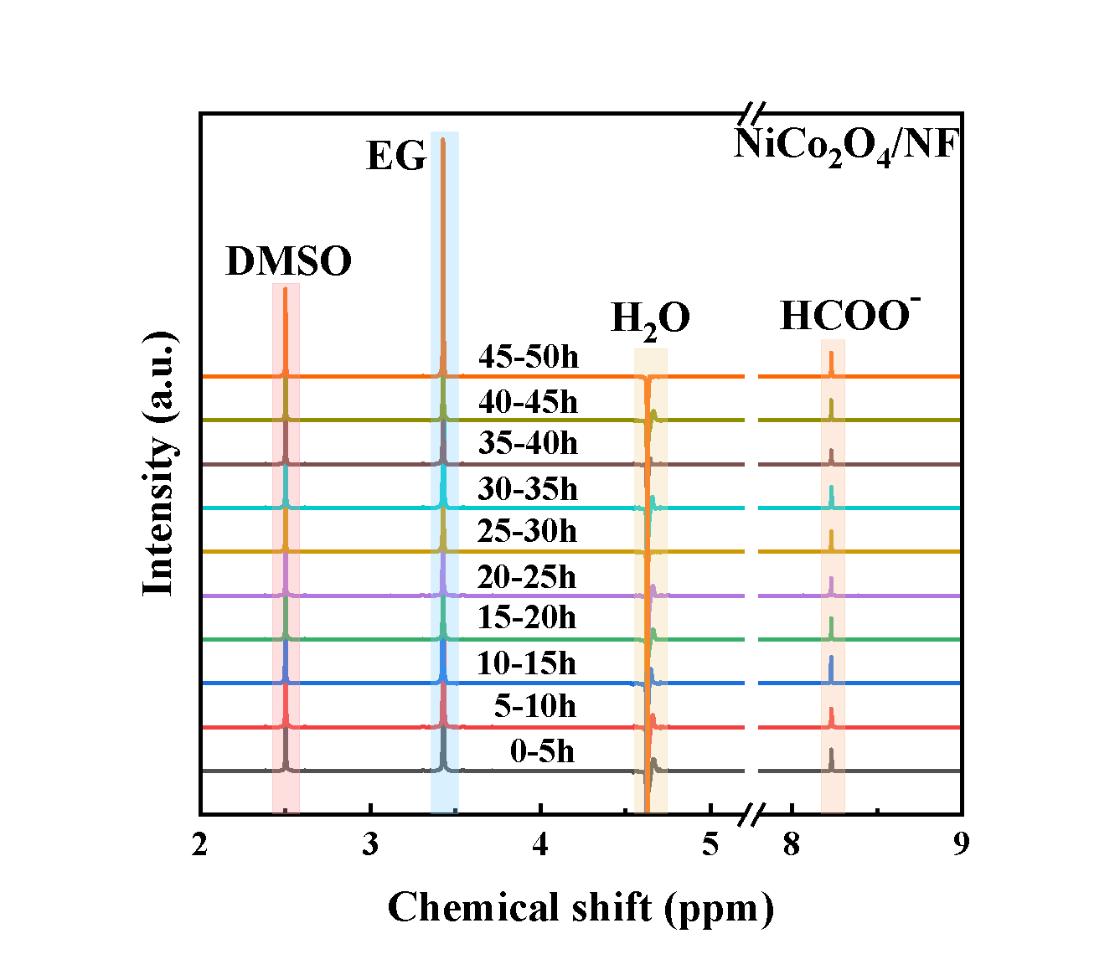
Figure S12. ¹H NMR spectra of successive chronoamperometric stability test at 1.5 V by NiCo₂O₄/NF.
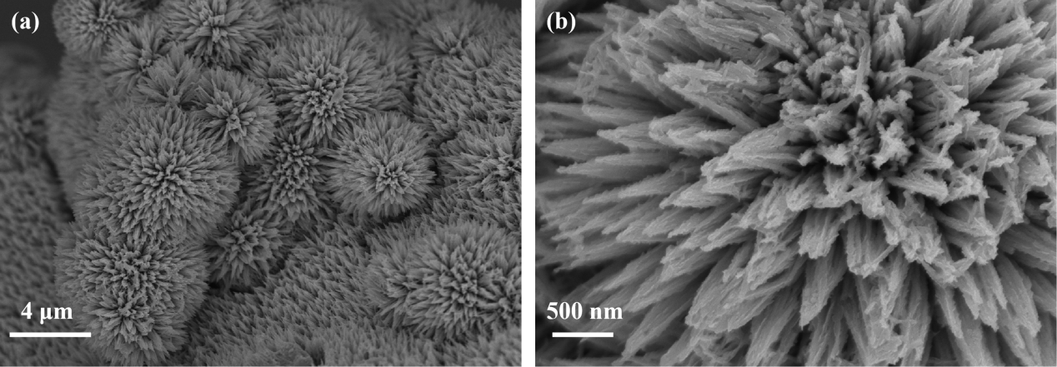
Figure S13. Post-electrolysis SEM images of NiCo₂O₄/NF at different magnifications after the 50 h consecutive chronoamperometric EGOR stability test in 1.0 mol·L⁻¹ KOH containing 0.5 mol·L⁻¹ EG at 1.50 V.

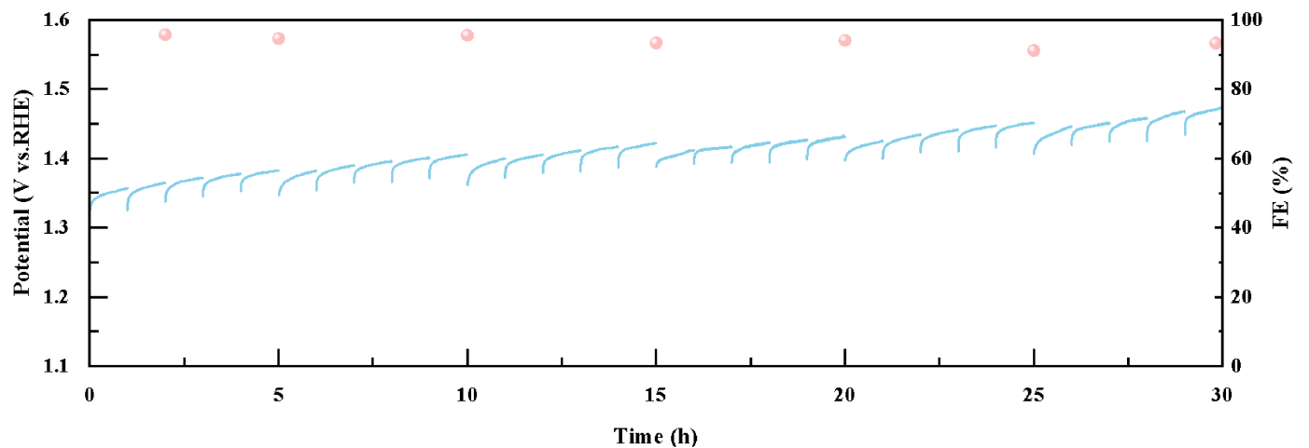
Figure S14. Electrochemical oxidation of PET hydrolysate over NiCo₂O₄/NF.

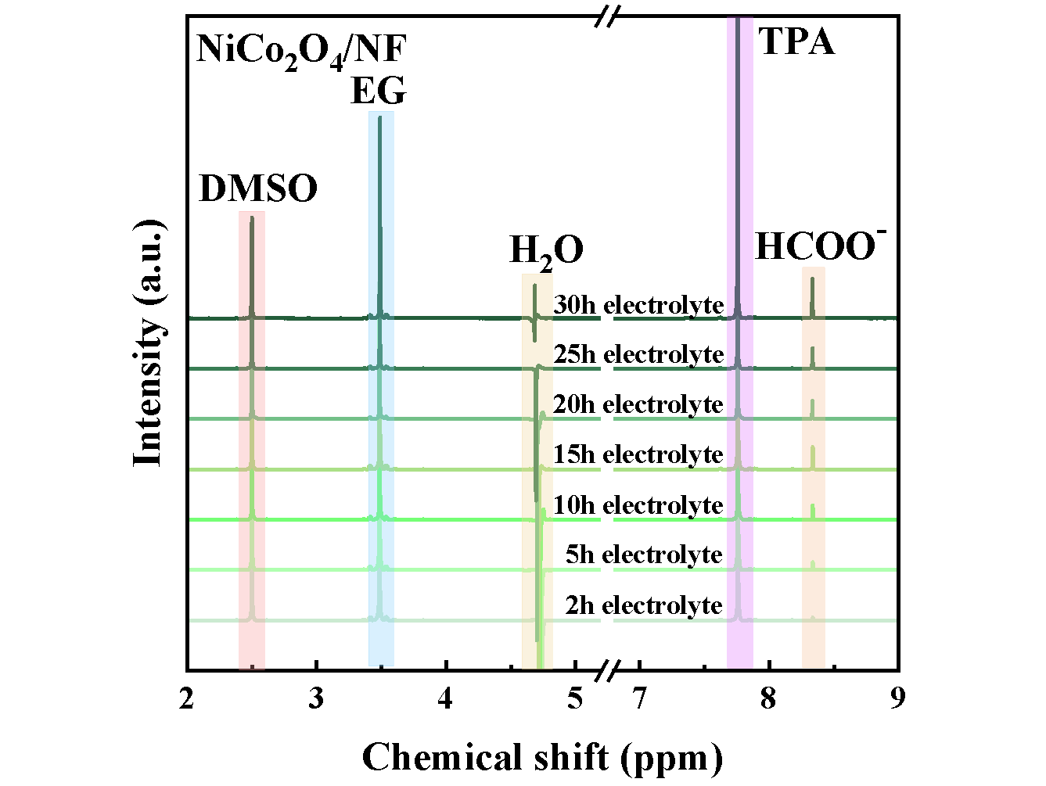
Figure S15. ¹H NMR spectra of the electrolyte after electrolysis of PET hydrolysate over NiCo₂O₄/NF.

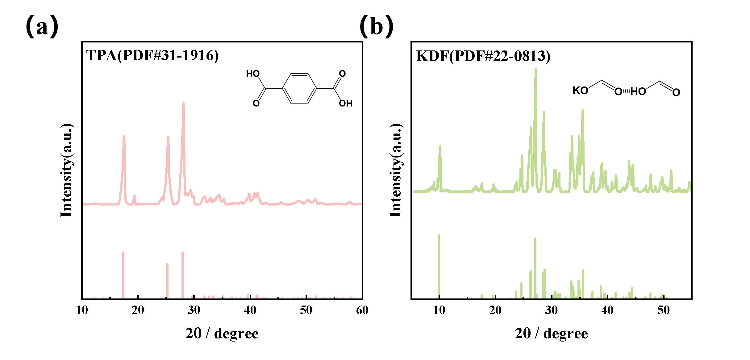
Figure S16. XRD patterns of self-prepared (a) TPA and (b) KDF.

Table S2. Mass loading of NiCo₂O₄ on Ni foam
Sample | Mass of Ni foam  (mg cm⁻²) | Mass of NiCo₂O₄/NF  (mg cm⁻²) | Mass loading of NiCo₂O₄ (mg cm⁻²)
#1 | 35.05 | 37.88 | 2.83
#2 | 35.75 | 38.50 | 2.75
#3 | 35.86 | 38.63 | 2.77
Average | / | / | 2.78

Table S3. Mass loading of Co₃O₄ on Ni foam
Sample | Mass of Ni foam  (mg cm⁻²) | Mass of Co₃O₄/NF  (mg cm⁻²) | Mass loading of Co₃O₄ (mg cm⁻²)
#1 | 34.07 | 35.40 | 1.33
#2 | 34.38 | 35.61 | 1.23
#3 | 34.91 | 36.21 | 1.30
Average | / | / | 1.29

Table S4. Mass loading of NiO on Ni foam
Sample | Mass of Ni foam  (mg cm⁻²) | Mass of NiO/NF  (mg cm⁻²) | Mass loading of NiO (mg cm⁻²)
#1 | 34.55 | 37.01 | 2.46
#2 | 35.02 | 37.43 | 2.41
#3 | 34.30 | 36.82 | 2.52
Average | / | / | 2.46

Table S5. The performance comparison of NiCo₂O₄/NF with other non-precious metal electrocatalysts that have been reported in EGOR
Catalyst | Electrolyte | Potential  (vs. RHE) | Current density  (mA cm⁻²) | Reference
NiCo₂O₄/NF | 1 mol·L⁻¹ KOH + 0.5 mol·L⁻¹ EG | 1.20 | 10 | This work
NiCo₂O₄/NF | 1 mol·L⁻¹ KOH + 0.5 mol·L⁻¹ EG | 1.37 | 100 | This work
CoCuOₓ@MXene | 1 mol·L⁻¹ KOH + 0.4 mol·L⁻¹ EG | 1.41 | 100 | [7]
Fe(0.3ωt)-CoPO | 1 mol·L⁻¹ KOH + 1 mol·L⁻¹ EG | 1.426 | 100 | [8]
Ni_{0.5}Ce_{0.5}Co₂O₄ | 1 mol·L⁻¹ KOH + 0.1 mol·L⁻¹ EG | 1.42 | 100 | [9]
FeCo(MOF)@C | 1 mol·L⁻¹ KOH + 0.5 mol·L⁻¹ EG | 1.42 | 100 | [10]
2D-CoNi-PET | 1 mol·L⁻¹ KOH + 0.3 mol·L⁻¹ EG | 1.41 | 100 | [11]
NiCu_{60s}/NF | 1 mol·L⁻¹ KOH + 0.3 mol·L⁻¹ EG | 1.45 | 100 | [12]
NiFe-LDH/NF | 1 mol·L⁻¹ KOH + 0.5 mol·L⁻¹ EG | 1.52 | 100 | [13]
NiSe₂ | 1 mol·L⁻¹ KOH + 1 mol·L⁻¹ EG | 1.389 | 10 | [14]
Ni₃S₂@NiFeMn-LDH/NF | 1 mol·L⁻¹ KOH + 1 mol·L⁻¹ EG | 1.29 | 10 | [15]
CoFe-LDH/NF-10 | 1 mol·L⁻¹ KOH + 0.1 mol·L⁻¹ EG | 1.44 | 10 | [16]
CoNiB:BO 1:0 500 °C | 1 mol·L⁻¹ KOH + 0.1 mol·L⁻¹ EG | 1.31 | 10 | [17]
NiFeP-FeP | 1 mol·L⁻¹ KOH + 0.5 mol·L⁻¹ EG | 1.43 | 10 | [18]
Ni_{0.9}Mn_{0.1}-LDH | 1 mol·L⁻¹ KOH + 1 mol·L⁻¹ EG | 1.37 | 10 | [19]
FeP/CoP@NC | 1 mol·L⁻¹ KOH + 0.5 mol·L⁻¹ EG | 1.32 | 10 | [20]

References
- Liu K, Gao X, Liu C, Shi R, Tse E, Liu F, Chen Y. Energy-Saving Hydrogen Production by Seawater Splitting Coupled with PET Plastic Upcycling. Advanced Energy Materials, 2024, 14(17): 2304065.
- Song M, Wu Y, Zhao Z, Zheng M, Wang C, Lu J. Corrosion Engineering of Part-Per-Million Single Atom Pt₁/Ni(OH)₂ Electrocatalyst for PET Upcycling at Ampere-Level Current Density. Advanced Materials, 2024, 36(23): 2403234.
- Zhou H, Ren Y, Li Z, Xu M, Wang Y, Ge R, Kong X, Zheng L, Duan H. Electrocatalytic upcycling of polyethylene terephthalate to commodity chemicals and H₂ fuel. Nature Communications, 2021, 12(1): 4679.
- Ma Y, Guo X, Du M, Kang S, Dong W, Nicolosi V, Cui Z, Zhang Y, Qiu B. Beyond biodegradation: upcycling of polylactic acid plastic waste into amino acids via cascade catalysis under mild conditions. Green Chemistry, 2024, 26(7): 3995–4004.
- Wang J, Li X, Zhang T, Chai X, Xu M, Feng M, Cai C, Chen Z, Qian X, Zhao Y. Photovoltaic-driven Ni(II)/Ni(III) redox mediator for the valorization of PET plastic waste with hydrogen production. Chemical Science, 2024, 15(20): 7596–7602.
- Shi K, Si D, Teng X, Chen L, Shi J. Pd/NiMoO₄/NF electrocatalysts for the efficient and ultra-stable synthesis and electrolyte-assisted extraction of glycolate. Nature Communications, 2024, 15(1): 2899.
- Yu Z, Ji M, Zhang Z, Zhang Y, Barras A, Addad A, Tang L, Chi Y, Roussel P, Szunerits S, Boukherroub R. Electrocatalytic upcycling of polyethylene terephthalate to formic acid and hydrogen fuels using CoCuO_{x}/MXene catalyst. Journal of Energy Chemistry, 2025, 104: 91–100.
- Bai X, Lin J, Cheng B, Yang C, Wang X, Li Y, Ishida T, Murayama T, Xiu G, Lin M. Fe-induced Co (IV) elimination enhancing selective ethylene glycol oxidation at high current density. Journal of Catalysis, 2026, 455: 116708.
- Li Z, Yang Z, Wang S, Luo H, Xue Z, Liu Z, Mu T. Medium entropy metal oxide induced *OH species targeted transfer strategy for efficient polyethylene terephthalate plastic recycling. Chemical Engineering Journal, 2024, 479: 147611.
- Li M, Xia T, Wang M, Peng Y, Zhang S, Jiang X, Yang H. Biocarbon-confined bimetallic FeCo metal-organic framework orthogonal nanosheet arrays for industry-level ethylene glycol oxidation. Chinese Journal of Structural Chemistry, 2025, 44(8): 100627.
- Yuan L, Wu C, Deng K, Liu X, Tian W, Ji J. Bimetallic 2D Metal Organic Frameworks for High Selective Ethylene Glycol Electrooxidation. Small, 2026, 22(7): e12758.
- Kang H, He D, Yan X, Dao B, Williams N, Elliott G, Streater D, Nyakuchena J, Huang J, Pan X, Xiao X, Gu J. Cu Promoted the Dynamic Evolution of Ni-Based Catalysts for Polyethylene Terephthalate Plastic Upcycling. ACS Catalysis, 2024, 14(7): 5314–5325.
- Jiang Y, Li J, Guo X, Chen Y, Sun W, Peng C. Electrocatalytic reforming of polyethylene terephthalate waste plastics into high-value-added chemicals with green hydrogen generation. Journal of Colloid and Interface Science, 2025, 685: 29–37.
- Li J, Li L, Ma X, Han X, Xing C, Qi X, He R, Arbiol J, Pan H, Zhao J, Deng J, Zhang Y, Yang Y, Cabot A. Selective Ethylene Glycol Oxidation to Formate on Nickel Selenide with Simultaneous Evolution of Hydrogen. Advanced Science, 2023, 10(15): 2300841.
- Ma Y, Ge H, Zhang Y, Jian N, Yu J, Arbiol J, Li C, Zhong Y, Li L, Kang H, Wang J, Cabot A, Li J. Selective Electrooxidation of Ethylene Glycol to Formate with Hydrogen Cogeneration in Ni₃S₂ Nanodomains on NiFeMn-LDH Nanosheet Arrays. ACS Sustainable Chemistry & Engineering, 2025, 13(15): 5601–5612.
- Zhang X, Li X, Zhang X, Lu H, Sun Y, Duan X, Ren Y. Hierarchical CoFe-LDH with nanoneedle-assembled architecture for selective and efficient electrocatalytic oxidation of ethylene glycol to formate. Journal of Electroanalytical Chemistry, 2025, 998: 119532.
- Braun M, Chatwani M, Kumar P, Hao Y, Sanjuán I, Apostoleri A, Brix A, Morales D, Hagemann U, Heidelmann M, Masa J, Schuhmann W, Andronescu C. Cobalt nickel boride as electrocatalyst for the oxidation of alcohols in alkaline media. Journal of Physics: Energy, 2023, 5(2): 024005.
- Wang M, Long X, Hu X, Zhou X, Yang Z, Jiang X, Yang H. Bimetallic phosphide heterojunctions with charge redistribution for polyethylene terephthalate plastic upgrading. Chemical Engineering Journal, 2026, 532: 173395.
- Wang Z, Li J, Zhang Q, Wu C, Meng H, Tang Y, Zou A, Zhang Y, Ma R, Lv X, Yu Z, Xi S, Xue J, Wang X, Wu J. Facilitating Formate Selectivity via Optimizing eg* Band Broadening in NiMn Hydroxides for Ethylene Glycol Electro-Oxidation. Angewandte Chemie International Edition, 2024, 63(44): e202411517.
- Li D, Gan Z, Zhang C, Wang X, Zheng M, Gao X, Huang Y, Fan Y, Zhang S, Zheng F, Chen W. Built-in electric field in hollow FeOOH/CoOOH heterostructure: Enhanced *OH adsorption and C-C bond cleavage towards efficient ethylene glycol-to-formate conversion. Applied Catalysis B: Environment and Energy, 2026, 381: 125867.

