Electronic Supplementary Material

Theoretical surface study of forward osmosis membranes by interlayering thin film composite membrane
Mahdi Hussainzadeh, Majid Peyravi ()
Department of Chemical Engineering, Babol Noshirvani University of Technology, Babol 47148-71167, Iran
E-mail: majidpeyravi@gmail.com

In order to validate the model, the FO filtration experiments were conducted using a bench-scale cross-flow system, examining the impact of osmotic pressure and draw salt concentration on water flux and RSF. Our Membrane group has also included this laboratory setup in other articles about forward osmosis. In this supplementary information, we also include a photo of the laboratory setup as relevant supporting information. It should be noted that all experiments were repeated 5 times to eliminate the error resulting from the experiment and outliers were removed and normalized. In this system, the reverse salt flux was also measured using an EC meter (Hussainzadeh, 2023).
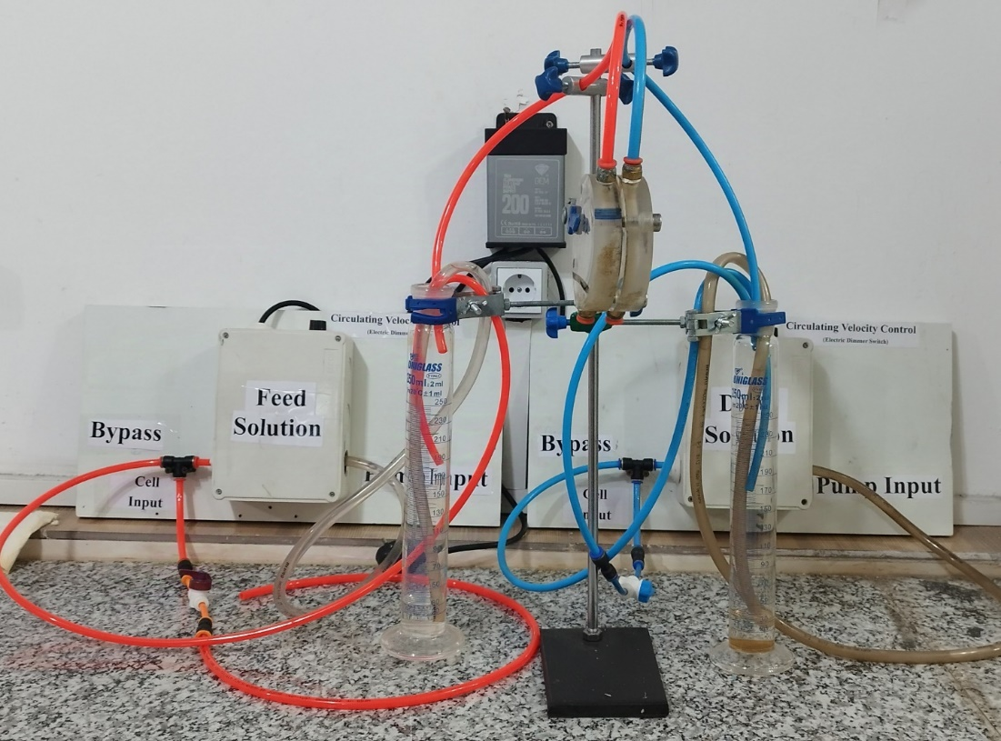
Figure SI-1-1: Laboratory-scale forward osmosis Setup

Table SI-1. Parameters used in the solution-friction model. (Samson et al., 2003) (Tedesco et al., 2016) (Biesheuvel et al., 2022) (Chu et al., 2021) (Stolov and Freger, 2020) (Kezia et al., 2014) (Das et al., 2018)
Parameter | Description | Value | Unit
DNa+ | Sodium diffusion coefficient1 | 1.33 × 10-9 | m²s⁻¹
DCl− | Chloride diffusion coefficient1 | 2.03 × 10-9 | m²s⁻¹
D | Salt diffusion coefficient2 | 1.64 × 10-9 | m²s⁻¹
𝑓f-m | Frictional coefficient between water and the membrane pore matrix (fitting parameter in model) | 5.3 × 1014 | mol s m-5
𝑓Na-f | Parameter related to the friction between Na+  and the fluid, calculated from 1/DNa⁺ | 7.52 × 1010 | s m-2
𝑓Cl-f | Parameter related to the friction between Cl-  and the fluid, calculated from 1/DCl⁻ | 4.93 × 109 | s m-2
$K$ f,𝑖 | Frictional factor describing interactions between ions and the membrane as well as  ions and the fluid. Specifically. | 0.20
k | Mass transfer coefficient of salt in the boundary layer (determined experimentally using the method described in Text S1) | 2.08 × 10-5 | m s-1
𝑋 | Membrane charge density5 | 200 | mM
$φ$ Na⁺ | Size-dependent partitioning coefficient of  𝑁𝑎+ (fitting parameter in our model, eq 6). | 0.011
$φ$ Cl⁻ | Size-dependent partitioning coefficient of  Cl⁻ (fitting parameter in our model, eq 6). | 0.016

The effects of the interlayer in membranes, such as the funnel and gutter effect, and their adaptation to the SF model will be covered in this study because modeling and experimental validation of interlayers and their adaptation to the model have not been completed. This research focuses on the interlayer's effect on water flux and RSF and investigates the occurrence of gutter and funnel phenomena and their adaptation to the SF model with the COMSOL software. The geometries and meshing of COMSOL was depicted in Figure SI-1-2.
Figure SI-1-2: Different perspectives of geometries, cell unit, half of a cell unit, and meshing method

In order to avoid making the article too long, additional information on how to model with COMSOL software is provided here. In order to model and obtain the gutter and funnel effect in membranes with an interlayer and conventional membranes, in one section we used a geometry with an interlayer (SI-1-2) and obtained the stream profile in the case with an interlayer, and in the other case, we removed the interlayer and used only a polyamide active layer. In the defined model for the COMSOL software, we specified the global, geometry, material, and study parameters. We also specified the new variables that we defined so that we could determine the performance of the interlayer on the membranes for the software. Then, in the components section, we dragged different geometries and assigned the materials defined from the software library to each part. Then, by combining multiple physics assigning new solution-friction equations and adding a study, we were able to extract the data and graphs in the main manuscript. In the physics section, Darcy's law of physics and transport in dilute and Concentrated media were used, and modeling was performed using these methods. Because this research study was not on different flows and schematics and only focused on the functional parameters of the membrane and interlayers, other data and figures weren't added to the main manuscript and only the efficiency results of interlayers and membranes were added.
Characterization:
Figure SI-1-3: The FT-IR Spectrum of Interlayered Membrane, b) EDS, c) EDS-mapping of Membrane Surface
References:
Biesheuvel, P.M., Porada, S., Elimelech, M. and Dykstra, J.E. 2022. Tutorial review of reverse osmosis and electrodialysis. Journal of Membrane Science 647, 120221.
Chu, K.H., Mang, J.S., Lim, J., Hong, S. and Hwang, M.-H. 2021. Variation of free volume and thickness by high pressure applied on thin film composite reverse osmosis membrane. Desalination 520, 115365.
Das, A.K., Manohar, M. and Shahi, V.K. 2018. Cation-Exchange Membrane with Low Frictional Coefficient and High Limiting Current Density for Energy-Efficient Water Desalination. ACS Omega 3(8), 10331-10340.
Hussainzadeh, M. 2023. The modified antifouling and hydrophilic thin layer composite membranes and evaluation of its performance in desalination and water purification in forward osmosis process (FOP). Materials Chemistry and Mechanics 1(4), 40-48.
Kezia, K., Lee, J., Ogieglo, W., Hill, A., Benes, N.E. and Kentish, S.E. 2014. The transport of hydronium and hydroxide ions through reverse osmosis membranes. Journal of Membrane Science 459, 197-206.
Samson, E., Marchand, J. and Snyder, K.A. 2003. Calculation of ionic diffusion coefficients on the basis of migration test results. Materials and Structures 36(3), 156-165.
Stolov, M. and Freger, V. 2020. Membrane Charge Weakly Affects Ion Transport in Reverse Osmosis. Environmental Science & Technology Letters 7(6), 440-445.
Tedesco, M., Hamelers, H.V.M. and Biesheuvel, P.M. 2016. Nernst-Planck transport theory for (reverse) electrodialysis: I. Effect of co-ion transport through the membranes. Journal of Membrane Science 510, 370-381.

