Boosting Visible-Light Photocatalytic Performance of Exfoliated Carbon Nitride Nanosheets via Optimizing Dopant Decoration for Efficient Pollutant Removal
Kingsley Igenepo John, Touma B. Issa, Aleksandar N. Nikoloski, Goen Ho, Dan Li*
College of Science, Technology, Engineering & Mathematics, Murdoch University, Murdoch, WA 6150, Australia.
Figures:

Fig. S1. Enlarged XRD patterns at the (002) plane of g-C₃N₄, Na(0.4)g-C₃N₄, Fe(0.4)g-C₃N₄ and Pr(0.4)g-C₃N₄.

Fig. S2. Enlarged XRD patterns at the (100) plane of g-C₃N₄ and Pr(x)g-C₃N₄.

Fig. S3. SEM images of g-C₃N₄ (a), Pr(0.1)g-C₃N₄ (b), Pr(0.2)g-C₃N₄ (c) and Pr(0.4)g-C₃N₄ (d).

Fig. S4. XPS survey spectrum of Pr(0.4)g-C₃N₄.

Fig. S5. Mott-Schottky plots with charge carrier density (N_{D}) of g-C₃N₄, Na(0.4) g-C₃N₄, Fe(0.4) g-C₃N₄, and Pr(0.4) g-C₃N₄.

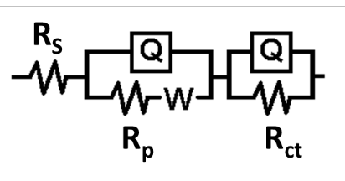
Fig. S6. The equivalent circuit used to model the EIS Nyquist plots for g-C₃N₄, Na(0.4)g-C₃N₄, Fe(0.4)g-C₃N₄, and Pr(0.4)g-C₃N₄. (R_{s}, R_{p}, R_{ct}, W, and Q represent the electrolyte resistance, pore resistance, charge transfer resistance, Warburg impedance, and constant phase element, respectively) [1].

Fig. S7. Proposed structures of (a) g-C₃N_{4,} (b) Na(0.4)g-C₃N₄, (c) Fe(0.4)g-C₃N₄, and (d) Pr(0.4)g-C₃N₄.
Fig. S8. Schematic diagram for degradation mechanism of (a) Na(0.4)g-C₃N₄ [2]; heterostructures of (b) Fe(0.4)g-C₃N₄ [3], and (c) Pr(0.4)g-C₃N₄ [4].

Fig. S9. Point of zero charge of Na(0.4)g-C₃N₄, Fe(0.4)g-C₃N₄, and Pr(0.4)g-C₃N₄.

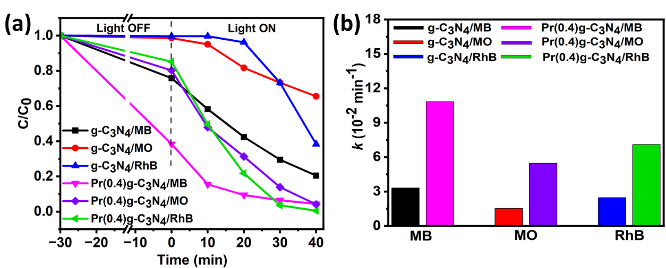
Fig. S10. (a – b) Effect of different types of dyes on the photocatalytic degradation and corresponding rate constants of g-C₃N₄ and Pr(0.4)g-C₃N₄.

Fig. S11. Photocatalytic degradation of MO (a) and RhB (b) using g-C₃N₄, Na(0.4)g-C₃N₄, Fe(0.4)g-C₃N₄, and Pr(0.4)g-C₃N₄.

Fig. S12. (a) Electronic structure of Pr(0.4)g-C₃N₄ and (b) mechanism of the reaction using Pr(0.4)g-C₃N₄.

Tables:
Table S1. MB removal performance of Pr(0.4)g-C₃N₄ in comparison to some conventional catalysts and modified g-C₃N₄ in the literature.
Photocatalyst | Dosage/Conc.  (g L⁻¹/mg L⁻¹) | Light source | Time (min) | Removal  (%)/k (min⁻¹) | Ref.
SnO₂ | 0.20/10 | UV lamp (3 x 11W) | 100 | 84.8/0.0185 | [5]
ZnO | 1.5/10 | UV lamp (8W) | 20 | 72.3/- | [6]
WO₃ | 1/10 | UV-Vis | 90 | 94.8/- | [7]
TiO₂ | 0.3/3.2 | UV lamp | 120 | 92.2/0.0072 | [8]
MnO₂/g-C₃N₄/ZnO | 0.13/10 | LED (60 W) | 180 | 94/0.0156 | [9]
CdSe/g-C₃N₄ | -/20 | 300 W Xe lamp (λ > 400 nm) | 120 | 89.4/0.0194 | [10]
ZnO/g-C₃N₄ | 1/5 | two 100 W Xe lamp | 180 | 97/0.022 | [11]
Alginate/ZnO/g-C₃N₄ | 0.3 wt%/4 | 300 W Tungsten lamp | 60 | 78.18/- | [12]
CuO/g-C₃N₄ | 1/5 | 400 W Halogen lamp | 40 | 98/- | [13]
Ce-MOF/g-C₃N₄ | 0.25/10 | UV light | 120 | 96.5/0.027 | [14]
CeO₂/g-C₃N₄ | 0.5/10 | 36 W UV lamp (OS72) (λ = 254 nm) | 180 | 94.0/0.030 | [15]
CeO₂/S-doped-g-C₃N₄₄ | 1/10 | 300 W Halogen lamp (λ > 400 nm) | 150 | 91.4/0.015 | [16]
Sm₂O₃/S-g-C₃N₄ | 0.7/8 | 300 W Halogen lamp (λ > 400 nm) | 150 | 93/0.013 | [17]
Nd-ZnO/g-C₃N₄ | 1/20 | 500 W Xe lamp | 105 | 94.9/0.026 | [18]
Ho-g-C₃N₄ | 0.4/10 | 120 W lamp | 300 | 71.4/0.004 | [19]
TiO₂/Na-doped g-C₃N₄ | 2/20 | 300 W Xe lamp  (λ > 400 nm) | 90 | 99.6/- | [20]
P-doped g-C₃N₄ | 0.5/- | 500 W Xe lamp  (λ > 420 nm) | 120 | -/0.0045 | [21]
K-doped g-C₃N₄ | 0.6/10 | 300 W Xe lamp (λ > 400 nm) | 60 | 99.0/- | [22]
CuO/g-C₃N₄ | 1/50 | 500 W halogen lamp (λ > 400 nm) | 100 | 94.0/0.030 | [23]
Pr(0.4)g-C₃N₄ | 0.4/10 | 300 W Xe lamp  (λ > 420 nm) | 40 | 95.6/0.108 | This study
Na(0.4)g-C₃N₄ | 0.4/10 | 300 W Xe lamp  (λ > 420 nm) | 40 | 92.6/0.053 | This study
Fe(0.4)g-C₃N₄ | 0.4/10 | 300 W Xe lamp  (λ > 420 nm) | 40 | 77.5/0.021 | This study

Table S2. Characteristics of water matrices in this study.
Water matrix | pH | Turbidity (NTU) | Conductivity (µS cm⁻¹) | Total Organic Carbon  (mg C L⁻¹) | Salinity (PPT)
Deionized Water (control) | 4.6 | 0.6 | 4.6 | < 0.5 | 0
Spring Water | 5.6 | 0.6 | 211.9 | < 0.5 | 0.1
Tap Water | 8.1 | 1.6 | 247.0 | 0.9 | 0.1
Primary Effluent | 7.2 | 15.3 | 1144.0 | 33 | 0.6
Secondary Effluent | 6.9 | 1.2 | 956.0 | 32 | 0.5

References
- Tyagi A, Mishra K, Sharma S K, Shukla V K, Performance studies of an electric double-layer capacitor (EDLC) fabricated using edible oil-derived activated carbon. Journal of Materials Science: Materials in Electronics, 2022, 33: 8920–8934.
- Wu S, Yu Y, Qiao K, Meng J, Jiang N, Wang J. A simple synthesis route of sodium-doped g-C₃N₄ nanotubes with enhanced photocatalytic performance. Journal of Photochemistry and Photobiology A: Chemistry, 2021, 406: 112999.
- Xu F, Chai B, Liu Y, Liu Y, Fan G, Song G. Superior photo-Fenton activity toward tetracycline degradation by 2D α-Fe₂O₃ anchored on 2D g-C₃N₄: S-scheme heterojunction mechanism and accelerated Fe³⁺/Fe²⁺ cycle. Colloids and Surfaces A: Physicochemical and Engineering Aspects, 2022, 652: 129854.
- Shende A G, Ghugal S G, Vidyasagar D, Kokane S B, Jagannath, Umare S S, Sasikala R. Solvent free solid-state synthesis of Pr₆O₁₁/g-C₃N₄ visible light active photocatalyst for degradation of AV7 dye. Materials Research Bulletin, 2018, 107: 154–163.
- Pandey A K, Nurhidayah E, Yuwono A H, Septiningrum F, Maulana F A, Dhaneswara D, Sofyan N, Pangesty A I, Noviyanto A, Said Z, Tyagi V V. Optimizing the photocatalytic performance of SnO₂ nanoparticles for methylene blue removal with variation in calcination temperatures. 2024, E3S Web of Conferences 488.
- Saadi H, Atmani E H, Fazouan N. Enhanced photocatalytic degradation of methylene blue dye by ZnO nanoparticles: Synthesis, characterization, and efficiency assessment. 2024, Environmental Progress & Sustainable Energy 44(1).
- Shakun S, Manmeet K, Chhavi P, Sonal S. Temperature dependent structural, optical, photocatalytic and magnetic properties of WO₃ nanoparticles. Journal of Water and Environmental Nanotechnology, 2024, 9(3): 318-326.
- Laghrib S, Gherdaoui C E, Belgherbi O, Benaskeur N, Boudissa M, Kanagaraj A, Aouffa N. Photocatalytic degradation of methylene blue using TiO₂ nanoparticles synthesized via the sol–gel method in acidic and neutral media. Reaction Kinetics, Mechanisms and Catalysis, 2025.
- Gindose, T.G., Atisme, T.B., Hailegebreal, T.D. and Zereffa, E.A. ZnO Modified g‐C₃N₄–MnO₂ composite for photodegradation of methylene blue. ChemistrySelect, 2025, 10: e202403418.
- Zhu Y, Jiang C, Meng T, Yao J, Peng Z, Wang P, Zhang Z, Wang C, Zhang Y, Zhao Y. Heterojunction engineering of g-C₃N₄ with superior photogenerated electron transfer for boosting photodegradation of methylene blue. Optical Materials, 2025, 159.
- Pourali S, Amrollahi R, Alamolhoda S, Masoudpanah S M. In situ synthesis of ZnO/g-C₃N₄ based composites for photodegradation of methylene blue under visible light. Scientific Report, 2025, 15(1), 462.
- Valiyathur M D F, Sakvai M S, Mithra S, Majeed S A, Kottur A B, Hameed A S S, Raza A A. Photocatalytic and toxicity assessment of alginate reinforced ZnO-g-C₃N₄ photocatalyst for the degradation of methylene blue - A sustainable strategy. International Journal of Biological Macromolecules, 2025, 298, 139935.
- Muthuganesh A, Rafi S M, Jacob I D, Soundranayagam J P, Surender S, Elangovan P, Flora X H. Efficient methylene blue dye degradation via visible light-activated g-C₃N₄/CuO nanocomposites. Hybrid Advances, 2025. 9: 100420.
- Durmus Z, Köferstein R, Lindenberg T, Lehmann F, Hinderberger D, Maijenburg A W. Preparation and characterization of Ce-MOF/g-C₃N₄ composites and evaluation of their photocatalytic performance. Ceramics International, 2023, 49(14): 24428–24441.
- Wei X, Wang X, Pu Y, Liu A, Chen C, Zou W, Zheng Y, Huang J, Zhang Y, Yang Y, Naushad M, Gao B, Dong L. Facile ball-milling synthesis of CeO₂/g-C₃N₄ Z-scheme heterojunction for synergistic adsorption and photodegradation of methylene blue: Characteristics, kinetics, models, and mechanisms. Chemical Engineering Journal, 2021, 420: 127719.
- Jourshabani M, Shariatinia Z, Badiei A. Facile one-pot synthesis of cerium oxide/sulfur-doped graphitic carbon nitride (g-C₃N₄) as efficient nanophotocatalysts under visible light irradiation. Journal of Colloid and Interface Science, 2017, 507: 59–73.
- Jourshabani M, Shariatinia Z, Badiei A. Synthesis and characterization of novel Sm₂O₃/S-doped g-C₃N₄ nanocomposites with enhanced photocatalytic activities under visible light irradiation. Applied Surface Science, 2018, 427: 375–387.
- Tian M, Zhang G, Zhao X, Yan Y, Zhao J, Bai H, Jiang J. Construction of rare-metal neodymium-doped ZnO and g-C₃N₄ Z-type heterostructures enhance the photocatalytic efficiency of methylene blue removal. Diamond and Related Materials, 2023, 140: 110493.
- Yavuz A, Aydin D, Disli B, Ozturk T, Gul B, Gubbuk I H, Ersoz M. Enhancing visible light photocatalytic activity of holmium doped g-C₃N₄ and DFT theoretical insights. Environmental Science and Pollution Research, 2024, 31(32): 44828–44847.
- Liu H, Yu D, Sun T, Du H, Jiang W, Muhammad Y, Huang L. Fabrication of surface alkalinized g-C₃N₄ and TiO₂ composite for the synergistic adsorption-photocatalytic degradation of methylene blue. Applied Surface Science, 2019, 473: 855–863.
- Liu S, Zhu H, Yao W, Chen K, Chen D. One step synthesis of P-doped g-C₃N₄ with the enhanced visible light photocatalytic activity. Applied Surface Science, 2018, 430: 309–315.
- Yuan L, Liu W, Zhang W. Potassium-doped g-C₃N₄ enables efficient visible-light-driven dye degradation. Environmental Science and Pollution Research, 2023, 58276–58281.
- Vijayakumar T P, Benoy M D, Duraimurugan J, Suresh Kumar G, Shkir M, Maadeswaran P, Senthil Kumar A, Ramesh Kumar K A. Hydrothermal synthesis of CuO/g-C₃N₄ nanosheets for visible-light driven photodegradation of methylene blue. Diamond and Related Materials, 2022, 121: 108735.

