Electronic Supplementary Material
Microbial growth study of advanced foam control agents (FCAs) for fermentation process

Wenjing Qi¹, Xue Chen ()², Erica Frankel³, Xinjie Tong⁴, Zeyu Zhong¹
1 The Dow Chemical Company, Shanghai 201203, China
2 The Dow Chemical Company, Industrial Solution Business R&D, Lake Jackson 77566, USA
3 The Dow Chemical Company, Collegeville 19426, USA
4 The Dow Chemical Company, Core R&D, Lake Jackson 77566, USA
E-mail: idaxuechen2025@gmail.com

Appendixes
1. Foamscan
The measurement reliability of Foamscan foam testing was validated by 6 repetitive tests of the same FCA. Per those data (Appendix, Figure S1), we could see that the RSD was around 7.56%.

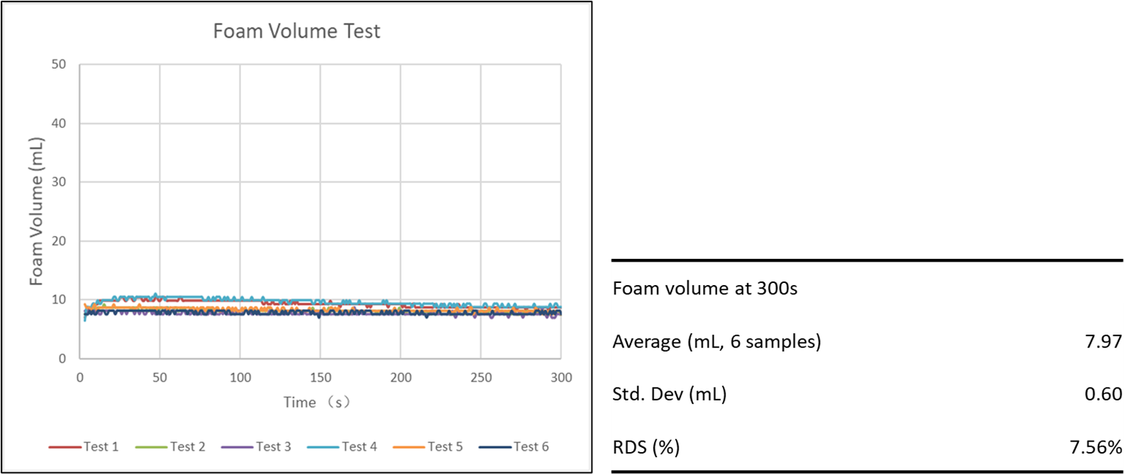
Figure S1. Data Reliability Check of Foamscan Foam Testing

2. Microbial Culture
Yeast Maintenance and Inoculum
1. Aseptic technique was used for culture maintenance and inoculums preparation.
2. Yeast cultures (18–24-hour broth cultures, ~10⁸ CFU/mL, diluted with sterile glycerol to a final 10% glycerol concentration) were stored in cryovials at -70 to -80°C.
3. One vial of each yeast (Table 2) were retrieved from cold storage.
4. Vials were placed at room temperature on the bench top until thawed.
5. Each yeast suspension (100 µL) was transferred from the cryovial to 10 mL PDB (potato dextrose broth) and grown for 18-24 hours at 30°C with shaking at 150 to 200 rpm.

Mold Culture Maintenance and Inoculum
1. Aseptic technique was used for culture maintenance and inoculum preparation.
2. Molds were maintained on PDA plates and stored at 2-5°C.
3. Five to seven days in advance of use a sterile swab is used to inoculate two new PDA plates for each mold.
4. The PDA plates are incubated at 25°C for 5 to 7 days.
5. A sterile container (e.g. 50 mL centrifuge tube) was charged with 10 mL sterile 0.1 M phosphate buffer (pH 7.0 – 7.5).
6. A sterile swab was wet in the sterile buffer, then wiped and rolled over approximately 1 square inch one plate of the sporulating mold culture to coat the swab with spores.
7. The swab was submerged in the sterile buffer and agitated to suspend the spores.
8. Steps 6 and 7 were repeated on the same plates for a total of 2 times for each mold, combining the molds into a single tube with 10 mL of buffer.
9. The extra plate was placed in the refrigerator as the maintenance culture.
10. Mold cultures were inspected each time they were grown. If they become compromised, retrieved fresh frozen stocks and start new plates.

3. Preparation of RABIT Sample Cells
1. Potassium hydroxide (0.35 g) was dissolved in 50 mL of deionized water, to form a potassium hydroxide solution. This solution was not heated.
2. Bacteriological Agar No.1 (1.0 g, available from Thermo Fisher Scientific) was dispersed in 50 ml of deionized water in a 100 ml screw capped bottle. The agar was completely dissolved by boiling or by autoclaving, to form an agar solution.
3. While the agar solution was still hot (approx. 70ºC), but not boiling, the cold potassium hydroxide solution was added to the agar solution, and the final solution was mix thoroughly, to form an agar mixture.
4. Using a suitable pipetting device, 0.7 ml of the agar mixture was dispensed into the base of each clean, dry RABIT impedance cell, taking care to minimize the quantity of agar that runs down the inside of the cell.
5. Within each cell, the agar mixture was allowed to cool and solidify within 15 and 30 minutes (maximum). Then each cell was sealed as tightly as possible using a supplied rubber stopper.
6. Next, the agar in each cell was allowed to equilibrate for a minimum of 2- hours (preferably overnight) prior to use.
7. These “RABIT pre-cells” containing the solidified agar may be stored at room temperature for one month, if tightly sealed and protected from strong light. These cells should not be refrigerated.
8. To check the condition of the prepared impedance cells before use, they are placed in the RABIT module and the conductivity readings from the cell are observed using a Global Conductivity Table function (supplied by the manufacturer of the RABIT instrumentation). These values should typically be from 7000 to 10000 µS at 30ºC. Cells with conductivity readings below 6000 µS, at 30°C, should not be used.

4. Calibration Details
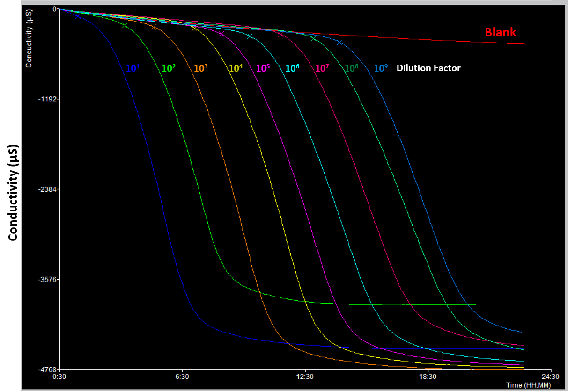
Figure S2: Sample dataset for conductivity curves as a function of time for different dilutions of yeast. Dilution factors are shown from most concentrated on the leftmost curve to least concentrated on the rightmost curve. Each curve is demarcated with an “x” denoting the time to detection.

5. Microorganism Growth Assays
Microbial growth was analyzed via the Rapid Automated Bacterial Impedance Technique (RABIT), an instrument that provides an in-situ monitoring of microbial solution conductivity over time. The instrument recognizes exponential growth within a sample, based on the change in conductivity over a certain amount of time. For each microbial solution, the “time to detection (TTD),” is used to determine the initial concentration of the microorganism(s) of interest. For yeast, the initial concentration is the concentration after incubation, at 30°C for one day (24 hours), right before the TTD-RABIT analysis. For mold, the initial concentration is the concentration after incubation, at 25°C for seven days, right before the TTD/RABIT analysis. The TTD is determined after a change in the threshold conductivity is observed for three consecutive readings on the microbial solution (typically done at six-minute intervals), and where the next consecutive reading (the fourth change in conductivity) is the reported “time to detection (TTD)”. The TTD can be used to back calculate the initial concentration of microorganisms based on a calibration curve.
Table S1. The foam volume of fermentation broth with the addition of FCA332.
*The fermentation broth was prepared by using LB broth supplied by Thermo Fisher Scientific Inc.

