Electronic Supplementary Material
Self-assembled mesoporous silica nanotubes as low-dose reinforcing units for balanced mechanical, thermal and tribological performance of epoxy composites
Dehan Chen¹, Jinian Yang ()¹, Jie Liu¹, Hengzhi Zhou ()², Hanxing Yang¹, Bingyi Li¹, Changfu Wan¹, Enhui Chen¹, Shibin Nie ()³
¹School of Materials Science and Engineering, Anhui University of Science and Technology, Huainan 232001, China
²School of Materials Science and Engineering, Nanjing Institute of Technology, Nanjing 211167, China
³School of Public Security and Emergency Management, Anhui University of Science and Technology, Hefei 231131, China

E-mails: yangjinian@163.com, jnyang@aust.edu.cn (Yang J); zhzmsc@njit.edu.cn (Zhou H); nieshibin88@163.com (Nie S)

2.1 Reagents and chemicals
Bisphenol A diglycidyl ether resin (E51) with an epoxy value of 0.52~0.54 mol/100 g was purchased from Shenzhen Jitian Chemical Co., Ltd., China. Cetyltrimethylammonium bromide (CTAB, 99%), ethylene oxide-propylene oxide block copolymer (F-127), tetraethyl orthosilicate (TEOS, SiO₂≥28.4%, AR), and aqueous ammonia (NH₃·H₂O, 25~28%, GR) were supplied by Titan Scientific Co., Ltd. (Shanghai, China). Anhydrous ethanol (C₂H₅OH, 99.8%) and 4,4′-diaminodiphenyl sulfone (DDS, 97%) were obtained from Aladdin Industrial Corporation, whereas acetone (CH₃COCH₃, 99.5%, AR) was purchased from Yasheng Chemical Co., Ltd (Wuxi, China). Deionized water was produced in-house. All chemicals were of analytical grade and used as received without further purification.
2.2 Sample fabrication
Briefly, 1.458 g of CTAB and 1.26 g of F-127 were dissolved sequentially in 100 mL of deionized water, followed by ultrasonication until a transparent and homogeneous solution was obtained, designated as Solution A. Solution B was prepared by mixing 120 mL of deionized water with 3.6 mL of NH₃·H₂O. Subsequently, Solution A and Solution B were combined and stirred vigorously to ensure uniformity. Then, 4.8 mL of TEOS was added dropwise into the mixture, followed by continuous vigorous stirring for an additional 10 min. After 6 h of static aging, the mixed solution gradually turned turbid. The product was collected by centrifugation, washed alternately with ethanol and deionized water, and dried preliminarily. To remove the surfactant template, the as-obtained precipitate was re-dispersed in an HCl/ethanol mixture at a volume ratio of 3:100 and refluxed at 90 °C for 12 h in a round-bottom flask. Finally, the acid-washed product was rinsed with ethanol and dried at 60 °C to constant weight, yielding the target MSNTs.
EP/MSNTs composites were fabricated via an in-situ solution mixing method, with MSNTs mass fractions ranging from 0.25 to 3%. Using the 1% MSNTs composite as a representative example, the typical fabrication procedure is described as follows: MSNTs were first dispersed in 20 mL of acetone and ultrasonicated for 1 h. The suspension was then added into 10 g of E51, followed by vigorous magnetic stirring in an oil bath at 80 °C for 4 h to ensure uniform dispersion of MSNTs in the EP matrix. The mixture was subsequently heated at 80 °C for 1 h to evaporate most of the acetone, and further dried in a vacuum oven at 80 °C for another 1 h to completely remove residual solvent. 2.5 g of DDS was then added and thoroughly mixed into the system. The mixture was poured into a preheated mold and degassed under vacuum at 130 °C to eliminate trapped air bubbles. Finally, the samples were cured at 130 °C for 2 h, followed by stepwise post-curing at 150, 180 and 200 °C for 2 h at each stage.
2.3 Characterizations
2.3.1 Structural characterization
The crystal structure and phase composition of the as-prepared samples were characterized by X-ray diffraction (XRD, XRD-6000, Shimadzu, Japan) with Cu Kα radiation operated at 40 kV. The diffraction patterns were recorded to identify the crystalline phases and analyze the crystallographic features of the synthesized fillers and corresponding composites.
The molecular structures and interfacial chemical bonding characteristics of the samples were investigated by Fourier transform infrared spectroscopy (FT-IR, Nicolet 380, Thermo Scientific, USA) over a wavenumber range of 400~4000 cm⁻¹. The FT-IR spectra were utilized to identify characteristic functional groups and reveal the interfacial interactions between the filler and epoxy matrix.
The surface morphologies of the as-synthesized fillers, as well as the fracture surfaces and worn surfaces of the EP composites, were observed by scanning electron microscopy (SEM, S3000 N and Regulus 8100, Hitachi, Japan). SEM was also employed to analyze the surface roughness and morphological evolution after wear tests, as well as the tensile fracture features, thereby revealing the failure mechanisms and tribological behaviors of the composites. The detailed microstructures and lattice features of the samples were characterized by transmission electron microscopy (TEM, JEM-2100 PLUS, Japan) at an accelerating voltage of 200 kV, which was used to acquire high-resolution morphological and structural information of the fillers.
The three-dimensional surface topography and roughness parameters of the worn surfaces were quantitatively characterized using a 3D profilometer (PS50, NANOVEA, USA). Prior to measurement, the worn surfaces were carefully cleaned with ethanol and dried to remove loose wear debris and impurities. Typical regions inside the wear tracks were then selected for scanning to acquire three-dimensional topography images. In accordance with ISO 25178 standard, areal roughness parameters including arithmetic mean height (Sa), root-mean-square height (Sq), maximum peak height (Sp), maximum valley depth (Sv) and maximum height (Sz) were extracted to characterize the worn surface morphology. Five random points were measured on each worn surface, and the average values were adopted to quantitatively analyze the wear degree and surface damage of composites.
Elemental distribution, chemical composition, and valence states of the samples were analyzed by energy-dispersive X-ray spectroscopy (EDS, TALOS F200, Thermo Fisher Scientific) and X-ray photoelectron spectroscopy (XPS, ESCALAB Xi⁺, Thermo Scientific, USA). Specifically, EDS was applied to determine the spatial distribution of elements, while XPS was used to identify the surface elemental composition and chemical oxidation states of the samples under the conditions of Al Kα monochromatic radiation (1.48 keV) operated at 15 kV, with an analysis chamber vacuum better than 1×10⁻⁹ Pa.
2.3.2 Performance testing
The mechanical properties of the samples were evaluated by tensile testing using a universal testing machine (WDW-50, KQL, China) according to GB/T 1040.2-2006. The dumbbell-shaped specimen with a type 1BA showed a length of 75 mm, a thickness of 2 mm and a gauge length of 25 mm. Tests were performed at room temperature at a constant crosshead speed of 2 mm/min. For each formulation, at least five repeated specimens were tested to ensure the reliability and repeatability of the results, and the average values were reported as the final data. Prior to testing, all specimens were conditioned at 23±2 ºC and 50 %±10 % relative humidity for at least 48 h.
The Shore D hardness of the samples was determined using a Shore hardness tester (LXD-D, SANLIANG, China). Rectangular specimens were used for hardness measurements, and each sample was tested at least 10 times at randomly selected positions. During testing, readings were recorded only after stabilization, and the final hardness value was obtained from the average of all valid measurements.
The tribological properties of the samples were evaluated using a block-on-ring friction and wear tester (M200, ZHONGLU, China) under dry-sliding conditions, following the testing procedure established in our previous work^{[1]}. A quenched 45# carbon steel ring (AISI 1045) with a hardness of 40~45 HRC and a surface roughness (Ra) of 0.4 μm was employed as the counterpart. The outer diameter, inner diameter and width of the steel ring were 40, 16 and 10 mm, respectively. The specimen dimensions were 30 mm in length, 7 mm in width and 6 mm in height. All tests were conducted at room temperature under an applied load of 117.6 N, a rotating speed of 100 rpm (1.05 m/s) and a duration of 3600 s. Before each test, the steel ring was polished using No. 1000 abrasive paper, cleaned with absolute ethanol and dried in air to ensure consistent initial surface conditions. The friction coefficient was continuously recorded throughout the sliding process. During the sliding process, a non-contact infrared thermometer (ABSD-01A, ABOSUD, China) was used to continuously monitor the real-time temperature variation of the contact surface. Meanwhile, a handheld thermal imaging camera (HM-TPK20-3AQF/W, HIKMICRO, China) was employed to capture representative infrared thermal images at 600, 1800 and 3000 s, respectively.
The thermal stability of the samples with different formulations was characterized by thermogravimetric analysis (TGA, Q500, TA Instruments, USA). All measurements were performed from room temperature (25 °C) to 700 °C at a heating rate of 10 °C/min under a nitrogen atmosphere with a flow rate of 50 mL/min to evaluate the thermal decomposition behavior and residual char yield of the composites.
Figure captions:
Fig. S1 Temperature profiles of the contact surface for EP/MSNTs composites under dry-sliding conditions
Table captions:
Table S1 Thermal property parameters of EP/MSNTs composites.
Table S2 Fitting results of samples based on Horowitz and Metzger equation.
Table S3 Detailed comparison with previous reported works.
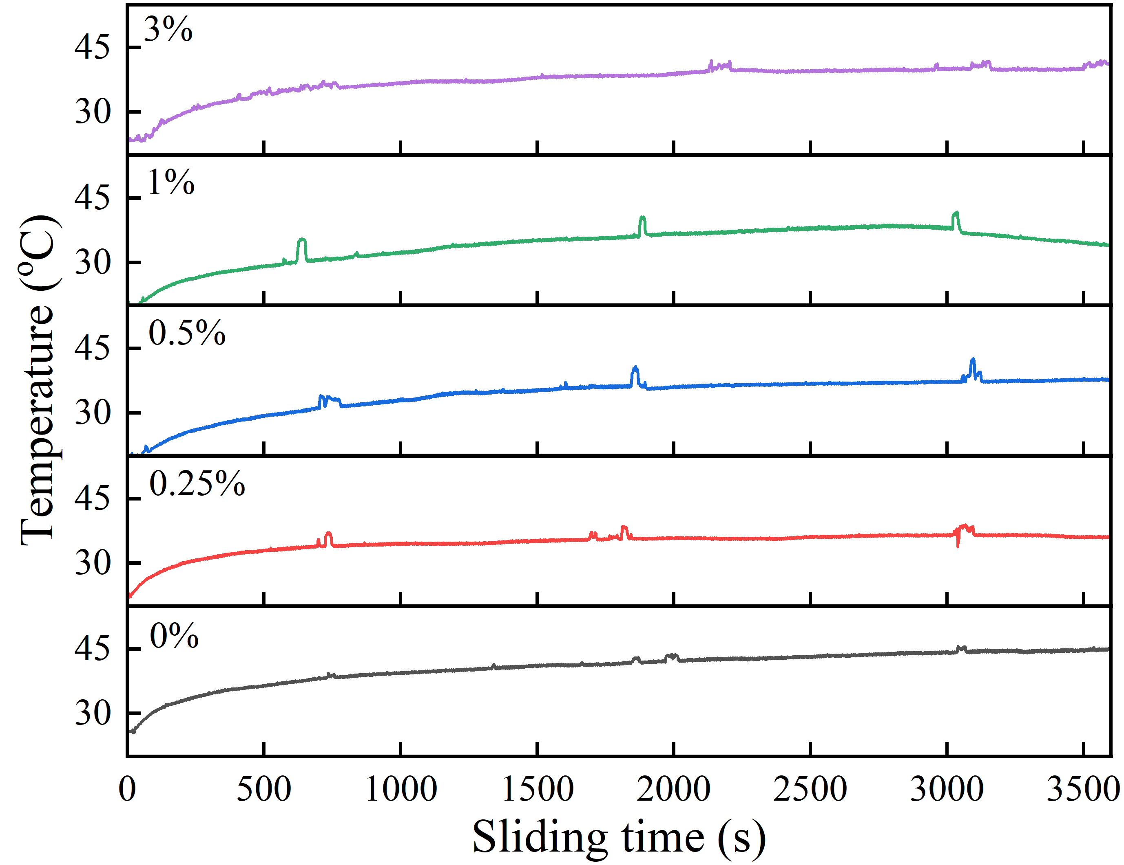
Fig. S1 Temperature profiles of the contact surface for EP/MSNTs composites under dry-sliding conditions.

Table S1 Thermal property parameters of EP/MSNTs composites.
Sample | T_{5%}(°C) | (dW/dT)_{5%} (%/K) | T_{max} (°C ) | (dW/dT)_{max} (%/K) | Char (%)
0%  0.25%  0.5%  1%  3% | 381.7  378.3  378.0  381.0  378.0 | -0.43  -0.34  -0.34  -0.35  -0.29 | 410.0  408.2  412.5  410.2  410.7 | -1.76  -1.74  -1.58  -1.77  -1.68 | 17.7  18.8  19.0  20.3  20.7
Notes: T_{5%} represents the temperature when the weight loss fraction is up to 5% and is employed to refer to the onset decomposition temperature in present study determined in the TGA profile. T_{max} indicates the temperature at which the maximum decomposition rate is reached and it is actually assigned to the peak temperature at the DTG curve. T_{s} is the statistical heat resistance index of the composites in terms of thermal fluidity and thermal stability, which is employed to reflect the resistance to heat flow before it is thermally damaged and calculated according to Equation (S1)^{[2]}. E_{α} is the activation energy of thermal decomposition determined using a calculating procedure proposed by Horowitz and Metzger^{[3]} and expressed in Equation (S2), where T_{30%} means the temperature when the weight loss fractions is up to 30%, α represents the weight conversion fraction at a temperature of T, and R is the gas constant.
$$T_{S}=0.49\left[T_{5\%}+0.6\left(T_{30\%}-T_{5\%}\right)\right] (S1)$$
$$\ln\left[\ln{{(1-α)}^{-1}}\right]=\left(T-T_{max}\right)∙\frac{E_{α}}{R{T_{max}}^{2}}+constant (S2)$$
Table S2 Fitting results of samples based on Horowitz and Metzger equation.
Sample | Slop | Intercept | Fitted equation | Pearson’s r | T_{s} (°C) | E_{α} (kJ/mol)
0%  0.25%  0.5%  1%  3% | 0.05820  0.05827  0.05773  0.05833  0.05440 | -0.77062  -0.83776  -0.83545  -0.79959  -0.75108 | y=0.05820·x-0.77062  y=0.05827·x-0.83776  y=0.05773·x-0.83545  y=0.05833·x-0.79959  y=0.05440·x-0.75108 | 0.989  0.991  0.991  0.990  0.990 | 193.9  193.0  192.7  193.9  193.2 | 225.8  224.9  222.4  226.4  211.5

Table S3 Detailed comparison with previous reported works.
Sample | Mass fraction of filler | Wear rate reduction | Tensile strength increment | Load/speed/duration | Ref.
EP/NiFePS  EP/OSNPs  EP/PANI  EP/MWFB  EP/POC  EP/MoS₂  EP/Graphite  EP/ND  EP/Al₂O₃  EP/GNP-BF  EP/HNT-CF  EP/BF  EP/NC  EP/MSNTs | 1.0%  2.0%  5.0%  10.0%  6.0%  0.3%  3.0%  0.1%  2.4%  0.5%  0.75%  15.0%  1.5%  1.0% | 10.2%  69.9%  70.0%  32.3%  27.5%  86.3%  83.3%  84.0%  90.0%  60.0%  52.4%  18.0%  60.3%  62.4% | 2.3%  79.1%  43.0%  20.6%  11.1%  35.5%  -29.5%  6.3%  -44.0%  42.6%  17.9%  39.6%  13.7 %  26.1% | 117.6 N/1.05 m·s⁻¹/3600 s  50 N/0.08 m·s⁻¹/36000 s  117.6 N/1.05 m·s⁻¹/3600 s  30 N/0.40 m·s⁻¹/2500 s  50 N/3.30 m·s⁻¹/1212 s  10 N/0.20 m·s⁻¹/2100 s  50 N/2.80 m·s⁻¹/2700 s  25 N/1.00 m·s⁻¹/3600 s  40 N/3.00 m·s⁻¹/1000 s  10 N/0.75 m·s⁻¹/3000 s  60 N/3.00 m·s⁻¹/1000 s  60 N/0.42 m·s⁻¹/1800 s  100 N/0.10 m·s⁻¹/7200 s  117.6 N/1.05 m·s⁻¹/3600 s | [38]  [50]  [51]  [52]  [53]  [54]  [55]  [56]  [57]  [58]  [59]  [60]  [61]  This work
Notes: OSNPs: organo-modified silica nanoparticles; NiFePS: nickel–iron phyllosilicates; PANI: polyaniline; MWFB: modified waste fish bone; POC: pongamic-oil-cake; MoS₂: molybdenum disulfide; ND: nanodiamond; Al₂O₃: aluminum oxide nanoparticles; NC: nanoclay; GNP-BF: graphene nanoplatelets-basalt fiber; HNT-CF: halloysite nanotube-carbon fiber; MSNTs: mesoporous silica nanotubes.
References:
[1] Yang J-n, Li Z-y, Xu Y-x, Nie S-b, Liu Y. Effect of nickel phyllosilicate on the morphological structure, thermal properties and wear resistance of epoxy nanocomposites. Journal of Polymer Research, 2020, 27(9): 274.
[2] Usha Rani P H, Rajaprakash B M, Mohan N, Akshay Prasad M. Study on thermal and erosive wear behaviour of hard powders filled glass-epoxy composite. Materials Today: Proceedings, 2020, 27: 2011–2016.
[3] Horowitz H H, Metzger G. A new analysis of thermogravimetric traces. Analytical Chemistry, 1963, 35(10): 1464–1468.

