Electronic Supplementary Material

Real-time yield prediction in microchannel gas-liquid sulfonation via augmented convolutional long short-term memory-based soft measurement

Yingjin Wang, Yingxin Mu, Shaokui Fu, Muxuan Qin, Wenjin Zhou, Wei Zhang ()

Shanxi Key Laboratory of Chemical Product Engineering, College of Chemistry and Chemical Engineering, Taiyuan University of Technology, Taiyuan, Shanxi 030024, China

E-mail: zhangwei01@tyut.edu.cn

Table S1 HPLC analytical conditions
Chromatographic conditions | Parameters
Column | C₁₈ column（250×4.6×5 μm）
Mobile phase | Methanol
Detector | Differential refractive index detector
Speed of moving fluid | 0.017 cm³*s⁻¹
Column temperature | 40 ℃
Feed volume | 15 μl

Table S2 Detailed information on network structure and parameters
Phase | Layer | Output
Input | Input | (B, 3, T, 200, 60)
Spatio-temporal feature extraction | ConvLSTM(kernel=3x3, padding=1) | (B, 32, T, 200, 60)
 | BatchNorm3d | (B, 32, T, 200, 60)
 | ConvLSTM(kernel=3x3, padding=1) | (B, 64, T, 200, 60)
 | BatchNorm3d | (B, 64, T, 200, 60)
 | Dropout3d(p=0.25) | (B, 64, T, 200, 60)
Frame-by-frame spatial feature deepening | TD(Conv2d) (kernel=3x3, padding=1) | (B, 64, T, 200, 60)
 | TD(BatchNorm2d) | (B, 64, T, 200, 60)
 | TD(ReLU) | (B, 64, T, 200, 60)
 | TD(MaxPool2d) (kernel=2x2) | (B, 64, T, 100, 30)
 | TD(Conv2d) (kernel=3x3, padding=1) | (B, 64, T, 100, 30)
 | TD(BatchNorm2d) | (B, 64, T, 100, 30)
 | TD(ReLU) | (B, 64, T, 100, 30)
 | TD(MaxPool2d) (kernel=2x2) | (B, 64, T, 50, 15)
Feature Integration and Classification | TD(Flatten) | (B, T, 48000)
 | Select Last Time | (B, 48000)
 | Fully Connect | (B, 128)
 | ReLU | (B, 128)
 | Dropout(p=0.5) | (B, 128)
 | Fully Connect | (B, 64)
 | ReLU | (B, 64)
 | Dropout(p=0.5) | (B, 64)
Output | Output | (B, 3)

Table S3 Summary of 5-fold cross-validation performance (T=12)
Fold | Best validation loss | Best validation accuracy/%
1 | 0.0624 | 96.88
2 | 0.0491 | 100
3 | 0.0251 | 100
4 | 0.0759 | 96.77
5 | 0.0773 | 93.55
Average value | 0.0580 | 97.44

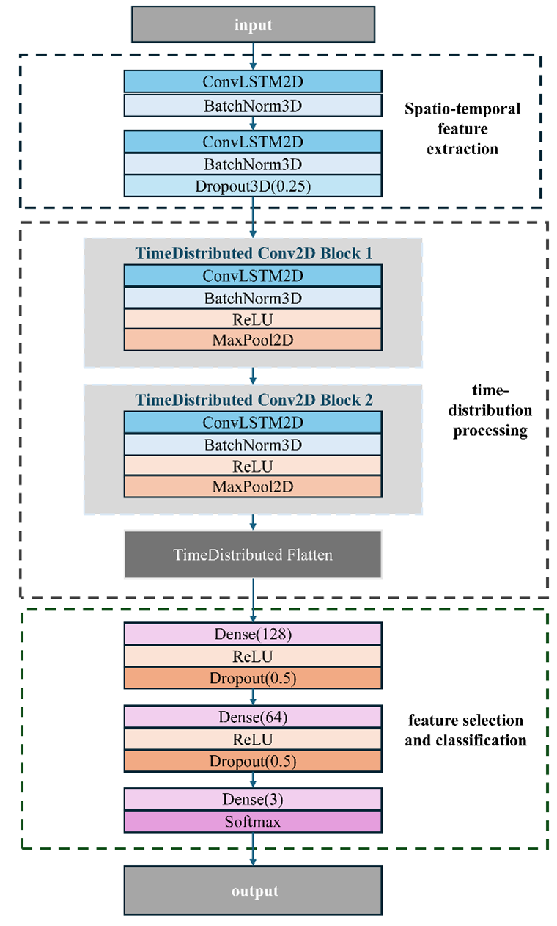
Fig. S1 Model architecture flowchart

