Electronic Supplementary Material

In situ growth of embedded pt nanoparticles in MIL-68(In)-derived In₂O₃ for enhanced CO₂ hydrogenation to methanol
Yanmei Cai^{1,2,3}, Kok Bing Tan ()^{1,3}, Meihong Lin,^{1,3}, Shuhan Luo^{1,3}, Kaishu Wu^{1,3}, Sajid Ali^{1,3}, Guifen Du⁴, Lanping Huang⁵, Jianbang Liu⁵, Dongren Cai ()¹, Guowu Zhan ()^{1,3}

¹College of Chemical Engineering, Academy of Advanced Carbon Conversion Technology, Huaqiao University, Xiamen 361021, China
²Department of Chemical and Biomolecular Engineering, National University of Singapore, Singapore 117585, Singapore
³Fujian Provincial Key Laboratory of Biomass Low-Carbon Conversion, Huaqiao University, Xiamen 361021, China
⁴Instrumental Analysis Center, Huaqiao University, Xiamen 361021, China
⁵Fujian Eversun Technology Co., Ltd., Putian 351156, China
E-mails: gwzhan@hqu.edu.cn (Zhan G); tankokbing@hqu.edu.cn (Tan K B); 15506@hqu.edu.cn (Cai D)

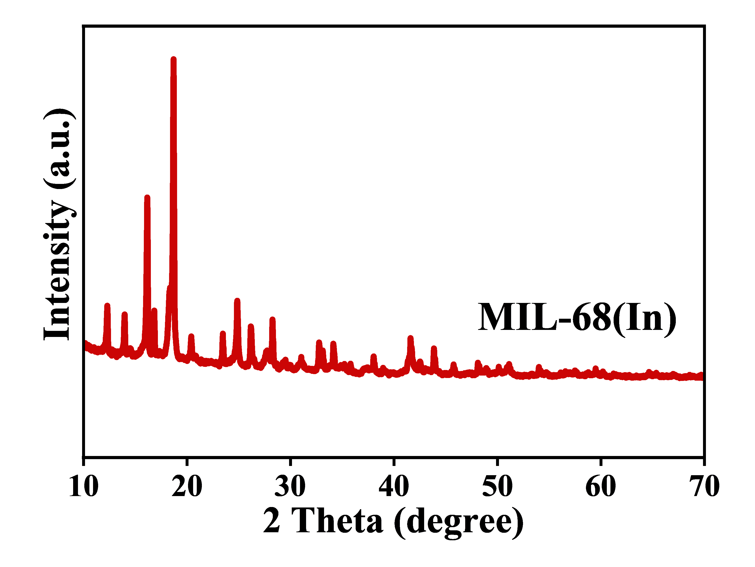
Figure S1. XRD patterns of Matériaux de l'Institut Lavoisier-68 (In), or MIL-68(In).
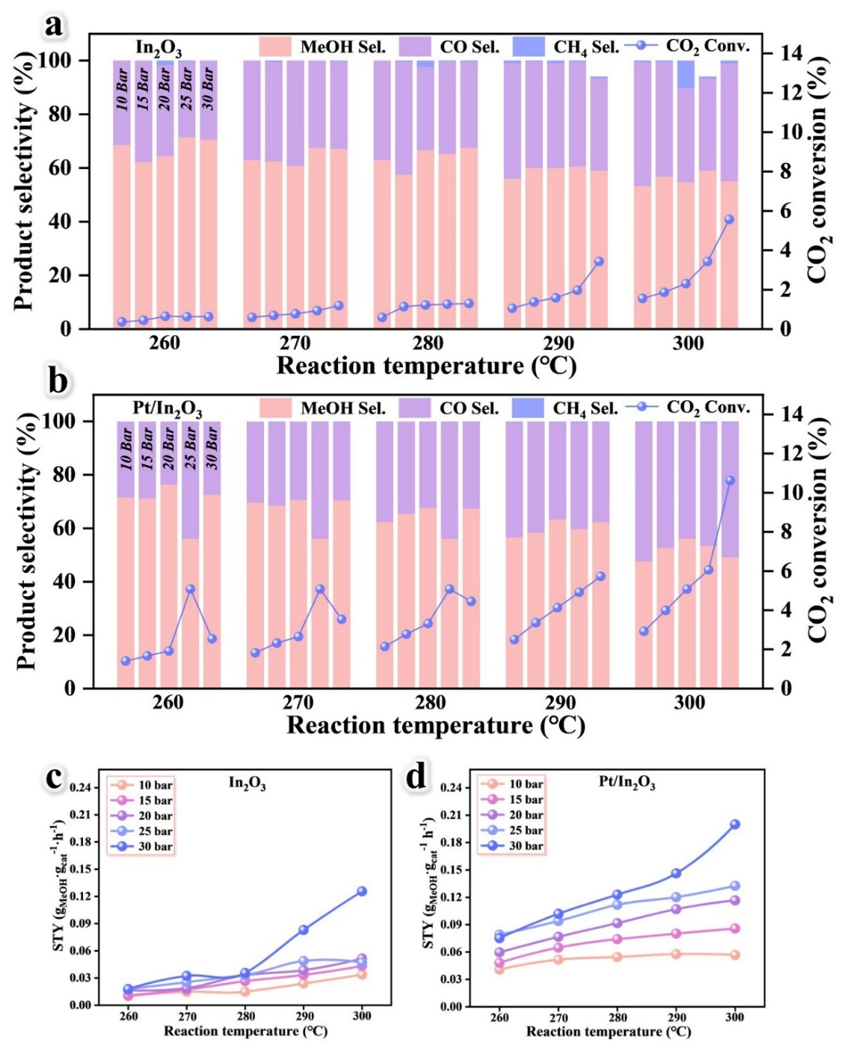
Figure S2. Product selectivity, CO₂ conversion, and space time yield of methanol (STY_{MeOH}) of (a, c) In₂O₃ and (b, d) Pt/In₂O₃ catalysts at different temperatures (260, 270, 280, 290, 300℃) and different pressures (10, 15, 20, 25, 30 bar). Reaction conditions: H₂/CO₂/He = 72%/24%/4%, and 12000 mL·g_{cat}⁻¹·h⁻¹.

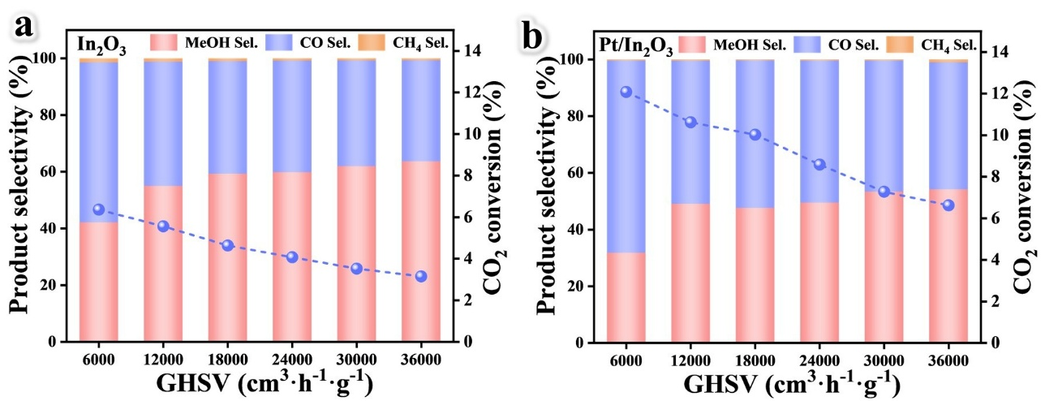
Figure S3. Product selectivity, and CO₂ conversion of (a) In₂O₃ and (b) Pt/In₂O₃ catalysts at different GHSV (6000, 12000, 18000, 24000, 30000, and 36000 mL·g_{cat}⁻¹· h⁻¹). Reaction conditions: 300℃, 3 MPa, H₂/CO₂/He = 72%/24%/4%.

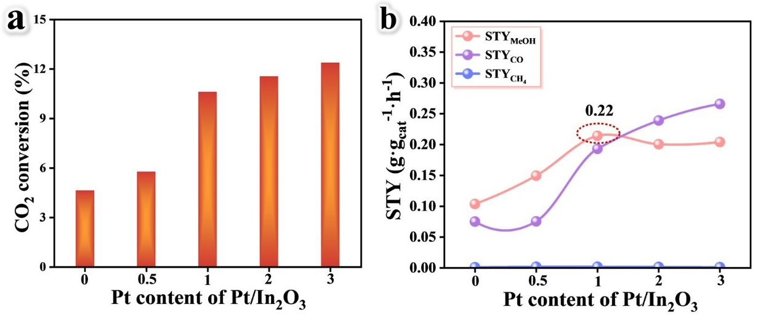
Figure S4. (a-b) Influence of different Pt loadings on the catalytic performance of Pt/In₂O₃ catalyst.

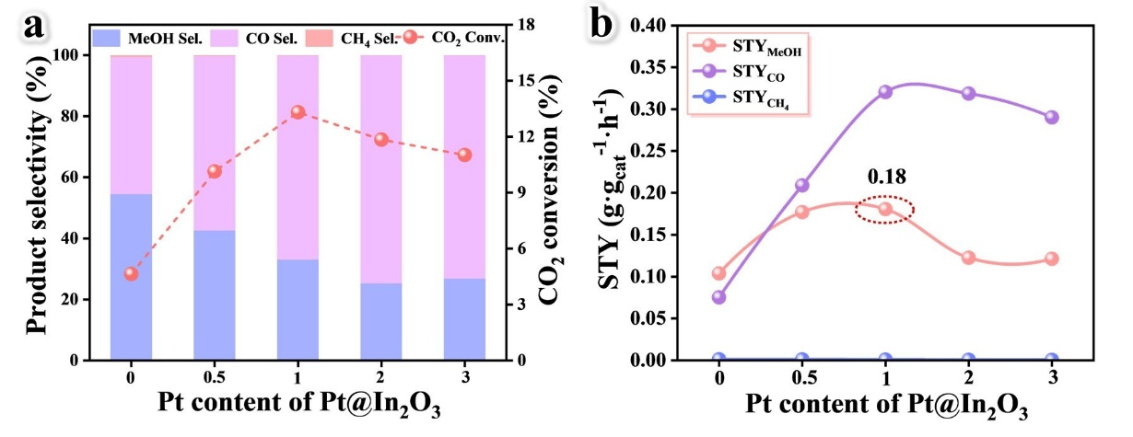
Figure S5. (a, b) Influence of different Pt loadings on the catalytic performance of Pt@In₂O₃ catalyst.
Notes: The Pt loading was controlled by varying the volume (x = 0, 0.5, 1, 2, and 3 mL) of 19.3 mM H₂PtCl₆·6H₂O aqueous solution added during catalyst preparation. Unless otherwise specified, Pt/In₂O₃ and Pt@In₂O₃ refer to catalysts prepared using 1 mL of H₂PtCl₆·6H₂O solution.

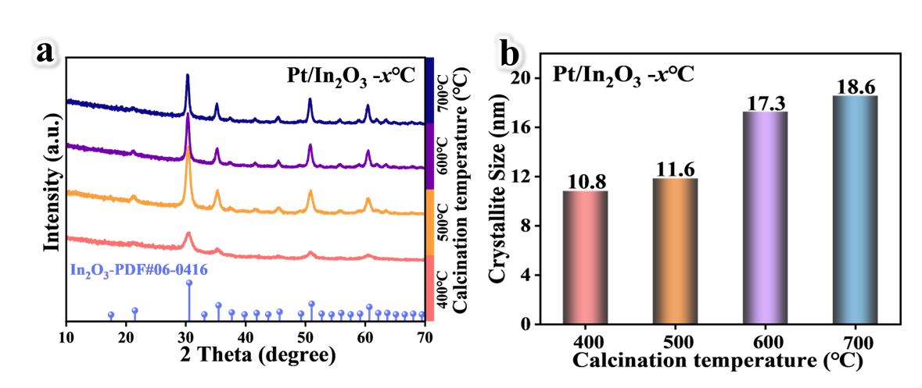
Figure S6. (a) XRD patterns, and (b) crystallite size of Pt/In₂O₃ catalysts.

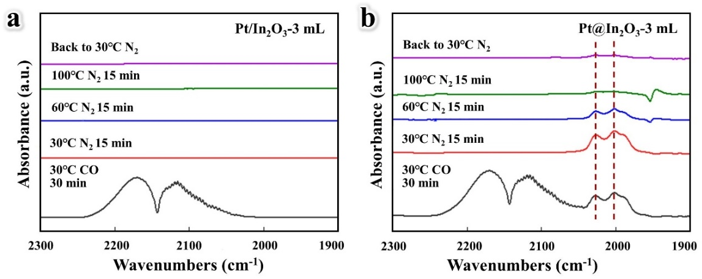
Figure S7. In-situ DRIFTS spectra of (a) Pt/In₂O₃-3 mL and (b) Pt@In₂O₃-3 mL treated by CO flow and N₂ flow.

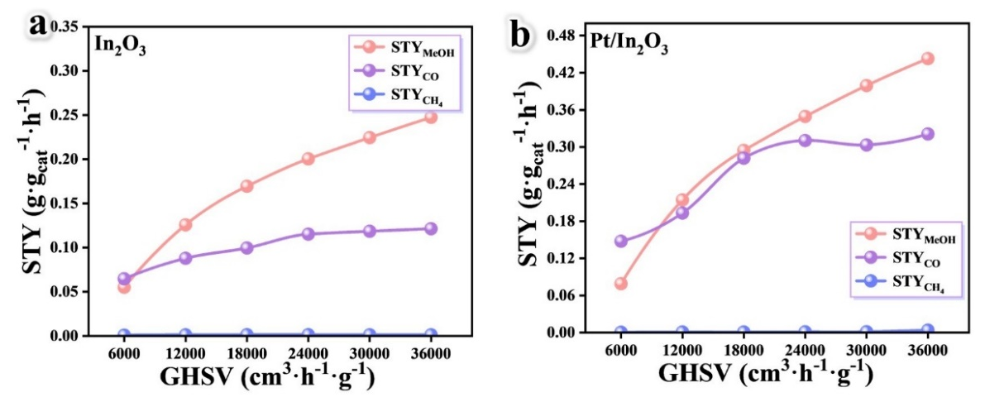
Figure S8. STY of (a) In₂O₃ and (b) Pt/In₂O₃ catalysts at different GHSV (6000, 12000, 18000, 24000, 30000, and 36000 mL·g_{cat}⁻¹·h⁻¹).
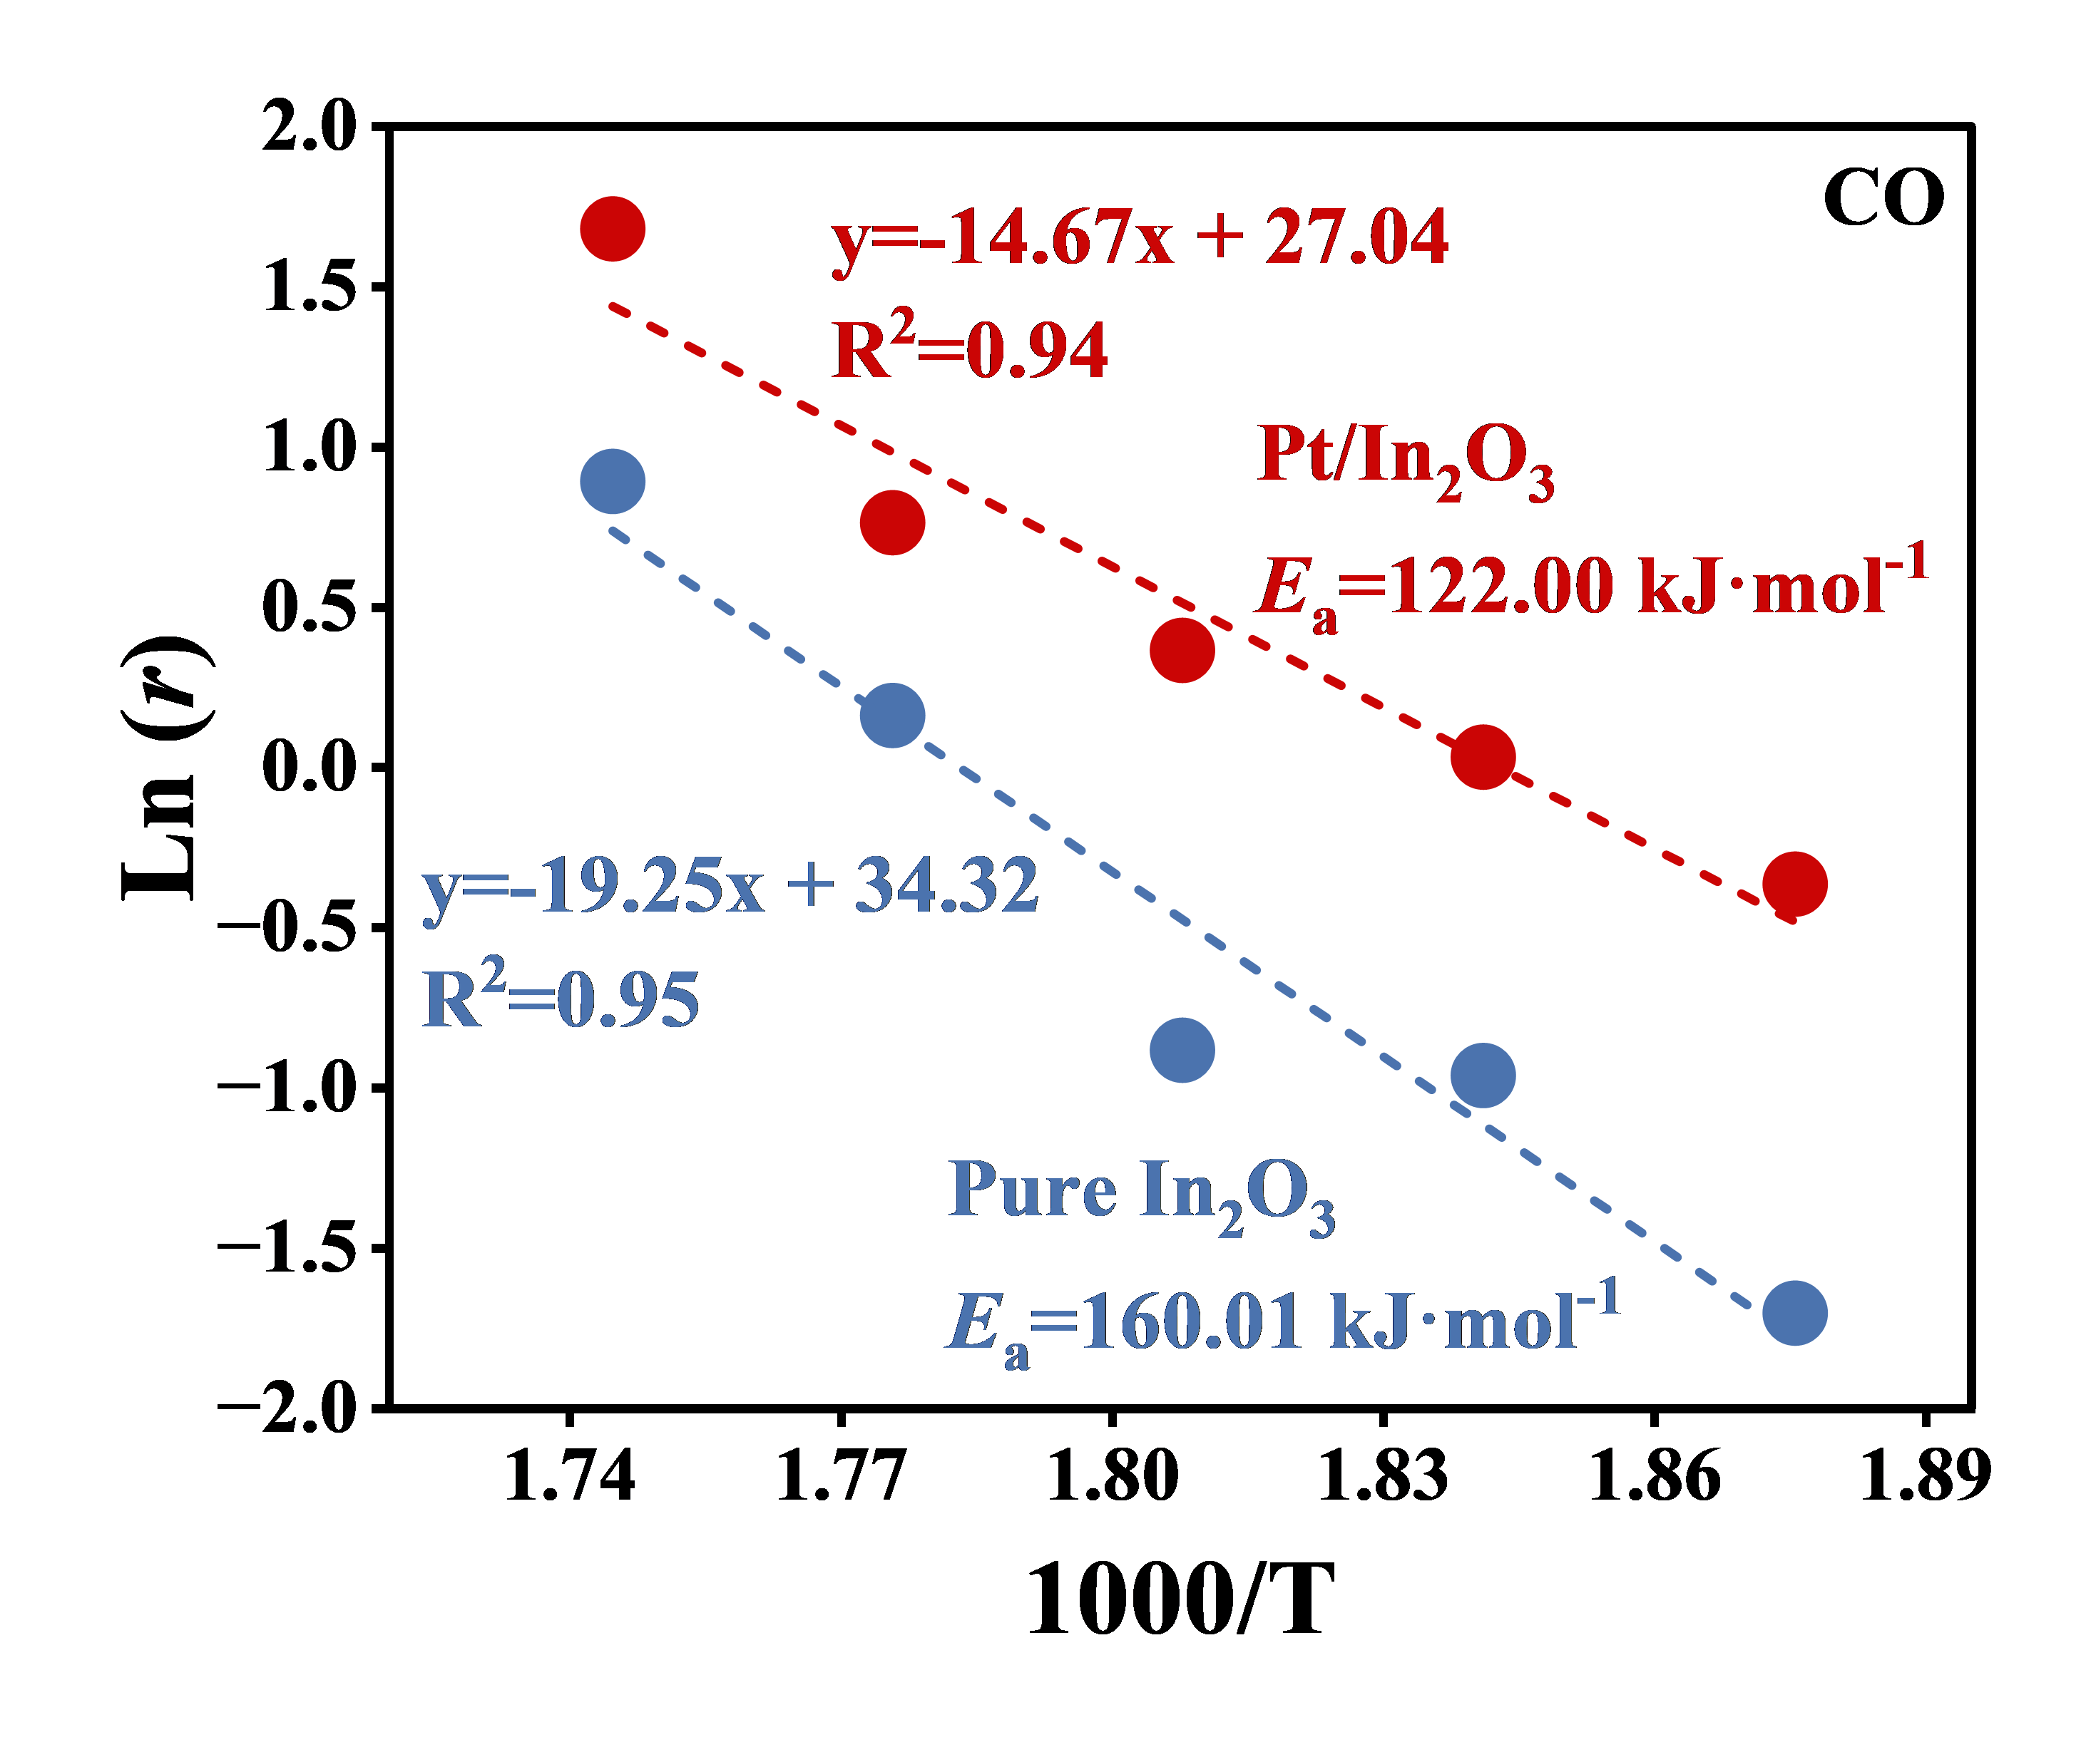
Figure S9. Arrhenius plots and activation energies of CO synthesis over Pure In₂O₃ and Pt/In₂O₃ catalysts.

Table S1. The crystallite size of different catalysts
Catalysts | Peak position/° | FWHM | Crystallite Size/nm
Pure In₂O₃ | 30.360 | 0.522 | 15.59
Pt@In₂O₃ | 30.440 | 0.517 | 15.75
Pt/In₂O₃-400 | 30.619 | 0.753 | 10.82
Pt/In₂O₃-500 | 30.459 | 0.687 | 11.85
Pt/In₂O₃-600 | 30.359 | 0.471 | 17.28
Pt/In₂O₃-700 | 30.261 | 0.438 | 18.58

Table S2. Textural properties of different catalysts.
Catalysts | Surface Area (m²·g⁻¹) | Pore diameter (nm)
MIL-68(In) | 1142.0 | 19.1
Pure In₂O₃ | 45.2 | 12.4
Ni@In₂O₃ | 38.2 | 30.8
Ni/In₂O₃ | 48.3 | 9.6

