Electronic Supplementary Material

Screening techniques as a preliminary diagnostic tool for advanced oxidative processes on a laboratory scale
Larissa Pinheiro de Souza ()¹, Flávio Olimpio Sanches-Neto^{2,3}, Júlio César de Oliveira Ribeiro^{2,5}, Bruno Ramos^{1,4}, Valter H. Carvalho-Silva², Antonio Carlos Silva Costa Teixeira ()¹
1 Research Group in Advanced Oxidation Processes (AdOx), Department of Chemical Engineering, Escola Politécnica, University of São Paulo, São Paulo 05508-010, Brazil
2 Modeling of Physical and Chemical Transformations Division, Theoretical and Structural Chemistry Group, Research and Postgraduate Center, Goiás State University, Anápolis 75132-903, Brazil
3 Instituto Federal de Educação, Ciência e Tecnologia de Goiás, Valparaíso de Goiás, 72876-601, Brazil
4 Department of Chemical Engineering, Centro Universitário da FEI, São Paulo 09850-901, Brazil
5 Chemistry Institute, Federal University of Goiás, Goiânia 74690-900, Brazil
E-mails: larissapdesouza@usp.br (de Souza L P); acscteix@usp.br (Teixeira A C S C)

1. Supplementary figures
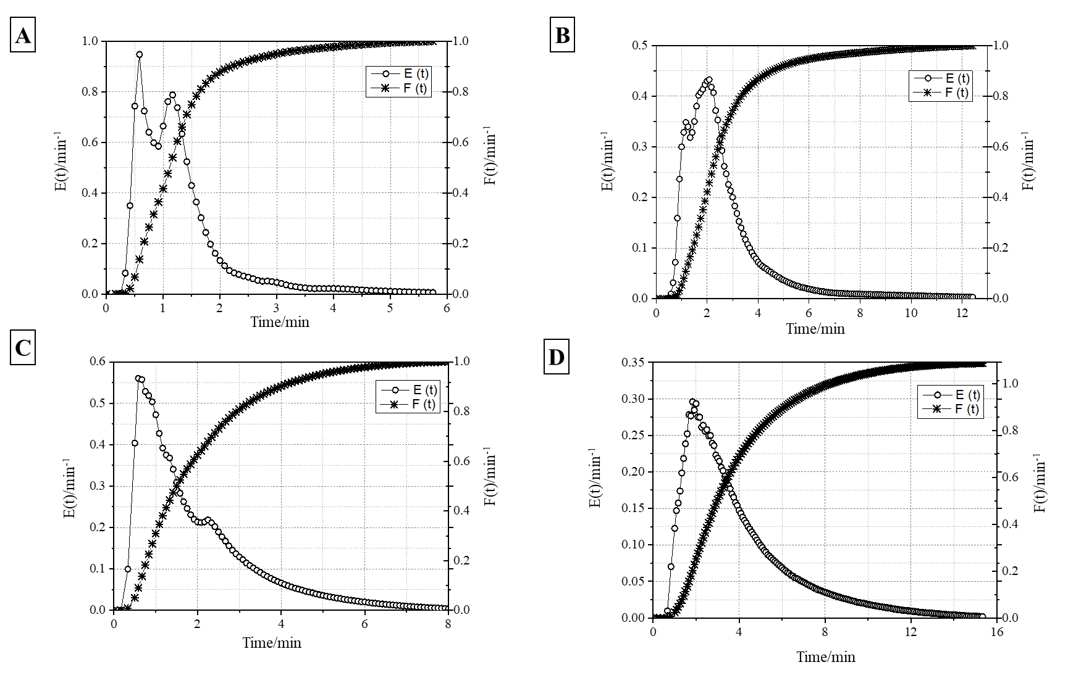
Figure S1. Exit function (E(t)) and cumulative distribution (F(t)) as a function of time for: (A) spiral reactor ($υ_{0}$= 10 mL min⁻¹); (B) spiral reactor ($υ_{0}$= 5 mL min⁻¹); (C) flat reactor ($υ_{0}$= 10 mL min⁻¹); (D) flat reactor ($υ_{0}$= 5 mL min⁻¹).

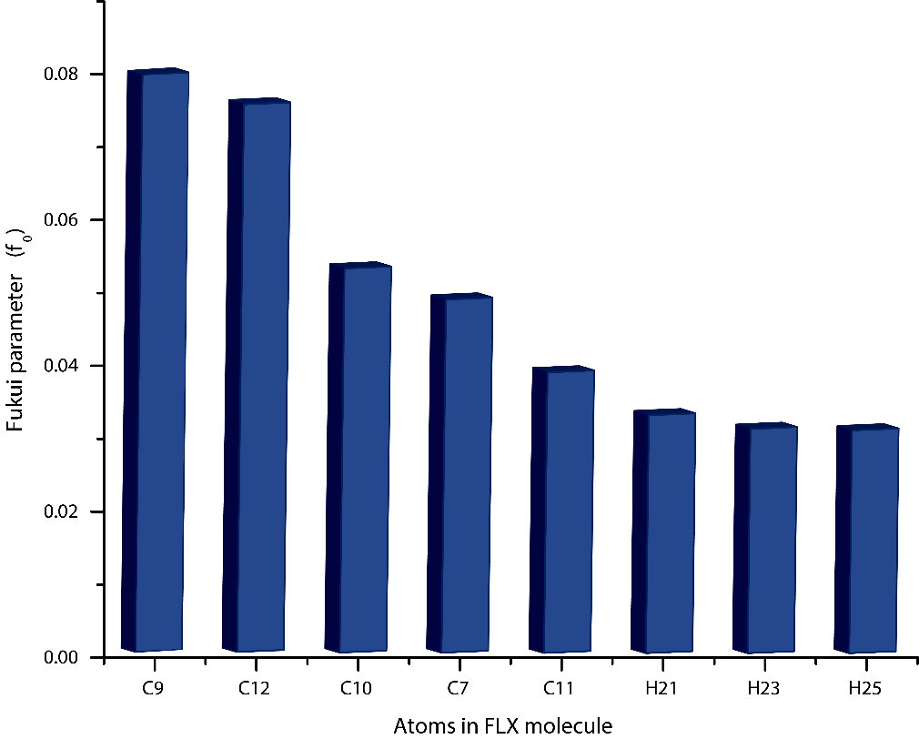
Figure S2. Fukui function ($f_{0})$ values for radical attack on selected carbon and hydrogen atoms of FLX in water.

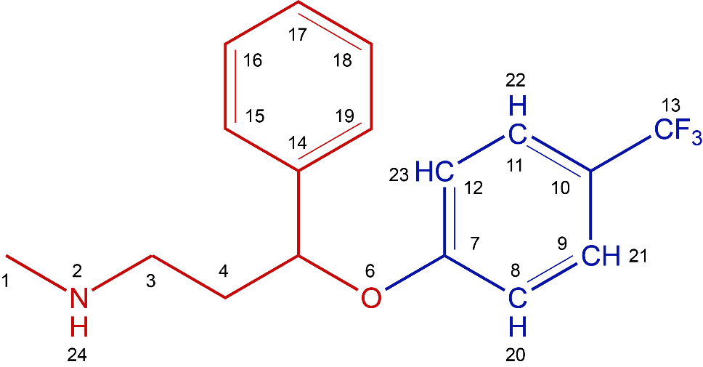
Figure S3. 2D structural scheme of the fluoxetine (FLX) molecule. Addition and abstraction reactions occur into the ring highlighted in blue.

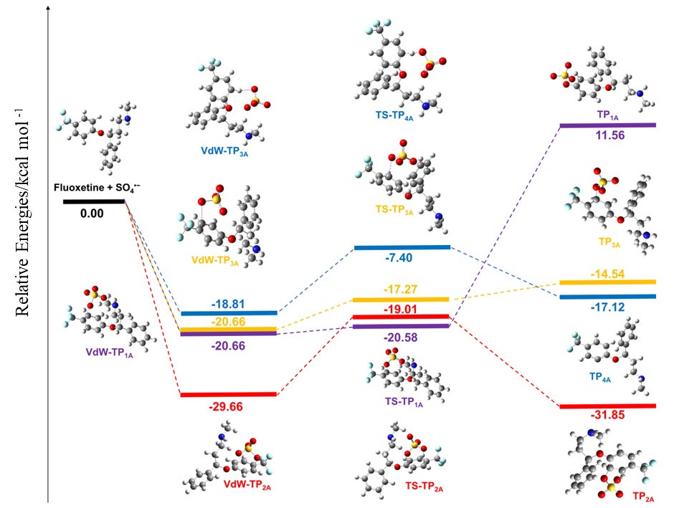

Figure S4. Schematic diagram of relative energies for the addition and H abstraction reactions of FLX with SO₄^{•−} at the M06HF/6–31+G(d) level

2. Supplementary table
Table S1. Physicochemical parameters of the effluent from the sewage treatment plant with membrane bioreactor (MBR) technology in the city of Campinas, Brazil, operated by SANASA (Sociedade de Abastecimento de Água e Saneamento SA). Samples collected on 01/17/2023.
Parameter/unit | Value
Apparent Color/mg Pt-Co L⁻¹ | 52
pH | 6.9
Temperature/°C | 29
Turbidity/NTU | 0.10
Volatile acids/mg L⁻¹ CH₃COOH | 9
Conductivity/μS cm⁻¹ | 553
BOD/mg L⁻¹ – BOD | <1
COD/mg L⁻¹ - O₂ | 34
Total phosphorus/mg L⁻¹ – P | 4.44
Phosphate/mg L⁻¹ | 13.59
Ammoniacal nitrogen/mg L⁻¹ - NH₃-N | 0.09
Nitrates Nit./mg L⁻¹ - NO₃⁻ - N | 5.55
Nitrites Nit./mg L⁻¹ - NO₂⁻ - N | <0.015
Total solids/mg L⁻¹ | 414
Total fixed solids/mg L⁻¹ | 224
Total volatile solids/mg L⁻¹ | 190
Total dissolved solids/mg L⁻¹ | 414
Fixed dissolved solids/mg L⁻¹ | 224
Volatile dissolved solids/mg L⁻¹ | 190
Total suspended solids/mg L⁻¹ | <2.5
Fixed suspended solids/mg L⁻¹ | <2.5
Volatile suspended solids/mg L⁻¹ | <2.5
Chlorides/mg L⁻¹ | 76
Total coliforms/SD-NMP 100mL⁻¹ | <1
Escherichia coli/SD-NMP 100mL⁻¹ | <1

