Electronic Supplementary Material

Enhanced formic acid production for CO₂ photocatalytic reduction over Pd/H-TiO₂ catalyst
Huimin Gao¹*, Jinpeng Zhang¹*, Fangyuan Zhang¹, Jieying Jing ()^{1,2}, Wen-Ying Li ()¹
1 State Key Laboratory of Clean and Efficient Coal Utilization, Taiyuan University of Technology, Taiyuan 030024, China
2 Shanxi-Zheda Institute of Advanced Materials and Chemical Engineering, Taiyuan 030000, China

E-mails: jingjieying@tyut.edu.cn (Jing J); ying@tyut.edu.cn (Li W-Y)
*These authors contributed equally to this work.

Figure S1. Schematic diagram of experimental device for photocatalytic reduction CO₂

Figure S2. Total HCOOH production of different catalysts in 3 h

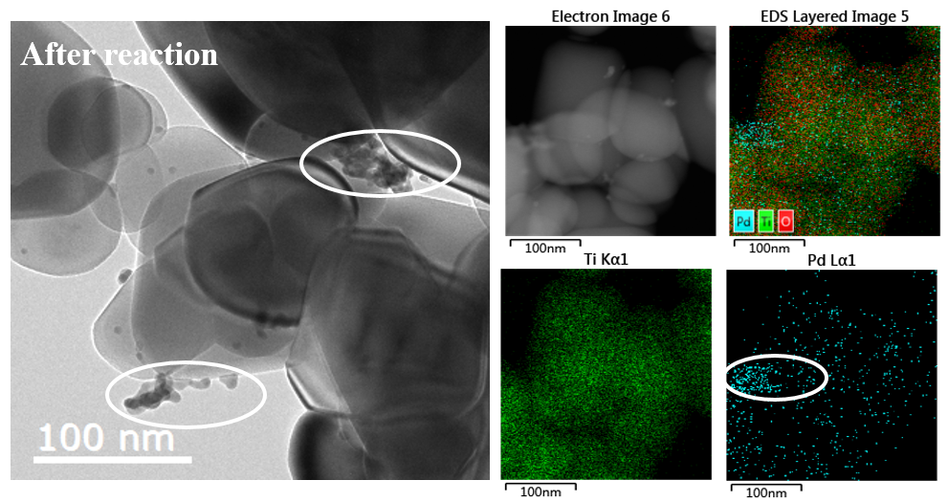
Figure S3. TEM image of Pd/H-TiO₂ catalyst after reaction
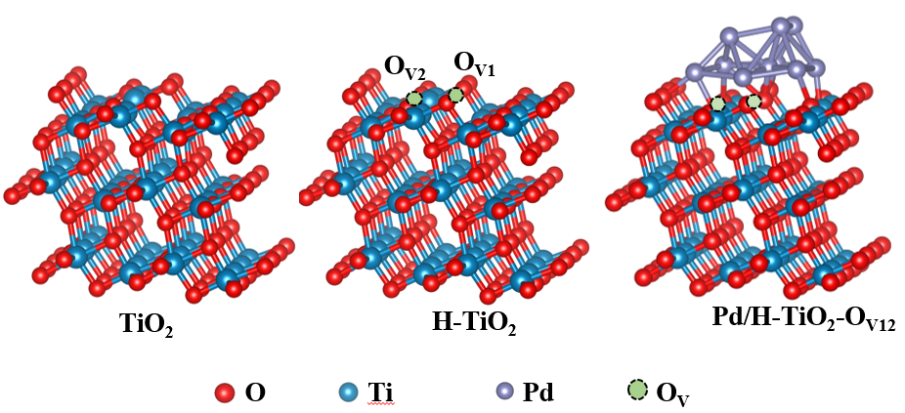
Figure S4. The models of TiO₂, H-TiO₂ and Pd/H-TiO₂

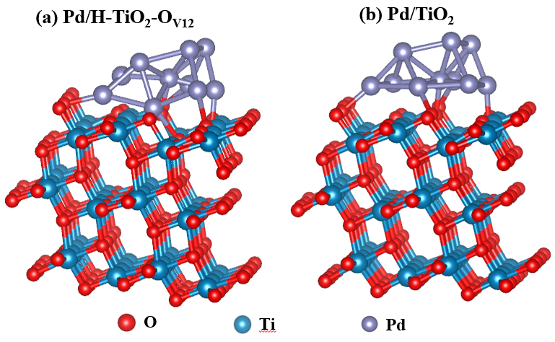
Figure S5. The models of Pd/H-TiO₂-O_{V12} and Pd/TiO₂

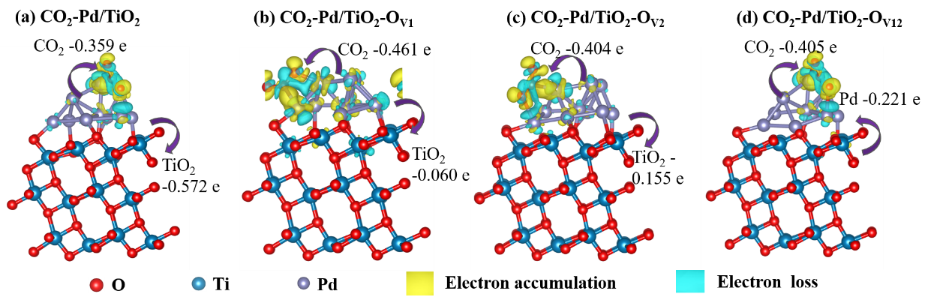
Figure S6. The charge density difference and Bader charge analysis of models with CO₂ adsorption Pd-TiO₂ with/without O_{V}. Yellow and cyan represent the electron accumulation and loss, respectively (isosurfaces = 0.0002 e/Bohr³). Note: This section studies the charge transfer between CO₂ and Pd/H-TiO₂.

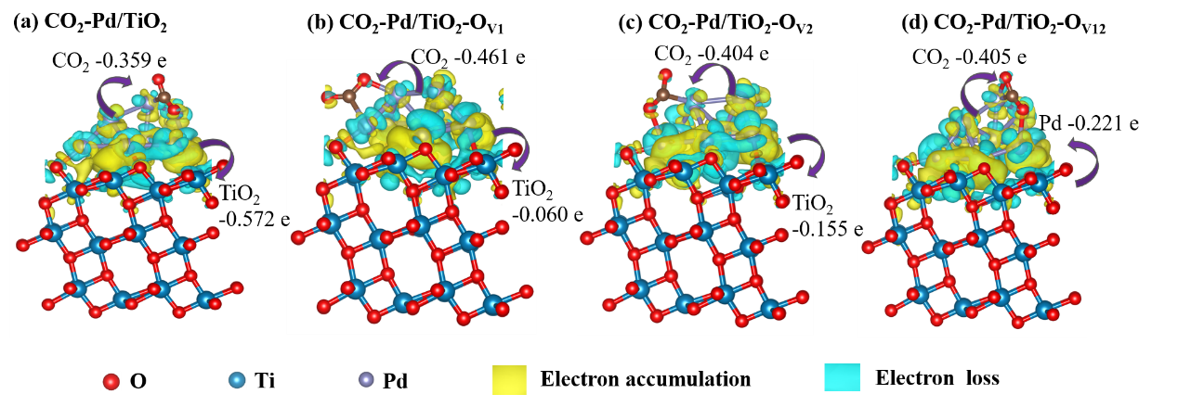
Figure S7. The charge density difference and Bader charge analysis of models with CO₂ adsorption Pd-TiO₂ with/without O_{V}. Yellow and cyan represent the electron accumulation and loss, respectively (isosurfaces = 0.0002 e/Bohr³). Note: This section studies the charge transfer between CO₂-Pd and H-TiO₂.

Figure S8. Thermal infrared image of Pd/H-TiO₂ in ultraviolet irradiation process

Figure S9. Performance of photocatalytic CO₂ reduction with different carbon sources as raw materials.

Table S1. The physical characteristics of the noble-loaded and unloaded mesoporous TiO₂ sanmples.
Catalyst | Theoretical (wt%) | Actual load (wt%)ª | Crystallite size (nm) ^{b} | CO₂ adsorption / mmol/g
TiO₂ | - | - | 39.8 | 0.09
H-TiO₂ | - | - | 38.2 | 0.13
1 wt%Pd/H-TiO₂ | 1.00 | 1.06 | 39.0 | 0.18
ª The Pd loading amount was measured by ICP-OES;
^{b} Estimated according to the Scherrer’s formula.

Table S2. The selected results for photocatalytic CO₂ reduction in recent literature
Catalyst | Pressure (MPa) | Catalyst amount (mg) | HCOOH production rate (mmol·g⁻¹·h⁻¹) | Selectivity (%) | Ref.
Pd/H-TiO₂ | 2.0 | 40 | 14.14 | 100 | This work
Cu@Cu₂O | 0.1 | 10 | 0.067 | 100% | ^{[1]}
Cu₂O/TiO₂ | 0.1 | 30 | 5.240 | 99.67 | ^{[2]}
3% Cu/TiO₂ | 0.14 | - | 0.026 | 90.1 | ^{[3]}
ABU-Co | 0.1 | - | 3.452 | 99% | ^{[4]}
Cu/TiO₂ | 0.1 | 60 | 4.03 | - | ^{[5]}
Pd/TiO₂ | 3.0 | 20 | 0.23 | 58.5% | ^{[6]}

Table S3. The amount of charge transferred between substances in different systems.
 | Model | CO₂(Δq) | Pd(Δq) | TiO₂(Δq)
CO₂-TiO₂ | CO₂-TiO₂ | -0.120 | - | +0.120
CO₂-TiO₂ | CO₂-TiO_{2-x}-v1 | -0.127 | - | +0.127
CO₂-TiO₂ | CO₂-TiO_{2-x}-v2 | -0.170 | - | +0.170
CO₂-TiO₂ | CO₂-TiO_{2-x}-v12 | -0.178 | - | +0.178
Pd/H-TiO₂ | Pd-TiO₂ | - | +0.597 | -0.597
Pd/H-TiO₂ | Pd-TiO_{2-x}-v1 | - | +0.156 | -0.156
Pd/H-TiO₂ | Pd-TiO_{2-x}-v2 | - | -0.035 | +0.035
Pd/H-TiO₂ | Pd-TiO_{2-x}-v12 | - | -0.302 | +0.302
CO₂-Pd/H-TiO₂ | CO₂-Pd-TiO₂ | -0.359 | +0.931 | -0.572
CO₂-Pd/H-TiO₂ | CO₂-Pd-TiO_{2-x}-v1 | -0.461 | +0.521 | -0.06
CO₂-Pd/H-TiO₂ | CO₂-Pd-TiO_{2-x}-v2 | -0.404 | +0.249 | -0.155
CO₂-Pd/H-TiO₂ | CO₂-Pd-TiO_{2-x}-v12 | -0.405 | -0.221 | +0.626

References
[1] Wang H, Cheng S J, Cai X, et al. Photocatalytic CO₂ reduction to HCOOH over core-shell Cu@Cu₂O catalysts[J]. Catalysis Communications, 2022, 162: 106372.
[2] Zhu Q H, Deng Z S, Xie H J, et al. Investigation of concerted proton-electron donors for promoting the selective production of HCOOH in CO₂ photoreduction[J]. Acs Catalysis, 2023, 13(5): 3254-3262.
[3] Gonell F, Puga A V, Julián-López B, et al. Copper-doped titania photocatalysts for simultaneous reduction of CO₂ and production of H₂ from aqueous sulfide[J]. Applied Catalysis B-Environmental, 2016, 180: 263-270.
[4] Al-Dolaimy F, Kzar M H, Hussein S A, et al. Incorporating of cobalt into UiO-67 Metal-organic framework for catalysis CO₂ transformations: An efficient Bi-functional approach for CO₂ Insertion and photocatalytic reduction[J]. Journal of Inorganic and Organometallic Polymers and Materials, 2023.
[5] Peña R, Romero R, Amado-Piña D, et al. Cu/TiO₂ photo-catalyzed CO₂ chemical reduction in a multiphase capillary reactor[J]. Topics in Catalysis, 2023.
[6] Jin B B, Ye X, Zhong H, et al. Light-Driven hydrogenation of bicarbonate into formate over nano-Pd/TiO₂[J]. Acs Sustainable Chemistry & Engineering, 2020, 8(17): 6798-6805.

