Electronic Supplementary Material
The role of Li₂CO₃ promoter and steam in increasing C₂H₄/C₂H₆ selectivity in chemical looping oxidative coupling of CH₄ over Mn-Na₂WO₄/Support catalysts

Jianshu Li^{1,2}*, Juan Chen^{1,2}*, Anna Zanina², Vita A. Kondratenko², Henrik Lund², Wen Jiang¹, Hanyang Zhou¹, Yuming Li¹, Guiyuan Jiang ()¹, Evgenii V. Kondratenko ()²

1 State Key Laboratory of Heavy Oil Processing, China University of Petroleum Beijing, Beijing 102249, China
2 Leibniz Institut für Katalyse e.V., 18059 Rostock, Germany

E-mails: jianggy@cup.edu.cn (Jiang G); evgenii.kondratenko@catalysis.de (Kondratenko E V)

*These authors contributed equally to this work.

Figure S1. XRD patterns of the Mn-Na₂WO₄/Support catalysts with (red lines) and without (black lines) Li₂CO₃. Identified phases: Li₂(Si₂O₅) Monoclinic (PDF-No. 01-072-0102), SiO₂ Hexagonal (PDF-No. 01-087-2096), Na₂WO₄ (PDF-No. 01-084-6510), MnWO₄ (PDF-No. 01-080-0133), LiAlSiO₄ Hexagonal (PDF-No. 01-070-1574), LiAl(Si₂O₆) Hexagonal (PDF-No. 01-073-2336), LiAl(Si₂O₆) Tetragonal (PDF-No. 01-071-2058), Mn₇SiO₁₂ (PDF-No. 01-071-1791), Li₂WO₄ Tetragonal (PDF-No. 01-071-1735), TiO₂ (PDF-No. 01-077-0440), Mn₂O₃ (PDF-No. 01-078-0390), (Li_{0.84}Mn_{0.16})(Li_{0.16}TiMn_{0.84})O₂ (PDF-No. 01-075-7715), CeO₂ (PDF-No. 01-080-8533), Li₂MnO₃ (PDF-No. 01-078-5048).

Figure S2. The selectivity to CO versus CH₄ conversion over (a) SiO₂-, (b) AlSiO_{x}-, (c) CeO₂-or (d) TiO₂-supported MnNa₂WO₄-based catalysts prepared with and without Li₂CO₃. Reaction conditions: T = 850 °C , single pulsing of CH₄/H₂O/Ar =40/55/5, catalyst amount: 50-400 mg.

Figure S3. The selectivity to CO₂ versus CH₄ conversion over (a) SiO₂-, (b) AlSiO_{x}-, (c) CeO₂-or (d) TiO₂-supported MnNa₂WO₄-based catalysts prepared with and without Li₂CO₃. Reaction conditions: T = 850 °C , single pulsing of CH₄/H₂O/Ar =40/55/5, catalyst amount: 50-400 mg.

Figure S4. The sum of C₂-hydrocarbons selectivity and CH₄ conversion versus CH₄ conversion over (a) SiO₂-, (b) AlSiO_{x}-, (c) CeO₂-or (d) TiO₂-supported MnNa₂WO₄-based catalysts prepared with and without Li₂CO₃. Reaction conditions: T = 850 °C, single pulsing of CH₄/H₂O/Ar =40/55/5, catalyst amount: 50-400 mg.

Figure S5 CH₄ conversion over the Mn-Na₂WO₄/Support catalysts prepared with and without Li₂CO₃. Reaction conditions: single pulsing of CH₄/H₂O/Ar = 40/30/30; 300 mg of catalyst; T = 850 °C.

Figure S6. XRD patterns of the M₂CO₃-Mn-Na₂WO₄/AlSiO_{x} (M = Li, Na, K) catalysts. Identified phases: LiAl(Si₂O₆) Hexagonal (PDF-No. 01-073-2336), LiAl(Si₂O₆) Tetragonal (PDF-No. 01-071-2058), Mn₇SiO₁₂ (PDF-No. 01-071-1791), MnWO4 (PDF-No. 01-080-0133), Li₂WO₄ Tetragonal (PDF-No. 01-071-1735), NaAlSiO₄ (PDF-No. 00-035-0424), KAlSiO₄ (PDF-No. 00-066-0070).

Figure S7. CL-OCM performance of Li₂CO₃-MnNa₂WO₄/AlSiO_{x} and LiNO₃-MnNa₂WO₄/AlSiO_{x} with the same Li loading. Reaction conditions: T = 850 °C, single pulsing of CH₄/H₂O/Ar =40/55/5, catalyst amount: 300 mg.

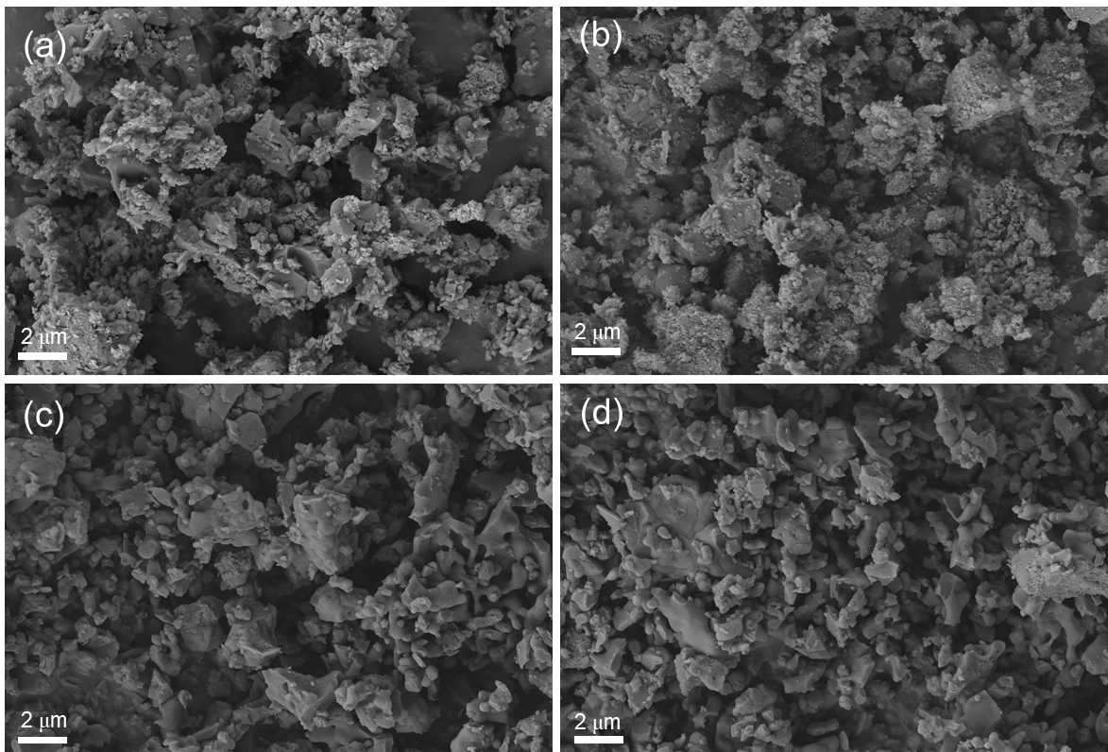
Figure S8. SEM images of (a) Mn-Na₂WO₄/AlSiO_{x}, (b) 5Li₂CO₃-Mn-Na₂WO₄/AlSiO_{x}, (c) 10Li₂CO₃-Mn-Na₂WO₄/AlSiO_{x}, and (d) 20Li₂CO₃-Mn-Na₂WO₄/AlSiO_{x},

Figure S9. (a) Methane conversion and (b) selectivity to C₂-hydrocarbons over XLi₂CO₃-Mn-Na₂WO₄/AlSiO_{x} (X =0,5,10,20 wt%). Reaction conditions: T = 850 °C, single pulsing of CH₄/H₂O/Ar =40/55/5, catalyst amount: 200 mg.

Figure S10. XRD patterns of the xLi₂CO₃-Mn-Na₂WO₄/Siral70 (x =0,5,10,20 wt%) catalysts. Identified phases: MnWO₄ (PDF-No. 01-080-0133), LiAl(Si₂O₆) Hexagonal (PDF-No. 01-073-2336), LiAl(Si₂O₆) Tetragonal (PDF-No. 01-071-2058), Mn₇SiO₁₂ (PDF-No. 01-071-1791), Li₂WO₄ Tetragonal (PDF-No. 01-071-1735).
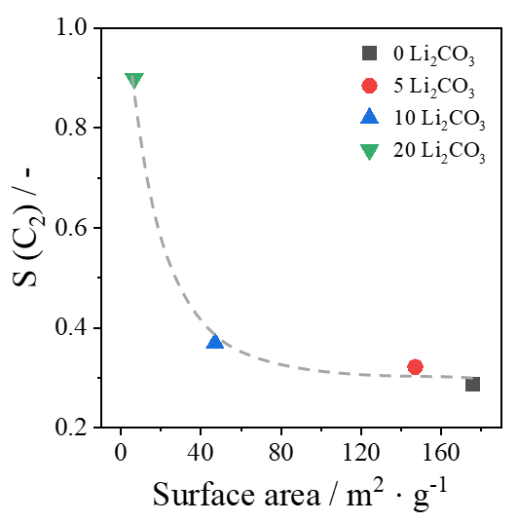
Figure S11. A correlation between the selectivity to C₂-hydrocarbons and the BET surface area of XLi₂CO₃-Mn-Na₂WO₄/AlSiO_{x} (X =0,5,10,20 wt%) catalysts.

Figure S12. (a) Effect of water content on methane conversion over Li₂CO₃-Mn-Na₂WO₄/AlSiO_{x}, (b) methane conversion obtained over the Li₂CO₃-Mn-Na₂WO₄/AlSiO_{x} catalyst used in the CL-OCM reaction with or without treatment in in H_{2.} Reaction conditions: single pulsing of CH₄/H₂O/Ar =40/(0-55)/(5-60); 300 mg of catalyst; T = 850°C.
Figure S13. XRD patterns of fresh and spent (after 90 CH4/air cycles) Li₂CO₃-Mn-Na₂WO₄/AlSiO_{x} catalyst samples.

Figure S14. (a) CO₂ profiles obtained during temperature-programmed oxidation (TPO) of fresh and spent (after 90 CH4/air cycles) Li₂CO₃-Mn-Na₂WO₄/AlSiO_{x} catalyst samples and (b) the corresponding amounts of CO₂ determined from the TPO tests in (a).

Table S1. A survey of supported OCM catalysts exhibiting C₂₊-hydrocarbons selectivity above 80% at methane conversion above 10% in the reported literature.
Catalysts | Contact time  / g·s·mL⁻¹ | CH₄:O₂ | X(CH₄)  / % | S(C₂₊-hydrocarbons)  / % | S(C₂H₄)  / % | Ref.
Li/MgO | 0.23 | 9.6 | 16.3 | 84 |  | [1]
Li/MgO | 0.23 | 9.6 | 15.4 | 83 |  | [2]
Li/MgO | 0.45 | 10 | 12 | 80 |  | [3]
Li/MgO | 0.45 | 10 | 16 | 85 |  | [3]
BaCO₃/Al₂O₃ | 0.05 | 19 | 10.5 | 84 | 27 | [4]
Sr-MgO | 0.05 | 19 | 10.3 | 83 | 31 | [4]
Ba-MgO | 0.05 | 19 | 10.3 | 83 | 31 | [4]
Sm-Ba-MgO | 0.05 | 19 | 10.2 | 82 |  | [4]
Ba-Ga₂O₃ |  | 8 | 11 | 89.9 |  | [5]
Na/CaO | 0.6 | 9 | 17 | 80 |  | [6]
Na/CaO | 0.2 | 9.9 | 13.7 | 80 | 36 | [7]
Li₂CaSiO₄ | 1.8 | 7 | 17 | 80 |  | [8]
SnBaTiO₃ | 0.21 | 4 | 20.77 | 84.36 |  | [9]
PbO_{x}/Na₄P₂O₇ | 6.43 | 5 | 11 | 80 |  | [10]
10%BaF₂/LaOF | 0.24 | 6 | 19.53 | 81.2 | 41.22 | [11]
10%BaF₂/LaOF | 0.24 | 9 | 16.54 | 84.55 | 23.48 | [11]
SrCO₃/La₂O₂CO₃ | 0.18 | 10.1 | 15.3 | 79.2 | 57.3 | [12]
SrO/La₂O₃/SA-5205 | 0.04 | 15.9 | 12.5 | 80.7 | 31.5 | [13]
La₂O₃/SrO/SA-5205 | 0.04 | 15.9 | 12.5 | 85.9 | 31.4 | [13]
Nd₂O₃/SrO/SA-5205 | 0.04 | 15.9 | 11.1 | 81.7 | 30.3 | [13]
Na₂WO₄/SiO₂ | 1.2 | 2.5 | 13.4 | 81 | 50 | [14]
Mn/Na₂WO₄/MgO | 0.52 | 7.3 | 20 | 80 |  | [15]
Mn/Na₂WO₄/SiO₂ | 1.33 | 4.6 | 33 | 80 | 50 | [16]
Mn/Na₂WO₄/SiO₂ | 0.22 | 7.5 | 20 | 80 | 46 | [17]
1% Mn/Na₂WO₄/SiO₂ | 0.22 | 7.3 | 22 | 81 |  | [18]
Mn−Na₂WO₄/SiO₂ |  | 4 | 20 | 81 |  | [19]
Mn−Na₂WO₄/SiO₂ |  | 2.5 | 24.6 | 80.6 |  | [20]
Mn−Na₂WO₄/SiO₂ |  | 3 | 19.8 | 84.3 |  | [20]
Mn−Na₂WO₄/SiO₂ |  | 4 | 15.9 | 86.2 |  | [20]
Mn−Na₂WO₄/SiO₂ | 0.15 | 5 | 22.3 | 82.8 |  | [21]
Mn−Na₂WO₄/SiO₂ | 0.15 | 10 | 15 | 85.1 |  | [21]
Mn−Na₂WO₄/SiO₂ | 0.15 | 10 | 12.7 | 86.9 |  | [21]
Mn−Na₂WO₄/SiO₂ |  |  | 18 | 89 |  | [22]
Mn−Na₂WO₄/SiO₂ |  |  | 21 | 87 |  | [22]
Mn−Na₂WO₄/SiO₂ |  |  | 19 | 87 |  | [22]
Mn−Na₂WO₄/SiO₂ |  |  | 13.2 | 93.8 |  | [23]
Mn−Na₂WO₄/SiO₂ |  |  | 16.6 | 92.5 |  | [23]
Mn−Na₂WO₄/SiO₂ |  |  | 21.2 | 87.6 |  | [23]
Li–W–Mn/SiO₂ | 0.07 | 2 | 11 | 82 | 30 | [24]
Li–W–Mn/SiO₂ | 0.07 | 3.2 | 15 | 85 | 36 | [24]
K–W–Mn/SiO₂ | 0.07 | 4.6 | 20 | 88 | 46 | [24]
Li₂CO₃-Mn−Na₂WO₄/SiO₂ |  |  | 10.8 | 95.4 | 56.2 | This work
Li₂CO₃-Mn−Na₂WO₄/SiO₂ |  |  | 11.4 | 93 | 55.4 | This work
Li₂CO₃-Mn−Na₂WO₄/Siral70 |  |  | 13.6 | 91.3 | 55.7 | This work
Li₂CO₃-Mn−Na₂WO₄/Siral70 |  |  | 19 | 89 | 59.5 | This work

Reference
1. Korf S J, Roos J A, De Bruijn N A, Van Ommen J G, Ross J R H. Lithium chemistry of lithium doped magnesium oxide catalysts used in the oxidative coupling of methane. Applied Catalysis, 1990, 58(1): 131-146
2. Korf S J, Roos J A, Derksen J W H C, Vreeman J A, Van Ommen J G, Ross J R H. Oxidative coupling of methane over Ba/CaO catalysts: A comparison with Li/MgO. Applied Catalysis, 1990, 59(1): 291-309
3. Hoogendam G C, Seshan K, van Ommen J G, Ross J R H. Oxidative coupling of methane over doped Li/MgO catalysts. Catalysis Today, 1994, 21(2): 333-340
4. Maitra A M. Solid-state basicity as a guide to formulation of improved catalysts for oxidative coupling of methane: I. Performance evaluation. Applied Catalysis A: General, 1994, 114(1): 65-81
5. Wu K, Zanina A, Kondratenko V A, Xu L, Li J, Chen J, Lund H, Bartling S, Li Y, Jiang G, Kondratenko E V. Fundamentals of Unanticipated Efficiency of Gd₂O₃-based Catalysts in Oxidative Coupling of Methane. Angewandte Chemie International Edition, 2024, 63(14): e202319192
6. Déchamp N, Gamez A, Perrard A, Gallezot P. Kinetics of glucose hydrogenation in a trickle-bed reactor. Catalysis Today, 1995, 24(1): 29-34
7. Machocki A, Jezior R. Oxidative coupling of methane over a sodium-calcium oxide catalyst modified with chloride ions. Chemical Engineering Journal, 2008, 137(3): 643-652
8. Matsumoto T, Saito M, Ishikawa S, Fujii K, Yashima M, Ueda W, Motohashi T. High Catalytic Activity of Crystalline Lithium Calcium Silicate for Oxidative Coupling of Methane Originated from Crystallographic Joint Effects of Multiple Cations. ChemCatChem, 2020, 12(7): 1968-1972
9. Yaghobi N, Ghoreishy M H R. Oxidative coupling of methane in a fixed bed reactor over perovskite catalyst: A simulation study using experimental kinetic model. Journal of Natural Gas Chemistry, 2008, 17(1): 8-16
10. Machocki A, Denis A, Borowiecki T, Barcicki J. Promotion of methane conversion catalysts into higher hydrocarbons. Applied Catalysis, 1991, 72(2): 283-294
11. Chao Z S, Zhou X P, Wan H L, Tsai K R. Methane oxidative coupling on BaF₂LaOF catalyst. Applied Catalysis A: General, 1995, 130(2): 127-133
12. Mimoun H, Robine A, Bonnaudet S, Cameron C J. Oxypyrolysis of natural gas. Applied Catalysis, 1990, 58(1): 269-280
13. Choudhary V R, Mulla S A R, Uphade B S. Oxidative coupling of methane over alkaline earth oxides deposited on commercial support precoated with rare earth oxides. Fuel, 1999, 78(4): 427-437
14. Yan Q J, Wang Y, Jin Y S, Chen Y. Methane oxidative coupling over Na₂WO₄/SiO₂. Catalysis Letters, 1992, 13(3): 221-228
15. Wang D J, Rosynek M P, Lunsford J H. Oxidative Coupling of Methane over Oxide-Supported Sodium-Manganese Catalysts. Journal of Catalysis, 1995, 155(2): 390-402
16. Palermo A, Holgado Vazquez J P, Lee A F, Tikhov M S, Lambert R M. Critical influence of the amorphous silica-to-cristobalite phase transition on the performance of Mn/Na₂WO₄/SiO₂ catalysts for the oxidative coupling of methane. Journal of Catalysis, 1998, 177(2): 259-266
17. Malekzadeh A, Khodadadi A, Abedini M, Amini M, Bahramian A, Dalai A K. Correlation of electrical properties and performance of OCM MOx/Na₂WO₄/SiO₂ catalysts. Catalysis Communications, 2001, 2(8): 241-247
18. Malekzadeh A, Abedini M, Khodadadi A A, Amini M, Mishra H K, Dalai A K. Critical Influence of Mn on Low-Temperature Catalytic Activity of Mn/Na₂WO₄/SiO₂ Catalyst for Oxidative Coupling of Methane. Catalysis Letters, 2002, 84(1): 45-51
19. Godini H R, Gili A, Görke O, Simon U, Hou K, Wozny G. Performance Analysis of a Porous Packed Bed Membrane Reactor for Oxidative Coupling of Methane: Structural and Operational Characteristics. Energy & Fuels, 2014, 28(2): 877-890
20. Godini H R, Xiao S, Kim M, Holst N, Jašo S, Görke O, Steinbach J, Wozny G. Experimental and model-based analysis of membrane reactor performance for methane oxidative coupling: Effect of radial heat and mass transfer. Journal of Industrial and Engineering Chemistry, 2014, 20(4): 1993-2002
21. Uzunoglu C, Leba A, Yildirim R. Oxidative coupling of methane over Mn-Na₂WO₄ catalyst supported by monolithic SiO₂. Applied Catalysis A: General, 2017, 547(22-29
22. Fleischer V, Littlewood P, Parishan S, Schomäcker R. Chemical looping as reactor concept for the oxidative coupling of methane over a Na₂WO₄/Mn/SiO₂ catalyst. Chemical Engineering Journal, 2016, 306(646–654
23. Zhao K, Gao Y, Wang X, Lis B M, Liu J, Jin B, Smith J, Huang C, Gao W, Wang X, Wang X, Zheng A, Huang Z, Hu J, Schömacker R, Wachs I E, Li F. Lithium carbonate-promoted mixed rare earth oxides as a generalized strategy for oxidative coupling of methane with exceptional yields. Nature Communications, 2023, 14(1): 7749
24. Dedov A G, Nipan G D, Loktev A S, Tyunyaev A A, Ketsko V A, Parkhomenko K V, Moiseev I I. Oxidative coupling of methane: Influence of the phase composition of silica-based catalysts. Applied Catalysis A: General, 2011, 406(1): 1-12

