Electronic Supplementary Material

Amine-functionalized metal-organic frameworks loaded with Ag nanoparticles for cycloaddition of CO₂ to epoxides
Huiyu Fu, Jiewen Wu, Changhai Liang (), Xiao Chen ()
State Key Laboratory of Fine Chemicals & Laboratory of Advanced Materials and Catalytic Engineering, School of Chemical Engineering, Dalian University of Technology, Dalian 116024, China.

E-mails: xiaochen@dlut.edu.cn (Chen X); changhai@dlut.edu.cn (Liang C)

Catalyst characterization
Powder X-ray diffraction (PXRD) analyses of samples were recorded on a Rigaku D/Max-RB diffractometer equipped with a Cu Kα1 monochromatized radiation source (λ=1.541Å) with a scanning rate of 10 º/min. The Fourier transform infrared (FT-IR) spectra of the samples were tested using Thermo Fisher Nicolet iS50 in the range of 400 cm⁻¹ to 4000 cm⁻¹. The morphology of the samples was analyzed using a Hitachi High-Tech cold-field scanning electron microscope (SEM) SU8220 with a test voltage of 5 kV and a current of 10 μA. Transmission electron microscopy (TEM) images and elemental mapping were obtained by adopting the aberration-corrected microscope operating at 200 kV. The metal content was determined by inductively coupled plasma-optical emission spectrometry (ICP-OES: Thermo Fisher iCAP PRO). The BET surface area and pore structure of samples were determined by N₂ adsorption-desorption measurements on a Quantachrome Autosorb iQ automated gas sorption analyzer. Samples were uniformly degassed at 200 °C for 3 h in advance of testing. CO₂ Physical Adsorption Properties of Materials (273 K and 298 K) tested with Kantar Instruments Autosorb-IQ2 (USA). The samples had to be dried in a vacuum oven at 120 °C for 24 h before the test. X-ray photoelectron spectroscopy (XPS) analyses were conducted on Thermo Escalab Xi⁺. ¹H NMR spectra were recorded on a Bruker Avance II 400 nuclear magnetic resonance instrument.
The preparation process of Ag/UiO-66-NH₂
0.0167 g of AgNO₃ was added to 10 mL of anhydrous methanol and 0.2 g of UiO-66-NH₂ was added under stirring at 30 ºC for 3 h. The sample (Ag⁺/UiO-66-NH₂) was centrifuged and dried under vacuum for 3 h at 40 ºC. The dried sample was dissolved in deionized water and reduced by NaBH₄ solution with 2 times the amount of AgNO₃ for 3 h in an inert atmosphere. Subsequently, the sample was washed and centrifuged 3 times with ultrapure water, and dried under vacuum at 80 ºC overnight. Finally, the Ag/UiO-66-NH₂ was obtained.

Figure S1 XRD patterns of PEI@UiO-66-NH₂ and Ag/PEI@UiO-66-NH₂.

Figure S2 Adsorption heat curves of CO₂ for PEI@UiO-66-NH₂ and Ag/PEI@UiO-66-NH_{2.}

Figure S3 XPS spectra of Ag50%/PEI@UiO-66-NH₂ with (a) C 1s, (b) O 1s, (c) N 1s, and (d) Zr 3d.

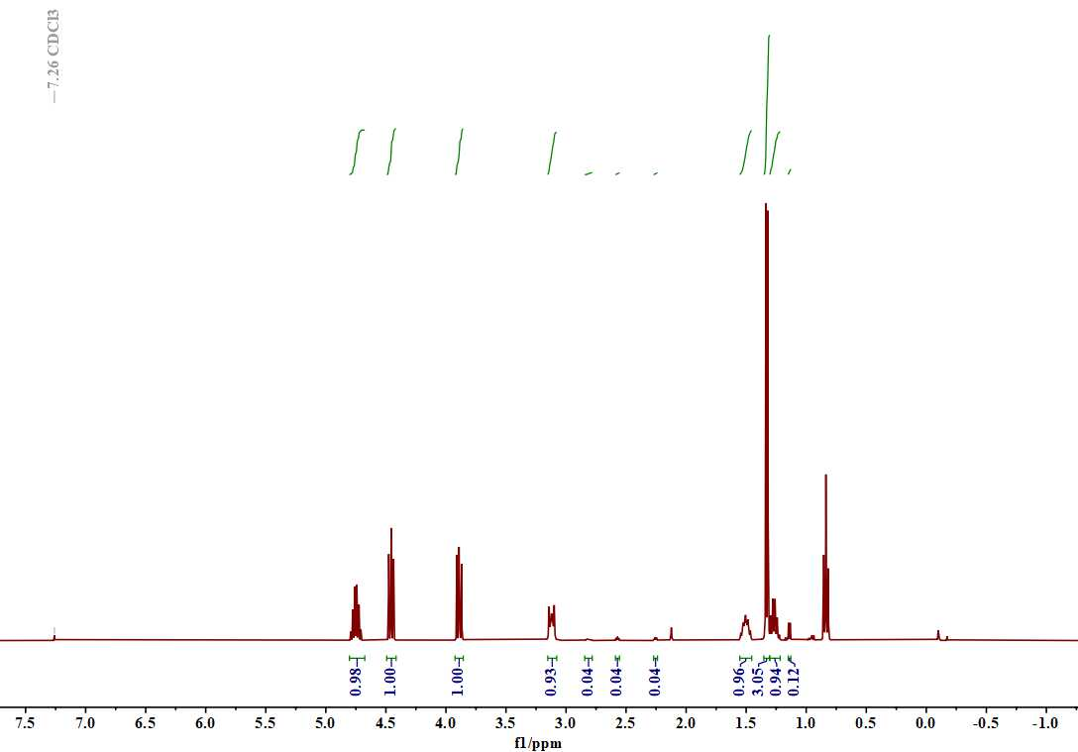
Figure S4 The typical ¹H NMR result of the cycloaddition of carbon dioxide with propylene oxide.

Figure S5 Thermogravimetric profiles of PEI@UiO-66-NH₂ and Ag/PEI@UiO-66-NH₂.

Figure S6 XRD patterns of Ag/PEI@UiO-66-NH₂ before and after cycle.
Table S1 The content of Ag NPs loaded in different catalysts.
Entry | Sample | Ag loading/wt.%
1 | Ag/30%PEI@UiO-66-NH₂ | 4.89
2 | Ag/40%PEI@UiO-66-NH₂ | 4.98
3 | Ag/50%PEI@UiO-66-NH₂ | 5.01
4 | Ag/60%PEI@UiO-66-NH₂ | 4.60
5 | Ag/70%PEI@UiO-66-NH₂ | 5.03
6 | Ag/50%PEI@UiO-66-NH₂(resue) | 3.20

Table S2 CO₂ adsorption data for PEI@UiO-66-NH₂ and Ag/PEI@UiO-66-NH₂.
Sample | Adsorption/cm³·g⁻¹ | Heats/kJ·mol⁻¹
Ag/PEI@UiO-66-NH₂ | 66.38 | 29.19
PEI@UiO-66-NH₂ | 51.83 | 29.28

