Electronic Supplementary Material

Plasma-catalytic cracking of polyethylene over Ni/Hβ zeolites to light hydrocarbon fuels and hydrogen without external heating
Jianhui Han*, Tianqi Yun*, Chengxin Hou, Bingbing Chen, Tianhao Shi, Yanan Diao (), Chuan Shi ()
School of Chemistry, State Key Laboratory of Fine Chemicals, Dalian University of Technology, Dalian 116024, China

E-mails: chuanshi@dlut.edu.cn (Shi C); diaoyanan@dlut.edu.cn (Diao Y)
* These authors contributed equally to the work.

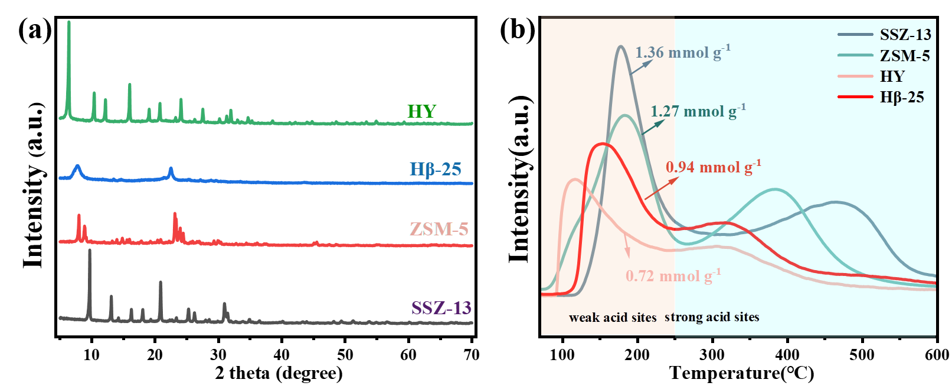

Figure S1 (a) XRD patterns and (b)NH₃-TPD profiles of SSZ-13, ZSM-5, Hβ-25, HY zeolites.

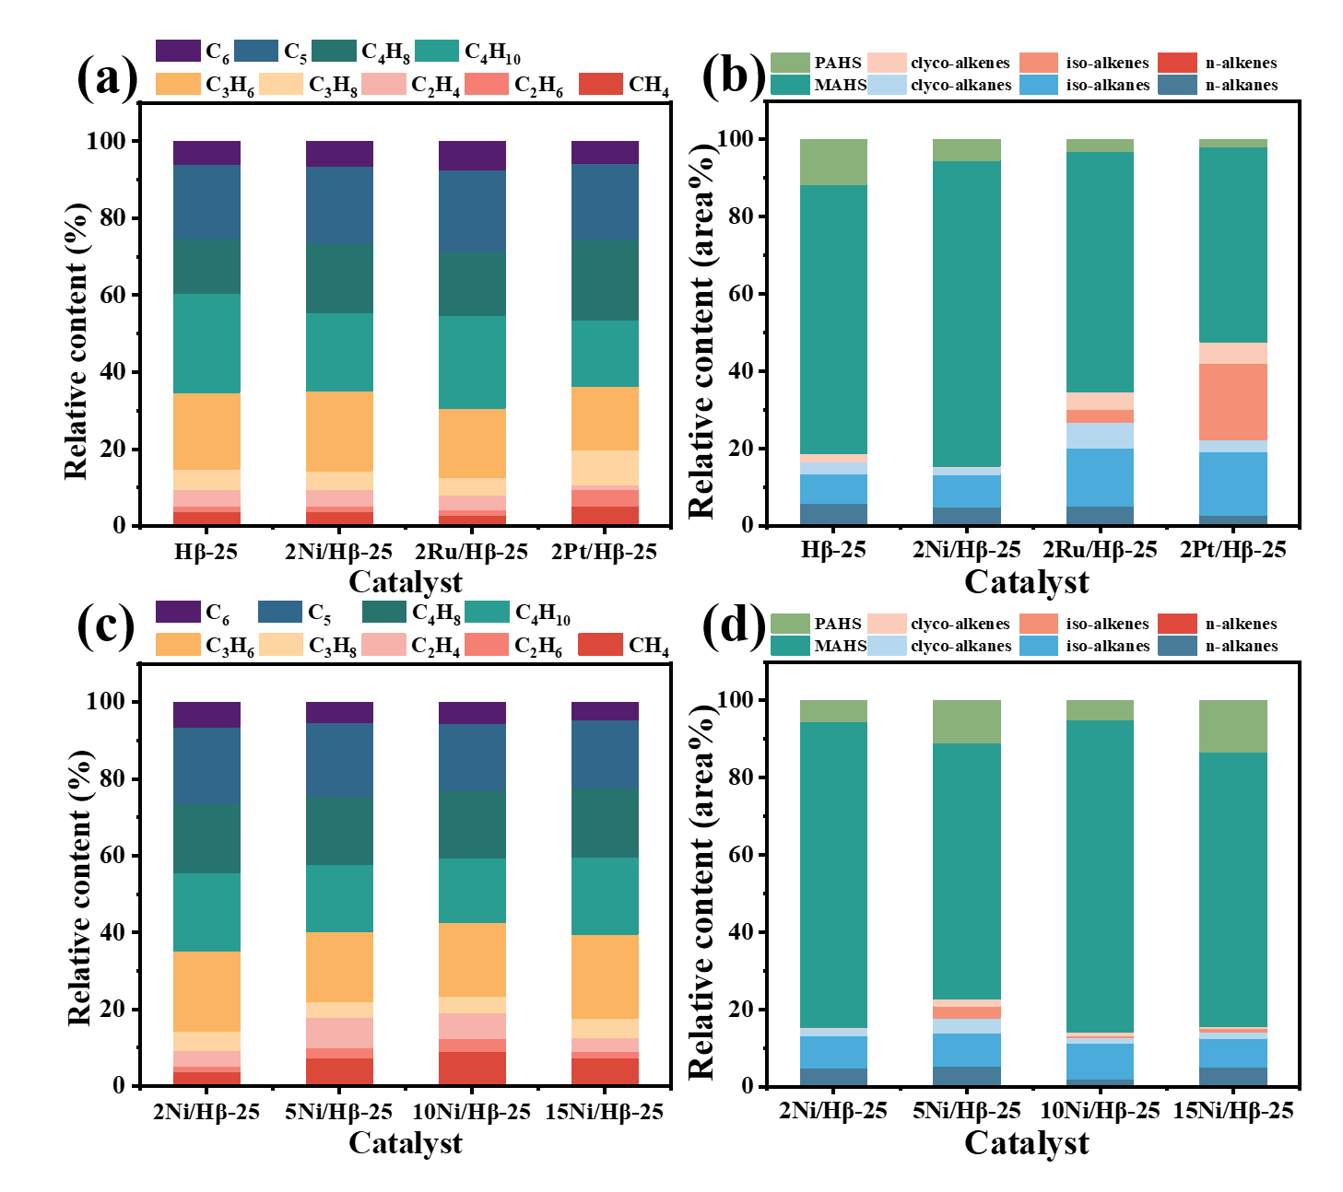
Figure S2 Effects of loading different metals on (a) C₁-C₆ composition, and (b) C₇-C₁₅ composition. Effects of Ni addition on (c) C₁-C₆ composition, and (d) C₇-C₁₅ composition.
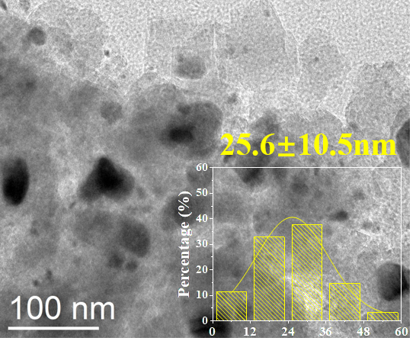

Figure S3 TEM image of spent 10Ni/Hβ-25.
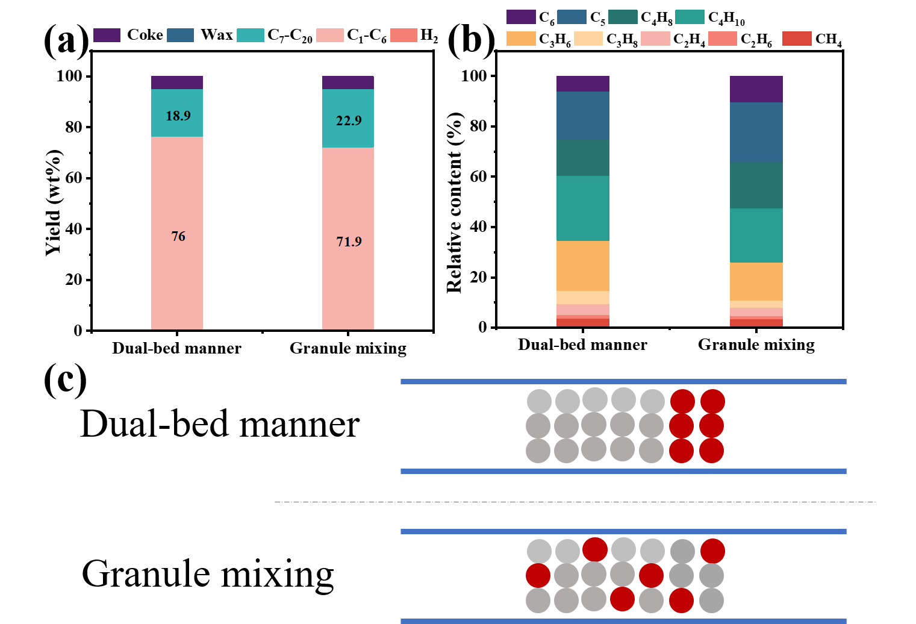

Figure S4 Effect of different contact modes on the (a) product yield and (b) C₁-C₆ product composition. (c) Different contact modes of the catalyst and LDPE.

Table S1 The integrated area and the proportion of different reduction peaks on the various catalysts.
 | Peak Ⅰ |  | Peak Ⅱ |  | Peak Ⅲ |  | Peak Ⅳ |  | Peak Ⅴ
2Ni/Hβ-25 | 320 ℃ | 1.3% | - | - | 427 ℃ | 71.4% | 500 ℃ | 13.0% | 570 ℃ | 14.3%
5Ni/Hβ-25 | 319 ℃ | 4.2% | 370 ℃ | 36.0% | 435 ℃ | 37.1% | 500 ℃ | 18.5% | 570 ℃ | 4.2%
10Ni/Hβ-25 | 325 ℃ | 8.4% | 390 ℃ | 61.5% | 458 ℃ | 17.2% | 507 ℃ | 7.5% | 570 ℃ | 5.4%
15Ni/Hβ-25 | 350 ℃ | 27.9% | 388 ℃ | 47.1% | 437 ℃ | 16.0% | 500 ℃ | 5.2% | 580 ℃ | 3.8%

Table S2 Comparison of the relevant results in previous literature and this work.
Catalyst | Conditions | Product distribution | References
s-ZSM-5 | Feed gas of 1%H₂/ 9%Ar/ 90% N₂, a flow rate of 10 mL/min, 280 °C, 7 h. | The yield of the C₁-C₇ is 74.6% and the selectivity of  C₃-C₆ olefins is 83.9% | [1]
TPC-3  (s-ZSM-5@miso -SiO₂) | Feed gas of 1%H₂/ 9%Ar/ 90% N₂, a flow rate of 10 mL/min, 280 °C, 7 h. | The yield of the C₁-C₇ is 68.2% and the selectivity of  C₃-C₆ olefins is 74.3% | [2]
Ce/b-ZSM-5 | 280 °C, 3 MPa H₂, 5 h | 78.0% yields of C₃-C₅ alkanes | [3]
ZSM-5 micro-spheres | 20 mL/min N_{2.} The temperature of first stage is 500 ℃, the second stage is plasma zone. | 13.4 mmol_{gas} g_{HDPE}⁻¹ | [4]
7%Ni/h-β | 400 °C, 0.15 MPa N₂ | The share of liquid fuels is ~ 90% | [5]
Pt@S-1 + Hβ | 250 ℃, 3 MPa H₂ | The yield of naphtha is  89.5% with 96.8% selectivity of C₅-C₉ hydrocarbons | [6]
Pt@Hie-TS-1 + Hβ | 250 ℃, 1 MPa H₂ | The yield of liquid alkane is  94% with 84.8% selectivity of C₅-C₇ hydrocarbons | [7]
Hβ-25 | 20 mL/min Ar, input power 35 W Discharge length 6cm, without external heating | The yield of the C₁-C₆ is 76% and the gas production rate is 103.8 mmol g_{cat}⁻¹·h⁻¹ | This work
10Ni/Hβ-25 | 20 mL/min Ar, input power 35 W, Discharge length 6cm, without external heating | The yield of hydrogen is  7.87 mmol g_{plastic}⁻¹ | This work

References
1. Duan J, Chen W, Wang C, Wang L, Liu Z, Yi X, Fang W, Wang H, Wei H, Xu S, Yang Y, Yang Q, Bao Z, Zhang Z, Ren Q, Zhou H, Qin X, Zheng A and Xiao F. Coking-resistant polyethylene upcycling modulated by zeolite micropore diffusion. Journal of the American Chemical Society, 2022, 144(31): 14269-14277.
2. Feng J, Duan J, Hung C T, Zhang Z, Li K, Ai Y, Yang C, Zhao Y, Yu Z, Zhang Y, Wang L, Zhao D and Li W. Micelles cascade assembly to tandem porous catalyst for waste plastics upcycling. Angewandte Chemie International Edition, 2024, 63(26): e202405252.
3. Wang X, Wu X, Zhao M, Zhang R, Wang Z, Li Y, Zhang L, Wang X, Song S and Zhang H. High-efficiency Ce-modified ZSM-5 nanosheets for waste plastic upgrading. Nano Research, 2024, 17(6): 5645-5650.
4. Nguyen H M and Carreon M L. Non-thermal plasma-assisted deconstruction of high-density polyethylene to hydrogen and light hydrocarbons over hollow ZSM-5 microspheres. ACS Sustainable Chemistry & Engineering, 2022, 10(29): 9480-9491.
5. Briones L, Cordero A, Alonso-Doncel M, Serrano D P and Escola J M. Catalytic upgrading of a model polyethylene pyrolysis oil by hydroconversion over Ni-containing hierarchical Beta zeolites with tailored acidity. Applied Catalysis B-Environment and Energy, 2024, 341: 123359.
6. Li L, Luo H, Shao Z, Zhou H, Lu J, Chen J, Huang C, Zhang S, Liu X, Xia L, Li J, Wang H and Sun Y. Converting plastic wastes to naphtha for closing the plastic loop. Journal of the American Chemical Society, 2023, 145(3): 1847-1854.
7. Wang S, Wang W, Chu M, Gao D, Wang Y, Lv Y, Wang R, Song L, Zhao H, Chen J and Chen G. Ultra-narrow alkane product distribution in polyethylene waste hydrocracking by zeolite micro-mesopore diffusion optimization. Angewandte Chemie International Edition, 2024, 63(49): e202409288.

