Supporting Information
Relay transesterification strategy for direct synthesis of high-purity glycolide from methyl glycolate
Xiaofeng Xu^{1,2}, Dai Zhang¹, Yifei Wang^{2,3}, Yueqiang Cao ()¹, Wei Li⁴, Jinghong Zhou ()^{1,2}, and Xinggui Zhou¹
1 State Key Laboratory of Chemical Engineering and Low-Carbon Technology, School of Chemical Engineering, East China University of Science and Technology, 130 Meilong Road, Shanghai 200237, China
2 School of Resources and Environmental Engineering, East China University of Science and Technology, 130 Meilong Road, Shanghai 200237, China.
3 State Key Laboratory of Coal liquification, Gasification and Utilization with High Efficiency and Low Carbon Technology, East China University of Science and Technology, 130 Meilong Road, Shanghai 200237, China.
4 School of Chemical Engineering, East China University of Science and Technology, 130 Meilong Road, Shanghai 200237, China.
E-mail: yqcao@ecust.edu.cn; jhzhou@ecust.edu.cn

Experimental
Materials
All chemicals were used as received without any purification. Dipentaerythritol (90%), 1-triacontanol (95%), SnCl₂ (99%) and D-sorbitol (98%) were purchased from Macklin, and stearyl alcohol (SA, 90%) was from Meryer. Behenyl alcohol (BA, 98%) and glycolide (98%) were purchased from TCI. CH₂Cl₂ (99%), O-Xylene (99%) and Methyl glycolate (96%) were obtained from Collins, Damas-beta and PJCHEM, respectively.
Synthesis of Glycolide
Glycolide was obtained via a two-step synthesis involving demetholization and subsequent cyclization. Typically, for the demethanolization, 0.05 mol of high-boiling alcohol, e.g., BA, was added into a 100 mL round bottled flask equipped with a magnetic stirrer and an atmospheric distillation unit. After BA was melted at 80~100 °C, a certain amount of MG with equivalent amount of hydroxyl group to that of BA and 18 mg of SnCl₂ (i.e., 0.4 wt% relative to the amount of MG) were added, and then the mixture was heated to 180 °C at a rate of 1 °C/min. After transesterification at 180 °C for 3 h, the product consist of BA, BG and BDG was obtained and the formed methanol was almost completely removed. Subsequently, for the cyclization, the atmospheric distillation unit was replaced with a vacuum distillation one. The reaction system was vacuumed to 0.5 kPa and heated to 235-250 °C for 2 h. The distillate was collected in a round bottled and separated by a separatory funnel at 90 °C. The upper separating liquid was alcohol phase, and the lower separating one was easter (glycolide) phase.
Characterizations
¹H NMR spectra were measured on a 400 MHz Bruker AVANCEⅢ 400 spectrometer (Switzerland). Chloroform-d (CDCl₃, 99.8 wt%) containing tetramethyl silane (TMS, 0.03 wt%) was used in the measurements, in which CDCl₃ was employed as the solvent while TMS as the reference. J values are given in Hz. Melting point of glycolide was determined by a DSC Q200TA (USA). About 5-8 mg of sample was heated from 40 to 95 °C at a rate of 10 °C/min and then hold at 95 °C for 5 min. Then, the sample was cooled down to 0 °C at a rate of 10 °C/min and hold at 0 °C for 5 min. The purpose of these steps is to eliminate thermal history. Finally, the temperature was raised to 60 °C at a rate of 10 °C/min and then to 95 °C at a rate of 0.5 °C/min. FTIR spectra were collected on a PerkinElmer Frontier FT-IR spewctrometer (USA) at the range of 4000–400 cm⁻¹ with 32 scans.
Column chromatography
A column chromatography packed with 200-300 mesh silica gel was used to separate the product of demetholization, where a mixed solution of petroleum ether (PE) and ethyl acetate (EA) (V_{PE}:V_{EA}=6:1) was used as the eluent. The isolated components were evaporated with a rotary evaporator to remove the solvent, and dried at 50° C for 10 h in a vacuum oven.
Analysis of glycolide
The compositions of products formed in different steps were analyzed by gas chromatography (GC9890, LINGHUA, China) equipped with a TH-1 column (with dimensions 30 m × 0.32 mm × 0.5 μm) and a flame ionization detector. Prior to analysis, samples were dissolved in CH₂Cl₂. Sample of 1 μL was injected into the GC column with a split ratio of 49:1. The carrier gas was N₂, and the flow rate was 40.0 mL min⁻¹. The oven temperature was initially held at 80 °C for 1 min, and then raised to 280 °C at a rate of 20 °C min⁻¹, followed by being held at 280 °C for 10 min.
The yield of GL was calculated as:
${\text{Yield of GL}}/{\text{\%}}\text{=}\frac{ {\text{m}}_{\text{GL}}×{\text{M}}_{\text{MG}}}{ {\text{m}}_{\text{MG}}\text{×}{\text{2M}}_{\text{GL}}}\text{×100\%}$ (1)
m_{GL} is the mass of synthetic glycolide;
M_{MG} is the molecular weight of MG;
m_{MG} is the mass of reactant MG;
M_{GL} is the molecular weight of glycolide.
The purity of Glycolide was determined by GC with using CH₂Cl₂ as the solvent and o-xylene as the internal standard.

Table S1 Reagent details in the glycolide synthesis experiment.
Entry | Alcohols | Property of alcohols |  | Feed
Entry | Alcohols | Boiling Point (ºC) | Hydroxyl Group/Alcohol |  | Alcohols (g) | MG (g)
1 | Stearyl alcohol(SA) | 336 | 1 |  | 13.52 | 4.54
2 | Behenyl alcohol(BA) | 375 | 1 |  | 16.33 | 4.56
3 | 1-Octacosanol | 428 | 1 |  | 20.57 | 4.56
4 | 1-Triacontanol | 443 | 1 |  | 22.04 | 4.57
5 | Sorbitol | 495 | 6 |  | 9.10 | 27.06
6 | Dipentaerythritol | 543 | 6 |  | 10.28 | 25.43

Fig. S1 GC standard curve for glycolide.
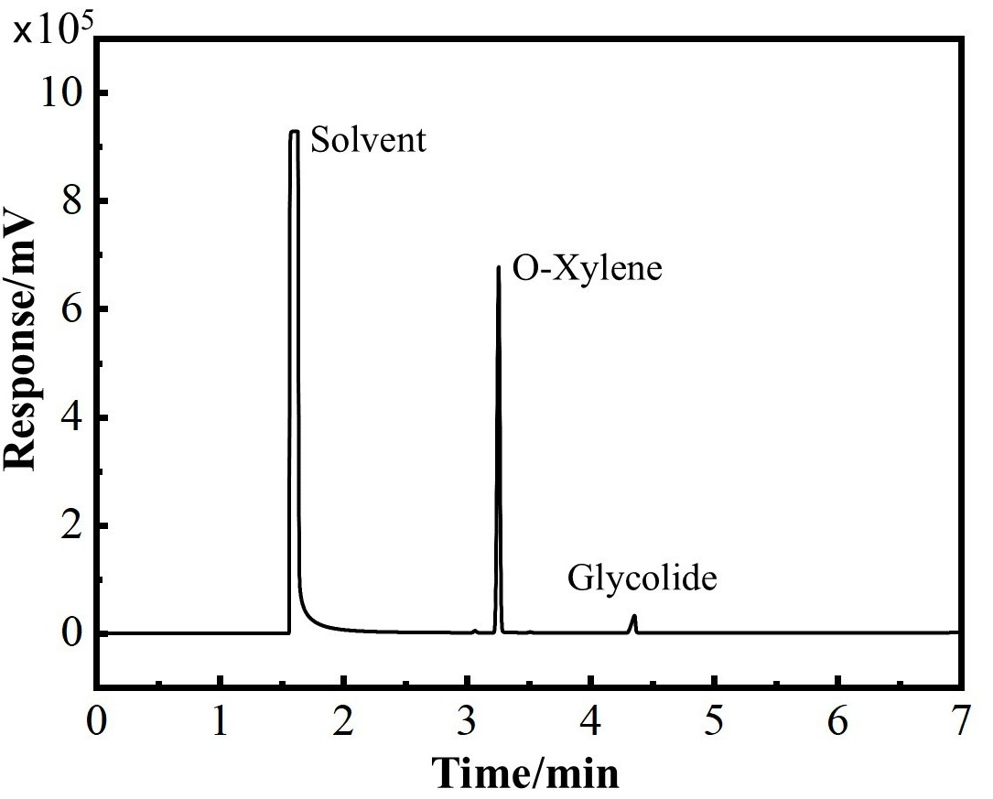
Fig. S2 Typical GC profile for as-synthesized glycolide.
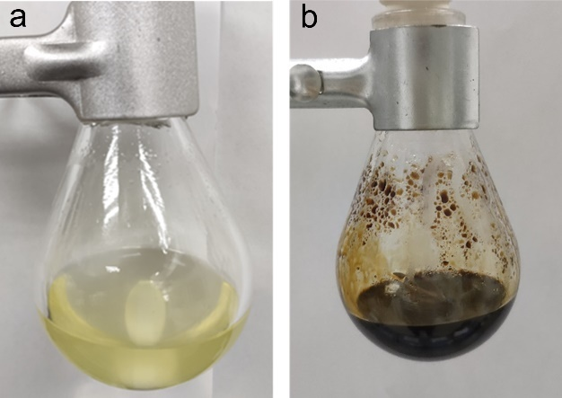
Fig. S3 Pictures of the reaction mixture after the glycolide synthesis experiment involving BA (a) and sorbitol (b).
When SA and BA were used as the transesterification agent, coking was hardly seen in the second step, as demonstrated by Fig. S3a. In contrast, when the other four alcohols with boiling points over 420 °C were used, the color of the mixture quickly darkened, as exemplified by the case of using sorbitol (Fig. S3b), and the glycolide product was barely collected.

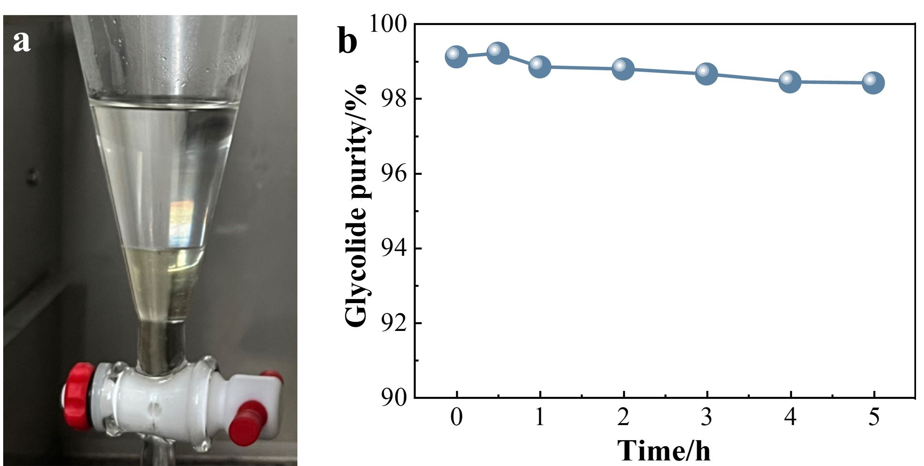
Fig. S4 (a) Liquid–liquid phase separation behavior between BA and glycolide (from TCL, >98%) at 90 °C; (b) variation in glycolide purity in the easter phase over 5 hours (determined by GC).
Fig. S5 Stratification phenomenon of the distillate in separatory funnel.

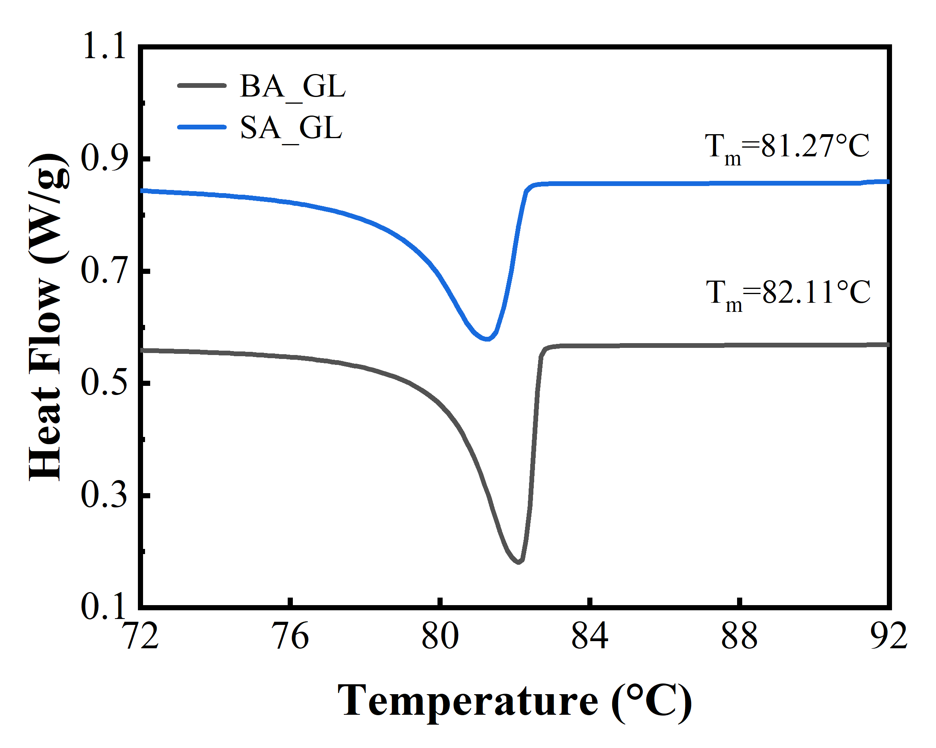
Fig. S6 DSC curves of glycolide synthesized using stearyl alcohol (SA_GL) and synthesized using BA(BA_GL).
The purity of glycolide was calculated by:[1]
$T_{f}=T_{0}-\frac{X_{2}RT_{0}^{2}}{∆H_{f}}$ (2)
$T_{f}$ is the melting point of the sample;
$T_{0}$ is the melting point of the standard;
$X_{2}$ is the mole fraction of impurities in the sample;
${ΔH}_{f}$ is the molar melting enthalpy of the standard.[2]
Table S2 The calculated purity of glycolide based on the results from DSC.
Entry | T_{m} (℃) | Purity(%)
BA_GL | 82.11 | 98.84
SA_GL | 81.27 | 97.75

Table S3 Synthesis of lactide using BA as a transesterification agent.
Entry | Transesterification agent | Feedstock | Lactide yield/% | Lactide purity/%
1 | BA | Methyl lactate | 27.2 | 98.3

Fig. S7 ¹H NMR spectrum of the lactide phase.

Table S4 Comparison of different feedstocks for glycolide synthesis.
Entry | Transesterification agent | Feedstock | Glycolide yield/% | Glycolide purity/%
1 | BA | MG | 44.3 | 99.6
2 | BA | Glycolic acid | 41.5 | 98.6
3 | BA | 70% aqueous glycolic acid | 43.2 | 98.7

Fig.S8 GC analysis of demethanolization products.
The pure products were obtained by the silica gel column chromatography as described in the section of 1.4. The feeding quantity is 1.52 g. 235 mg of BA, 918 mg of BG and 76 mg of BDG were collected by the separation, and the overall yield was 80.8% (1.23 g).
BA：Behenyl alcohol (1-Docosanol)
¹H NMR (400MHz, Chloroform-d, ppm, Fig. S9) δ=3.63 (t, 2H), δ=1.56 (m, 2H), δ=1.25 (m, 38H), δ=0.88 (t, 3H). FTIR (KBr, Fig. S12) : ν_{max}/cm⁻¹ 2960 2917 2848 1472 1062 725.
BG：Behenyl glycolate
¹H NMR (400MHz, Chloroform-d, ppm, Fig. S10) δ=4.20 (t, 2H), δ=4.15 (d, J=4Hz, 2H), δ=1.64 (m, 2H), δ=1.25 (m, 38H), δ=0.88 (t, 3H). FTIR (KBr, Fig. S13) : ν_{max}/cm⁻¹ 2956 2921 2849 1745 1472 1236 1110 721.
BDG：Behenyl dimer glycolate
¹H NMR (400MHz, Chloroform-d, ppm, Fig. S11) δ=4.72 (s, 2H), δ=4.31 (d, J=4Hz, 2H), δ=4.17 (t, 2H), δ=1.63 (m, 2H), δ=1.25 (m, 38H), δ=0.88 (t, 3H). FTIR (KBr, Fig. S14) : ν_{max}/cm⁻¹ 2960 2923 2852 1755 1468 1189 1107 720.

The assignments of peaks in ¹H NMR spectra to different H atoms in different substances are shown below.
Fig. S9 ¹H NMR spectrum of BA separated from the product in demetholization.
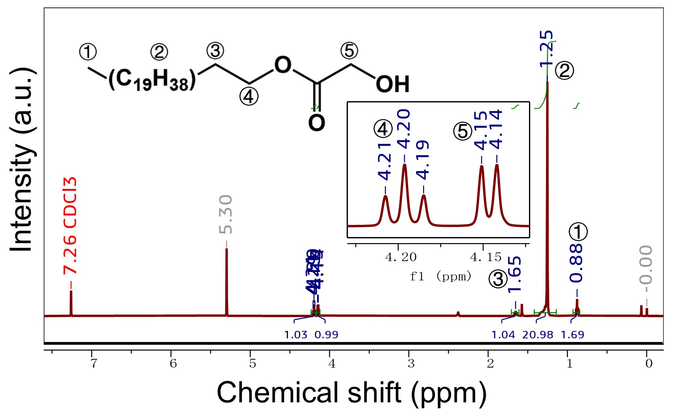
Fig. S10 ¹H NMR spectrum of BG separated from the product in demetholization.
Fig. S11 ¹H NMR spectrum of BDG separated from the product in demetholization.

After the reaction between BA and MG, the pure samples of the main products were obtained by column chromatography. In addition to the previous characterization by ¹H NMR, FTIR measurements were also performed. The three FTIR spectra match well with the standard spectra of BA, BG and BDG respectively. The standard spectrum of BA is obtained from the AIST. For the other two, there were no corresponding spectra in the database, so simulations were carried out with Gaussian 09.[3] The calculation method is B3LYP and the basis set is 6-31G(d,p).[4]
Fig. S12 Experimental (a) and standard (b) FTIR spectra of BA.

Fig. S13 Experimental (a) and Gaussian simulated (b) FTIR spectra of BG.

Fig. S14 Experimental (a) and Gaussian simulated (b) FTIR spectra of BDG.

Fig. S15 ¹H NMR spectrum of the residue of distillation after the reaction of the BG.
In Fig. S15, the signal of δ=3.64 ppm was assigned to the methylene group connected with hydroxyl group of the BA. The signal of δ=4.15 ppm was assigned to the methylene group connected with hydroxyl group of the BG. The signal of δ=4.30 ppm was assigned to the methylene group connected with hydroxyl group of the BDG. The signal of δ=4.72 ppm was assigned to the methylene group between the two ester groups of the BDG. The above information indicates that the residue of the distillation contains BA, BG and BDG.
Fig. S16 ¹H NMR spectrum of the distillate after the reaction of the BG.

Table S5. Results of the four-run experiment with cycling alcohol phase.
Run | Feed |  | Theoretical output of glycolide (g) | Yield of glycolide (g)
Run | MG (g) | Catalyst (g) | Theoretical output of glycolide (g) | Yield of glycolide (g)
1 | 4.56 | 0.018 | 2.82 | 1.25
2 | 4.56 | 0.016 | 2.82 | 2.60
3 | 4.65 | 0.020 | 2.88 | 2.37
4 | 4.57 | 0.018 | 2.83 | 2.36

Fig. S17 ¹H NMR spectrum of the alcohol phase after four runs.

Table S6 Recycling experiments of catalyst and alcohol phase.
Run | BA/g | MG/g | SnCl₂/g | glycolide yield /g | glycolide yield/% | glycolide purity/%
1 | 16.33 | 4.58 | 0.018 | 1.14 | 40.2 | 99.2
2 | - | 4.54 | - | 2.54 | 90.4 | 98.5

Table S7 Comparison of glycolide production by the conventional process and this strategy.
 | Conventional process | This strategy
Temperature | ≥280 ℃ | 235-250 ℃
Pressure | ＜0.1 kPa | 0.5 kPa
Viscosity | High | Low
Crude GL purity | 85-96% | ≥99%
Crude GL yield | 50-70% | ≥75.8%
Need for purification | Yes | No
Purification | Recrystallization  Melting crystallization | -
Distillation Residue Appearance | Solid phase with severe carbonization | Low-viscosity liquid

References
- ASTM E793-06, Standard test method for enthalpies of fusion and crystallization by differential scanning calorimetry. West Conshohocken (PA): ASTM International, 2006
- Huang Q, Li Y, Yuan F, Xiao L, Hao H, Wang Y. Thermodynamic properties of enantiotropic polymorphs of glycolide. The Journal of Chemical Thermodynamics, 2017, 111: 106-114
- Gaussian 09. Revision D.01. Wallingford (CT): Gaussian, Inc., 2013
- Tirado-Rives J, Jorgensen W L. Performance of B3LYP density functional methods for a large set of organic molecules. Journal of Chemical Theory and Computation, 2008, 4(2): 297–306.

