Electronic Supplementary Material
Effect of chelating agents on selective catalytic reduction activity and mechanism for MnCr₂O₄ spinel catalyst
Fenghe Sheng^{1,2}, De Fang ()^{1,2,3}, Sensheng Hou², Feng He⁴, Junlin Xie ()⁴
1 State Key Laboratory of Silicate Materials for Architectures, Wuhan University of Technology, Wuhan 430070, China
2 School of Materials Science and Engineering, Wuhan University of Technology, Wuhan 430070, China
3 Center for Materials Research and Analysis, Wuhan University of Technology, Wuhan 430070, China
4 School of Materials Science and Engineering, Beijing University of Technology, Beijing 100124, China
E-mails: fangde@whut.edu.cn (Fang D); xjlclxy@126.com (Xie J)

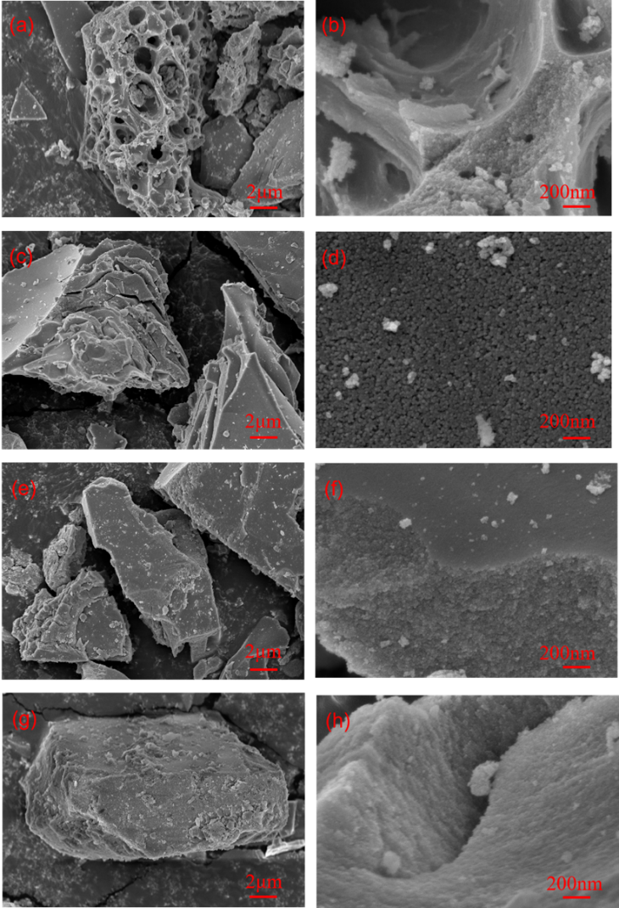
Fig. S1. SEM of MnCr₂O₄-E-600(a,b), MnCr₂O₄-C-500(c,d), MnCr₂O₄-G-600(e,f), and MnCr₂O₄-S-700(g,h).
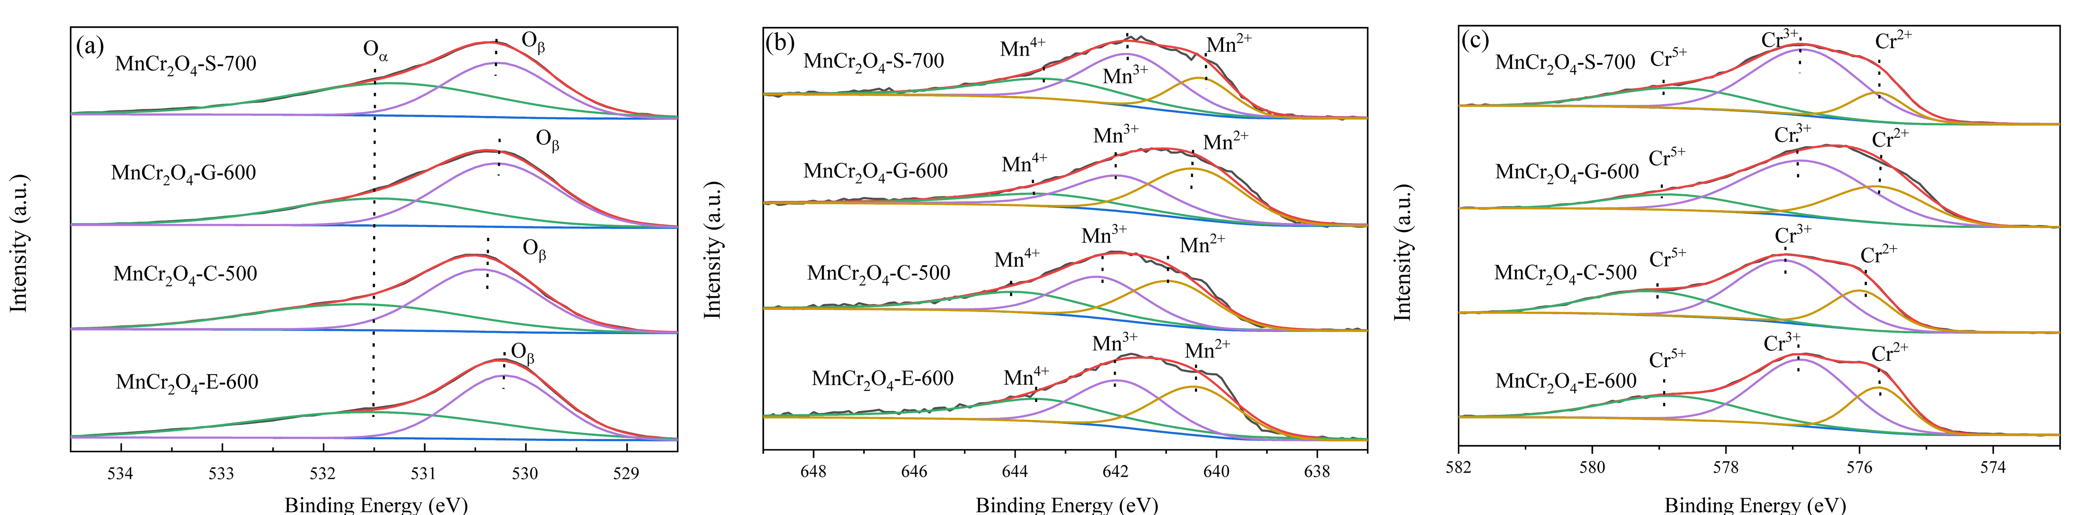
Fig. S2. XPS spectra for O 1s (a), Mn 2p (b) and Cr 2p (c) of MnCr₂O₄

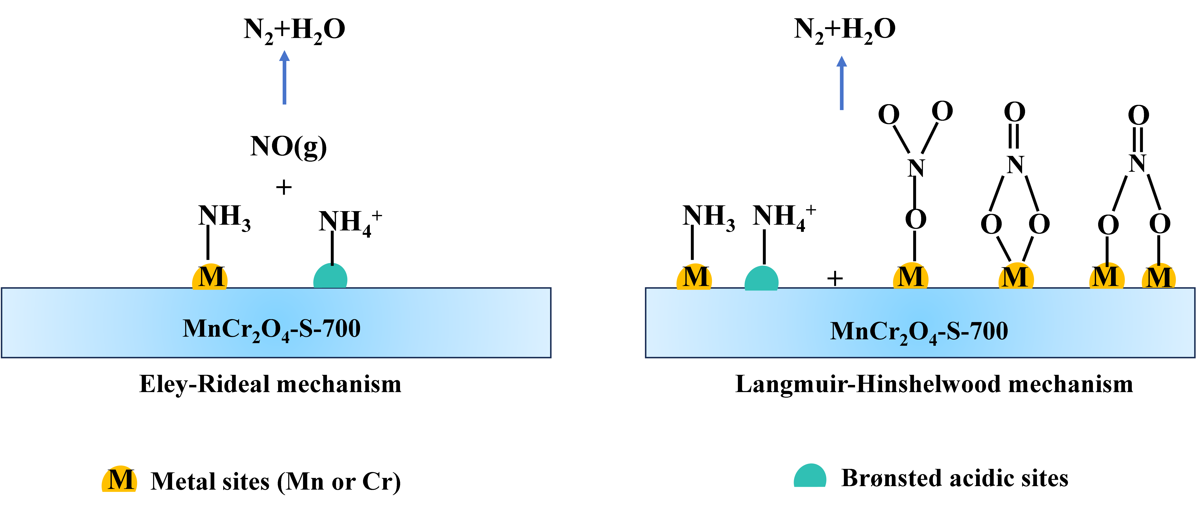
Fig. S3 The adsorption model of MnCr₂O₄-S-700 catalyst in the NH₃-SCR reaction process.

