Electronic Supplementary Material

Hydrothermal regulation of hierarchical Al-doped nickel-cobalt layered double hydroxide nanoneedle arrays for hybrid supercapacitors
Zhen Li¹, Yin-Tao Li², Li Tian¹, Chun-Mei Zha¹, Kavinkumar Veerappan ()¹, Tie-Zhen Ren ()¹
¹State Key Laboratory of Chemistry and Utilization of Carbon-based Energy, Resources and Key Laboratory of Coal Clean Conversion & Chemical Engineering Process Xinjiang Uyghur Autonomous Region, School of Chemical Engineering and Technology, Xinjiang University, Urumqi 830017, China
²Baotou Ecological Environment Information Center, Baotou 014060, China
E-mails: rtz@xju.edu.cn (Ren T-Z); vkavinchem@gmail.com (Veerappan K)

1. Experimental Section
1.1 Materials characterization
The samples were characterized using a scanning electron microscope (JSM-6490LV, Japan), TEM (JEOL JEM-2100F), and an X-ray diffractometer (Bruker D8 Advance, Germany) to analyze their morphology and structure. Analysis of structure and chemical composition by X-ray Photoelectron Spectroscopy (ESCALAB 250Xi, USA). The specific surface area and pore size distribution of the materials were determined using a nitrogen adsorption-desorption analyzer (Autosorb-iQ, USA).
1.2 Electrochemical tests
Electrochemical tests were performed using the CHI760E electrochemical workstation (Shanghai Chenhua, China). The device includes a graphite counter electrode, a 3 mol L⁻¹ KOH electrolyte, and a Hg/HgO reference electrode. Before measurement, the working electrode needs to be immersed in the electrolyte for 12 hours. It was found that the loading amount of in-situ growth of active material on nickel foam substrate at 1×1 cm² was about 0.7 mg.
(1) Three-electrode system: platinum plate electrode and an Hg/HgO electrode were used as the counter electrode and reference electrode, respectively. Cyclic voltammetry (CV) tests were performed in a 3 mol L⁻¹ KOH electrolyte in a potential window between 0 and 0.6 V, with scan rates ranging from 5 to 100 mV s⁻¹. Constant current charge-discharge (GCD) tests were performed at current densities between 1 and 10 A g⁻¹. Electrochemical impedance spectroscopy (EIS) measurements were performed at an amplitude of 5 mV in a frequency range from 100 kHz to 0.01 Hz. The specific capacitance (C_{s}) was calculated using the following formula:
$$\begin{aligned}{\text{C}}_{s}\text{=}\frac{\text{IΔt}}{\text{mΔV}}\#\text{(1)}\end{aligned}$$
Where I (A) and m (g) denote the discharge current and the mass of active material in the charge, respectively; Δt (s) and ΔV (V) represent the discharge duration and the voltage variation during discharge.
(2) Double electrode system:
The manufacturing process of anode materials is as follows: activated carbon AC, acetylene black (conductive agent) and PTFE binder were mixed in ethanol at a weight ratio of 8:1:1 to form a slurry mixture, and the resulting carbon paste was coated on a 1×1 cm² nickel foam substrate. After drying the electrode material in an oven at 70°C, the nickel foam was pressed at 10 MPa for 1 minute to obtain the required thickness, Finally, the positive electrode material was assembled with the negative electrode material and subjected to testing. At the beginning of the test, a small current was applied for activation.
The specific capacitance (C_{d}) in a double electrode system can be calculated using the following equation:
$$\begin{aligned}{\text{C}}_{d}\text{=}\frac{\text{I}\text{Δ}\text{t}}{\text{M}\text{Δ}\text{V}}\#\text{(2}\end{aligned}\text{)}$$
$$\begin{aligned}\text{E}\text{=}\frac{\text{C}\text{(Δ}{\text{V}}^{\text{2}}\text{)}}{\text{2}\text{×}\text{3.6}}\#\text{(3}\end{aligned}\text{)}$$
$$\begin{aligned}\text{P}\text{=}\frac{\text{E}}{\text{Δ}\text{t}}\text{×3600}\# \text{(4)}\end{aligned}$$
$$\frac{m_{+}}{m_{-}}\text{=}\frac{C_{-}\text{Δ}{\text{V}}_{-}}{C_{+}\text{Δ}{\text{V}}_{+}} (5)$$
Where C (F g⁻¹) denotes the specific capacitance of the device; I (A) and M (g) represent the applied current and the total mass of cathode and anode materials in the device; Δt (s) and ΔV (V) denote the discharge time and the potential window; E (Wh kg⁻¹) and P (W kg⁻¹) denote the energy density and power density. The m₊ and m₋ represent the mass (mg) of the positive and negative electrode materials, respectively, and C₊ and C₋ represent the corresponding specific capacitance. △ V₊ and △ V₋ represent the voltage windows of the positive and negative electrode materials, respectively.
(3) The ion diffusion coefficient is calculated using the following formula:
$$\begin{aligned}iv=a×v^{b}\#(5)\end{aligned}$$
$$\begin{aligned}iV=k_{1}+k_{2}v^{\frac{1}{2}}\#(6)\end{aligned}$$
Here, i denotes current density, ν and V represent scan rate and potential, respectively, while b serves as a crucial indicator for evaluating charge storage kinetics. The terms denote surface-controlled and diffusion-controlled processes, respectively.

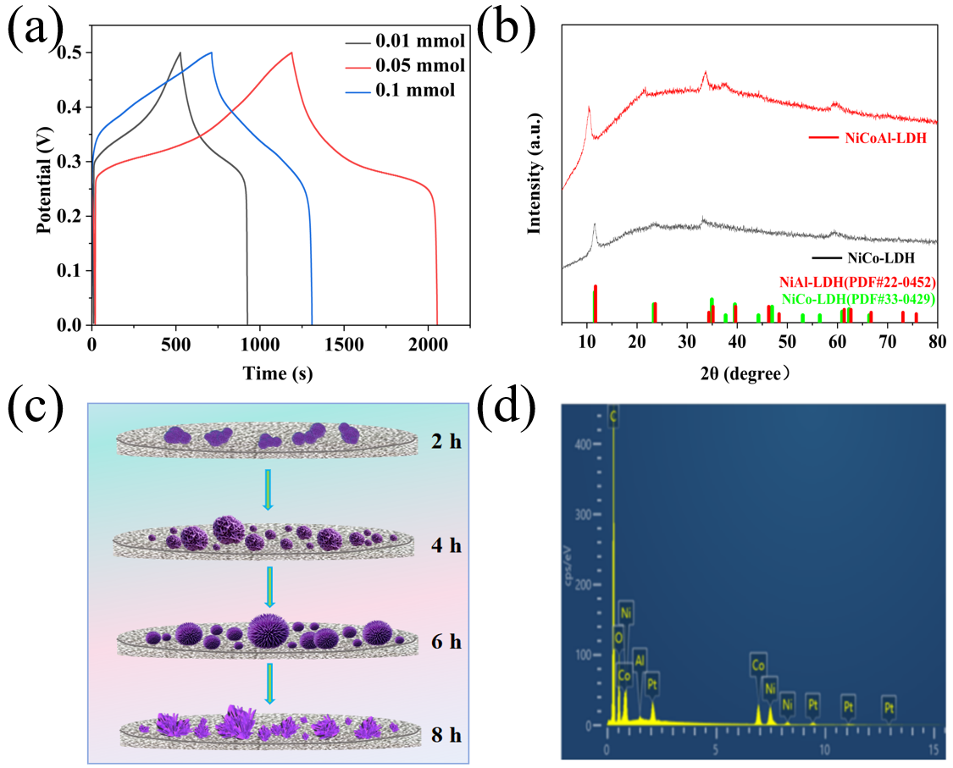

Fig. S1. (a) Comparison of GCD curves for different Al addition levels, (b) XRD patterns of NiCo-LDH and NiCoAl-LDH-6, (c) schematic illustration of the morphology evolution of NiCoAl-LDH with hydrothermal reaction time, and (d) EDS spectrum of NiCoAl-LDH-6

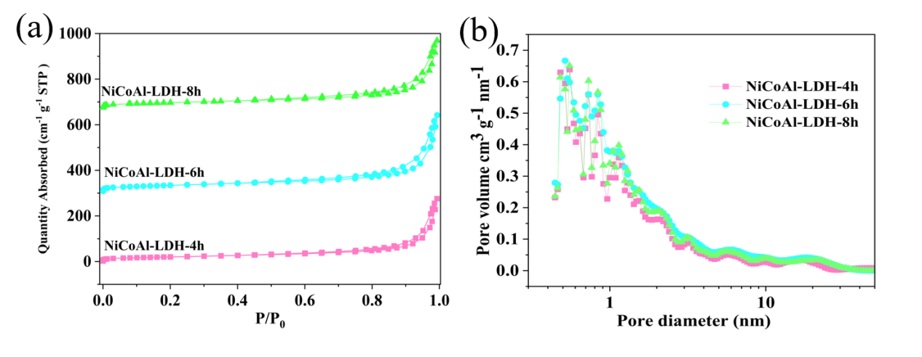
Fig. S2. (a) N₂ adsorption-desorption isotherms and (b) pore size distributions
Table S1. Pore structure parameters.

Sample | S_{BET}  (m²·g⁻¹) | V_{t}  (cm³·g⁻¹) | S _{ext}  (m²·g⁻¹) | V_{ext}  (cm³·g⁻¹) | V_{ext}/V_{t}
NiCoAl-LDH-4h | 73.232 | 0.427 | 70.267 | 0.419 | 0.981
NiCoAl-LDH-6h | 98.726 | 0.517 | 92.344 | 0.509 | 0.985
NiCoAl-LDH-8h | 86.992 | 0.459 | 82.312 | 0.451 | 0.983

Table S2. EDS elemental analysis of NiCoAl-LDH-6
Element  Number | Element  Symbol | Element  Name | Atomic  Conc. | Weight  Conc.
8 | O | Oxygen | 85.36 | 61.82
13 | Al | Aluminum | 0.52 | 0.62
27 | Co | Cobalt | 6.87 | 18.31
28 | Ni | Nickel | 7.25 | 19.24

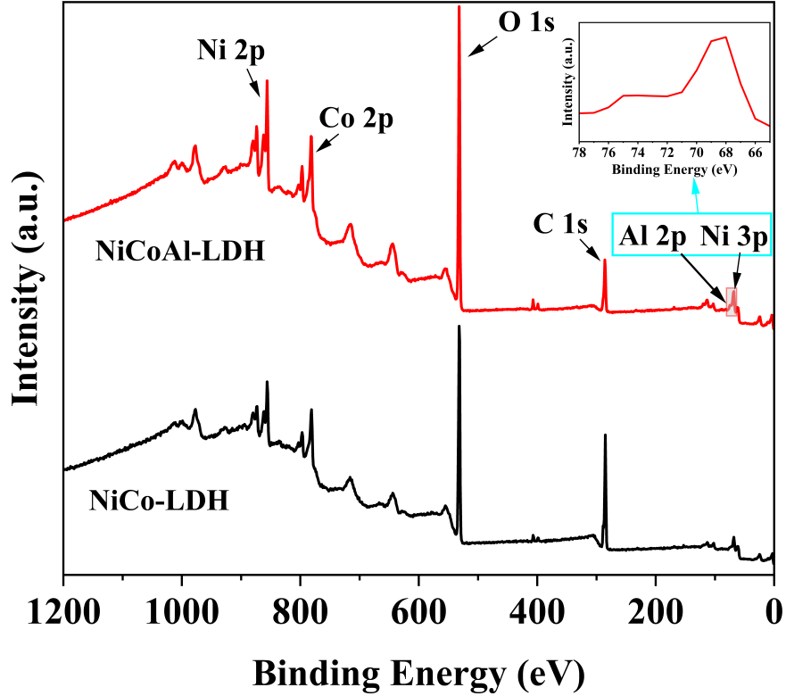
Fig. S3. The XPS survey spectra of NiCoAl-LDH and NiCo-LDH

Table S3. Element compositions (at. %) of samples calculated from XPS results.
Samples | Contents (%)
Samples | Ni | Co | Al | O
NiCoAl-LDH-6 | 12.69 | 11.56 | 1.4 | 74.35
NiCo-LDH | 12.87 | 11.72 | - | 75.41
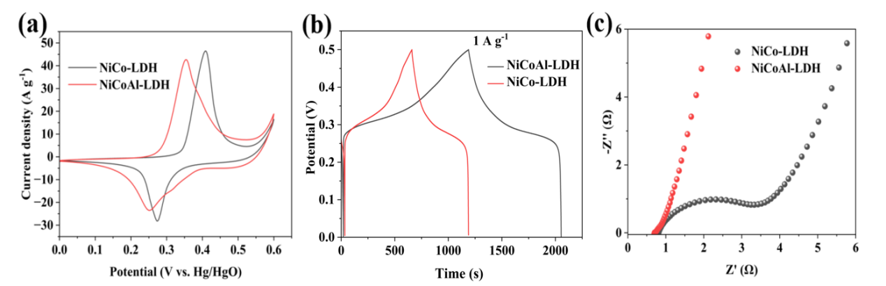
Fig. S4. (a) CV curves of NiCoAl-LDH and NiCo-LDH at a scan rate of 5 mV s⁻¹, (b) GCD curves of NiCoAl-LDH and NiCo-LDH at 1 A g⁻¹, and (c) EIS Nyquist plot of of NiCoAl-LDH and NiCo-LDH.

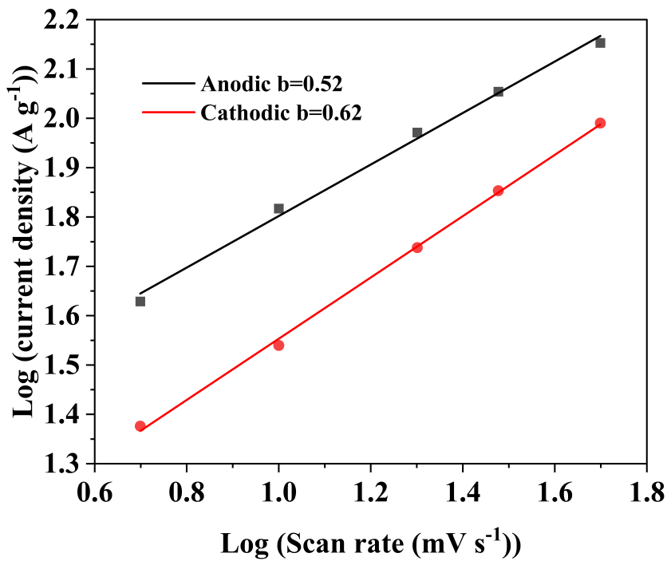
Fig. S5. The b-values of the anodic and cathodic peaks

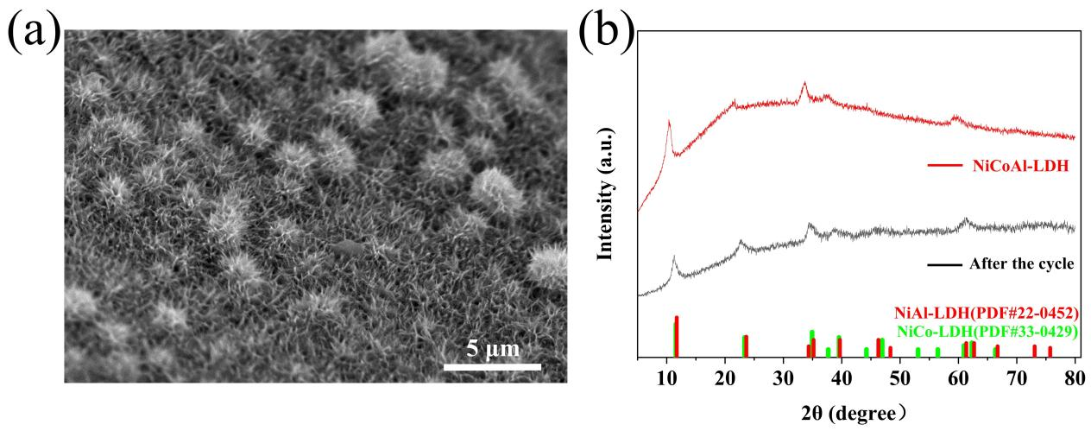
Fig. S6. (a) Surface morphology of the electrode after cycling and (b) XRD pattern of the electrode before and after cycling.
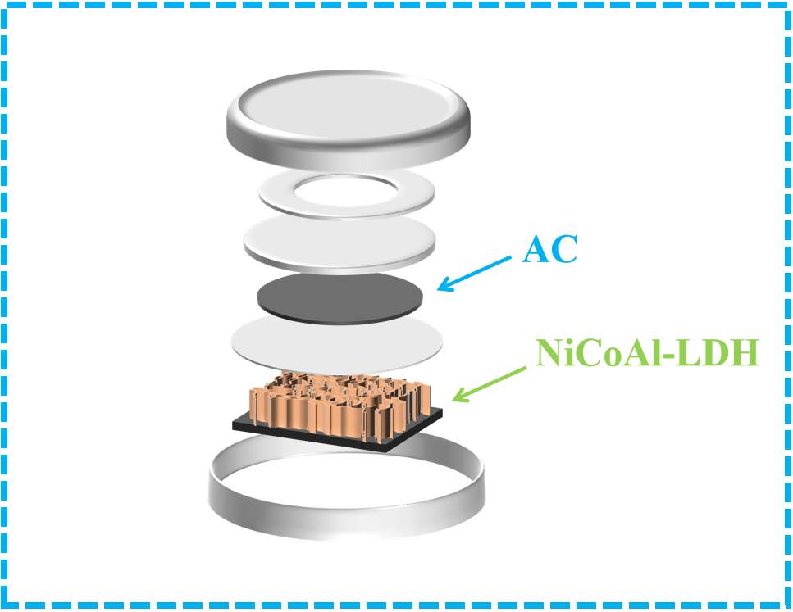
Fig. S7. Schematic diagram of NiCoAl-LDH-6 // AC device assembly
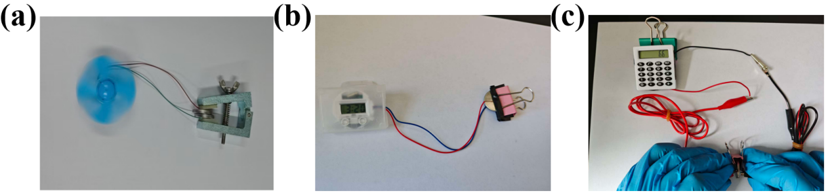
Fig. S8. (a) Operation of a fan powered by the device, (b) powering of an electronic watch, and (c) calculator.

