SUPPORTING INFORMATION
Metalated Polymer Brush Coatings with Excellent Transparence and Antibacterial Properties
Ling Yin^{1,2}, Shengfei Li¹, Yuxiang Zhao^{1,2}, Guangen Fu¹, Haoyong Yang¹, Daheng Wu¹, Jianing Wang¹, Tao Zhang¹
1 State Key Laboratory of Advanced Marine Materials, Ningbo Institute of Materials Technology and Engineering, Chinese Academy of Sciences, Ningbo 315201, China
2 University of Chinese Academy of Sciences, Beijing 100049, China

Supplementary Figures
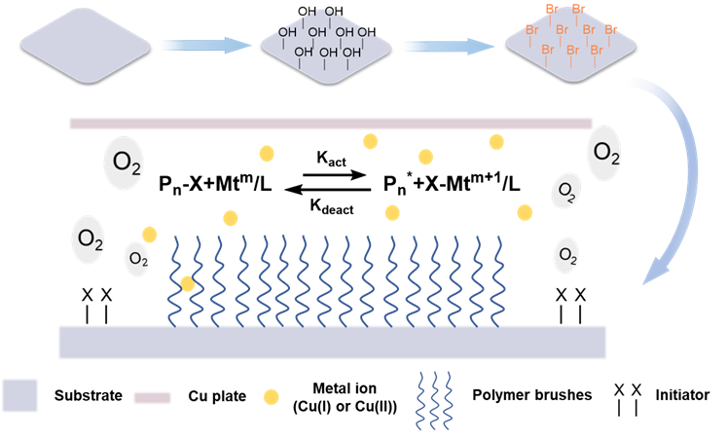
- Schematic diagram of Cu⁰-mediated surface-initiated controlled radical polymerization method (SI-Cu⁰CRP).

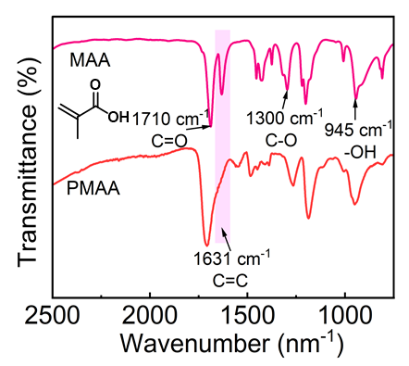
- The corresponding FTIR spectrum of MAA monomer (pink line) and PMAA polymer brush (red line).
MAA, monomer, displays characteristic carboxylic acid peaks at 1710 cm⁻¹ (-C=O, stretch), 1631 cm⁻¹ (-C=C, stretch), 1300 cm⁻¹ (-C-O, stretch) and 945 cm⁻¹ (-OH, out-plane bending). The -C=O peaks increasing and the -C=C peaks decreasing of fourier transform infrared spectroscopy measurements (FTIR) indicate that the PMAA brushes have been successful polymerized.

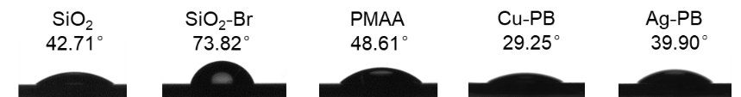
- The static water angle of the silicon wafers modified with different material, including SiO₂, SiO₂-Br, PMAA brushes, Cu-PB, and Ag-PB.

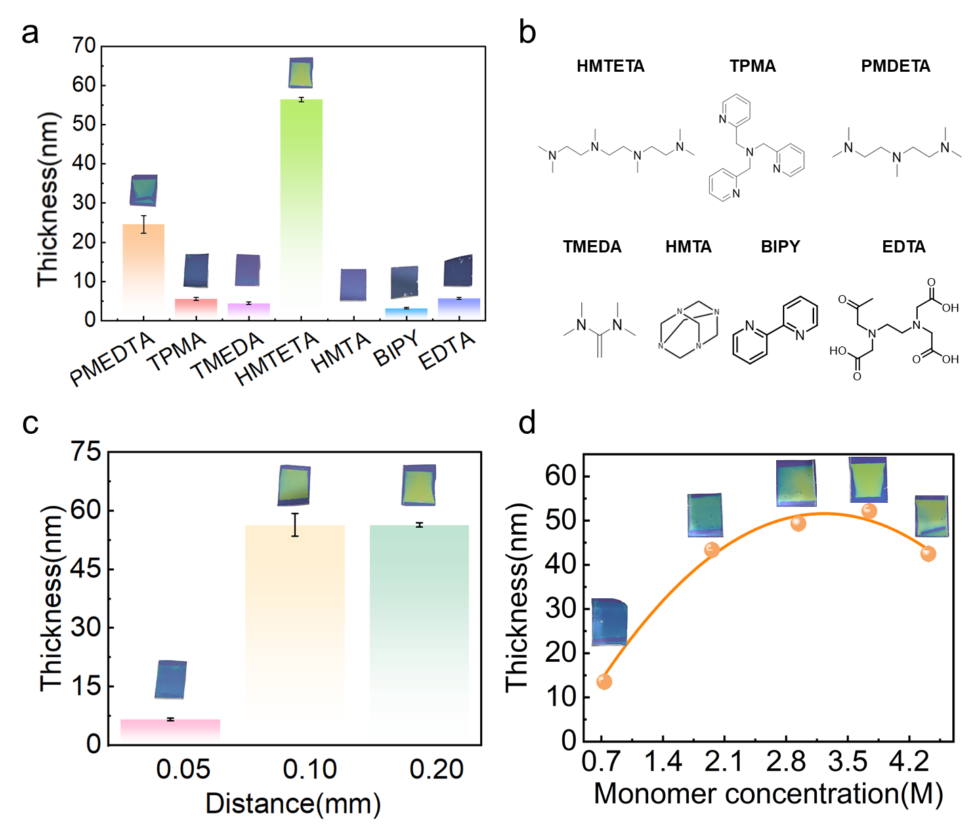
- (a) PMAA brush thicknesses were obtained by SI-Cu⁰CRP with different kinds of ligands fixed at 75 mmol in 0.5 ml MAA and 1.5 mL of deionized water/DMSO (1:3) mixture. (b) Structural formulae for different ligands including 1,1,4,7,10,10-hexamethyltriethylene-tetramine (HMTETA), Tris(2-pyridylmethyl)amine (TPMA), Pentamethyl diethylenetriamine (PMDETA), N,N,N',N'-Tetramethylethylenediamine (TMEDA), Methenamine (HMTA), 2,2'-Bipyridine (BIPY), and Ethylene Diamine Tetraacetic Acid (EDTA). (c) Relationship between the thickness of PMAA brushes and the deposition distance (d=0.05, 0.10, 0.20 mm). (d) Variation of the growth thickness of PMAA brushes with the monomer concentration (the polymerization time is 50 min). (i) 0.733 M, (ii) 1.96 M, (iii) 2.40 M, (iv) 3.744 M, and (v) 4.415 M. Optical photographs of PMAA brushes of different thicknesses are shown in Figures (a), (c), and (d).

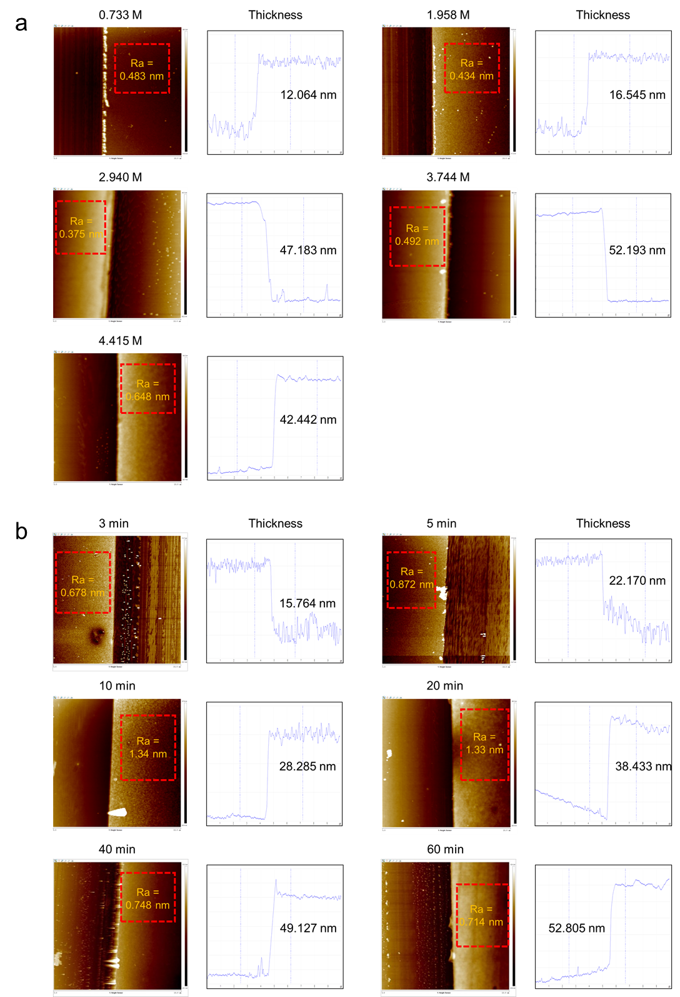
- SPM micrographs (10 μm ×10 μm) of the thickness of PMAA brushes with different monomer concentration (the polymerization time is 60 min) (a) and different polymerization times (the monomer concentration is 3.744 M).

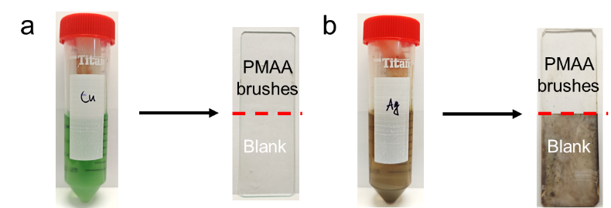
- Optical photographs of blank glass metallization and polymer brush-modified glass metallization.
We split the glass in half, one half is blank glass, and the other half is PMAA trimmed. Under Ag conditions, a layer of black particles was attached to the surface of the blank glass, which significantly affected the optical properties.

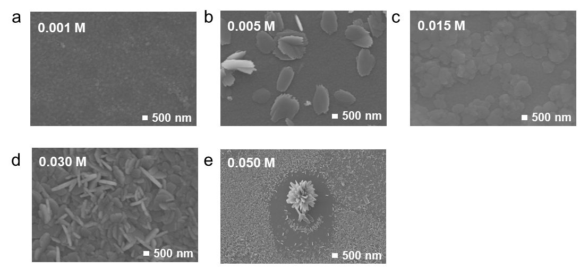
- SEM images of Cu-PB at different reaction concentrations (the Cu(NO₃)₂ solution using DMF as the solvent).
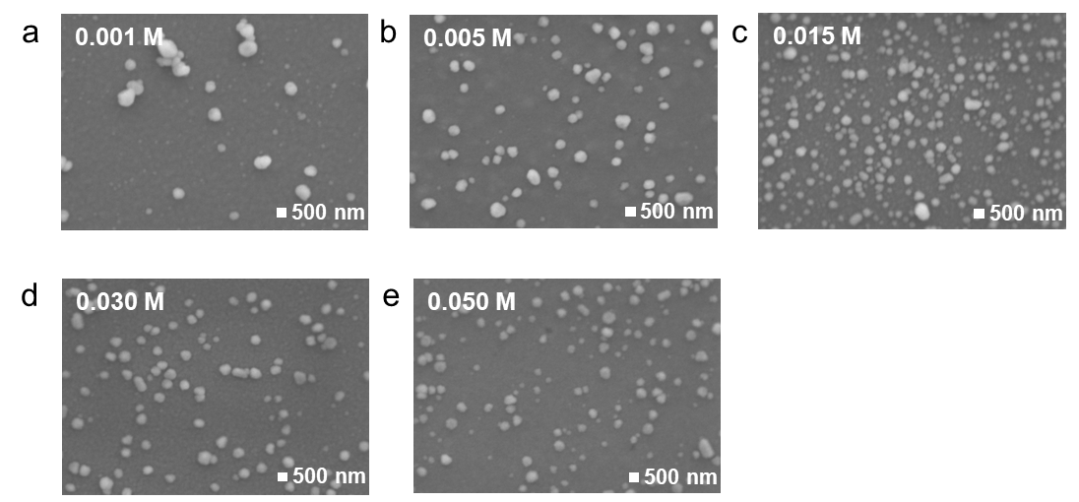
- SEM images of Ag-PB coating at different reaction concentrations (the AgNO₃ solution using DMF as the solvent).

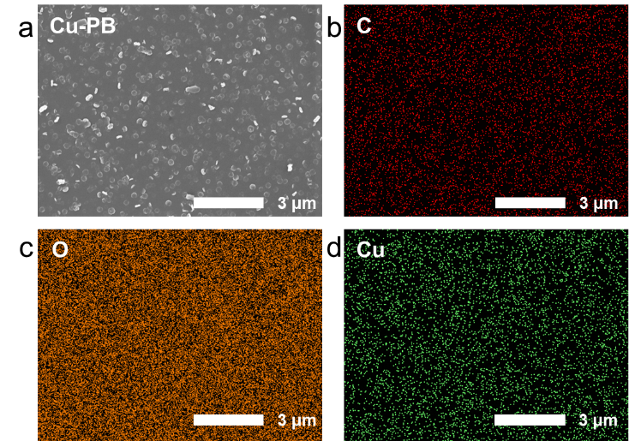
- EDS elemental maps of Cu-PB (The elemental analysis encompasses C, O and Cu).
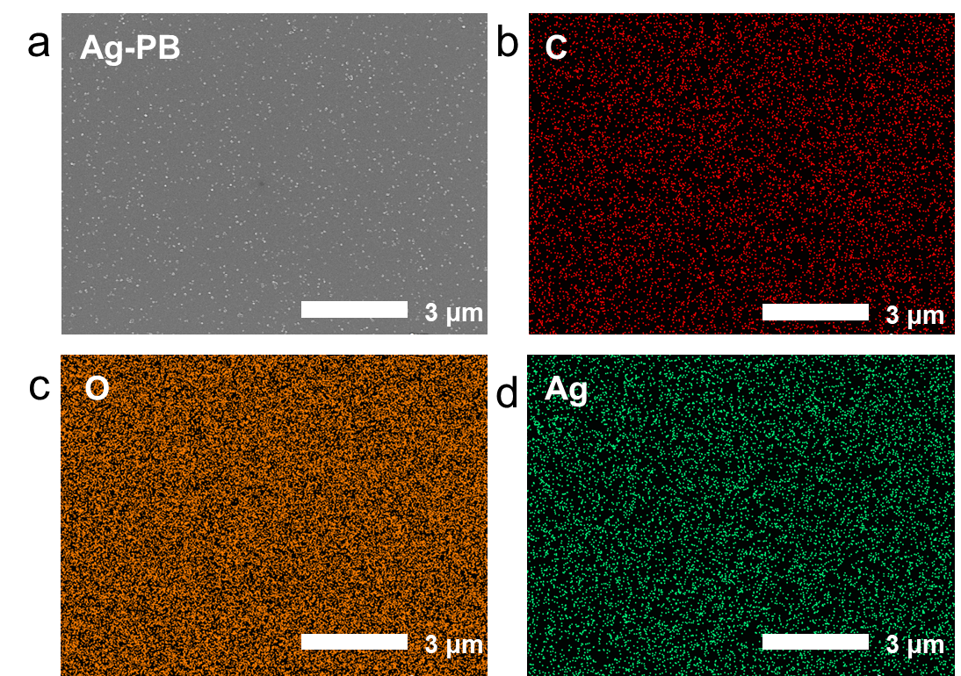
- EDS elemental maps of Ag-PB (The elemental analysis encompasses C, O and Ag).
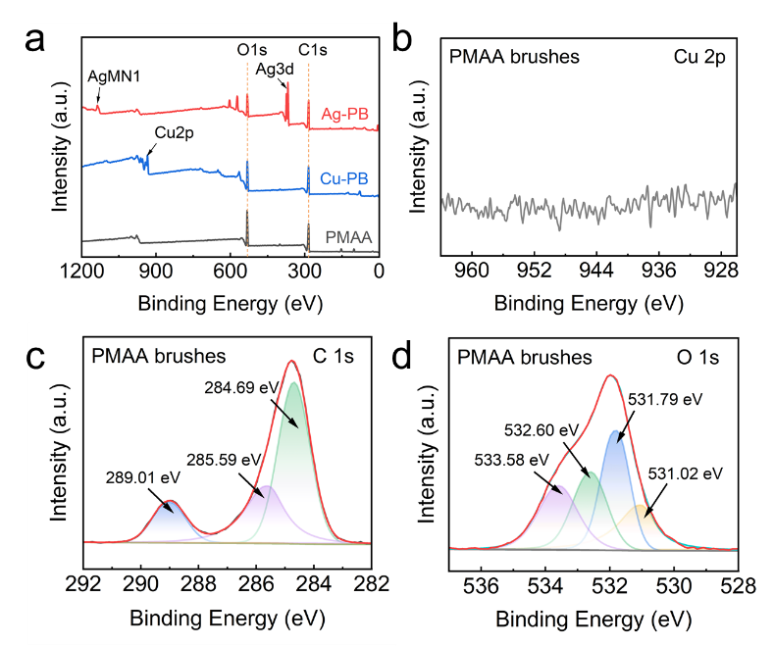
- The full-scan XPS spectra of (a) different coatings. High resolution XPS spectra of (b) Cu 2p, (c) C 1s, and (d) O 1s of PMAA brushes.
The absence of Cu 2p in PMAA brushes indicates that there is no residual catalytic copper after the preparation of the polymer brushes by SI-Cu⁰CRP.

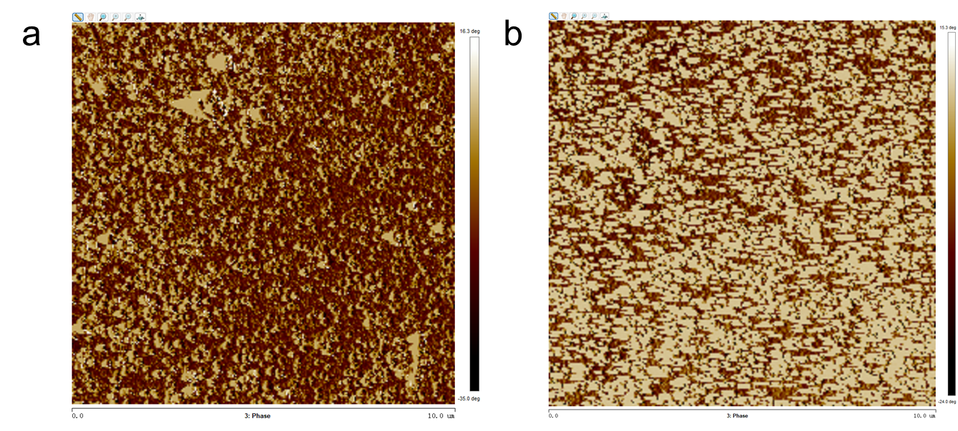
- SPM 2D phase diagrams of Cu-PB coating (a) and Ag-PB coating (b).
The yellow background indicates that the substrate is of a flexible nature, demonstrating PMAA polymer brushes, while the brown spheres indicate Cu, CuO, Ag, and Ag₂O inorganic material adhering to the surface, which is a rigid material.

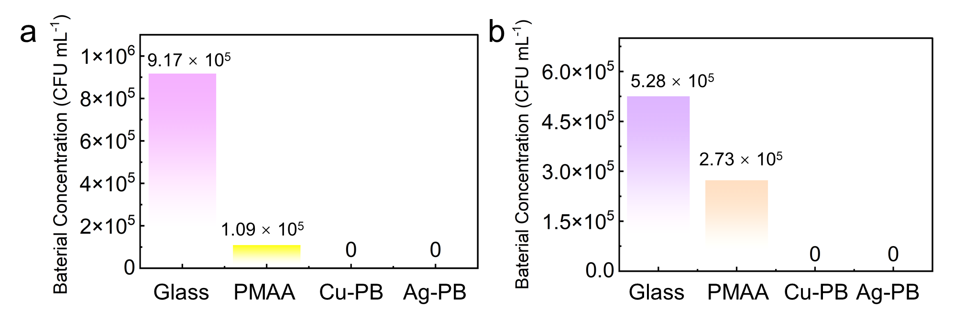
- The bacterial concentration ((a) E. coil and (b) S. aureus) of the antibacterial experiment of blank glass, PMAA brushes, Cu-PB, and Ag-PB.
The antibacterial efficiency can be quantitatively determined based on the experimental data obtained through Eq. 1 in Section 2.5.

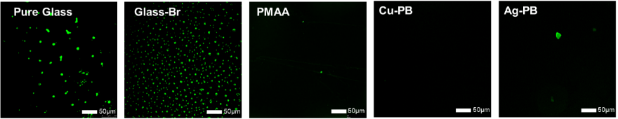
- Fluorescence microscope photos of anti-BSA adhesion tests on pure glass, initiator-functionalized glass (glass-Br), PMAA brushes, Cu-PB, and Ag-PB.

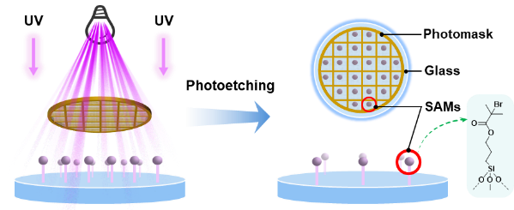
- Schematic of the preparation of patterned PMAA brushes with the photomask. (Wavelength: 254 nm; time: 30 min) The mask plate is skeletonized and can be in a variety of shapes, such as grids, pandas, and bamboo.

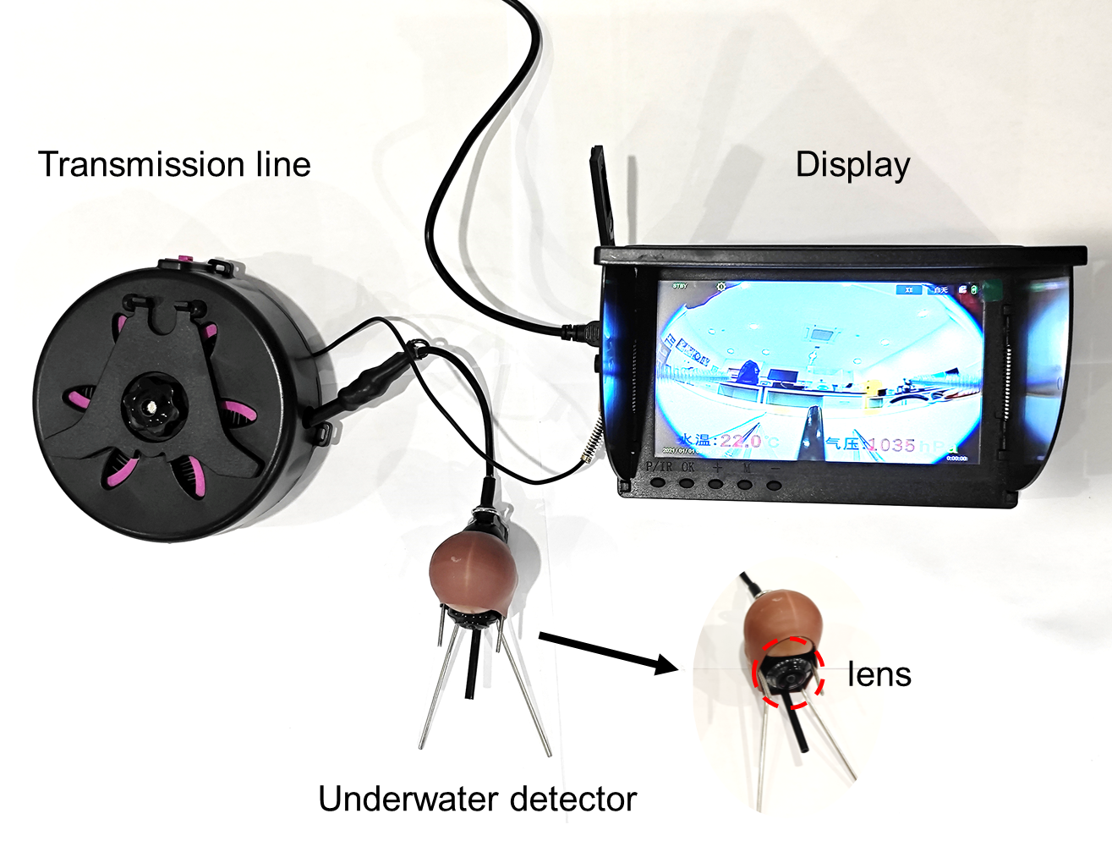
- Underwater photography equipment displays Equipment includes a transmission line, display, an underwater detector, and a lens. (The lens of the detector is coated with Cu-PB. The length of the wire is 5m. The display allows real-time observation of the underwater state, and the quality of the presentation reflects the attachment of contaminants to the surface of the lens.)

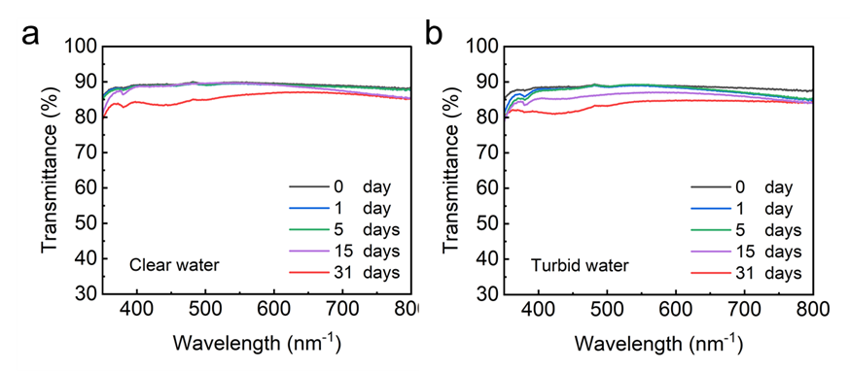
- Optical transmission spectra in the visible light range (350-800 nm) of Cu-PB coated glass during 31 days underwater test in clear water and turbid water.
We conducted transparency tests of Cu-PB coated glass for different underwater test durations in both clear and turbid water at five time points (0 days, 1 day, 5 days, 10 days, and 30 days) to evaluate Mt-PB stability. In clear water, the optical transparency of the Cu-PB coated glass exhibited only minor variation from 86.70% to 85.13% (Δ=1.57%) between day 0 and day 31. Similarly, in muddy water, the transparency gradually decreased to 84.76%.

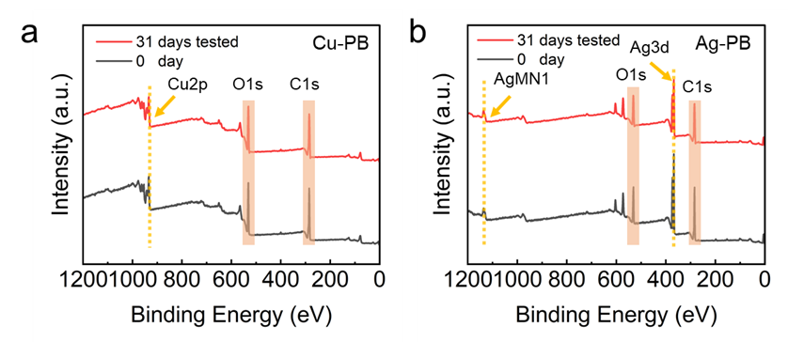
- The full-scan XPS spectra of Cu-PB (a) and Ag-PB (b) before and after 31-day underwater exposure in clear water.

Supplementary Tables
Table S1. The atomic ratio of different elements (C, O, Cu, and Ag) in PMAA brushes and Mt-PB via XPS spectrum.
Atomic ratio/% | C 1s | O 1s | Cu 2p | Ag 3d
PMAA | 68.83 | 30.85 | 0.26 | 0.06
Cu-PB | 65.86 | 26.59 | 7.49 | 0.07
Ag-PB | 70.74 | 21.70 | 0.44 | 7.12

Table S2. Summary of the Antibacterial performance of different polymer brushes.
Material | Antibacterial Time (h) | Inhibition rate (%) |  | Durability (days) | Ref.
Material | Antibacterial Time (h) | E. coli | S. aureus | Durability (days) | Ref.
PDMAEMA brushes | 3 | ~90 | None | None | [1]
Si-g-PEGMA-QAC₂ | 8 | ~98 | ~98 | 7 | [2]
CM-1 | 2 | 90.5 | 95.1 | None | [3]
HSF-NPA | 6 | 99.9 | 99.5 | None | [4]
CB-75 | 24 | 96 | 91 | None | [5]
CA-PLL2.5 | 24 | 99.99 | 99.99 | 65 | [6]
P2-g-PMETA | 1 | ~96 | ~97 | None | [7]
PSBMA/PQA4C-10% | 24 | None | 91.9 | None | [8]
PSBMA/PQA4C-30% | 24 | None | 94.9 | None | [8]
PSBMA/PQA₈C-10% | 24 | None | 93.6 | None | [8]
PVC-PFMC-IL | 3 | 93.7 | 92.5 | None | [9]
Si-pSBMA | 0.5 | ~1 | ~3 | None | [10]
Si-pAG₈ | 0.5 | ~100 | ~100 | None | [10]
Si-pSBMA-pAGC₈ | 0.5 | ~100 | ~100 | None | [10]
PIL-BF₄ | 24 | 99.2 | 88.1  (B. subtilis) | None | [11]
PIL-Br | 24 | 99.2 | 86.6  (B. subtilis) | None | [11]
C₁₂-M | 6 | 81.2 | 64.3  (E. faecalis) | None | [12]
TA-C₁₂-M | 6 | 87.2 | 67.9  (E. faecalis) | None | [12]
TA-M | 6 | 63.2 | 54.6  (E. faecalis) | None | [12]
C₁₂-TA-M | 6 | 92.0 | 77.6  (E. faecalis) | None | [12]
PMAA brushes | 24 | 88.11 | 48.30 | None | This work
Mt-PB | 24 | 99.99 | 99.99 | 31 | This work
Notes: Since some articles lack specific value labels, the '~' symbol denotes estimated values based on article images. ‘()’ indicates the antibacterial strain rather than S. aureus.

Table S3. The atomic ratio of different elements (C, O, Cu, and Ag) in PMAA brushes and Mt-PB before and after 31-day underwater exposure via XPS spectrum.
Atomic ratio/% |  | C 1s | O 1s | Cu 2p | Ag 3d
0 day | Cu-PB | 65.86 | 26.59 | 7.49 | 0.07
0 day | Ag-PB | 70.74 | 21.70 | 0.44 | 7.12
31 days | Cu-PB | 65.18 | 27.97 | 6.76 | 0.09
31 days | Ag-PB | 63.45 | 30.58 | 0.26 | 5.71

References
1. Y. Ko, V. K. Truong, S. Y. Woo, M. D. Dickey, L. Hsiao and J. Genzer. Counterpropagating Gradients of Antibacterial and Antifouling Polymer Brushes. Biomacromolecules. 2022, 23(1): 424-430.
2. S. Yan, L. Song, S. Luan, Z. Xin, S. Du, H. Shi, S. Yuan, Y. Yang and J. Yin. A hierarchical polymer brush coating with dual-function antibacterial capability. Colloids and Surfaces B: Biointerfaces. 2017, 149: 260-270.
3. C. Xu, J. Jiang, H. Oguzlu, Y. Zheng and F. Jiang. Antifouling, antibacterial and non-cytotoxic transparent cellulose membrane with grafted zwitterion and quaternary ammonium copolymers. Carbohydrate Polymers. 2020, 250: 116960.
4. K. Li, J. Chen, Y. Xue, T. Ding, S. Zhu, M. Mao, L. Zhang and Y. Han. Polymer brush grafted antimicrobial peptide on hydroxyapatite nanorods for highly effective antibacterial performance. Chemical Engineering Journal. 2021, 423: 130133.
5. S. Kinali-Demirci. Cross-Linked Polymer Brushes Containing N-Halamine Groups for Antibacterial Surface Applications. Polymers. 2021, 13(8): 1269.
6. J. Liu, Y. Xu, X. Lin, N. Ma, Q. Zhu, K. Yang, X. Li, C. Liu, N. Feng, Y. Zhao, X. Li and W. Zhang. Immobilization of poly-L-lysine brush via surface initiated polymerization for the development of long-term antibacterial coating for silicone catheter. Colloids and Surfaces B: Biointerfaces. 2023, 221: 113015.
7. S. Dhingra, A. Joshi, N. Singh and S. Saha. Infection resistant polymer brush coating on the surface of biodegradable polyester. Materials Science and Engineering: C. 2021, 118: 111465.
8. Y. He, X. Wan, K. Xiao, W. Lin, J. Li, Z. Li, F. Luo, H. Tan, J. Li and Q. Fu. Anti-biofilm surfaces from mixed dopamine-modified polymer brushes: synergistic role of cationic and zwitterionic chains to resist staphyloccocus aureus. Biomaterials Science. 2019, 7(12): 5369-5382.
9. Y. Yu, S. Liu, W. Xia, Z. Zhu, W. Wang, C. Zhou, Z. Wu and H. Chen. Fabrication of ionic liquid-functionalized aliphatic polycarbonate brushes for self-polishing antibacterial application. Applied Surface Science. 2023, 639: 158157.
10. T. Chen, L. Zhao, Z. Wang, J. Zhao, Y. Li, H. Long, D. Yu, X. Wu and H. Yang. Hierarchical Surface Inspired by Geminized Cationic Amphiphilic Polymer Brushes for Super-Antibacterial and Self-Cleaning Properties. Biomacromolecules. 2020, 21(12): 5213-5221.
11. D. Wu, J. Wang, X. Yin, R. Tan and T. Zhang. Grafting of Poly(ionic liquid) Brushes through Fe0-Mediated Surface-Initiated Atom Transfer Radical Polymerization for Marine Antifouling. Langmuir. 2024, 40(16): 8393-8399.
12. D. Xie, H. Zhao, D. Dilxat, S. Ren and Y. Wang. Antibiofouling Polyvinylidene Fluoride Membrane Functionalized by Diblock Copoly(ionic liquid) Brushes. ACS ES&T Engineering. 2023, 3(9): 1330-1338.

