Electronic Supplementary Material

Gas pressure-sensitive regulation of exciton state of monolayer tungsten disulfide
Shuangping Han¹, Pengyu Zan¹, Yu Yan¹, Yaoxing Bian¹, Chengbing Qin ()², Liantuan Xiao ()^{1,2}
1 College of Physics, Taiyuan University of Technology, Taiyuan 030002, China
2 State Key Laboratory of Quantum Optics and Quantum Optics Devices, Institute of Laser Spectroscopy, Shanxi University, Taiyuan 030006, China

E-mails: chbqin@sxu.edu.cn (Qin C); xlt@sxu.edu.cn (Xiao L)

1. Sample homogeneity
Mechanical exfoliation is a well-established method for preparing monolayer and thin-layer two-dimensional materials [1]. The samples prepared using this method typically exhibit better lattice quality, fewer defects, and controllable thickness [2]. In addition to Atomic Force Microscope image, optical image and photoluminescence (PL) image are commonly used to characterize the quality of sample.
Fig. S1 (a) PL imaging of the sample. (b) Statistical histogram of the emission intensity.
In this work, we used a monolayer tungsten disulfide (WS₂) prepared by mechanical exfoliation. The optical image of the sample was shown in Fig. 1b, and the colour of the image reflected the number of layers due to the direct correlation between the material's thickness and refractive index [3]. The uniform colour distribution indicated the homogeneity of the number of layers. The interlayer dielectric shielding effect causes the PL of transition metal dichalcogenides to weaken as the increases of layers’ number. Additionally, the bandgap of bulk materials changes from direct bandgap of the monolayer to indirect [4-6]. Therefore, homogeneous PL emission intensities can further prove that the sample is monolayer. Fig. S1a showed the PL image of the experimental sample. The orange-colored area represented the prepared monolayer WS₂. It can be observed that PL intensities of the ME WS₂ are essentially identical. Fig. S1b showed a statistical histogram of the emission intensity in Fig. S1a. The data were analyzed by three-peak Gaussian fitting. And the three peaks correspond to the orange region (WS₂), light-green region (another material prepared by ME), and green region (heterostructure region where WS₂ overlaps with the other material). The intensity peak of WS₂ can be well matched with Gaussian fitting, proving the homogeneity of the sample.

2. Evolution of exciton states with gas pressure
To determine the impact of various pressure on the emission profile of the exciton states in WS₂, we measured the PL spectra at different gas pressure. Results are presented in Figs. 4 and S2. The spectral weight of the neutral exciton state (A⁰) decreases with increasing pressure, while the proportion of the charged exciton (A⁻) increases. And the peak energies of A⁰ and A⁻ were obtained by Lorentz bimodal fitting, as shown in the upper panel of Fig. S2b. The binding energy of trion, which is the difference between the two, decreased from 48.6 meV to 40.1 meV as the pressure increased. The main reasons for these two phenomena are the pressure-induced gas desorption and variation of the trion’s binding energy with the concentration of 2D electron gas (2DEG) on the surface of the material.
Fig. S2 (a) Spectral weights of A⁰ and A⁻ as a function of pressure. (b) Upper panel: peak energies of A⁰ and A⁻ as a function of pressure. Lower panel: evolution of the binding energy of the trion as a function of pressure.

2.1 Evolution of the spectral weights of exciton states with pressure
Fig. S2a showed that the spectral weight of A⁰ is higher while the proportion of A⁻ is lower at low pressure,. As pressure increased, the proportion of A⁻ increased while the weight of A⁰ decreased. The phenomenon was caused by the desorption of gas from the surface due to the combined effect of pressure and laser irradiation. This can also be observed from the bi-exponential behaviour of the PL quenching with time at different pressure (Fig. S3). The quenching process from 222 mTorr to atmospheric pressure consists of two time components. In the main text, we noted that these two time components correspond to the quenching rates induced by laser irradiation (t₁) and pressure (t₂), respectively. The time evolution of the electron population under pressure can be expressed by the following equation [7]:
where N(t, P) is the electron population at time t when the pressure is P; N(0) is the number of electrons at the initial time of laser illumination; k₁, k₃ represent the gas desorption and adsorption rates due to laser irradiation, respectively, and the adsorption rate is very slow and can be neglected in low-pressure environments; and k₂ denotes the gas desorption rate under the effect of ambient pressure.
Fig. S3 (a) Pressure-induced PL quenching trajectories at the same point. (b) Results of the bi-exponential fitting of the quenching curve in Fig. S3a, where t₁ is the time component representing the laser irradiation and t₂ is related to the pressure.

2.2 Evolution of trion's binding energy with pressure
WS₂ is a typical transition metal dichalcogenides with an energy band structure that follows space inversion symmetry breaking [8]. It has two energy valleys, K and K', with different spin directions in the hexagonal honeycomb lattice in momentum space, as shown in Fig. S4. The K and K' valleys respond to left- and right-spinning light, respectively, making them an ideal platform for studying valley electronics. These valleys contain electrons with different spin orientations, resulting in a rich combination of particles and physical processes. Taking trion as an example, there are three main types binding modes within WS₂ [9-10]: (i) Intra-valley trion, consisting of an electron-hole pair with identical spin and a charge of opposite spin in the same energy valley, as shown in Fig S4a. The binding between carriers does not require crossing energy valleys. (ii) Inter-valley trion with the same spin, consisting of an inner neutral exciton with identical spin in the K(K') valley and a charge with the same spin in the K'(K) valley, is required to cross the energy valley (Fig S4b). (iii) Inter-valley trion with opposite spin, consisting of an inner neutral exciton of the same spin in the K(K') valley and a charge of opposite spin in the K'(K) valley, is required to cross the energy valley and overcome the energy of the electron spin-flip (Fig S4c). The stability of these trions are ordered from small to large as (iii)<(ii)<(i).
At lower 2DEG concentrations, trion (i) dominates. While at higher 2DEG concentrations, when the electron’s Fermi energy level is located above the higher spin-splitting conduction band, trions are dominated by (ii) and (iii) [9]. The lower the pressure, the more obvious the effect of gas desorption on the surface of WS₂. Under low pressure, the number of electrons on the surface of WS₂ decreases, resulting in a decrease in the concentration of 2DEG. This result leads to the formation of low-energy and stable trions, which in turn increases the binding energy of the trions. As pressure increases, the concentration of 2DEG increases, causing the trion to tend to be bound in a high-energy form, thereby decreasing the binding energy. Furthermore, the increase in the proportion of A⁰ at low pressure can be attributed to the significant decrease in charged ions resulting from the gas desorption phenomenon induced by pressure (Fig. 4, Fig. S2a).
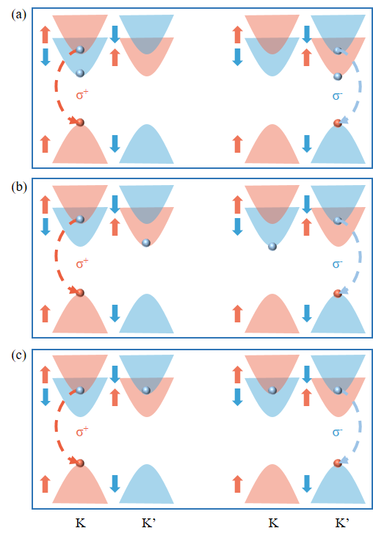
Fig. S4 Possible combinations of trions within a monolayer WS₂. (a) Intra-valley trion. (b) Inter-valley trion with the identical spin. (c) Inter-valley trion with opposite spin.

References
1. Xin, N.; Lourembam, J.; Kumaravadivel, P.; Kazantsev, A. E.; Wu, Z.; Mullan, C.; Barrier, J.; Geim, A. A.; Grigorieva, I. V.; Mishchenko, A.; Principi, A.; Fal’ko, V. I.; Ponomarenko, L. A.; Geim, A. K.; Berdyugin, A. I., Giant magnetoresistance of Dirac plasma in high-mobility graphene. Nature 2023, 616 (7956), 270-274
2. Yi, M.; Shen, Z., A review on mechanical exfoliation for the scalable production of graphene. Journal of Materials Chemistry A 2015, 3 (22), 11700-11715
3. Yang, A.; Blancon, J. C.; Jiang, W.; Zhang, H.; Wong, J.; Yan, E.; Lin, Y. R.; Crochet, J.; Kanatzidis, M. G.; Jariwala, D.; Low, T.; Mohite, A. D.; Atwater, H. A., Giant enhancement of photoluminescence emission in WS2-two-dimensional perovskite heterostructures. Nano Letters 2019, 19 (8), 4852-4860
4. Lin, Y.; Ling, X.; Yu, L.; Huang, S.; Hsu, A. L.; Lee, Y.-H.; Kong, J.; Dresselhaus, M. S.; Palacios, T., Dielectric screening of excitons and trions in single-layer MoS2. Nano Letters 2014, 14 (10), 5569-5576
5. Li, L. H.; Tian, T.; Cai, Q.; Shih, C. J.; Santos, E. J. G., Asymmetric electric field screening in van der Waals heterostructures. Nature Communications 2018, 9 (1), 1271
6. Qin, C.; Gao, Y.; Qiao, Z.; Xiao, L.; Jia, S., Atomic‐layered MoS2 as a tunable optical platform. Advanced Optical Materials 2016, 4 (10), 1429-1456
7. Yang, C.; Gao, Y.; Qin, C.; Liang, X.; Han, S.; Zhang, G.; Chen, R.; Hu, J.; Xiao, L.; Jia, S., All-optical reversible manipulation of exciton and trion emissions in monolayer WS2. Nanomaterials 2019, 10 (1), 23
8. Xu, X.; Yao, W.; Xiao, D.; Heinz, T. F., Spin and pseudospins in layered transition metal dichalcogenides. Nature Physics 2014, 10 (5), 343-350
9. Jadczak, J.; Kutrowska-Girzycka, J.; Kapuściński, P.; Huang, Y. S.; Wójs, A.; Bryja, L., Probing of free and localized excitons and trions in atomically thin WSe2, WS2, MoSe2 and MoS2 in photoluminescence and reflectivity experiments. Nanotechnology 2017, 28 (39), 395702
10. Bonnet, N.; Lee, H. Y.; Shao, F.; Woo, S. Y.; Blazit, J.-D.; Watanabe, K.; Taniguchi, T.; Zobelli, A.; Stéphan, O.; Kociak, M.; Gradečak, S.; Tizei, L. H. G., Nanoscale modification of WS2 trion emission by its local electromagnetic environment. Nano Letters 2021, 21 (24), 10178-10185

