Supporting Information for

Development of a flame-retardant epoxy resin with high glass transition temperature and transparency based on a diphenylphosphine oxide derivative
Luyu Zheng ^{a,1}, Mei Wu ^{a,1}, Dayu Sun ª, Wei Zhao ^{b}, Qingzhong Xue ^{a,c}, Liang Song ^{a,c}, Qing Yu ^{a,c}, Haodong Duan ^{a,c}*，Hui Yang ^{d}*, Zhongwei Wang ^{a,c}
ª College of Materials Science and Engineering, Shandong University of Science and Technology, Qingdao 266590, PR China
^{b} Shandong Rede New Materials Co., Ltd., Linyi 276000, China
^{c} Shandong Key Laboratory of Special Epoxy Resin, School of Materials Science and Engineering, Shandong University of Science and Technology, Qingdao 266590, China
^{d} Library, Shandong University of Science and Technology, Qingdao 266590, PR China
Correspondence to: Haodong Duan (duanhd@sdust.edu.cn), Hui Yang (huiyang@sdust.edu.cn)

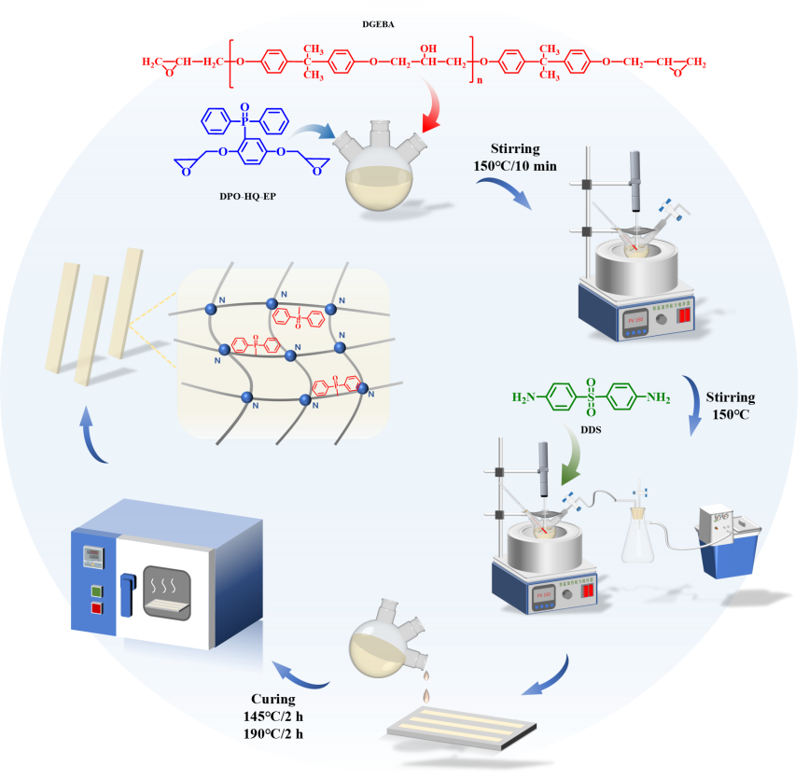
Fig. S1 Schematic diagram of preparation process of EP thermosets
Table S1 Formulations of EP thermosets
Samples | DGEBA (g) | DDS (g) | DPO-HQ-EP (g) | DPO-HQ (g) | P (wt %)
EP/0 | 60 | 20.12 | 0 | 0 | 0
EP/DPO-HQ-EP/0.3 | 60 | 21.13 | 3.46 | 0 | 0.3
EP/DPO-HQ-EP/0.6 | 60 | 22.27 | 7.33 | 0 | 0.6
EP/DPO-HQ-EP/0.9 | 60 | 23.55 | 11.69 | 0 | 0.9
EP/DPO-HQ/0.6 | 60 | 18.12 | 0 | 5.00 | 0.6

1. Crosslinking density of EP thermosets
The Crosslink density (ν_{e}) of the EP thermosets was calculated according to the following equation:
ν_{e} = E'/3RT
Where E' is the storage modulus of the EP thermoset in the rubbery region (T_{g} + 40 °C). R is the gas constant. T =T_{g} + 40 +273.15.
Table S2 DMA results of the EP thermosets.
Sample | T_{g} (°C) | E' (MPa) |  | ν_{e} (×10³ mol/m³)
Sample | T_{g} (°C) | Glass region ª | Rubbery region ^{b} | ν_{e} (×10³ mol/m³)
EP-0 | 214 | 1909 | 13.84 | 1052
EP/DPO-HQ-EP/0.3 | 212 | 1902 | 15.30 | 1168
EP//DPO-HQ-EP/0.6 | 216 | 2125 | 14.43 | 1093
EP//DPO-HQ-EP/0.9 | 212 | 2032 | 15.05 | 1145
EP/DPO-HQ/0.6 | 193 | 1869 | 8.61 | 680
ª E' at 50 ºC; ^{b} E' at (T_{g}+40) ºC.

2. Thermal degradation behavior of EP thermosets under air atmosphere
EP thermosets underwent decomposition in two stages under an air atmosphere. The first decomposition stage could be attributed to the thermos-oxidative degradation of the matrix. The second decomposition stage could be attributed to further thermos-oxidative degradation of the above-mentioned residue. Compared with the decomposition process under a nitrogen atmosphere, the oxygen in the air induced the oxidative degradation of EP thermosets. The TGA and DTG curves of EP/DPO-HQ-EP and EP/DPO-HQ samples were nearly identical that of EP/0, indicating that the addition of flame retardants did not change the degradation behavior of pure EP under an air atmosphere.
Fig. S2 TGA (a) and DTG (b) curves of EP thermosets under air atmosphere
(a)
(b)
Table S3 TGA results of EP thermosets under an air atmosphere
Sample | T_{5%} (°C) | T_{max1} (°C) | T_{max2} (°C) | R_{max1} (%/°C) | R_{max1} (%/°C) | Y₆₀₀ (wt.%)
EP/0 | 309 | 330 | 513 | 0.69 | 0.68 | 2.36
EP/DPO-HQ-EP/0.3 | 310 | 329 | 512 | 0.75 | 0.68 | 2.59
EP/DPO-HQ-EP/0.6 | 313 | 332 | 515 | 0.69 | 0.71 | 3.43
EP/DPO-HQ-EP/0.9 | 314 | 331 | 518 | 0.68 | 0.70 | 4.43
EP/DPO-HQ/0.6 | 313 | 331 | 514 | 0.66 | 0.70 | 3.28

