Electronic Supplementary Material

Rhodium complex-anchored and supramolecular polymer-grafted CdS nanoflower for enhanced photosynthesis of H₂O₂ and photobiocatalytic C–H bond oxyfunctionalization
Hongwei Jia¹, Xiaoyang Yue ()¹, Yuying Hou¹, Fei Huang¹, Cuiyao Cao¹, Feifei Jia¹, Guanhua Liu¹, Xiaobing Zheng ()^{1,2}, Yunting Liu ()¹, Yanjun Jiang^{1,2}
1 School of Chemical Engineering and Technology, Hebei University of Technology, Tianjin 300401, China
2 National-Local Joint Engineering Laboratory for Energy Conversion in Chemical Process Integration and Resources Utilization, School of Chemical Engineering and Technology, Hebei University of Technology, Tianjin 300401, China
E-mails: xiaoyang.yue@hebut.edu.cn (Yue X); zhengxiaobing@hebut.edu.cn (Zheng X); ytliu@hebut.edu.cn (Liu Y).

1. Characterizations
Morphology and composition characterizations includes: The physical structure of the sample was analyzed by scanning electron microscope (SEM, FEI NanoSEM450) and transmission electron microscope (TEM, JEOL-2100F). The crystal structure of the sample was characterized by X-ray diffractometer (XRD, Ultima IV, Cu Kα (λ = 1.5418), scanning rate 5 °/ min, range 20-80 °) and Raman, DM2700M. The element composition of the sample was determined by X-ray photoelectron spectroscopy (XPS, ESCALAB 250Xi). The specific surface area of BET and the pore size distribution of BJH were measured by nitrogen adsorption and desorption apparatus. Nuclear magnetic resonance spectra (1H NMR and ¹³C NMR) were recorded on a Bruker AV 400 spectrometer at 400MHz. The conversion and enantioselectivity (ee) of the products were determined by high performance gas chromatography (GC, Shimadzu GC2010). Photoelectrochemical measurements includes: The optical absorption ability, energy band structure and carrier transport rate of the samples were measured by ultraviolet-visible diffuse reflectance spectroscopy (DRS, U-3010) and photoluminescence spectra (PL, Fluorolog3-21). The photoelectric properties of the samples were tested by electrochemical workstation (CHI 760E). Under the simulated solar irradiation conditions (300W, xenon lamp), the transient photocurrent response of the sample was carried out in 0.5m Na₂SO₄ aqueous solution.

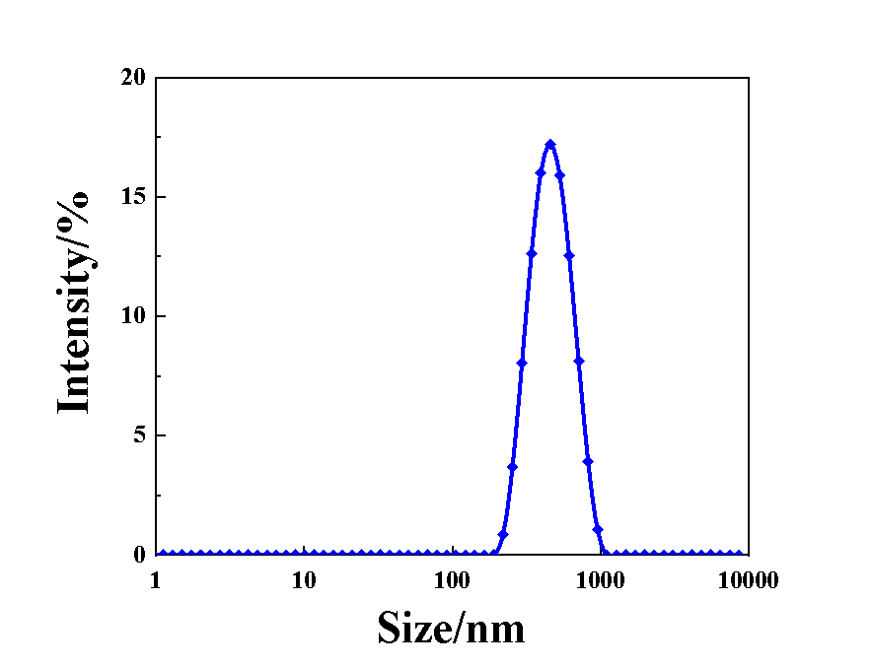
Figure S1. Dynamic light scattering spectrum of M@CdS
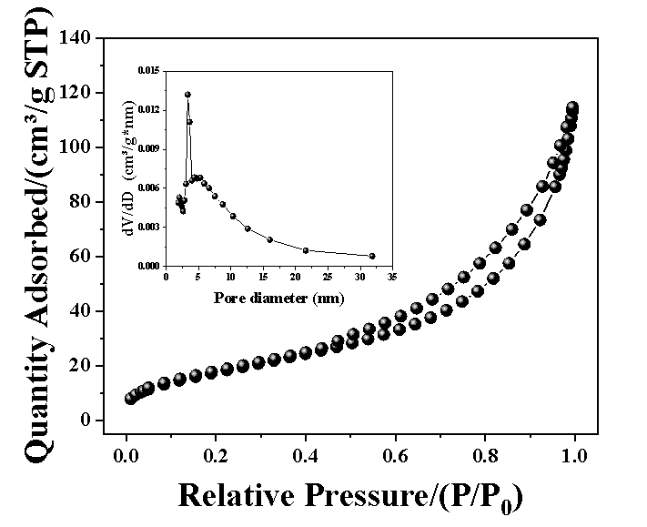
Figure S2. N₂ adsorption-desorption isotherm and the corresponding pore size distribution curve of CdS nanoflower

Table S1.Structural and textural properties of CdS
 | Band gapª/eV | Surface area^{b}/(m²/g) | Average pore diameter^{c} /nm
CdS | 2.48 | 87.74 | 9.59
[a] Estimated band gap from Kubelka-Munk plots; [b] BET specific surface areas were calculated by N₂ adsorption-desorption isotherm; [c] Average pore diameter estimated by BJH.
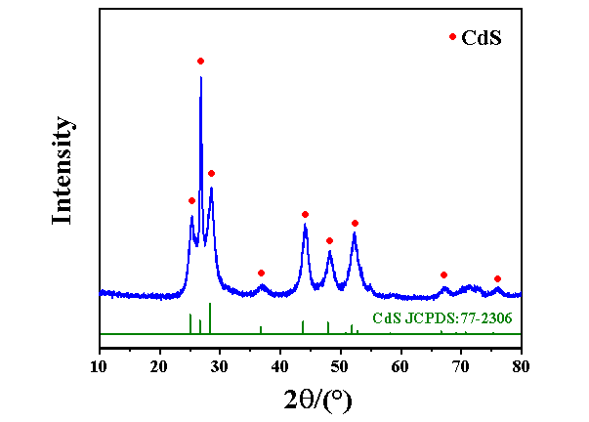
Figure S3. XRD pattern of CdS nanoflower

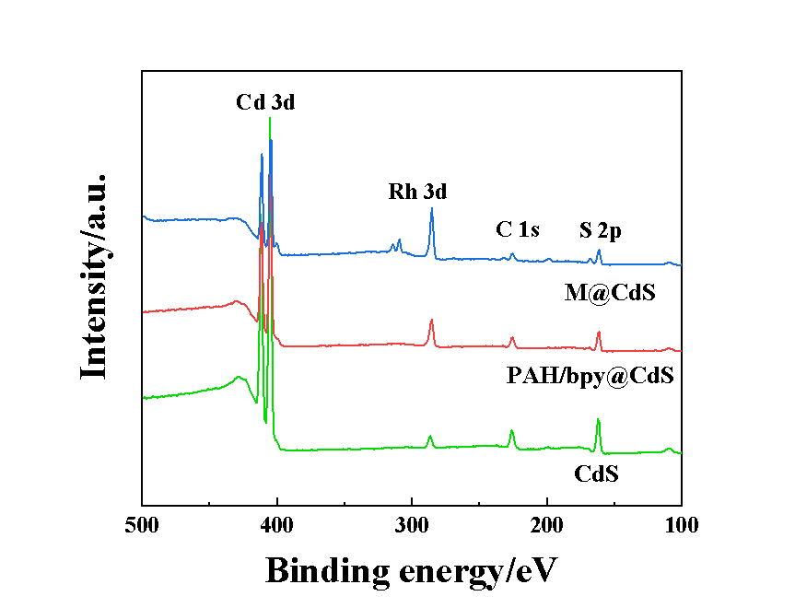
Figure S4. Wide XPS spectra of CdS, PAH/bpy@CdS and M@CdS
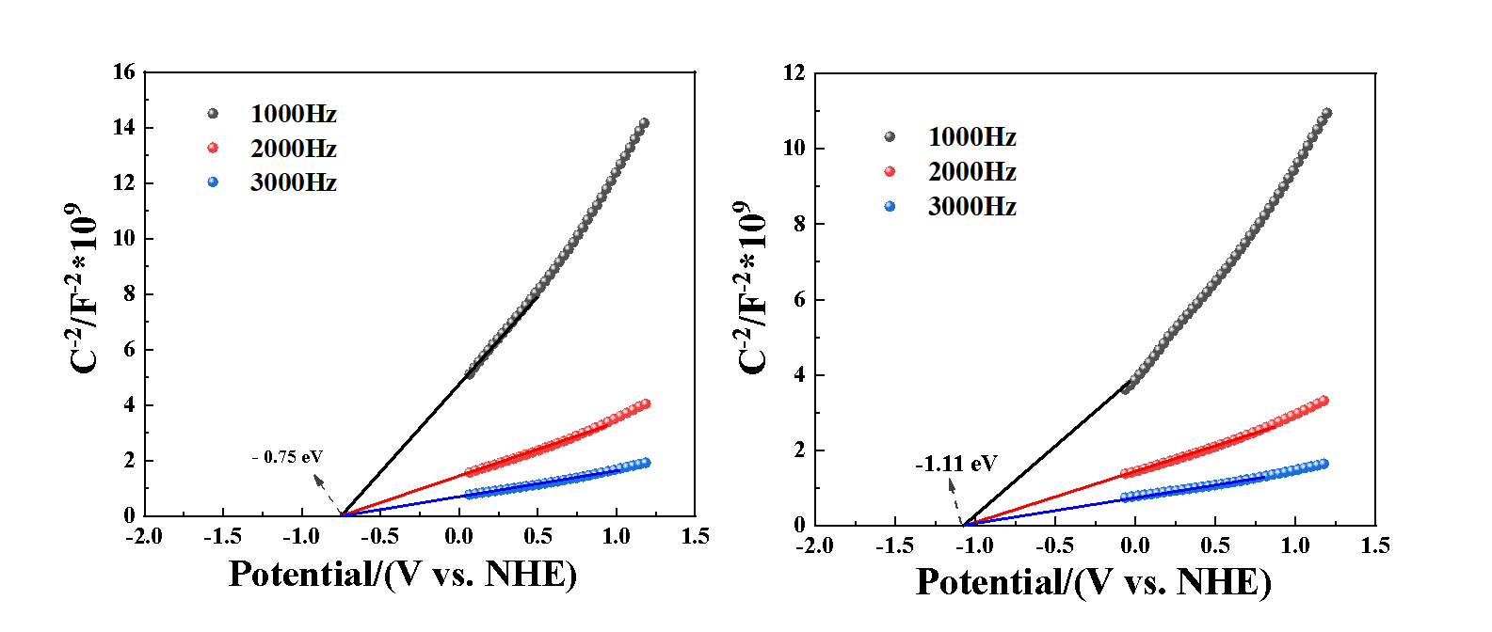
Figure S5. Mott–Schottky plots of a) pristine CdS and b) M@CdS (1, 2 and 3 kHz)

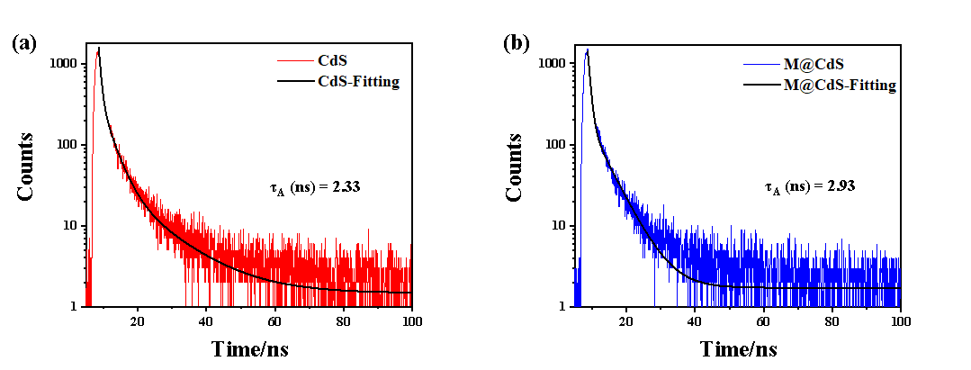
Figure S6. TRPL spectra of a) pristine CdS and b) M@CdS

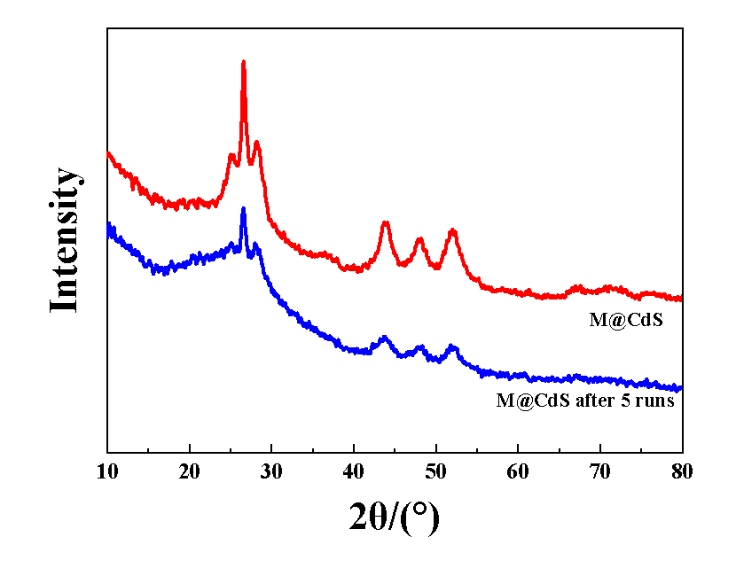
Figure S7. XRD patterns of M@CdS and M@CdS after 5 runs
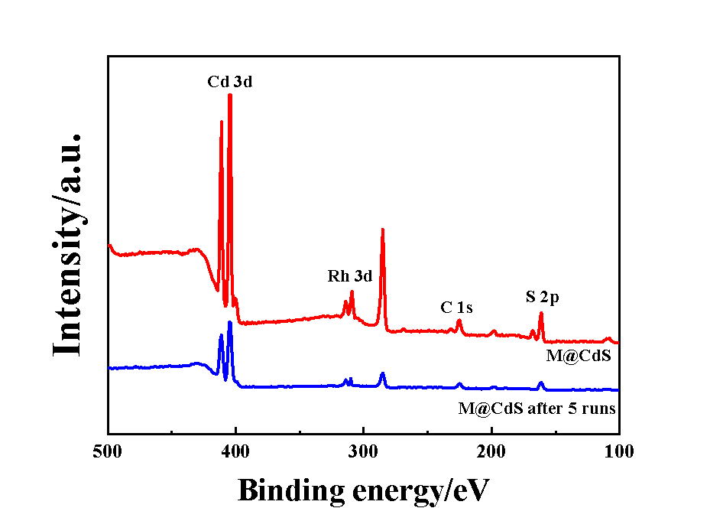
Figure S8. XPS spectra of M@CdS and M@CdS after 5 runs

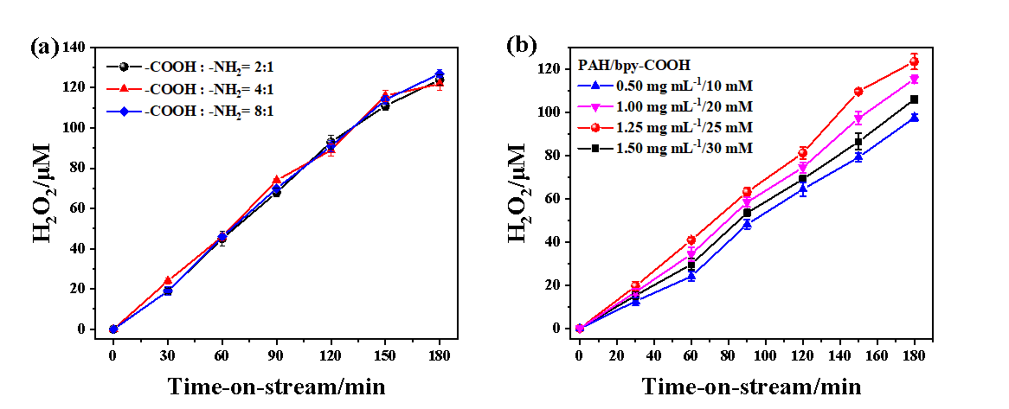

Figure S9. Influence of a) the ratio of bpy-COOH and PAH and b) initial concentration of bpy-COOH and PAH on the photocatalytic H₂O₂ generation performances f M@CdS.
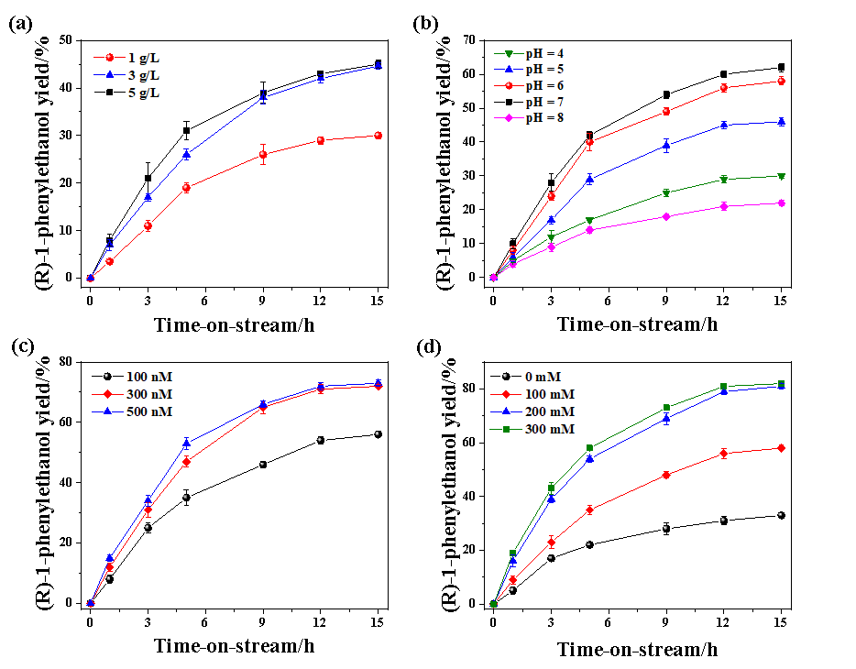
Figure S10. Influence of a) the concentration of M@CdS, b) pH value, c) initial concentration of UPO and d) the concentration of methanl on the photobiocatalytic production of (R)-1-phenylethanol.

