Electronic Supplementary Material
Effective lateral dispersion of momentum, heat and mass in bubbling fluidized beds

Gabriel Gustafsson¹, Guillermo Martinez Castilla², David Pallarès², Henrik Ström ()¹

1 Division of Fluid Dynamics, Chalmers University of Technology, SE-412 96 Gothenburg, Sweden
2 Division of Energy Technology, Chalmers University of Technology, SE-412 96 Gothenburg, Sweden
E-mail: henrik.strom@chalmers.se

CONTENTS

1. The two-fluid model

2. Additional notes on the methodologies

3. Experimental setup

4. Experimental determination of the dispersion coefficient

5. Power spectral density (PSD) analysis

6. Evaluation of methods

7. Simulation time

1. The two-fluid model

Table S1. The equations making up the framework of the two-fluid model used.
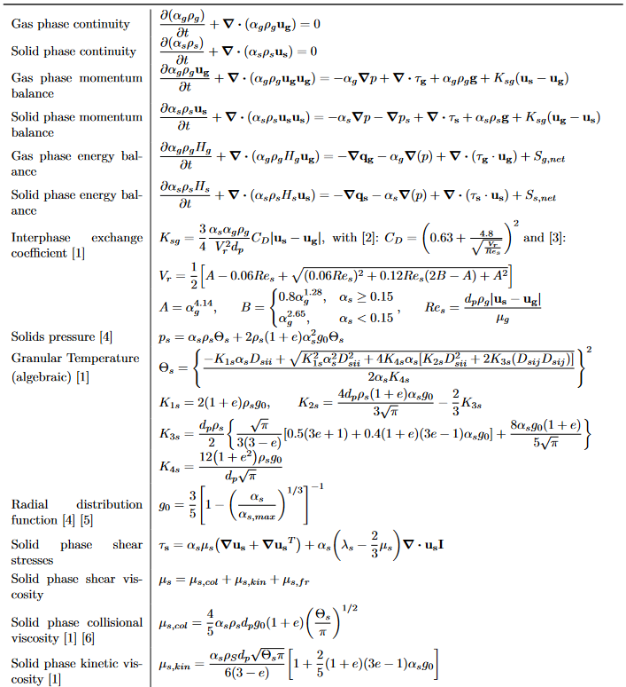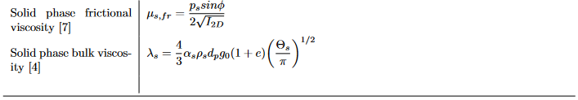

We choose this model formulation as we have used it in our previous works, including studies focusing on lateral solids dispersion in multi-staged fluidized beds [8], and observed satisfactory agreement with experiments.
2. Additional notes on the methodologies

2.1 Method 1 (CondTrans)

For the system depicted in Figure 1b in the main manuscript, a solution for the temperature profile, T∗, can be obtained through use of Fourier series:

$T^{*}\left(x,t;k_{eff}\right)=S\left(x\right)+ \frac{2}{π}\sum_{n=1}^{∞}{\frac{1}{n}\left(∆T_{h}-∆T_{c}{\left(-1\right)}^{n}\right)sin\left(\frac{nπx}{L}\right)exp\left[-\frac{k_{eff}}{ρc_{p}}{\left(\frac{nπ}{L}\right)}^{2}t\right]}$ (S1)

where

$S\left(x\right)=\frac{T_{c}-T_{h}}{L}x+T_{h}$ and $∆T_{h}=T_{0}-T_{h}$, $∆T_{c}=T_{0}-T_{c}$.

Given both the analytical temperature profile and the simulated profile, the effective conduction value, k_{eff}, for the simulated system is then obtained as the value minimizing the loss function:

$L≡\left|T^{*}\left(x,t;k_{eff}\right)-\overline{T}(x,t)\right|$ (S2)

where T∗ represents the analytical temperature profile and $\overline{T}$ the averaged profile from the simulated system. The average is twofold, both along the z-axis and the y-axis, the latter average being a weighted mean with the solid volume fraction as weight. Mathematically the averaging procedure to go from T(x,y,z,t) to $\overline{T}(x,t)$ can be described as:

$\overline{T}\left(x,t\right)=\frac{\sum_{j=0}^{n_{y}}{{\hat{α}}_{s}(x,j,t)\hat{T}(x,j,t)}}{\sum_{j=0}^{n_{y}}{{\hat{α}}_{s}(x,j,t)}}$ (S3)

where

${\hat{α}}_{s}\left(x,y,t\right)=\frac{1}{n_{z}}\sum_{k=0}^{n_{z}}{α_{s}(x,y,k,t)}$ and $\hat{T}\left(x,y,t\right)=\frac{1}{n_{z}}\sum_{k=0}^{n_{z}}{T(x,y,k,t)}$.

The purpose of this treatment is partly to reduce the dimensionality of the data. The second benefit from going to 1D is that the mixing from different vertical sections of the bed is lumped together and, through the z-average, more of the movement in the bed is taken into account compared to if only mixing along a plane had been studied. While the lumping of different contributions constitutes a loss of detail it is still desired in this case since a typical use for the effective conduction value would be in a reduced-order model with similarly lumped transport phenomena.

2.2 Method 2 (DispTrans)

The dimensionless marker function concentration field C is solved for using the following equation:

$\frac{∂C}{∂t}+∇∙\left(u_{s}C\right)=0$ (S4)

with no-flux boundary conditions on the walls and periodic boundary conditions in the z-direction. The applied initial condition is:

$C\left(t=0\right)=\left\{\begin{matrix}0, x≤{L_{x}}/2 \\ 1, x>{L_{x}}/2 \end{matrix}\right.$ (S5)

The ideal concentration profile is again obtained through Fourier series:

$C\left(x,t;D_{L}\right)=\frac{1}{2}-\frac{2}{π}\sum_{n=1}^{∞}{\frac{1}{n}sin\left(\frac{nπ}{2}\right)cos\left(\frac{nπx}{L}\right)exp\left[-D_{L}{\left(\frac{nπ}{L}\right)}^{2}t\right]}$ (S6)

Given the ideal solution, the procedure is analogous to that of method 1 in that a loss function is formulated and the simulation data averaged first along the z-axis and then volume-fraction weighted.

2.3 Method 4 (DispFluct)

Following the approach from Hinze [9], the turbulent dispersion coefficient, D_{T}, is defined as:

$D_{T}\left(a\right)=\overline{v^{'}{(a)}^{2}}T_{L}$ (S7)

where v’ is the fluctuating velocity, making the quantity $\overline{v^{'}{(a)}^{2}}$ correspond to the normal Reynolds stress. The a denotes direction (i.e x, y or z in this case) and T_{L} is the Lagrangian integral time scale of particle motion defined as:

$T_{L}=\int_{0}^{∞}{R_{L}(a,τ)dτ}=\int_{0}^{∞}{\frac{\overline{v^{'}(t)v^{'}(t+τ)}}{\overline{{v^{'}}^{2}}}dτ}$. (S8)

Here, R_{L} is the Lagrangian auto-correlation function. It is then assumed that the Lagrangian and Eulerian time scales are approximately equal, allowing for calculation of the dispersion coefficient from the available Eulerian fluctuating velocities rather than the Lagrangian ones [9, 10].

3. Experimental setup

The experiments were carried out in a fluid-dynamically down-scaled unit (see Glicksman [11] and Horio et al. [12] for details) where industrial hot-scale conditions can be resembled under ambient conditions. The scaling factor between the up-scaled and down-scaled units was λ = 4.91. For the sake of simplicity and to maximize their comparability with other studies, all the dimensions, values and results herein given are in up-scaled form. The experiments were performed in a bed with cross-sectional area of 1.28 x 1.28 m² and a dense bed height of approximately 0.54 m when fluidized. Air was used to fluidize the bulk solids (two different solids were tested resembling mean sizes of 385 and 784 µm, respectively) which resembled a material density of 2559 kg/m3. The fluidization velocities investigated ranged up to 0.40 and 0.87 m/s respectively for the two materials. The two air distributor plates investigated gave pressure drops of 3.35 kPa and 24.10 kPa at 0.60 m/s. The low-pressure-drop plate can be regarded as representing that of an industrial bubbling fluidized bed (i.e. more similar to the “nozzles” inlet boundary condition), while the high-pressure-drop plate is more similar to a “porous plate” condition [13]. As described below in Section 3.5.2, the method applied requires a heat source so an electrical heater with a maximum capacity of 1500 W was placed close to one of the reactor walls. Finally, a thermographic camera was set above the unit so the temperature field over the dense bed surface could be sampled. In the present work, the data acquired for the coarser particles with the low-pressure-drop plate are used in the comparison against simulation results for the LoVoid bed.

4. Experimental determination of the dispersion coefficient

The method used to determine the lateral dispersion coefficient of the solids is based on the sampling of the temperature field at the surface of a bed that contains a known heat source, the bed sidewalls being thermally insulated. Figure S1 shows a schematic top-view of the bed surface including the coordinate system used, the location of the heat source and the domain selected for data analysis. For such a setup, the 1D heat balance over the y-direction can be expressed in differential form as shown in Equation S7. The measured temperature field of the bed surface revealed no need for discretization in the x-direction, while discretization in the z-direction was disregarded as perfect thermal mixing was assumed in the vertical direction due to the very high vertical solids mixing under fluidized conditions. Note that the heat input is included as a temperature boundary condition for the first cell in the y-direction. The last term in Equation S7 has the implicit assumption that the fluidization air leaves the bed at the same temperature as that of solids on the bed surface, i.e. the temperature measured.

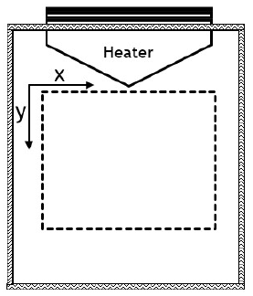
Figure S1: Schematic top-view of the insulated bed. The dashed area represents the domain taken for data analysis.

$ρ_{s}c_{p,s}\frac{∂T}{∂t}=\frac{∂}{∂y}\left(k_{eff}\frac{∂T}{∂y}\right)+u_{g}ρ_{g}c_{p,g}\frac{∆T}{H_{b}}$ (S9)

The temperature field over the bed surface was sampled and averaged over time (30 s) as well as over the x-direction, yielding a temperature gradient in the y-direction. The heat balance shown in Equation S9 was then discretized at the pixel level using the finite-volume method, and the effective heat dispersion coefficient k_{eff} was determined by matching the modelled temperature profile to the sampled one.

5. Power spectral density (PSD) analysis

Figure S2 shows the integrated PSD of the x-velocity at a point from the LoVoid-large-uniform case (the denser bed). The highest sampled frequency was 400 kHz, but since most of the variation is captured already at 20 Hz that is the cutoff used here. As seen in Figure S2, most of the variation in the flow appears captured at a frequency of 20 Hz and already at 10 Hz the integrated value is above 99%.
According to the Nyquist sampling theorem, the sampling frequency should be twice that of the signal’s maximum frequency component to perfectly reconstruct the velocity signal. While there would appear to be some variation left out, a sampling frequency of 20 Hz should still capture more than 99% of the variation. An arguably more important point is found in the lower portion of the PSD in Figure S2. It would seem that for the denser bed, at least at this point, close to 40 percent of the variation in the x-velocity is tied up in movements occurring once every 4 seconds or more. This relatively long time period should be taken into consideration both when observing time-averaged properties for the bed as well as when fitting dispersion values to transient phenomena. Furthermore, it is known that the time to reach pseudo-steady-state in a fluidized bed depends on the particle properties and the fluidization velocity [14].

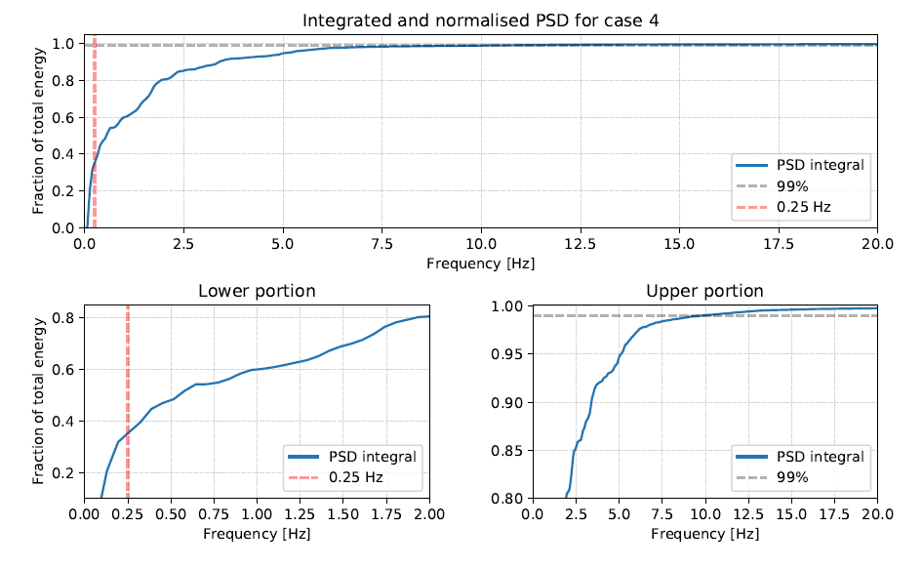
Figure S2: Power spectral density (PSD) integrated and normalized by the total energy.

6. Evaluation of methods

In Figure S3, several temperature profiles at different times are plotted together with the corresponding analytical solutions for the best fit of k_{eff} to the numerical data using method 1.
The simulated profiles show a discontinuity at the edge, where the profile moves from the region of constant temperature into the free bed region. It appears as if the simulated boundary condition fails to emulate that of the intended reference system. Instead, the inner part of the bed is seemingly tethered by a temperature lower than that of the constant region. This phenomenon will compress the profiles closer to the starting temperature, even at steady state. In the fitting process, all analytical profiles will exhibit the same deviation due to the compressed profile even at steady state. However, a profile with a lower conduction value will linger closer to the starting temperature for a longer time and thus fit the compressed profile better even though it is not necessarily the correct choice. This method is therefore prone to underestimating k_{eff}.
The failure of the fixed temperature region to emulate the boundary condition of the ideal system stems from the underlying mechanisms for heat transfer in the two cases. In the ideal system, the heat transfer would be driven by the temperature difference and thus a uniform heat flux would occur across the entire boundary. In the simulated system, however, the heat transfer is driven by the movement of particles and thus the net heat flux through each cell will vary not only with the temperature but also with the lateral velocities. While the net heat flux through the simulated boundary might even be greater than that of the ideal system at times, the average temperature of the boundary felt by the inner region of the bed will be lower, since only faces where there is an incoming x-velocity contribute the desired fixed temperature. In the inner parts of the bed however, the average temperature across any one plane will not necessarily be underestimated since in that case there will be faces with higher temperatures as well to stabilize the average.
To conclude, use of method 1 without modification would lead to a constant underestimation of the effective conduction, given that the underlying simulation is appropriate. To get around this problem the ideal system would need to be changed.
The same comparison as shown for method 1 in Figure S3 is visualized for method 2 in Figure S4, where it is apparent that there is no similar skewing effect in the latter method.

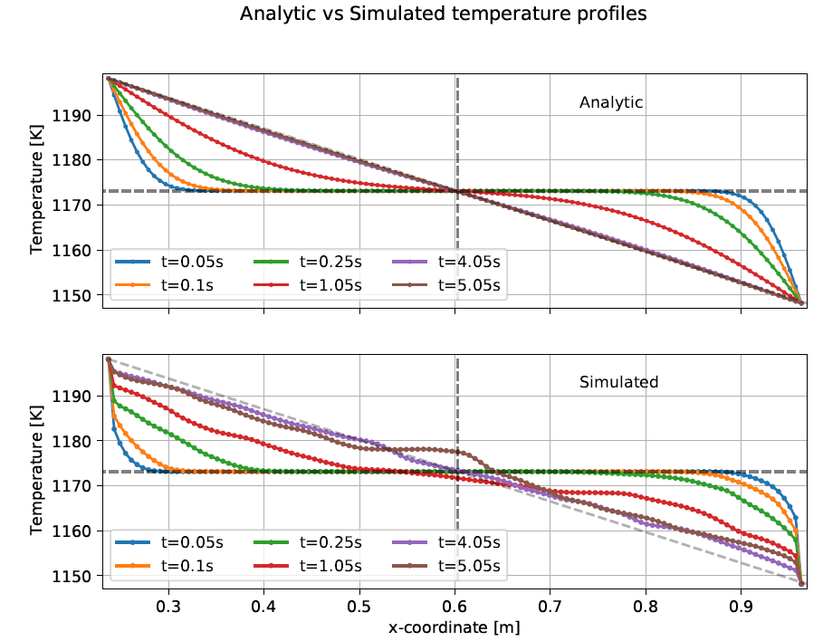
Figure S3: A comparison between the analytical temperature profile in a slab and that observed in the simulated bed. Note the apparent discontinuity at the edges of the simulated profiles.

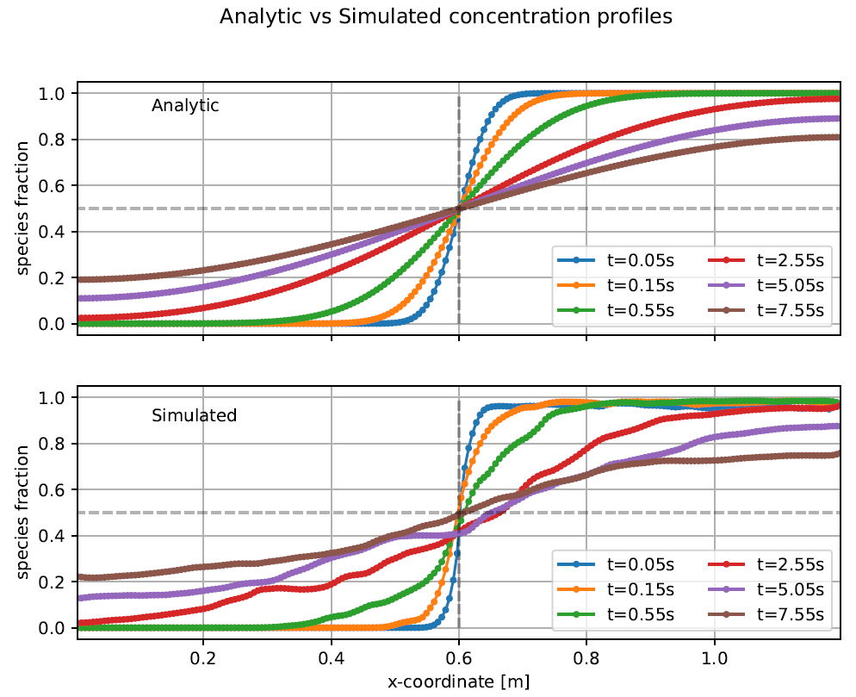
Figure S4: Analytical and simulated concentration profiles at different times using method 2.

Figure S5 shows the resulting signal for the lateral dispersion over time for the LoVoid-large-uniform case. From Figure S5a it is clear that the system needs some time to reach steady state, and if the entire time series is used to form the average an overestimation would be made. At around 16 s, the signal seems to have stabilized somewhat. However, as is visible from Figure S5b, the signal still fluctuates, and some fluctuations seems to have long periods as well. Recalling the results from the PSD, there are flow structures in this bed with periods longer than 4 seconds, and failure to include enough of these movements in the average will introduce uncertainty. However, the PSD was constructed at a single point in the bed, and it would appear reasonable to assume that across the planes used for data collection there could be multiple of these 4 second movements occurring out of phase from each other.

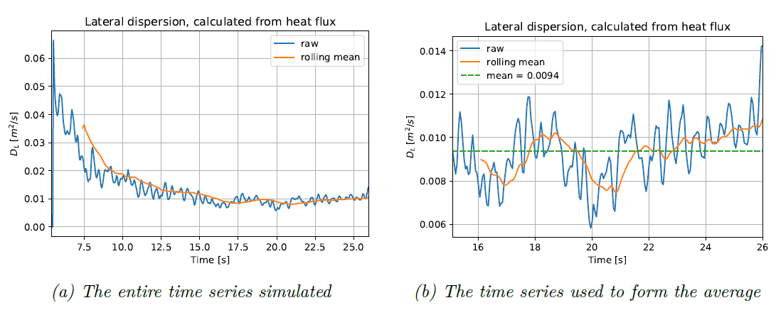
Figure S5: Evolution of the resulting lateral dispersion coefficient, based on the net heat flow through the domain using method 3.

7. Simulation time

A diagram explaining the time required for data collection is presented below as Figure S6.

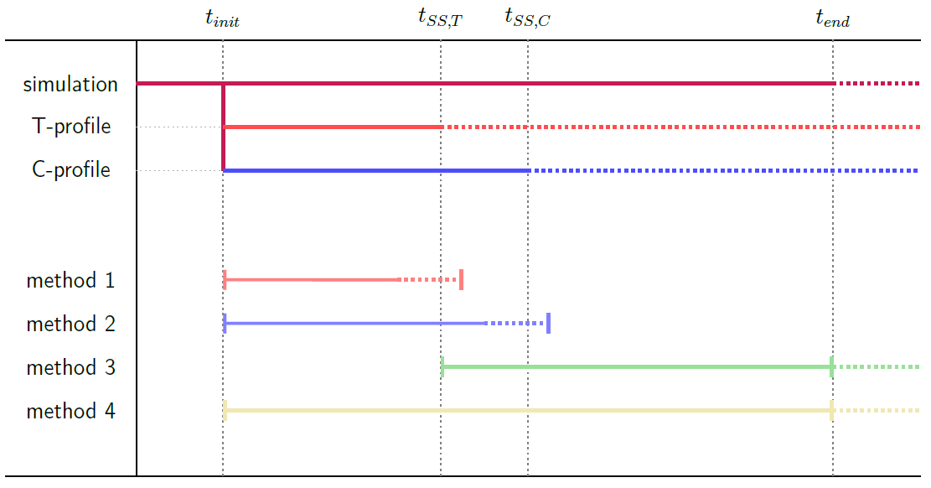
Figure S6: An overview of the different lengths of time involved in the analyses presented here. The dotted segments show that the process in question could be extended further to achieve greater precision.

All methods need the initial startup time t_{init} to allow the bed to come from a static to a pseudo-steady fluidized state. Here, the pseudo-steady state is assessed by monitoring the pressure drop (when the average pressure drop is stationary over time then the bed is steady). After the startup time, the data collection is started, for methods 1, 2 and 3 this is when the constraints for the analytical problem are imposed.
From this point the process moves towards a steady state in terms of mixing and temperature. For methods 1 and 2, the bulk of the data needed is found in the time before steady state t_{SS}. The maximum time needed for a study using method 1 or 2 is thus just slightly after t_{SS} for each process – just enough to identify that steady state has been reached. In our practical experience, however, the fitting procedure will have converged on a value even before the analytical steady state has been reached. Note that in this study t_{SS,T} occurred before t_{SS,C}, and has been drawn so in Figure S6, this is not necessarily the case for a study in which the analytical systems are formulated differently.
For method 3 however, the important data collection starts after the process has reached steady state, which means that method 3 always will require more time than the fitting methods 1 and 2. Since both methods 3 and 4 depend on time-averaged quantities, the data collection for these could in theory proceed indefinitely. However, in practice the maximum time will be dictated by the amount of precision needed. The maximum times for methods 3 and 4 will in any case be harder to estimate a priori than those for methods 1 and 2. In the current work, time series of 25-30 s were used for methods 3 and 4.

References

1. Syamlal M, Rogers W, O’brien T J. MFIX Documentation Theory Guide Technical Note. Technical Report, 1993
2. DallaValle J M, Klemin A. Micromeritics: the technology of fine particles. p. 377-415. New York: Pitman Pub. Corp., 1943
3. Garside J, Al-Dibouni M R. Velocity-voidage relationships for fluidization and sedimentation in solid-liquid systems. Industrial & Engineering Chemistry Process Design and Development, 1977, 16:206-214
4. Lun C K K, Savage S B, Jeffrey D J, Chepurniy N. Kinetic theories for granular flow: inelastic particles in Couette flow and slightly inelastic particles in a general flowfield. Journal of Fluid Mechanics, 1984, 140:223
5. Ogawa S, Umemura A, Oshima N. On the equations of fully fluidized granular materials. Zeitschrift für angewandte Mathematik und Physik ZAMP, 1980, 31.:483-493
6. Gidaspow D, Bezburuah R, Ding J. Hydrodynamics of circulating fluidized beds: Kinetic theory approach. 7th International Conference on Fluidization, Gold Coast (Australia), 3-8 May 1992
7. Schaeffer D G. Instability in the evolution equations describing incompressible granular flow. Journal of Differential Equations, 1987, 66:19-50
8. Zhao K, Thunman H, Pallarès D, Ström H. Control of the solids retention time by multi-staging a fluidized bed reactor. Fuel Processing Technology, 2017, 167:171-182.
9. Hinze J. Turbulence. McGraw-Hill, 1959.
10. Jiradilok V, Gidaspow D, Breault R W. Computation of gas and solid dispersion coefficients in turbulent risers and bubbling beds. Chemical Engineering Science, 2007, 62:3397-3409
11. Glicksman L R. Scaling relationships for fluidized beds. Chemical Engineering Science, 1984, 39:1373-1379
12. Horio M, Nonaka A, Sawa Y, Muchi I. A new similarity rule for fluidized bed scale-up. AIChE Journal, 1986, 32:1466-1482
13. Martinez Castilla G, Larsson A, Lundberg L, Johnsson F, Pallarès D. A novel experimental method for determining lateral mixing of solids in fluidized beds – Quantification of the splash-zone contribution. Powder Technology, 2020, 370:96-103
14. Salehi M-S, Askarishahi M, Radl S. Quantification of Solid Mixing in Bubbling Fluidized Beds via Two- Fluid Model Simulations’. Industrial & Engineering Chemistry Research, 2020, 59:10606-10621.

