Electronic Supplementary Material

Azeotropic distillation process for methanol-ethyl acetate-water separation: design and control
Prakhar Srivastava, Prit Dadhania, Aayush Gupta, Nitin Kaistha ()
Department of Chemical Engineering, Indian Institute of Technology, Kanpur 208016, UP, India
E-mail: nkaistha@iitk.ac.in
List of Figures
S1 Variation of distribution coefficient with solvent rate . . . . . . . . . . . . . . 2
S2 Nominal design and operating condition of proposed design without HI . . . 3
S3 C1 column composition and temperature profile of proposed design . . . . . 4
S4 C2 column composition and temperature profile of proposed design . . . . . 5
S5 C3 column composition and temperature profile of proposed design . . . . . 6
S6 Optimization of dominant design variable of EHAD design (a) water composi-
tion (b) C1 column EtAc composition (c) Water split rate . . . . . . . . . . 8
S7 Pressure Swing Design …………………………………………………… 12
List of Tables
S1 NRTL interaction parameter adapted from Srivastava et al.¹ 2
S2 Equipment dimensioning, cost relationships, and unit pricing data 9
S3 Major equipment cost and dimensional details of adapted EHAD design 10
S4 The parameters and their values used for environmental evaluation ………………………. 11
NRTL interaction parameter
Table S1: NRTL interaction parameter adapted from Srivastava et al.1
Comp i | Comp j | Source | A_{ij} | A_{ji} | B_{ij} | B_{ji} | C_{ij}
MeOH | Water | Regressed | 3.6493 | -2.471 | -1556.88 | 1460.82 | 0.13
MeOH | EtAc | Regressed | 4.5620 | -5.518 | -1196.92 | 2216.77 | 1.11
Water | EtAc | Regressed | -3.750 | -3.640 | 2229.930 | 1699.11 | 0.36

Proposed Design
LLX Design
Distribution Coefficient (D) is defined as the ratio of the concentration of solute in the raffinate phase to the concentration of solute in the extract phase.
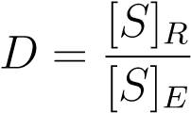
We have incorporated the distribution coefficient (D) as a quantitative indicator for mass
transfer.
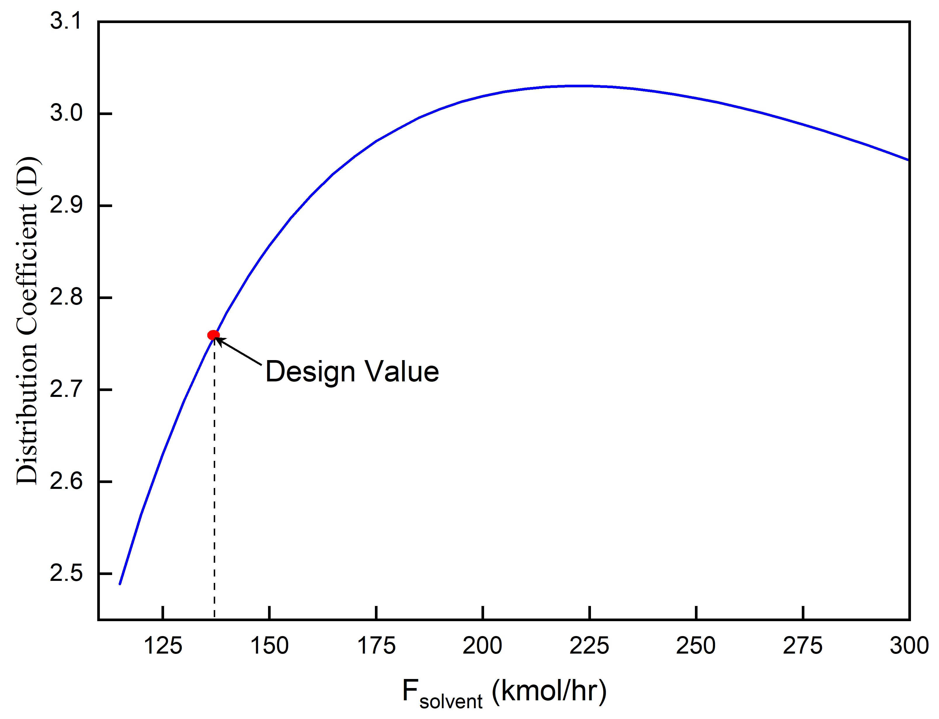
Figure S1: Variation of distribution coefficient with solvent rate
A sensitivity analysis was conducted by varying the solvent (water) flow rate while keeping the number of stages fixed. As shown in Figure S1, the distribution coefficient exhibits a maximum value of 3.02 to 200 kmol/hr. The TAC optimum water flow rate is lower at 138 kmol/hr. At this flow rate, the distribution coefficient is 2.75, indicating effective mass transfer. Increasing the distribution coefficient further would require raising the water flow rate to approximately 200 kmol/h, which incurs a higher solvent recovery and recycle cost.
Without heat integration (HI) design
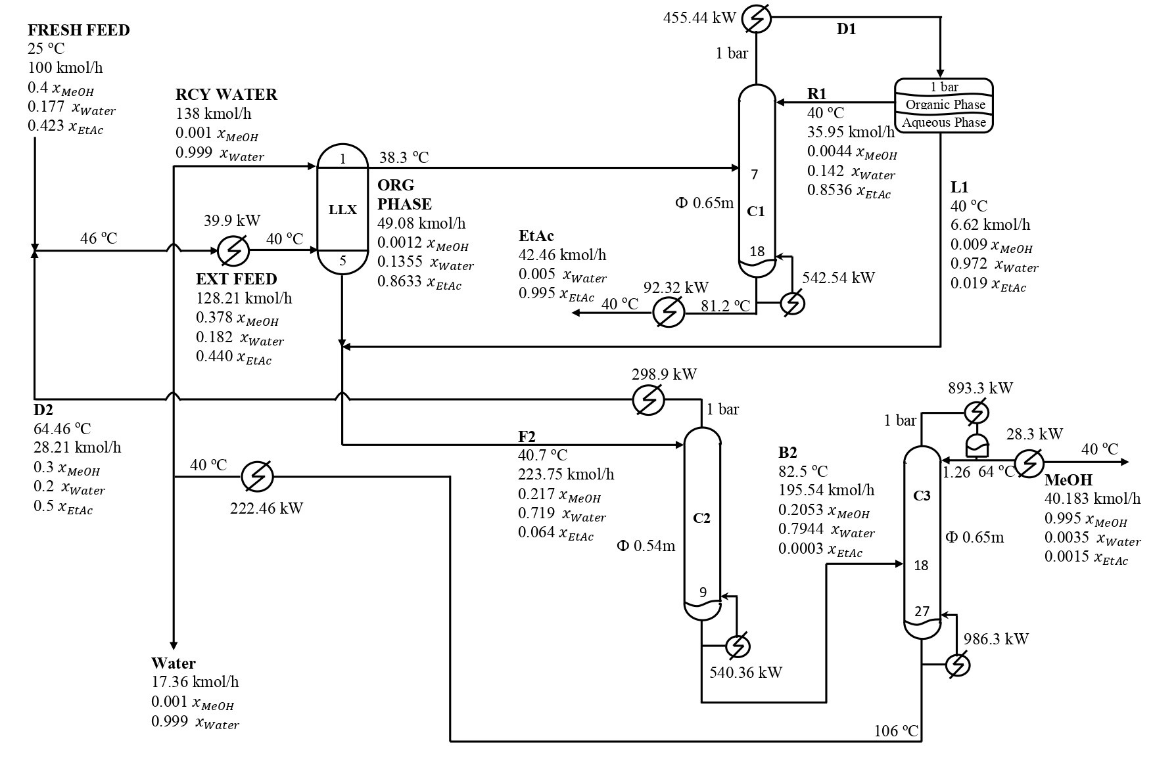
Figure S2: Nominal design and operating condition of proposed design without HI

Column Profiles
Figure S3: C1 column composition and temperature profile of proposed design
Figure S4: C2 column composition and temperature profile of proposed design
Figure S5: C3 column composition and temperature profile of proposed design

Dominant design variables of EHAD design
Similar to our proposed design, we used engineering heuristics to fix the degrees of freedom, after which the economically dominant design variables were identified and fixed using the Aspen Plus sensitivity tool.
The three dominant design variables are as follows: water composition in the C2 column distillate x_{Water}, EtAc composition in the C1 bottom stream x_{EtAc}, and the water split rate
F_{Split} to the C1 column. To obtain near-optimum value of TAC, we performed iterative cycles. During each cycle, we systematically adjusted each of the three design variables within a specified range, keeping the others constant. Each variable was updated to the value that minimized TAC, and the iteration process continued until the reduction in TAC between cycles was smaller than a predefined tolerance.
Figures S6 a, b, and c show how TAC changes in relation to the recommended design values that correspond to the minimum TAC. The design value for x_{Water} in the C2 distillate is 0.28; increasing this value further results in a rise in TAC as the composition approaches the distillation boundary, which raises the distillate rate (D2). For x_{EtAc}, values above the optimum result in a higher TAC due to an increase in the C3 column reboiler duty, while values below the optimum TAC rise due to the higher reboiler duty in the C1 column. The optimal water split rate F_{Split} is 427.49 kmol/h; above this value, TAC increases due to a higher solvent water recycle rate, which increases the reboiler duties in both the C1 and C3 columns. Below this optimum, TAC increases due to the rise in the C2 column reboiler duty.
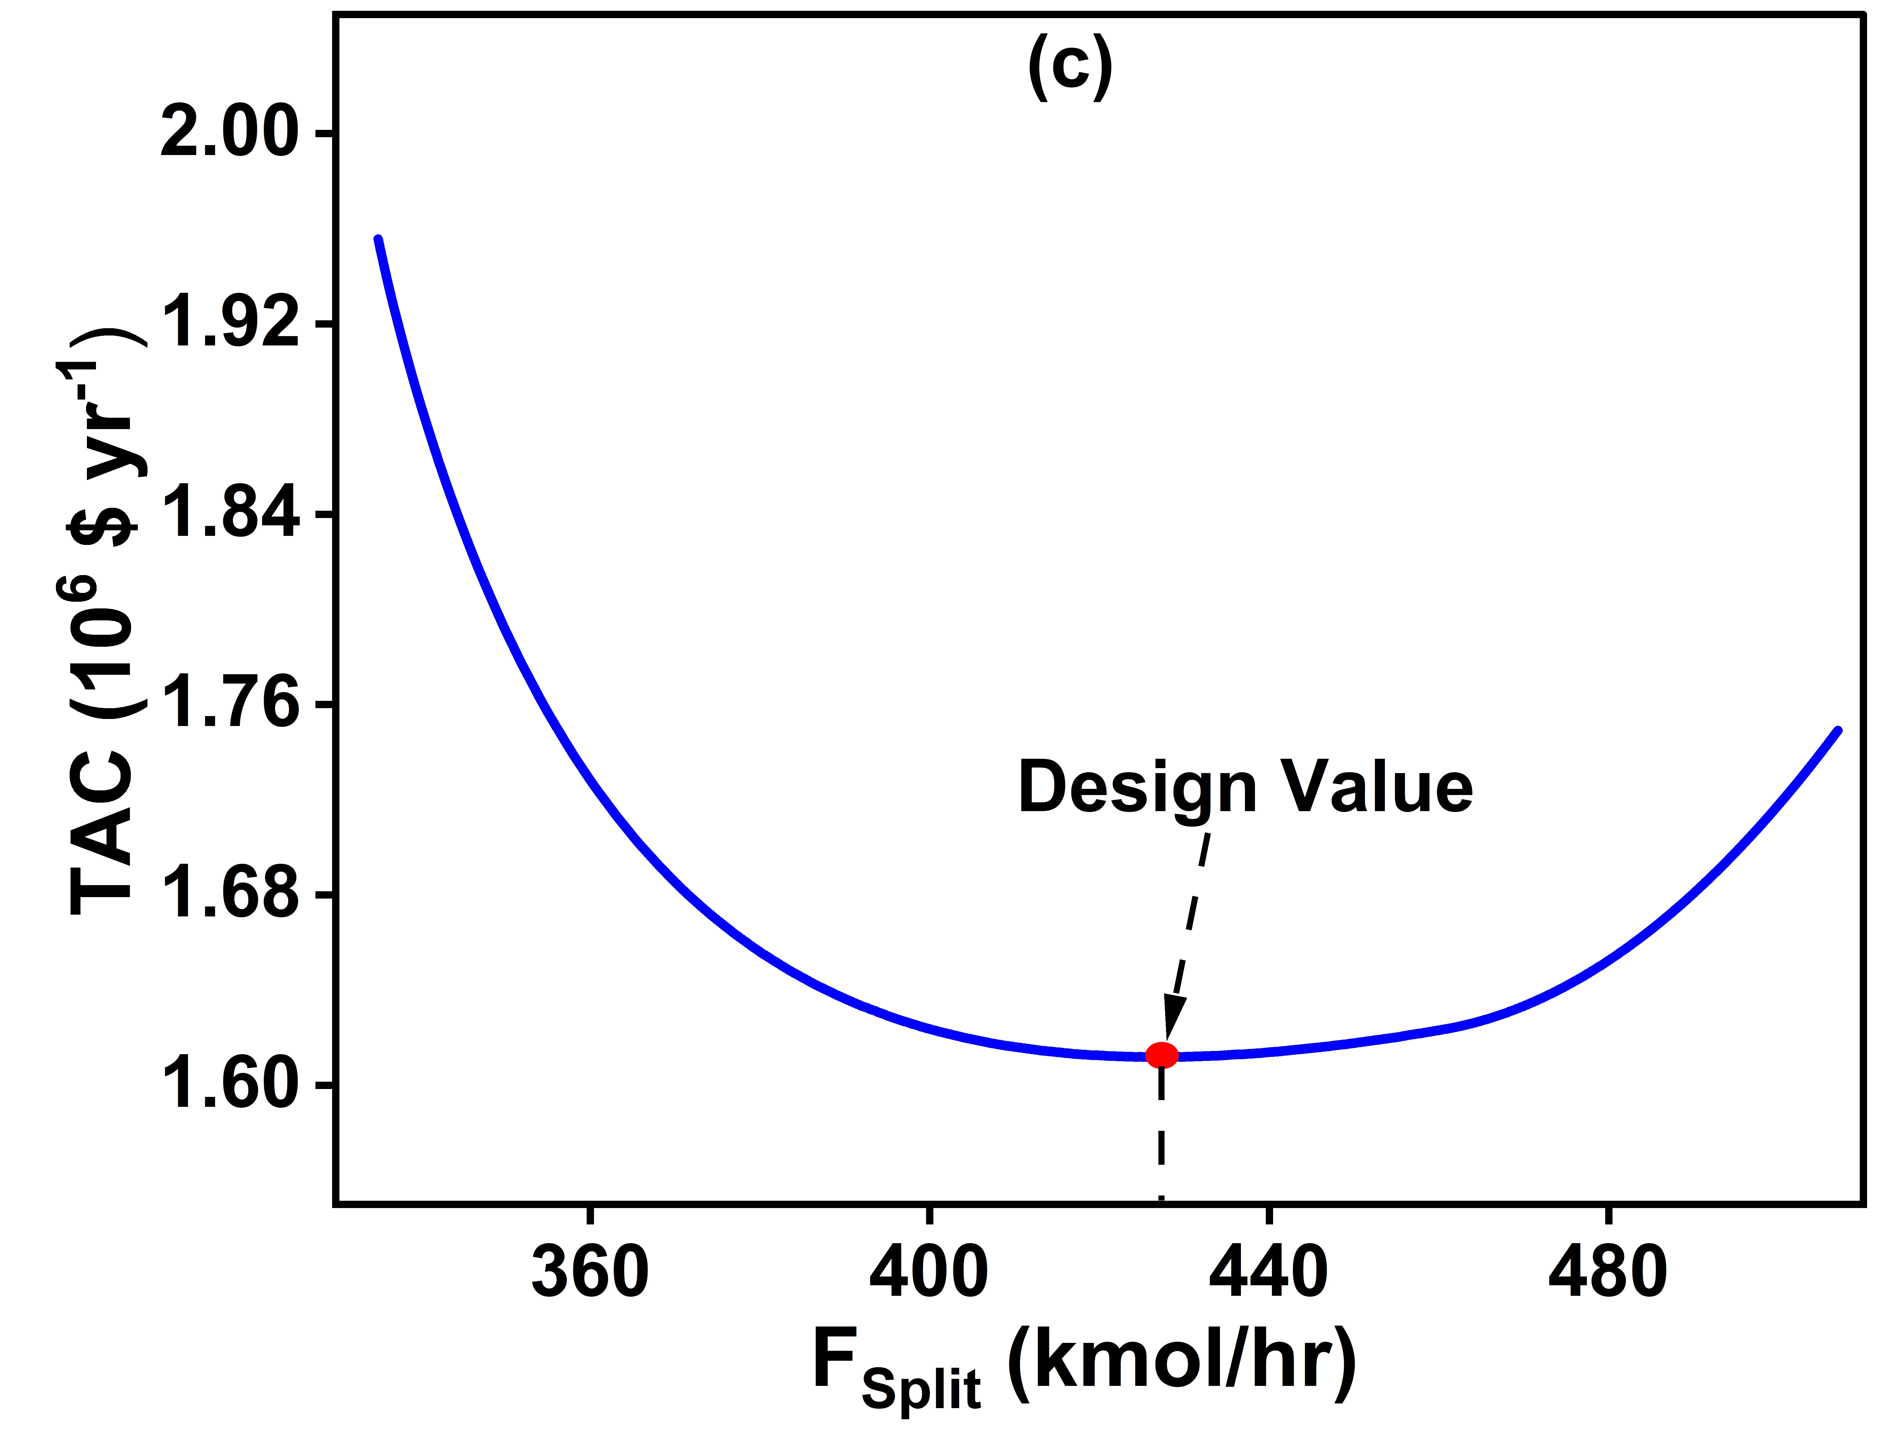
Figure S6: Optimization of dominant design variable of EHAD design (a) water composition
(b) C1 column EtAc composition (c) Water split rate

Costing and sizing details

Table S2: Equipment dimensioning, cost relationships, and unit pricing data
Column | Diameter | Tray Sizing utility (Fair’s method)
 | Height | Tray with 2 ft spacing  20 % Extra length for sump
 | Capital cost | $17640(D)^{1.066}(L)^{0.802} (D,L in m)
Condenser | HTC | 0.568 kW/(K.m²)
 | Capital cost | $7296(A)^{0.65}
Reboiler | HTC | 0.852 kW/(K.m²)
 | Capital cost | $7296(A)^{0.65}
FEHE | HTC | 0.85 kW/(K.m²)
LLX | HETS | 2 ft
 | Capital cost | $17640(D)^{1.066}(L)^{0.802} (D,L in m)
Utilities | HP Steam | $17.7 /GJ
 | MP Steam | $14.85 /GJ
 | LP Steam | $14.05 /GJ
 | Cooling water | $0.354 /GJ
HTC=Heat transfer coefficient A= area

Table S3: Major equipment cost and dimensional details of adapted EHAD design
 | Measurement |  | CC  $10⁶ | Energy kW | EC  $10⁶/yr
C1  Column | Height (m)  Diameter (m) | 6.58  0.85 | 0.067
 | Condenser (m²) | 23.16 | 0.0562 | 584.7 | 0.0054
 | Reboiler (m²) | 22.1 | 0.0546 | 1310.7 | 0.4773
C2  Column | Height (m)  Diameter (m) | 13.89  0.76 | 0.1081
 | Condenser (m²) | 25.24 | 0.0595 | 616.6 | 0.0057
 | Reboiler (m²) | 11.1 | 0.0349 | 737.9 | 0.2687
C3  Column | Height (m)  Diameter (m) | 19.02  0.79 | 0.1458
 | Condenser (m²) | 58.26 | 0.1025 | 1295.5 | 0.0119
 | Reboiler (m²) | 31.69 | 0.0689 | 1450.8 | 0.5283
Decanter |  |  | 0.0453
FEHE | Area (m²) | 1.65 | 0.0101 | 37.8
Cooler 1 | Area (m²) | 2.28 | 0.0124 | 29.1 | 0.0003
Cooler 2 | Area (m²) | 50.74 | 0.0937 | 648.5 | 0.0059
Cooler 3 | Area (m²) | 4.57 | 0.0196 | 58.4 | 0.0005
Cooler 4 | Area (m²) | 12.7 | 0.038 | 162.1 | 0.0015
TCC |  |  | 0.9166
YOC |  |  |  |  | 1.3055
TAC |  |  |  | $1.611×10⁶ /yr
CC=Capital cost, EC=Energy Cost, TCC=Total Capital cost
YOC=Yearly Operating Cost

CO₂ analysis
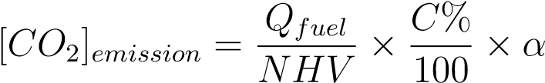 (1)
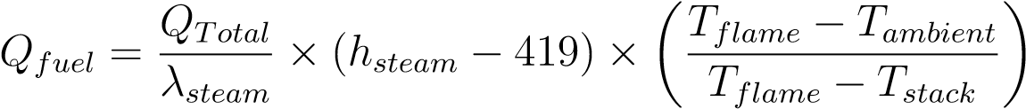 (2)
All the values given in the equation are given in Table S4.²
Table S4: The parameters and their values used for environmental evaluation
Variable | Definition | Value | Unit
Qfuel | energy consumption of the heavy oil fuel | - | kJ/s
NHV | net heating value | 39771 | kJ/kg
C% | carbon content | 86.5 | kg/kg
α | the molar mass of CO₂ and C | 3.67 | -
Qtotal | reboiler energy consumption | - | kW
λsteamLP | latent heat of the steam | 2081.63 | kJ/kg
λsteamMP | latent heat of the steam | 1999.69 | kJ/kg
λsteamHP | latent heat of the steam | 1725.33 | kJ/kg
hsteamLP | enthalpy of the steam | 2756.37 | kJ/kg
hsteamMP | enthalpy of the steam | 2778.64 | kJ/kg
hsteamHP | enthalpy of the steam | 2800.32 | kJ/kg
Tflame | flame temperature | 2073.15 | K
Tstack | stack temperature | 433.15 | K
Tambient | ambient temperature | 298.15 | K

Structure of PSD Design
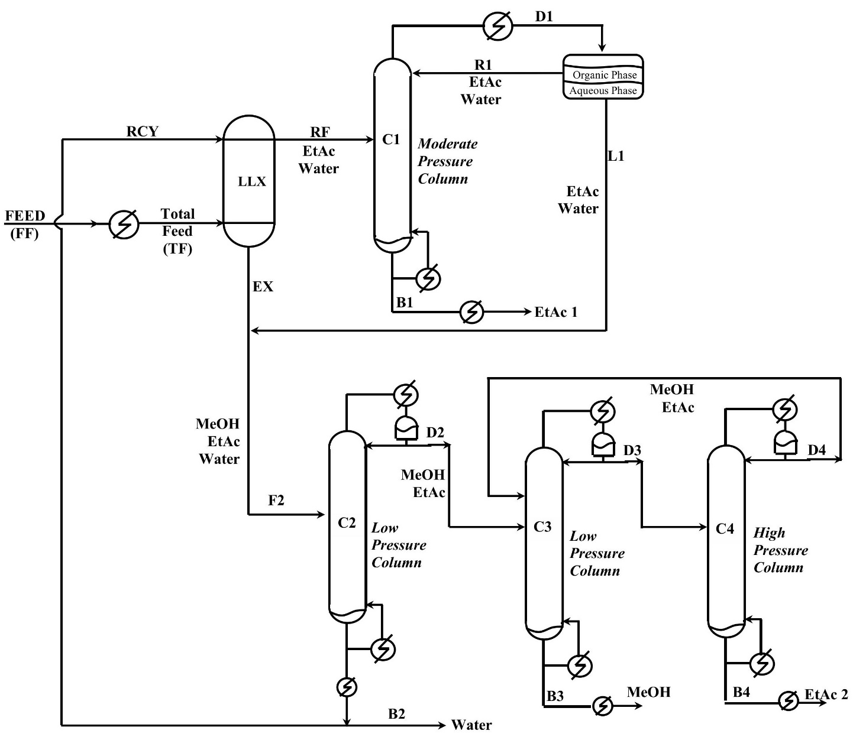
Figure S7: Pressure Swing Design

References
- Srivastava, P.; Gupta, A.; Kaistha, N. Synthesis and Integrated Design of a Compact Azeotropic Process for EtAc–MeOH–Water Separation. Industrial & Engineering Chemistry Research 2024, 63, 21466–21478.
- Mukherjee, R.; Mondal, B.; Jana, A. K. A Carbon-Neutral Highly Productive SolarPowered Desalination Process: Improving Economic Performance with Carbon Pricing.
Industrial & Engineering Chemistry Research 2024, 63, 9107–9123.

