Electronic Supplementary Material
Kinetic study of the effect of thermal hysteresis on pyrolysis of vacuum residue
Chao Wang¹, Xiaogang Shi ()¹, Aijun Duan¹, Xingying Lan¹, Jinsen Gao¹, Qingang Xiong ()²
1 State Key Laboratory of Heavy Oil Processing, China University of Petroleum-Beijing, Beijing 102249, China
2 State Key Laboratory of Pulp and Paper Engineering, South China University of Technology, Guangzhou 510640, China
E-mails: shixiaogang68@cup.edu.cn (Shi X); qingangxiong@scut.edu.cn (Xiong Q)

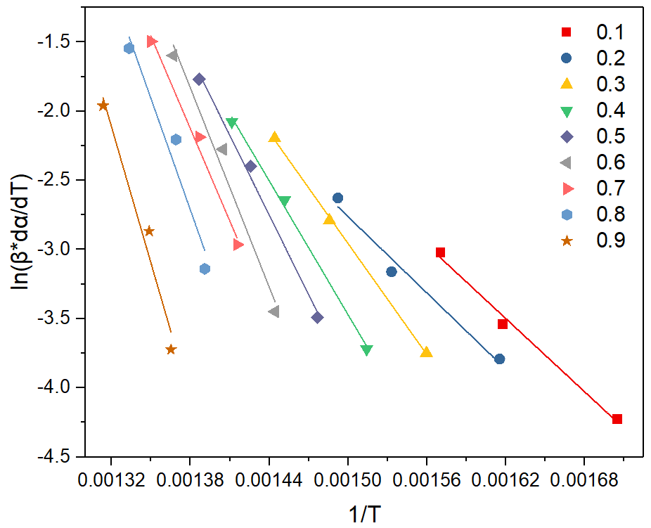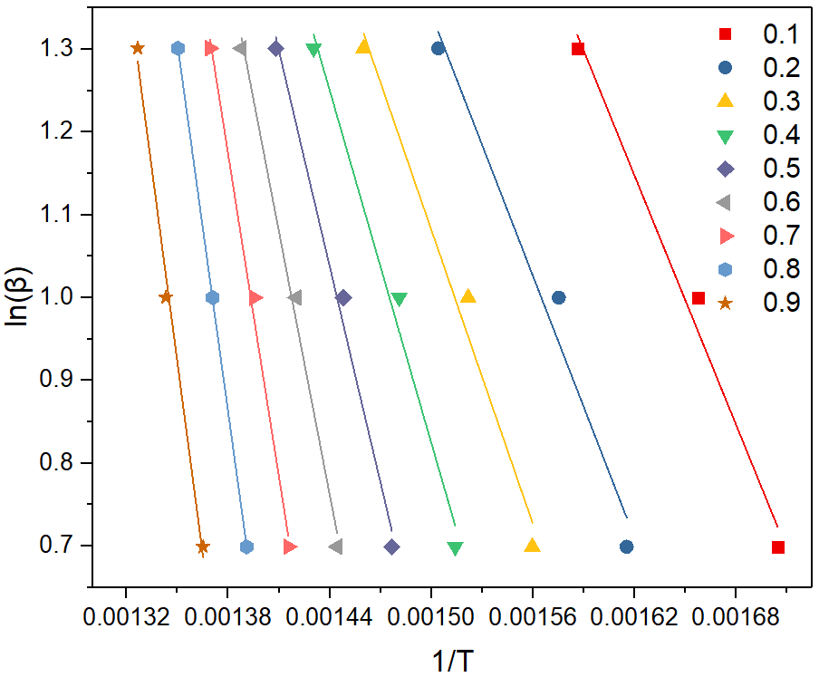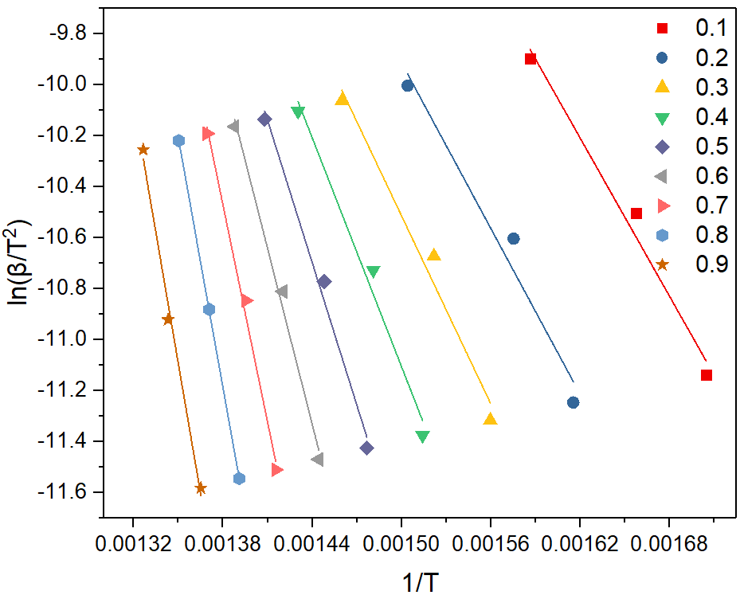
Figure. S1. Fitting curves of different iso-conversional methods for VR, (a) Friedman, (b) FWO and (c) KAS.
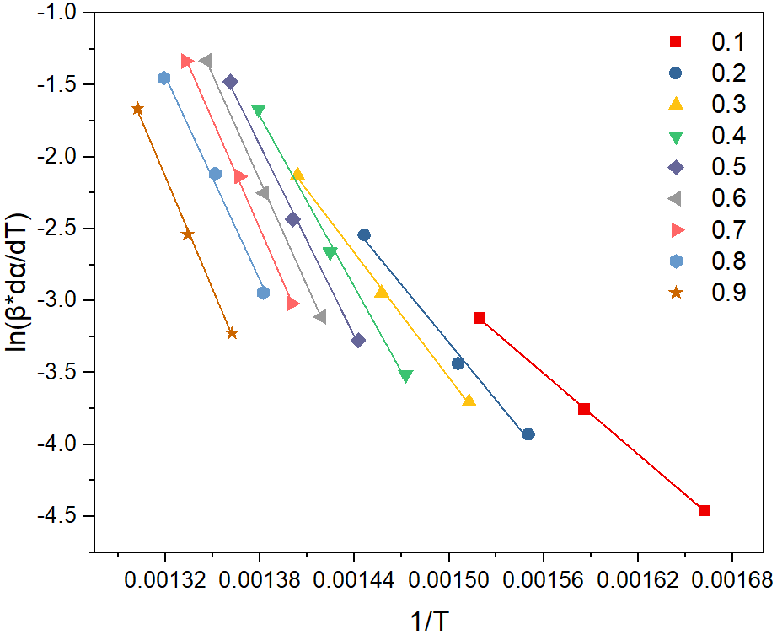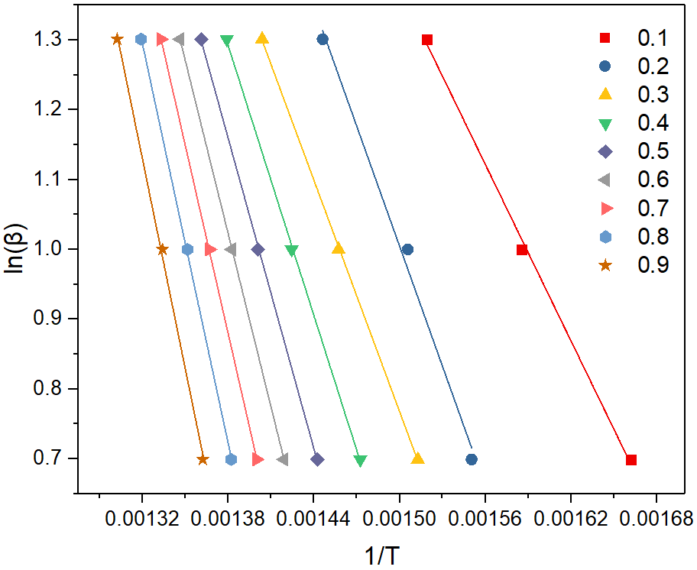
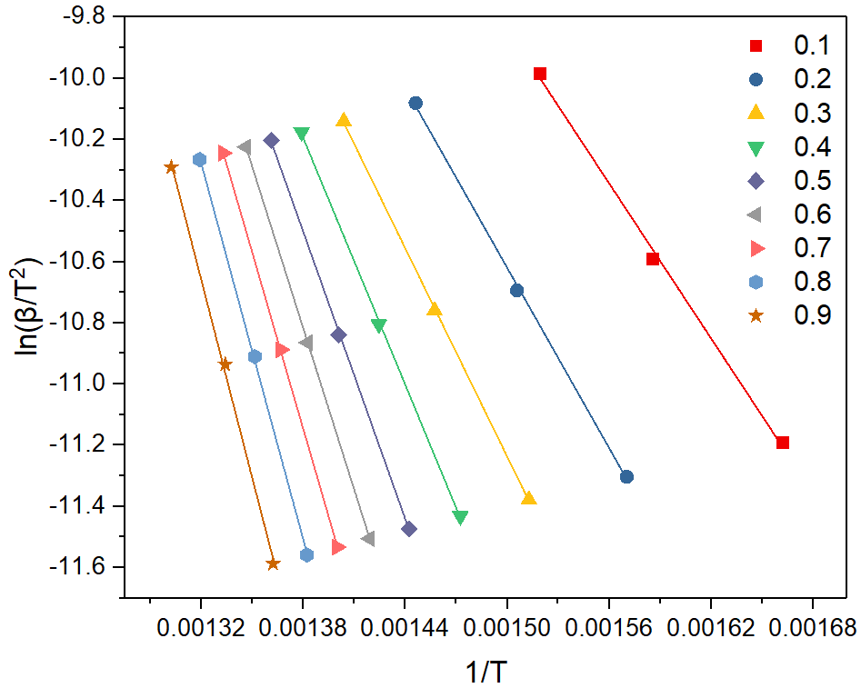
Figure. S2. Fitting curves of different isoconversional methods for S-VR, (a) Friedman, (b) FWO and (c) KAS.

Friedman:
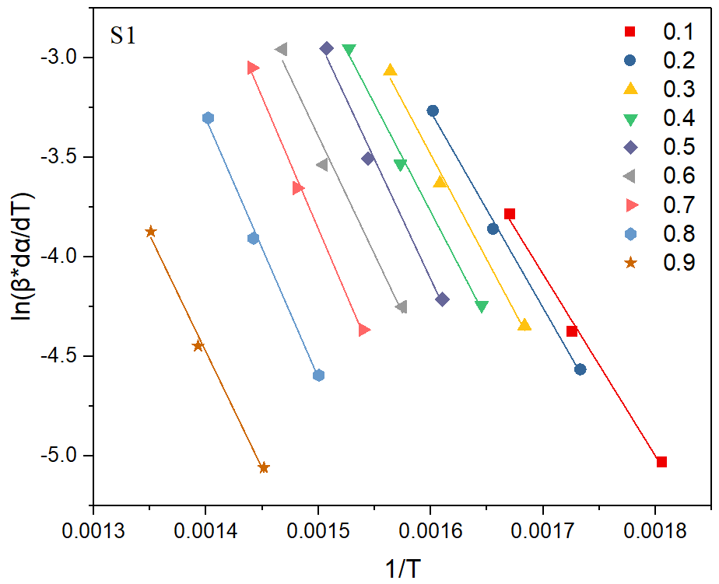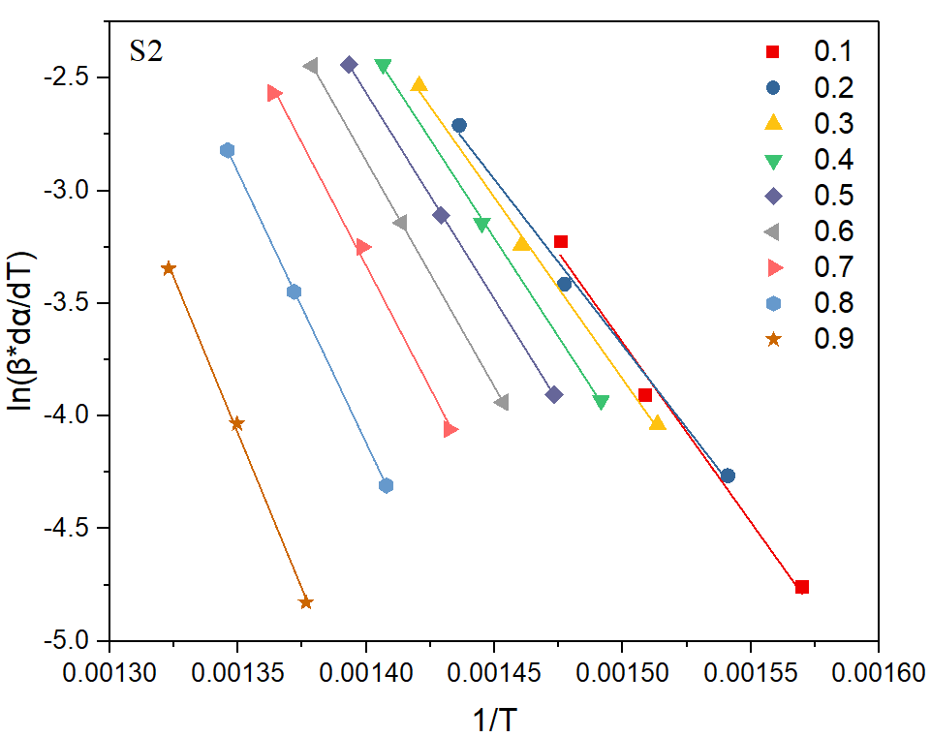
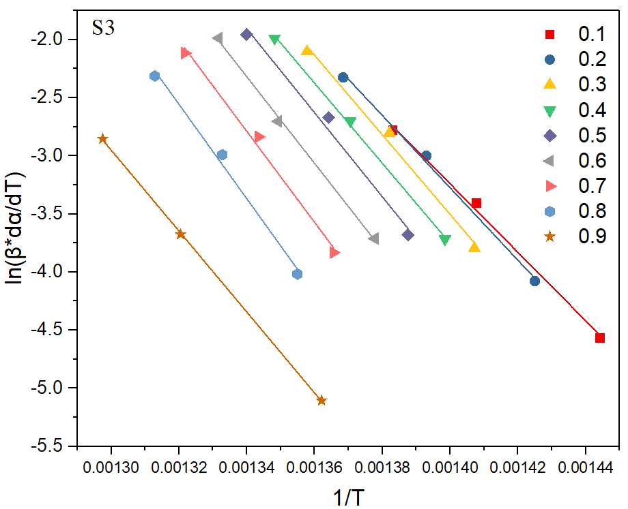
Figure. S3. Arrhenius plots of VR with Friedman method for three stage.
FWO：
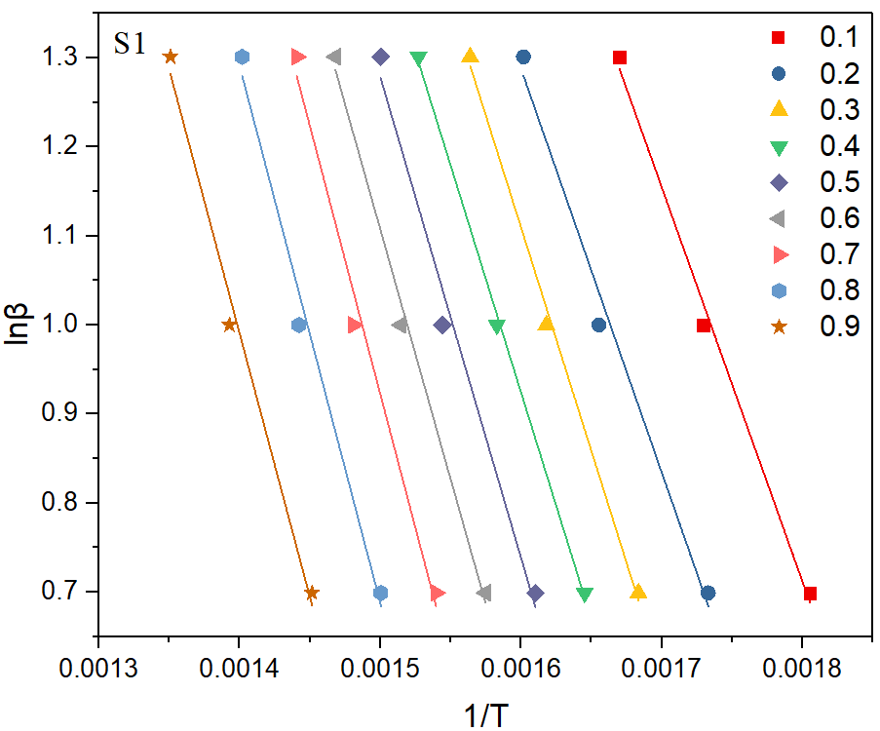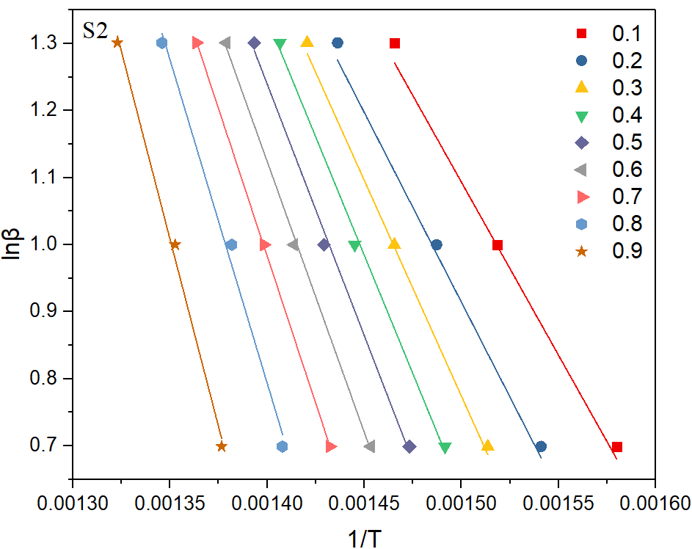
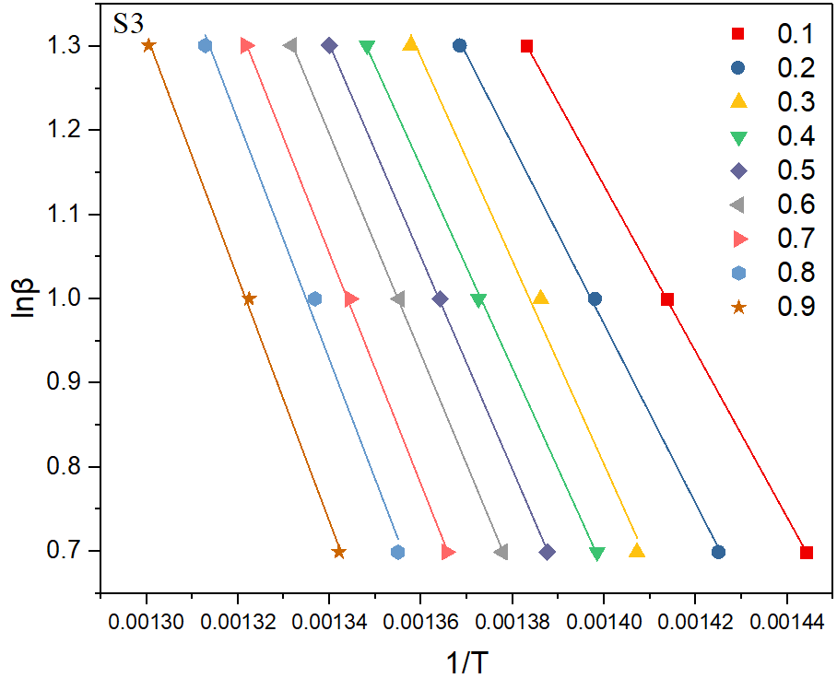
Figure. S4. Arrhenius plots of VR with FWO method for three stage.

KAS：
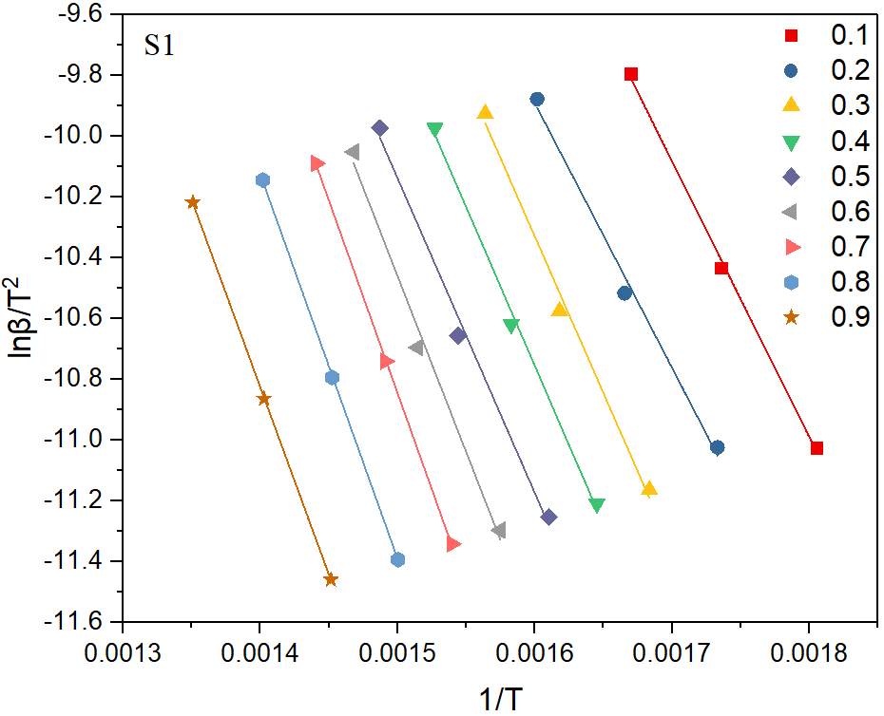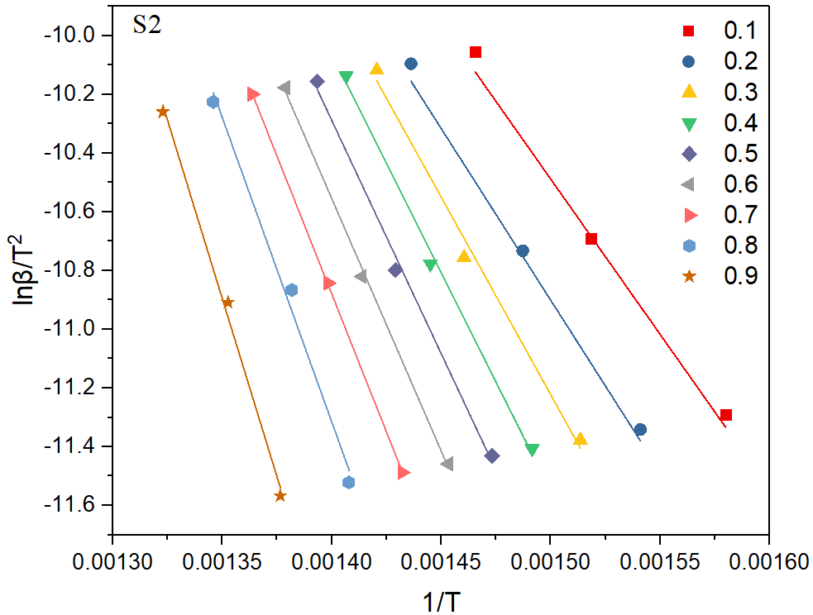
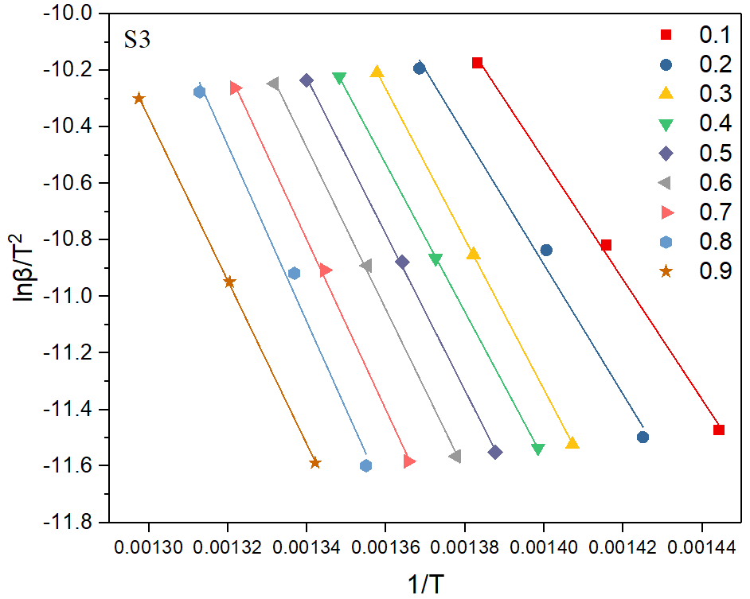
Figure. S5. Arrhenius plots of VR with KAS method for three stage.

Friedman：
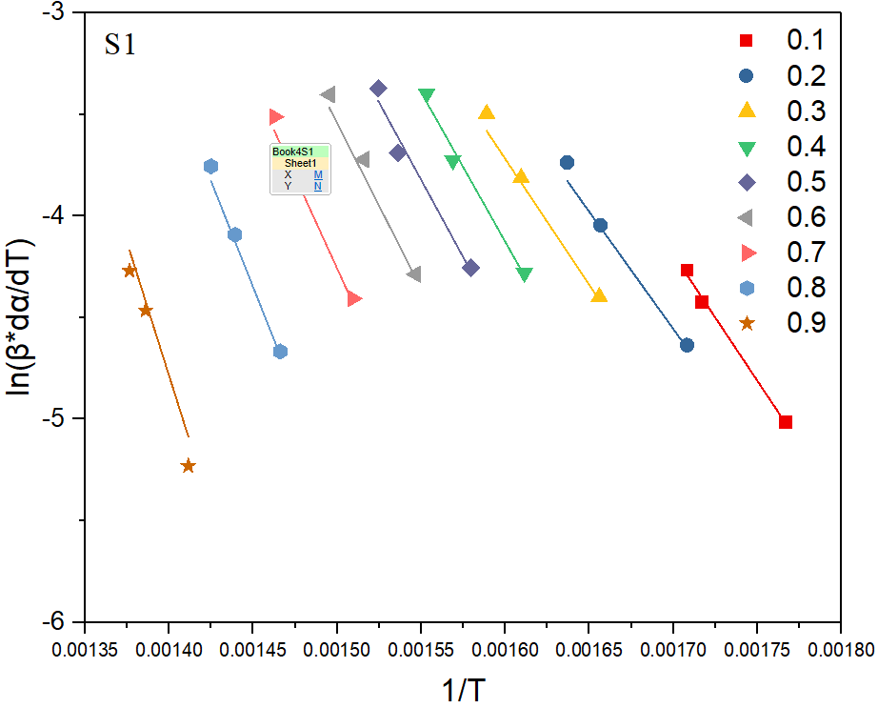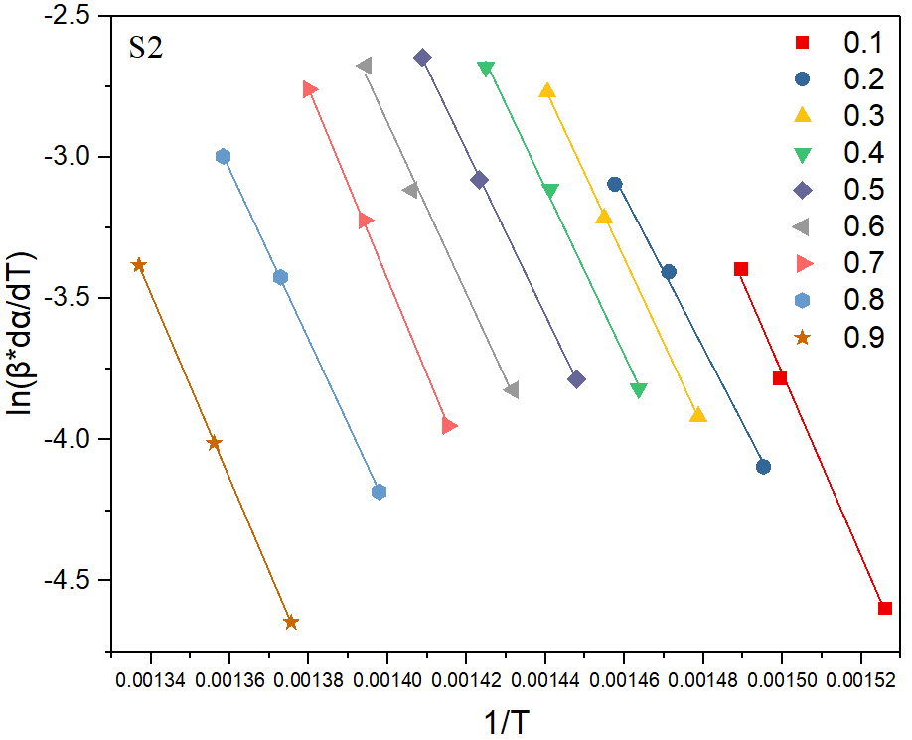
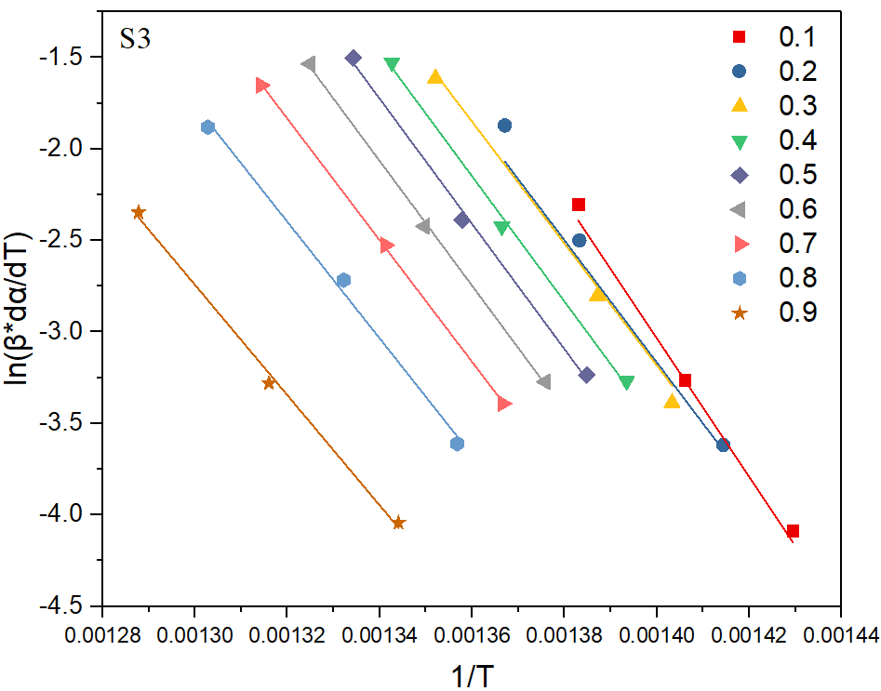
Figure. S6. Arrhenius plots of S-VR with Friedman method for three stage.

KAS：
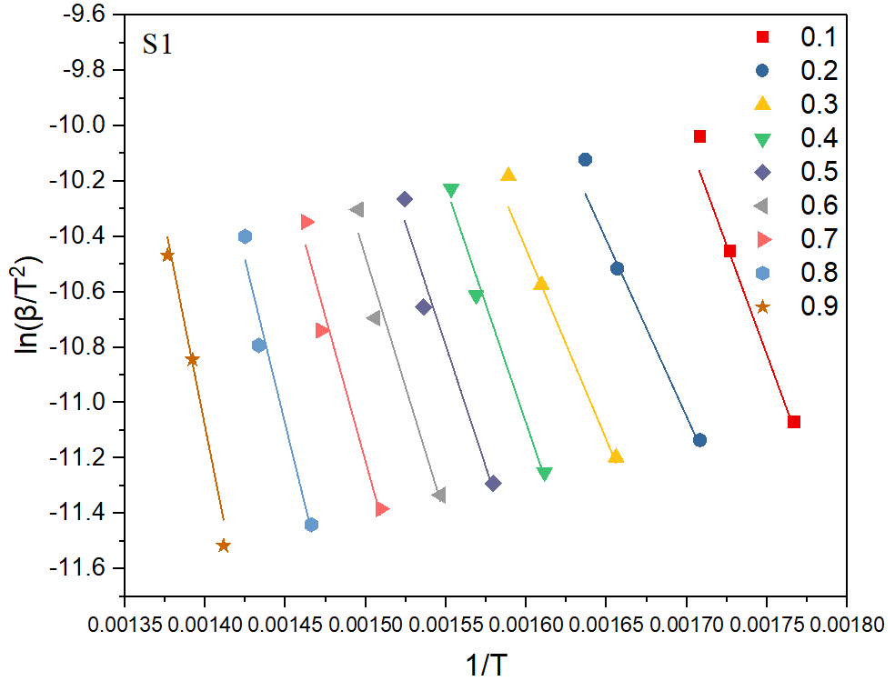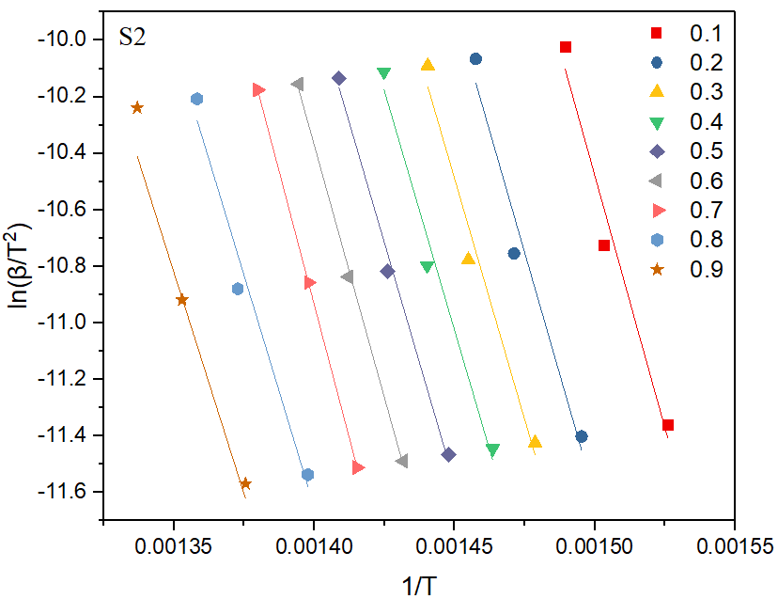
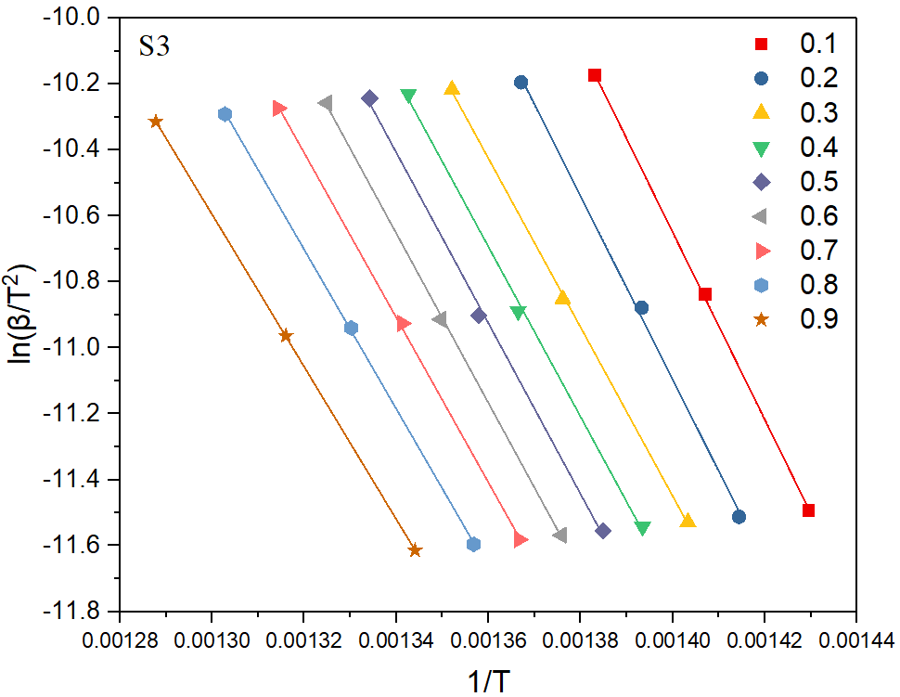
Figure. S7. Arrhenius plots of S-VR with FWO method for three stage.

FWO：
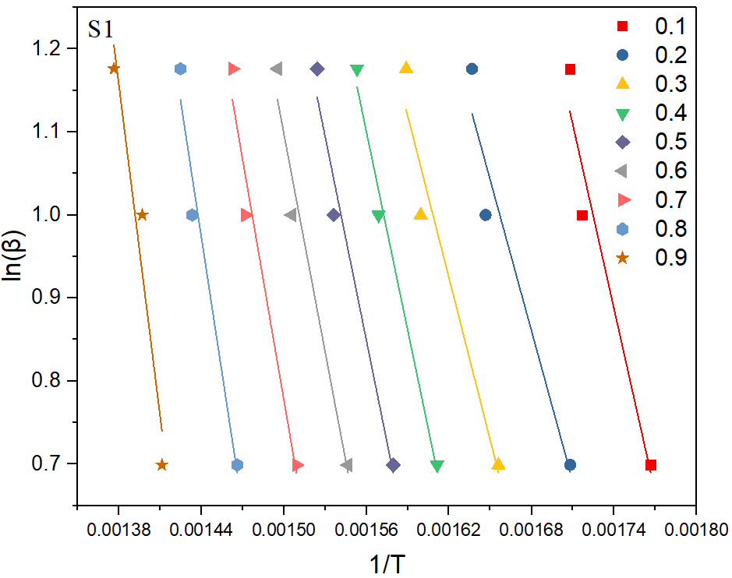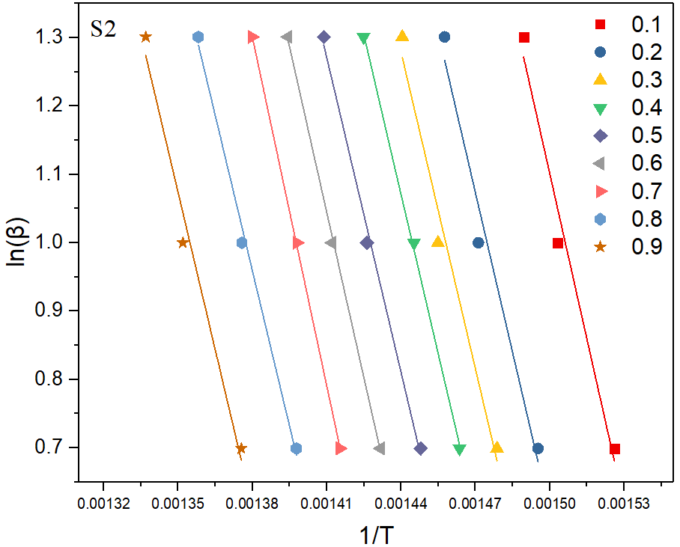
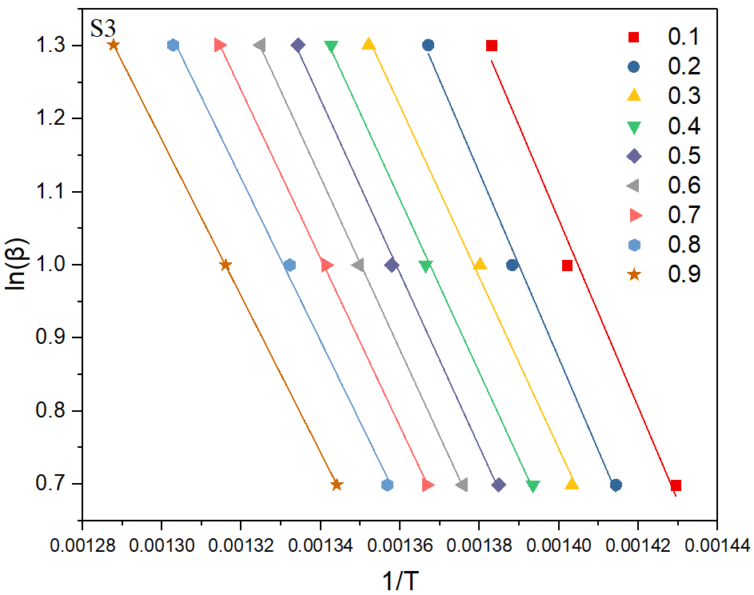
Figure. S8. Arrhenius plots of S-VR with KAS method for three stage.

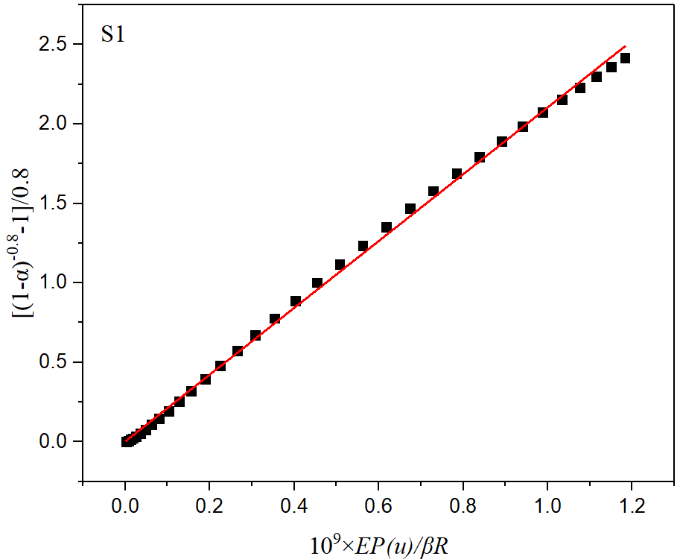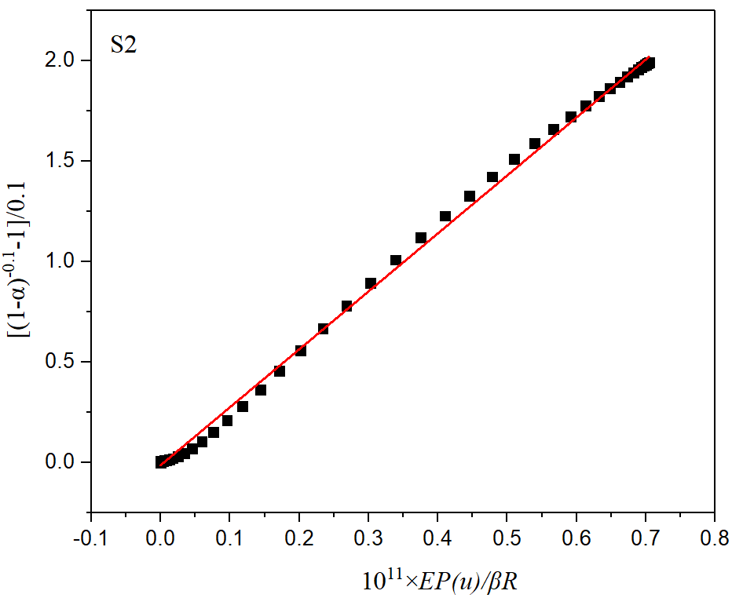
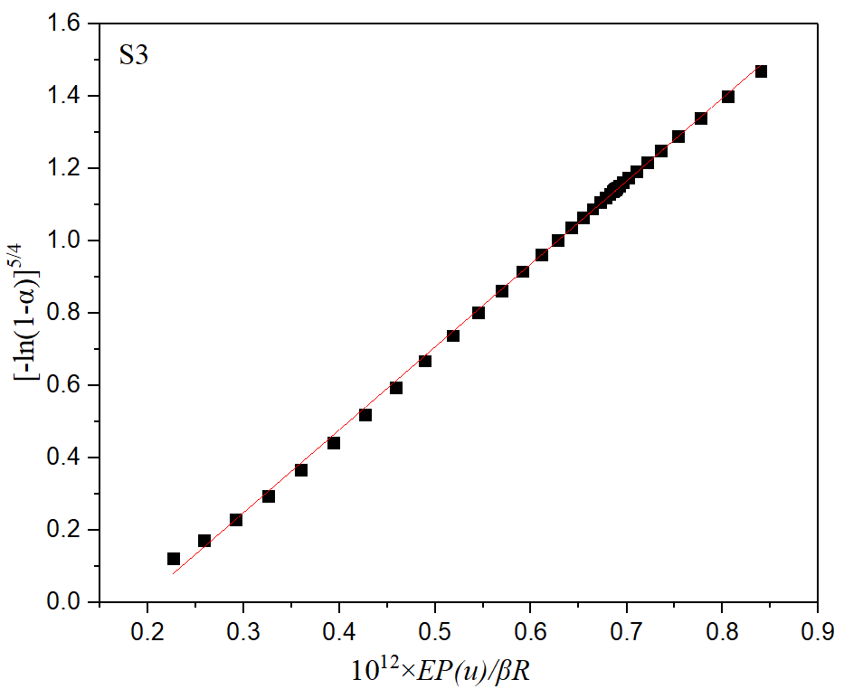
Fig. S9. Plotting G(α) versus 10^{x}×EP(α)/βR for various pyrolysis stages[(a) S1, (b) S2, (c) S3] of VR at 10 K min⁻¹;

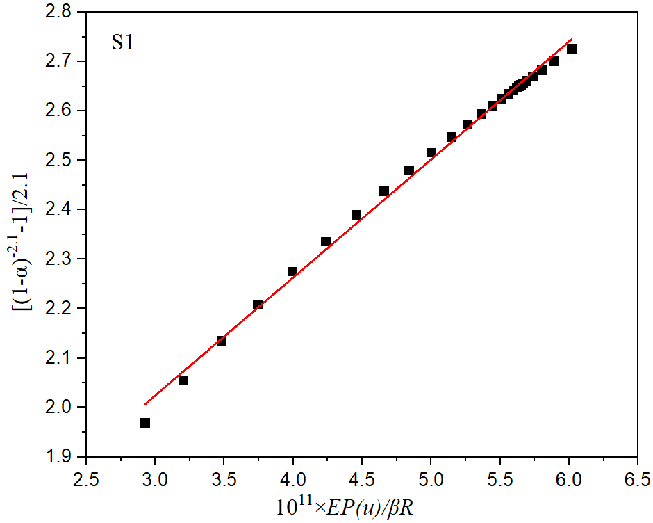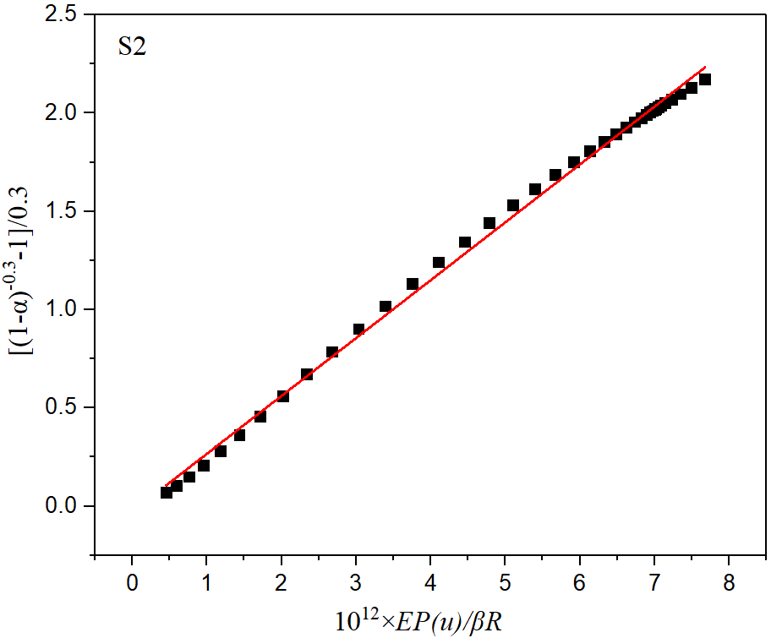
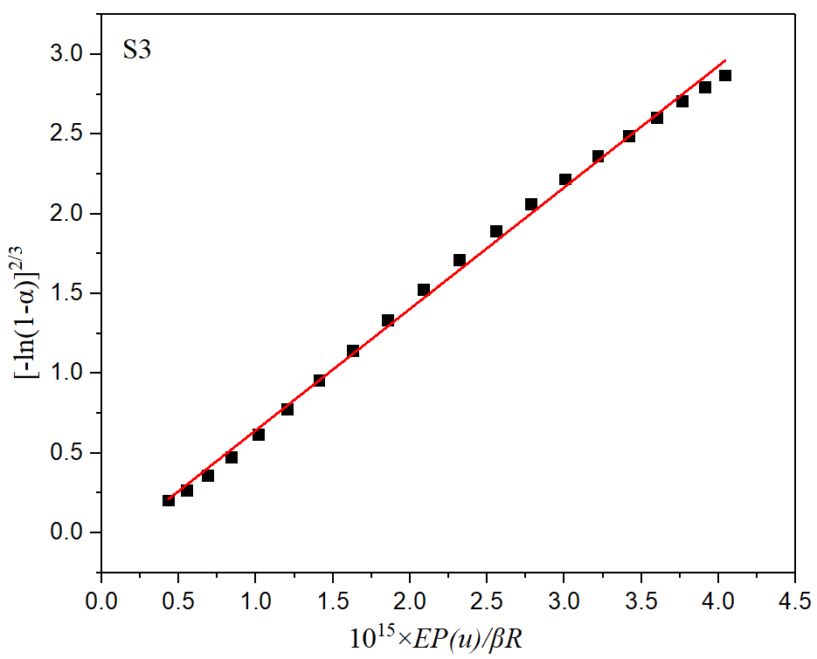
Fig. S10. Plotting G(α) versus 10^{x}×EP(α)/βR for various pyrolysis stages[(a) S1, (b) S2, (c) S3] of S-VR at 10 K min⁻¹;
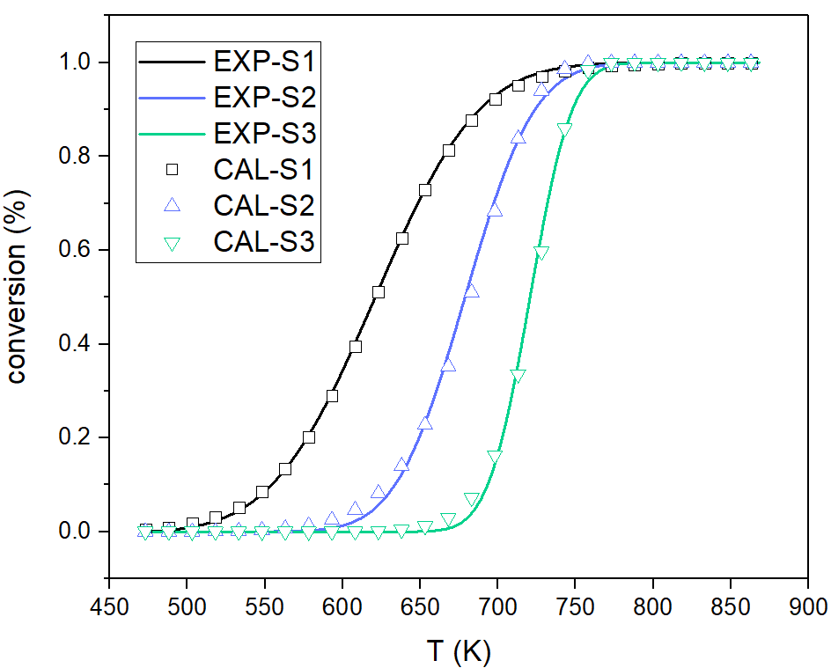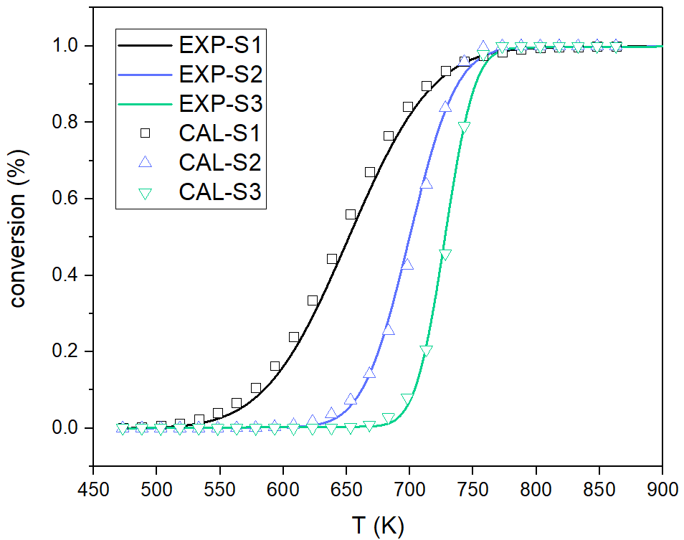
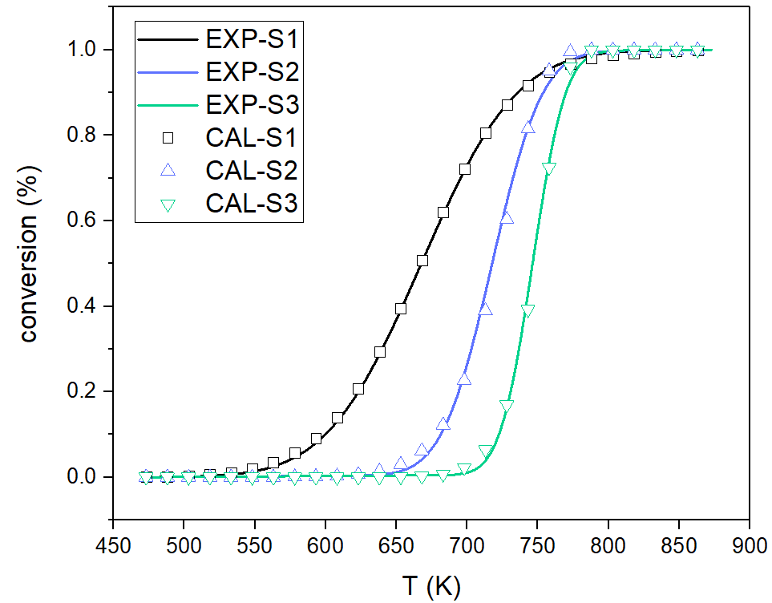
Fig. S11. Comparison of calculated and experimental conversion of pyrolysis of VR at 5,10 and 20K min⁻¹.
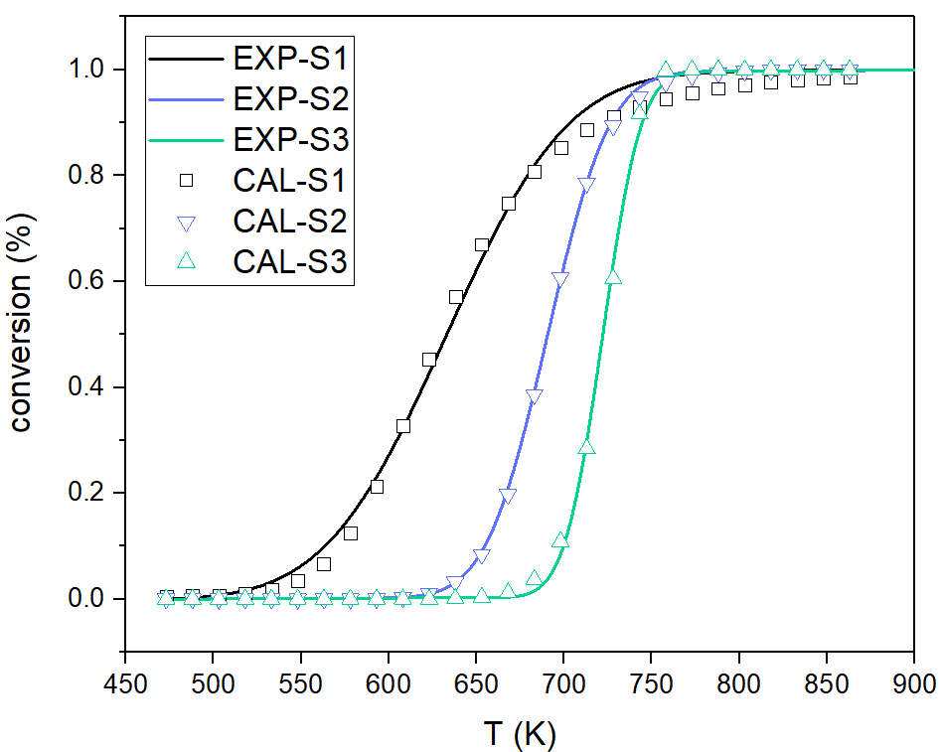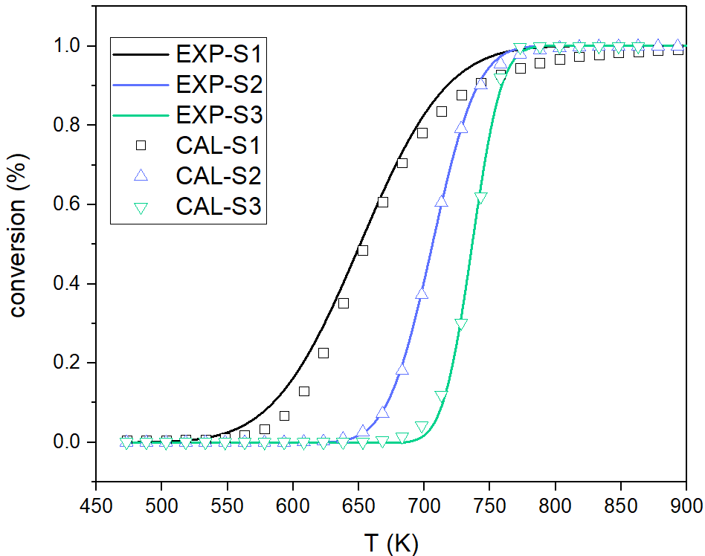
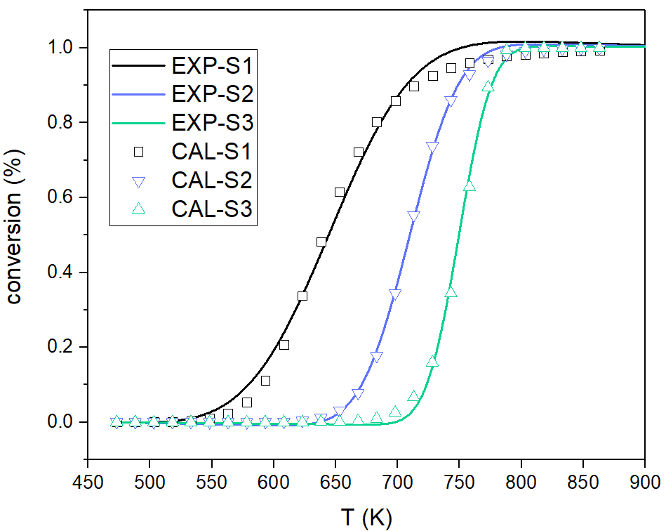
Fig. S12. Comparison of calculated and experimental conversion of pyrolysis of S-VR (a) at 5,10 and 20K min⁻¹.

