Electronic Supplementary Material

Selective C–C coupling via copper atom reconfiguration in CO₂ electroreduction

Linlin Zhou¹, Yang Zhong², Kai Sun³, Benqiang Tian¹, Haoyang Wu¹, Wei Liu¹, Tong Wan¹, Huijun Xin⁴, Chen Deng⁵, Xiaojie Li⁵, Jinjie Fang⁵, Geoffrey I.N. Waterhouse³, Yun Kuang ()⁴, Daojin Zhou ()¹, Xiaoming Sun ()¹

1State Key Laboratory of Chemical Resource Engineering, Beijing University of Chemical Technology, Beijing 100029, China
2 Weichai Power Co., Ltd., Weifang 261061, China
3 School of Chemical Sciences, the University of Auckland, Auckland 1010, New Zealand
4 Ocean Hydrogen Energy R&D Center, Research Institute of Tsinghua University in Shenzhen, Shenzhen 518057, China
5 PetroChina Shenzhen New Energy Research Institute Co., Ltd.

E-mails: kuangy@tsinghua-sz.edu.cn (Kuang Y); zhoudj@buct.edu.cn (Zhou D); sunxm08@126.com (Sun X)

Supplementary Figures:

Figure S1. Morphological characterisation of Cu-50. (a) HAADF image and (b) EDS-mapping of Cu.

Figure S2. Phase composition and crystal structure of Cu foil and Cu-50. XRD patterns of Cu foil and Cu-50.

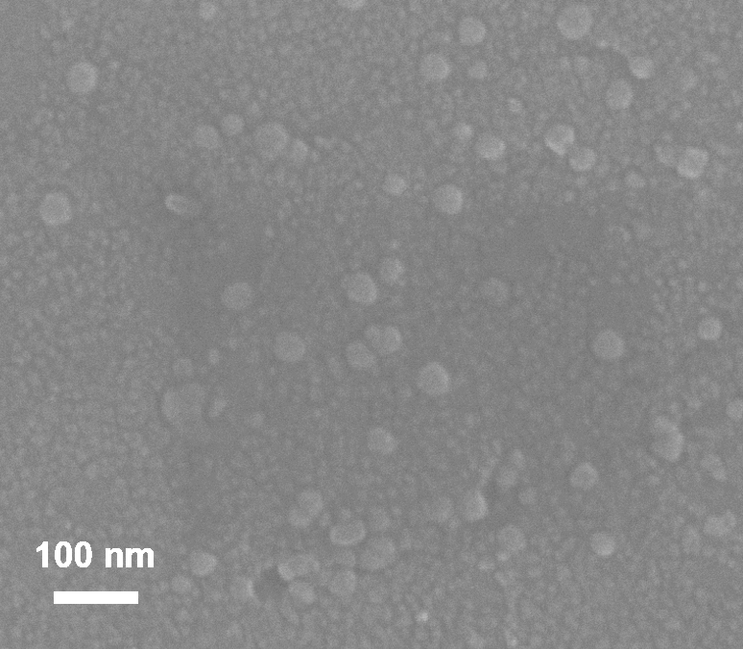
Figure S3. Morphological characterisation of Cu-15. SEM image of Cu-15.

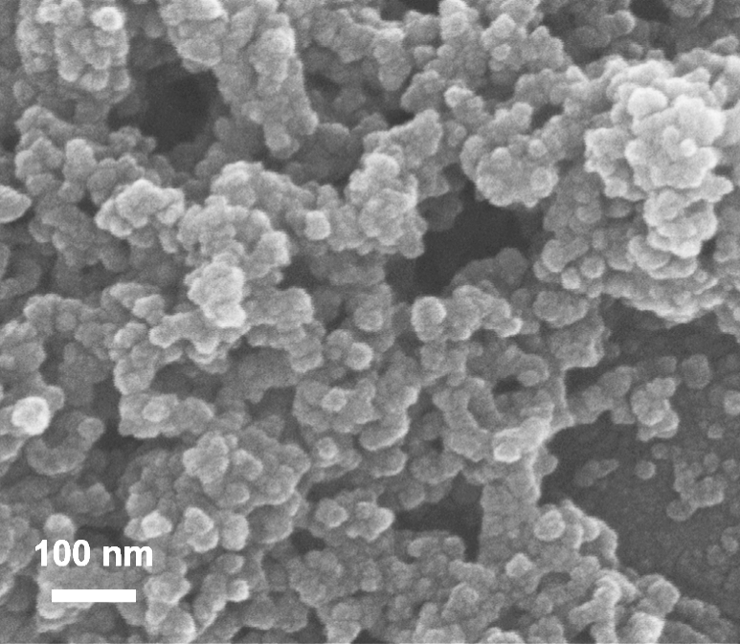
Figure S4. Morphological characterisation of Cu-75. SEM image of Cu-75.

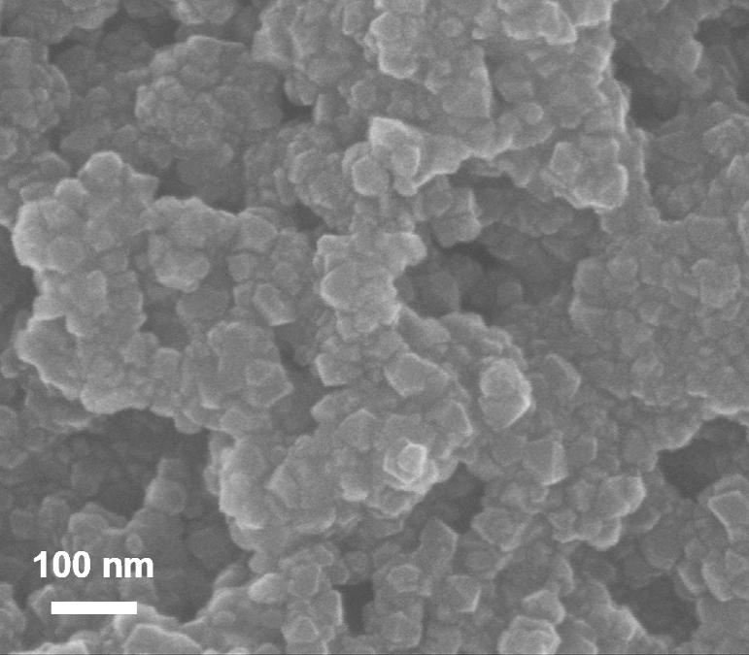
Figure S5. Morphological characterisation of 0-Cu-50. SEM image of 0-Cu-50.

Figure S6. Morphological characterisation of 10-Cu-50. (a-c) SEM images of 10-Cu-50.

Figure S7. Chemical structure of Cu foil and Cu-50. S 2p XPS spectra of Cu foil and Cu-50.

Figure S8. CER performance of restructured Cu cathodes. LSV curves of (a) Cu foil, (b) Cu-50, (c) Cu-15, (d) Cu-75 and (e) 10-CV-50 collected at a scanning rate of 5 mV/s in an N₂/CO₂-saturated 0.1 M KCl aqueous solution.

Figure S9. CER performance of the restructured Cu cathodes. Faradaic efficiencies of all products during CER on (a) Cu foil, (b) Cu-15, (c) Cu-50, (d) Cu-75, (e) 0-Cu-50 and (f) 10-Cu-50 in a CO₂-saturated 0.1 M KCl aqueous solution.

Figure S10. CER performance of the restructured Cu cathodes. Faradaic efficiencies towards C₂₊, C₁ and H₂ during CER on (a) Cu foil, (b) Cu-15, (c) Cu-50, (d) Cu-75, (e) 0-Cu-50 and (f) 10-Cu-50 in a CO₂-saturated 0.1 M KCl aqueous solution.

Figure S11. Cyclic voltammetry curves for ECSA determination. CV data for (a) Cu foil and (b) Cu-50. The measurements were performed at various scan rates (60, 80, 100, 120, 140, 160, 180 and 200 mV s⁻¹) from −0.28 to −0.185 V_{RHE}.

