Electronic Supplementary Material
Multilevel dispersion induced graphdiyne mixed-matrix membranes for ethanol recovery
Sen Li¹*, Xiaoting Zhou¹*, Tieyan Li¹, Yingzhou Lu¹, Chunxi Li¹, Hongwei Fan ()¹, Hong Meng ()²
¹ State Key Laboratory of Chemical Resource Engineering, College of Chemical Engineering, Beijing University of Chemical Technology, Beijing 100029, China
² State Key Laboratory of Chemistry and Utilization of Carbon Based Energy Resources, Xinjiang University, Urumqi 830046, China
E-mails: fanhongwei@mail.buct.edu.cn (Fan H); menghong@xju.edu.cn (Meng H)
*These authors contributed equally to this work.
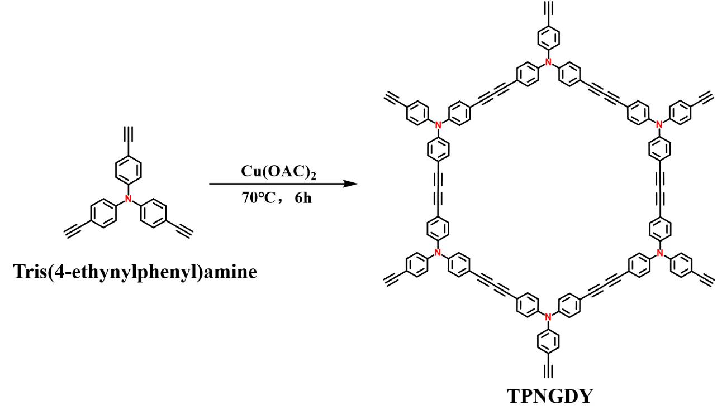
Fig. S1. TPNGDY synthetic reaction formula.

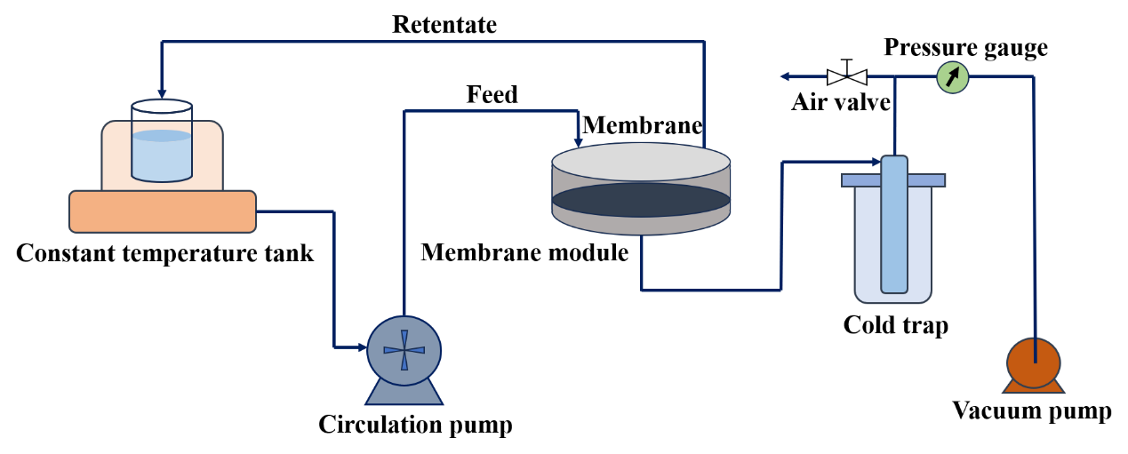
Fig. S2. Laboratory self-made device for testing PV performance.
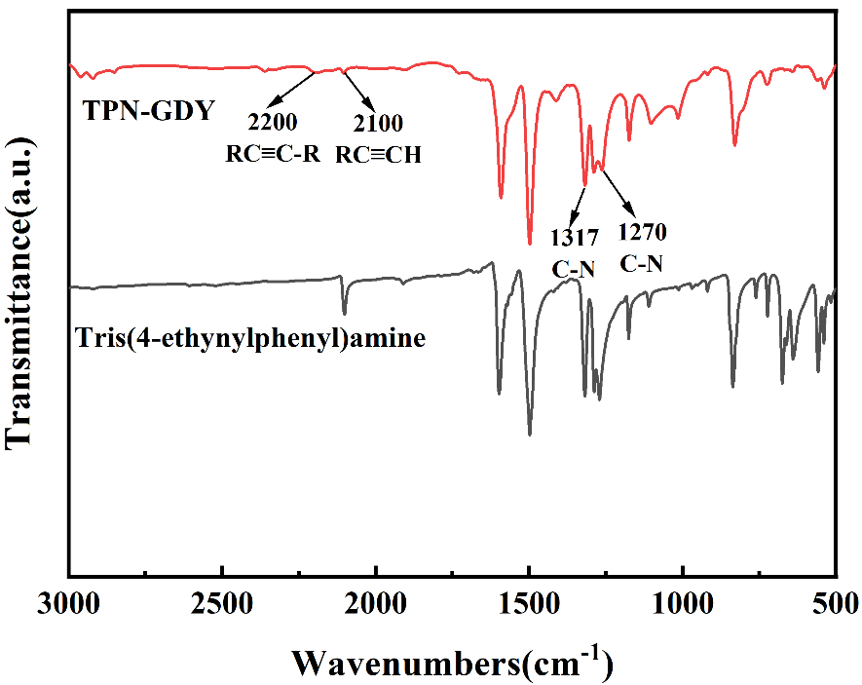
Fig. S3. FT-IR spectra of TPNGDY and Tris(4-ethynylphenyl)amine.
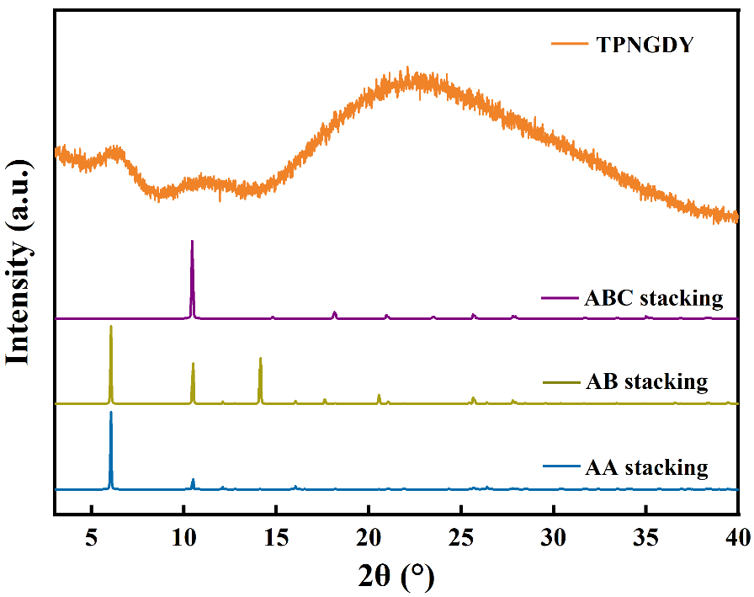
Fig. S4. XRD spectrum of TPNGDY.
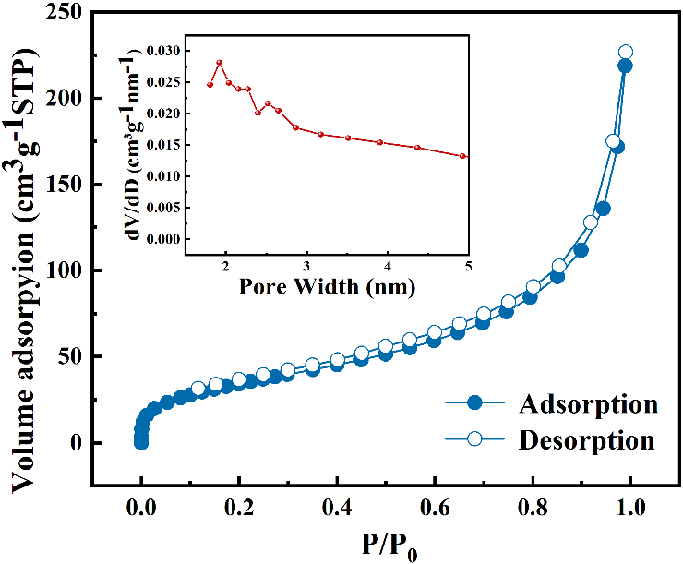
Fig. S5. Nitrogen adsorption-desorption isotherms of TPNGDY nanoparticles.
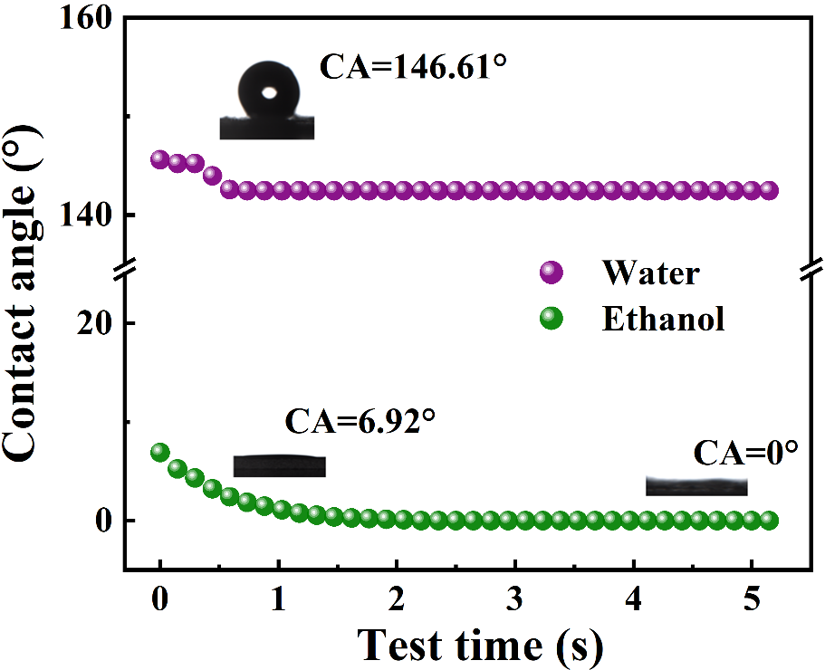
Fig. S6. Ethanol /water contact angle of TPNGDY.
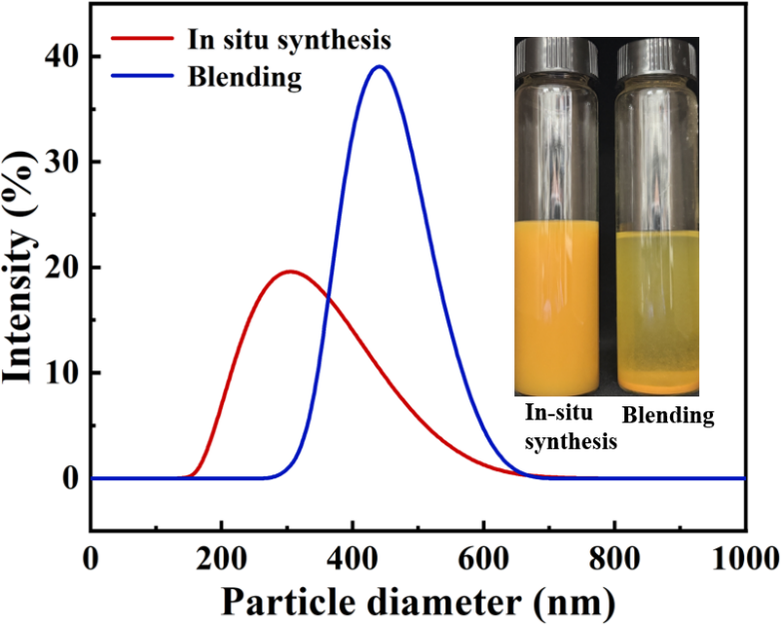
Fig. S7. DLS particle size analysis of TPNGDY with different preparation methods.

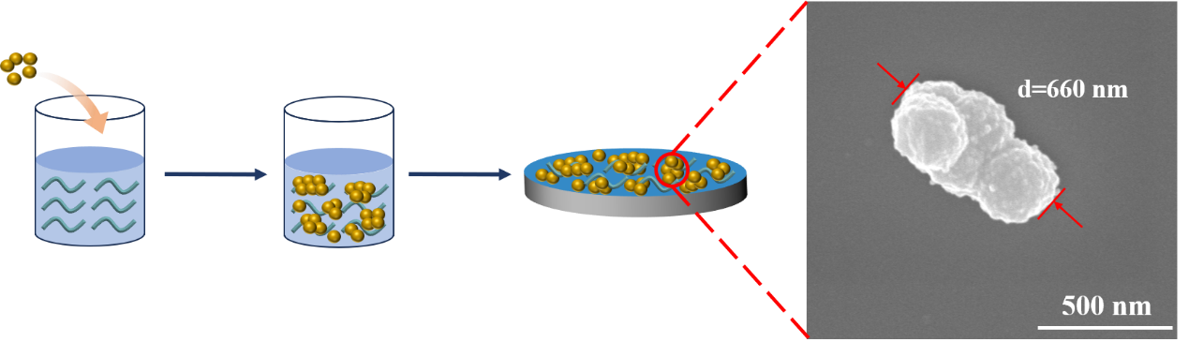
Fig. S8. Size of TPNGDY particles in cast membrane solution prepared by general stirring-casting method.

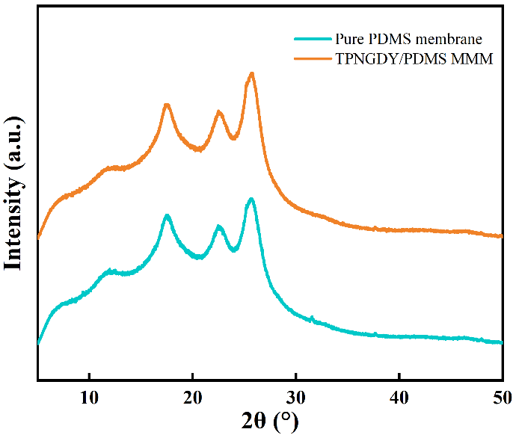
Fig. S9. XRD patterns of pure PDMS membranes and TPNGDY/PDMS MMM.
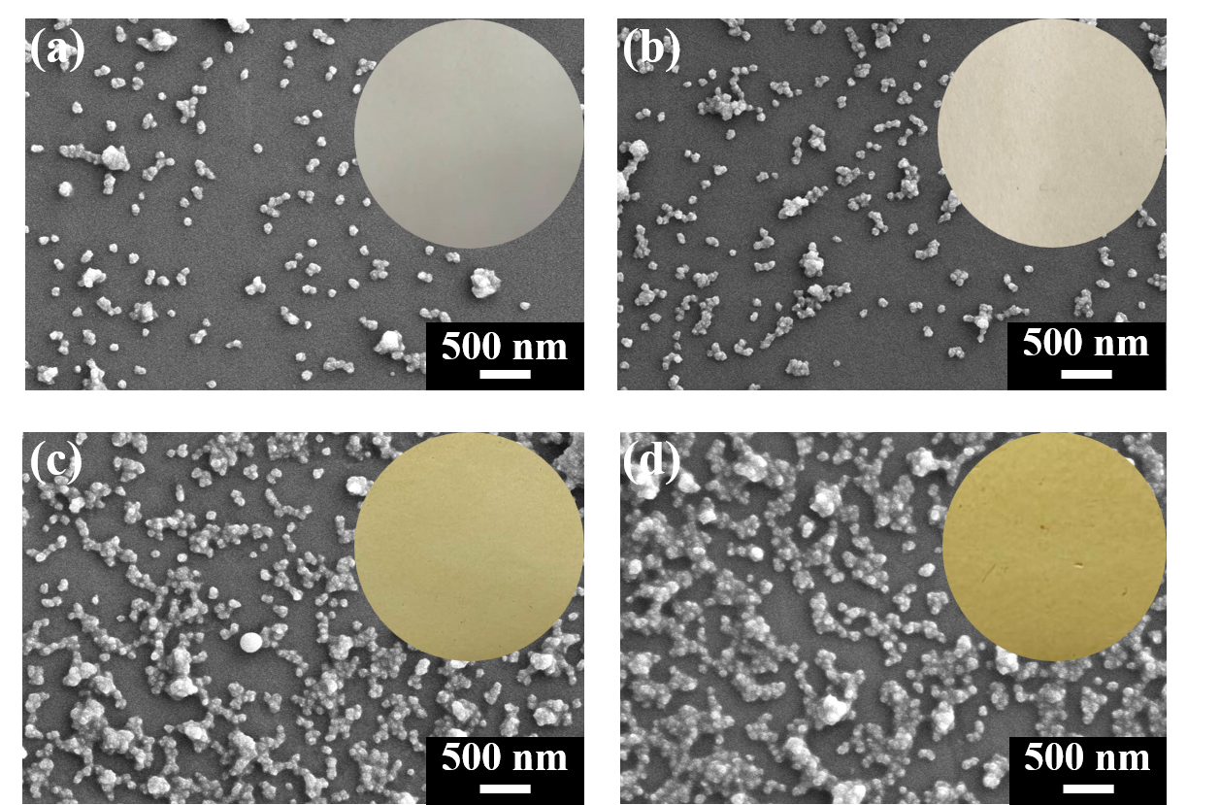
Fig. S10. Surface SEM of ultrasonically sprayed 1,2,4 and 5 layers (a~d) of MMM.
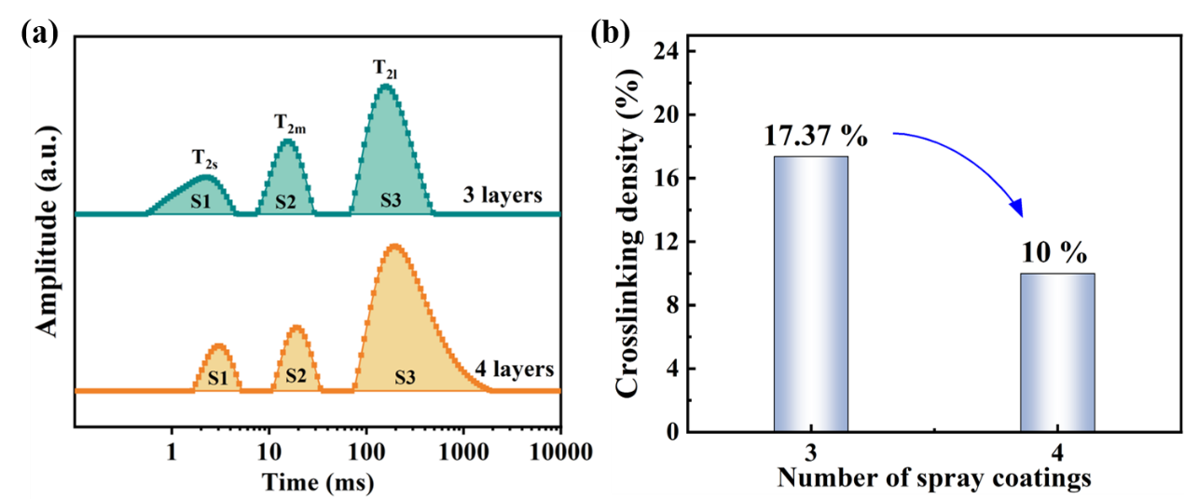
Fig. S11. Comparison of (a) T₂ relaxation time and (b) crosslink density of PDMS on membrane surfaces with different numbers of sprayed layers.

Part 1.
We analyzed the relaxation time (T₂) reflecting the movement of PDMS polymer chains on the membrane surface using low-field nuclear magnetic resonance (LFNMR). As shown in Fig. S11(a), the polymer network exhibits different relaxation times, categorized as T_{2s}, T_{2m}, and T_{2l}, each representing a different degree of proton migration. T_{2s} correspond to protons in the polymer chains close to the cross-linking sites. T_{2m} corresponds to protons located within the network but not directly attached to the cross-linker, and T_{2l} denotes protons with greater mobility at the end of the chain [1, 2]. Comparison of the relaxation times of PDMS on membrane surfaces with different numbers of sprayed layers shows that the relaxation time T_{2s} is shorter. The peak area share is larger (Fig. R11(b)) for the sprayed 3-layer (the peak area is calculated from S1/(S1+S2+S3)), which suggests that there is better and more homogeneous cross-linking between the PDMS, with fewer free spaces in the chain segments.

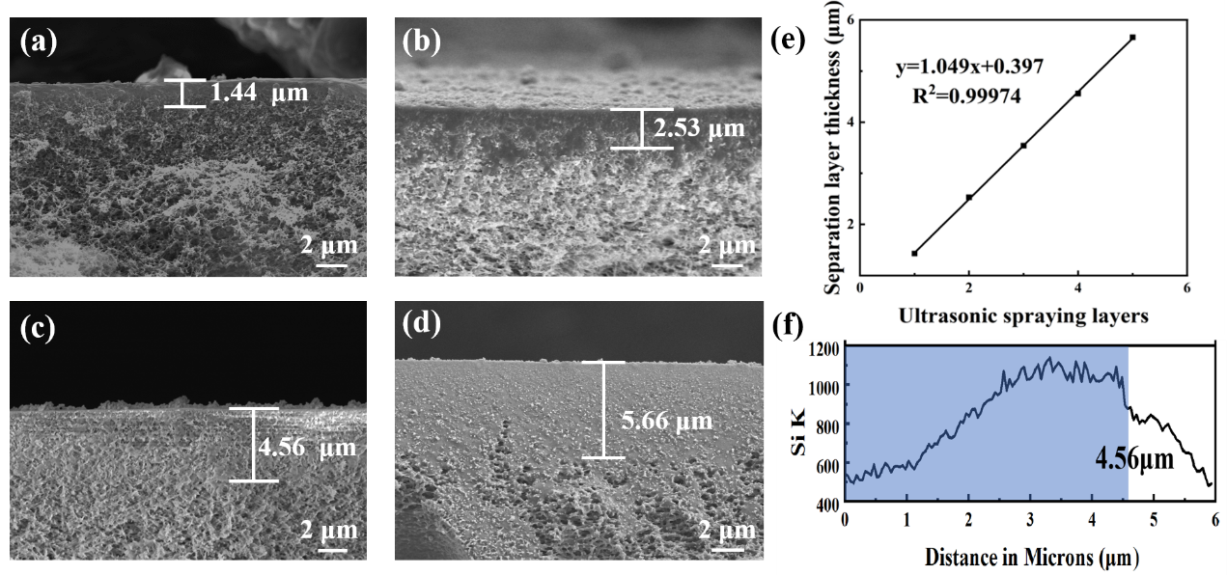
Fig. S12. Cross-sectional SEM images of ultrasonically sprayed TPNGDY/PDMS MMMs with 1,2,4 and 5 layers (a-d) and the trend of the thickness of the separating layer with the number of sprayed layers (e) and EDS characterization of 4 layers of ultrasonic spraying (f).
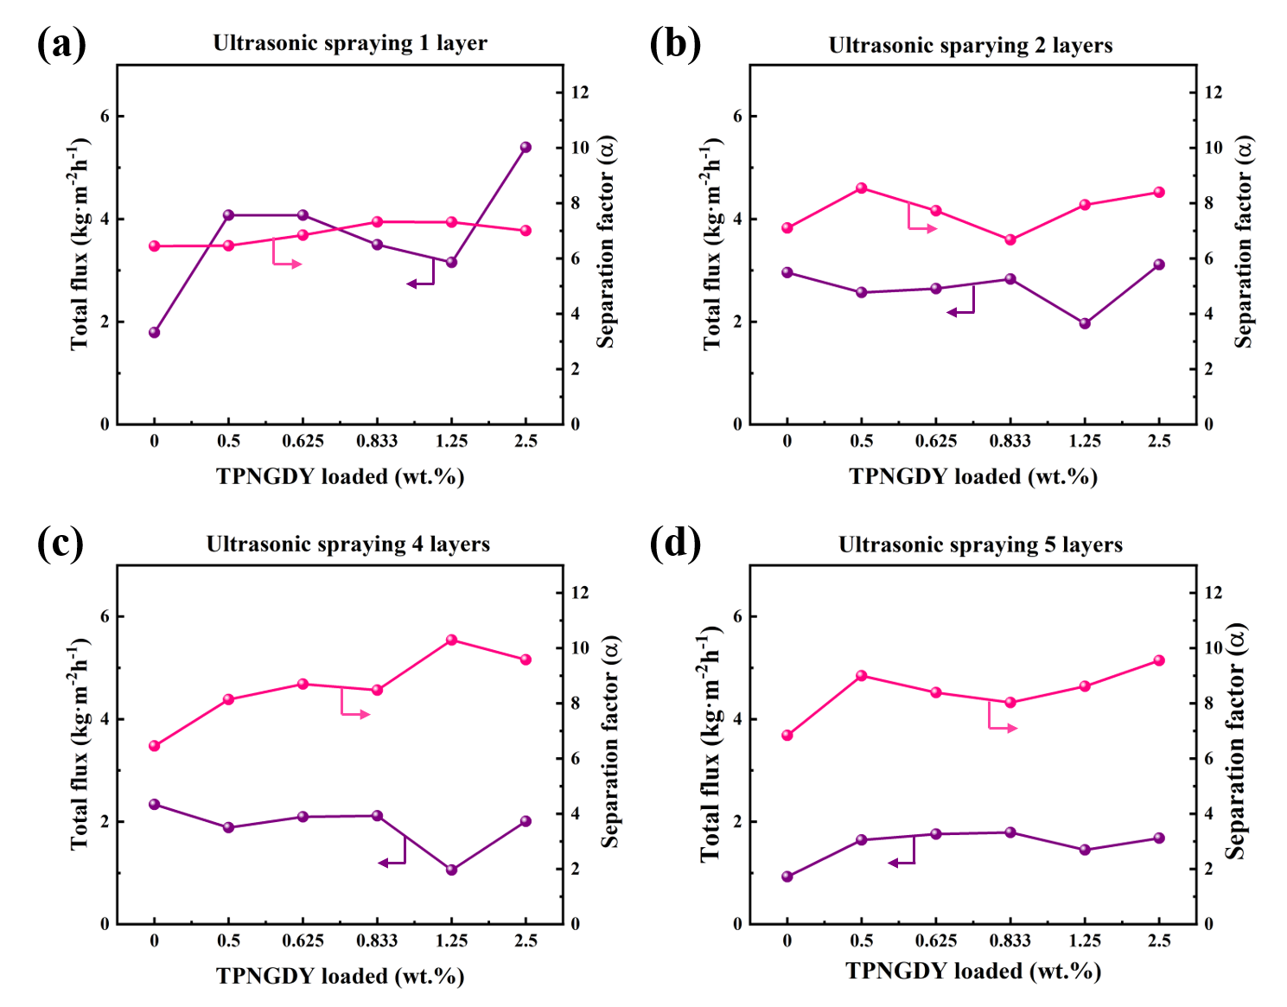
Fig. S13. Effect of TPNGDY loading on PV performance of TPNGDY/PDMS MMM with 1,2,4, and 5 layers (a-d) of spraying layers.
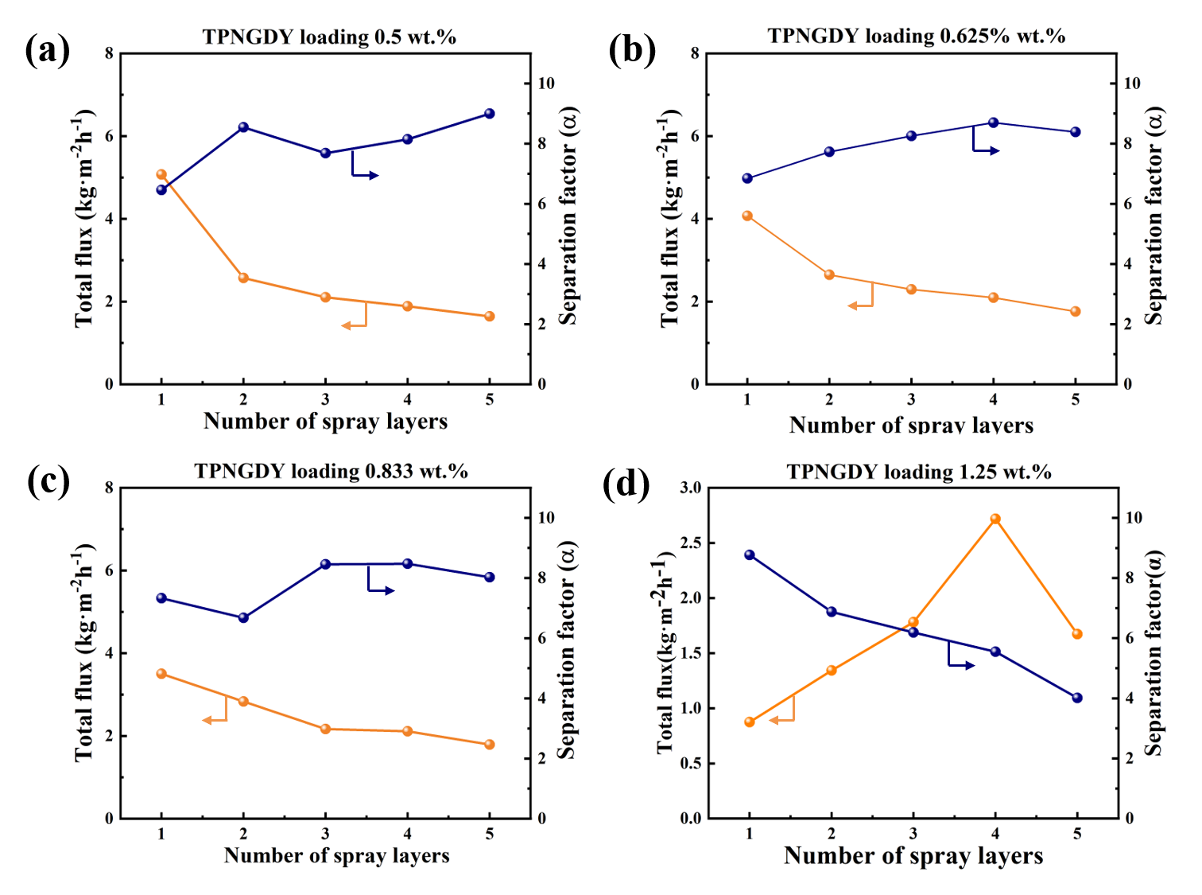
Fig. S14. Effect of spraying layers on PV performance of TPNGDY/PDMS MMM with the TPNGDY loadings of 0.5 wt.% to 1.25 wt.% (a~d).
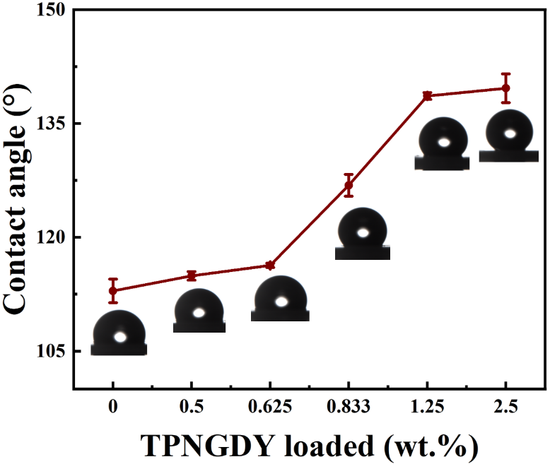
Fig. S15. Effect of TPNGDY loading on the static water contact angle of TPNGDY/PDMS MMMs. Error, 0.24% ~1.37%.

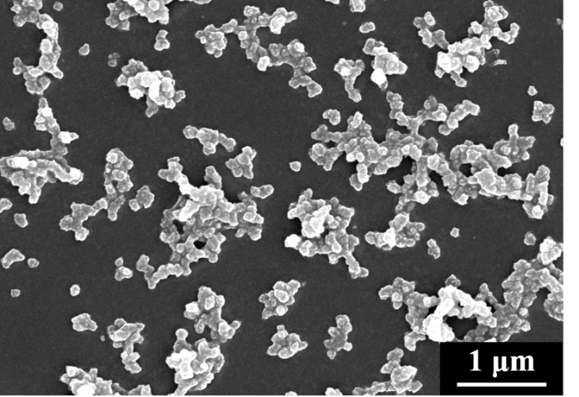
Fig. S16. SEM image before ultrasonic spray PDMS post-processing.
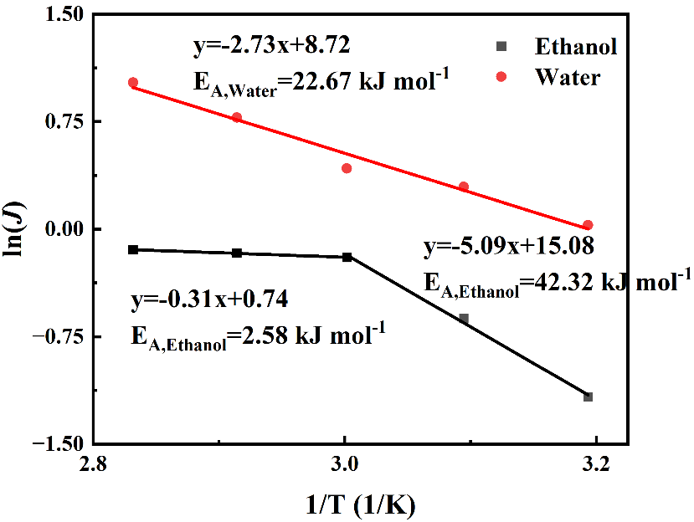
Fig. S17. The Arrhenius equation diagram of ethanol and water permeation flux and temperature.

Table S1. PV performance comparison
Materials | Selective thickness/μm | Feed temperature /℃ | Feed concentration/wt.% | Total flux  /kg·m⁻²·h⁻¹ | Separation factor | Reference
Silicalite-1/PDMS | 100 | 35 | 6 | 0.085 | 16.4 | [3]
Silica/PDMS | 6 | 60 | 5 | 0.807 | 12.5 | [4]
ZIF-71/PDMS | 5 | 50 | 5 | 0.900 | 9.5 | [5]
ZIF-67/PDMS | 7.3 | 40 | 6 | 2.78 | 15.4 | [6]
ZIF-90/PDMS | 100 | 60 | 5 | 0.099 | 15.1 | [7]
UiO-66-TMS/PDMS | — | 40 | 5 | 5.278 | 5.4 | [8]
MCM-41@ZIF-8/PDMS | 3 | 70 | 5 | 2.204 | 10.4 | [9]
Silica/PTMSP | 125 | 50 | 10 | 0.400 | 15.3 | [10]
PDMS | <1 | 60 | 5 | 3.275 | 7.5 | [11]
PDVB/PDMS | 15 | 60 | 6 | 1.423 | 10 | [12]
PDMS-PTFPMS block copolymer | 9 | 60 | 5 | 1.348 | 10.1 | [13]
PSI | 100 | 60 | 5 | 0.27 | 4.3 | [14]
Porous PTFE | 175 | 60 | 2 | 10. 592 | 2.25 | [15]
TPNGDY/PDMS | 3.8 | 60 | 5 | 2.35 | 11.31 | this work
TPNGDY/PDMS-after work | 4 | 60 | 5 | 2.19 | 12.55 | this work

References
1. Cheng Z, Sun H, Xu Y, Wang N and An Q. Facile fabrication of Al-fumarate mixed matrix membranes for azeotrope mixture separation. Separation and Purification Technology, 2025, 360: 130963.
2. Azoug A, Constantinescu A, Nevière R and Jacob G. Microstructure and deformation mechanisms of a solid propellant using 1H NMR spectroscopy. Fuel, 2015, 148: 39-47.
3. Liu X, Hu D, Li M, Zhang J, Zhu Z, Zeng G, Zhang Y, Sun Y. Preparation and characterization of silicalite-1/PDMS surface sieving pervaporation membrane for separation of ethanol/water mixture. Journal of Applied Polymer Science, 2015, 132: 42460.
4. Yan H, Li J, Fan H, Ji S, Zhang G, Zhang Z. Sonication-enhanced in situ assembly of organic/inorganic hybrid membranes: Evolution of nanoparticle distribution and pervaporation performance. Journal of Membrane Science, 2015, 481: 94-105.
5. Li Y, Wee L, Martens J, Vankelecom I. ZIF-71 as a potential filler to prepare pervaporation membranes for bio-alcohol recovery. Journal of Materials Chemistry A, 2014, 2: 10034-10040.
6. Khan A, Ali M, Ilyas A, Naik P, Vankelecom I, Gilani M, Bilad M, Sajjad Z, Khan A. ZIF-67 filled PDMS mixed matrix membranes for recovery of ethanol via pervaporation. Separation and Purification Technology, 2018, 206: 50-58.
7. Xu S, Zhang H, Yu F, Zhao X, Wang Y. Enhanced ethanol recovery of PDMS mixed matrix membranes with hydrophobically modified ZIF-90. Separation and Purification Technology, 2018, 206: 80-89.
8. Wang H, Tang S, Ni Y, Zhang C, Zhu X, Zhao Q. Covalent cross-linking for interface engineering of high flux UiO-66-TMS/PDMS pervaporation membranes. Journal of Membrane Science, 2020, 598: 117791.
9. Wang N, Shi G, Gao J, Li J, Wang L, Guo H, Zhang G, Ji S. MCM-41@ZIF-8/PDMS hybrid membranes with micro- and nanoscaled hierarchical structure for alcohol permselective pervaporation. Separation and Purification Technology, 2015, 153: 146-155.
10. Claes S, Vandezande P, Mullens S, Leysen R, De Sitter K, Andersson A, Maurer F, Van den Rul H, Peeters R, Van Bael M. High flux composite PTMSP-silica nanohybrid membranes for the pervaporation of ethanol/water mixtures. Journal of Membrane Science, 2010, 351: 160-167.
11. Wang R, Shan L, Zhang G, Ji S. Multiple sprayed composite membranes with high flux for alcohol permselective pervaporation. Journal of Membrane Science, 2013, 432: 33-41.
12. He X, Wang T, Huang J, Chen J, Li J. Fabrication and characterization of superhydrophobic PDMS composite membranes for efficient ethanol recovery via pervaporation. Separation and Purification Technology, 2020, 241: 116675.
13. Liu C, Xue T, Yang Y, Ouyang J, Chen H, Yang S, Li G, Cai D, Si Z, Li S, Qin P. Effect of crosslinker 3-methacryloxypropylmethyldimethoxysilane on UV-crosslinked PDMS-PTFPMS block copolymer membranes for ethanol pervaporation. Chemical Engineering Research and Design, 2021, 168: 13-24.
14.Song Z, Zhu J, Jiang L. Novel polysiloxaneimide/polyetherimide/non-woven fabric composite membranes for organophilic pervaporation. Journal of Membrane Science, 2014, 472: 77-90.
15. Aroujalian A, Raisi A. Pervaporation as a means of recovering ethanol from lignocellulosic bioconversions. Desalination, 2009, 247: 509-517.

