Electronic Supplementary Material

Fe/Ru synthesized by hydrothermal deposition on hyper-crosslinked polystyrene as promising Fischer-Tropsch catalyst
Mariia E. Markova¹, Antonina A. Stepacheva ()¹, Alexey V. Bykov¹, Yurii V. Larichev², Valentin Y. Doluda¹, Mikhail G. Sulman¹, Lioubov Kiwi-Minsker^{1,3}
1 Tver State Technical University, Tver 170026, Russia
2 Boreskov Institute of Catalysis SB RAS, Novosibirsk 630090, Russia
3 Ecole Polytechnique Fédérale de Lausanne, ISIC-EPFL, Lausanne CH-1015, Switzerland

E-mail: a.a.stepacheva@mail.ru

Figure S1. FTIR-spectra of the initial HPS and the polymer treated in catalyst synthesis conditions

(a) | (b)
(c) | (d)
(e) | (f)

Figure S2. Nitrogen adsorption-desorption isotherms and differential curve of pore size distribution for 2%-Fe-HPS (a, b), 1%-Ru-HPS (c, d), and 2%-Fe-1%-Ru-HPS (e, f)

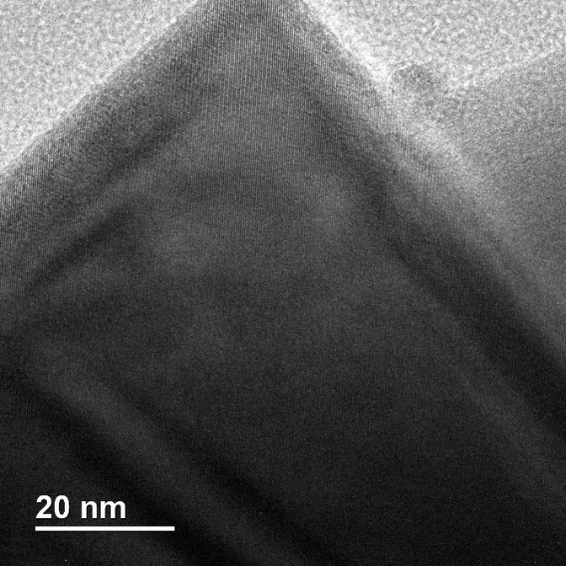 | 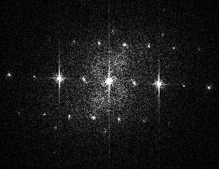
 | 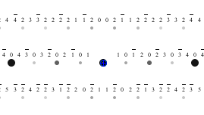

Figure S3. TSM image, two-dimentiona Fourier spectra and electronogramm for 2%-Fe-HPS

(a) | (b)
(c) | (d)

Figure S4. The survey spectra of the samples of initial HPS (a), 2%-Fe-HPS (b), 1%-Ru-HPS (c), and 2%-Fe-1%-Ru-HPS (d)

Table S1. Surface composition of the catalyst samples
Element | Surface concentration, at. %
Element | HPS | 2%-Fe-HPS | 1%Ru-HPS | 2%Fe-1%Ru-HPS
C | 79.17 | 92.63 | 91.20 | 90.15
O | 17.68 | 6.80 | 6.94 | 7.32
Cl | 1.35 | - | - | -
Si | 0.43 | - | - | -
S | 0.32 | - | - | -
N | 1.04 | - | - | -
Na | - | 0.21 | 0.12 | 0.16
Fe | - | 0.36 | - | 0.72
Ru | - | - | 1.74 | 1.65

(a) | (b)

Figure S5. High-resolution spectra of O 1s sublevel for 2%-Fe-HPS (a), and 2%-Fe-1%-Ru-HPS (b)

(a) | (b)

Figure S6. High-resolution spectra for Fe 2p, C1s, and Ru 3d sublevels for as-synthesized 2%-Fe-HPS (a), and 1%-Ru-HPS (b)

Figure S7. Possible reaction scheme of the liquid-phase FTS over Ru-Fe-HPS

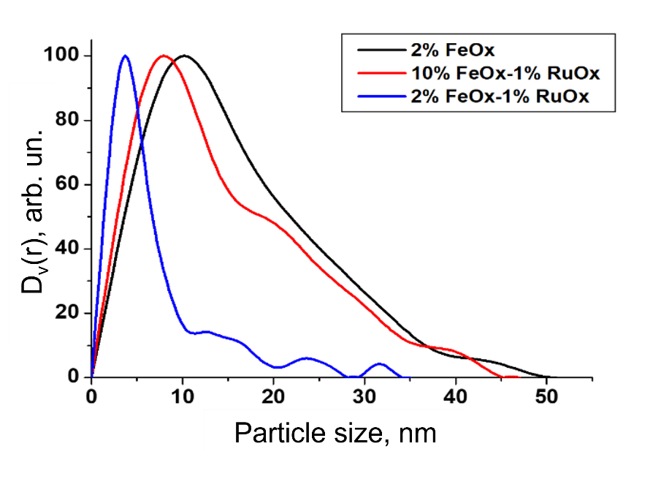

Figure S8. Particle-size distribution obtained by SAXS for 2%-Fe-HPS, 2%Fe-1%Ru-HPS, and 10%-Fe-1%-Ru-HPS

