Electronic Supplementary Material
DFT insights into oxygen vacancy formation and chemical looping dry reforming of methane on metals-substituted CeO₂ (111) surface
Mingyi Chen^{1,2}*, Zeshan Wang^{1,2}*, Yuelun Li^{1,2}, Yuxin Wang^{1,2,3}, Lei Jiang^{1,2}, Huicong Zuo^{1,2}, Linan Huang^{1,2}, Yuhao Wang^{1,2,3}, Dong Tian ()^{1,2,3}, Hua Wang ()^{1,2,3}, Kongzhai Li ()^{1,2,3}
1 Engineering Research Center of Metallurgical Energy Conservation and Emission Reduction, Ministry of Education, Kunming University of Science and Technology, Kunming 650093, China
2 Faculty of Metallurgical and Energy Engineering, Kunming University of Science and Technology, Kunming 650093, China
3 State Key Laboratory of Complex Nonferrous Metal Resources Clean Utilization, Kunming University of Science and Technology, Kunming 650093, China
E-mails: dong.tian@aliyun.com; dong.tian@kust.edu.cn (Tian D); wanghua65@163.com (Wang H); kongzhai.li@foxmail.com; kongzhai.li@aliyun.com (Li K)
* These authors contributed equally to this work.

Table S1. DFT calculated the effective bader charge of different metals and the surrounding oxygen atoms for the substituted CeO₂ (111) surfaces.
Substituted-metal |  | M | O₁ | O₂ | O₃ | O₄ | O₅
Ge |  | -1.28 | 1.20 | 1.11 | 1.20 | 1.20 | 1.11
Zr |  | -2.30 | 1.16 | 1.21 | 1.26 | 1.26 | 1.21
Ta |  | -2.51 | 1.13 | 1.18 | 1.24 | 1.24 | 1.18
Pr |  | -2.02 | 1.16 | 1.19 | 1.24 | 1.24 | 1.19
Hf | -2.27 |  | 1.15 | 1.21 | 1.26 | 1.26 | 1.21
Re | -2.45 |  | 1.10 | 1.06 | 1.14 | 1.14 | 1.06
V | -1.81 |  | 1.07 | 1.06 | 1.24 | 1.24 | 1.06
W | -2.56 |  | 1.11 | 1.09 | 1.16 | 1.16 | 1.09
Pt | -0.81 |  | 1.11 | 1.05 | 1.07 | 1.07 | 1.05
Nb | -2.63 |  | 1.13 | 1.18 | 1.28 | 1.28 | 1.18
Ir | -1.45 |  | 1.00 | 1.03 | 1.07 | 1.07 | 1.03
Rh | -1.24 |  | 1.12 | 1.08 | 1.11 | 1.11 | 1.08
Ti | -1.94 |  | 1.16 | 1.14 | 1.21 | 1.21 | 1.14
La | -2.09 |  | 1.20 | 1.22 | 1.24 | 1.24 | 1.22
Sb | -1.81 |  | 1.19 | 1.17 | 1.23 | 1.23 | 1.17
Ru | -1.60 |  | 1.11 | 1.11 | 1.15 | 1.15 | 1.11
Y | -2.19 |  | 1.27 | 1.25 | 1.28 | 1.28 | 1.25
Cr | -1.70 |  | 1.11 | 1.10 | 1.10 | 1.10 | 1.10
In | -1.07 |  | 1.18 | 1.15 | 1.19 | 1.19 | 1.15
Pd | -0.82 |  | 1.12 | 1.07 | 1.08 | 1.08 | 1.07
Os | -2.07 |  | 1.01 | 1.01 | 1.11 | 1.11 | 1.01
Co | -1.40 |  | 1.09 | 1.09 | 1.18 | 1.18 | 1.09
Sc | -2.09 |  | 1.24 | 1.22 | 1.27 | 1.27 | 1.22
Ga | -1.61 |  | 1.18 | 1.17 | 1.17 | 1.17 | 1.17
Mo | -2.30 |  | 1.08 | 1.00 | 1.16 | 1.16 | 1.00
Al | -2.41 |  | 1.31 | 1.40 | 1.18 | 1.18 | 1.40
Fe | -1.53 |  | 1.18 | 1.10 | 1.18 | 1.18 | 1.10
Au | -1.00 |  | 1.11 | 1.00 | 1.06 | 1.06 | 1.00
Ni | -1.16 |  | 1.19 | 1.09 | 1.19 | 1.19 | 1.09
Mn | -1.41 |  | 1.20 | 1.14 | 1.23 | 1.23 | 1.14
Sr | -1.56 |  | 1.19 | 1.20 | 1.22 | 1.22 | 1.20
Rb | -0.84 |  | 1.14 | 1.12 | 1.16 | 1.16 | 1.12
Ca | -1.55 |  | 1.14 | 1.15 | 1.17 | 1.17 | 1.15
Cd | -1.23 |  | 1.16 | 1.15 | 1.18 | 1.18 | 1.15
K | -0.83 |  | 1.14 | 1.12 | 1.16 | 1.16 | 1.12
Na | -0.83 |  | 1.12 | 1.10 | 1.16 | 1.16 | 1.10
Mg | -1.66 |  | 1.28 | 1.14 | 1.30 | 1.30 | 1.14
Zn | -1.25 |  | 1.20 | 1.10 | 1.21 | 1.21 | 1.10

Table S2. DFT calculated adsorption energies of CH₄ on pristine CeO₂ (111) and Zn substituted CeO₂ (111) during the chemical looping dry reforming of methane to produce syngas process.
Adsorption site | Pristine CeO₂(111)  E_{ads}/eV | Zn substituted CeO₂ (111)  E_{ads}/eV
Ce-TOP | -0.38 | -0.24
Hollow | -0.64 | -0.18
O-TOP | -0.38 | -0.06
O-O bridge | -0.47 | -0.12
Ce-O bridge | -0.49 | -0.18
O vacancy | -0.29 | -0.37
Zn-TOP | / | -0.31

Table S3. DFT calculated adsorption energies of CH₃ on pristine CeO₂ (111) and Zn substituted CeO₂ (111) during the chemical looping dry reforming of methane to produce syngas process.
Adsorption site | Pristine CeO₂(111)  E_{ads}/eV | Zn substituted CeO₂ (111)  E_{ads}/eV
Ce-TOP | -2.33 | -0.98
Hollow | -2.33 | -1.08
O-TOP | -3.22 | -3.42
O-O bridge | -2.34 | -0.76
Ce-O bridge | -3.10 | -2.87
O vacancy | -2.24 | -1.09
Zn-TOP | / | -1.17

Table S4. DFT calculated adsorption energies of CH₂ on pristine CeO₂ (111) and Zn substituted CeO₂ (111) during the chemical looping dry reforming of methane to produce syngas process.
Adsorption site | Pristine CeO₂(111)  E_{ads}/eV | Zn substituted CeO₂ (111)  E_{ads}/eV
Ce-TOP | -3.13 | -1.34
Hollow | -3.12 | -5.92
O-TOP | -4.46 | -5.04
O-O bridge | -3.15 | -1.60
Ce-O bridge | -4.41 | -3.73
O vacancy | -3.14 | -1.33
Zn-TOP | / | -4.50

Table S5. DFT calculated adsorption energies of CH on pristine CeO₂ (111) and Zn substituted CeO₂ (111) during the chemical looping dry reforming of methane to produce syngas process.
Adsorption site | Pristine CeO₂(111)  E_{ads}/eV | Zn substituted CeO₂ (111)  E_{ads}/eV
Ce-TOP | -3.35 | -5.43
Hollow | -3.61 | -5.65
O-TOP | -4.64 | -5.72
O-O bridge | -3.62 | -6.32
Ce-O bridge | -5.54 | -5.06
O vacancy | -3.62 | -5.20
Zn-TOP | / | -6.27

Table S6. DFT calculated adsorption energies of C on pristine CeO₂ (111) and Zn substituted CeO₂ (111) during the chemical looping dry reforming of methane to produce syngas process.
Adsorption site | Pristine CeO₂(111)  E_{ads}/eV | Zn substituted CeO₂ (111)  E_{ads}/eV
Ce-TOP | -3.93 | -7.53
Hollow | -3.93 | -8.48
O-TOP | -7.35 | -8.44
O-O bridge | -7.51 | -9.14
Ce-O bridge | -7.27 | -7.30
O vacancy | -3.97 | -6.81
Zn-TOP | / | -8.24

Table S7. DFT calculated adsorption energies of H on pristine CeO₂ (111) and Zn substituted CeO₂ (111) during the chemical looping dry reforming of methane to produce syngas process.
Adsorption site | Pristine CeO₂(111)  E_{ads}/eV | Zn substituted CeO₂ (111)  E_{ads}/eV
Ce-TOP | 0.08 | 2.17
Hollow | 0.09 | 1.77
O-TOP | -1.50 | -1.53
O-O bridge | 1.88 | 1.77
Ce-O bridge | -1.41 | -1.16
O vacancy | 0.08 | 1.77
Zn-TOP | / | 1.77

Table S8. DFT calculated adsorption energies of CHO on pristine CeO₂ (111) and Zn substituted CeO₂ (111) during the chemical looping dry reforming of methane to produce syngas process.
Adsorption site | Pristine CeO₂(111)  E_{ads}/eV | Zn substituted CeO₂ (111)  E_{ads}/eV
Ce-TOP | -1.58 | -0.54
Hollow | -1.59 | -3.85
O-TOP | -3.98 | -4.09
O-O bridge | -0.77 | -0.30
Ce-O bridge | -4.04 | -3.62
O vacancy | -1.57 | 0.64
Zn-TOP | / | -1.11

Table S9. DFT calculated adsorption energies of CH₂O on pristine CeO₂ (111) and Zn substituted CeO₂ (111) during the chemical looping dry reforming of methane to produce syngas process.
Adsorption site | Pristine CeO₂(111)  E_{ads}/eV | Zn substituted CeO₂ (111)  E_{ads}/eV
Ce-TOP | -1.21 | -0.59
Hollow | -1.76 | -0.97
O-TOP | -1.75 | -1.04
O-O bridge | -1.16 | -1.03
Ce-O bridge | -1.76 | -1.31
O vacancy | -1.22 | 0.86
Zn-TOP | / | -1.05

Table S10. DFT calculated adsorption energies of CH₃O on pristine CeO₂ (111) and Zn substituted CeO₂ (111) during the chemical looping dry reforming of methane to produce syngas process.
Adsorption site | Pristine CeO₂(111)  E_{ads}/eV | Zn substituted CeO₂ (111)  E_{ads}/eV
Ce-TOP | -3.92 | -1.64
Hollow | -3.90 | -1.75
O-TOP | -3.93 | -0.05
O-O bridge | -9.90 | -0.13
Ce-O bridge | -3.93 | -1.61
O vacancy | -3.72 | 1.65

Fig. S1 DFT calculated the charge-density difference of M-substituted CeO₂ (111) (M = Ag, Au, CO, Hf, Cr, In, Mg, Mo, Na, Nb, Ni, Pd)

Fig. S2 DFT calculated the charge-density difference of M-substituted CeO₂ (111) (M = Pt, Rh, Fe, Ga, W, Y, Zn, Ge, Ir, K, La, Mn)

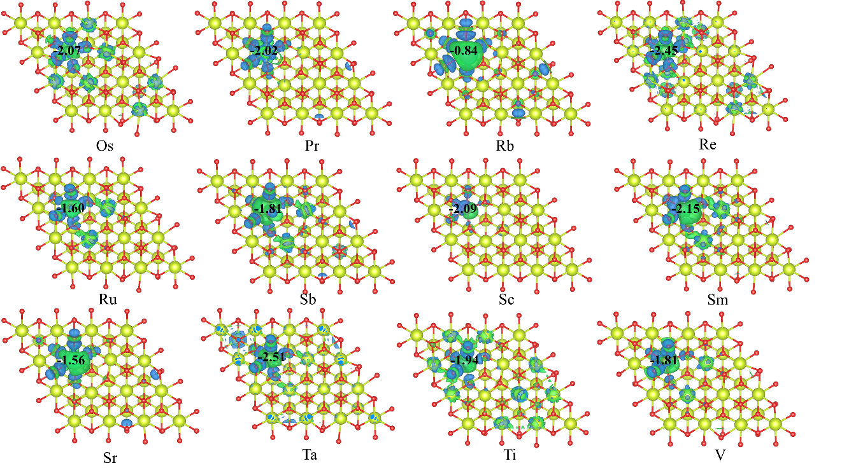
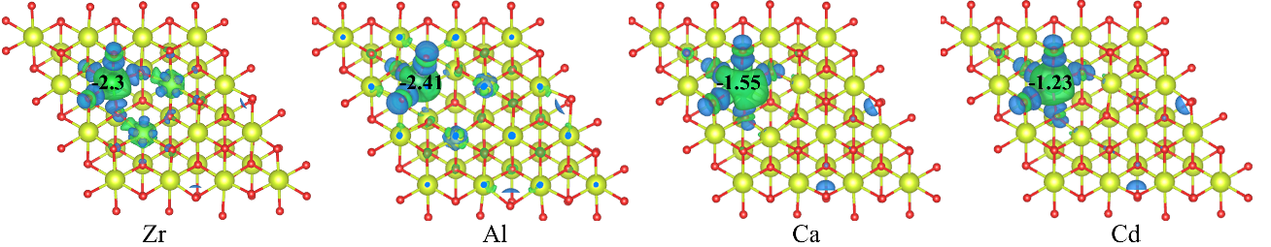
Fig. S3 DFT calculated the charge-density difference of M-substituted CeO₂ (111) (M = Os, Pr, Rb, Re, Ru, Sb, Sc, Sm, Sr, Ta, Ti, V, Zr, Al, Ca, Cd)

