Electronic Supplementary Material

Producing “green” methanol from syngas, derived from anaerobic digestion biogas
Huili Zhang¹*, Yibing Kou¹*, Miao Yang²*, Margot Vander Elst³ , Jan Baeyens ()^{2,3},
Yimin Deng ()⁴
1 Beijing University of Chemical Technology, College of Life Science and Technology, Beijing 100029, China
2 Beijing University of Chemical Technology, Beijing Advanced Innovation Centre for Soft Matter Science and Engineering, Beijing 100029, China
3 KU Leuven, Chemical Engineering Department, 3001 Leuven, Belgium
4 Beijing Institute of Technology, School of Chemistry and Chemical Engineering, Beijing 102488, China
* These authors contributed equally to the work.
E-mails: baeyens.j@gmail.com (Baeyens J.); deng.yimin0718@163.com (Deng Y.)
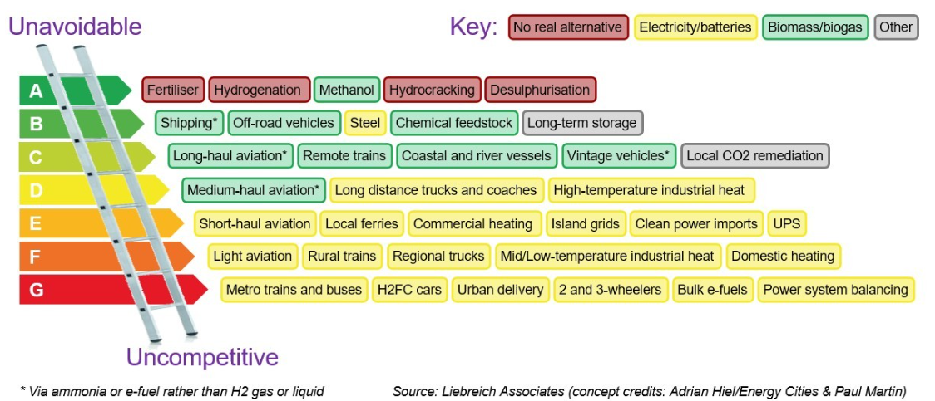
Figure S1 The Clean Hydrogen Ladder by Michael Liebreich [1]
The clean hydrogen ladder is visualized in Figure S1. and confirms our interest in methanol. The higher on the ladder, the more economically interesting and unavoidable is the use of hydrogen for the mentioned applications. At the bottom of the ladder the opposite applies. Unavoidable applications for H₂ are hydrogenation, hydrocracking and desulphurization applications where H₂ is produced and can get used directly.
The red color also indicates that no alternatives to replace H₂ for these processes exist. An exception at the top of the ladder is methanol. According to Michael Liebreich, the production of methanol via hydrogen is unavoidable but biomass/biogas can be used as H₂ feedstock. Since the previously discussed process is based on biogas, the hydrogen ladder confirms the usefulness of converting the produced hydrogen to methanol when no direct applications of hydrogen are available.

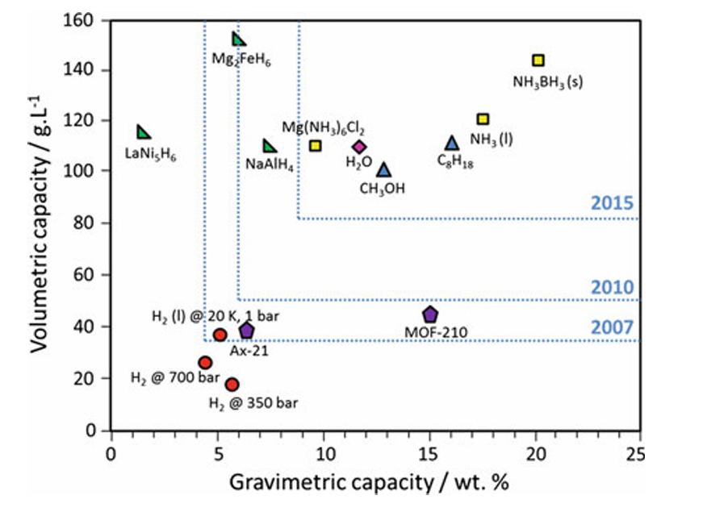
Figure S2 Hydrogen storage capacity (volumetric and gravimetric) from potential hydrogen vectors. Adapted from [2]
Figure S2 visualises that due to the tightening of the hydrogen storage rules, only six suitable hydrogen vectors remain since 2015. Of these six, water, methanol and ammonia are the most common chemicals. Water is converted into hydrogen and oxygen by electrolysis without emitting any greenhouse gasses when renewable electricity is applied. Although it is considered as a mature hydrogen producing technology, the production cost needs to be reduced to be competitive with other mature hydrogen producing methods, which includes carbon-based technologies like natural gas reforming [3].

Reference
[1] ASSOCIATES L, The Clean Hydrogen Ladder [Now updated to V4.1], 2021
[2] JOLAOSO L and ZAMAN S F. Catalytic Ammonia Decomposition for Hydrogen Production: Utilization of Ammonia in a Fuel Cell. 2020:
[3] DENG Y, LI S, DEWIL R, et al. Water splitting by MnFe₂O₄/Na₂CO₃ reversible redox reactions. RSC Advances, 2022, 12(48): 31392-31401.

