Electronic Supplementary Material
Unraveling the critical role of initial isomerization in n-hexane catalytic cracking over HZSM-5 with molecular kinetic model
Rui Li¹*, Yuming Li¹*, Ruipu Wang², Siying An¹, Yan Zhang¹, Qingxin Yang¹, Zhengyu Chen ()¹, Kebin Chi², Dejun Shi², Zhongdong Zhang², Caizhong Hu ()², Linzhou Zhang¹, Guiyuan Jiang ()¹

¹State Key Laboratory of Heavy Oil Processing, China University of Petroleum, Beijing 102249, China
²Petrochemical Research Institute, PetroChina, Beijing 102206, China

E-mails: jianggy@cup.edu.cn (Jiang G); zychen@cup.edu.cn (Chen Z); hucaizhong@petrochina.com.cn (Hu C)
*These authors contributed equally to this work.

Table S1. Digital representation of outlet gas composition.
Components | Digital representation
n-Hexane | R=6;
Methane | R=1;
Ethane | R=2;
Ethylene | R=2;RIH=-2;
Propane | R=3;
Propylene | R=3;RIH=-2;
Isobutane | R=3;Br=1;
n-Butane | R=4;
Butene | R=4;RIH=-2;
Isobutylene | R=3;Br=1;RIH=-2;
1,3-Butadiene | R=4;RIH=-4;
2-Methylpentane | R=5;Br=1;
Benzene | A6=1;
Hydrogen | RIH=2;
Cyclohexane | N6=1;
1-Pentene | R=5;RIH=-2;
1-Hexene | R=6;RIH=-2;
n-Pentane | R=5;
1-Heptene | R=7;RIH=-2;
2-Methyl-1-hexene | R=6;Br=1;RIH=-2;
1-Octene | R=8;RIH=-2;
2-Methyl-1-heptene | R=7;Br=1;RIH=-2;
2-Methyl-1-pentene | R=5;Br=1;RIH=-2;
2-Methyl-1-butene | R=4;Br=1;RIH=-2;

The SU-BEM method was employed, wherein the structural units comprise those representing the core structure as well as those with heteroatoms as side chains. A total of 34 structural vectors are involved, consisting of 23 core units and 11 side chain structures. Table S1 presents the corresponding notations, with R denoting the number of carbon atoms in the main chain, Br denoting methyl branches, RIH denoting the number of double bonds, A6 denoting aromatic rings, Me denoting methyl groups on aromatic rings, and N6 denoting six-membered cycloalkanes.

Table S2. Core molecules.
Core molecules | Structured
n‑Hexane | 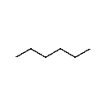
Methane | CH₄
Ethane | 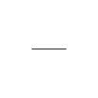
Ethylene | 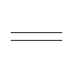
Propane | 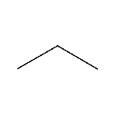
Propylene | 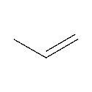
Isobutane | 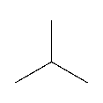
n-Butane | 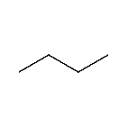
Butene | 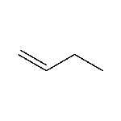
Isobutene | 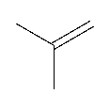
Isohexane | 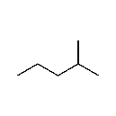
Eleven molecules with significant yields were identified as core compounds based on the distribution data of n-hexane catalytic cracking products. Specific core molecules were listed in Table S2.

Figure S1. Reaction rules for the catalytic cracking.
A molecular-level kinetic model for n-hexane catalytic cracking relied on the structure unit-bond electric matrix(SU-BEM) framework. Formulation of reaction rules for catalytic cracking constituted a prerequisite for model construction. Eleven reaction rules for catalytic cracking were deduced and formulated based on the carbocation reaction mechanism in acid-catalyzed reactions and product molecular composition distribution (Figure S1).[1-4] Two typical reactions, n-hexane cracking and isomerization, served as examples to illustrate the process of formulating group change-based reaction rules within the SU-BEM framework. For n-hexane cracking, structural units of n-hexane molecules (R=6) were first screened from the feed composition through reactant selection rules. Target product molecules, propane and propylene (R=3 and R=3, RIH=-2), were then obtained by modifying reactant structural units according to product formation rules. Beyond these examples, the rules covered multiple reaction types. Alkanes proceeded via cracking, dehydrogenation, and isomerization. Alkenes were subject to cyclization, cracking, isomerization, and polymerization. Dehydrogenation, ring opening, and hydrogen transfer characterized cycloalkane transformations. All detectable molecules fell within the scope of the formulated reaction rules. After formulating the reaction rules, the structural units of n-hexane were input into the eleven reaction rules. The developed automatic reaction network generation algorithm was then invoked to generate the reaction network for n-hexane catalytic cracking. More comprehensive information on the reaction rules can be found in our earlier publication.[5]
Table S3. Comparison of conversion, ethylene and propylene selectivities with and without isohexane introduction.
Reaction Condition | Conversion (%) | Ethylene selectivity (%) | Propylene selectivity (%)
With 1% volume fraction of isohexane | 6.7 | 7.7 | 39.7
With 2% volume fraction of isohexane | 6.4 | 7.7 | 39.7
With 5% volume fraction of isohexane | 7.8 | 7.3 | 40.2
With 10% volume fraction of isohexane | 6.9 | 7.2 | 42.7
Without isohexane | 7.5 | 6.6 | 43.5

To better validate the results of the kinetic model, we performed experimental verification. For comparative experiments, we adopted identical experimental conditions. The reaction temperature was set to 550 °C, and the catalyst loading amount was 0.2g. The SiO₂/Al₂O₃ ratio of the selected catalyst was 236. The only difference was whether isohexane was introduced or not. It should be noted that isohexane was included in the reactants when calculating reaction selectivity, regardless of whether it was introduced or not. The selectivity to ethylene and propylene in reactions with and without isohexane was compared under similar conversion levels. As shown in Table S3, isohexane exhibited different effects on the enhancement of ethylene and propylene formation pathways. This observation was consistent with the predictions of the kinetic model. With the introduction of isohexane, the pathway for ethylene formation was enhanced, while the pathway for propylene formation was weakened.

Table S4. The reaction kinetics parameters of catalytic cracking of n-hexane considering n-hexane isomerization.
Index | Chemical reaction | Reaction expression (SOL) | Reaction type | A | Ea(J/mol) | k
1 |  | 1[R=6;] -> 1[R=1;] + 1[R=5;RIH=-2;] | Alkane cracking | 8.81×10⁵ | 1.06×10⁵ | 1.75×10⁻¹
2 | 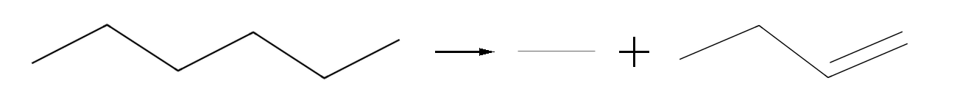 | 1[R=6;] -> 1[R=2;] + 1[R=4;RIH=-2;] | Alkane cracking | 7.62×10⁴ | 9.10×10⁴ | 1.28×10⁻¹
3 |  | 1[R=6;] -> 1[R=3;] + 1[R=3;RIH=-2;] | Alkane cracking | 9.04×10⁵ | 1.06×10⁵ | 1.76×10⁻¹
4 | 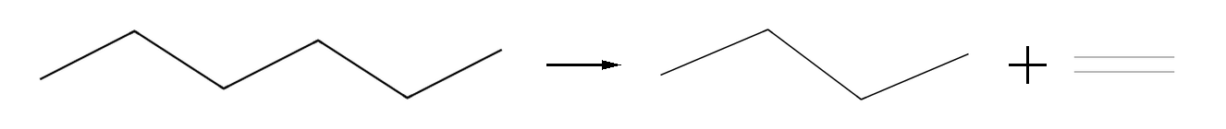 | 1[R=6;] -> 1[R=4;] + 1[R=2;RIH=-2;] | Alkane cracking | 4.42×10⁵ | 1.55×10⁵ | 6.31×10⁻⁵
5 | 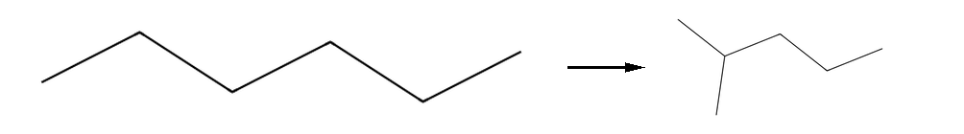 | 1[R=6;] -> 1[ R=5;Br=1;] | Alkane isomerization | 1.37×10⁵ | 1.14×10⁵ | 7.46×10⁻³
6 |  | 1[R=3;RIH=-2;] + 1[R=6;] -> 1[R=3;] + 1[R=6;RIH=-2;] | Alkane alkene hydrogen transfer | 1.10×10⁶ | 1.76×10⁶ | 7.97×10⁻⁶
7 |  | 1[R=4;RIH=-2;] + 1[R=6;] -> 1[R=4;] + 1[R=6;RIH=-2;] | Alkane alkene hydrogen transfer | 3.77×10⁹ | 1.52×10⁴ | 8.99×10⁻¹
8 |  | 1[R=5;RIH=-2;] + 1[R=6;] -> 1[R=5;] + 1[R=6;RIH=-2;] | Alkane alkene hydrogen transfer | 1.81×10⁵ | 6.42×10⁵ | 3.67×10⁻¹⁷
9 |  | 1[R=6;RIH=-2;] + 1[R=6;] -> 1[R=6;] + 1[R=6;RIH=-2;] | Alkane alkene hydrogen transfer | 6.10×10⁷ | 1.59×10⁶ | 6.64×10⁻¹⁸
10 |  | 1[R=6;] -> 1[R=6;RIH=-2;] + 1[RIH=2;] | n-Alkane dehydrogenation | 1.13×10⁴ | 1.95×10⁶ | 4.25×10⁻¹⁹
11 | 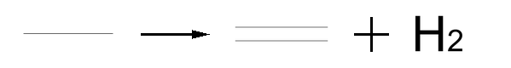 | 1[R=2;] -> 1[R=2;RIH=-2;] + 1[RIH=2;] | n-Alkane dehydrogenation | 1.37×10² | 6.39×10⁴ | 1.21×10⁻²
12 |  | 1[R=3;RIH=-2;] + 1[R=3;] -> 1[R=3;] + 1[R=3;RIH=-2;] | Alkane alkene hydrogen transfer | 4.63×10⁵ | 4.29×10⁵ | 2.68×10⁻²²
13 |  | 1[R=4;RIH=-2;] + 1[R=3;] -> 1[R=4;] + 1[R=3;RIH=-2;] | Alkane alkene hydrogen transfer | 4.57×10⁸ | 4.12×10⁵ | 3.11×10⁻¹⁸
14 |  | 1[R=5;RIH=-2;] + 1[R=3;] -> 1[R=5;] + 1[R=3;RIH=-2;] | Alkane alkene hydrogen transfer | 7.51×10⁹ | 1.64×10⁶ | 1.76×10⁻¹²
15 |  | 1[R=6;RIH=-2;] + 1[R=3;] -> 1[R=6;] + 1[R=3;RIH=-2;] | Alkane alkene hydrogen transfer | 8.87×10¹² | 1.51×10⁶ | 2.18×10⁻⁷
16 | 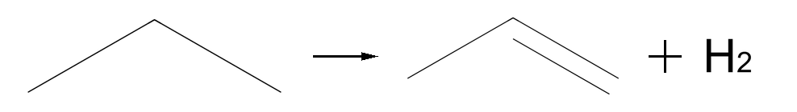 | 1[R=3;] -> 1[R=3;RIH=-2;] + 1[RIH=2;] | n-Alkane dehydrogenation | 2.78×10⁶ | 8.95×10⁴ | 5.77×10⁰
17 |  | 1[R=3;RIH=-2;] + 1[R=4;] -> 1[R=3;] + 1[R=4;RIH=-2;] | Alkane alkene hydrogen transfer | 8.22×10¹ | 2.25×10⁶ | 2.90×10⁻²¹
18 |  | 1[R=4;RIH=-2;] + 1[R=3;RIH=-2;] -> 1[R=7;RIH=-2;] | Alkene polymerization | 1.04×10² | 6.92×10⁵ | 1.46×10⁻²³
19 | 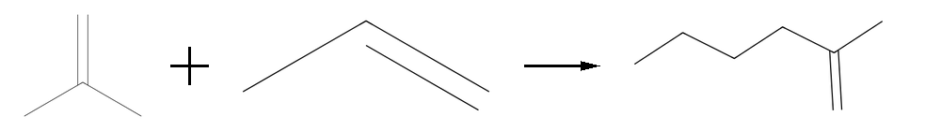 | 1[R=3;Br=1;RIH=-2;] + 1[R=3;RIH=-2;] -> 1[R=6;Br=1;RIH=-2;] | Alkene polymerization | 9.10×10¹ | 2.49×10⁶ | 1.25×10⁻²³
20 |  | 1[R=5;RIH=-2;] + 1[R=3;RIH=-2;] -> 1[R=8;RIH=-2;] | Alkene polymerization | 1.52×10² | 2.35×10⁵ | 1.73×10⁻¹³
21 | 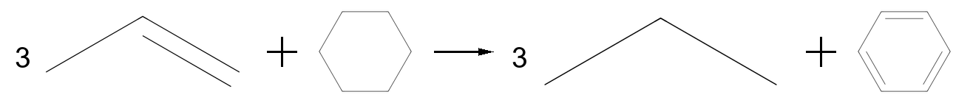 | 3[R=3;RIH=-2;] + 1[N6=1;] -> 3[R=3;] + 1[A6=1;] | Alkene cycloalkane hydrogen transfer | 8.19×10²⁵ | 4.27×10⁵ | 6.99×10⁻²
22 | 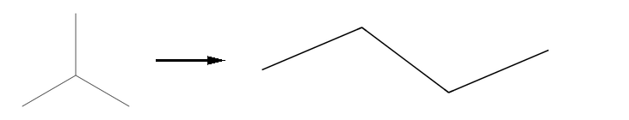 | 1[R=3;Br=1;] -> 1[R=4;] | Alkane isomerization | 2.25×10¹⁰ | 1.30×10⁶ | 1.24×10⁻¹
23 | 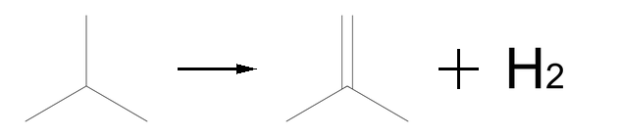 | 1[R=3;Br=1;] -> 1[R=3;Br=1;RIH=-2;] + 1[RIH=2;] | i-Alkane dehydrogenation | 3.20×10⁵ | 9.26×10⁴ | 4.23×10⁻¹
24 | 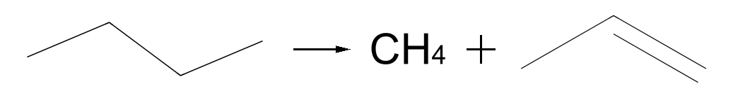 | 1[R=4;] -> 1[R=1;] + 1[R=3;RIH=-2;] | Alkane cracking | 1.65×10⁴ | 3.89×10⁵ | 3.44×10⁻²¹
25 | 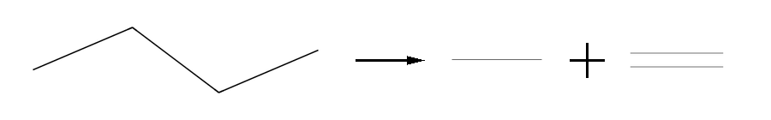 | 1[R=4;] -> 1[R=2;] + 1[R=2;RIH=-2;] | Alkane cracking | 2.30×10¹ | 1.37×10⁶ | 8.14×10⁻²³
26 | 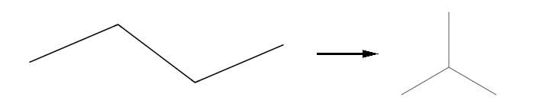 | 1[R=4;] -> 1[R=3;Br=1;] | Alkane isomerization | 5.69×10¹⁰ | 2.09×10⁵ | 3.20×10⁻³
27 |  | 1[R=4;RIH=-2;] + 1[R=4;] -> 1[R=4;] + 1[R=4;RIH=-2;] | Alkane alkene hydrogen transfer | 4.50×10²² | 9.85×10⁵ | 4.07×10⁻⁵
28 |  | 1[R=5;RIH=-2;] + 1[R=4;] -> 1[R=5;] + 1[R=4;RIH=-2;] | Alkane alkene hydrogen transfer | 2.34×10¹ | 1.53×10⁶ | 1.51×10⁻²⁰
29 |  | 1[R=6;RIH=-2;] + 1[R=4;] -> 1[R=6;] + 1[R=4;RIH=-2;] | Alkane alkene hydrogen transfer | 2.52×10² | 1.33×10⁶ | 3.62×10⁻¹⁹
30 | 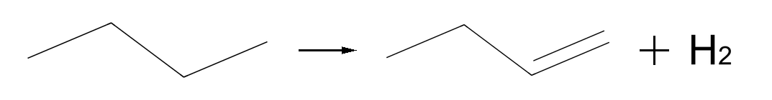 | 1[R=4;] -> 1[R=4;RIH=-2;] + 1[RIH=2;] | n-Alkane dehydrogenation | 5.54×10¹ | 6.58×10⁴ | 3.71×10⁻³
31 | 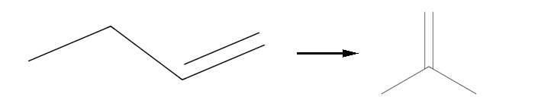 | 1[R=4;RIH=-2;] -> 1[R=3;Br=1;RIH=-2;] | Alkene isomerization | 7.81×10⁴ | 5.32×10⁴ | 3.30×10¹
32 |  | 1[R=4;RIH=-2;] + 1[R=4;RIH=-2;] -> 1[R=8;RIH=-2;] | Alkene polymerization | 4.31×10² | 2.13×10⁶ | 4.48×10⁻¹⁹
33 | 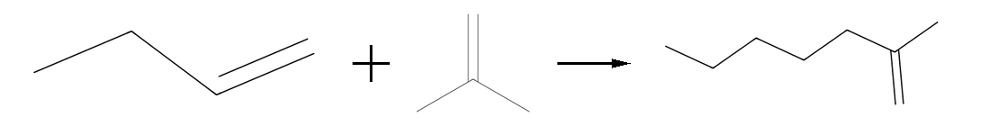 | 1[R=4;RIH=-2;] + 1[R=3;Br=1;RIH=-2;] -> 1[R=7;Br=1;RIH=-2;] | Alkene polymerization | 1.13×10² | 1.13×10⁶ | 2.55×10⁻¹⁹
34 |  | 3[R=4;RIH=-2;] + 1[N6=1;] -> 3[R=4;] + 1[A6=1;] | Alkene cycloalkane hydrogen transfer | 4.10×10²¹ | 1.31×10⁶ | 1.62×10⁻⁵
35 |  | 1[R=6;RIH=-2;] + 1[R=4;RIH=-2;] -> 1[R=6;] + 1[R=4;RIH=-4;] | Alkene alkene hydrogen transfer | 9.84×10¹⁷ | 1.22×10⁵ | 1.68×10¹⁰
36 | 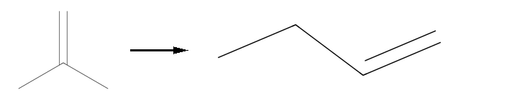 | 1[R=3;Br=1;RIH=-2;] -> 1[R=4;RIH=-2;] | Alkene isomerization | 2.61×10⁵ | 6.64×10⁴ | 1.59×10¹
37 | 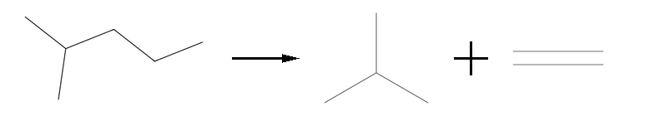 | 1[R=5;Br=1;] -> 1[R=3;Br=1;] + 1[R=2;RIH=-2;] | Alkane cracking | 6.00×10¹ | 2.41×10⁵ | 2.91×10⁻⁵
38 | 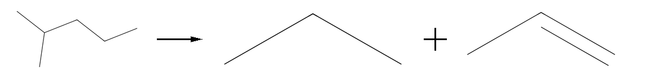 | 1[R=5;Br=1;] -> 1[R=3;] + 1[R=3;RIH=-2;] | Alkane cracking | 8.95×10¹ | 8.87×10⁵ | 6.25×10⁻⁵
39 | 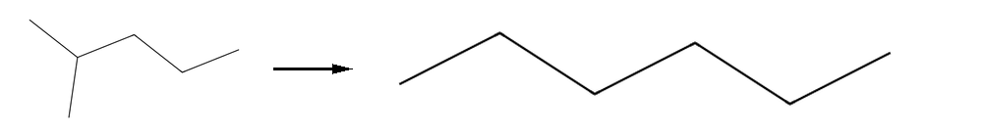 | 1[R=5;Br=1;] -> 1[R=6;] | Alkane isomerization | 4.60×10³ | 1.42×10⁵ | 4.25×10⁻⁶
40 | 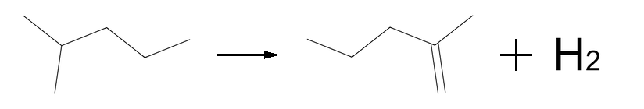 | 1[R=5;Br=1;] -> 1[R=5;Br=1;RIH=-2;] + 1[RIH=2;] | i-Alkane dehydrogenation | 4.12×10⁶ | 1.80×10⁶ | 2.26×10⁻¹³
41 |  | 3[R=5;RIH=-2;] + 1[N6=1;] -> 3[R=5;] + 1[A6=1;] | Alkene cycloalkane hydrogen transfer | 4.24×10²¹ | 6.76×10⁵ | 5.97×10⁻⁵
42 |  | 3[R=6;RIH=-2;] + 1[N6=1;] -> 3[R=6;] + 1[A6=1;] | Alkene cycloalkane hydrogen transfer | 7.80×10²¹ | 1.78×10⁶ | 3.78×10⁻⁵
43 | 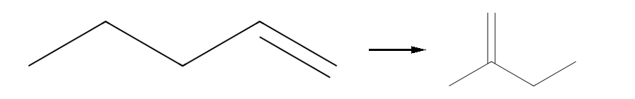 | 1[R=5;RIH=-2;] -> 1[R=4;Br=1;RIH=-2;] | Alkene isomerization | 2.86×10⁵ | 6.88×10⁴ | 1.22×10¹
44 | 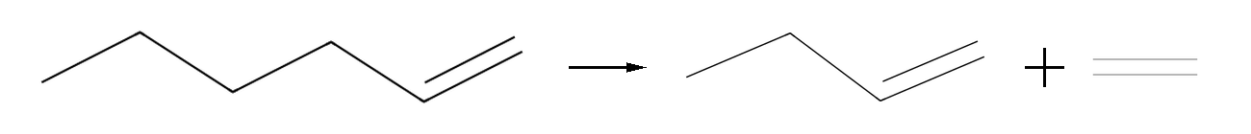 | 1[R=6;RIH=-2;] -> 1[R=4;RIH=-2;] + 1[R=2;RIH=-2;] | Alkene cracking | 8.28×10⁶ | 1.88×10⁶ | 3.58×10⁻¹⁸
45 |  | 1[R=6;RIH=-2;] -> 1[R=3;RIH=-2;] + 1[R=3;RIH=-2;] | Alkene cracking | 2.87×10⁶ | 1.14×10⁶ | 4.58×10⁻¹⁶
46 | 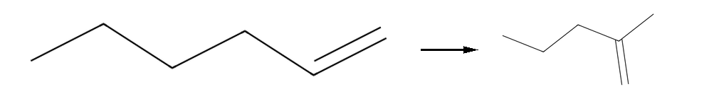 | 1[R=6;RIH=-2;] -> 1[R=5;Br=1;RIH=-2;] | Alkene isomerization | 4.83×10¹⁵ | 8.82×10⁵ | 2.70×10⁻⁹
47 | 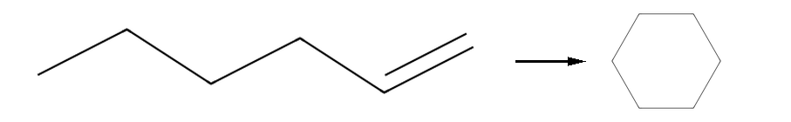 | 1[R=6;RIH=-2;] -> 1[N6=1;] | Alkene cyclization | 3.43×10¹⁵ | 2.36×10⁵ | 3.88×10⁰
48 | 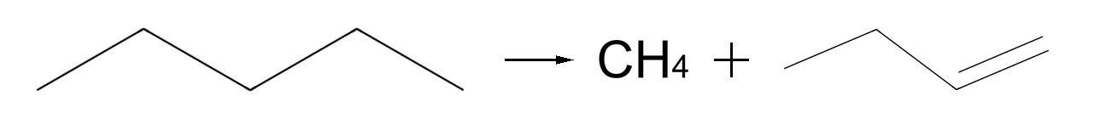 | 1[R=5;] -> 1[R=1;] + 1[R=4;RIH=-2;] | Alkane cracking | 4.80×10¹⁴ | 1.13×10⁶ | 8.71×10⁻⁷
49 | 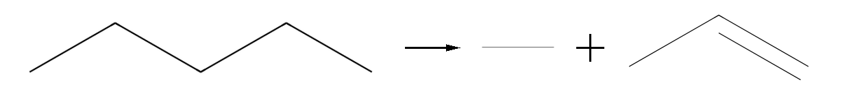 | 1[R=5;] -> 1[R=2;] + 1[R=3;RIH=-2;] | Alkane cracking | 1.03×10⁵¹ | 4.81×10⁵ | 5.17×10⁰
50 | 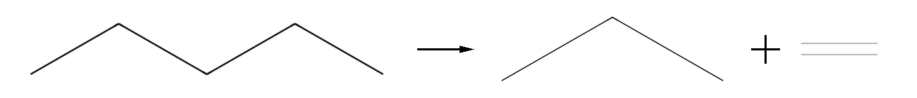 | 1[R=5;] -> 1[R=3;] + 1[R=2;RIH=-2;] | Alkane cracking | 9.97×10¹⁶ | 3.32×10⁵ | 8.74×10⁻⁵
51 |  | 1[R=7;RIH=-2;] -> 1[R=4;RIH=-2;] + 1[R=3;RIH=-2;] | Alkene cracking | 8.11×10²⁰ | 4.30×10⁵ | 4.19×10⁻⁷
52 | 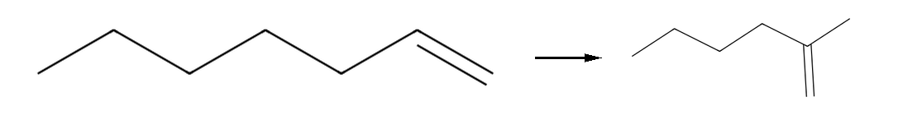 | 1[R=7;RIH=-2;] -> 1[R=6;Br=1;RIH=-2;] | Alkene isomerization | 1.89×10²² | 2.64×10⁵ | 3.11×10⁵
53 | 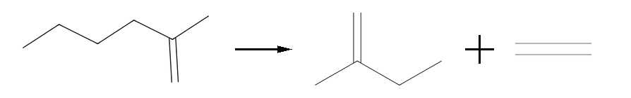 | 1[R=6;Br=1;RIH=-2;] -> 1[R=4;Br=1;RIH=-2;] + 1[R=2;RIH=-2;] | Alkene cracking | 2.80×10¹⁰ | 4.61×10⁵ | 1.45×10⁻¹⁹
54 | 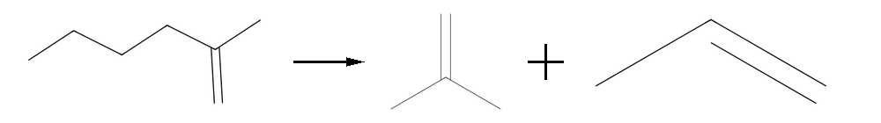 | 1[R=6;Br=1;RIH=-2;] -> 1[R=3;Br=1;RIH=-2;] + 1[R=3;RIH=-2;] | Alkene cracking | 5.08×10⁹ | 1.92×10⁶ | 2.27×10⁻¹¹
55 | 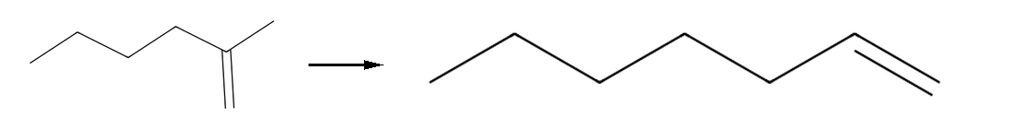 | 1[R=6;Br=1;RIH=-2;] -> 1[R=7;RIH=-2;] | Alkene isomerization | 2.90×10¹³ | 1.32×10⁶ | 2.94×10⁻⁷
56 |  | 1[R=8;RIH=-2;] -> 1[R=4;RIH=-2;] + 1[R=4;RIH=-2;] | Alkene cracking | 8.33×10¹² | 1.07×10⁶ | 1.41×10⁻¹¹
57 | 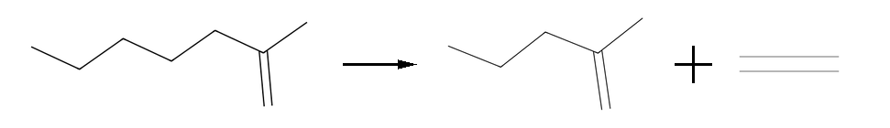 | 1[R=7;Br=1;RIH=-2;] -> 1[R=5;Br=1;RIH=-2;] + 1[R=2;RIH=-2;] | Alkene cracking | 5.15×10³ | 2.11×10⁶ | 5.41×10⁻¹⁷
58 | 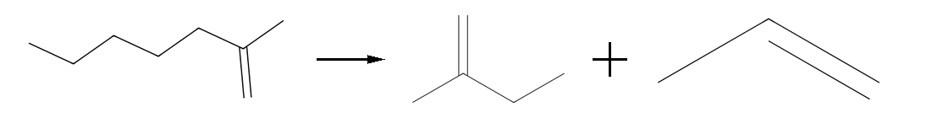 | 1[R=7;Br=1;RIH=-2;] -> 1[R=4;Br=1;RIH=-2;] + 1[R=3;RIH=-2;] | Alkene cracking | 1.73×10⁹ | 4.95×10⁵ | 1.42×10⁻¹⁶
59 | 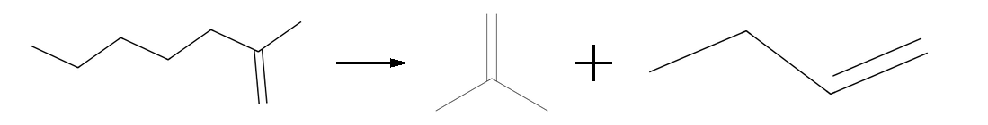 | 1[R=7;Br=1;RIH=-2;] -> 1[R=3;Br=1;RIH=-2;] + 1[R=4;RIH=-2;] | Alkene cracking | 5.22×10⁵ | 2.26×10⁶ | 8.54×10⁻¹⁸
60 | 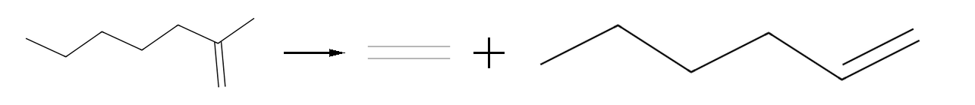 | 1[R=7;Br=1;RIH=-2;] -> 1[R=2;RIH=-2;] + 1[R=6;RIH=-2;] | Alkene cracking | 2.43×10⁵ | 3.76×10⁵ | 3.16×10⁻¹⁹
61 | 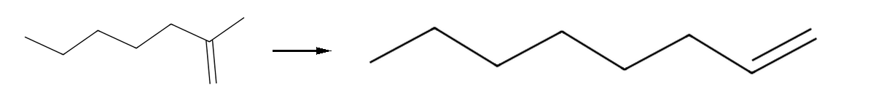 | 1[R=7;Br=1;RIH=-2;] -> 1[R=8;RIH=-2;] | Alkene isomerization | 9.28×10⁵ | 9.54×10⁵ | 3.40×10⁻¹⁷
62 | 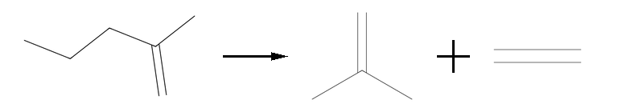 | 1[R=5;Br=1;RIH=-2;] -> 1[R=3;Br=1;RIH=-2;] + 1[R=2;RIH=-2;] | Alkene cracking | 1.43×10⁶ | 5.69×10⁵ | 5.13×10⁻¹⁸
63 | 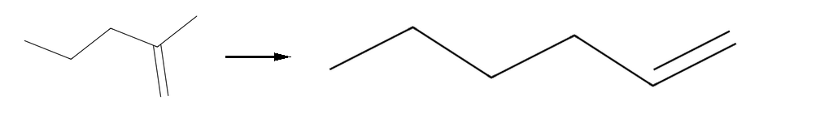 | 1[R=5;Br=1;RIH=-2;] -> 1[R=6;RIH=-2;] | Alkene isomerization | 2.43×10⁷ | 2.14×10⁶ | 3.14×10⁻¹⁵
64 | 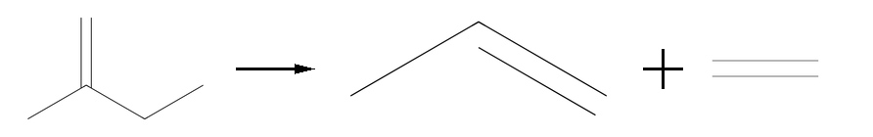 | 1[R=4;Br=1;RIH=-2;] -> 1[R=3;RIH=-2;] + 1[R=2;RIH=-2;] | Alkene cracking | 8.02×10⁶ | 7.16×10⁴ | 2.29×10²

Table S5. The reaction kinetics parameters of catalytic cracking of n-hexane without considering n-hexane isomerization.
Index | Chemical reaction | Reaction expression (SOL) | Reaction type | A | Ea(J/mol) | k
1 |  | 1[R=6;] -> 1[R=1;] + 1[R=5;RIH=-2;] | Alkane cracking | 8.81×10⁵ | 1.06×10⁵ | 1.75×10⁻¹
2 |  | 1[R=6;] -> 1[R=2;] + 1[R=4;RIH=-2;] | Alkane cracking | 7.62×10⁴ | 9.10×10⁴ | 1.28×10⁻¹
3 |  | 1[R=6;] -> 1[R=3;] + 1[R=3;RIH=-2;] | Alkane cracking | 8.85×10⁵ | 1.15×10⁵ | 4.70×10⁻²
4 |  | 1[R=6;] -> 1[R=4;] + 1[R=2;RIH=-2;] | Alkane cracking | 6.76×10⁵ | 9.77×10⁴ | 4.27×10⁻¹
5 |  | 1[R=3;RIH=-2;] + 1[R=6;] -> 1[R=3;] + 1[R=6;RIH=-2;] | Alkane alkene hydrogen transfer | 1.10×10⁶ | 1.76×10⁵ | 7.97×10⁻⁶
6 |  | 1[R=4;RIH=-2;] + 1[R=6;] -> 1[R=4;] + 1[R=6;RIH=-2;] | Alkane alkene hydrogen transfer | 3.77×10⁹ | 1.52×10⁵ | 8.99×10⁻¹
7 |  | 1[R=5;RIH=-2;] + 1[R=6;] -> 1[R=5;] + 1[R=6;RIH=-2;] | Alkane alkene hydrogen transfer | 1.81×10⁵ | 3.42×10⁵ | 3.67×10⁻¹⁷
8 |  | 1[R=6;RIH=-2;] + 1[R=6;] -> 1[R=6;] + 1[R=6;RIH=-2;] | Alkane alkene hydrogen transfer | 6.10×10⁷ | 3.93×10⁵ | 6.64×10⁻¹⁸
9 |  | 1[R=6;] -> 1[R=6;RIH=-2;] + 1[RIH=2;] | n-Alkane dehydrogenation | 1.13×10⁴ | 3.53×10⁵ | 4.25×10⁻¹⁹
10 |  | 1[R=2;] -> 1[R=2;RIH=-2;] + 1[RIH=2;] | n-Alkane dehydrogenation | 1.37×10² | 6.39×10⁴ | 1.21×10⁻²
11 |  | 1[R=3;RIH=-2;] + 1[R=3;] -> 1[R=3;] + 1[R=3;RIH=-2;] | Alkane alkene hydrogen transfer | 4.63×10⁵ | 4.29×10⁵ | 2.68×10⁻²²
12 |  | 1[R=4;RIH=-2;] + 1[R=3;] -> 1[R=4;] + 1[R=3;RIH=-2;] | Alkane alkene hydrogen transfer | 4.57×10⁸ | 4.12×10⁵ | 3.11×10⁻¹⁸
13 |  | 1[R=5;RIH=-2;] + 1[R=3;] -> 1[R=5;] + 1[R=3;RIH=-2;] | Alkane alkene hydrogen transfer | 7.51×10⁹ | 3.41×10⁵ | 1.76×10⁻¹²
14 |  | 1[R=6;RIH=-2;] + 1[R=3;] -> 1[R=6;] + 1[R=3;RIH=-2;] | Alkane alkene hydrogen transfer | 8.87×10¹² | 3.09×10⁵ | 2.18×10⁻⁷
15 |  | 1[R=3;] -> 1[R=3;RIH=-2;] + 1[RIH=2;] | n-Alkane dehydrogenation | 2.78×10⁶ | 8.95×10⁴ | 5.77×10⁰
16 |  | 1[R=3;RIH=-2;] + 1[R=4;] -> 1[R=3;] + 1[R=4;RIH=-2;] | Alkane alkene hydrogen transfer | 8.22×10¹ | 3.54×10⁵ | 2.90×10⁻²¹
17 |  | 1[R=4;RIH=-2;] + 1[R=3;RIH=-2;] -> 1[R=7;RIH=-2;] | Alkene polymerization | 1.04×10² | 3.92×10⁵ | 1.46×10⁻²³
18 |  | 1[R=3;Br=1;RIH=-2;] + 1[R=3;RIH=-2;] -> 1[R=6;Br=1;RIH=-2;] | Alkene polymerization | 7.36×10¹ | 4.27×10⁵ | 6.26×10⁻²⁶
19 |  | 1[R=5;RIH=-2;] + 1[R=3;RIH=-2;] -> 1[R=8;RIH=-2;] | Alkene polymerization | 1.52×10² | 2.35×10⁵ | 1.73×10⁻¹³
20 |  | 3[R=3;RIH=-2;] + 1[N6=1;] -> 3[R=3;] + 1[A6=1;] | Alkene cycloalkane hydrogen transfer | 8.19×10²⁵ | 4.27×10⁵ | 6.99×10⁻²
21 |  | 1[R=3;Br=1;] -> 1[R=4;] | Alkane isomerization | 1.92×10⁷ | 1.52×10⁵ | 4.45×10⁻³
22 |  | 1[R=3;Br=1;] -> 1[R=3;Br=1;RIH=-2;] + 1[RIH=2;] | i-Alkane dehydrogenation | 2.43×10⁵ | 1.02×10⁵ | 8.32×10⁻²
23 |  | 1[R=4;] -> 1[R=1;] + 1[R=3;RIH=-2;] | Alkane cracking | 1.65×10⁴ | 3.89×10⁵ | 3.44×10⁻²¹
24 |  | 1[R=4;] -> 1[R=2;] + 1[R=2;RIH=-2;] | Alkane cracking | 2.30×10¹ | 3.70×10⁵ | 8.14×10⁻²³
25 |  | 1[R=4;] -> 1[R=3;Br=1;] | Alkane isomerization | 6.37×10¹⁰ | 1.64×10⁵ | 2.38×10⁰
26 |  | 1[R=4;RIH=-2;] + 1[R=4;] -> 1[R=4;] + 1[R=4;RIH=-2;] | Alkane alkene hydrogen transfer | 4.50×10²⁰ | 3.95×10⁵ | 4.07×10⁻⁵
27 |  | 1[R=5;RIH=-2;] + 1[R=4;] -> 1[R=5;] + 1[R=4;RIH=-2;] | Alkane alkene hydrogen transfer | 2.34×10¹ | 3.34×10⁵ | 1.51×10⁻²⁰
28 |  | 1[R=6;RIH=-2;] + 1[R=4;] -> 1[R=6;] + 1[R=4;RIH=-2;] | Alkane alkene hydrogen transfer | 2.52×10² | 3.28×10⁵ | 3.62×10⁻¹⁹
29 |  | 1[R=4;] -> 1[R=4;RIH=-2;] + 1[RIH=2;] | n-Alkane dehydrogenation | 5.54×10¹ | 6.58×10⁴ | 3.71×10⁻³
30 |  | 1[R=4;RIH=-2;] -> 1[R=3;Br=1;RIH=-2;] | Alkene isomerization | 7.81×10⁴ | 5.32×10⁴ | 3.30×10¹
31 |  | 1[R=4;RIH=-2;] + 1[R=4;RIH=-2;] -> 1[R=8;RIH=-2;] | Alkene polymerization | 4.31×10² | 3.31×10⁵ | 4.48×10⁻¹⁹
32 |  | 1[R=4;RIH=-2;] + 1[R=3;Br=1;RIH=-2;] -> 1[R=7;Br=1;RIH=-2;] | Alkene polymerization | 1.13×10² | 3.25×10⁵ | 2.55×10⁻¹⁹
33 |  | 3[R=4;RIH=-2;] + 1[N6=1;] -> 3[R=4;] + 1[A6=1;] | Alkene cycloalkane hydrogen transfer | 4.10×10¹⁴ | 3.06×10⁵ | 1.62×10⁻⁵
34 |  | 1[R=6;RIH=-2;] + 1[R=4;RIH=-2;] -> 1[R=6;] + 1[R=4;RIH=-4;] | Alkene alkene hydrogen transfer | 9.84×10¹⁷ | 1.22×10⁵ | 1.68×10¹⁰
35 |  | 1[R=3;Br=1;RIH=-2;] -> 1[R=4;RIH=-2;] | Alkene isomerization | 2.28×10⁵ | 7.54×10⁴ | 3.76×10⁰
36 |  | 3[R=5;RIH=-2;] + 1[N6=1;] -> 3[R=5;] + 1[A6=1;] | Alkene cycloalkane hydrogen transfer | 4.24×10¹⁹ | 3.76×10⁵ | 5.97×10⁻⁵
37 |  | 3[R=6;RIH=-2;] + 1[N6=1;] -> 3[R=6;] + 1[A6=1;] | Alkene cycloalkane hydrogen transfer | 7.80×10¹⁹ | 3.83×10⁵ | 3.78×10⁻⁵
38 |  | 1[R=5;RIH=-2;] -> 1[R=4;Br=1;RIH=-2;] | Alkene isomerization | 2.86×10⁵ | 6.88×10⁴ | 1.22×10¹
39 |  | 1[R=6;RIH=-2;] -> 1[R=4;RIH=-2;] + 1[R=2;RIH=-2;] | Alkene cracking | 8.28×10⁶ | 3.84×10⁵ | 3.58×10⁻¹⁸
40 |  | 1[R=6;RIH=-2;] -> 1[R=3;RIH=-2;] + 1[R=3;RIH=-2;] | Alkene cracking | 2.87×10⁶ | 3.43×10⁵ | 4.58×10⁻¹⁶
41 |  | 1[R=6;RIH=-2;] -> 1[R=5;Br=1;RIH=-2;] | Alkene isomerization | 4.83×10¹⁵ | 3.82×10⁵ | 2.70×10⁻⁹
42 |  | 1[R=6;RIH=-2;] -> 1[N6=1;] | Alkene cyclization | 3.43×10¹⁵ | 2.36×10⁵ | 3.88×10⁰
43 |  | 1[R=5;] -> 1[R=1;] + 1[R=4;RIH=-2;] | Alkane cracking | 4.80×10¹⁴ | 3.27×10⁵ | 8.71×10⁻⁷
44 |  | 1[R=5;] -> 1[R=2;] + 1[R=3;RIH=-2;] | Alkane cracking | 1.03×10²³ | 3.51×10⁵ | 5.17×10⁰
45 |  | 1[R=5;] -> 1[R=3;] + 1[R=2;RIH=-2;] | Alkane cracking | 9.97×10¹⁶ | 3.32×10⁵ | 8.74×10⁻⁵
46 |  | 1[R=7;RIH=-2;] -> 1[R=4;RIH=-2;] + 1[R=3;RIH=-2;] | Alkene cracking | 8.11×10²⁰ | 4.30×10⁵ | 4.19×10⁻⁷
47 |  | 1[R=7;RIH=-2;] -> 1[R=6;Br=1;RIH=-2;] | Alkene isomerization | 1.89×10²² | 2.64×10⁵ | 3.11×10⁵
48 |  | 1[R=6;Br=1;RIH=-2;] -> 1[R=4;Br=1;RIH=-2;] + 1[R=2;RIH=-2;] | Alkene cracking | 2.80×10¹⁰ | 4.61×10⁵ | 1.45×10⁻¹⁹
49 |  | 1[R=6;Br=1;RIH=-2;] -> 1[R=3;Br=1;RIH=-2;] + 1[R=3;RIH=-2;] | Alkene cracking | 5.08×10⁹ | 3.21×10⁵ | 2.27×10⁻¹¹
50 |  | 1[R=6;Br=1;RIH=-2;] -> 1[R=7;RIH=-2;] | Alkene isomerization | 2.90×10¹³ | 3.15×10⁵ | 2.94×10⁻⁷
51 |  | 1[R=8;RIH=-2;] -> 1[R=4;RIH=-2;] + 1[R=4;RIH=-2;] | Alkene cracking | 8.33×10¹² | 3.75×10⁵ | 1.41×10⁻¹¹
52 |  | 1[R=7;Br=1;RIH=-2;] -> 1[R=5;Br=1;RIH=-2;] + 1[R=2;RIH=-2;] | Alkene cracking | 5.15×10³ | 3.15×10⁵ | 5.41×10⁻¹⁷
53 |  | 1[R=7;Br=1;RIH=-2;] -> 1[R=4;Br=1;RIH=-2;] + 1[R=3;RIH=-2;] | Alkene cracking | 1.73×10⁹ | 3.95×10⁵ | 1.42×10⁻¹⁶
54 |  | 1[R=7;Br=1;RIH=-2;] -> 1[R=3;Br=1;RIH=-2;] + 1[R=4;RIH=-2;] | Alkene cracking | 5.22×10⁵ | 3.59×10⁵ | 8.54×10⁻¹⁸
55 |  | 1[R=7;Br=1;RIH=-2;] -> 1[R=2;RIH=-2;] + 1[R=6;RIH=-2;] | Alkene cracking | 2.43×10⁵ | 3.76×10⁵ | 3.16×10⁻¹⁹
56 |  | 1[R=7;Br=1;RIH=-2;] -> 1[R=8;RIH=-2;] | Alkene isomerization | 9.28×10⁵ | 3.54×10⁵ | 3.40×10⁻¹⁷
57 |  | 1[R=4;Br=1;RIH=-2;] -> 1[R=3;RIH=-2;] + 1[R=2;RIH=-2;] | Alkene cracking | 8.02×10⁶ | 7.16×10⁴ | 2.29×10²
58 |  | 1[R=5;Br=1;RIH=-2;] -> 1[R=3;Br=1;RIH=-2;] + 1[R=2;RIH=-2;] | Alkene cracking | 1.43×10⁶ | 3.69×10⁵ | 5.13×10⁻¹⁸

References
1. Virk P S, Chambers L E, Woebcke H N. Thermal Hydrogasification of Aromatic Compounds. In: Coal Gasification. Washington DC: American Chemical Society, 1974, 237-258
2. Corma A, Orchillés A V. Current views on the mechanism of catalytic cracking. Microporous and Mesoporous Materials, 2000, 35-36: 21-30
3. Behar F, Kressmann S, Rudkiewicz J L, Vandenbroucke M. Experimental simulation in a confined system and kinetic modelling of kerogen and oil cracking. Organic Geochemistry, 1992, 19(1): 173-189
4. Buchanan J S, Santiesteban J G, Haag W O. Mechanistic considerations in acid-catalyzed cracking of olefins. Journal of Catalysis, 1996, 158(1): 279-287
5. Chen Z Y, Zhao X Y, Wu J, Xu C M, Zhang L Z. Recent progress toward molecular-level kinetic model for complex hydrocarbon conversion processes. Chemical Engineering Journal, 2024, 487: 150462

