Electronic Supplementary Material
Fractional and simultaneous precipitation: recovering critical metals from multicomponent solutions
Andressa Mazur, Frederico Marques Penha ()
Division of Resource Recovery, Department of Chemical Engineering, KTH Royal Institute of Technology, 114 28 Stockholm, Sweden
E-mail: fremp@kth.se

Ageing influence on the material

During the kinetic set of experiments, three batch experiments were set at the same time and kept under agitation for the following residence times: 1, 7 and 14 days, with the time 0 set to the moment of complete addition of NaOH in a single addition step. After the determined time, a liquid sample was collected and the crystals were filtered, washed and dried. XRD was performed in the solids, and the raw results are shown in Figure A.1.
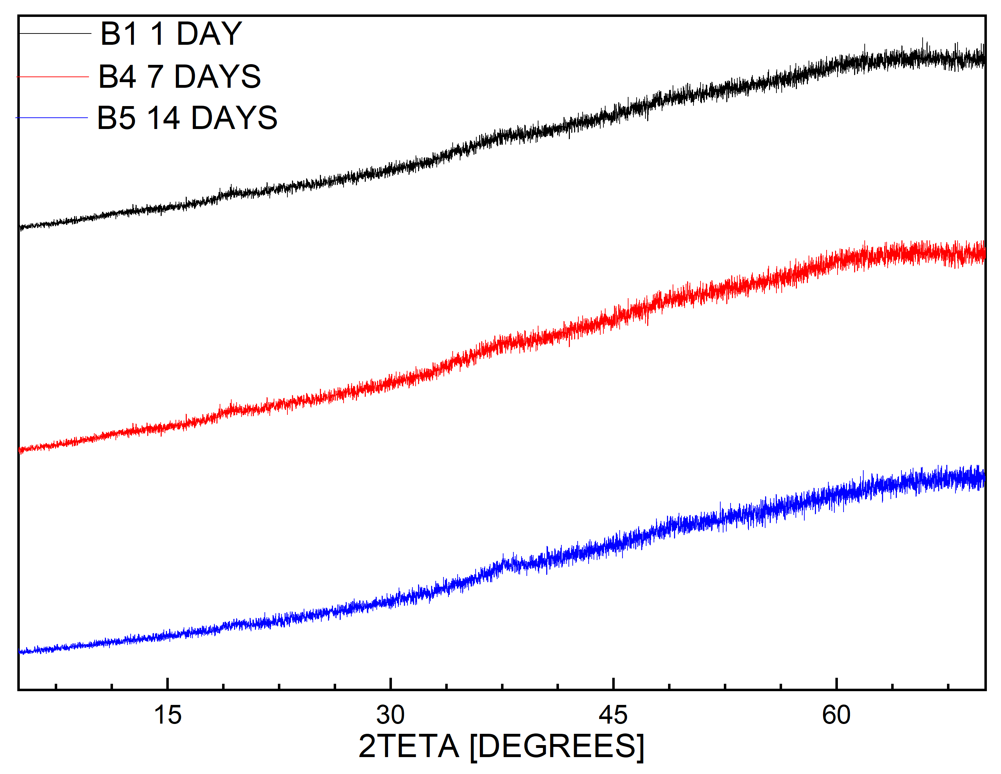
Figure A1. XRD made on non-calcinated samples after residence time of 1, 7 and 14 days

D2 and D3 XRD partial match

Samples D2 and D3 after calcination show a partial match obtained in HighScore Plus 3.0, as observed in Figure B1, with compounds Mn_{0.25}Ni_{0.75}O and Li_{11.92}Mn_{11.12}O_{32.0} for sample D2, and Co_{13.69}Mn_{10.31}O_{32.00} and Ni_{4.0}O_{4.0} for D3.
Figure B1. XRD for calcinated samples D2 and D3, and partial matches

SEM-EDS for sample D3

Sample D3 calcinated was analyzed in SEM-EDS, showing the presence of 2 phases, one rich in Ni, Co and Mn and impurities with major composition of Na and S.
Figure C1. Image characterization of solid D3 after calcination: a. Backscattered Electrons (BSE) image from SEM amplification x1.4K; and b. BSE image from SEM amplification x60; c. EDS elemental mapping.

Kinetic study of metal removal

The removal of metals was evaluated for a time period between 5 minutes and 14 days, as plotted in Figure B.1. Results show cobalt, nickel and manganese are removed completely from 5 minutes, and lithium and sodium show some variation towards one day and remain constant until 7 days before growing in 30%. The experiment residence time was determined to be acceptable between 1 and 24 hours.

Figure D1. Metal removal through time, after the addition of 3.6M of NaOH at time zero

Washing protocol for sample SP

Solid recovered from SP experiment was washed by mixing with 50ml of lukewarm water (30°C) for 30 minutes before vacuum filtration. A sample of the water used in the washing and solid recovered (W1) was stored for analysis on ICP-OES, SEM-EDS and XRD to evaluate the removal of mother liquor remaining in the crystals and dissolution of any other phase formation in case of local supersaturation. The washing protocol was performed twice more, producing liquid and solid samples named W2 and W3. Removal of metals in the process is presented in Figure E1:
Figure E1. Metal removal (%) from solid in washing steps W1, W2 and W3
Error <1% for Li and Na, <0.01% for Ni, Co and Mn

Lithium and sodium were recovered over 21% cumulatively in the 3-step washing procedure, while nickel, cobalt and manganese present in the liquid phase sum less than 0.1% of the metal removed in the SP experiment. The efficiency of removal is lower for each new washing step added, and many more steps would be required to achieve removal of Li and Na closer to 99% as desired, showing that optimization of the washing protocol is required for future experiments. Solid analysis shows no real improvement in the solid quality.

