Electronic Supplementary Material
Synthesis of bimetallic crednerite nanosheet as an efficient heterogeneous catalyst in Fenton-like degradation of bisphenol A
Hanxiao Chen, Bin Deng, Heng Lin, Hui Zhang ()
Department of Environmental Science and Engineering, School of Resource and Environmental Sciences, Wuhan University, Wuhan 430079, China
Email: eeng@whu.edu.cn
Table S1. Kinetic rate constants of BPA degradation in the CuMnO₂/PMS system at different conditions.
Catalyst dosage (g/L) | PMS concentration (mM) | pH | k_{obs} (min⁻¹) | R²
0.2 | 0.4 | 8.0 | 0.075 | 0.9956
0.2 | 0.1 | 8.0 | 0.020 | 0.9866
0.2 | 0.3 | 8.0 | 0.056 | 0.9931
0.2 | 0.5 | 8.0 | 0.071 | 0.9786
0.1 | 0.4 | 8.0 | 0.027 | 0.9797
0.3 | 0.4 | 8.0 | 0.130 | 0.9330
0.5 | 0.4 | 8.0 | 0.189 | 0.9784
0.2 | 0.4 | 4.0 | 0.042 | 0.9993
0.2 | 0.4 | 6.2 | 0.057 | 0.9976
0.2 | 0.4 | 10.0 | 0.093 | 0.9811

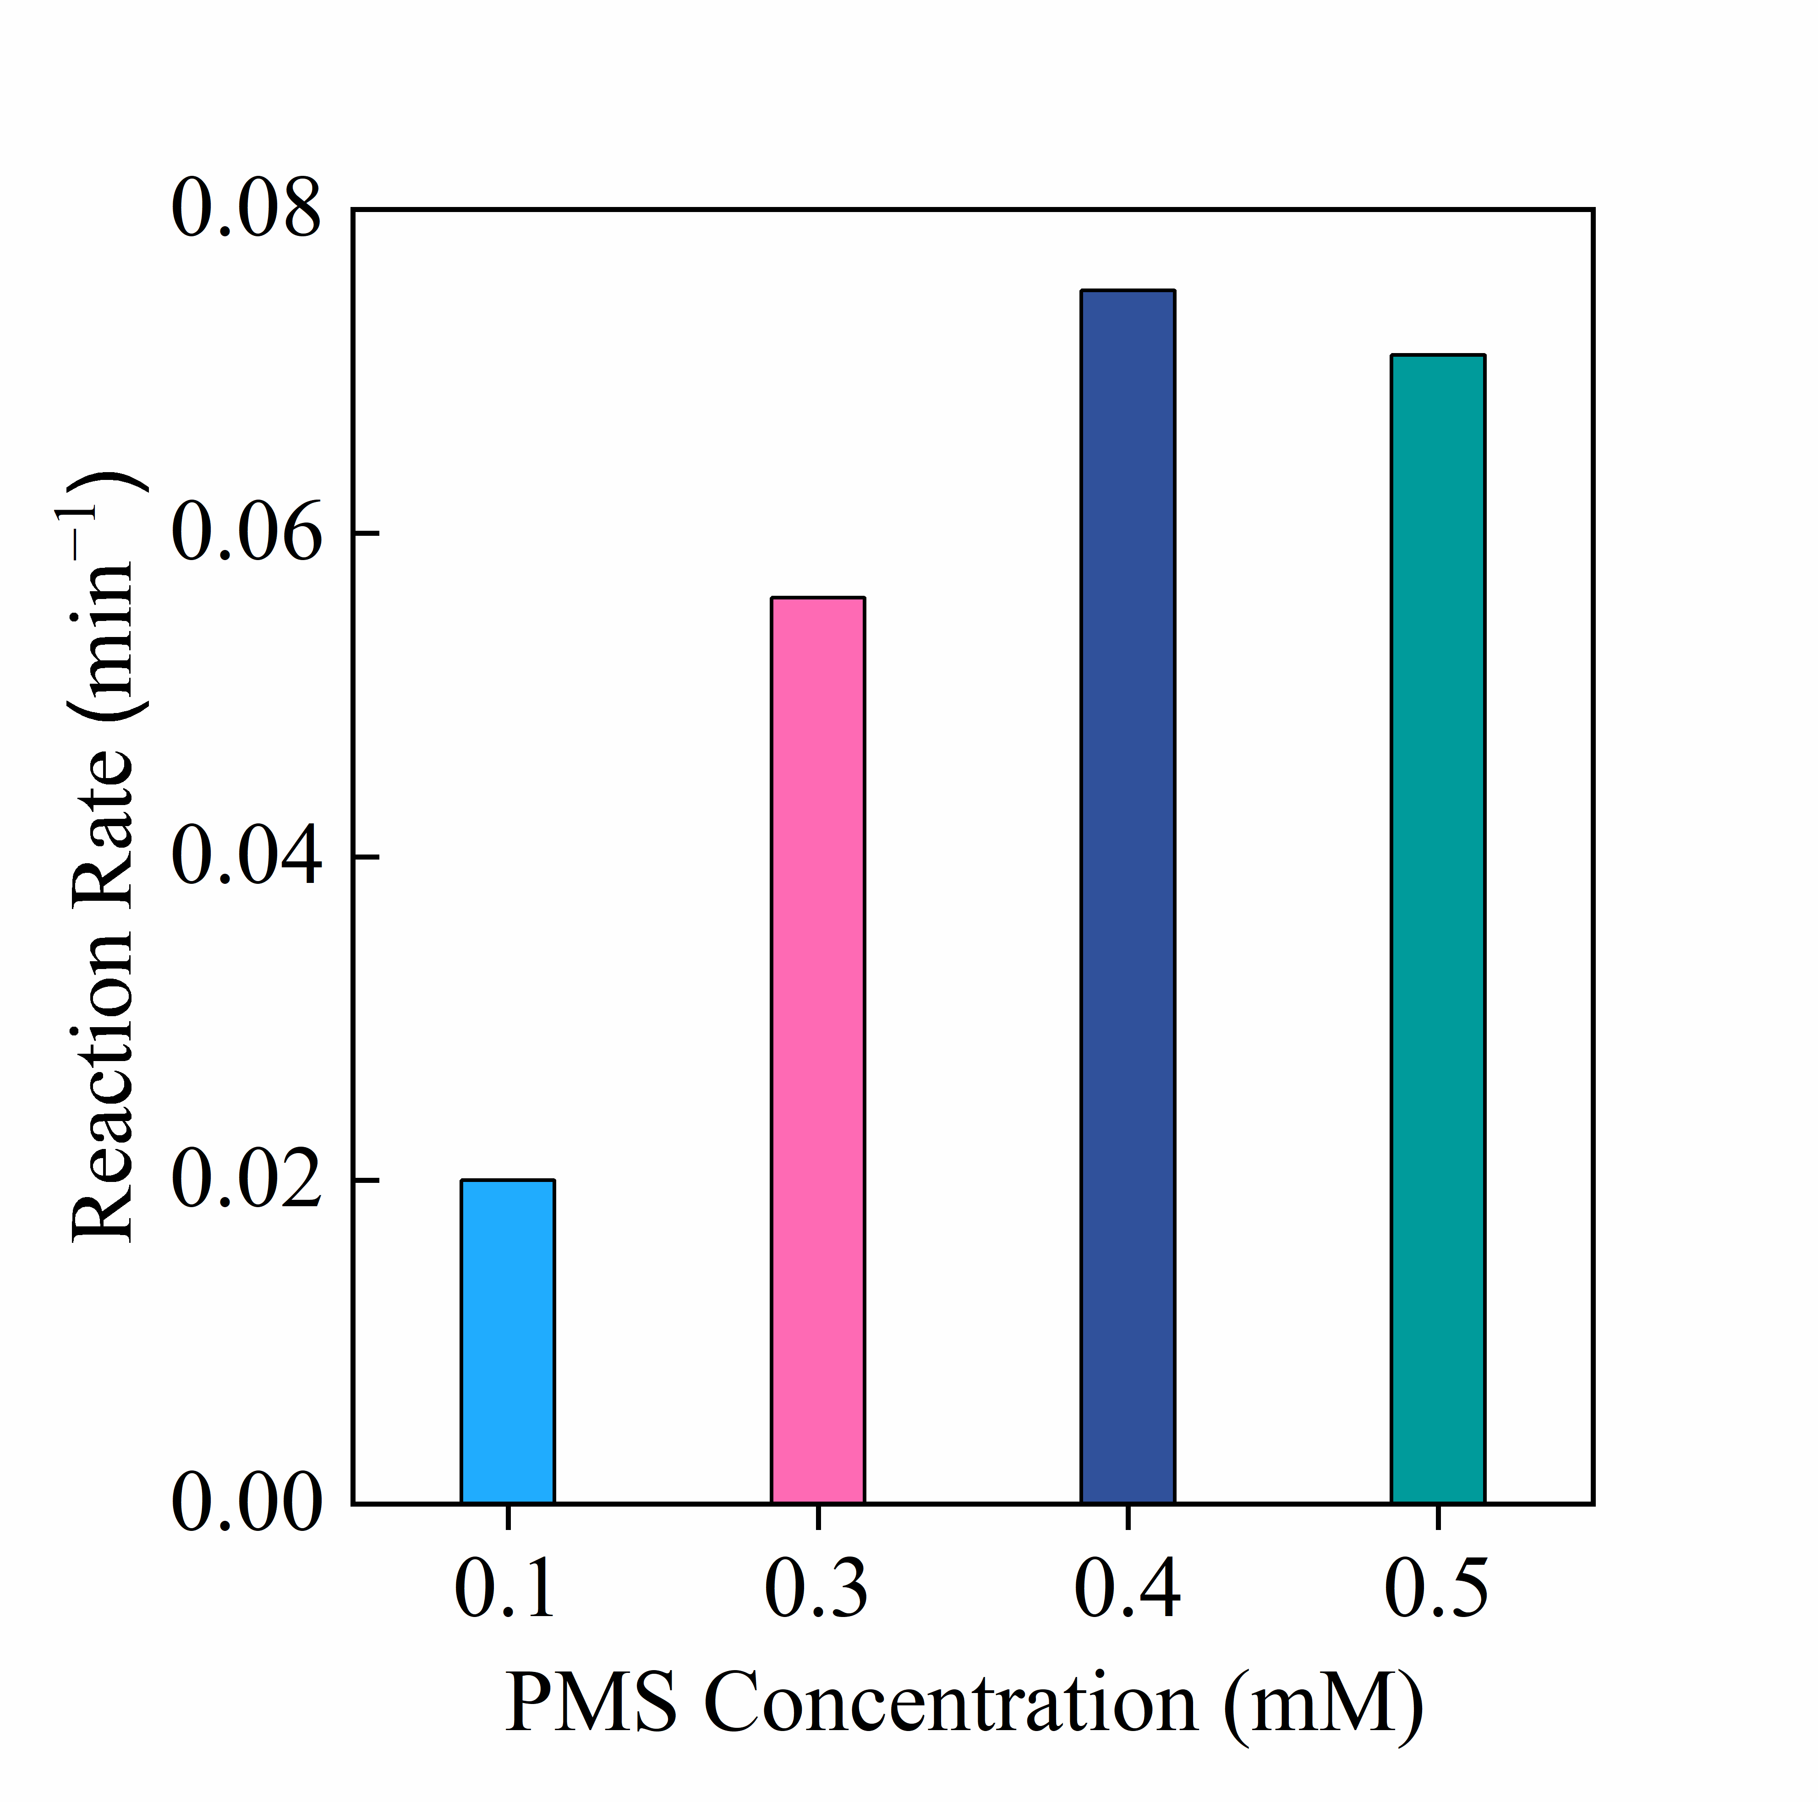
Figure S1. Effect of PMS concentration on the CuMnO₂/PMS system. Conditions: [BPA] = 0.1 mM, [CuMnO₂] = 0.2 g/L, pH 8.0 with BBS.
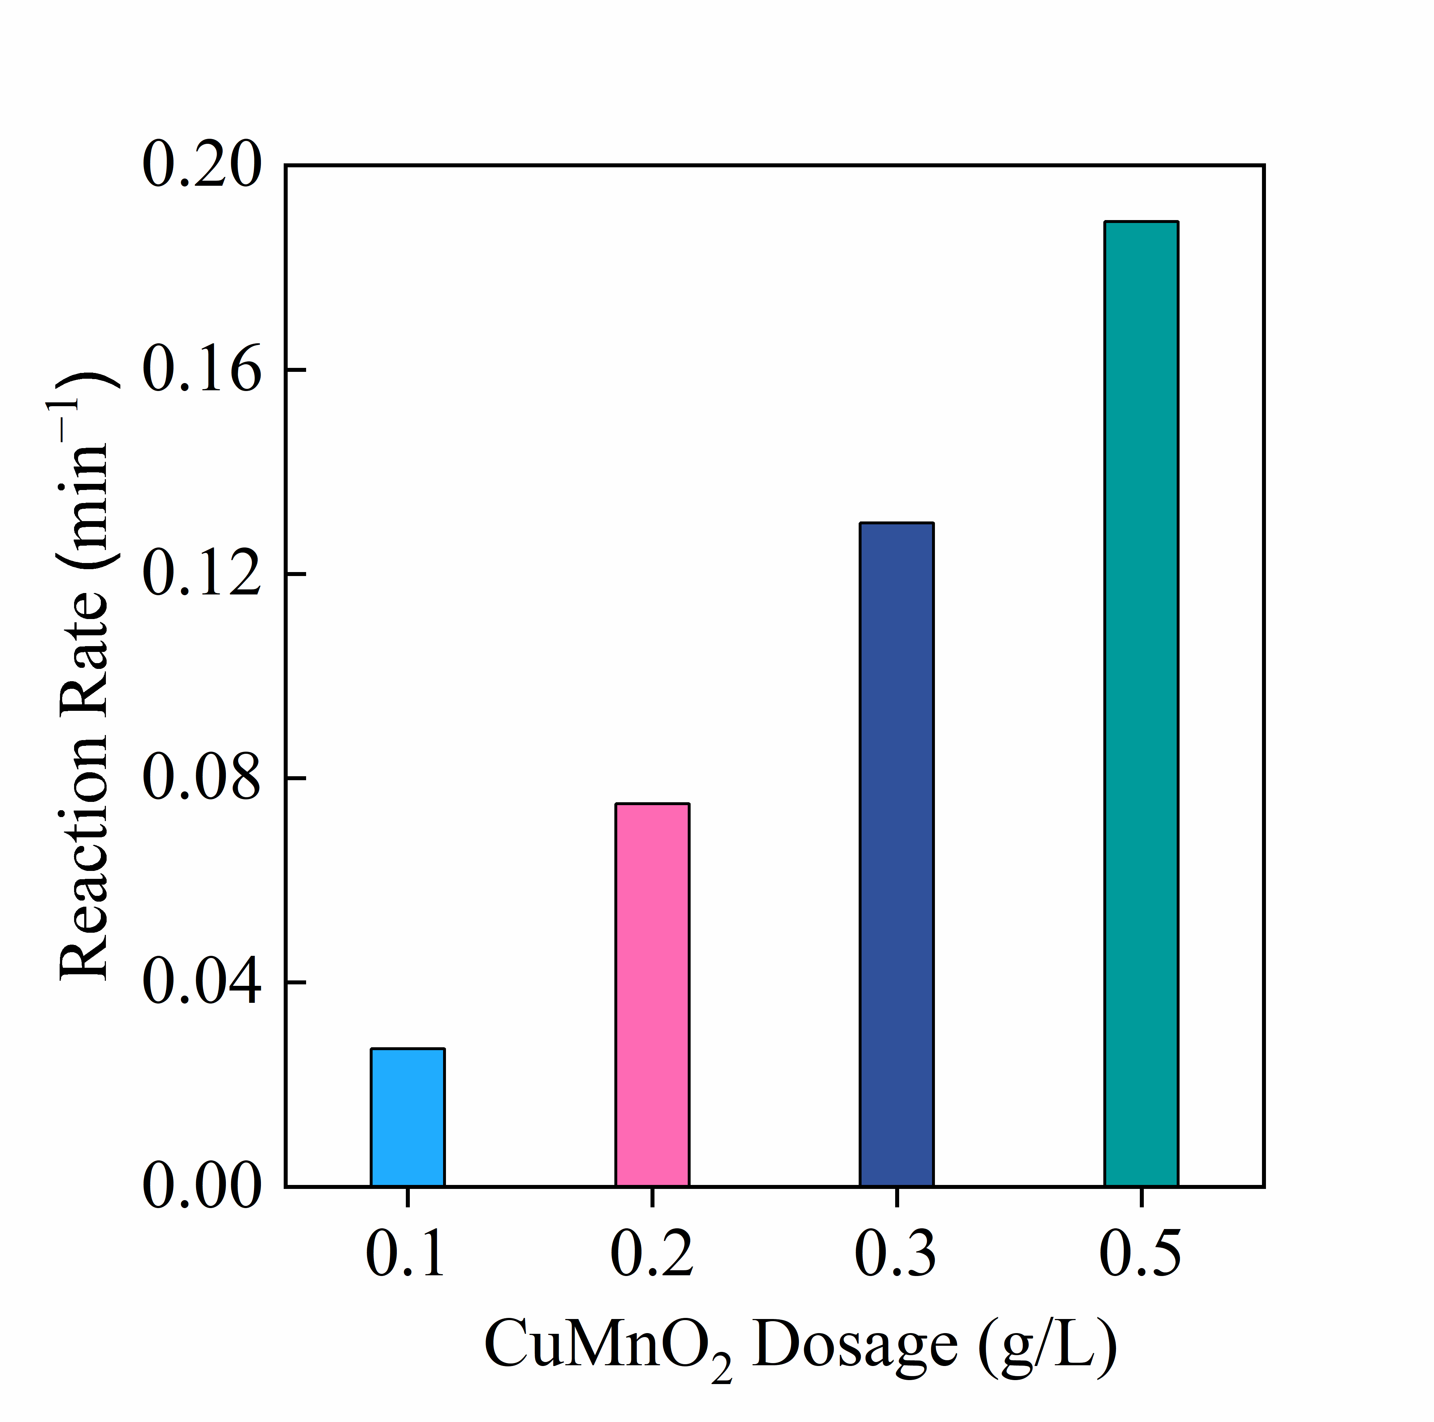
Figure S2. Effect of CuMnO₂ dosage on the CMNS/PMS system. Conditions: [BPA] = 0.1 mM, [PMS] = 0.4 mM, pH 8.0 with BBS.
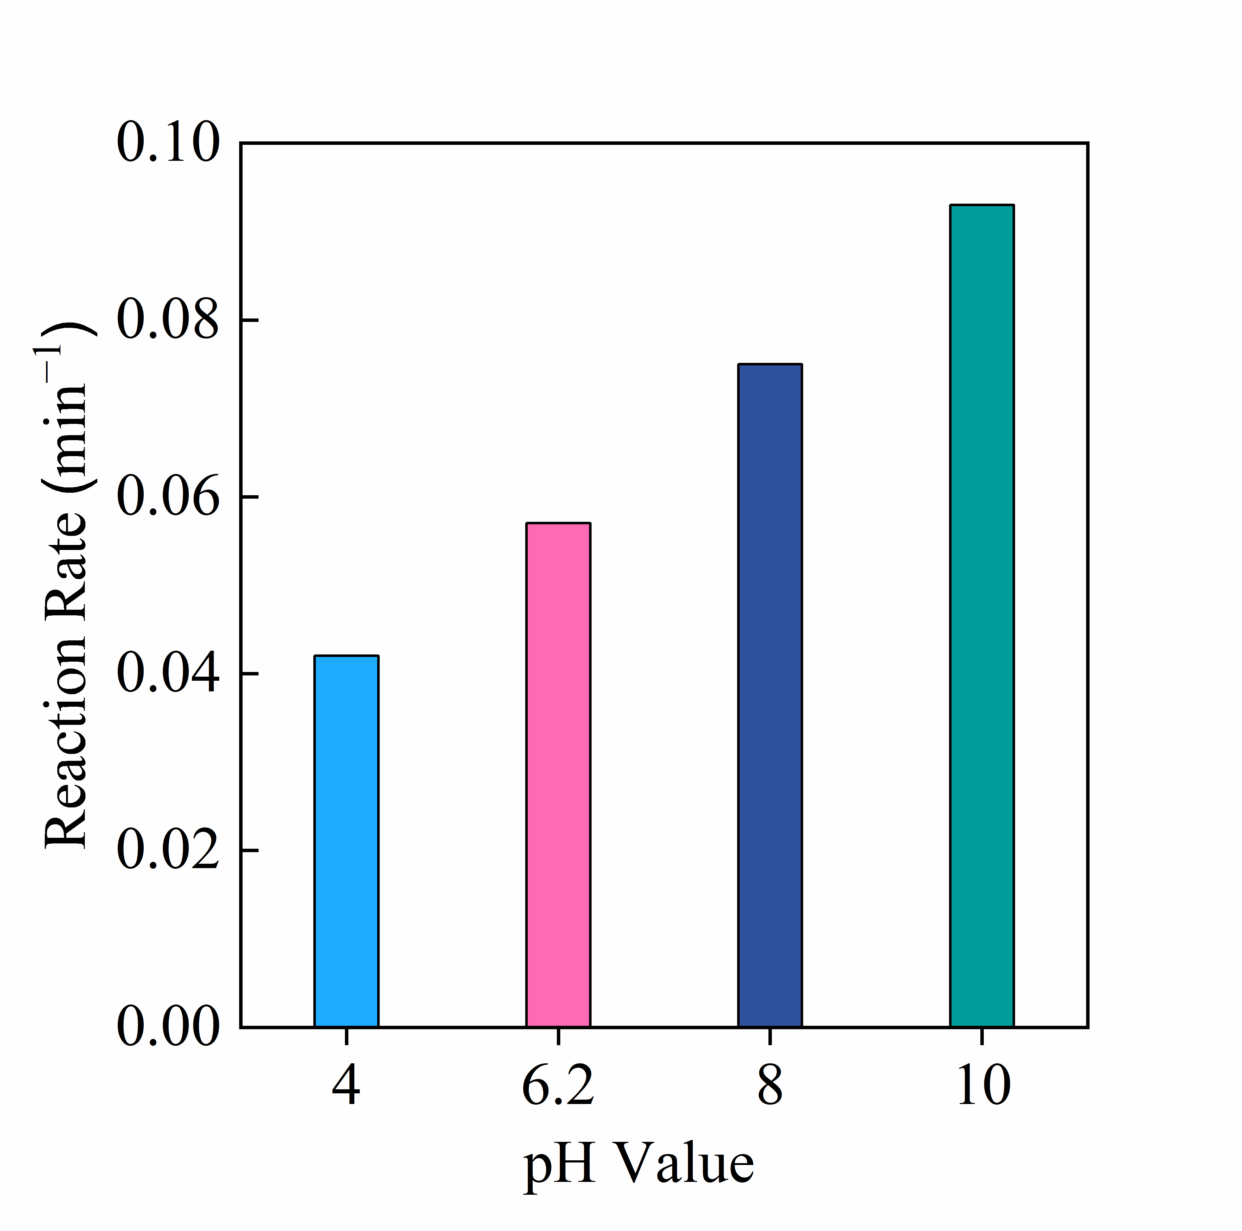
Figure S3. Effect of pH on the CuMnO₂/PMS system. Conditions: [BPA] = 0.1 mM, [PMS] = 0.4 mM, [CuMnO₂] = 0.2 g/L.

