Supplementary file
Chemical activation of phosphogypsum exhibits enhanced adsorption of malachite green from aqueous solution due to porosity refinement
Anurag Pandaª, Anuradha Upadhyayaª, Ramesh Kumar^{b}, Argha Acooliª, Shirsendu Banerjee^{a,c}, Amrita Mishra^{c}, Moonis Ali Khan^{d}, Somnath Chowdhury^{e}, Byong-Hun Jeon^{b*}, Sankha Chakrabortty^{a,c}*, Suraj K. Tripathy^{a,c}*
ª School of Chemical Technology, Kalinga Institute of Industrial Technology, Bhubaneswar 751024, India
^{b} Department of Earth Resources & Environmental Engineering, Hanyang University, Seoul 04763, Republic of Korea
^{c}School of Biotechnology, Kalinga Institute of Industrial Technology, Bhubaneswar 751024, India
^{d}Department of Chemistry, College of Science, King Saud University, Riyadh 11451, Saudi Arabia
^{e} Department of Chemical Engineering, National Institute of Technology, Durgapur 713209, West Bengal

*Corresponding author: S. K. Tripathy (E-mail: suraj.tripathy@kiitbiotech.ac.in), S. Chakrabortty (sankha.chakrabortty@kiitbiotech.ac.in), B-H Jeon (bhjeon@hanyang.ac.kr)

Table S1. Weights connecting the input layer and hidden layer
Number of Nodes | A: Adsorbent dose | B: MG concentration | C: Stirring time | D: Temperature | E: Time
Node 1 | -0.64105 | -0.22703 | -0.30612 | 1.78184 | -0.12426
Node 2 | -0.47922 | -1.01179 | 0.47261 | -0.03435 | 0.65442
Node 3 | 1.06349 | 0.27913 | 1.09883 | -0.28504 | -0.34286
Node 4 | -0.10658 | 0.11073 | 0.19148 | 0.08176 | -0.08781
Node 5 | -1.44563 | 0.27299 | 0.03914 | -1.07498 | 0.59499
Node 6 | 0.16423 | -0.30744 | -0.37042 | -1.05317 | -0.18639
Node 7 | 0.20297 | 0.66823 | -0.64720 | -0.12574 | -0.82339
Node 8 | 0.10904 | -0.11962 | -0.21169 | -0.08336 | 0.09630
Node 9 | 0.10364 | -0.09901 | -0.16543 | -0.07959 | 0.07738
Node 10 | -0.10811 | 0.11634 | 0.20419 | 0.08277 | -0.09310

Table S2. Biases connecting the input layer and hidden layer.
Number of Nodes | Adsorption efficiency
Node 1 | -0.82101
Node 2 | 0.52857
Node 3 | -0.35788
Node 4 | -0.51556
Node 5 | -0.85408
Node 6 | -0.09828
Node 7 | 0.52163
Node 8 | 0.52889
Node 9 | 0.49356
Node 10 | -0.52430

Table S3. Weights connecting hidden layer and output layer.
Number of Nodes | Adsorption efficiency
Node 1 | -1.42408
Node 2 | 0.96643
Node 3 | -1.18560
Node 4 | 0.64523
Node 5 | -1.46718
Node 6 | -0.87463
Node 7 | 0.89698
Node 8 | -0.67061
Node 9 | -0.60736
Node 10 | 0.66158

Table S4 Comparative study of malachite green removal by employing different types of adsorbent materials.
Sorbents | Maximum adsorption capacity | Operational parameters | References
Zinc treated PG | 166.66 mg/g | Dye concentration, pH, Adsorbent dosage, stirring speed, Temperature | This study
Nutraceutical industrial fenugreek seed spent mass | 168 mg/g | Dye concentration, pH, Adsorbent dosages, Temperature | [1]
Bagasse fly ash | 9.980 mg/g | Dye concentration, pH, Adsorbent dosage, Temperature, contact time | [2]
Thermal power plant-based fly ash | 1 mg/g | Dye concentration, pH, Adsorbent dosages, Temperature, contact time | [3]
TiO₂-Fly ash Composite | 110.7 mg/g | Adsorbent dosage, Dye concentration, pH, Temperature | [4]
A coal fly ash/CoFe₂O₄ | 89.3 mg/g | Adsorbent dose, Dye concentration, pH contact time. | [5]
zeolite-magnetite nanocomposite | 21.05 mg/ g | Adsorbent dosage, Dye concentration, pH contact time, and temperature. | [6]
Steel slag wastes | 88.26 mg/g | Adsorbent dosage, Dye concentration. | [7]
Coconut-activated carbon | 91.24 mg/ g | Contact time, pH, Temperature. | [8]
The industrial waste coffee husk | 78 mg/g | Contact time, pH, Dye concentration | [9]
Industrial solid | 10.058 mg/g | Contact time, pH, Dye concentration | [10]
Clayey soil of Indian origin | 78.57 mg/g | pH, Adsorbent dosage, Contact time, Dye concentration, Temperature | [11]
carbonized pomegranate peel | 31.45 mg/g | pH, Dye concentration, Adsorbent dosage, Temperature, Contact time. | [12]
Formaldehyde treated Prosopis Cineraria sawdust | 65.80 mg/g | Surface change, pH, Dye concentration, Adsorbent dosage, Contact time | [13]
Multi-walled carbon nanotubes functionalized with the carboxylate group | 11.73 mg/g | Contact time, pH, Temperature, Dye concentration | [14]
Fig (Ficus cartia) | 51.79 mg/g | Dye concentration, Adsorbent dosages, pH, Contact time, Temperature | [15]
Pumice stone | 22.57 mg/g | Contact time, Particle size, Absorbent dosages, pH, Dye concentration, Temperature | [16]
Microwave-assisted synthesis of graphene as adsorbent. | 23.8095 mg/g | pH, Dye concentration, Contact time, | [17]
lotus leaf as an adsorbent | 125.3 mg/g | Contact time, Adsorbent dosages, Dye concentration, pH, salt ionic strength, Temperature. | [18]
Rattan sawdust | 62.71 mg/g | pH, Dye concentration, Temperature | [19]

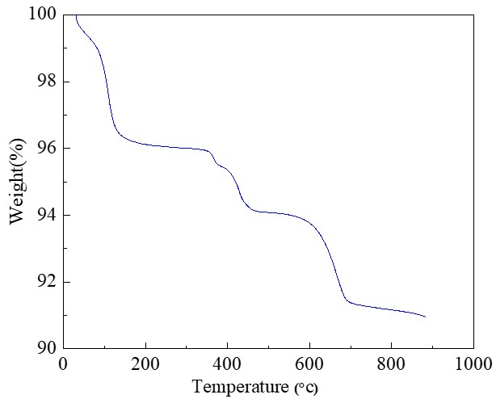
Fig. S1 TGA spectra of PG-Zn

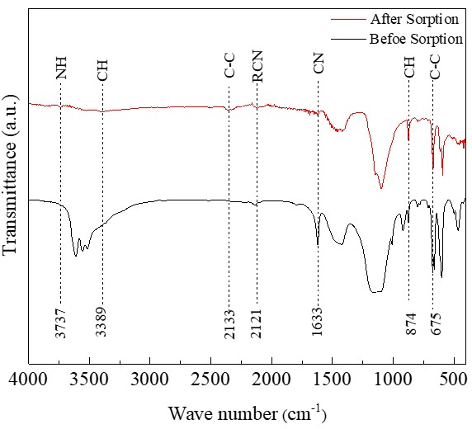
Fig. S2 FTIR spectra of PG-Zn before and after sorption of MG Dye

Fig. S3 UV/Vis plot for (a) Sorption of MG dye on raw PG, (b) Sorption of MG dye on PG-Zn

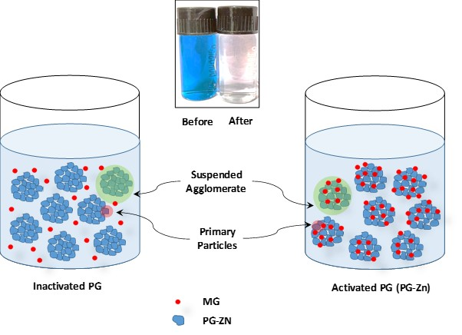
Fig. S4. Proposed mechanism of adsorption of MG on PG-Zn

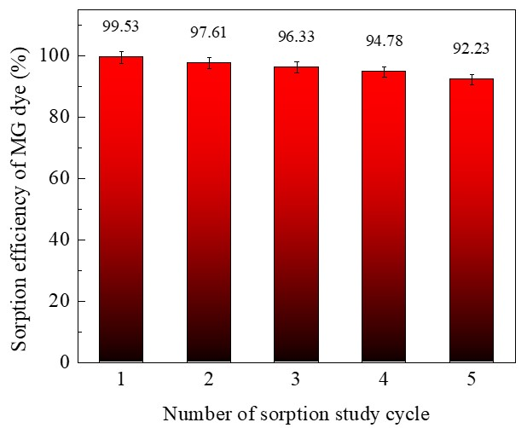
Fig. S5 Sorption efficiency of MG dye (%) on PG-Zn with respect to number of cycles

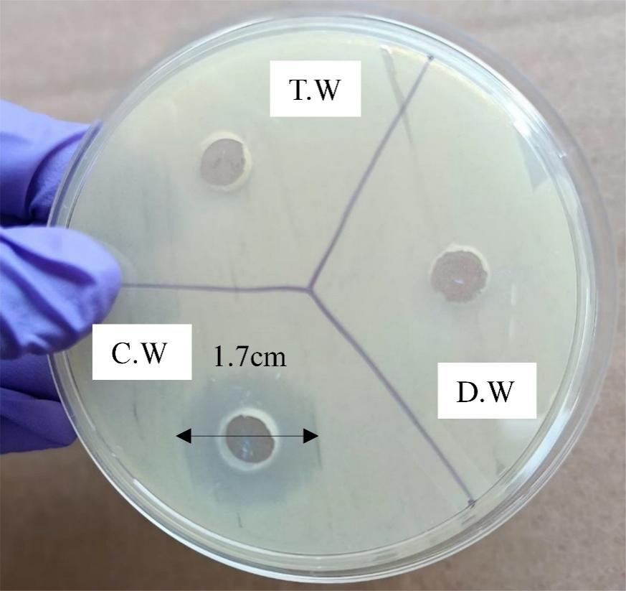
Fig. S6. Toxicity test of MG dye after adsorption; DW- Distilled Water; CW-Contaminated Water (containing MG dye); TW - Treated Water

References
[1] Taqui SN, Mohan C, Khatoon BA, Soudagar MEM, Khan TY, Mujtaba M, et al. Sustainable adsorption method for the remediation of malachite green dye using nutraceutical industrial fenugreek seed spent. Biomass Conversion and Biorefinary, 2023, 13:9119-30.
[2] Mall ID, Srivastava VC, Agarwal NK, Mishra IM. Adsorptive removal of malachite green dye from aqueous solution by bagasse fly ash and activated carbon-kinetic study and equilibrium isotherm analyses. Colloids and Surfaces A: Physicochemical and Engineering Aspects, 2005, 264:17-28.
[3] Dubey S, Uma, Sujarittanonta L, Sharma YC. Application of fly ash for adsorptive removal of malachite green from aqueous solutions. Desallination and Water Treatment, 2015, 53:91-8.
[4] Singh K, Kumar A, Singh AK, Agarwal A. Fly ash and TiO2 modified fly ash as adsorbing materials for effective removal of methylene blue and malachite green from aqueous solutions. Journal of the Indian Chemical Society, 2023, 100:100942.
[5] Zhang M, Mao Y, Wang W, Yang S, Song Z, Zhao X. Coal fly ash/CoFe 2 O 4 composites: a magnetic adsorbent for the removal of malachite green from aqueous solution. Royal Society of Chemistry Advances, 2016, 6:93564-74.
[6] Tanyol M. Rapid malachite green removal from aqueous solution by natural zeolite: process optimization by response surface methodology. Desallination and Water Treatment, 2017, 65:294-303.
[7] Blanco-Flores A, Toledo-Jaldin HP, Vilchis-Néstor AR, López-Téllez G, Sánchez-Mendieta V, Ávila-Márquez DM. Metallurgical slag properties as a support material for bimetallic nanoparticles and their use in the removal of malachite green dye. Advanced Powder Technolology, 2020, 31:2853-65.
[8] Qu W, Yuan T, Yin G, Xu S, Zhang Q, Su H. Effect of properties of activated carbon on malachite green adsorption. Fuel, 2019, 249:45-53.
[9] Mohamad M, Wannahari R, Mohammad R, Shoparwe NF, Nawi ASM, Lun KW, et al. Adsorption of malachite green dye using spent coffee ground biochar: optimisation using response surface methodology. Jurnal Teknologi, 2021, 83 (1):1–12
[10] Savcı S, Dönmez S, Mazmancı MA. PERFORMANCE AND MECHANISMS OF MALACHITE GREEN DYE ADSORPTION USING INDUSTRIAL SOLID WASTE AS ADSORBENT. Environmental Engineering and Management Journal, 2023, 22.
[11] Saha P, Chowdhury S, Gupta S, Kumar I. Insight into adsorption equilibrium, kinetics and thermodynamics of Malachite Green onto clayey soil of Indian origin. Chemical Engineering Journal, 2010, 165:874-82.
[12] Gündüz F, Bayrak B. Biosorption of malachite green from an aqueous solution using pomegranate peel: equilibrium modelling, kinetic and thermodynamic studies. Journal of Molecular Liquids, 2017, 243:790-8.
[13] Garg V, Kumar R, Gupta R. Removal of malachite green dye from aqueous solution by adsorption using agro-industry waste: a case study of Prosopis cineraria. Dyes Pigments, 2004, 62:1-10.
[14] Rajabi M, Mirza B, Mahanpoor K, Mirjalili M, Najafi F, Moradi O, et al. Adsorption of malachite green from aqueous solution by carboxylate group functionalized multi-walled carbon nanotubes: determination of equilibrium and kinetics parameters. Journal of Industrial and Engineering Chemistry, 2016, 34:130-8.
[15] Gebreslassie YT. Equilibrium, kinetics, and thermodynamic studies of malachite green adsorption onto Fig (Ficus cartia) leaves. Journal of Analytical Methods in Chemistry, 2020, 7384675
[16] Shayesteh H, Rahbar-Kelishami A, Norouzbeigi R. Adsorption of malachite green and crystal violet cationic dyes from aqueous solution using pumice stone as a low-cost adsorbent: kinetic, equilibrium, and thermodynamic studies. Desal Water Treatment. 2016, 57:12822-31.
[17] Rathour R, Das P, Aikat K. Microwave-assisted synthesis of graphene and its application for adsorptive removal of malachite green: thermodynamics, kinetics and isotherm study. Desal Water Treatment. 2016;57:7312-21.
[18] Han X, Yuan J, Ma X. Adsorption of malachite green from aqueous solutions onto lotus leaf: equilibrium, kinetic, and thermodynamic studies. Desallination and Water Treatment, 2014, 52:5563-74.
[19] Hameed B, El-Khaiary M. Malachite green adsorption by rattan sawdust: Isotherm, kinetic and mechanism modeling. Journal of Hazard Materials, 2008, 159:574-9.

