Electronic Supplementary Material

Oxygen vacancy-mediated lewis acid-base pairs on Ce-doped BiOI enable efficient CO₂ conversion
Chengguang Yue¹, Wenhao Ji¹, Tiantian Xiao¹, Weiying Pang¹, Shouying Huang¹, Ji Qi², Yue Wang¹, Mei-Yan Wang ()¹, Xinbin Ma ()¹

1 School of Chemical Engineering and Technology, Key Laboratory for Green Chemical Technology of Ministry of Education, Tianjin University, Tianjin 300072, China
2 Institute of Molecular Plus, Tianjin University, Tianjin 300072, China
© Higher Education Press 2026
Received March 5, 2026; accepted February 7, 2026
E-mail: mywang2017@tju.edu.cn; xbma@tju.edu.cn

Adsorption energy calculations: Regarding the Ce_{x}Bi_{1-x}OI and BiOI materials synthesized in this work, XRD results confirm that the predominant crystal facet is associated with the (010) orientation, with a relatively minor presence of the (001) facet (Fig. S1). Prior studies^{1, 2} have also indicated that for BiOX-catalyzed CO₂ cycloaddition systems, the (010) facet is a high active surface as it simultaneously exposes Lewis acid sites (Bi³⁺) and nucleophilic halide ions (X⁻), which could facilitate the adsorption and ring-opening of epoxide molecules. Therefore, the (010) facet was selected to model the active surface in this work.
Fig. S1 XRD peak intensity ratios for Ce_{x}Bi_{1-x}OI and BiOI samples.
The Perdew-Burke-Ernzerhof (PBE) exchange-correlation functional within the generalized gradient approximation (GGA) was employed to describe the exchange-correlation energy. The projector-augmented-wave (PAW) method was adopted for the pseudopotentials. The energy cutoff for the plane wave basis expansion was set to 400 eV. The force and energy change for all atomic structures were set as 0.03 eV/Å and 10⁻⁵ eV for convergence criterion, respectively. The computational model employed a 2 × 4 supercell. The lattice parameters for the BiOI crystal were: a = 4.00421 Å, b = 4.00421 Å, c = 9.60482 Å, α = β = γ = 90°. 15 Å vacuum layer is set up above the Z-direction to make sure that the calculations are free from the influence of periodic boundaries, and the k-point lattice was set to 3 × 3 × 1. In the BiOI (010) and Ce doped BiOI (010) slab models, the top two atomic layers were relaxed during the BO adsorption. Spin polarization was explicitly taken into account during the adsorption energy calculations.

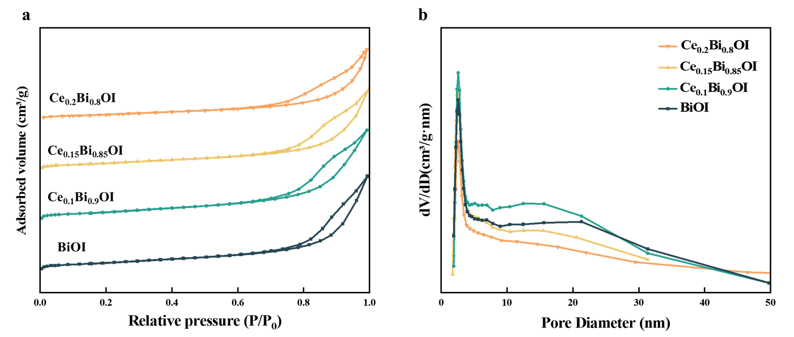
Fig. S2 (a) N₂ adsorption-desorption isotherms and (b) pore size distribution of Ce_{x}Bi_{1-x}OI and BiOI samples.

Tab. S1 Specific surface area and pore volume of Ce_{x}Bi_{1-x}OI and BiOI samples
Samples | S_{BET}ª (m²/g) | V_{Pore}ª (cm³/g)
BiOI | 72.8 | 0.31
Ce_{0.1}Bi_{0.9}OI | 77.9 | 0.30
Ce_{0.15}Bi_{0.85}OI | 64.6 | 0.22
Ce_{0.2}Bi_{0.8}OI | 58.8 | 0.22
ª Specific surface area and pore structure data were obtained by BET and BJH methods, respectively.
Fig. S3 EPR spectra of Ce_{x}Bi_{1-x}OI and BiOI samples.

Fig. S4 Catalytic performance of Ce_{0.1}Bi_{0.9}OI toward the CO₂ cycloaddition with different epoxides at 120 °C and 2 MPa CO₂ for 12 h.

Table S2 Catalytic performance over reported MOX and Ce_{0.1}Bi_{0.9}OI samples
Catalyst | Reaction conditions | Solvent | Yield of  cyclic carbonates ª  (%) | Ref.
BiOBr-(010) | 150 °C,  0.8 MPa CO₂ | DMF | 85 (PO) | 1
BiOBr-(010) | 150 °C,  0.8 MPa CO₂ | DMF | 72 (BO) | 1
BiO_{1-x}Br_{1-y}-(010) | 100 °C,  2 MPa CO₂ | - | 99 (PO) | 2
FeOCl-V_{Fe–Cl} | 150 °C,  0.3 MPa CO₂ | DMF | 81 (PO) | 3
FeOCl-V_{Fe–Cl} | 150 °C,  0.3 MPa CO₂ | DMF | 30 (BO) | 3
Ce_{0.1}Bi_{0.9}OI | 120 °C,  2 MPa CO₂ | - | 91 (BO) | This work
Ce_{0.1}Bi_{0.9}OI | 120 °C,  2 MPa CO₂ | - | 99 (PO) | This work
ª PO: propylene oxide, BO: butylene oxide.
Fig. S5 GC crude spectra for the PO (top) and BO (middle) reaction systems; ¹H NMR spectrum for the epichlorohydrin (bottom) system

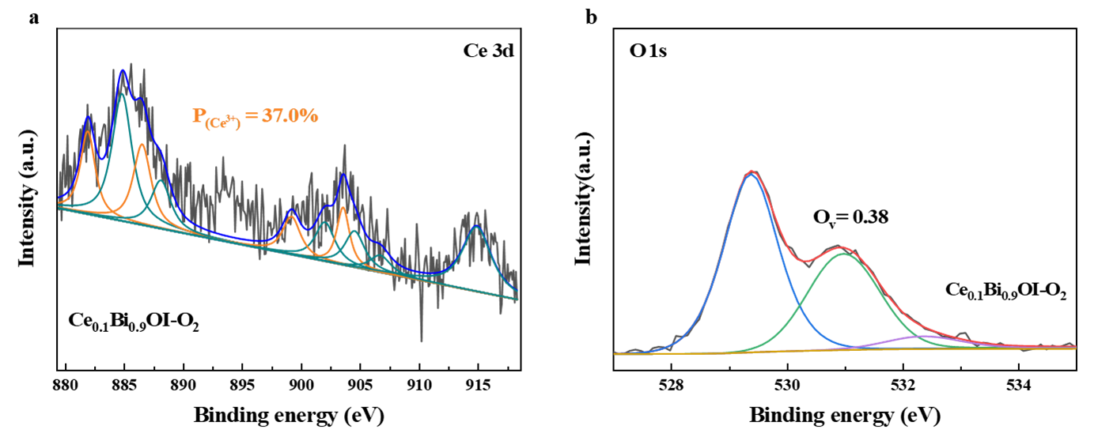

Fig. S6 (a) Ce 3d and (b) O 1s XPS spectra of Ce_{0.1}Bi_{0.9}OI-O₂

Fig. S7 Cyclic stability of Ce_{0.1}Bi_{0.9}OI in the CO₂ cycloaddition with BO at 120 °C and 2 MPa CO₂ for 12 h.
Fig. S8 TEM images of (a) fresh and (b) reused Ce_{0.1}Bi_{0.9}OI catalyst

Fig. S9 Results of "hot filtration" experiment on Ce_{0.1}Bi_{0.9}OI in the CO₂ cycloaddition with BO at 120 °C and 2 MPa CO₂ at 6 h.

Fig. S10 Effect of reaction temperature on catalytic activity of Ce_{0.1}Bi_{0.9}OI and BiOI samples (1 mL BO, 2 MPa CO₂, 0.1 g catalysts, 12 h)

Fig. S11 The electron density difference image for BO adsorbed on O_{v}–Ce³⁺ sites

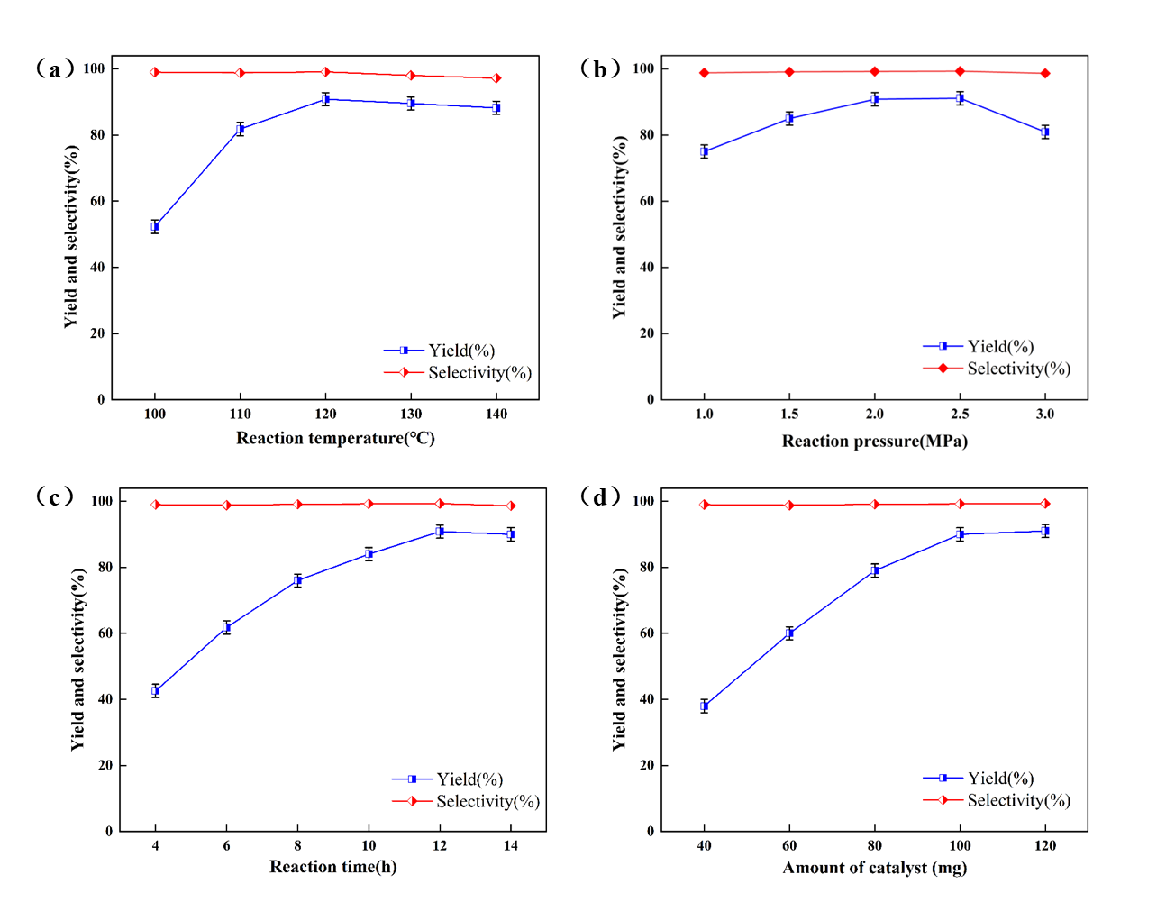
Fig. S12 The influence of different reaction parameters on BC yield and selectivity over Ce_{0.1}Bi_{0.9}OI: (a) temperature; (b) CO₂ pressure; (c) reaction time; (d) catalyst dosage. (Reaction conditions: 1mL BO, 120 ℃, 2MPa CO₂, 0.1 g Ce_{0.1}Bi_{0.9}OI for 12 h, when one parameter is varied, the other experimental conditions held constant.)

Table S3 Atomic ratio of Ce and Bi atom in Ce_{x}Bi_{1-x}OI based on ICP data
Samples | Atomic ratio (Bi:Ce)
Samples | Theoretical | Actual
Ce_{0.1}Bi_{0.9}OI | 1:0.05 | 1:0.09
Ce_{0.15}Bi_{0.85}OI | 1:0.1 | 1:0.17
Ce_{0.2}Bi_{0.8}OI | 1:0.15 | 1:0.28

References
1. S. Shang, W. Shao, X. Luo, M. Zuo, H. Wang, X. Zhang and Y. Xie, Research, 2022, 2022, 9878054.
2. L. Xia, H. Chen, W. Wang, X. Jia, D. Zhang, L. Wang, P. Wu, L. Li and J. Huang, J. Mater. Sci. Technol., 2024, 202, 39-49.
3. W. X. Liu, L. Li, W. Shao, H. Wang, Y. Dong, M. Zuo, J. D. Liu, H. J. Zhang, B. J. Ye, X. D. Zhang and Y. Xie, Chem. Sci., 2023, 14, 1397-1402.

