Electronic Supplementary Material

The influence of protic acid regulation of activated carbon on the performance of zinc catalysts in the acetylene acetoxylation
Qingle Wang, Yuli Hou, Qinqin Wang (), Dekai Yuan, Qianran Sun, Bin Dai ()
School of Chemistry and Chemical Engineering, State Key Laboratory Incubation Base for Green Processing of
Chemical Engineering, Shihezi University, Shihezi 832000, China

E-mails: wqq_shzu@sina.com (Wang Q); db_tea@shzu.edu.cn, dbinly@126.com (Dai B)

  - Catalyst performance evaluation
The performance evaluation of the zinc-based catalyst for the acetylation of acetylene was conducted using a fixed-bed reactor (FD-2000) (Fig. S1), which features a pure titanium reaction tube with an inner diameter of 14 mm and an outer diameter of 22 mm. The specific experimental procedure is as follows: First, 2 mL of the catalyst was placed in the central constant temperature zone of the reaction tube and secured in place with a reactor clamp. The system was then heated to 473.5 K under a nitrogen atmosphere for pretreatment. Subsequently, liquid acetic acid (CH₃COOH) was introduced into the reaction system at a flow rate of 0.013 mL·min⁻¹ through a vaporization device (vaporized at 473.5 K) to activate the catalyst, while the reaction temperature was increased to 493.5 K. After 30 minutes of activation, the nitrogen valve was closed and switched to acetylene (C₂H₂) gas, setting the gas hourly space velocity (GHSV) to 500 h⁻¹, while maintaining a molar ratio of C₂H₂ to CH₃COOH of 3:1, at which point the reaction officially commenced. Following the initiation of the reaction, product samples were collected every hour, and the products were analyzed online using a gas chromatograph (GC2014) equipped with a dual-channel N2000 chromatographic data workstation.
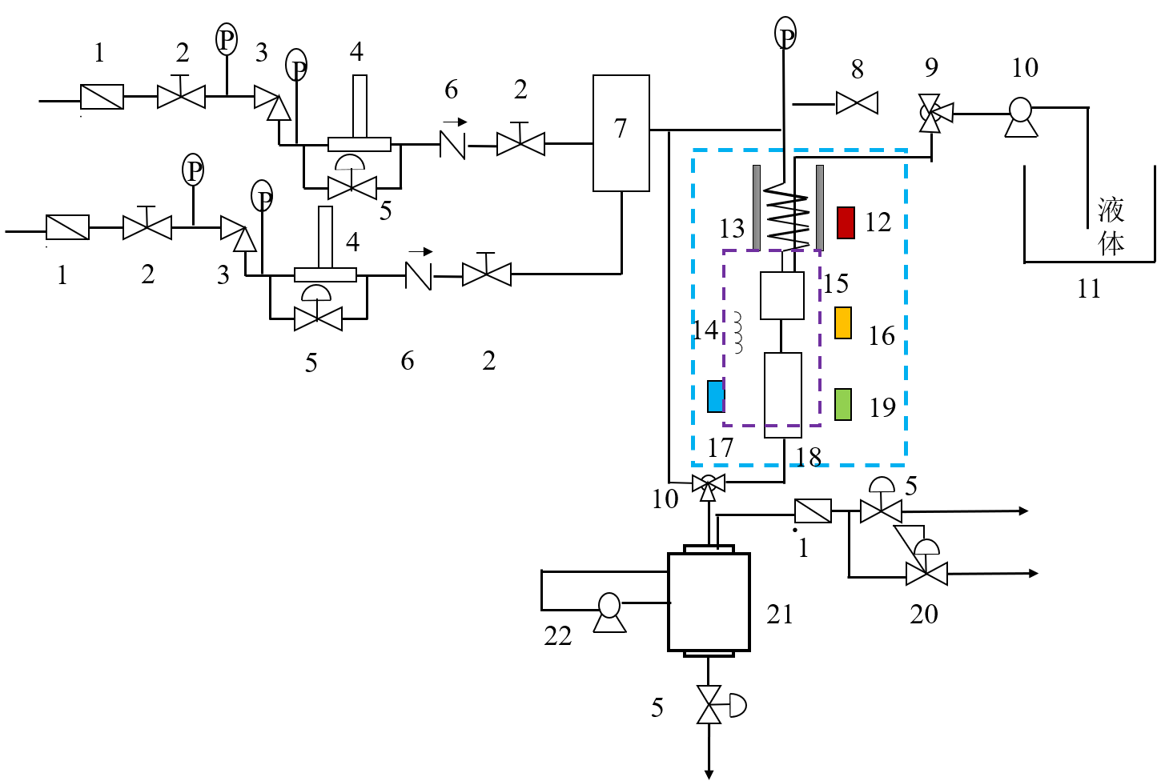
Fig. S1 High pressure fixed bed reactor FD-2000.
Note: 1. Filter, 2. Switch valve, 3. Pressure reducing valve, 4. Flow meter, 5. Needle valve, 6. Check valve, 7. Mixer, 8. Safety valve, 9. Three-way valve, 10. Liquid pump, 11. Liquid raw material tank, 12. Vaporizer temperature, 13. Reactor, 14. Insulation box, 15. Vaporization pipe, 16. Insulation temperature, 17. Reaction temperature mixer, 18. Reactor, 19. Reactor temperature, 20. Back pressure valve, 21. Gas-liquid separator, 22. Cooling pump.
  - Product Analysis Methods
Gas chromatography was employed to analyze the conversion rate and selectivity of the product. The primary components detected by gas chromatography were VAC, CH₃COOH, CH₃CH=CHCHO, and CH₃COCH₃, as shown in Fig. S2.
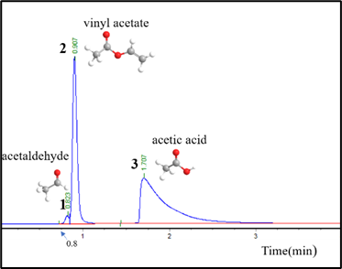
Fig. S2 Gas chromatogram spectrum of the products.
Conversion rate and selectivity of CH₃COOH. The calculation formulas for both are as follows:
$$\text{Conversion=}\frac{{\text{n}}_{\text{0}}\text{-}{\text{n}}_{\text{1}}}{{\text{n}}_{\text{0}}}\text{×100\%}$$
$$\text{Selectivity=}\frac{{\text{n}}_{\text{p}}}{{\text{n}}_{\text{0}}\text{-}{\text{n}}_{\text{1}}}\text{×100\%}$$
Here, n₀ denotes the amount of CH₃COOH in the raw material before reaction; n₁ denotes the amount of CH₃COOH in the collected product after reaction; and n_{P} denotes the amount of CH₃COOH converted to VAC.
  - Characterization
The surface area and pore size distribution of the samples were determined using low-temperature N₂ adsorption/desorption isotherms, conducted with the eight-station research-grade scalable multi-channel gas physical adsorption instrument (TOP-200) from Altamira Instruments, USA. The specific surface area was calculated using the Brunauer-Emmett-Teller (BET) method, while the pore size distribution was analyzed from the adsorption data using the Barrett-Joyner-Halenda (BJH) method. The microstructure of the catalyst was observed using a field emission transmission electron microscope (TEM, Tecnai G2 F30 S-TWIN 300 KV). The surface chemical state of the samples was characterized using X-ray photoelectron spectroscopy (XPS, Thermo Scientific K-Alpha, USA). The carbon content in the samples was measured using thermogravimetric analysis (TG, HITACHI STA200, Japan), with experiments conducted in an air atmosphere at a heating rate of 10 K/min from 323 K to 1073 K to obtain the TG curve. The surface acidity was analyzed through ammonia temperature-programmed desorption (NH₃-TPD, AutoChem II 2920, Micromeritics). The molecular structure of the samples was examined using a Raman spectrometer (Raman, Renishaw in Via) with a measurement range of 500-3500 cm⁻¹ and a laser wavelength of 532 nm. The surface chemical structure was analyzed with a Fourier Transform Infrared Spectrometer (FTIR, Bruker Vertex 70V/INVENIO S, Germany). The elemental composition was determined using an Inductively Coupled Plasma Optical Emission Spectrometer/Mass Spectrometer (ICP-OES/MS, Agilent 5110 (OES), USA). Surface acidity was assessed through Pyridine Infrared Spectroscopy (Py-FTIR, Thermo Nicolet 380). The crystal structure and phase composition were analyzed using X-ray Diffraction (XRD, DX-27MINI), where diffraction patterns were collected and evaluated. Furthermore, a fully automated chemical adsorption instrument (AMI-300Lite, Altamira Instruments, USA) was utilized for temperature-programmed analysis: temperature-programmed desorption (TPD) was performed to characterize the types and amounts of adsorption sites on the catalyst surface under various pretreatment conditions and atmospheres, while temperature-programmed reduction (TPR) was conducted to investigate the interactions among active components, promoters, and supports, as well as the catalyst's reduction properties. The TPD-MS analysis method is used for the quantitative and qualitative analysis of oxygen-containing functional groups on the surface of phosphoric acid modified activated carbon.

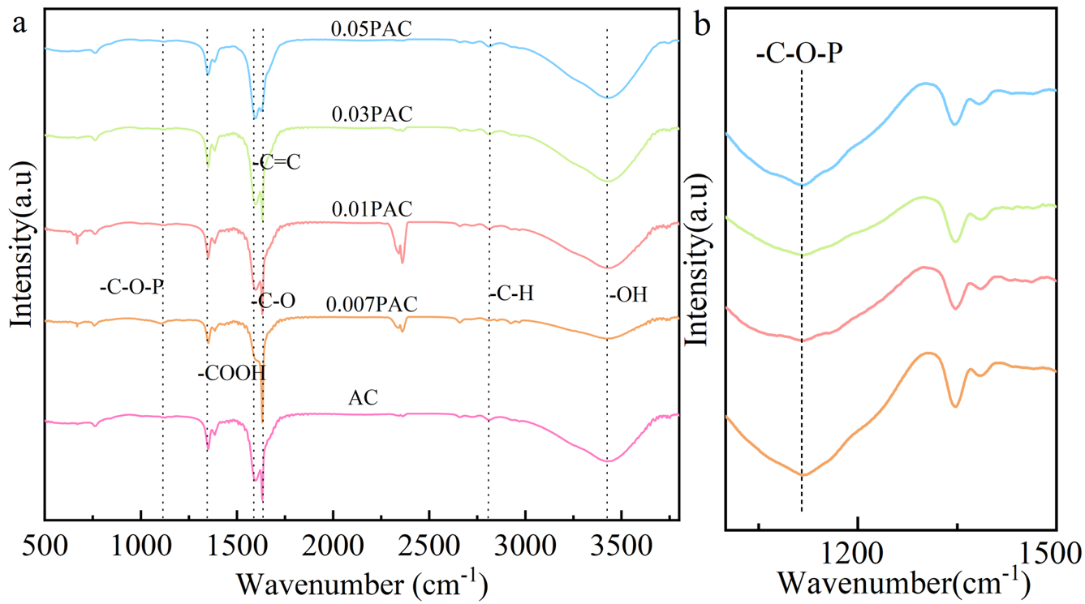
Fig. S3 (a) FTIR spectra of carriers；(b) the fingerprint peak spectra of the -C-O-P

Fig. S4 Catalyst stability performance testing

Fig. S5 XPS spectra of the used Zn/0.01PAC and Zn/AC catalysts: (a) Zn 2p; (b) C 1s; (b) P2p; (d) O 1s.
Fig. S6 XPS survey spectra and high-resolution XPS spectra.

Fig. S7 (a)The NH3-TPD spectra of activated carbon and P-doped activated carbon; (b)The pyridine infrared spectrum of activated carbon samples at 200 °C.

Fig. S8 Acid content of activated carbon samples

Fig. S9 NH₃–TPD profiles of the used Zn/0.01PAC and Zn/AC catalysts

Fig. S10 Pyridine-FTIR analysis of the used Zn/0.01PAC and Zn/AC catalysts measured at 200 ℃.
Table S1 Comparison of different catalysts
Catalyst | Reaction conditions | Zn loading (wt %) | Acetic acid conversion  (10 h) | Stability evaluation | References
Zn/0.02 B-AC-900 | 220 ℃，  1 atm | 7.3 | 62% | 320 h  45% | [1]
Zn(OAc)₂ /0.5 N-AC | 220 ℃，  1 atm | 3.6 | 31% | 10 h | [2]
0.9 Zn/CS-PC₁-800 | 220 ℃，  1 atm | 14.3 | 81% | 10 h | [3]
Zn1Ni0.05/AC | 220 ℃，  1 atm | 3.6 | 29.9% | 120 h  25% | [4]
MOF5-750 | 220 ℃，  1 atm | 24.5 | 60% | 50 h  58% | [5]
Zn0.3Co/AC | 220 ℃，  1 atm | 3.6 | 30% | 120 h  22.1% | [6]
Zn/0.01PAC | 220 ℃，  1 atm | 10.0 | 78% | 60 h  47% | This work
[1] Zhu F, Zhu M, Kang L. B-doped activated carbon as a support for a high-performance Zn-based catalyst in acetylene acetoxylation[J]. Green Energy & Environment, 2022, 7(2): 221-228.
[2] Wu X, He P, Wang X. Zinc acetate supported on N-doped activated carbon as catalysts for acetylene acetoxylation[J]. Chemical Engineering Journal, 2017, 309: 172-177.
[3] Zhang J, Zhu F, Zhang Y. Chitosan-based porous carbon as a support for Zn-based catalysts in acetylene acetoxylation[J]. Korean Journal of Chemical Engineering, 2022, 39(7): 1768-1774.
[4] He P, Wu X, Huang L. Acetoxylation of acetylene to vinyl acetate monomer over bimetallic Zn-Ni/AC catalysts[J]. Catalysis Communications, 2018, 112: 5-9.
[5] Li M, Xu Z, Chen Y. MOFs-derived Zn-based catalysts in acetylene acetoxylation[J]. Nanomaterials, 2021, 12(1): 98.
[6] He P, Huang L, Wu X. A novel high-activity Zn-Co catalyst for acetylene acetoxylation[J]. Catalysts, 2018, 8(6): 239.

Table S2 Pore structure information for the supports and catalysts.
Samples | S¹_{BET} m²∙g⁻¹ | V²_{Total} cm³∙g⁻¹ | D³_{pore} nm
AC | 799.596 | 0.457 | 2.288
0.007PAC | 793.780 | 0.453 | 2.284
0.01PAC | 813.058 | 0.461 | 2.269
0.03PAC | 788.422 | 0.440 | 2.235
0.05PAC | 774.612 | 0.443 | 2.289
Table S3 Pyridine IR analysis of sample acidity
Sampes | Acid amount (μmol/g)
Sampes | Brönsted | Lewis | Total | B/L
AC | 1.705 | 15.787 | 17.492 | 0.108
0.007PAC | 0.324 | 16.463 | 16.787 | 0.020
0.01PAC | 0.428 | 17.053 | 17.481 | 0.025
0.03PAC | 0.609 | 15.241 | 15.850 | 0.040
0.05PAC | 0.820 | 13.230 | 14.050 | 0.062
Zn/AC | 1.216 | 14.693 | 15.909 | 0.083
Zn/0.01PAC | 0.264 | 18.545 | 18.809 | 0.014

Table S4 Pyridine IR analysis of the used sample acidity
Sampes | Acid amount (μmol/g)
Sampes | Brönsted | Lewis | Total | B/L
Zn/AC | 0.846 | 9.407 | 10.253 | 0.090
Zn/0.01PAC | 1.141 | 13.220 | 14.361 | 0.086

